Corner Grocer Item-Tracking Program 1
Tim Harris
Southern New Hampshire University
CS-210: Programming Languages
Project Three: Corner Grocer Item-Tracking Program
June 16, 2026

Corner Grocer Item-Tracking Program Documentation
The Corner Grocer Item-Tracking Program was developed to analyze daily grocery purchase records and provide frequency data for each item sold. The purpose of the program is to help store management identify purchasing trends and make informed decisions about product placement within the store. The program reads purchase data from a text file, calculates the frequency of each grocery item, and presents the information through a menu-driven user interface.
The program is built using object-oriented programming principles and centers around the GroceryTracker class. This class contains a private map data structure that stores grocery item names as keys and purchase frequencies as values. Using a map allows the program to efficiently count and retrieve item frequencies while maintaining organized data management. The class provides public member functions that load data from the input file, create a backup file, retrieve the frequency of a specific item, display all item frequencies, and generate a text-based histogram.
When the program starts, it reads data from CS210_Project_Three_Input_File.txt and processes each item in the file. As each item is read, its frequency count is updated within the map. After processing the input file, the program automatically creates a backup file named frequency.dat, which stores all grocery items and their corresponding frequencies. This file serves as a permanent backup of the processed data and fulfills the project requirement for data file creation.
The user interacts with the program through a menu that contains four options. The first option allows the user to enter a grocery item and view the number of times it appears in the purchase records. The second option displays a complete list of all grocery items and their frequencies. The third option generates a histogram using asterisks to visually represent the frequency of each item. The fourth option exits the program safely.
Exception handling is implemented using C++ try-catch blocks to improve reliability and prevent unexpected program failures. If the input file cannot be opened or the backup file cannot be created, the program throws an exception and displays an informative error message to the user. Input validation is also included in the menu system to ensure users enter only valid menu selections. Invalid input is detected and handled gracefully without causing the program to terminate.
Several object-oriented programming concepts are demonstrated within this project. Encapsulation is achieved by keeping the frequency map private and providing controlled access through public member functions. Abstraction is demonstrated by hiding file-processing and frequency-calculation details inside the GroceryTracker class, allowing the main program to interact with simple function calls. While inheritance and polymorphism were studied during the course, they were not necessary for this implementation because the project requirements could be efficiently met using a single class design.
Industry-standard best practices were followed throughout development. The program uses meaningful variable and function names, modular design, in-line comments, exception handling, and input validation to improve readability, maintainability, and reliability. These practices make the code easier to understand, modify, and expand in future versions.
Screenshot 1: Program startup and successful loading of the input file.
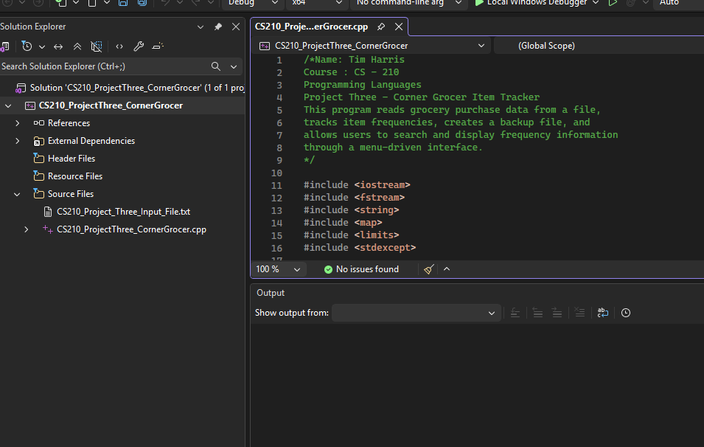
The application loads purchase data and creates the frequency.dat backup file.
Screenshot 2: Main menu displayed to the user.
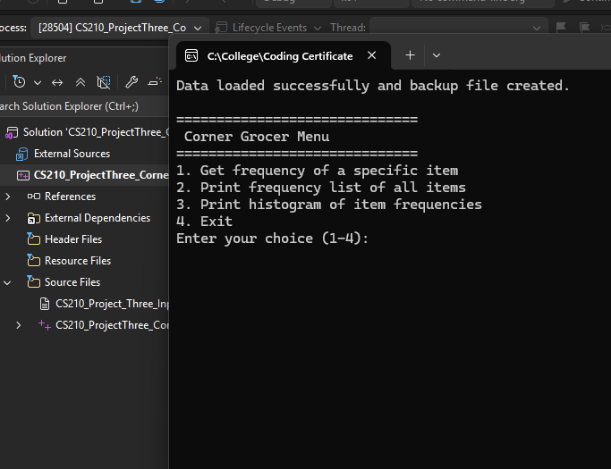
Menu interface showing all available program options.
Screenshot 3: Individual item frequency search.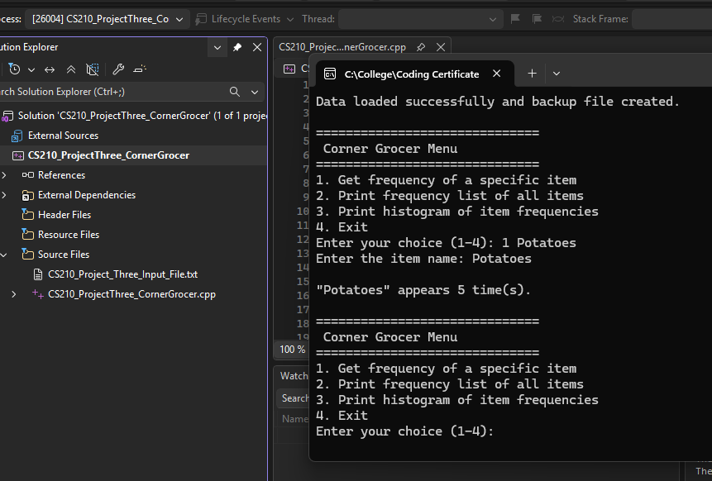
Example showing the frequency count returned for a user-selected grocery item.
Screenshot 4: Complete frequency list output.
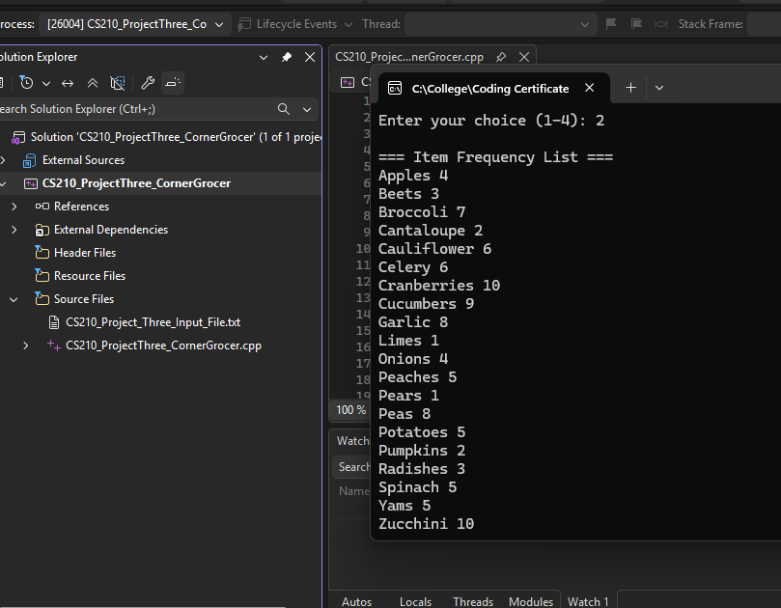
Display of all grocery items and their corresponding purchase frequencies.
Screenshot 5: Histogram output.
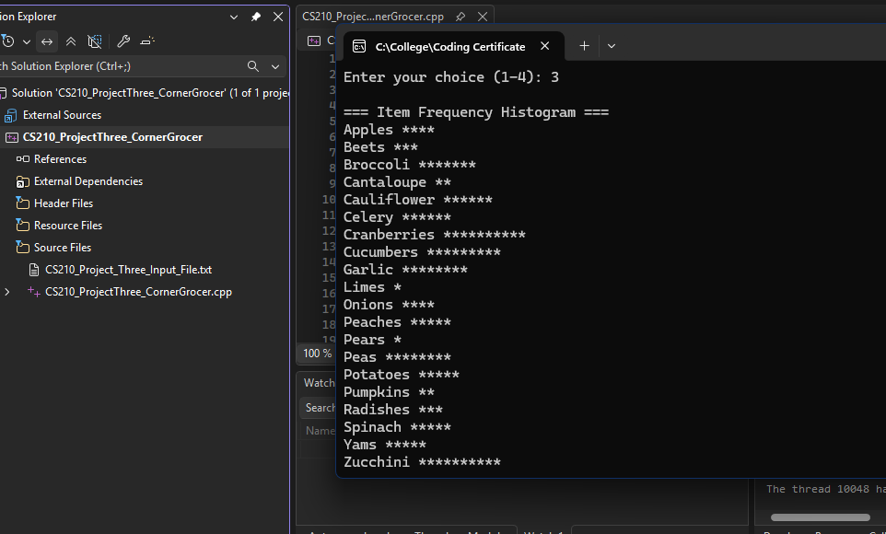
Text-based graphical representation of grocery item frequencies using asterisks.
Screenshot 6: Program Exit
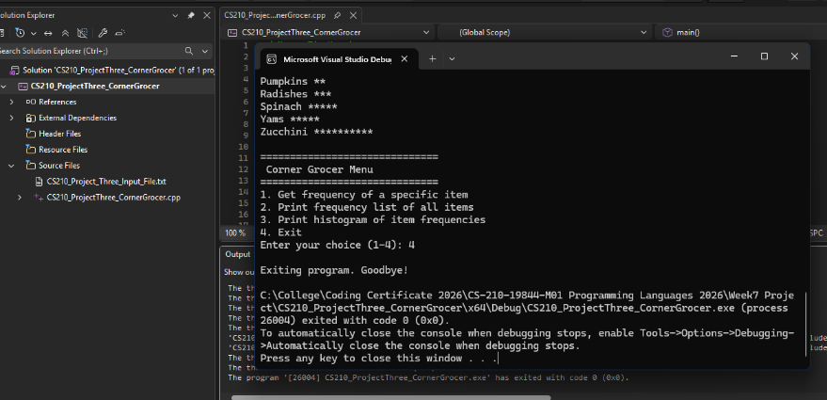
User selects the exit option and the program terminates with a goodbye message.
In conclusion, the Corner Grocer Item-Tracking Program successfully fulfills all project requirements by providing accurate item frequency analysis, a user-friendly interface, automatic data backup, exception handling, and clear object-oriented design principles.

AI Usage Statement:
Portions of this code and documentation were assisted by the SNHU-provided ChatGPT tool, in accordance with course guidelines. All code and written materials were reviewed and finalized by the student.

