OMNet-V3: A Magnification-Aware Dual-Branch Network for Breast Cancer Histopathology Classification
Department of Information Technology ,
Guru Nanak Institute of Technology, Kolkata, India
gnit.info@jisgroup.org
Abstract— Reading a breast tissue slide well means reading it at more than one zoom level: low magnification shows how tissue is organized, high magnification shows what individual cells look like. Most automated classifiers pick one architecture and one scale and stick with it, which leaves useful information on the table. This paper presents OMNet-V3, a dual-branch network that pairs an EfficientNet-B0 backbone (local texture) with a ViT-Tiny/16 backbone (global context) and combines them with a Magnification-Aware Adaptive Fusion (MAF) module — a small gate that learns, per image, how much to trust each branch based on the magnification the image was captured at (40X to 400X). Training uses a hierarchical loss combining binary classification (benign vs. malignant), 8-class histological subtype classification, and a consistency term that keeps the two prediction heads from contradicting each other. We evaluate OMNet-V3 on the BreaKHis dataset with strict patient-disjoint 5-fold cross-validation, so a patient's images never appear in both the training and test split of the same fold. Averaged across folds, OMNet-V3 reaches 84.05% ± 3.13% binary accuracy (AUC 0.894, MCC 0.607) and 24.42% ± 3.84% macro-F1 on the harder 8-class subtype task. We also examine what the fusion gate learns: its reliance shifts from the CNN branch toward the transformer branch as magnification increases, giving insight into what each branch contributes rather than treating the fusion as a black box.
Index Terms— breast cancer histopathology, BreaKHis, multi-scale fusion, vision transformer, EfficientNet, multi-task learning, patient-disjoint cross-validation

I. INTRODUCTION
Breast cancer is diagnosed with certainty only after a pathologist examines a tissue biopsy under a microscope. That reading is not done at a single zoom level. A pathologist typically starts at low magnification to judge how the tissue is organized — whether normal architecture has broken down, whether there is an invasive pattern — and then moves to high magnification to look at individual cell nuclei, mitotic figures, and other fine detail that decides the subtype and grade. An automated system working from a single fixed scale is working with less information than the expert it is trying to assist.
Convolutional networks and vision transformers each capture a different part of this picture. A CNN like EfficientNet builds up features from small, overlapping local patches, which suits it to texture and local morphology — the kind of thing that matters most at high magnification. A vision transformer looks at the whole image through self-attention from the first layer, which suits it to capturing how structures relate to each other across the slide — closer to what a pathologist is doing at low magnification when judging overall tissue architecture. Using only one of the two throws away the strength of the other, and recent hybrid CNN-transformer work on BreaKHis backs this up empirically [1]–[3].
This paper proposes OMNet-V3, a dual-branch network built around three ideas. First, it keeps both an EfficientNet-B0 branch and a ViT-Tiny/16 branch running side by side rather than picking one. Second, it fuses the two branches with a Magnification-Aware Adaptive Fusion (MAF) module that conditions the fusion weight on the magnification of the input image, so the network learns — rather than is told — how much to lean on each branch at each scale. Third, it trains with a hierarchical multi-task loss that combines a coarse benign/malignant decision with a fine-grained 8-class subtype decision, plus a consistency term that discourages the two heads from disagreeing with each other.
We evaluate the approach with patient-disjoint stratified group cross-validation, a stricter and more clinically meaningful protocol than the random image-level splits used in a good deal of earlier BreaKHis work — a model can score very well on a random split simply by recognizing a patient's tissue rather than genuinely generalizing to new patients, a concern raised explicitly in recent patient-aware benchmarking work on this exact dataset [1]. The contributions of this paper are:
• A dual-branch CNN + transformer architecture with a learned, magnification-conditioned fusion gate rather than a fixed fusion rule.
• A hierarchical multi-task loss that ties binary and subtype predictions together through an explicit consistency term.
• A patient-disjoint 5-fold evaluation protocol on all four BreaKHis magnifications, removing patient-identity leakage between train and test splits.
• An analysis of the learned fusion gate showing, quantitatively, how the network's reliance on CNN versus transformer features shifts with magnification.
The rest of the paper is organized as follows. Section II covers related work. Section III describes the dataset and preprocessing. Section IV details the OMNet-V3 architecture and loss. Section V covers the experimental setup. Section VI presents results, and Section VII discusses what they mean, including limitations. Section VIII concludes.
II. RELATED WORK
Recent benchmarking work on BreaKHis has pushed toward stricter, leakage-free evaluation: Priyanka et al. compare nine CNN and transformer architectures under a patient-aware protocol and show that image-wise random splits meaningfully inflate reported accuracy relative to patient-disjoint evaluation [1], which is the same concern that motivates the cross-validation protocol used in this paper.
On the architecture side, several 2024–2025 papers combine a CNN branch with a transformer branch rather than committing to one family. Wang et al.'s MFF-ClassificationNet fuses a CNN and a Transformer branch through a CBAM/squeeze-excitation fusion block and reports strong per-magnification accuracy on BreaKHis [2]. Fiaz et al.'s DFViT fuses a CNN-derived RGB stream with a stain-normalized stream inside a Vision Transformer, showing that combining complementary image representations — rather than a single input stream — improves histopathology classification [3]. Ding et al. propose a multi-branch attention architecture that similarly widens the intermediate feature representation to capture more of the information available in a histopathology image [5]. Compared to this line of work, OMNet-V3's fusion is explicitly conditioned on the magnification metadata attached to each image rather than only on the visual features themselves.
Attention and stain-normalization also feature prominently in recent BreaKHis literature. Aldakhil et al.'s ECSAnet builds on EfficientNetV2 with a convolutional block attention module and Reinhard stain normalization, and report that stain normalization measurably affects cross-magnification generalization [4] — consistent with the stain-augmentation strategy used in this paper, though we perturb stain color during training rather than normalizing it away.
On subtype-level classification specifically, Desai and Mahto benchmark ResNet-18/34/50 on the same 8-class BreaKHis subtype task used here and report that performance tracks patient-level representation in the training data as much as raw image count [6], a pattern our results (Section VI-C) reproduce independently. Srikantamurthy et al. propose a hybrid CNN-LSTM transfer-learning pipeline for the same 8-class problem and likewise report a large gap between binary and subtype-level performance [7], mirroring the gap we observe between the binary and subtype tasks in Section VI-A.
A wave of 2026 work has pushed this dual-branch idea further. Ashab et al.'s MagViT extracts per-magnification ViT representations and combines them through a scale-gated fusion module with patient-level model selection, reporting strong patient-level accuracy on BreaKHis and preliminary cross-dataset transfer to BUSI and IDC [8]. Ativi et al.'s CMAF-Net pairs a CNN-Transformer backbone with a cross-modal attention fusion block and an information-theoretic, margin-based loss aimed squarely at the class-imbalance problem this paper also confronts in Section VI-B–C [9]. Khan et al.'s DSVTLA integrates a hierarchical Swin Transformer with ResNet50 features across several histopathological cancer types, reinforcing that CNN-Transformer hybrids generalize beyond BreaKHis alone [14]. OMNet-V3 differs from all three chiefly in conditioning its fusion gate on explicit magnification metadata rather than on visual features or missing-scale masking alone.
Attention-heavy single-backbone designs remain an active alternative to explicit dual-branch fusion. Acikgoz et al.'s BreasTransNeXt extends a vision transformer with multiple attention modules for early breast cancer diagnosis [10], while Shankar et al. propose a fast hierarchical-attention ViT for the same 8-class BreaKHis subtype task addressed in this paper [11]. Anand and Khajuria benchmark transformer and CNN combinations specifically for breast mass classification, echoing the CNN/transformer complementarity argument made in Section I [12]. Aldawsari et al.'s Swin-DAMFN fuses a Swin Transformer branch with a CNN-based dual-attention multi-scale module [15], and Jeevan et al. benchmark CNNs, ViTs, Swin Transformers, and token-mixing models under magnification shift on BreaKHis [13] — both consistent with this paper's own finding (Section VI-D) that magnification systematically changes which architectural family is more informative.

III. DATASET AND PREPROCESSING
A. BreaKHis Dataset
The dataset used in this work is the BreaKHis breast cancer histopathology image set. The copy used here contains 7,909 microscopic images collected from 82 patients, each image captured at one of four magnifications: 40X, 100X, 200X, and 400X. Every image carries a binary label (benign or malignant) and one of eight fine-grained histological subtype labels: four benign — adenosis (A), fibroadenoma (F), phyllodes tumor (PT), tubular adenoma (TA) — and four malignant — ductal carcinoma (DC), lobular carcinoma (LC), mucinous carcinoma (MC), papillary carcinoma (PC).
The dataset is unbalanced in two ways that matter for training and for interpreting results. Class-wise, malignant images outnumber benign by more than two to one. Subtype-wise the imbalance is far more severe: ductal carcinoma alone accounts for close to half the dataset and comes from 38 of the 82 patients, while phyllodes tumor has only 453 images from 3 patients. Table I summarizes the distribution; Table II gives patients per subtype, the number that really controls how much the model can learn about a class.
TABLE I. IMAGE DISTRIBUTION BY CLASS, SUBTYPE, AND MAGNIFICATION
Category | Images (share)
Benign | 2,480 (31.4%)
Malignant | 5,429 (68.6%)
DC | 3,451 (43.6%)
F | 1,014 (12.8%)
MC | 792 (10.0%)
LC | 626 (7.9%)
TA | 569 (7.2%)
PC | 560 (7.1%)
PT | 453 (5.7%)
A | 444 (5.6%)
40X / 100X | 1,995 / 2,081
200X / 400X | 2,013 / 1,820

TABLE II. PATIENTS PER SUBTYPE
Subtype | Patients
A | 4
F | 10
PT | 3
TA | 7
DC | 38
LC | 5
MC | 9
PC | 6

Fig. 1 shows representative example patches from the BreaKHis dataset spanning the four magnification levels (40X–400X) used throughout this study, illustrating the change in visible structure — from overall tissue architecture at low magnification to individual cell nuclei at high magnification — that motivates the multi-scale, dual-branch design of OMNet-V3.
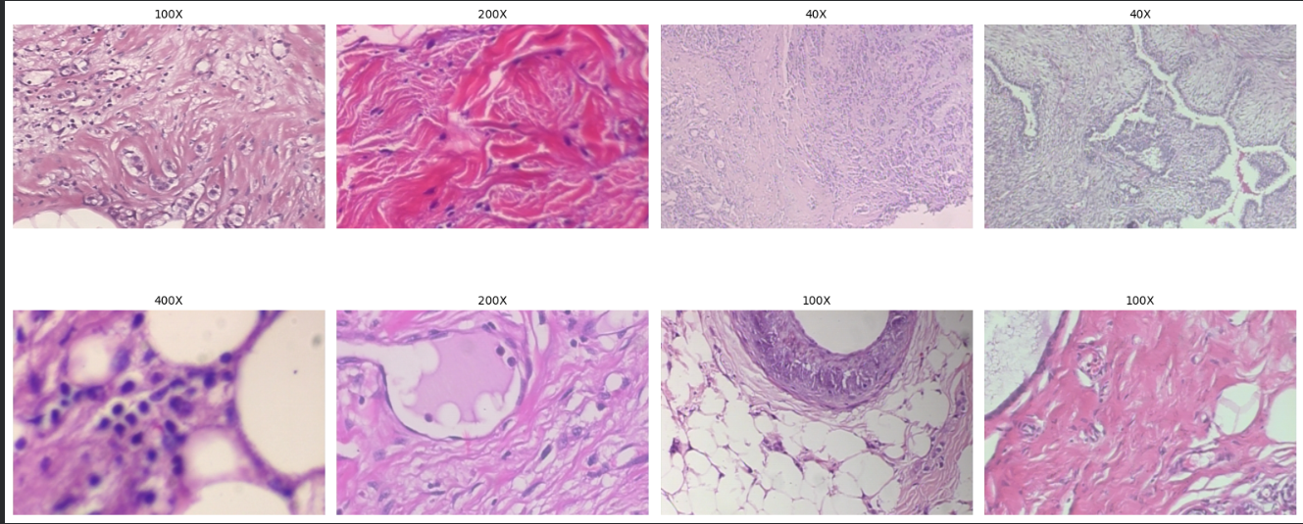
Fig. 1. Representative BreaKHis histopathology patches at increasing magnification (40X, 100X, 200X, 400X), illustrating the shift from tissue-level architecture to cell-level detail.

B. Patient-Disjoint Splitting
Images from the same patient and tumor block look alike — same tissue, same staining batch, often the same field imaged at different magnifications. If a random split lets some of a patient's images fall into training and others into test, a model can score well by partly recognizing that patient rather than generalizing to new tissue [1]. We use scikit-learn's StratifiedGroupKFold with patient_id as the grouping variable and subtype as the stratification target, producing 5 folds in which no patient's images appear in both the training and test portion of the same fold. Within each fold's training portion, 10% of patients are further held out for validation, so validation is patient-disjoint from both training and test as well. Table III shows the resulting fold sizes.
TABLE III. PATIENT-DISJOINT FOLD SIZES (5-FOLD STRATIFIEDGROUPKFOLD)
Fold | Train img / pat | Test img / pat
0 | 6,345 / 66 | 1,564 / 16
1 | 6,418 / 66 | 1,491 / 16
2 | 6,257 / 66 | 1,652 / 16
3 | 6,270 / 64 | 1,639 / 18
4 | 6,346 / 66 | 1,563 / 16

C. Preprocessing and Augmentation
Training images are resized to 256×256 and randomly cropped to 224×224, with random horizontal/vertical flips and rotation up to 20 degrees — reasonable for histopathology since tissue has no canonical orientation. Validation and test images are resized to 256×256 and center-cropped to 224×224 with no further augmentation. All images are normalized with ImageNet statistics, since both backbones start from ImageNet-pretrained weights.
Because H&E staining color varies across labs, scanners, and reagent batches — a source of domain shift also highlighted in recent BreaKHis work using explicit stain normalization [4] — we apply a stain-color perturbation based on the Macenko decomposition with 50% probability during training. The image is converted to optical density space, the hematoxylin/eosin stain directions are estimated by SVD, the stain concentrations are randomly rescaled and shifted, and the image is reconstructed. This trains the network to rely on structural cues rather than absolute stain color.

IV.METHODOLOGY
OMNet-V3 has four parts: two pretrained backbones extracting features from the same input image, a fusion module that combines them conditioned on magnification, and two classification heads sharing the fused representation.

Fig. 2 illustrates the overall OMNet-V3 architecture: the input image is passed through the EfficientNet-B0 and ViT-Tiny/16 branches in parallel, each projected to a shared 256-d space; the Magnification-Aware Adaptive Fusion (MAF) module combines the two using a magnification embedding, a residual refinement block sharpens the fused representation, and the resulting 256-d feature feeds the binary and 8-class subtype heads.
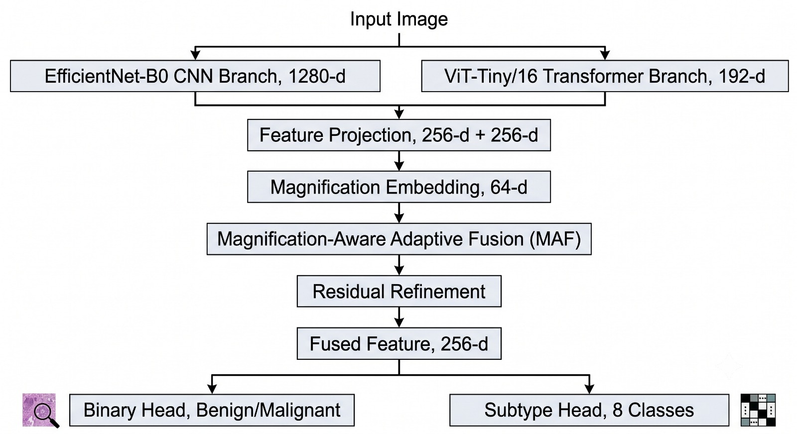
Fig. 2. OMNet-V3 architecture: dual-branch feature extraction, magnification-conditioned fusion (MAF), residual refinement, and the two classification heads.

A. Dual-Branch Feature Extraction
The CNN branch is an EfficientNet-B0, pretrained on ImageNet, used with its classification head removed and its final pooled feature (1,280-d) taken as output. This branch is expected to carry local texture and morphology — nuclear texture, chromatin pattern, small-scale structure.
The transformer branch is a ViT-Tiny/16, also ImageNet-pretrained, with the [CLS] token's final representation (192-d) taken as output. Because self-attention relates every patch to every other patch from the first layer, this branch is expected to carry more of the global tissue architecture.
Both vectors are projected into a shared 256-dimensional space by a linear layer followed by layer normalization, giving f_cnn and f_vit, both in R^256.
B. Magnification-Aware Adaptive Fusion (MAF)
Rather than a fixed fusion rule, the MAF module learns a per-sample gate α ∈ (0, 1) conditioned on the image's magnification. A learned embedding e_m ∈ R^64 represents each of the four magnification levels. The gate concatenates f_cnn, f_vit, and e_m and passes them through a linear layer with sigmoid activation to produce α:
fused = α · f_cnn + (1 − α) · f_vit
A small residual block — two linear layers with GELU and dropout, also conditioned on e_m — refines the fused vector, giving the final 256-d representation f_out passed to both heads. Conditioning the gate on magnification gives the network an explicit hook to learn scale-dependent behaviour. Section VI-D examines what the trained gate actually does.
C. Hierarchical Multi-Task Loss
Two linear heads sit on f_out: a binary head and an 8-class subtype head. Training combines three terms. L_binary and L_subtype are class-weighted cross-entropy losses, weighted inversely to class frequency. L_consistency groups the eight subtype probabilities into benign-group and malignant-group probabilities and applies a KL-divergence penalty against the binary head's own softmax output, discouraging the two heads from disagreeing:
L = 0.3·L_binary + 0.6·L_subtype + 0.1·L_consistency
Subtype classification gets the largest weight because it is the harder, more information-rich task, and pushing gradient through the fine-grained head tends to shape a more useful shared representation than the coarse task alone.

V. EXPERIMENTAL SETUP
A. Cross-Validation Protocol
All results are averaged over the 5 patient-disjoint folds in Section III-B. For each fold, the checkpoint with the best validation subtype macro-F1 is kept and evaluated once on the fold's held-out test patients. No test data is used for any training decision.
B. Training Configuration
Table IV summarizes training details. Backbones train at a lower learning rate than the newly initialized heads/fusion module under a single AdamW optimizer. For the first 5 epochs both backbones are frozen; afterward the whole network fine-tunes end-to-end. A cosine schedule decays the learning rate over up to 30 epochs, with early stopping after 8 epochs without validation improvement. Training uses mixed precision. All experiments use a fixed seed (42).
TABLE IV. TRAINING CONFIGURATION
Setting | Value
Backbones | EfficientNet-B0 + ViT-Tiny/16
Input size | 224 × 224
Batch size | 16
Optimizer | AdamW, wd 1e-4
LR | 1e-4 (backbone), 5e-4 (head)
Schedule | Cosine, 30 epochs max
Warm-up | 5 epochs, frozen backbones
Early stop | Patience 8 (val subtype F1)
Grad clip | Max norm 1.0
Precision | Mixed (AMP)
Loss weights | 0.3 / 0.6 / 0.1
Hardware | 1× Tesla T4 (15.6 GB)

C. Evaluation Metrics
For both tasks we report accuracy, macro-F1, balanced accuracy, and Matthews correlation coefficient (MCC), since accuracy alone is misleading on an imbalanced dataset like this one. We also report ROC-AUC (one-vs-rest for the 8-class task) and confusion matrices aggregated across all five test folds, examine the learned fusion gate α by magnification, and visualize the fused embedding space with t-SNE.

VI. RESULTS
A. Aggregate Performance
Table V reports mean ± standard deviation across the 5 test folds. The binary task reaches 84.05% ± 3.13% accuracy and an MCC of 0.607, a fairly consistent benign/malignant decision across folds. The subtype task is considerably harder: 45.29% accuracy but only 24.42% macro-F1 — macro-F1 weights every class equally and exposes the effect of the subtype imbalance from Table II far more clearly than accuracy does, echoing the same accuracy/macro-F1 gap reported for BreaKHis subtype classification elsewhere [6], [7].
TABLE V. AGGREGATED PERFORMANCE (MEAN ± STD, 5 FOLDS)
Metric | Binary | Subtype
Accuracy | 0.8405±0.0313 | 0.4529±0.0765
Macro-F1 | 0.7989±0.0366 | 0.2442±0.0384
Bal. accuracy | 0.8084±0.0366 | 0.3535±0.0713
MCC | 0.6074±0.0679 | 0.2975±0.0630
Weighted-F1 | — | 0.4608±0.0651
ROC-AUC | 0.8945 | see VI-C

Figure 5 places two generations of the model side by side. The left panel benchmarks single-scale OMNet-V2 variants at 200X magnification alone — a standalone EfficientNet-B0 (CNN) branch, a standalone ViT-B/16 (transformer) branch, and a soft-voting ensemble of the two — on binary accuracy, macro-F1, sensitivity, specificity, and ROC-AUC. All three reach 81.8–84.3% accuracy and 87.1–90.0% ROC-AUC, but specificity lags well behind sensitivity throughout (51.2–56.0% versus 94.9–97.5%), showing that even before the multi-scale, multi-task redesign, the model already erred heavily toward flagging tissue as malignant. The right panel reports the current multi-scale (40X–400X), multi-task OMNet-V3 under its two deployment configurations — a larger Cloud-hosted variant and a lighter Local (on-device) variant. Binary accuracy and macro-F1 are essentially unchanged between the two deployments (84.6%/80.3% Cloud versus 83.8%/81.2% Local), while the added subtype task is markedly harder for both: weighted-F1 sits at 44.8% (Cloud) and 42.0% (Local), and macro-F1 falls further still to 23.4% and 25.6% respectively, consistent with the subtype-level class imbalance discussed in Table V and Section VI-C. The comparison indicates that moving from single-scale to multi-scale, multi-task operation preserves binary performance while exposing the same rare-subtype difficulty regardless of deployment footprint.
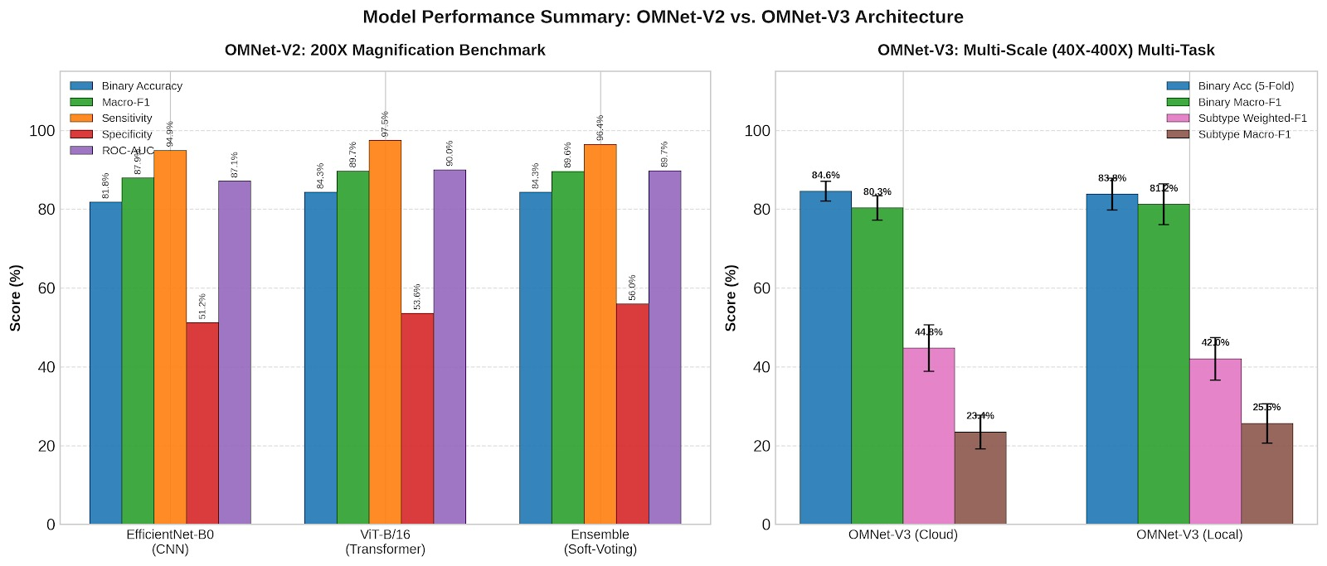
Fig. 5. Model performance summary: single-scale OMNet-V2 architectures (EfficientNet-B0, ViT-B/16, and their soft-voting ensemble) at 200X magnification, left, versus the multi-scale (40X–400X), multi-task OMNet-V3 in its Cloud and Local deployment configurations, right.

B. Binary Classification
Figure 3 shows the aggregated binary confusion matrix. Malignant cases are recognized correctly 87.9% of the time, versus 75.4% for benign; errors lean toward calling benign tissue malignant (24.6%) more than the reverse (12.1%). In a screening context this asymmetry is the safer direction to err in, though it also means roughly a quarter of benign cases would be flagged for further review under this model as configured.
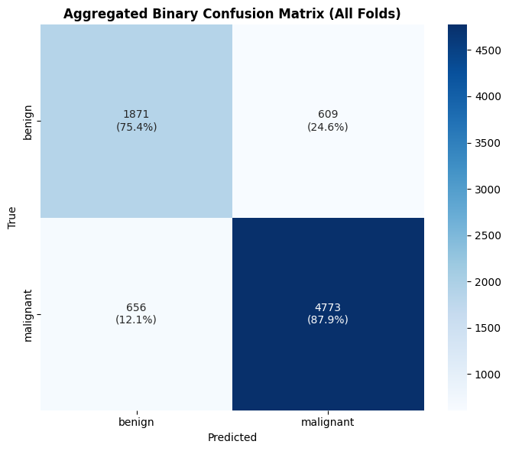
Fig. 3. Aggregated binary confusion matrix (all 5 test folds).
C. Subtype Classification
Figure 4 shows the aggregated 8-class confusion matrix. Ductal carcinoma (DC, 38 patients) is recognized correctly 72.3% of the time; adenosis (A) and fibroadenoma (F), with more patients than the remaining rare classes, reach 52.9% and 46.0% recall. Classes with the fewest contributing patients fare far worse: phyllodes tumor (PT, 3 patients) is correctly identified only 3.3% of the time, most often confused with fibroadenoma or DC. This pattern tracks the per-patient counts in Table II rather than being an unexplained failure — with three or five patients' worth of tissue there is not enough visual variation in training for a reliable subtype signature, the same conclusion reached independently for BreaKHis subtype classification in [6].
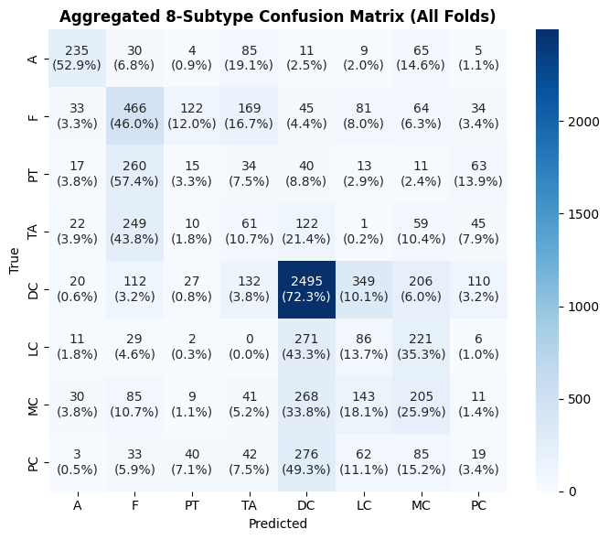
Fig. 4. Aggregated 8-class subtype confusion matrix (all 5 test folds).

Figure 6 shows ROC curves. The aggregated binary ROC gives an AUC of 0.894. The one-vs-rest subtype curves separate classes by how well-supported they are: adenosis reaches an AUC of 0.941 and ductal carcinoma 0.817, both above the fibroadenoma/lobular/mucinous group (0.6–0.8), while phyllodes tumor (0.590) and papillary carcinoma (0.490, near chance) sit lowest — again tracking patient count rather than image count, since PT has more images (453) than several better-performing classes.
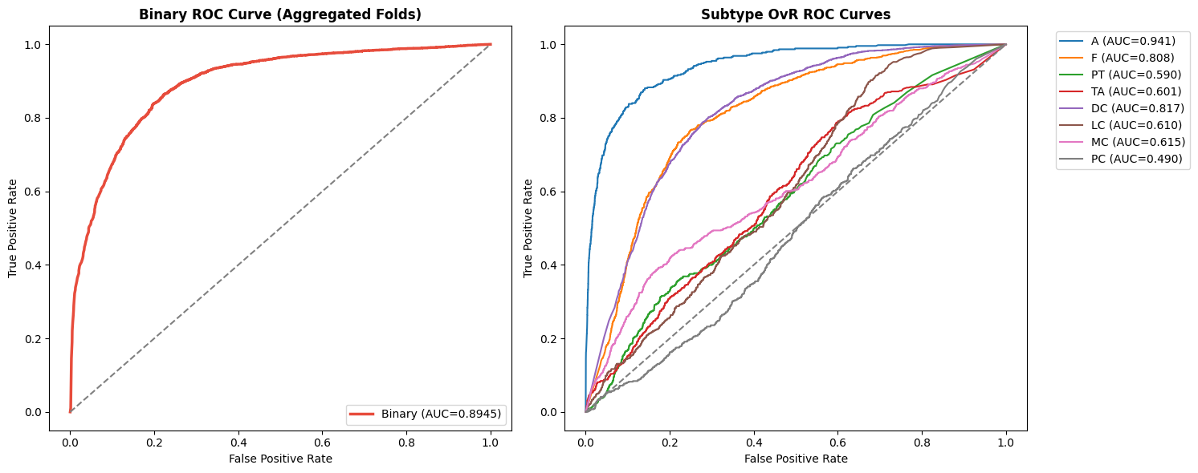
Fig. 6. Binary ROC curve (left) and one-vs-rest subtype ROC curves (right), aggregated across folds.

D. Fusion Gate Behaviour Across Magnifications
Table VI and Figure 7 show the learned gate α — weight on the CNN branch, with (1 − α) on the transformer branch — by input magnification, measured on the fold-0 test set. Mean α falls steadily as magnification increases: from 0.685 at 40X to 0.470 at 400X. The network relies more on the CNN branch at low magnification and shifts toward the transformer branch as magnification increases, reaching near-parity at 400X.
TABLE VI. FUSION GATE α BY MAGNIFICATION (FOLD-0 TEST SET)
Mag. | Mean α ± std
40X | 0.6850±0.1301
100X | 0.5991±0.1283
200X | 0.5258±0.1449
400X | 0.4701±0.1459

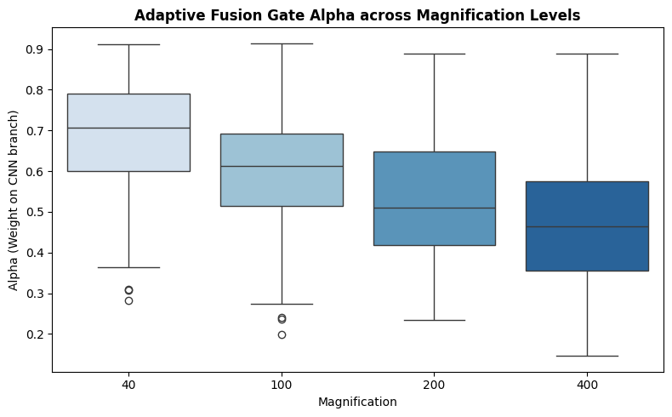
Fig. 7. Distribution of the fusion gate α across magnification levels.
This runs counter to the naive intuition that a CNN's local receptive field should matter most at high magnification, where individual cells fill the frame. A plausible reading is that at 40X/100X, where one field of view spans a wide swath of tissue, the CNN's locally-pooled texture summary already efficiently describes the coarse architecture the image mostly consists of; at 400X, where a handful of cells dominate the frame, the relationships between them — closer to what the transformer's global attention models — become more informative. We treat this as an observation about the trained gate rather than a settled explanation, worth follow-up with attention-map analysis at each scale.
E. Embedding Space Visualization
Figure 8 shows a t-SNE projection of the fused embedding f_out, colored by subtype, on the fold-0 test set. Adenosis and ductal carcinoma — the strongest per-class AUC in Section VI-C — form the most visually distinct clusters. The rarer subtypes, particularly phyllodes tumor, show far more overlap with neighbouring classes, mirroring their weak confusion-matrix and ROC performance and reinforcing that the limitation lies in the representation the network could learn from limited patient data, not just the downstream classification head.
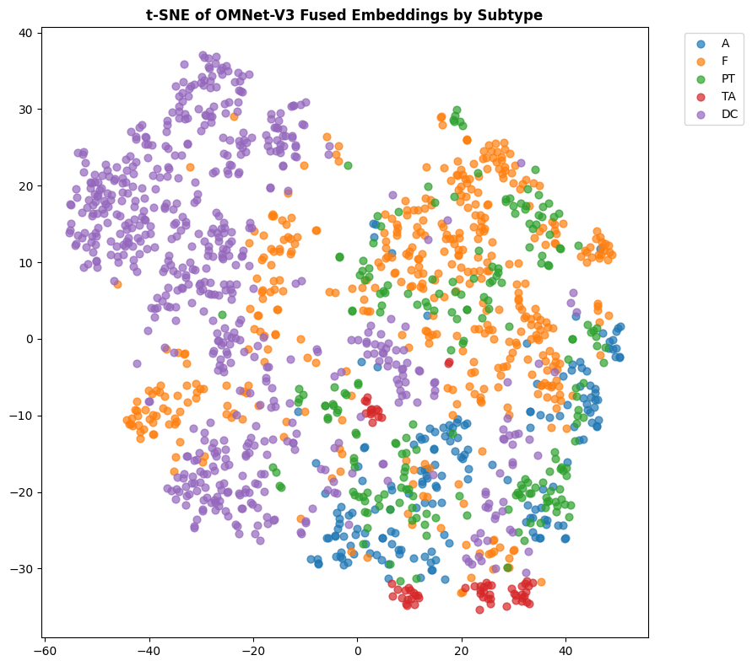
Fig. 8. t-SNE projection of the fused embedding space, colored by subtype (fold-0 test set).

VII. DISCUSSION
A. What the Results Say
The binary results (84% accuracy, 0.89 AUC, patient-disjoint) are competitive with recent published BreaKHis work while using a stricter evaluation protocol than random image-level splitting — a concern that recent patient-aware benchmarking has shown inflates reported numbers considerably [1], so a patient-disjoint 84% is not directly comparable to an image-level-split figure in the mid-90s or higher, even though the latter looks more impressive on paper. The subtype results are the more useful part of this study: a macro-F1 of 24% makes clear that fine-grained BreaKHis subtype classification is currently bottlenecked by how few patients contribute to several of the eight classes, not by architecture choice — reporting only accuracy or weighted-F1 (46%) here would have painted an overly optimistic picture.
B. Class Imbalance as the Core Limitation
Every place the model struggles — phyllodes tumor, lobular carcinoma, papillary carcinoma — lines up with the subtypes that have the fewest contributing patients (3, 5, and 6 respectively), not the fewest images, consistent with what Desai and Mahto [6] and Srikantamurthy et al. [7] independently report on the same 8-class task. This says the bottleneck is genuine diversity of tissue seen during training, not merely a labeled-sample-count problem that oversampling or reweighting could fully fix. Meaningful gains on rare subtypes most likely require more patients per class, or an approach — few-shot learning, pathologist-validated synthetic augmentation, or transfer from a larger external cohort — designed for the low-patient-count regime.
C. The Fusion Gate as an Interpretability Tool
Beyond its architectural role, the MAF gate doubles as a lightweight interpretability signal: because α is a single scalar per image with a clear meaning (branch reliance), it is easier to inspect than transformer attention maps alone, and the fact that it tracks magnification smoothly and monotonically (Section VI-D) suggests the network learned something coherent about scale rather than an arbitrary weighting.
D. Limitations
The dataset is small by deep-learning standards — 82 patients — and severely imbalanced at the subtype level, capping what any architecture can achieve on rare classes. Results come from a single dataset and staining pipeline; generalization to other labs or scanners is untested here, and stain augmentation only partially substitutes for external validation. The fusion-gate analysis (Section VI-D) uses a single fold's test set rather than all five folds, so its exact numbers should be read as illustrative of a trend. No single-branch CNN-only or ViT-only baseline under the same patient-disjoint protocol is reported here; such an ablation would more directly isolate the fusion design's contribution and is a natural next step.

VIII. CONCLUSION AND FUTURE WORK
This paper presented OMNet-V3, a dual-branch EfficientNet-B0 / ViT-Tiny/16 network for BreaKHis histopathology classification, fused through a magnification-aware adaptive gate and trained with a hierarchical multi-task loss. Under strict patient-disjoint 5-fold evaluation, the model reaches 84.05% binary accuracy (AUC 0.894, MCC 0.607) and 24.42% subtype macro-F1. The learned fusion gate shifts smoothly from favouring the CNN branch at low magnification to a near-even split with the transformer branch at high magnification, giving an interpretable window into how the two branches divide labour across scales. The dominant limitation is subtype-level class imbalance measured in patients rather than images, which architecture alone cannot solve.
Future work should prioritize: (1) a same-protocol ablation against single-branch CNN-only and ViT-only baselines to isolate the contribution of fusion itself; (2) external validation on a second histopathology dataset or scanner; (3) methods aimed at low-patient-count subtypes, such as few-shot fine-tuning or validated synthetic augmentation; and (4) a fold-aggregated version of the fusion-gate analysis together with attention-map visualization.

REFERENCES
[1] V. Priyanka, M. Narendra, and T. Dilleswar Rao, "A patient-aware benchmarking of CNN and transformer architectures for breast cancer histopathology classification," Frontiers in Digital Health, vol. 8, art. 1752938, 2026.
[2] X. Wang, G. Wang, L. Li, H. Zou, and J. Cui, "MFF-ClassificationNet: CNN-Transformer hybrid with multi-feature fusion for breast cancer histopathology classification," Biosensors, vol. 15, no. 11, art. 718, 2025.
[3] A. S. Fiaz, B. Raza, M. Faheem, and A. Raza, "A deep fusion-based vision transformer for breast cancer classification," Healthcare Technology Letters, vol. 11, no. 6, pp. 471–484, 2024.
[4] L. A. Aldakhil, H. F. Alhasson, and S. S. Alharbi, "Attention-based deep learning approach for breast cancer histopathological image multi-classification," Diagnostics, vol. 14, no. 13, art. 1402, 2024.
[5]A. Desai and R. Mahto, "Multi-class classification of breast cancer subtypes using ResNet architectures on histopathological images," Journal of Imaging, vol. 11, no. 8, art. 284, 2025.
[6] M. M. Srikantamurthy, V. P. S. Rallabandi, D. B. Dudekula, S. Natarajan, and J. Park, "Classification of benign and malignant subtypes of breast cancer histopathology imaging using hybrid CNN-LSTM based transfer learning," BMC Medical Imaging, vol. 23, art. 19, 2023.
[8] N. Ashab, S. K. Kundu, S. M. Parvez, S. H. Sohag, B. Biswas, and N. Subha, “MagViT: Interpretable multi-magnification transformers with patient-level model selection for breast histopathology,” in Proc. Int. Conf. Electr., Comput. Commun. Technol. (ECCT 2026), Taylor & Francis, 2026, arXiv:2608.16959.
[9] W. X. Ativi, W. Chen, L. Kwao, W. Ayivi, F. Sam, A. Alqahtani, Y. H. Gu, and M. A. Al-antari, “CMAF-Net: Cross-modal attention fusion with information-theoretic regularization for imbalanced breast cancer histopathology,” Scientific Reports, vol. 16, art. 9607, 2026.
[10] H. Acikgoz, A. Aytekin, and S. Gezici, “BreasTransNeXt: An enhanced multi-module vision transformer for early breast cancer diagnosis,” Journal of Imaging Informatics in Medicine, 2026, doi: 10.1007/s10278-026-01863-w.
[11] A. Shankar, M. M. Poornima, H. F. Ansari, S. Senthilnathan, M. S. Divate, and P. A. Naidu, “Fast vision transformer with hierarchical attention for multi-class breast cancer classification in histopathology images,” Journal of Computing & Biomedical Informatics, 2026.
[12] V. Anand and A. Khajuria, “Transformers meet CNNs for insights into breast mass classification from histopathological images,” Frontiers in Artificial Intelligence, vol. 9, art. 1770667, 2026.
[13] P. Jeevan, N. C. Kurian, and A. Sethi, “A comparative study of deep neural network architectures in magnification invariant breast cancer histopathology image analysis,” in Pattern Recognition and Machine Intelligence, Lecture Notes in Computer Science, Springer, 2026.
[14] M. H. Khan, T. Hasnain, Md. J. Khan, R. Amin, Md. S. Reza, and Md. A. M. Hasan, “DSVTLA: Deep Swin Vision Transformer-based transfer learning architecture for multi-type cancer histopathological image classification,” arXiv:2604.09468, 2026.
[15] M. A. Aldawsari, S. J. Aldosari, A. Ismail, and M. M. Emam, “A deep learning framework for breast cancer diagnosis using Swin Transformer and Dual-Attention Multi-scale Fusion Network,” Scientific Reports, vol. 16, art. 8941, 2026.

