GUI system tutorial

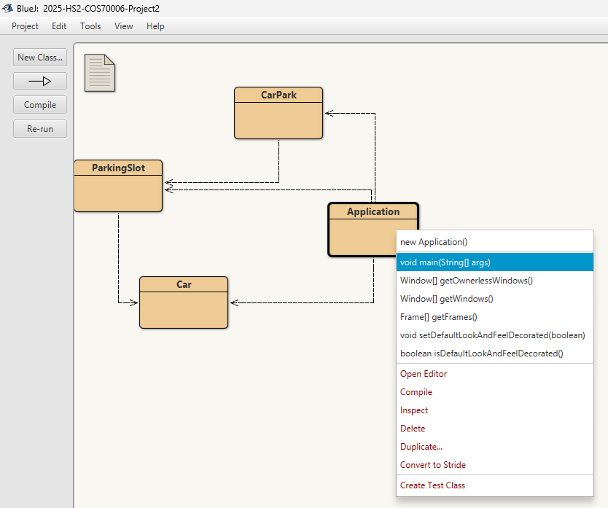

From BlueJ, Run the main function from the Application (no additional argument needed). This will initialize the GUI

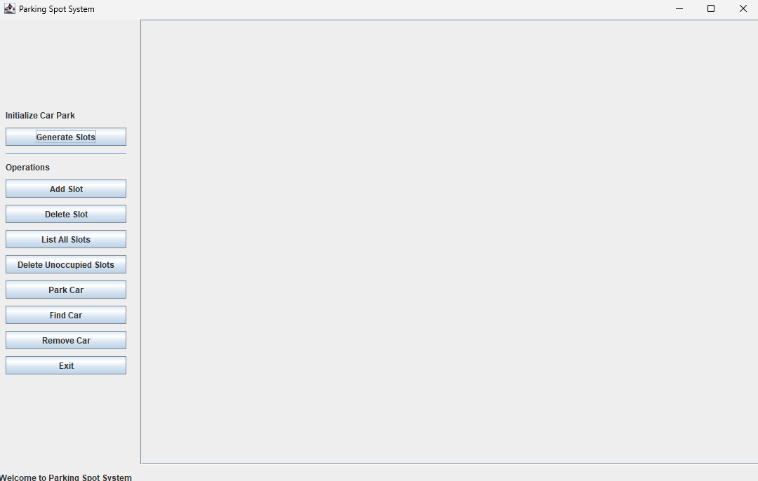

The GUI is split into 3 main sections: The event buttons, the parking slot display, and the notification (status) text (Bottom left)

To make a new parking slot, the user can press “Generate Slots” to generate multiple slots at the same time, or “Add Slot” to generate them one by one.

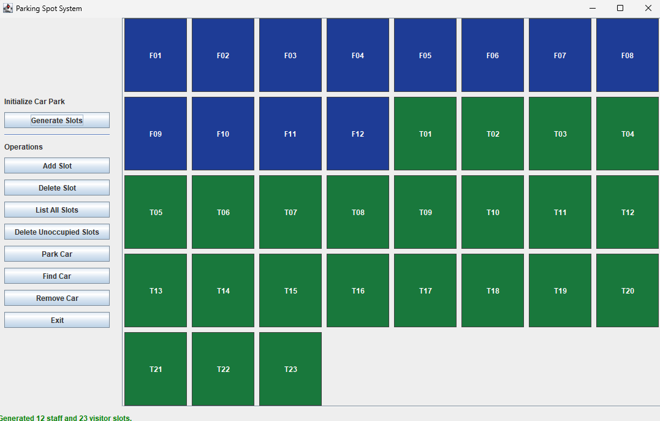

The generated slot are displayed on the right side. With blue as staff, and green as visitor slot.

To park a car, the user can press “Park Car” which will prompt the user to input the car and slot details, or left-click the slot directly to input a car there.

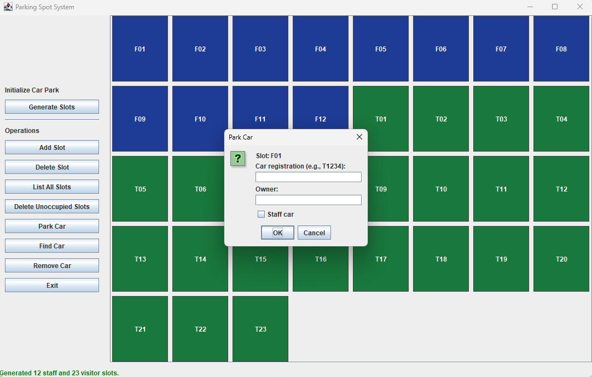

After a car is successfully parked, the slot will display a yellow border indicating that the car is parked

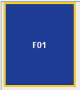

The user can remove a car from a slot by pressing “Remove Car” or left-clicking on an occupied slot

The user can delete a slot by pressing “Delete Slot” or right-clicking on an unoccupied slot (right-clicking on an occupied slot will return a warning)

Unoccupied slots can also be deleted by pressing “Delete Unoccupied Slots”

To check on the information of the slot, the user can:

* Hover over the slot to check the tooltip for the information of each slot

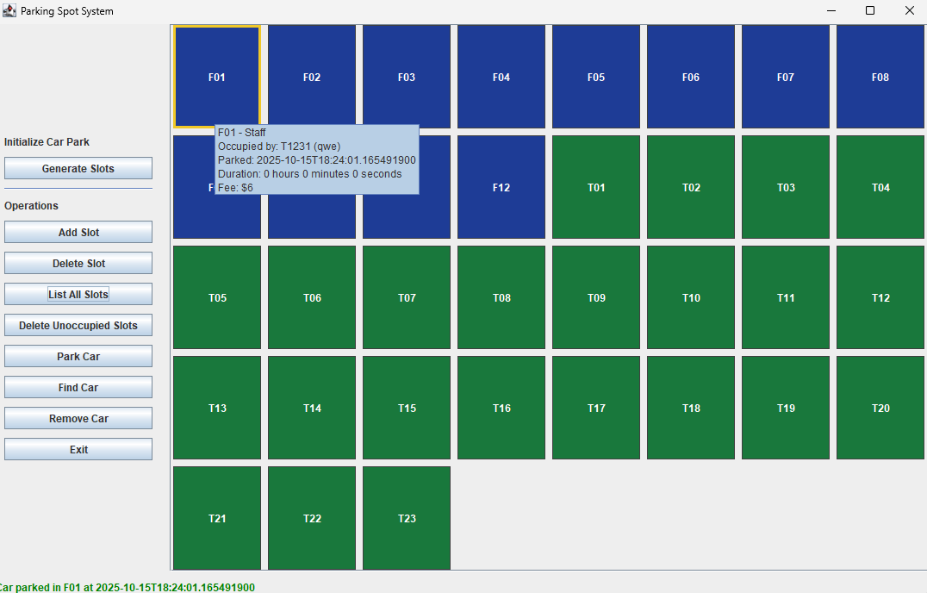

Press “List All Slots” which shows a table with all slots with their information

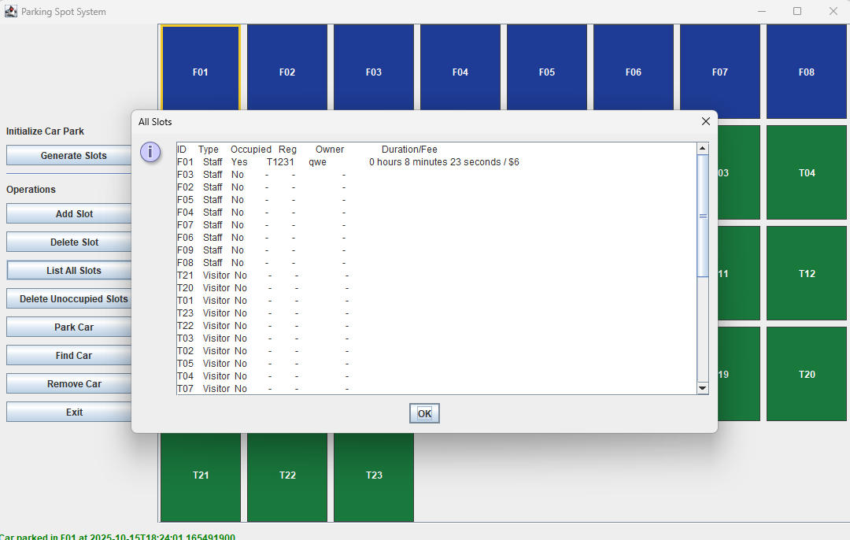

The user can find a car by pressing “Find Car”. This will prompt the user to input the desired car registration number

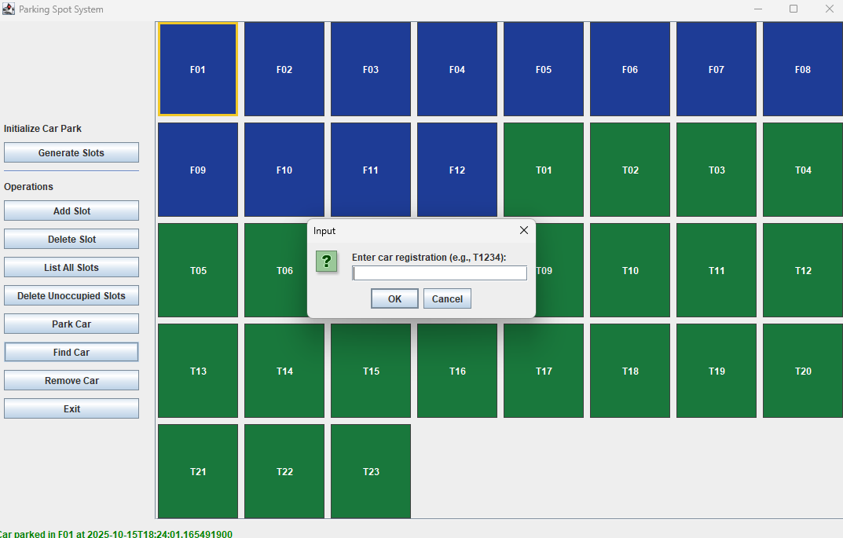

The user can exit the program by pressing “X” on the top right of the program or pressing “Exit”