**Saveetha School of Engineering**

**Saveetha Institute of Medical And Technical Science**

**LAB PROGRAM - 02**

**PROGRAMMING LANGUAGE**

Python

**COURSE CODE / NAME**

CSA0666 - Design And Analysis Of Algorithm For Divide And Conquer Techniques

**SUBMITTED BY**

T Svetha – 192321155

1. **Write a program to find the reverse of a given number using recursive.**

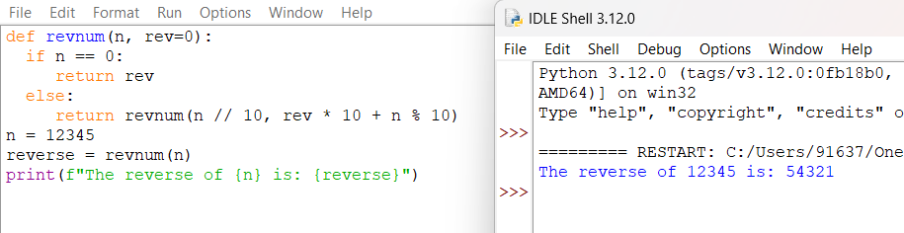

Time complexity: O(n)

1. **Write a program to find the perfect number.**

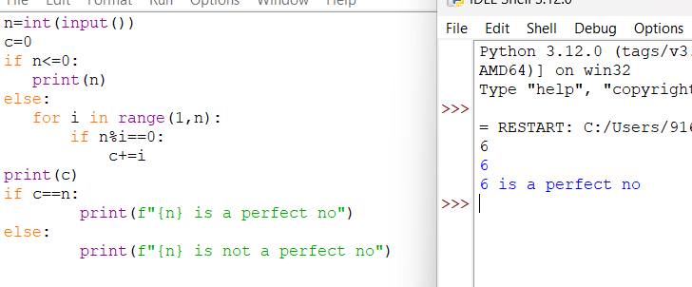

Time complexity: O(n)

1. **Write C program that demonstrates the usage of these notations by analyzing the time complexity of some example algorithms.**

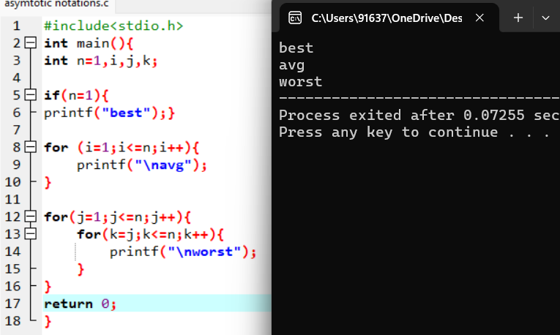

Time complexity: best= O(1)

Avg= O(n)

Worst=O(n^2)

* O(n^2)

1. **Write C programs that demonstrate the mathematical analysis of non-recursive and recursive algorithms.**

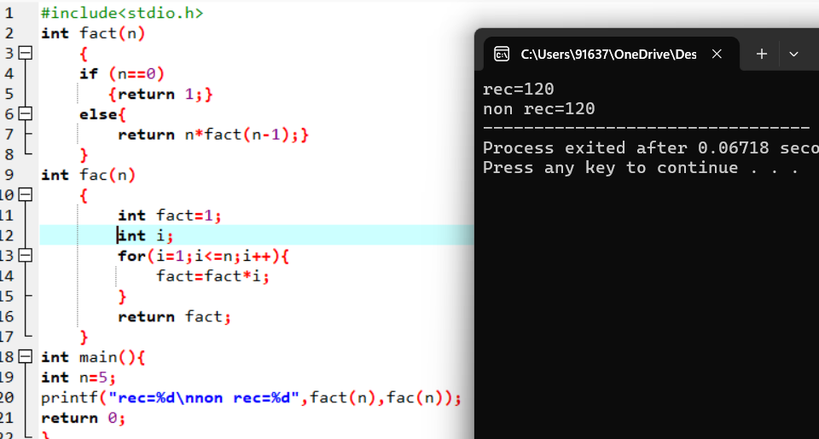

Time complexity: rec= O(n)

Non rec= O(n)

* O(n)

1. **Write C programs for solving recurrence relations using the Master Theorem, Substitution Method, and Iteration Method will demonstrate how to calculate the time complexity of an example recurrence relation using the specified technique.**

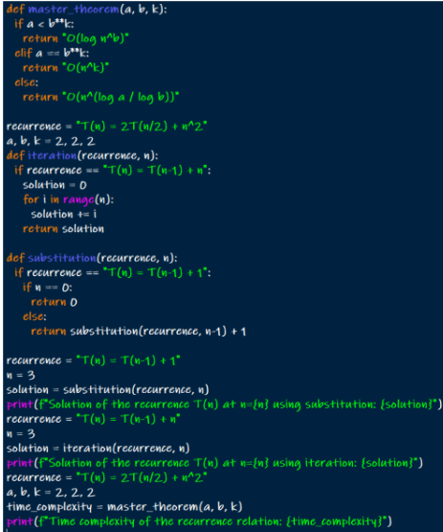

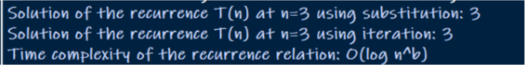

1. **Given two integer arrays nums1 and nums2, return an array of their Intersection. Each element in the result must be unique and you may return the result in any order.**

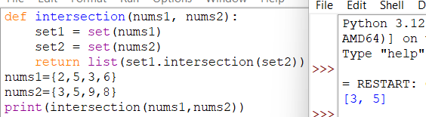

Time complexity: O(n)

1. **Given two integer arrays nums1 and nums2, return an array of their intersection. Each element in the result must appear as many times as it shows in both arrays and you may return the result in any order.**

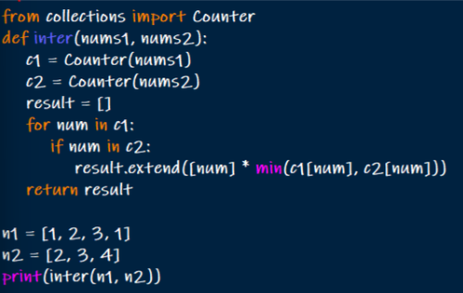

**OUTPUT:** [2,3]

Time complexity: O(n)

1. **Given an array of integers nums, sort the array in ascending order and return it.You must solve the problem without using any built-in functions in (nlog(n)) time complexity and with the smallest space complexity possible.**

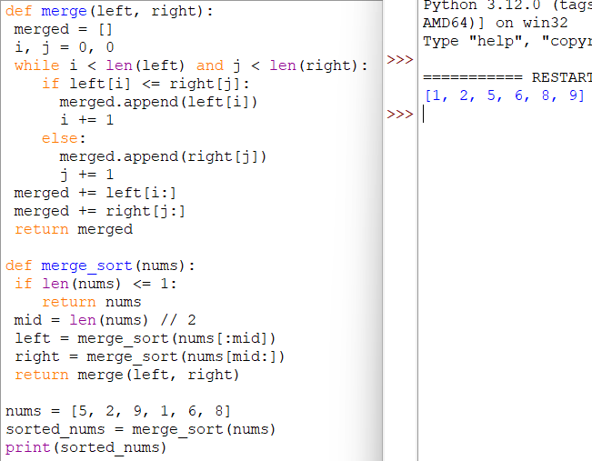

1. **Given an array of integers nums, half of the integers in nums are odd, and the other half are even.**

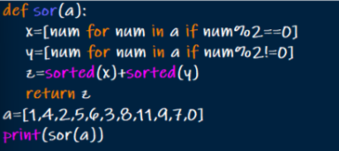

1. **Sort the array so that whenever nums[i] is odd, i is odd, and whenever nums[i] is even, i is even. Return any answer array that satisfies this condition.**

