

CAPSTONE PROJECT REPORT
Report 1 – Project Introduction

– Hanoi, September 2026 –
Table of Contents
Change Log 4
Definition and Acronyms 5
I. Project Overview 5
1. Project Information 5
2. Project Purpose 5
3. Project Stakeholders 6
II. Product Background 6
III. Existing Solutions 8
3.1 Jira (Ticket tracker / issue tracker) 8
Website / Link 8
Target Users 8
Core Features 8
Strengths 8
Weaknesses 9
GAP for this project 10
3.2 Confluence (Knowledge base / wiki) 11
Website / Link 11
Target Users 11
Core Features 11
Strengths 12
Weaknesses 12
GAP for this project 13
3.3 Microsoft 365 — Excel / Word documents on SharePoint 13
Website / Link 13
Target Users 13
Core Features 13
Strengths 14
Weaknesses 14
GAP for this project 15
3.4 ServiceNow (Enterprise ITSM / service-desk platform) 16
Website / Link 17
Target Users 17
What it is, and how big 17
Core Features 19
Strengths 21
Weaknesses 21
Positioning: why T-Solve, given ServiceNow exists 23
GAP for this project 23
3.5 Identified Gaps 23
3.6 Section Summary 24
IV. Proposed Solution 25
V. Project Scope & Limitations 25
1. Major Features 25
2. Limitations & Exclusions 26
VI. References 27

Change Log
Date | A*  M, D | In charge | Change Description
14/09/2026 | A | DuongPT | Created initial document
15/09/2026 | A | BinhDT | Add content for Project Scope & Limitations,Project Overview, Product Background, Proposed Solution, Existing Solutions
17/09/2026 | M | BinhDT | Modify content for Existing Solutions, Proposed Solution, Project Scope & Limitations
20/09/2026 | M | BinhDT | Add examples for Project Overview, Product Background,Existing Solutions
08/10/2026 | M | MinhDN | V.1 FE-02 Role-Based Access Control: changed “five fixed roles (Guest, Staff, Department Manager, Project Manager, Admin)” to four roles (Guest, Staff, Project Manager, Admin). Reason: Report 3 (SRS, 04/10/2026) has no Department Manager role; each user has exactly one fixed role (I.4.1, GBR-16).
08/10/2026 | M | MinhDN | V.1 FE-04 Review & Approval Workflow: replaced the “daily Review Queue” with a real-time Review Queue (one or several tickets at once, reject with reason, request changes, Expired tickets sent back). Reason: the daily processing run (JOB-01) and Cluster review were deleted from Report 3 on 03/10/2026; tickets now enter the queue immediately (BF-02, UC-29, UC-30). FE-05: removed “review ranges” from the Admin and added the assignment of Project Managers to Departments. Reason: the review range is set per Project by its Project Manager (UC-14); the Admin assigns Project Managers to Departments (UC-06).
08/10/2026 | M | MinhDN | V.1 FE-06: renamed “Jira Integration & Project Management” to “Jira Integration” and rewrote it: Project Managers add and link Projects (read-only token) and become their Project Manager, instead of “Department Managers connect Jira projects and assign a Project Manager”. Reason: matches the feature name and UC-14 to UC-16, GBR-25 of Report 3. FE-07: imported tickets are reviewed at import time and Published immediately, without the Review Queue. Reason: import was rewritten in Report 3 on 04/10/2026 (BF-04, UC-20 to UC-22).
08/10/2026 | M | MinhDN | V.1 FE-08: comments are optional and only on the web app; feedback from Jira is helpful / not helpful only. Reason: UC-18 and UC-28 of Report 3. FE-09: Project Managers see the dashboard of their assigned Departments and only the Admin views the audit log. Reason: UC-34, UC-35 and the Permission Matrix of Report 3. FE-01 and IV: fixed “A staff” to “a Staff user” and added search in the Issue Panel (UC-26).
08/10/2026 | M | MinhDN | V.2 LI-01: notifications are email only (rejected, changes requested) and there are no in-app notifications. LI-03: desktop browsers only (1366 × 768 or higher), no phone or tablet support, instead of “a responsive web application covers mobile use cases”. LI-05: the user interface is in English only, instead of “Vietnamese and English”. Reason: Report 3 III.3.1 Scope Boundaries and IV usability rules (screen size, language and formats).
09/10/2026 | M | MinhDN | v25: Corrected page numbering to continue across all sections. The cover page has no visible page number; subsequent section-opening pages display the shared Page / total-pages footer.
*A - Added M - Modified D - Delete

Definition and Acronyms
Acronym | Definition
T-Solve | Ticket Solution Repository Application
AMS | Application Management Services
SLA | Service Level Agreement
HR | Human Resource
IT | Information Technology
ITSM | IT Service Management
KCS | Knowledge-Centered Service
MTTR | Mean Time To Recovery

I. Project Overview

1. Project Information
- English name: Ticket Solution Repository Application
- Vietnamese name: Ứng dụng Lưu trữ Giải pháp Hỗ trợ Xử lý Ticket
- Project code: T-Solve
- Group name: SEP490_G89
- Software type: Web Application

2. Project Purpose
The purpose of the T-Solve (Ticket Solution Repository Application) project is to develop an application for capturing, structuring, and reusing knowledge generated from resolved tickets. The product targets support and internal service teams that handle their requests as tickets in Jira, starting with IT application support; teams such as Human Resources, Finance, and Asset Management are in scope when they also work in Jira. It enables valuable resolution outcomes to be transformed into structured, reviewed solutions with clearly defined applicability, supporting the resolution of similar requests in the future.
The project aims to reduce information retrieval time and repeated investigation, decrease reliance on individual expertise, and preserve organizational knowledge during personnel changes. Linking solutions to source tickets, supporting evidence allows users to assess their relevance before applying them, thereby improving the consistency and reliability of request handling.
T-Solve is positioned as a knowledge management application that complements existing ticket management systems. The project focuses on transforming resolution outcomes into reviewed, published, and reusable knowledge, while the source systems retain responsibility for the ticket lifecycle. The initial release aims to validate this process in a test environment using a prepared set of resolved tickets. Effectiveness is assessed by how often the relevant solution appears among the top five suggestions for a newly worded ticket, compared with keyword-only search, and by testers' feedback.

3. Project Stakeholders
Full Name | Role | Email | Mobile
Tô Thanh Hải | Lecture | haitt14@fe.edu.vn
Đặng Nhật Minh | Leader | ngaidang53@gmail.com | 0966391258
Đặng Tấn Bình | Member | binhdthe176177@fpt.edu.vn | 0333705356
Trần Trung Hiếu | Member | hieugia3030@gmail.com | 0398333162
Trần Hải Anh | Member | tranham442@gmail.com | 0916897138
Phạm Tùng Dương | Member | phamtungduong763@gmail.com | 0978490205

II. Product Background
2.1 Initial Observations
The initial idea for T-Solve originated from the experience of one team member, who worked as an L2 support engineer at a Vietnamese IT services company, handling tickets about internal systems. The people in the examples below are illustrative, not real individuals.
Consider Minh, a support engineer on an Application Management Services (AMS) team that handles its daily work through a ticket-tracking system. At around 10:00 AM, he receives a ticket reporting that a user can no longer access a business function after a role change. The symptom looks familiar: Someone on the team solved a similar case months earlier but he does not remember the ticket number or the exact resolution. He searches the tracker using several keywords, opens multiple closed tickets, reads old comments, checks internal messages, and finally asks a senior colleague whether they remember the case. Although the organization has already solved the problem once, part of the investigation is effectively repeated because the previous resolution is difficult to locate and reuse.
The same pattern can be expected beyond technical teams. Hoa, an HR specialist, receives a question about maternity leave policy that closely resembles a case she remembers handling for a different employee months ago, but the original answer lives only in a closed HR ticket she cannot easily locate. Tuan, a Finance analyst, is asked to review an invoice exception and suspects a colleague resolved something similar in a prior quarter, yet has no quick way to confirm the earlier reasoning or the policy it relied on. In each case, the underlying task is not to solve a new problem, but to rediscover a solution the organization already has.
2.2 The Cost of Poor Knowledge Reusability
These examples illustrate a broader problem that industry surveys have measured. Atlassian's State of Teams 2025 report (approx. 12,000 knowledge workers, 200 executives) found teams spend about 25% of their working time searching for answers, and 56% say the only way to get needed information is to ask someone directly or schedule a meeting; the same report found about 50% workers say teams in their organization unknowingly duplicate each other's work [1]. According to Atlassian State of Developer Experience 2025 [2], 50% of developers reported losing 10 or more hours per week to non-coding tasks from poor information access, fragmented tools, and context switching.
The risk compounds when experienced employees change roles or leave: Panopto's workplace knowledge research found colleagues retain only about 58% of a departing employee's knowledge, leaving roughly 42% at risk of loss [3]. That knowledge may technically remain in old tickets, but if no one can find or validate it, the effect is much the same as losing it.
2.3 Why the Timing Is Right
Ticket-based work is not confined to IT, but IT remains the domain where its scale is best documented. The Freshservice Benchmark Report 2025 analyzed more than 187 million tickets from 10,743 organizations across 118 countries, illustrating how large and continuous ticket-driven workloads already are within IT support alone [4].
This same practice, however, is no longer limited to IT. According to HDI's State of Service Management Report, 45% of organizations already apply IT service management principles and practices outside the IT department; among organizations sharing these practices, adoption reaches 35–37% in Finance, 32–35% in HR, and 29-37% in Facilities [5]. Reinforcing this trend, the Freshservice Benchmark Report 2025 introduced dedicated Enterprise Service Management metrics for the first time in its five-year benchmarking history, specifically covering non-IT functions such as HR, Finance, and Facilities [4]. Together, these findings show that ticket-based service management is becoming a cross-departmental practice, not an IT-specific one and as more departments generate their own growing volumes of historical tickets, relying on personal memory, informal communication, and manual searching becomes increasingly difficult to sustain across the organization.
2.4 Conclusion
These conditions create the business need for T-Solve. Existing ticket-tracking systems remain responsible for managing ticket status, assignment, SLA (Service Level Agreement), escalation, and operational workflow. T-Solve addresses a different problem: ensuring that useful knowledge generated when tickets are resolved does not become buried in historical records, but remains discoverable, trustworthy, and reusable when similar cases occur in the future. This is consistent with the current project scope, in which T-Solve acts as a knowledge layer for resolved tickets rather than managing the lifecycle of source tickets.

III. Existing Solutions

3.1 Jira (Ticket tracker / issue tracker)
Jira, developed by Atlassian, is one of the most widely used issue- and project-tracking tools in the software industry. Teams use it to log incidents and service requests, assign them to staff, and move them through configurable workflows from creation to closure. It performs this role extremely well, but its unit of work is the ticket, not a reusable solution, which makes Jira the natural source of the resolved tickets T-Solve draws on rather than a place where knowledge is reviewed and reused.

Website / Link
https://www.atlassian.com/software/jira

Target Users
- Software development and IT/support teams of all sizes.
- In an AMS context: support agents and developers who resolve tickets, and team leads / project managers who track the ticket lifecycle.

Core Features
Jira organises everything around the ticket and its workflow:
- Ticket (issue) management: the day-to-day handling of a work item.
  - Create, edit, transition status, and comment on tickets.
  - Assign tickets to individuals, teams, and projects.
  - Configure workflows, statuses, priorities, labels, and SLAs.
- Planning & tracking: organising work over time.
  - Scrum and Kanban boards, sprints, and backlogs.
  - Roadmaps, dashboards, and built-in reports.
- Search & retrieval: finding existing tickets.
  - Keyword search and structured queries via JQL (Jira Query Language).
  - Saved and shareable filters.
- Automation & extensibility: connecting Jira to the wider toolchain.
  - Alerts, notifications, and automation rules.
  - A REST API and a large Marketplace of apps and integrations.

Strengths
- Market-leading adoption and brand recognition. Jira is the standard, so the knowledge it holds is worth unlocking.
  - Ranked #1 in project management with ~21% market share and ~101,770 companies, ahead of its nearest competitor (Datanyze).
  - Consequence: most teams already run Jira.
- Mature ticket lifecycle and audit trail. Robust assignment, status, SLA, and full change history.
- Broad, open integration ecosystem. A large Marketplace and open REST API make it straightforward to connect Jira to other systems, including a knowledge layer such as T-Solve.

Weaknesses
Although Jira is excellent at tracking work, it is not designed to turn a resolution into reusable knowledge:
- Knowledge stays buried in the ticket. The fix goes where the work went, not where it can be found again.
  - The resolution is written into comments or a resolution field, tied to one closed ticket.
- No knowledge of governance. A resolution is never treated as a reusable asset.
  - No review or approval of a resolution.
- Retrieval is shallow for reuse. Finding a past fix depends on memory.
  - Search is keyword/JQL only — no semantic search.
  - Nothing suggests a past fix when a new ticket is created.
- Overall consequence: because past resolutions are hard to find and trust, recurring issues are re-investigated and re-escalated even when they were solved before.
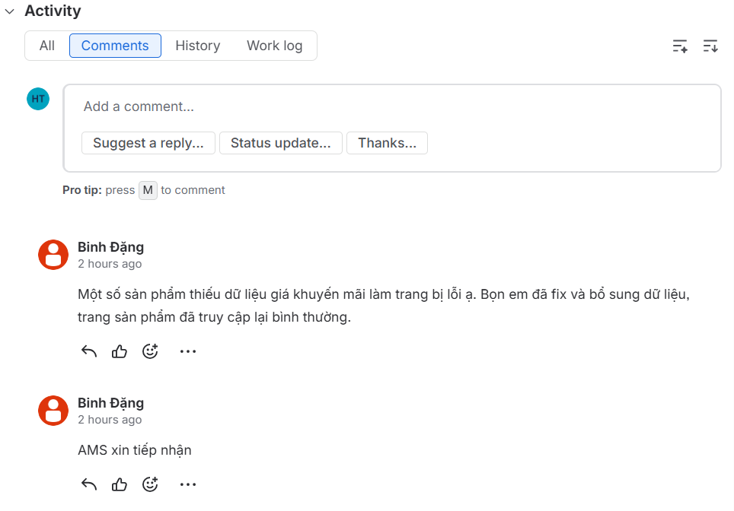
Figure 1. Comments as solution in free-text form in a Jira ticket (demo site created by the team)
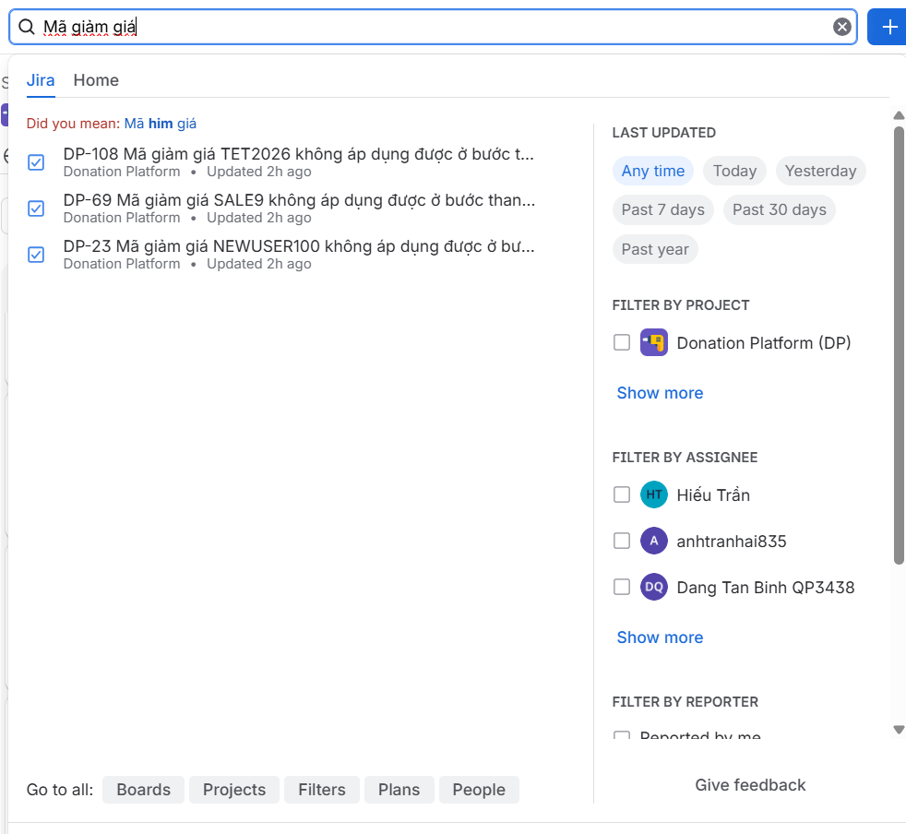
Figure 2. Search for tickets with keywords, not solutions (demo site created by the team)

GAP for this project

- GAP-01: Search is keyword-only, with no semantic retrieval
- Example: Typing “error” in the Jira search box (Figure 4) returns a list of tickets filtered by keyword: Error in Payment Processing, UI Error on Dashboard Loading, API Error When Submitting Form, Login Issues.
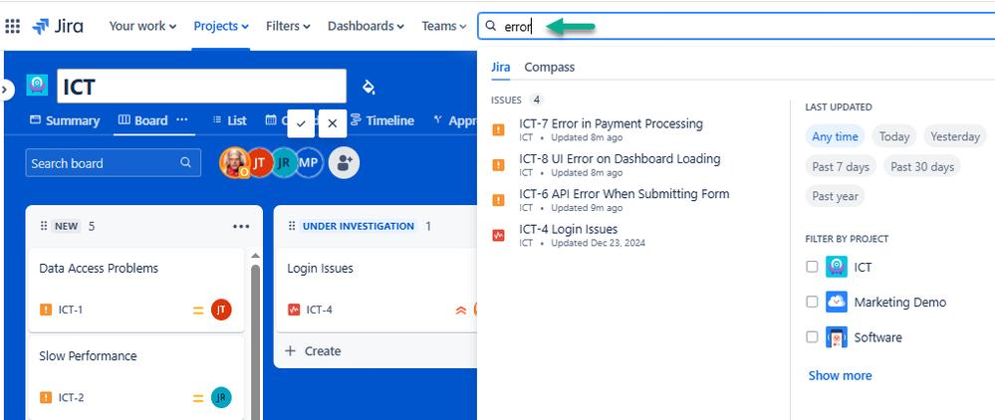
Figure 4. Jira quick search for “error” returns tickets matched by keyword, not solutions
- GAP-02: Nothing suggests a past fix when a new ticket is created, so recurring issues are re-investigated and re-escalated.
- Example: When a new ticket is created, Jira suggests nothing: the handler has to think of the right keyword and search by hand.

3.2 Confluence (Knowledge base / wiki)
Confluence, also by Atlassian, is a team wiki and content-collaboration workspace in which teams write pages, runbooks, how-to guides, troubleshooting notes organised into "spaces." It is the tool teams most commonly reach for when they decide to "write the knowledge down," and it integrates tightly with Jira. It is genuinely useful for documentation, but it stores static pages, not structured solutions linked to the tickets and outcomes they came from.

Website / Link
https://www.atlassian.com/software/confluence

Target Users
- Teams that need to document and share knowledge in one place.
- Page authors, readers, and space administrators.

Core Features
Confluence is built around the page and the space:
- Content authoring: creating and organising documentation.
  - Rich-text pages with templates, tables, and attachments.
  - Pages grouped into spaces with a page tree/hierarchy.
  - Page version history and inline comments.
- Collaboration: working on content together.
  - Real-time co-editing, mentions, and notifications.
  - Manual linking between a page and related Jira issues.
- Search & permissions: finding and protecting content.
  - Keyword search, plus AI-assisted search (Atlassian Rovo) on paid tiers.
  - Space- and page-level permissions.
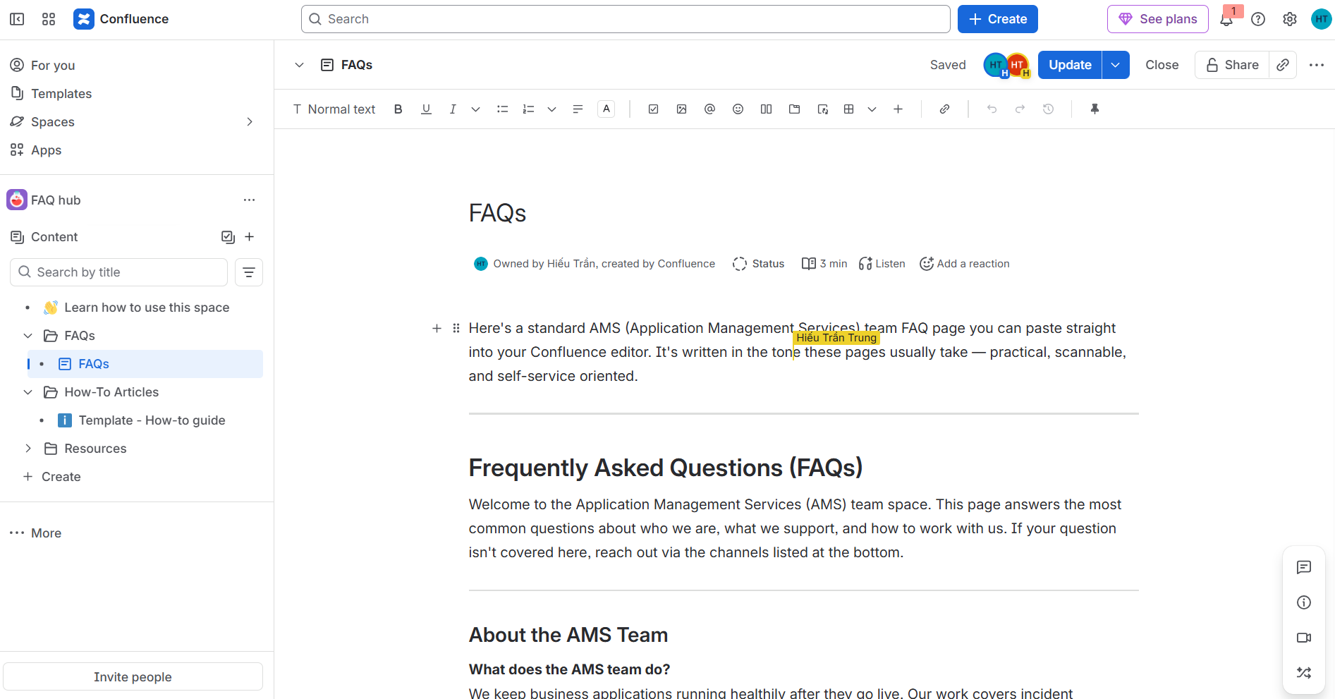
Figure 5. A document on Confluence with realtime collaboration (demo site created by the team)

Strengths
- A proper, widely adopted home for documentation. It is the default companion to Jira, so teams already use it.
  - Reported adoption ranges from 40,000+ to over 100,000 organisations worldwide (2024), and a single Cloud site can support up to 150,000 users (ElectroIQ, 2025).
  - Consequence: many teams already store knowledge here — so the shortfall below is felt widely.
- Preserves history and supports natural-language search. Page version history is built in, and higher tiers add AI-assisted (Rovo) search.
- Integrates with Jira. A page can be manually linked to related issues.

Weaknesses
Although Confluence is good at storing documents, it is not designed to turn a resolution into governed, reusable knowledge:
- Static pages, disconnected from tickets and outcomes. The knowledge floats free of the work that produced it.
  - A page is free-form prose; a template can suggest a structure (symptom / cause / steps / applicability scope) but cannot enforce it.
  - No record of which ticket it resolved or whether applying it actually worked.
- No native review or currency control. Correctness depends on whoever wrote the page.
  - According to Atlassian’s documentation [6], Confluence’s native page approvals are available only on the Premium and Enterprise plans, apply to pages only (not live docs or blog posts), and are enforced only when a space admin requires approval before publishing. On Free and Standard plans, or in spaces where this setting is off, pages can still be published without any review.
  - Pages are authored manually and drift out of date, with nothing prompting revalidation.
- Retrieval is not targeted to the moment of need. Search returns documents, not a vetted answer.
  - Knowledge appears only when someone searches for it; nothing is suggested when a new ticket is raised.
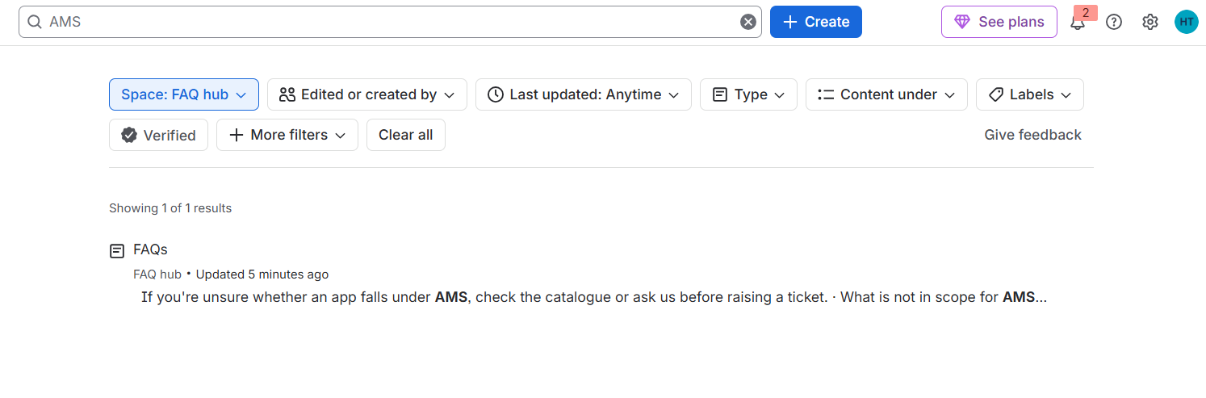
Figure 6. Search documents with keywords only (demo site created by the team)

GAP for this project
- GAP-02 — Knowledge is found only when someone searches for it: no past solution is suggested when a new ticket is raised, and pages are disconnected from the tickets they came from.
  - Example: In Figure 6, the “FAQs” page appears only because someone searched for “AMS”. The result carries no link to the ticket it resolved and no sign that its advice worked.

3.3 Microsoft 365 — Excel / Word documents on SharePoint
Many teams have no dedicated knowledge tool and instead record fixes in Microsoft Excel spreadsheets and Word documents kept in a SharePoint document library (or OneDrive/Teams). This "office files on a shared drive" combination is the baseline: already paid for through existing Microsoft 365 licensing, familiar to everyone, and requiring no new system. It is where operational knowledge most often actually lives today, and precisely why it stays buried.

Website / Link
https://www.microsoft.com/en-us/microsoft-365/sharepoint/collaboration

Target Users
- Teams without a dedicated ITSM or knowledge-base tool.
- Effectively any organisation with Microsoft 365; staff informally recording and looking up fixes.

Core Features
The baseline is a stack of general-purpose office tools:
- Capture: writing things down.
  - Free-form Excel spreadsheets (issue logs, "known fixes" sheets) and Word documents.
  - Real-time co-authoring.
- Storage: keeping the files somewhere shared.
  - SharePoint document libraries with folders and full-text search.
  - Per-file version history.
- Access & integration: sharing and connecting.
  - Site/library/file-level permissions.
  - Integration with Teams and Outlook.
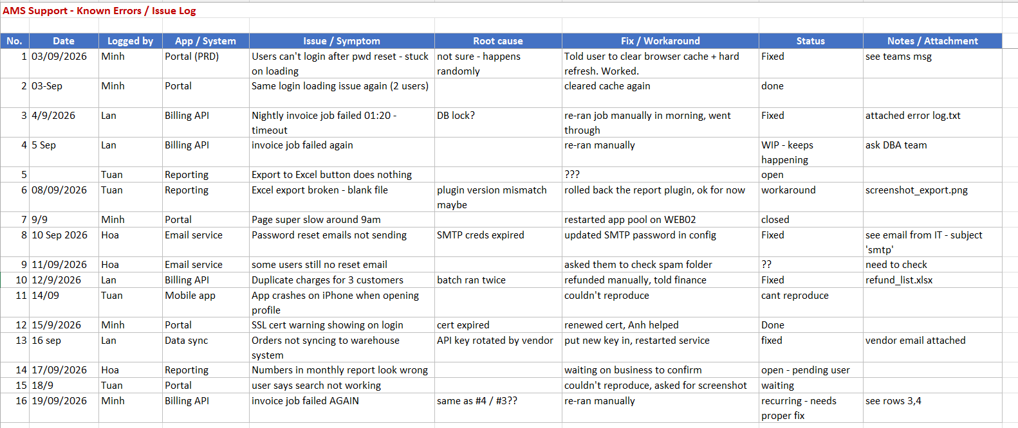
Figure 8. Illustrative issue log prepared by the team: solutions are saved with no form or structure

Strengths
- Zero extra cost and universal familiarity. Nothing to buy, nobody to train.
  - Microsoft 365 has ~345 million paid seats and roughly a 30% share of the office-software market (2024) (ElectroIQ, 2025) — the tools are effectively everywhere.
  - Consequence: it is the path of least resistance, which is exactly why teams default to it.
- Highly flexible and already in place. A spreadsheet can be shaped into any log within minutes; SharePoint gives central storage, basic search, and file version history.

Weaknesses
Although convenient, the baseline offers no structure and no governance, and it degrades as volume grows:
- No structured, connected solution model. Knowledge is scattered and context-free.
  - Fixes are spread across many files, sheets, and cells — no template, no schema.
  - No link to the originating ticket and no record of whether a fix actually worked.
- No review, and fragile versioning. Correctness and integrity are not protected.
  - No review/approval workflow; content quality is unmanaged and drifts stale.
  - Manual file handling and concurrent edits invite accidental overwrites and duplicate, inconsistent copies. Independent studies find a high error rate in real-world spreadsheets — one 2024 analysis reported that ~94% of business spreadsheets contained critical errors (phys.org, 2024).
- No retrieval or targeted delivery. Finding the right fix relies on memory.
  - No semantic retrieval and no suggestion of a past fix when a similar ticket arrives — finding one depends on typing the same wording that was used when it was logged.
- Coarse access and no accountability. Governance is file-level at best.
  - Permissions are whole-file (a file is shared or not) — sensitive steps inside a record cannot be scoped to a role.
  - No meaningful audit trail and no reuse metrics.
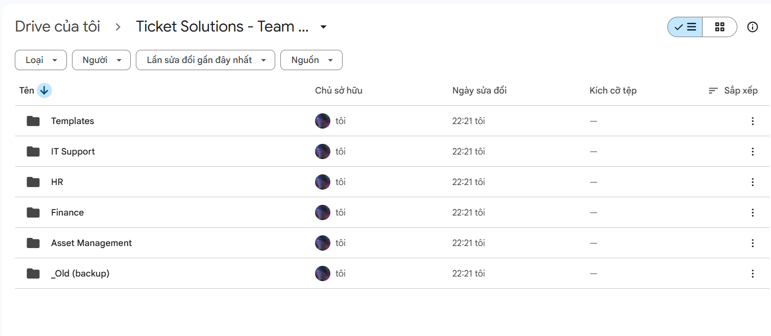
Figure 9. Illustrative shared drive prepared by the team, divided by folders (Google Drive shown)

GAP for this project
- GAP-01: Absence of semantic retrieval; search matches only the exact text that is typed.
  - Example: A new ticket reports “users not receiving the password link”. Searching the sheet for “not receiving” with Find (Figure 10) returns nothing, although row 8 of Figure 8 (“Password reset emails not sending”) holds the fix.
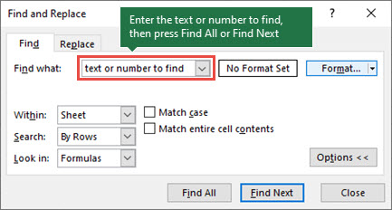
Figure 10. Excel’s Find dialog matches only the literal text typed in “Find what” (Source: Microsoft Support)
- GAP-02: No suggestion of past fixes when a new ticket arrives, and no traceability from tickets to solutions.
  - Example: When the invoice job failed again (row 16 of Figure 8), the sheet did not point the handler to the earlier fixes in rows 3 and 4. The handler had to remember them (“see rows 3,4”). No row records which ticket it came from.
- GAP-03: Knowledge is scattered across ad-hoc files, sheets, and cells, not captured as structured, reusable solutions.
  - Example: In the illustrative issue log (Figure 8), the same invoice-job failure is logged three times (rows 3, 4 and 16), root causes are blank or guesses (“DB lock?”), and fixes are one-line notes (“re-ran manually”). None of these rows can be reused as a solution.
- GAP-04: Absence of a review and approval workflow; concurrent editing and manual file handling create risks of accidental overwrites and out-of-date copies.
  - Example: In Figure 8, rows 2 and 7 are marked “done” and “closed” with no root cause, and the sheet has no column that shows who checked the fix. Four people also edit the same file, so one person can overwrite another person’s row, and a downloaded copy soon becomes out of date.
- GAP-05: Permissions are basic (whole-file only, no role-based access).
  - Example: Every person who logs rows in Figure 8 can also change any other row’s status to “Fixed”. The Share dialog (Figure 12) grants rights for the whole file at once, so there is no way to let handlers add fixes while only reviewers approve them.
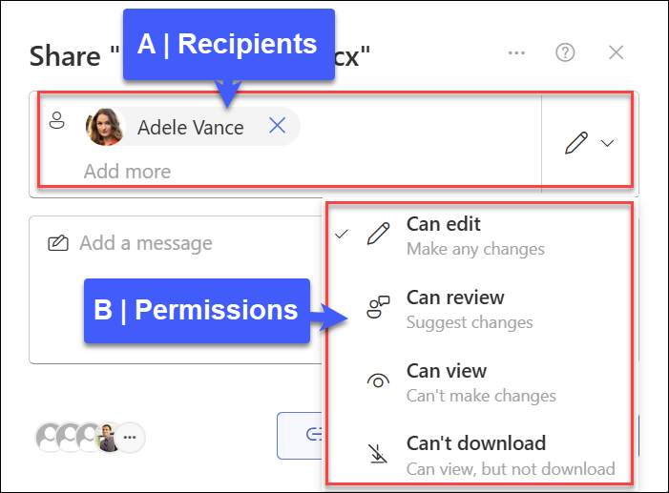
Figure 12. SharePoint sharing sets permissions per file and per person, not per role (Source: Microsoft Support)

3.4 ServiceNow (Enterprise ITSM / service-desk platform)
ServiceNow is the closest existing product to T-Solve's intent. It genuinely delivers a reviewed, ticket-linked knowledge loop. It is also the least familiar of the four to a Vietnamese audience, because it is an enterprise platform rarely adopted by small and mid-sized local teams. So this section first explains what ServiceNow is and how large it is, then shows that its knowledge capability, while real, comes bundled inside a platform whose cost and staffing requirements put it out of reach for T-Solve's target users.

Website / Link
https://www.servicenow.com

Target Users
- Large enterprises and government bodies: IT, HR, customer-service, and operations departments running at scale.
- In practice its customer base is the Fortune 500 and similar; it is uncommon among small/mid-sized organisations and rare among Vietnamese SMEs.

What it is, and how big
ServiceNow is not a single tool but a large enterprise workflow platform. ServiceNow is organised into three workflow families:
- Technology workflows: ITSM, IT Operations, IT Asset Management, Security Operations.
- Customer & employee workflows: HR Service Delivery, Customer Service, Field Service, Legal.
- Creator workflows: a low-code App Engine and automation tools.
Its scale:
- Revenue ~US$13.3 billion in 2025 (US$10.98 billion in 2024) and ~29,000 employees (Cyntexa, ServiceNow Statistics 2026).
- ~8,800 customers, including ~85% of the Fortune 500, with 2,100+ customers paying over US$1M/year (Cyntexa).
- A Gartner Magic Quadrant Leader for ITSM for nine consecutive years (ServiceNow / Gartner) and the market-share leader in IT help-desk software (~50%, Enlyft).
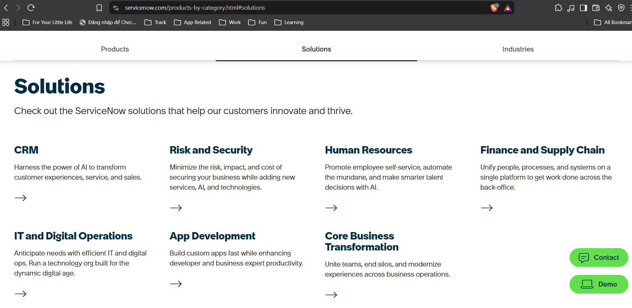
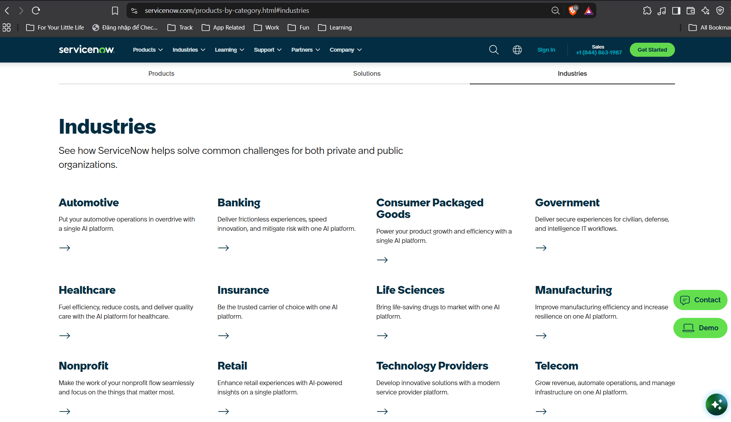
Figure 13. Products of ServiceNow span across industries and departments

Core Features
Within that platform, the parts relevant to T-Solve are genuinely capable:
Service management (the ticket side): Incident, request, and problem management with configurable workflows, handled by agents in a dedicated workspace.
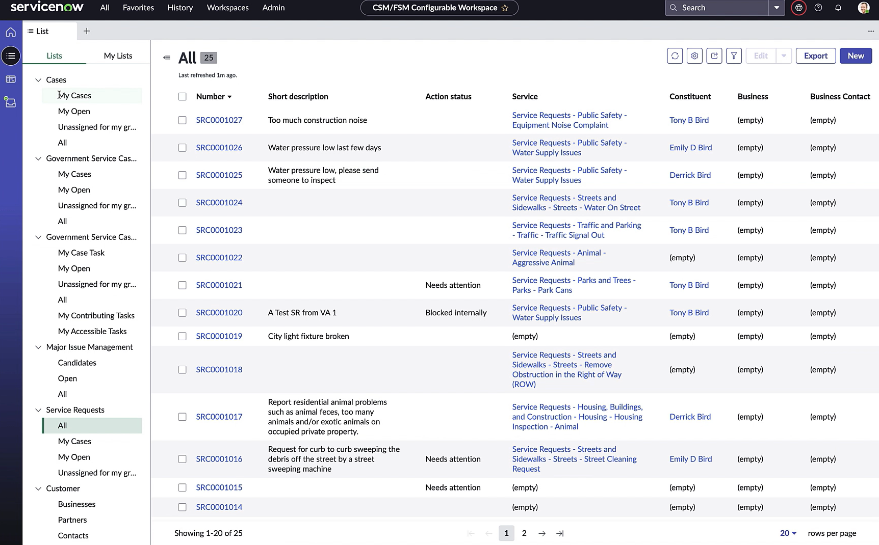
Figure 14. Issues list with status, category, description and assignee
Knowledge management (KCS). Structured knowledge articles linked to tickets, featuring an article lifecycle spanning draft, review, published, and retired states, alongside routine review processes and scheduled publishing.
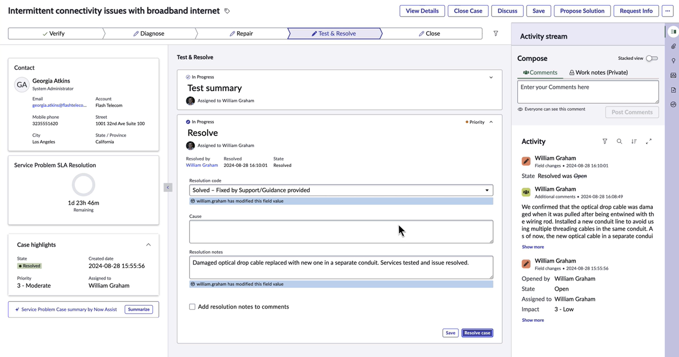
Figure 15. Solutions are saved and linked to each ticket
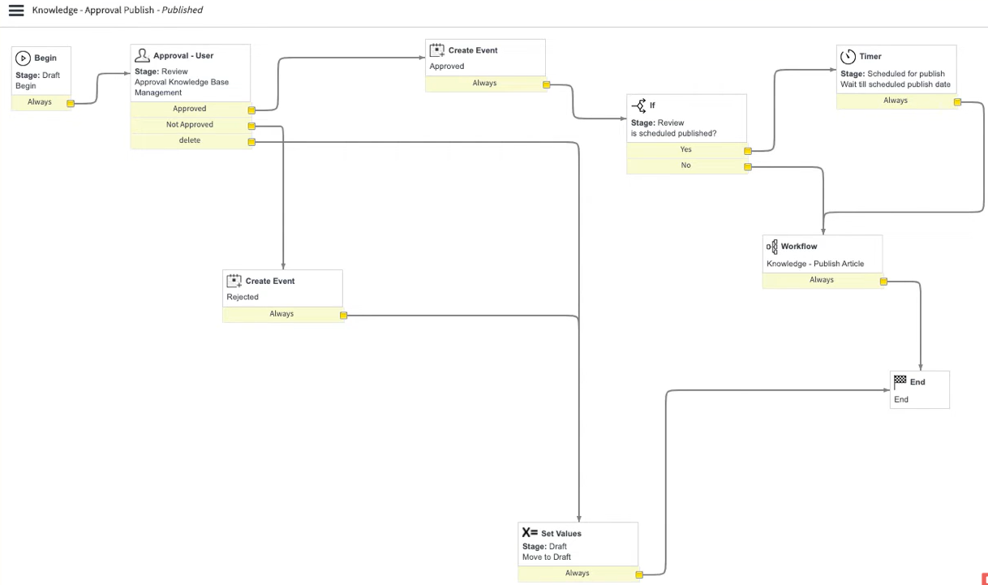
Figure 16. State transition of knowledge/solution is called a workflow. This is Publish workflow
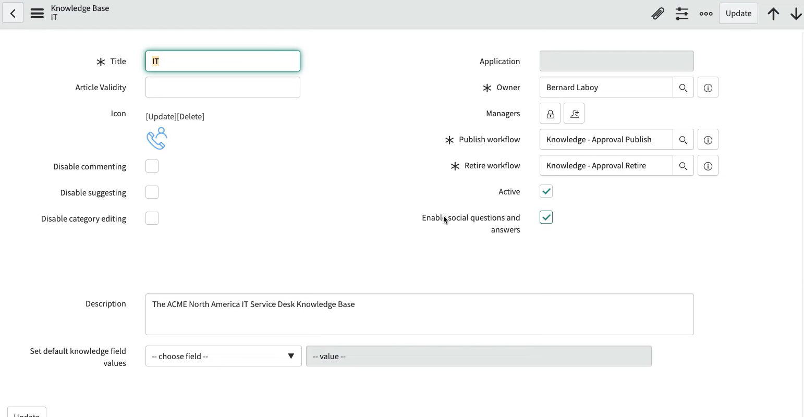
Figure 17. Users can run Publish/Retire by activating a workflow

AI-assisted knowledge. AI Search (semantic), Now Assist article summaries, GenAI article creation from past cases, and automatic knowledge-gap detection (vSoft Consulting).
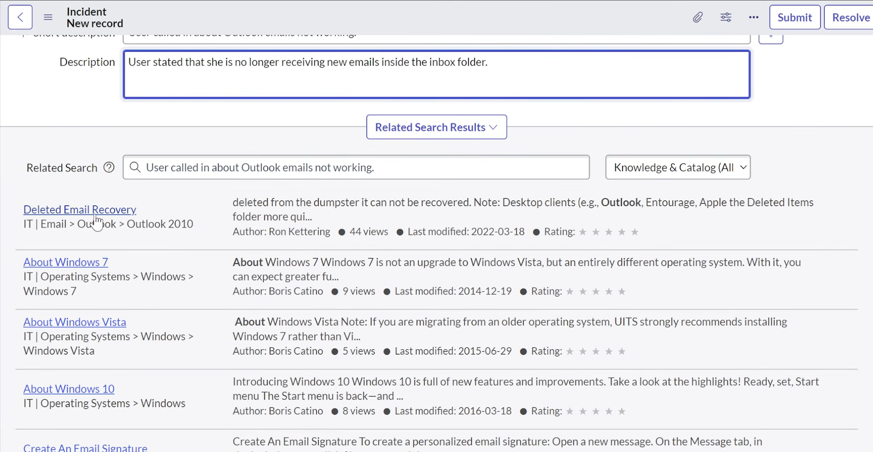
Figure 18. On ticket creation, AssistNow show list of related tickets by semantics, not keywords

Strengths
- It proves the demand is real. A nine-year Gartner ITSM leader used by most of the Fortune 500 shows that reviewed, reusable, ticket-linked knowledge is a genuine enterprise need — not a niche idea.
- Deep, mature capability. Full article lifecycle, versioning, AI search, feedback, and analytics, hardened at enterprise scale.
- One integrated ecosystem. For an organisation that also wants enterprise ITSM, HR, and customer-service workflows, having knowledge inside the same platform is convenient.

Weaknesses
For T-Solve's target teams, the problem is not capability but cost, staffing, and weight:
- Expensive, with no transparent pricing. ServiceNow publishes no public prices — everything is a custom enterprise quote (eesel AI, ServiceNow pricing). Third-party estimates (not official ServiceNow figures) indicate the scale:
  - ITSM agent ("fulfiller") licences around US$70–200 per user per month.
  - Initial implementation of US$30,000–150,000+, typically via a certified partner.
  - A dedicated administrator costing US$100,000–120,000+ per year, plus 5–10% annual price escalators.
- A real staffing and training burden. ServiceNow is a platform you must be certified to run, not an app you simply use.
  - The admin role of Service Now expects a Certified System Administrator (CSA), a paid exam (~US$300).
  - The CSA is only the entry point; deeper work needs further certifications (CIS-ITSM for the ITSM module, CAD for developers), so a team typically needs certified admins and developers, or an external partner.
- Heavy and complex to adopt. Because ITSM is one module of a vast suite, a team adopting ServiceNow takes on far more platform than a knowledge tool requires, and it becomes the team's ticket system and source of truth.
- No standalone knowledge product. ServiceNow states that its Knowledge Center is available only with Customer Service Management, IT Service Management or HR Service Delivery [7], and its ITSM packages (Foundation, Advanced, Prime) are sold only by custom quote [8]. A team that already runs Jira and only needs a knowledge base must still license a full ITSM package (incident, request, asset/CMDB and more) for every agent, paying for ticket-management features it will not use.
- Integration exists, but does not remove the weight. ServiceNow can connect to Jira, through its native IntegrationHub "Jira Spoke" but in order to use “Jira Spoke” customers need to buy other unnecessary modules. This also requires a Jira license which adds more to the integration cost.
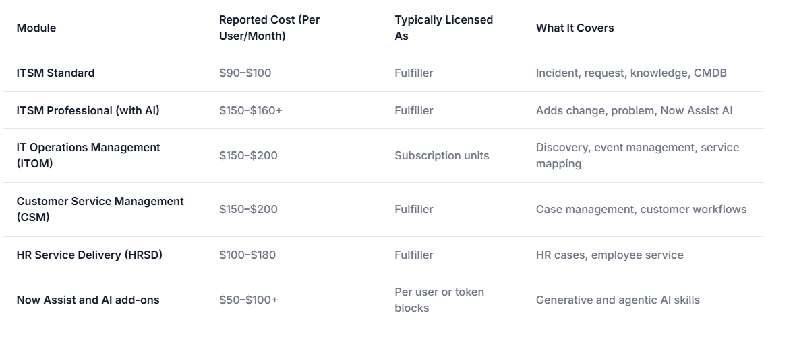

Figure 19. Reported ServiceNow module prices (third-party estimates, not official ServiceNow pricing)

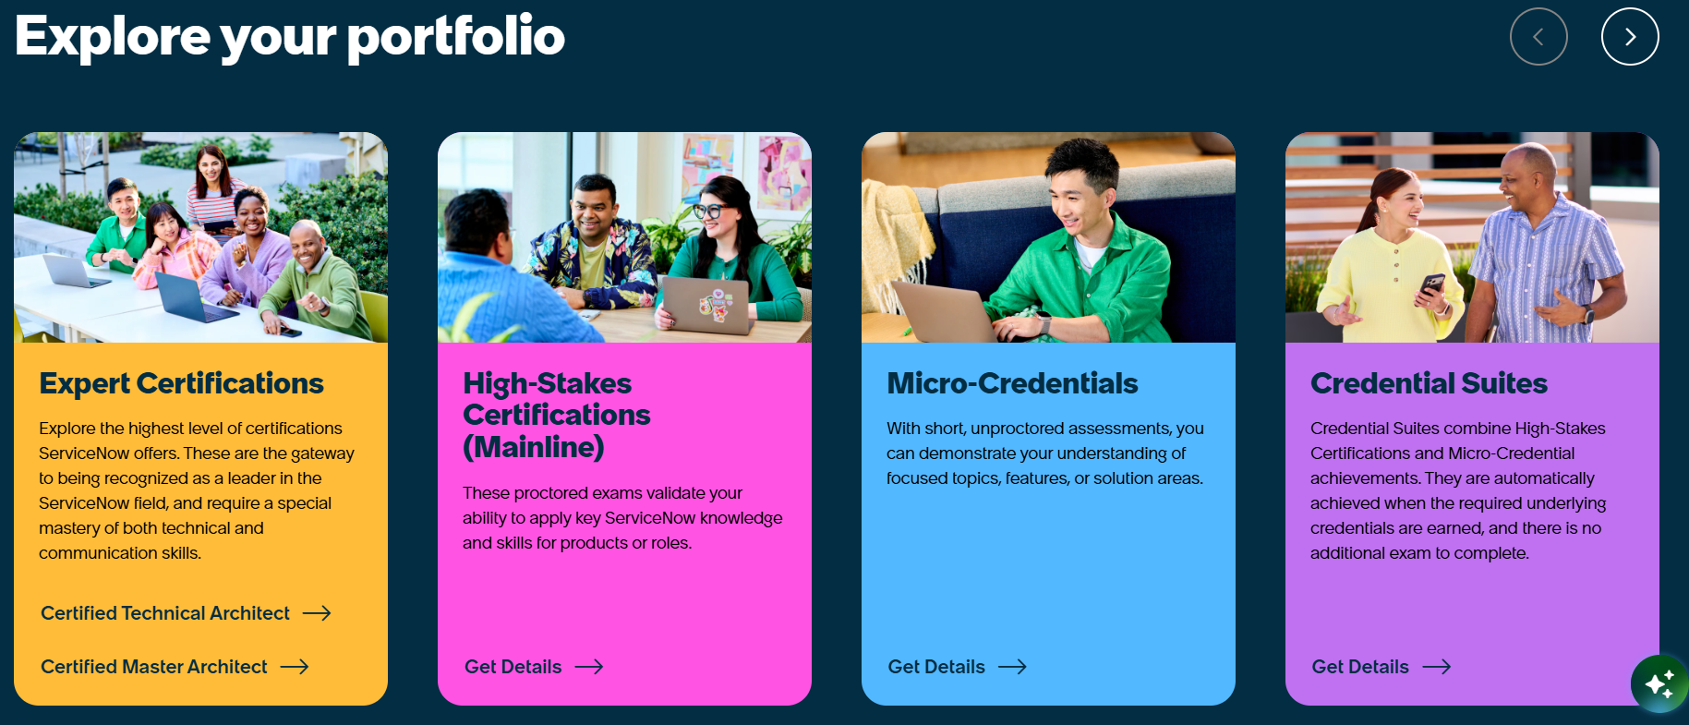
Figure 20. Certifications required for operations

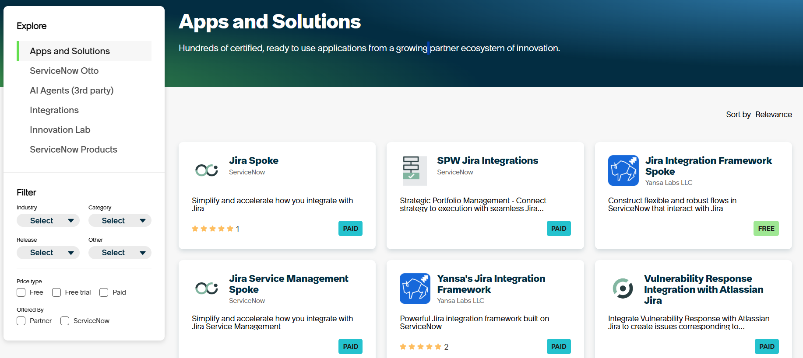
Figure 21. Applications and extensions can be used for Jira connector

Positioning: why T-Solve, given ServiceNow exists
ServiceNow is the enterprise-grade way to get a reviewed knowledge loop, and for a Fortune 500 company already standardising on it, that is the right answer. But for the teams T-Solve targets, small and mid-sized operational and service teams, especially in Vietnam, the entry cost, the opaque enterprise contracts, the need for certified administrators and developers, and the weight of adopting an entire platform make it too large for the actual need: reusing the knowledge from resolved tickets. ServiceNow therefore fits organisations that want it to run their entire ticket-management flow. For a team that keeps Jira and only wants a knowledge add-on, no such option exists: the connectors can sync tickets, but only by licensing and running ServiceNow ITSM alongside Jira. T-Solve is a lightweight layer that works alongside the Jira a team already has, with no enterprise licence, no certified-staff requirement, and no platform migration.

GAP for this project
- GAP-06: ServiceNow closes GAP-01 through GAP-05, but only by adopting a heavyweight, enterprise-scale platform: opaque enterprise pricing (with six-figure implementations and dedicated certified staff) and the weight of a full ITSM suite that becomes the team's ticket system. That cost and complexity are disproportionate for a small or mid-sized team.

3.5 Identified Gaps
The analysis above surfaces six gaps that no existing solution closes on its own. They are declared here with stable IDs so that the Proposed Solution and Major Features sections can reference them directly.
Gap ID | Gap description | Left open by
GAP-01 | Search is keyword-based without semantic ranking, so a past fix that is written in different words is not found. | Jira, Excel/Word + SharePoint
GAP-02 | Past fixes are not suggested when a new ticket is raised, so recurring issues are re-investigated and re-escalated. | Jira, Confluence, Excel/Word + SharePoint
GAP-03 | Where a structure for solutions exists, it is optional and not enforced, so operational knowledge ends up as free-form text, not as structured, reusable solutions. | Excel/Word + SharePoint
GAP-04 | No review/approval workflow, currency control, so content is unvetted and drifts out of date. | Excel/Word + SharePoint
GAP-05 | No role-based access — permissions are whole-file, so who may view, edit or approve a fix cannot be controlled by role. | Excel/Word + SharePoint
GAP-06 | No lightweight option that adds this to the tracker a team already uses — the only tool that closes GAP-01–GAP-05 (ServiceNow) does so solely as a heavyweight, all-in-one platform. | ServiceNow

3.6 Section Summary
Across the four solutions, two patterns emerge. The tools already present in every organisation: Jira for tickets, Confluence for wikis, and above all the Excel/Word + SharePoint baseline where most operational knowledge actually lives, provide storage and lifecycle, but leave that knowledge unstructured, hard to retrieve, unreviewed, and (for the file-based baseline) ungoverned (GAP-01 to GAP-05). At the other end, ServiceNow does deliver structured, reviewed, ticket-linked knowledge and closes those five gaps, but only inside a heavyweight, enterprise-scale platform that a team must adopt wholesale and that becomes its ticket system (GAP-06).
The result is a clear opening. Among the tools reviewed, none offers a lightweight, access-controlled knowledge-reuse loop, one that turns resolved tickets into reviewed, retrievable solutions, links them to their source tickets, suggests the right solution to the handler, within their own Department, before re-investigation, and runs alongside the ticket tracker a team already uses (Jira in this release). That is precisely the gap T-Solve is designed to fill.

IV. Proposed Solution
T-Solve is a knowledge application that works alongside Jira and does not replace it. Jira continues to manage tickets, while T-Solve keeps the solutions of resolved tickets so that they can be found and used again. It closes the six gaps identified in Section III. Users can search Published tickets by keyword and by meaning (GAP-01). When a user opens an issue in Jira, T-Solve suggests similar Published tickets from the user's own Departments (GAP-02). When a Staff user resolves an issue, the Solution is written in a fixed form, so every Solution has the same structure (GAP-03). A Project Manager reviews each Solution, and only approved Solutions are published (GAP-04). Each user has one fixed role, and the system controls who can view, write and approve Solutions (GAP-05). All of this is added to the Jira that the team already uses, with no enterprise licence and no move to a new platform (GAP-06).
Each group of users receives a clear benefit. Ticket resolvers search reviewed solutions inside Jira before they investigate or escalate, so they can resolve more tickets by themselves. Project Managers see how often solutions are reused and how helpful they are, and they spend less time training new employees, because new staff can learn from reviewed solutions. The organisation keeps its knowledge even when experienced staff move to another team or leave.
This is the right time to build T-Solve. Ticket-based work is growing in many departments, not only in IT, so the number of resolved tickets increases every year. Among the reviewed tools, none offers this knowledge loop as a light addition to Jira. Jira, Confluence and office files leave solutions hard to find and not reviewed. ServiceNow solves the problem, but its cost and complexity are too high for small and mid-sized teams. T-Solve fills this gap with a lightweight product that a team can use without changing its current ticket system.

V. Project Scope & Limitations

1. Major Features
The features listed below represent the core capabilities of the project, derived directly from the identified gaps in Section 3.
ID | Feature Name | Description | Addressed Gaps
FE-01 | Sematic Search | Suggests similar Published tickets in the T-Solve Jira App when a Staff user or Project Manager opens an issue in Jira (the query is built from the issue), and lets users search Published tickets by combining keyword and semantic search on the web app and in the Issue Panel; results cover only the user’s own Departments. | GAP-01, GAP-02
FE-02 | Role-Based Access Control | Four fixed roles — Guest, Staff, Project Manager and Admin; each user has exactly one role, assigned by the Admin. Staff and Project Managers see only the tickets of their own Departments; who writes and who reviews Solutions is decided by Project membership. | GAP-05
FE-03 | Solution Authoring & Standardisation | Staff write the Solution in the Solution Form in Jira when resolving an issue, using a template covering symptoms, root cause, resolution steps, workaround and scope of applicability; the Solution stays part of its Ticket. | GAP-03
FE-04 | Review & Approval Workflow | The Project Manager of each Project reviews submitted Tickets in a real-time Review Queue, one at a time or several at once: approve, reject with a reason, or request changes. Tickets not decided within the Project’s review range become Expired and can be sent back to the queue; only approved Tickets become Published. | GAP-04

In addition to the gap-driven features above, T-Solve provides the following major features to support workspace administration, historical knowledge capture, user feedback and operational oversight.

ID | Feature Name | Description
FE-05 | Workspace & Department Management | Admin sets up the Workspace (company information, sign-in provider, Jira site address), manages Departments, assigns Project Managers to Departments, and can delete or restore a Department while preserving its data.
FE-06 | Jira Integration | Project Managers add Projects to the Departments assigned to them, link each Project to one Jira project with a read-only access token and become its Project Manager; they manage Project members and settings (field mapping, Done status, review range). The T-Solve Jira App links user accounts and provides the Issue Panel, Published Ticket Preview and Solution Form.
FE-07 | Ticket Import & Repository | Project Managers import resolved Jira issues on demand, upload CSV files or create tickets manually. They write or check the Solutions at import time, so imported tickets are published immediately without going through the Review Queue. The repository retains ticket details, source links and Evidence, and supports unpublishing and re-publishing.
FE-08 | Reuse & Feedback | Users rate Published tickets as helpful or not helpful from the web application or Jira, and may add an optional comment on the web application, to provide feedback on the available knowledge.
FE-09 | Dashboard & Audit | Project Managers view the Knowledge Usage Statistics of the Departments assigned to them, while Admin has Workspace-wide visibility. The audit log is a read-only record of actions for traceability and governance, viewable only by the Admin.

2. Limitations & Exclusions

ID | Excluded Item | Reason
LI-01 | Teams, SMS and in-app notifications | Automated Teams and SMS notifications depend on third-party integrations, which add cost, security review, and maintenance effort. To keep the initial release focused, notifications are sent only by email for two events. T-Solve has no in-app notifications, and other channels are deferred to a future release once the core workflow is validated.
LI-02 | Early-stage limitations | The quality of suggestions and search results depends on the volume of accumulated solutions, so in the early stage, when data is still limited, retrieval accuracy will be low.
LI-03 | Phone, tablet and native mobile support | The initial release targets desktop browsers at a resolution of 1366 × 768 or higher; phones and tablets are not supported. Mobile support, including a native iOS/Android app, is deferred until post-launch usage patterns confirm the need.
LI-04 | Dependence on user-entered content quality | The system standardizes the structure of solutions but cannot verify the technical correctness of their content; this still relies on reviewers.
LI-05 | Multi-language support | In the initial release, the user interface and all system messages are in English and Vietnamese only, and other language localisation are planned for a future release based on user feedback from the initial rollout.
LI-06 | Ticket tracker system | This release supports Jira Cloud only, support for other ticket trackers is future work.

VI. References
[1] Atlassian, "State of Teams 2025," Atlassian, 2025. [Online]. Available: https://www.atlassian.com/blog/state-of-teams-2025.
[2] Atlassian, "State of Developer Experience Report 2025," Atlassian, 2025. [Online]. Available: https://www.atlassian.com/teams/software-development/state-of-developer-experience-2025.
[3] Panopto, "Bridging Knowledge Gaps: How to Protect Institutional Knowledge with Video Learning," Panopto, eBook, n.d. [Online]. Available: https://get.panopto.com/rs/575-BKF-414/images/eBook_Bridging%20Knowledge%20Gaps.pdf.
[4] Freshworks, "Freshservice Benchmark Report 2025," Freshworks, 2025. [Online]. Available: https://www.freshworks.com/assets/resources/FS-Benchmark-2025.pdf.
[5] SysAid, "Practical Business Use Cases for ESM," citing HDI's The State of Service Management Report, 2022. [Online]. Available: https://sysaid.com/?p=55280.
[6] Atlassian, "Request and manage approvals in Confluence," Atlassian Support. [Online]. Available: https://support.atlassian.com/confluence-cloud/docs/request-and-manage-approvals-in-confluence/
[7] ServiceNow, "Knowledge Center," ServiceNow. [Online]. Available: https://www.servicenow.com/platform/knowledge-management.html.
[8] ServiceNow, "IT Service Management (ITSM) Pricing," ServiceNow. [Online]. Available: https://www.servicenow.com/products/itsm/pricing.html.

