

CAPSTONE PROJECT REPORT
Report 3 – Software Requirement Specification

T-Solve – Ticket Solution Repository Application
Group SEP490_G89

– Hanoi, September 2026 –
Table of Contents
Change Log 5
Definition and Acronyms 7
I. Overall Requirements 10
1. Context Diagram 10
2. Main Business Flow 11
2.1 Capture a Solution in Jira (BF-01) 11
2.2 Review Solutions by Project (BF-02) 12
2.3 Reuse Knowledge (BF-03) 13
2.4 Bring in Historical Tickets (BF-04) 13
3. Conceptual Data Model 14
3.1 Entity Relationship Diagram 14
3.2 Entity Descriptions 14
3.3 Data Business Rules 17
4. User Requirements 19
4.1 Actors 19
4.2 Use Cases (UC) 21
4.3 Use Case Diagrams 26
4.4 Permission Matrix 28
5. System Functionalities 32
5.1 Screen Inventory 32
5.2 External API Inventory 35
5.3 Background Job Inventory 36
II. Use Case Specifications 37
1. Role-Based Access Control 37
1.1 UC-01 Log in with company account 37
1.2 UC-04 Sign in to T-Solve from Jira 38
1.3 UC-06 Add user account 40
1.4 UC-07 Update user account status 41
2. Workspace & Department Management 42
2.1 UC-08 Add workspace information 42
2.2 UC-10 Create Department 43
2.3 UC-11 Update Department 44
2.4 UC-12 Delete Department 45
2.5 UC-13 Restore Department 45
3. Jira Integration 46
3.1 UC-14 Add & configure Jira project 46
3.2 UC-15 Add Staff to Project 48
3.3 UC-16 Remove member from Project 49
3.4 UC-17 View suggested Published tickets 50
4. Solution Authoring & Standardisation 51
4.1 UC-19 Submit solution from Jira 51
5. Ticket Import & Repository 55
5.1 UC-20 Import tickets from Jira 55
5.2 UC-21 Import tickets from CSV 57
5.3 UC-22 Create ticket manually 58
5.4 UC-24 View ticket detail 59
5.5 UC-25 Unpublish / re-publish ticket 60
6. Intelligent Retrieval 61
6.1 UC-26 Search Published tickets 61
7. Review & Approval Workflow 62
7.1 UC-29 View review queue 62
7.2 UC-30 Review tickets 62
8. Dashboard & Audit 65
8.1 UC-34 View knowledge dashboard 65
III. Functional Requirements 67
1. Role-Based Access Control 67
1.1 Authentication 67
1.2 Account 69
1.3 User Management 70
2. Workspace & Department Management 72
3. Jira Integration 75
4. Solution Authoring & Standardisation 80
5. Ticket Import & Repository 83
6. Intelligent Retrieval 90
7. Review & Approval Workflow 92
8. Reuse & Feedback 97
9. Dashboard & Audit 98
10. Background Job Inventory 101
10.1 Expire Overdue Tickets (JOB-02, UC-33) 101
11. External API Inventory 102
11.1 POST: /api/v1/jira-app/solutions (API-01) 102
11.2 GET: /api/v1/jira-app/issues/{issueKey}/panel (API-02) 102
11.3 GET: /api/v1/jira-app/search (API-03) 102
11.4 POST: /api/v1/jira-app/tickets/{id}/feedback (API-04) 102
11.5 GET: /api/v1/auth/oidc/callback (API-05) 103
IV. Non-Functional Requirements 104
1. External Interfaces 104
1.1 User Interfaces 104
1.2 Software Interfaces 104
1.3 Communication Interfaces 105
2. Quality Attributes 106
2.1 Usability 106
2.2 Performance 106
2.3 Security 107
2.4 Availability and Reliability 108
V. Requirement Appendix 109
1. Business Rules 109
2. System Messages 115
3. Other Requirements 120
3.1 Scope Boundaries 120

Change Log
Date | A*  M, D | In charge | Change Description
30/09/2026 | A | Phạm Tùng Dương | First full version of Report 3, written from the team context: overall requirements, 52 use cases, use case specifications, functional requirements, non-functional requirements and appendix. Diagrams and mock-ups are left as placeholders.
01/10/2026 | M | Trần Trung Hiếu | Modified I.4.1 Actors (split AI services into Local AI service (Ollama) and Embedding service (OpenRouter), added actor descriptions); rewrote UC-04 as a one-time link between the Jira account and T-Solve; modified the Preconditions of UC-21; added GBR-23 and MSG80 to MSG82.
03/10/2026 | M | Trần Trung Hiếu | Change Request, review by Project: added the Project Manager role and the Project entity (linked to one Jira project; each Project has exactly one Project Manager). The Project Manager reviews each ticket of the Projects they manage in a real-time Review Queue; each Project Manager is estimated to review about 20 tickets per day. Renumbered the use cases: together with the import change of 04/10, the 52 use cases became 45 (see the attached mapping table); updated every related part from I to V. UC codes in the rows above this row are old codes.
03/10/2026 | D | Trần Hải Anh | Deleted Cluster, the 18:00 processing run (JOB-01), Defer and the Deferred status, and Unassigned Department. Deleted the old UCs: UC-12 Move tickets to another Department, UC-39 Review a Cluster, UC-43 Defer ticket / Cluster, UC-44 Move ticket to another Cluster, UC-45 Remove ticket from Cluster, UC-50 Build daily review queue. Deleted the Cluster Review screen. Retired MSG16, MSG22 to MSG24 and MSG69.
03/10/2026 | A | Đặng Tấn BÌnh | Added UC-16 Assign Project Manager and UC-17 Manage Project members; the Project Detail screen; GBR-25 to GBR-27; MSG51 to MSG87, MSG89 and MSG19; non-functional targets for reviewing one ticket at a time.
04/10/2026 | M | Đặng Nhật Minh | Rewrote import (BF-04): past issues pulled from Jira never went through the Solution Form, so they have no Solution; the Project Manager pulls issues by date range (at most 100) and writes Solutions on the Import Preview for each issue or for several issues at once before importing. Tickets from Jira import, CSV and manual entry are reviewed by the Project Manager at import time, so they are Published immediately without going through the Review Queue; an import cannot be saved as a draft. Renamed the UC Run Bulk sync manually to UC-26 Import tickets from Jira. Deleted scheduled Bulk sync (JOB-03), sync history, the Bulk Sync Run entity and the old UCs UC-18 Configure Bulk sync schedule, UC-20 View Jira sync history and errors, UC-52 Run scheduled Bulk sync; retired MSG48 and MSG49. Added the Import Ticket Preview screen (popup), GBR-23, MSG35 and MSG36 to MSG40.
17/10/2026 | M |  | Change Request, actors and knowledge features: replaced the actors with Employee (base actor), Ticket Resolver (replaces Staff), Project Manager, Knowledge Manager and Admin, and three external systems (OIDC Provider, Ticket Tracker (Jira), Email System); AI is a module inside T-Solve and Guest is out of scope. Each user has at most one Department and a Project Manager manages Projects only in their Department; roles are changed with UC-50 and Projects handed over with the new UC-65. Added Migrate Department data (UC-66), AI Ticket Triage (UC-38, UC-39, UC-41), the Wiki organised in Department Spaces with Department or Company-wide visibility, View / Create permissions, ownership and review by Knowledge Managers (UC-42 to UC-46, UC-51 to UC-64) and the Knowledge Chatbot (UC-47 to UC-49). UC-03 shows the user's Solutions and Wiki documents; UC-34 shows Solution outcomes. Deleted UC-17, UC-18 and UC-36. Part II specifies all 61 use cases. Added BF-05, BF-06, new entities, GBR-28 to GBR-38 and MSG78 to MSG116. Diagrams and mock-ups of the new parts are left as placeholders.
*A - Added, M - Modified, D - Deleted

Definition and Acronyms
The terms below are used with exactly this meaning throughout the document.
Acronym / Term | Definition
Acronyms
API | Application Programming Interface
BF | Business Flow
CSV | Comma-Separated Values, the file format used to import tickets
ERD | Entity Relationship Diagram
GBR | General Business Rule
JOB | Background job, a task that runs in the background
LLM | Large Language Model
MSG | System message
MVP | Minimum Viable Product, the product scope delivered in this capstone project
NFR | Non-Functional Requirement
OIDC | OpenID Connect, the standard used to sign in with a company account
PII | Personally Identifiable Information
REST | Representational State Transfer, the design style of the T-Solve web API
SRS | Software Requirement Specification
SMTP | Simple Mail Transfer Protocol, the protocol T-Solve uses to send notification emails
SSO | Single Sign-On
T-Solve | Ticket Solution Repository Application, the system specified in this document
UC | Use Case
VPS | Virtual Private Server
Organisation and roles
Workspace | The company that uses T-Solve. In the MVP, each installation serves exactly one Workspace; the Workspace contains the Departments and the Workspace Space.
Department | A group inside the Workspace (for example IT, HR, Finance) that owns Projects and a Department Space. Each user has at most one Department, set by the Admin (UC-06, UC-50); a Project Manager must have one and manages Projects only in it. A user also belongs to the Departments of the Projects they are a member of. A Department can have several Project Managers. A deleted Department is only hidden and frozen; the Admin can restore it.
Role | A set of permissions given by the Admin. Every account has the Employee role; the Admin can add the Ticket Resolver, Project Manager, Knowledge Manager and Admin roles, and a user can hold several of them (GBR-28). The actors of each role are described in I.4.1.
Employee | The base role of every Active account: sign in, create issues and receive AI suggestions, read the Wiki, write Wiki documents where allowed and use the Knowledge Chatbot.
Ticket Resolver | The role of the people who handle the issues of Projects. A Ticket Resolver is added to Projects by their Project Manager (UC-15) and writes Solutions for those Projects. Replaces the former Staff role.
Project Manager | The role that adds and configures Projects in their own Department, adds Ticket Resolvers to them and reviews their Solutions. A Project Manager belongs to exactly one Department at a time. Not related to the “Project lead” in Jira or to the Project Manager role of the capstone team.
Knowledge Manager | The role that administers one or more Spaces assigned by the Admin (the Space Administrator): permissions, folders, review of documents, trash.
Admin | The role that administers the whole system: users and roles, Workspace, Departments and the Knowledge Managers of each Space.
Tickets and review
Project | A T-Solve object that belongs to exactly one Department and holds the Tickets that come from one linked Jira project; it is the unit of review. A Project has a system-generated Project ID, Project members and Project settings. The Project Manager who adds a Project becomes its Project Manager, and an Active Project always has exactly one Project Manager (see No Project Manager).
Jira project | The project inside Jira that a T-Solve Project is linked to. It is not a T-Solve object.
Project member | A Ticket Resolver added to a Project by its Project Manager (UC-15). A Project member writes Solutions for that Project and views the tickets of the Department that contains the Project.
No Project Manager | The state of a Removed Project whose Project Manager account has been deactivated. The Project has no reviewer until an Active Project Manager assigned to the Department re-adds the Jira project and becomes its Project Manager (UC-13, UC-14, MSG54). An Active Project never reaches this state.
Project settings | The configuration of a Project, set by its Project Manager on the Project Detail: field mapping, Done status, review range and Escalation handler (UC-14).
Escalation handler | The member of a Project to whom T-Solve assigns the issues that need a person (UC-39). Chosen by the Project Manager in the Project settings; by default the Project Manager.
Field mapping | The mapping from T-Solve fields (title, description, resolution comments, resolved date, reporter) to the Jira fields used to read issue data. The default is the standard Jira fields.
Done status | The Jira status chosen by the Project Manager for each Project (UC-14) to mark an issue as resolved. Default: the statuses in the Done status category of Jira. In this document, to “resolve” an issue means to move the issue to a Done status of the Project.
Access token | The API token of a Jira account with read permission on the Jira project, entered by the Project Manager when adding the Project (UC-14, GBR-14). T-Solve only uses the token to read.
Ticket | A snapshot of a resolved issue brought into T-Solve (from the Solution Form, Jira import, CSV or manual entry). It belongs to exactly one Project, is identified by a unique Ticket ID and carries exactly one Solution. “Issue” always means the Jira object and “Ticket” always means the T-Solve object.
Ticket ID | The unique identifier of a Ticket: the Jira key of the issue (Solution Form, Jira import), the value of the ticket_id column (CSV) or the value entered manually.
Ticket status | One of Pending review, Changes requested, Published, Rejected, Unpublished, Expired.
Solution | The content that explains how a Ticket was resolved, written in the Solution template (GBR-33). The Solution is part of the Ticket and has no versions; on resubmission the old Solution is deleted and the new one is added (GBR-05).
Solution Form | The mandatory form of the T-Solve Jira App that a Project member fills in right after an issue of the Jira project linked to their Project is moved to a Done status. It contains the Solution drafted by AI and optional Evidence; “Finish” submits it and “Save as draft” saves a Draft. If the user closes the form, it submits an empty Solution (GBR-04).
Evidence | Optional files attached to a Ticket (at most 5 files, each at most 10 MB; PNG, JPG, PDF, DOCX, XLSX, TXT, LOG). The Evidence of a Ticket is never deleted or replaced.
Draft | A temporary copy saved on purpose with “Save as draft” on the Solution Form, the Import Preview or the Manual entry tab. Only its creator can see it; it is not a Ticket (GBR-26). Wiki documents also have a Draft status, described under Wiki document.
Published ticket | A Ticket approved by the Project Manager, or imported and reviewed at import time (or re-published). Only Published tickets appear in Search, are used by AI Ticket Triage and are cited by the Knowledge Chatbot.
Unpublished ticket | A Ticket that was Published and has been removed from use by the Project Manager. It is never reviewed again and can only be re-published.
Review Queue | The list of Tickets waiting for a decision from the Project Manager, limited to that Project Manager's Projects. A Ticket submitted by a Ticket Resolver enters the queue as soon as it is submitted; imported tickets do not go through the queue.
Review range | The number of calendar days (1 or more) a Ticket can wait for a decision before it becomes Expired; set for each Project by its Project Manager (UC-14). Default: 3.
Review due date | The date the Ticket first entered the Review Queue plus the review range of the Project at that time, in calendar days. It does not change on resubmission, change requests or a change of the review range, except when an Expired Ticket is sent back to the queue (GBR-10).
Review History | A read-only list of every decision made on tickets (approve, reject, request changes, unpublish, re-publish, send back) with the reason or comment (UC-32).
Feedback | A helpful or not helpful rating, with an optional comment, that a user leaves on a Published ticket (UC-28).
Jira import | The Project Manager pulls the Jira issues of the Project resolved within a date range, writes Solutions for them on the Import Preview and imports them; imported tickets are Published immediately.
Search | Finding Published tickets in the user's Departments, ranked by combined semantic and keyword relevance (UC-26).
Jira App and AI Ticket Triage
T-Solve Jira App | The part of T-Solve delivered inside Jira, installed by the Jira administrator on the company Jira site. It contains the Issue Panel, the Published Ticket Preview and the Solution Form, receives the issue events, and posts the comments, labels and assignees decided by triage. It calls the Jira App API of T-Solve (API-01 to API-07).
Issue Panel | The panel of the T-Solve Jira App shown inside an issue of a Jira project linked to a Project: the Solution status of the issue, a search box for Project members, and the triage question for the reporter.
Jira administrator | The person who administers the company Jira site, outside T-Solve: installs the T-Solve Jira App and issues an access token for each Jira project.
AI module | The component inside T-Solve that drafts and rewrites Solutions, classifies new issues, writes suggested solutions, computes embeddings and writes Knowledge Chatbot answers, always on PII-masked content (IV.1.2). It is not an actor.
AI Ticket Triage | The automatic processing of each new issue of a linked Jira project: T-Solve classifies the issue, posts a suggested solution when it is safe and possible, or routes the issue to a handler (UC-38, UC-39).
Triage class | The class given to a new issue: Simple (can be answered from Published knowledge), Complex (needs a handler, contains personal, security or confidential HR or finance matters; never answered by AI).
Triage Result | The record of the triage of one issue: class, reason, sources used, routing, the reporter's answer and any correction by the Project Manager (UC-41).
Wiki and Knowledge Chatbot
Wiki | The collection of knowledge documents written in T-Solve, organised in Spaces and folders, next to the tickets.
Space | An area of the Wiki with its own permissions, folders, Knowledge Managers and trash. Each Department has exactly one Department Space; there is no separate company-wide Space (GBR-29).
Space permission | The access of a Department or of an individual user to a Space: View (read Published documents) or Create (View, plus create documents and propose updates). A user's access is the highest one they receive (GBR-30).
Visibility | The audience of a Wiki document, chosen by its author and checked by the reviewer: Department (readable by the users who can view the Space) or Company-wide (readable by every user, whatever their Space permissions) (GBR-31).
Company-wide view | The part of the Wiki Home that lists the Company-wide Published documents of every Department Space, grouped by Department.
Folder | A category inside a Space that groups Wiki documents; folders can be nested up to three levels.
Wiki document | A knowledge document of a Space, written in the editor or uploaded from a file. Its status is Draft, Pending review, Changes requested, Published, Rejected or Deleted (in the trash).
Owner | The user who created a Wiki document, or to whom its ownership was transferred (UC-59). The Owner edits, deletes and transfers their document; Owner is a property of the document, not a role.
Document version | One saved state of a Wiki document. An update of a Published document is a new version that waits for review while the Published version stays in use (GBR-34).
Wiki Review List | The list of new documents and updates waiting for a decision from the Knowledge Managers of a Space.
Space trash | The place where deleted Wiki documents of a Space are kept until a Knowledge Manager restores them or deletes them permanently (GBR-35).
Knowledge Chatbot | The chat screen where a user asks questions in natural language and receives answers built only from the Published tickets and Published Wiki documents they are allowed to see, with citations (GBR-37).
Citation | A numbered link in a Knowledge Chatbot answer that opens the ticket or Wiki document the answer was built from.
Email notification | An email T-Solve sends when a ticket is rejected or changes are requested, and when a Wiki document or update is published, returned for changes or rejected (GBR-27).
Audit log | A read-only log of the actions performed in the system; only the Admin can view it (UC-35).

I. Overall Requirements

1. Context Diagram
T-Solve (Ticket Solution Repository Application) is a lightweight knowledge layer next to Jira, not an issue tracker. It gathers two kinds of knowledge. Tickets: when a Ticket Resolver moves a Jira issue of their Project to a Done status, the T-Solve Jira App asks them to write the Solution in the Solution Form, starting from an AI draft; the Project Manager of the Project reviews it and only approved tickets become Published. Wiki documents: employees write guides and policies in the Spaces where they have the Create permission, and Knowledge Managers review them before they are published. Published knowledge is reused in three ways: Search, the Knowledge Chatbot, and AI Ticket Triage. Published knowledge answers new issues in Jira when it is safe to do so and otherwise routes them to a handler.
Jira still manages the issue lifecycle (Open, In Progress, Resolved, SLA); T-Solve never changes the status of an issue and only adds a comment, a label. Issues resolved in the past can be brought in through Jira import, CSV import or manual entry. The MVP serves one Workspace (the pilot company), divided into Departments such as IT, HR and Finance. Each Department contains Projects, each linked to one Jira project with one Project Manager, and has its own Department Space; Wiki documents marked Company-wide are readable by everyone. Every user is an Employee, and the Admin can give them more roles. The AI module is part of T-Solve and is not an external entity.
The system interacts with the following external entities:
External entity | Interaction with T-Solve
Employee | Signs in with the company account; creates issues in Jira and receives the solution suggested by T-Solve; reads the Wiki asks the Knowledge Chatbot.
Ticket Resolver | Writes Solutions in the Solution Form in Jira for the Projects they are a member of (can save a Draft); searches and views the tickets of their Departments and gives Feedback; receives an email when a Solution is rejected or changes are requested.
Project Manager | Adds, configures and removes Projects in their Department; adds and removes Project members; reviews each ticket in the Review Queue; unpublishes, re-publishes and sends Expired tickets back; imports tickets; views the review, import and triage history and the dashboard of their Departments.
Knowledge Manager | Administers the Spaces assigned by the Admin: gives View or Create permission to Departments and users, manages folders and the trash, reviews new Wiki documents and updates written by others, and transfers or deletes documents.
Admin | Manages user accounts and roles, the Workspace, Departments, the Project Managers of each Department and the Knowledge Managers of each Space; views the audit log and the Workspace-wide dashboard.
Ticket Tracker (Jira) | Holds the Jira projects and issues and runs the T-Solve Jira App; sends issue events; provides issue data through the Jira REST API; receives the comments, labels.
OIDC Provider (Google and Atlassian in the MVP) | Authenticates users with their company account through OIDC. T-Solve does not store passwords.
Email System (SMTP) | Delivers the notification emails of ticket review and Wiki review (GBR-27).

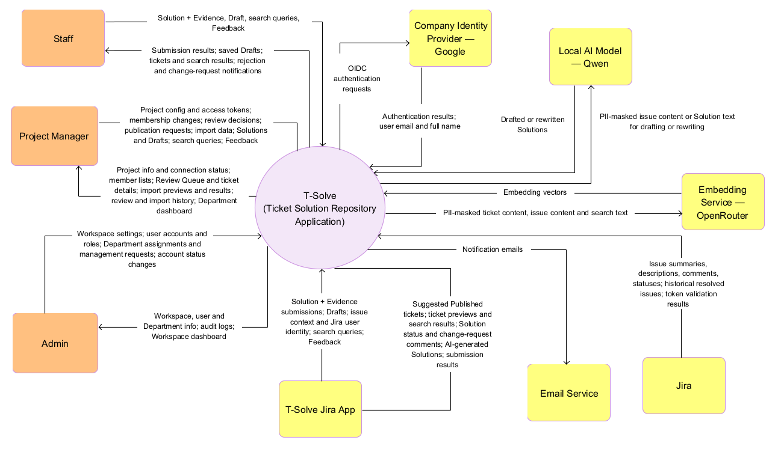

2. Main Business Flow
T-Solve supports six business flows. BF-01 to BF-03 form the ticket knowledge loop; BF-04 brings historical data into this loop; BF-05 handles new issues with AI Ticket Triage; BF-06 builds the Wiki.

2.1 Capture a Solution in Jira (BF-01)

2.1.1 Submit a Solution when Resolving an Issue
Trigger: A Ticket Resolver (or the Project Manager) moves a Jira issue of their Project to a Done status (for example, from In Progress to Resolved).
End condition: The issue stays in its Done status in Jira, and one of the following holds: - The Ticket is saved in Pending review with its Solution and appears in the Project's Review Queue. The flow continues in BF-02.
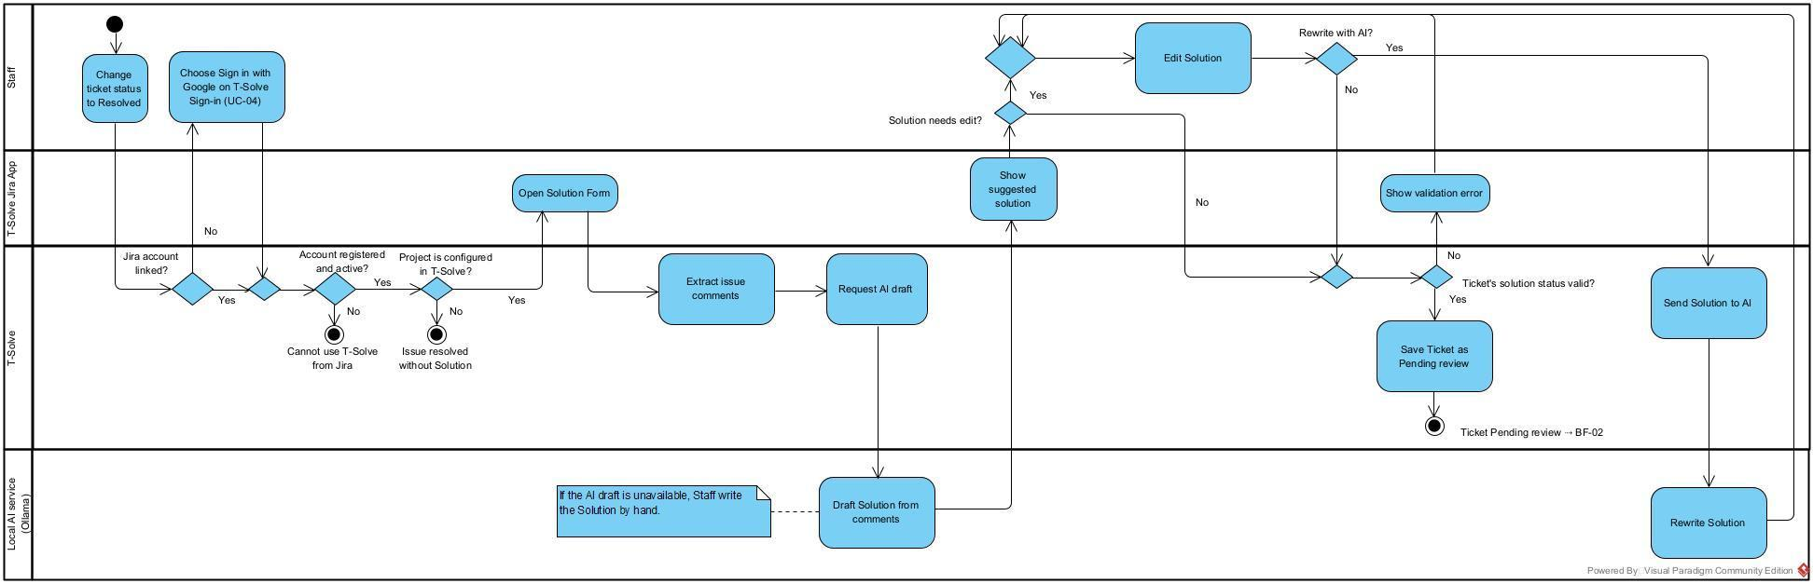

2.1.2 Resubmit a Solution after Changes Are Requested
Trigger: The writer of a Ticket in Changes requested status opens its Jira issue and reads the Project Manager's comment.
End condition: The Ticket is back in Pending review with the new Solution(the old Solution is deleted), keeps its original review due date, and appears in the Project's Review Queue. The flow continues in BF-02.

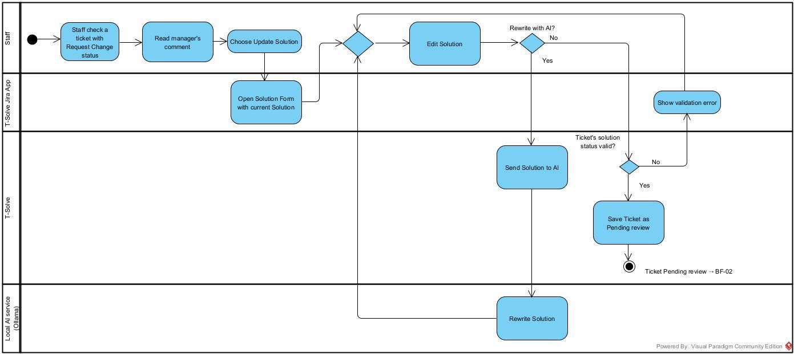

2.2 Review Solutions by Project (BF-02)
Trigger: A Ticket is saved in Pending review status (submitted from the Solution Form, resubmitted after changes were requested, or sent back to the queue) and appears immediately in the Project's Review Queue.
End condition: Each Ticket has left the Review Queue as Published, Rejected, Changes requested
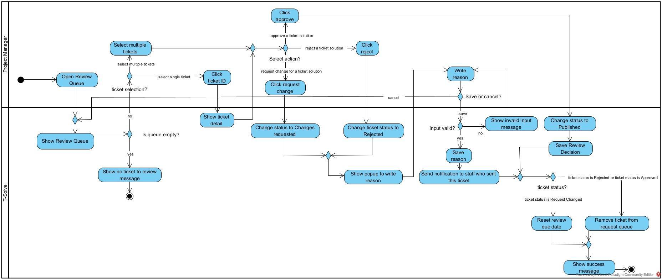

2.3 Reuse Knowledge (BF-03)
Trigger: A user asks the Knowledge Chatbot, a Ticket Resolver or Project Manager searches on the web app or in the Issue Panel, or AI Ticket Triage looks for knowledge for a new issue (BF-05).
End condition: The user has read a Published ticket or Wiki document, applied it and given Feedback; or no matching Published knowledge exists and the search or question is recorded as a knowledge gap.
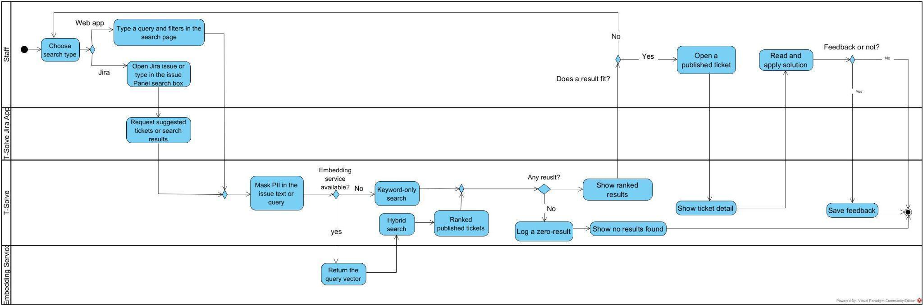

2.4 Bring in Historical Tickets (BF-04)
Trigger: A Project Manager wants to bring the tickets resolved in the past of their Project into T-Solve: from Jira, from a CSV file, or by manual entry.
End condition: Each imported ticket has a Solution and is in Published status; issues or rows removed from the import are not saved; the import is recorded in the Import History. Or the import is saved as a Draft to be finished later.
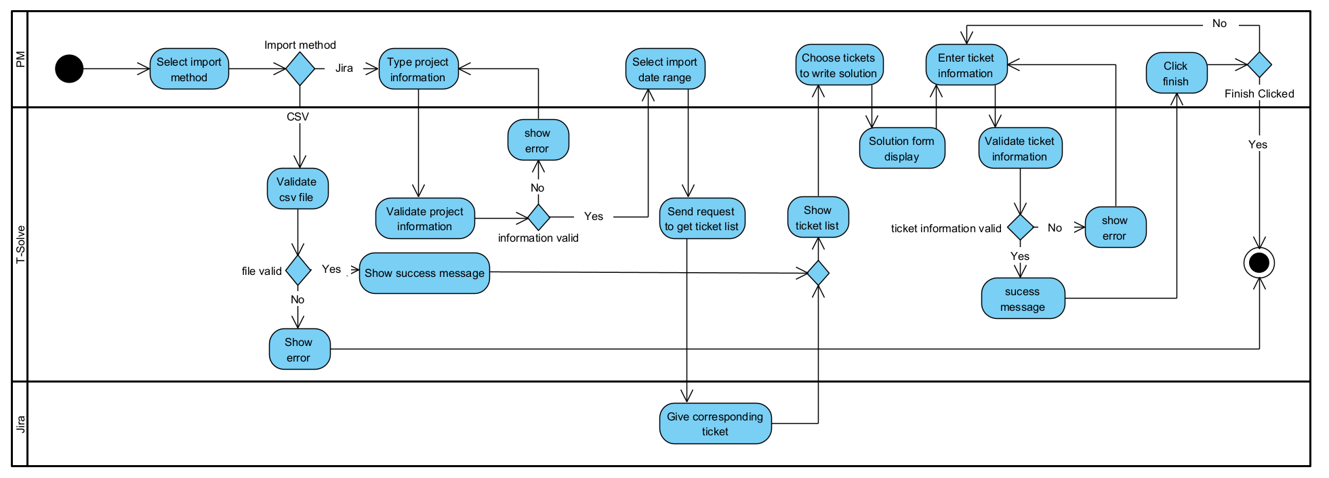

2.5 Triage a New Issue (BF-05)
Trigger: An Employee creates an issue in a Jira project linked to an Active Project.
End condition: The issue has a suggested solution posted as a comment and the reporter has answered whether it solved the problem; or the issue has the label tsolve-needs-handler and an assignee; the triage result is recorded. The issue status is never changed by T-Solve.
[Diagram placeholder: BF-05 Triage a New Issue]

2.6 Write and Review a Wiki Document (BF-06)
Trigger: An Employee with the Create permission in a Department Space creates or uploads a document, choosing its visibility (Department or Company-wide), or proposes an update of a Published document.
End condition: The document or update is Published and used by Wiki search, AI Ticket Triage and the Knowledge Chatbot according to its visibility; or it is returned for changes, rejected, or kept as a Draft. A Knowledge Manager never reviews their own document.
[Diagram placeholder: BF-06 Write and Review a Wiki Document]

3. Conceptual Data Model

3.1 Entity Relationship Diagram
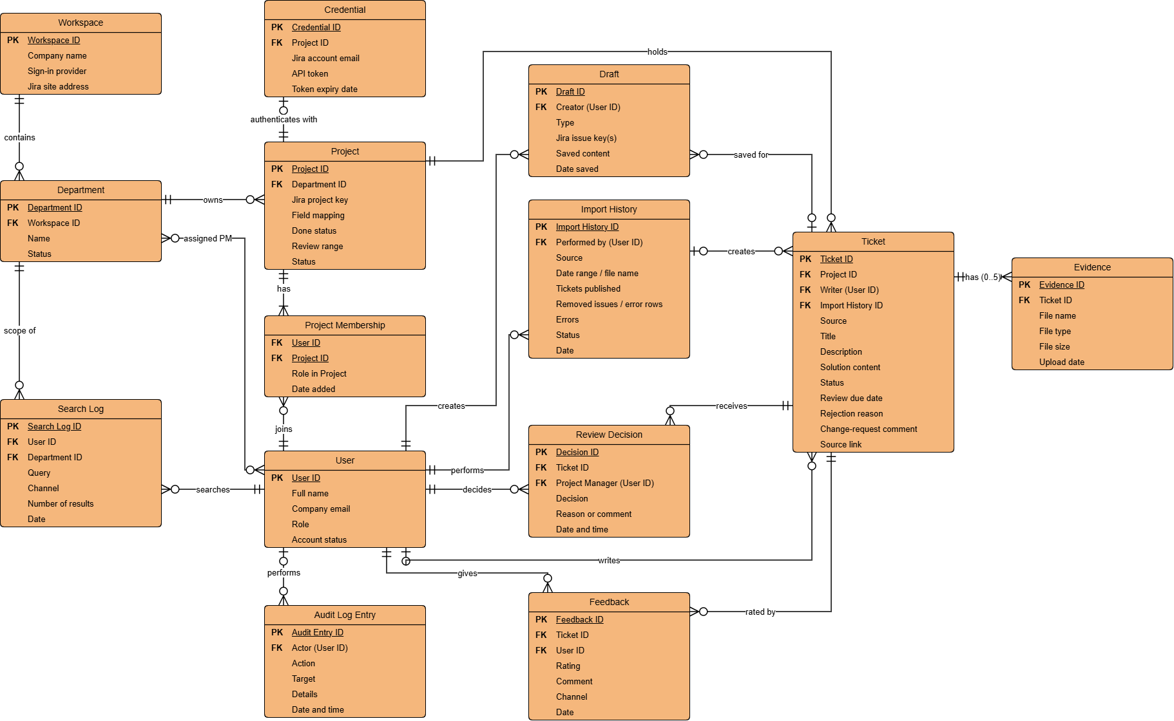

3.2 Entity Descriptions
Entity: Workspace
Purpose | The company that uses T-Solve; stores the company information and the sign-in configuration.
Key business attributes | Company name, sign-in provider (Google in the MVP), company Jira site address
Business identity | In the MVP, each installation has exactly one Workspace.
Status / lifecycle | Created together with the first Admin at installation (GBR-24); the Admin enters the information for the first time (UC-08) and edits it later (UC-09). The Workspace is never deleted.

Entity: Department
Purpose | A group inside the Workspace that owns Projects.
Key business attributes | Name, Workspace, status, assigned Project Managers, Department Space
Business identity | The Department name is unique in the Workspace, including against deleted Departments.
Status / lifecycle | From Active to Deleted, and from Deleted back to Active. A deleted Department is only hidden and frozen: its Projects, members and tickets are kept and are shown again when the Admin restores it; its Projects stay Removed until a Project Manager re-adds the Jira project (UC-14).

Entity: User
Purpose | Every person who can sign in to T-Solve.
Key business attributes | Full name, company email, Department (required for a Project Manager, optional otherwise), roles, account status; for a Knowledge Manager, the Spaces they administer (UC-06, UC-50). A user also belongs to the Departments of the Projects they are a member of.
Business identity | The company email is unique in the whole system.
Status / lifecycle | From Active to Deactivated, and from Deactivated back to Active. Users are never deleted. The last active Admin cannot be deactivated or lose the Admin role.

Entity: Project
Purpose | The unit of review of T-Solve: belongs to one Department, is linked to one Jira project and holds the Tickets that come from that Jira project.
Key business attributes | Project ID, Department, Jira project key, field mapping, done status, review range, status. The Project Manager and the members are recorded in Project Membership; the Jira access token is stored in the Credential of the Project.
Business identity | The Project ID is unique in the whole system. A Project belongs to exactly one Department and is linked to exactly one Jira project; a Jira project is linked to only one Project. The Project Manager who adds the Project becomes its Project Manager; an Active Project always has exactly one Project Manager.
Status / lifecycle | From Active to Removed, and from Removed back to Active. A Project is never permanently deleted.

Entity: Credential
Purpose | The Jira access of a Project: the access token that T-Solve uses to read issues from the linked Jira project.
Key business attributes | Project, Jira account email, API token (stored encrypted), token expiry date
Business identity | Each Credential belongs to exactly one Project; an Active Project has exactly one Credential.
Status / lifecycle | Created when the Project Manager adds the Project and the connection test succeeds (UC-14). Deleted when the Project is removed or its Department is deleted (GBR-17); a new Credential is created when a Project Manager re-adds the Jira project with a new access token.

Entity: Project Membership
Purpose | Links a User to a Project and states whether that User is the Project Manager or a member of the Project.
Key business attributes | User, Project, role in the Project, date added
Business identity | Each pair of User and Project has only one membership; each Project has at most one membership with the Project Manager role (exactly one while the Project is Active).
Status / lifecycle | The Project Manager membership is created when a Project Manager adds the Project, when an Active Project Manager re-adds a Removed Project that has no Project Manager, or when the Admin hands the Project over (UC-07, UC-50). Member memberships are added and removed by the Project Manager; only Ticket Resolver accounts can be added as members. Removing the Ticket Resolver role removes the user's member memberships.

Entity: Resolved Ticket
Purpose | A snapshot of a resolved issue, with its Solution.
Key business attributes | Ticket ID, source, title, description, Solution content, writer, Project, Import History (when the Ticket was created by an import), status, review due date, rejection reason, change-request comment, link to the source
Business identity | The Ticket ID is unique in the whole system; each Ticket belongs to exactly one Project and has exactly one Solution.
Status / lifecycle | Pending review, Changes requested, Published, Rejected, Unpublished, Expired.

Entity: Evidence
Purpose | A file that supports the Solution of a Ticket.
Key business attributes | File name, file type, file size, upload date, Ticket
Business identity | At most 5 files per Ticket.
Status / lifecycle | Can only be added; never deleted or replaced.

Entity: Review Decision
Purpose | The record of a decision made on a Ticket.
Key business attributes | Ticket, Project Manager, decision (approve / reject / request changes / unpublish / re-publish / send back), reason or comment, date and time
Business identity | Identified only by its system-generated ID.”; each record has its own Decision ID. A Ticket has many records.
Status / lifecycle | Kept permanently.

Entity: Feedback
Purpose | A user's rating of a Published ticket.
Key business attributes | Ticket, User, helpful / not helpful, comment, date
Business identity | Identified only by its system-generated ID.”; each Feedback has its own Feedback ID.
Status / lifecycle | Kept permanently.

Entity: Import History
Purpose | One import: a Jira import, a CSV import or one manual entry.
Key business attributes | Project Manager, source (Jira import / CSV / Manual), date range or file name, number of tickets published, number of removed issues or error rows, errors, date
Business identity | Identified only by its system-generated ID.”.
Status / lifecycle | Completed or Failed.
Entity: Draft
Purpose | A temporary copy of a Solution or of an import, saved on purpose by the user with the "Save as draft" button.
Key business attributes | Creator, type (Solution Form / Jira import / CSV / Manual), tickets, saved content, date saved
Business identity | Each user has at most one Solution Form Draft per issue. Import Drafts have Identified only by its system-generated ID.”.
Status / lifecycle | Saved; deleted when it is submitted or imported successfully, or when its creator deletes it.

Entity: Search Log
Purpose | The record of one search, used for the search gaps section of the dashboard.
Key business attributes | User, Department, query, channel, number of results, date
Business identity | Identified only by its system-generated ID.”.
Status / lifecycle | Kept permanently.

Entity: Audit Log Entry
Purpose | The record of an action performed in the system.
Key business attributes | Actor, action, target, details, date and time
Business identity | Identified only by its system-generated ID.”.
Status / lifecycle | Kept permanently; read-only.
Entity: User Role
Purpose | The assignment of a role to a User.
Key business attributes | User, role (Ticket Resolver, Project Manager, Knowledge Manager, Admin), Spaces (Knowledge Manager only), date assigned, assigned by
Business identity | Each User has at most one assignment per role; the Employee role is implicit for every account.
Status / lifecycle | Created and removed by the Admin (UC-06, UC-50); every change is recorded in the audit log.

Entity: Triage Result
Purpose | The result of the AI Ticket Triage of one new issue.
Key business attributes | Issue key, Project, triage class, reason, sources used (tickets and Wiki documents), suggested solution, routing (label, assignee, status of the routing), reporter's answer, corrected class and note, date
Business identity | One Triage Result per issue. For a Sensitive issue, only the key, class and reason are stored.
Status / lifecycle | Created when the issue is triaged (UC-38); updated by routing (UC-39), by the reporter's answer and by a correction (UC-41). Kept permanently.

Entity: Space
Purpose | The Wiki area of one Department, with its own permissions, folders, Knowledge Managers and trash.
Key business attributes | Department, name, Knowledge Managers, status
Business identity | Exactly one Space per Department.
Status / lifecycle | Created with its Department (UC-10), renamed with it (UC-11), hidden when the Department is deleted (UC-12) and shown again when it is restored (UC-13). Never deleted.

Entity: Space Permission
Purpose | The access of a Department or a user to a Space.
Key business attributes | Space, grantee type (Department / User), grantee, level (View / Create), granted by, date
Business identity | One permission per Space and grantee.
Status / lifecycle | Created, changed and removed by a Knowledge Manager of the Space (UC-60 to UC-62). The Create permission of the Space’s own Department cannot be removed (GBR-30).

Entity: Folder
Purpose | A category inside a Space.
Key business attributes | Space, parent folder, name
Business identity | The name is unique within its parent folder; at most three levels.
Status / lifecycle | Created, renamed, moved and deleted by a Knowledge Manager of the Space (UC-51 to UC-53); only an empty folder can be deleted.

Entity: Wiki Document
Purpose | A knowledge document of a Department Space.
Key business attributes | Space, folder, title, visibility (Department / Company-wide), Owner, status, current Published version, source (editor / uploaded file and its original file)
Business identity | The title is unique within its folder.
Status / lifecycle | Draft, Pending review, Changes requested, Published, Rejected, Deleted (in the trash). A Deleted document can be restored or deleted permanently (UC-63, UC-64).

Entity: Document Version
Purpose | One saved state of a Wiki document.
Key business attributes | Wiki document, version number, title, folder, visibility, content, author of the version, change summary, status (Draft / Pending review / Changes requested / Published / Superseded / Rejected), date
Business identity | Version numbers are unique within a document; at most one version waits for review at a time.
Status / lifecycle | Created when a document is created or an update is proposed (UC-43, UC-45); Published versions are kept as history when a newer version is approved (UC-56).

Entity: Wiki Review Decision
Purpose | The record of a decision on a Wiki document or update.
Key business attributes | Document version, Knowledge Manager, decision (publish / request changes / reject), comment or reason, date
Business identity | Identified only by its system-generated ID.
Status / lifecycle | Kept permanently.

Entity: Chat Session
Purpose | One conversation with the Knowledge Chatbot.
Key business attributes | User, start time, messages (question, answer, citations), feedback on answers
Business identity | Identified only by its system-generated ID.
Status / lifecycle | Messages are kept until the user's session ends (UC-48); Feedback on answers is kept permanently with the question and answer, PII masked (UC-49).

3.3 Data Business Rules
Rule | Description | Applies when
Email is unique | No two users share the same company email (MSG11). | Adding a user
Users are never deleted | User accounts are only deactivated, never deleted; their tickets, decisions and Feedback are kept. | Deactivating a user
Department name is unique | No two Departments share the same name, including deleted Departments (MSG43). | Creating or renaming a Department
Ticket ID is unique | Each Ticket has a unique Ticket ID. A CSV row or a manually entered ticket whose ID already exists is rejected and needs a new ID (MSG31); Jira import does not list issues that already have a Ticket. | Jira import, CSV import, manual entry
One Solution per Ticket | Each Ticket has exactly one Solution, with no versions. When the writer resubmits a Solution in Changes requested status, the old Solution is deleted and the new Solution is added; nothing is overwritten. An issue pulled from Jira only becomes a Ticket once it has a Solution; a Solution filled in for several issues is copied separately into each Ticket. | Solution Form, Solution resubmission, Jira import
Evidence is permanent | Saved Evidence is never deleted or replaced; new files can only be added after changes are requested; at most 5 files per Ticket. | Solution Form, manual entry
Each Jira project is linked to one Project | A Jira project can only be linked to one Project of one Department. | Adding a Project
A Ticket always belongs to a Project | Each Ticket belongs to exactly one Project and, through it, to one Department. Removed Projects and deleted Departments are never permanently deleted, so no ticket loses its owner. | Submitting a Solution, importing; removing a Project, deleting a Department
One Project Manager per Project | The Project Manager who adds a Project becomes its Project Manager, and an Active Project always has exactly one Project Manager. A Project Manager cannot be removed from their Project (UC-16); the Project Manager only changes when the Admin hands the Project over to another Active Project Manager of the same Department while deactivating the account (UC-07, MSG58, MSG59). A Removed Project whose Project Manager has been deactivated has no Project Manager until an Active Project Manager re-adds it (MSG54). | Adding a Project, deactivating a user, re-adding a Project
There is always an Admin | The last active Admin cannot be deactivated (MSG56). The first Admin is created at installation (GBR-24). | Installation, deactivating a user
TicketDrafts are private | Only the creator can see a Draft; a Draft is not a Ticket and does not change the status or review due date of a ticket (GBR-26). | Save as draft, reopening or deleting a Draft
Roles of a user | Every account has the Employee role. The Admin adds or removes the Ticket Resolver, Project Manager, Knowledge Manager and Admin roles (UC-06, UC-50). A Project Manager belongs to exactly one Department and a Knowledge Manager manages at least one Space (GBR-28). | Adding a user, changing roles
Review history is permanent | Review decisions, rejection reasons and change-request comments cannot be edited or deleted. | Every review decision
Rejected is final | A Rejected ticket never returns to the Review Queue or Search. | Rejecting, sending back to the queue
One Workspace per installation | Each T-Solve installation has exactly one Workspace, created together with the first Admin account when the system starts for the first time (GBR-24). The Workspace is never deleted; only the Admin can edit the company information, the sign-in provider and the Jira site address. | Installation, editing the Workspace information
Feedback only for Published tickets | Feedback can only be given on a ticket in Published status that belongs to one of the user's Departments (GBR-02). Feedback is kept permanently and cannot be edited or deleted; rating again replaces the previous rating of the same user. | Giving Feedback
Each import is one Import Batch | Each import (Jira import, CSV or manual entry) creates exactly one Import Batch of one Project, recording the Project Manager who performed it, the source and the result. The Import Batch is recorded in the Import History, including when it fails (Failed), and cannot be edited or deleted. An import that has only been saved as a Draft does not create an Import Batch yet. | Jira import, CSV import, manual entry
One Search Log per search | Each search on the web app or in the Issue Panel, and each Knowledge Chatbot question without a source, creates a Search Log that records the user, the Department, the channel and the number of results. A search or question with no result counts as a knowledge gap on the Knowledge Dashboard. Search Logs are kept permanently. | Searching Published tickets, viewing the dashboard
Audit log is read-only | Audit Log Entries are only created by the system when an audited action happens (IV.2.3). Nobody can edit or delete them, including the Admin; only the Admin can view the audit log. | Every audited action, viewing the audit log
One Space per Department | Each Department has exactly one Department Space and every Wiki document belongs to exactly one Department Space; a Space is never deleted (GBR-29). | Creating, deleting or restoring a Department
Unique titles and folder names | A Wiki document title is unique within its folder; a folder name is unique within its parent folder; folders have at most three levels. | Creating, uploading, moving documents; creating or moving folders
One pending version per document | A Wiki document has at most one version waiting for review; the Published version stays in use until a newer version is approved (GBR-34). | Updating and reviewing Wiki documents
A document always has an Owner | Every Wiki document has exactly one Owner, who must have the Create permission in the Space when the ownership is transferred (GBR-32). | Creating, transferring a document
No self-review | A Knowledge Manager cannot review a document they own or an update they wrote (GBR-34). | Reviewing Wiki documents and updates
One Triage Result per issue | Each issue created in a linked Jira project has at most one Triage Result; Sensitive issues keep only their key, class and reason (GBR-36). | AI Ticket Triage
Migration keeps identities | Migrating the data of a deleted Department keeps Project IDs, Ticket IDs, statuses, review due dates, document Owners, visibility and history (GBR-38). | Migrating Department data

4. User Requirements

4.1 Actors
T-Solve has five user actors and three external systems. Employee is the base actor: every person with an Active account is an Employee, and every other user actor is a specialisation of Employee that inherits all of its use cases. A person can hold several roles; the Admin assigns them (UC-06, UC-50). The Owner of a Wiki document is a property of the document, not an actor: any Employee who creates a document in a Space where they have the Create permission becomes its Owner.
# | Actor | Description
1 | Employee (base user actor) | Any person with an Active account added by the Admin (UC-06); self-registration is not allowed. Signs in with the company account, logs out, views My Profile, including the Solutions and Wiki documents they contributed, and links the Jira account to T-Solve once (UC-01 to UC-04). Creates issues in Jira and receives the solution suggested by T-Solve (UC-38). Opens the Published tickets cited by the Knowledge Chatbot (UC-24). Browses folders and reads every Company-wide Wiki document and the Published documents of the Spaces they can view (UC-54, UC-44). In Spaces where they have the Create permission, uploads and creates documents, proposes updates, and deletes or transfers the documents they own (UC-42, UC-43, UC-45, UC-46, UC-59). Asks the Knowledge Chatbot, views the chat history of the session and rates answers (UC-47 to UC-49). Lands on the Knowledge Chatbot screen when they have no other role.
2 | Ticket Resolver (specialises Employee) | An Employee with the Ticket Resolver role, added to one or more Projects by a Project Manager (UC-15) and belonging to the Departments of those Projects. When moving an issue of their Project to a Done status, writes the Solution in the Solution Form, can ask AI to rewrite it, attach Evidence, save a Draft and resubmit when changes are requested (UC-19). Searches Published tickets (UC-26), views the ticket list and ticket details of their Departments (UC-27, UC-24) and gives Feedback (UC-28). Can be the Escalation handler of a Project and then receives the issues routed by T-Solve (UC-39). Lands on the Search screen.
3 | Project Manager (specialises Employee) | An Employee with the Project Manager role and exactly one Department, set by the Admin (UC-06, UC-50). Adds, configures and removes Projects in that Department (UC-14); each Project has exactly one Project Manager and a Department can have several Project Managers. Adds Ticket Resolvers to a Project and removes members (UC-15, UC-16). Reviews tickets of their Projects (UC-29 to UC-31), views review history (UC-32), unpublishes and re-publishes tickets (UC-25). Imports tickets from Jira or CSV, or creates them manually; the tickets are Published immediately (UC-20 to UC-22); views import history (UC-23). Views and corrects the triage history of their Projects (UC-41). Views the Knowledge Dashboard of their Department (UC-34) and has the same ticket access as a Ticket Resolver within that Department (UC-24, UC-26 to UC-28). Lands on the Review Queue screen.
4 | Knowledge Manager (specialises Employee) | An Employee with the Knowledge Manager role, assigned by the Admin to one or more Spaces (UC-06, UC-50); the Space Administrator of those Spaces, with the Create permission in them. Views the permissions of the Space and grants, changes and revokes View or Create access for Departments and individual users (UC-57, UC-60 to UC-62). Creates, renames, moves and deletes folders (UC-51 to UC-53). Reviews new documents and updates written by others, comparing versions side by side (UC-55, UC-56); never reviews their own documents. Deletes any document of the Space, transfers its ownership, and restores or permanently deletes documents in the trash (UC-46, UC-58, UC-59, UC-63, UC-64). Lands on the Wiki Review List screen.
5 | Admin (specialises Employee) | Adds users by company email and sets their Department and roles (UC-06), views the user list (UC-05), changes account status (UC-07) and changes the Department and roles of a user, including the Spaces of a Knowledge Manager (UC-50), and hands over the Projects of a Project Manager who leaves (UC-65). Enters and edits the Workspace information (UC-08, UC-09). Creates, updates, deletes and restores Departments and with them their Department Spaces, and migrates the data of a deleted Department to another Department (UC-10 to UC-13, UC-66). Cannot deactivate their own account or remove their own Admin role. Views the audit log (UC-35) and the Workspace-wide Knowledge Dashboard (UC-34). The first Admin is created at installation (GBR-24) and the system always keeps at least one active Admin (GBR-25). Lands on the User List screen.
6 | OIDC Provider (external system) | The company identity provider (Google in the MVP). Authenticates users through OpenID Connect when they sign in to the web app (UC-01) and when they link their Jira account (UC-04). T-Solve does not store passwords.
7 | Ticket Tracker (Jira) (external system) | The ticket tracker of the company (Jira in the MVP). Holds the projects and issues and runs the T-Solve Jira App. Notifies T-Solve when an issue is created or moved to a Done status, identifies the Jira user in every request, and provides issue data for the Solution Form, triage and import through its REST API; verifies the access token of a Project (UC-14). Receives the comment, label and assignee set during triage (UC-38, UC-39); T-Solve never changes the status of an issue.
8 | Email System (external system) | The company mail server (SMTP). Delivers the emails T-Solve sends when a ticket is rejected or changes are requested (UC-30), and when a Wiki document or update is published, returned for changes or rejected (UC-55, UC-56).

4.2 Use Cases (UC)

ID | Use Case | Feature | Actor | Description
01 | Log in with company account | Role-Based Access Control | Employee | Sign in to the web app with a company account through the OIDC Provider (Google in the MVP) and land on the default page of the user's roles.
02 | Log out | Role-Based Access Control | Employee | Sign out of T-Solve and end the session; the chat history of the session is cleared.
03 | View my profile | Role-Based Access Control | Employee | View account information, Department, roles, Projects and Spaces, and the Solutions and Wiki documents the user has contributed, with their status and latest review decision.
04 | Sign in to T-Solve from Jira | Role-Based Access Control | Employee | Link the Jira account to the T-Solve account once by signing in with the company account in a new browser tab, so the T-Solve Jira App can identify the user.
05 | View user list | Role-Based Access Control | Admin | View and search user accounts with their Department, roles and status.
06 | Add user account | Role-Based Access Control | Admin | Add a user by company email, select their Department (required for a Project Manager) and assign roles; every account has the Employee role. For a Knowledge Manager, select their Spaces.
07 | Update user account status | Role-Based Access Control | Admin | Change an account between Active and Deactivated; a deactivated account cannot sign in but its history is kept. The last active Admin cannot be deactivated.
50 | Update user roles and Department | Role-Based Access Control | Admin | Change the Department and the roles of an existing account and the Spaces of a Knowledge Manager. A Project Manager hands over their Active Projects before changing Department or losing the role, and the last active Admin keeps the Admin role.
65 | Hand over Projects | Role-Based Access Control | Admin | Give every Active Project of a Project Manager who leaves the company, the role or the Department to another Project Manager of the same Department; included by UC-07 and UC-50.
08 | Add workspace information | Workspace & Department Management | Admin | Enter the Workspace information for the first time after installation: company information, sign-in provider and Jira site address.
09 | Update workspace information | Workspace & Department Management | Admin | Edit the company information, sign-in provider and Jira site address of the Workspace.
10 | Create Department | Workspace & Department Management | Admin | Create a Department with a unique name; its Department Space is created at the same time.
11 | Update Department | Workspace & Department Management | Admin | Rename a Department and its Department Space; the new name must be unique.
12 | Delete Department | Workspace & Department Management | Admin | Set a Department to Deleted: its Projects become Removed, and its tickets and Department Space are hidden from every list, Search, triage and the Knowledge Chatbot. No data is deleted; the data can later be restored (UC-13).
66 | Migrate Department data | Workspace & Department Management | Admin | Open a deleted Department and move its data, in two groups, to an Active Department: Projects with their tickets and Solutions (choosing a new Project Manager for each), and the folders and Wiki documents of its Department Space.
13 | Restore Department | Workspace & Department Management | Admin | Restore a deleted Department with the data that was not migrated; its tickets and Department Space are shown again. Its Projects stay Removed until a Project Manager reconnects them.
14 | Add & configure Jira project | Jira Integration | Project Manager | Add a Project to the Project Manager's Department, link it to a Jira project with a read-only access token, and configure field mapping, Done status, review range.
15 | Add Ticket Resolver to Project | Jira Integration | Project Manager | Add Active users with the Ticket Resolver role to a Project; they can then submit Solutions for its issues and see the tickets of its Department.
16 | Remove member from Project | Jira Integration | Project Manager | Remove a member from a Project; they no longer get the Solution Form for its issues and cannot resubmit its Solutions. Tickets they wrote are kept.
19 | Submit solution from Jira | Solution Authoring & Standardisation | Ticket Resolver | Fill in the Solution Form when moving an issue of the user's Project to a Done status: AI drafts the Solution, the writer can ask AI to rewrite it, attach Evidence, save a Draft or submit, and resubmit when changes are requested.
20 | Import resolved ticket from ticket management | Ticket Import & Repository | Project Manager | Pull issues resolved within a date range from Jira, write their Solutions on the Import Preview (a Draft can be saved), then import; tickets are Published immediately.
21 | Import resolved tickets from CSV | Ticket Import & Repository | Project Manager | Upload a CSV file that already contains Solutions, review valid and invalid rows (a Draft can be saved), then import; tickets are Published immediately.
22 | Create a ticket with solution manually | Ticket Import & Repository | Project Manager | Manually enter a resolved ticket with its Solution and optional Evidence; a Draft can be saved; the ticket is Published immediately.
23 | View import history | Ticket Import & Repository | Project Manager | View previous imports of own Projects with source, time and result.
24 | View resolved ticket detail | Ticket Import & Repository | Employee, Ticket Resolver, Project Manager | View the snapshot, Solution, Evidence, Project, status, review due date and source link of a ticket. Ticket Resolvers and Project Managers open tickets of their Departments.
25 | Unpublish / re-publish a resolved ticket | Ticket Import & Repository | Project Manager | Remove a Published ticket from Search, triage and the Knowledge Chatbot, or re-publish an Unpublished ticket.
26 | Search Published tickets | Intelligent Retrieval | Ticket Resolver, Project Manager | Search the Published tickets of own Departments by semantic relevance and keywords, on the web app and in the Issue Panel.
27 | View ticket list | Intelligent Retrieval | Ticket Resolver, Project Manager | View tickets in every status in own Departments, with filters.
28 | Give feedback | Reuse & Feedback | Ticket Resolver, Project Manager | Mark a Published ticket as helpful or not helpful, with an optional comment.
29 | View review queue | Review & Approval Workflow | Project Manager | View the tickets waiting for review in own Projects, updated in real time.
30 | Review tickets | Review & Approval Workflow | Project Manager | Approve one, several or all tickets; reject with a mandatory reason; request changes with a comment; send Expired tickets back to the queue. The writer is emailed on reject or request changes.
31 | View expired tickets | Review & Approval Workflow | Project Manager | View the Expired tickets of own Projects.
32 | View review history | Review & Approval Workflow | Project Manager | View past review decisions with their reasons and open the related tickets.
33 | Expire overdue tickets | Review & Approval Workflow | None | At 00:00 every day, TSolve System mark tickets expire once their review due date has passed (JOB-02).
34 | View knowledge dashboard | Dashboard & Audit | Project Manager, Admin | View Solution outcomes (approved, rejected, changes requested) per Project and per day, review workload, knowledge coverage, reuse and feedback, knowledge gaps and triage results; Project Managers see their Department, the Admin sees the whole Workspace.
35 | View audit log | Dashboard & Audit | Admin | View and filter the log of actions performed in the system.
38 | Auto suggest solution after ticket is created | AI Ticket Triage | Employee | When the user creates an issue in a linked Jira project, T-Solve classifies it (Simple, Complex). For a Simple issue it posts a suggested solution with sources as a comment, and the user answers whether it solved the problem.
39 | Route issue to handler | AI Ticket Triage | System (T-Solve) | For a Compolex issue, or when the suggestion did not help, add the label tsolve-needs-handler and assign the issue to the Project's Escalation handler when it has no assignee.
41 | View triage history | AI Ticket Triage | Project Manager | View the triage results of own Projects (issue, class, reason, sources,, answer).
57 | View Space permissions | Wiki Space Management | Knowledge Manager | View the Departments and individual users that can access the Space, with their access level (View or Create); Company-wide documents stay readable by everyone.
60 | Grant Space access | Wiki Space Management | Knowledge Manager | Give View or Create access to the Space to a Department or to an individual user who has no access yet.
61 | Change Space access level | Wiki Space Management | Knowledge Manager | Change the access of a Department or a user between View and Create.
62 | Revoke Space access | Wiki Space Management | Knowledge Manager | Remove the access of a Department. Documents they own stay in the Space; a user who still has access through their Department keeps that access.
51 | Create folder in Space | Wiki Space Management | Knowledge Manager | Create a folder at the top level or inside a folder of the Space; the name is unique within its parent and folders have at most three levels.
52 | Update folder in Space | Wiki Space Management | Knowledge Manager | Rename a folder or move it to another parent folder in the same Space.
53 | Delete folder in Space | Wiki Space Management | Knowledge Manager | Delete an empty folder of the Space.
54 | View folders in Space | Wiki Space Management | Employee | Browse the Company-wide view and the folder tree of the Spaces the user can view.
58 | View Space trash | Wiki Space Management | Knowledge Manager | List the deleted documents of the Space with their Owner, who deleted them and when.
63 | Restore deleted Wiki document | Wiki Space Management | Knowledge Manager | Restore a deleted document to its folder (or to the top level if the folder no longer exists) with its previous status; a Published document is used again by the Wiki and the Knowledge Chatbot.
64 | Permanently delete Wiki document | Wiki Space Management | Knowledge Manager | Delete a document from the trash for good after confirmation; it can no longer be restored.
42 | Upload multiple documents from user device to T-Solve | Wiki Document Management | Employee | In a Department Space where the user has the Create permission, upload one or more files (PDF, DOCX, Markdown, TXT) to a folder, choose their visibility (Department or Company-wide), preview the extracted text and submit them for review. The user becomes the Owner of each document.
43 | Create Wiki document | Wiki Document Management | Employee | In a Department Space where the user has the Create permission, write a new document with a title, folder, visibility (Department or Company-wide) and content; save it as a Draft or submit it for review. The user becomes its Owner.
44 | View Wiki documents | Wiki Document Management | Employee | List, search and open the Published documents the user can see: the Company-wide documents of every Space and the documents of the Spaces the user can view, with their Owner.
46 | Delete Wiki document | Wiki Document Management | Employee, Knowledge Manager | The Owner deletes their document, or a Knowledge Manager deletes any document of the Space. The document moves to the Space trash and is no longer used by the Wiki or the Knowledge Chatbot.
55 | Review Wiki document | Wiki Document Management | Knowledge Manager | Publish, request changes on (with a comment) or reject (with a reason) a new document of the Space. A Knowledge Manager cannot review a document they own. The Owner is emailed.
47 | Ask the Knowledge Chatbot | Knowledge Chatbot | Employee | Ask a question and receive an answer built only from the Published tickets and Wiki documents the user is allowed to see, with citations; follow-up questions use the session context.
48 | View chat history in session | Knowledge Chatbot | Employee | View and continue the conversations of the current session.
49 | Give feedback on a Chatbot answer | Knowledge Chatbot | Employee | Mark an answer as helpful or not helpful.
Every user actor inherits the use cases of Employee. UC numbers 17, 18, 36, 37 and 40 are no longer used (see the Change Log).

4.3 Use Case Diagrams

4.3.1 Actor Hierarchy
[Diagram placeholder] Employee is the base actor; Ticket Resolver, Project Manager, Knowledge Manager and Admin specialise Employee. External systems: OIDC Provider, Ticket Tracker (Jira), Email System.

4.3.2 UCs for Employee
[Diagram placeholder] UC-01, UC-02, UC-03, UC-04 (OIDC Provider, Ticket Tracker), UC-38 extended by UC-39 (Ticket Tracker), UC-24, UC-54, UC-44, UC-42, UC-43, UC-45, UC-46, UC-59, UC-47, UC-48, UC-49.

4.3.3 UCs for Ticket Resolver
[Diagram placeholder] UC-19 (Ticket Tracker), UC-26, UC-27, UC-24, UC-28, UC-39 as Escalation handler (Ticket Tracker).

4.3.4 UCs for Project Manager
[Diagram placeholder] UC-14, UC-20 (Ticket Tracker), UC-15, UC-16, UC-21, UC-22, UC-23, UC-25, UC-29, UC-30 (Email System), UC-31, UC-32, UC-33 (scheduled), UC-34, UC-41, plus UC-24, UC-26 to UC-28.

4.3.5 UCs for Knowledge Manager
[Diagram placeholder] UC-57, UC-60, UC-61, UC-62, UC-51, UC-52, UC-53, UC-58, UC-63, UC-64, UC-46, UC-59, UC-55 and UC-56 (Email System).

4.3.6 UCs for Admin
[Diagram placeholder] UC-05, UC-06, UC-07 and UC-50, both including UC-65; UC-08, UC-09 (OIDC Provider), UC-10, UC-11, UC-12, UC-66, UC-13, UC-34, UC-35.

4.4 Permission Matrix
Full means unrestricted; Restricted means conditional (see the notes); No means not allowed. Every role inherits the permissions of Employee, and a user who holds several roles has the union of their permissions. UC-33 and UC-39 are run by T-Solve itself.
UC | Entity | Action | Admin | Project Manager | Ticket Resolver | Knowledge Manager | Employee
01 | User | Log in with company account | Full | Full | Full | Full | Full
02 | User | Log out | Full | Full | Full | Full | Full
03 | User | View My Profile | Full | Full | Full | Full | Full
04 | User | Link Jira account to T-Solve | Full | Full | Full | Full | Full
05 | User | View user list | Full | No | No | No | No
06 | User, User Role | Add a user, their Department and roles | Full | No | No | No | No
07 | User | Change account status | Full | No | No | No | No
50 | User, User Role | Change the Department, roles and Spaces of a user | Full | No | No | No | No
65 | Project, Project Membership | Hand over Projects | Full | No | No | No | No
08 | Workspace | Enter Workspace information for the first time | Full | No | No | No | No
09 | Workspace | Edit Workspace information | Full | No | No | No | No
10 | Department, Space | Create a Department | Full | No | No | No | No
11 | Department | Update a Department | Full | No | No | No | No
12 | Department | Delete a Department | Full | No | No | No | No
66 | Department, Project, Space | Migrate Department data | Full | No | No | No | No
13 | Department | Restore a Department | Full | No | No | No | No
14 | Project | Add, configure and remove a Project | No | Restricted ¹ | No | No | No
15 | Project Membership | Add a Ticket Resolver to a Project | No | Restricted ² | No | No | No
16 | Project Membership | Remove a member from a Project | No | Restricted ² | No | No | No
19 | Ticket, Evidence, Draft | Submit or resubmit a Solution from Jira | No | Restricted ³,⁵ | Restricted ³,⁵ | No | No
20 | Ticket, Import Batch, Draft | Import tickets from Jira | No | Restricted ²,⁵ | No | No | No
21 | Ticket, Import Batch, Draft | Import tickets from CSV | No | Restricted ²,⁵ | No | No | No
22 | Ticket, Evidence, Import Batch, Draft | Create a ticket manually | No | Restricted ²,⁵ | No | No | No
23 | Import Batch | View import history | No | Restricted ² | No | No | No
24 | Ticket, Evidence | View ticket detail | Restricted ⁶ | Restricted ¹ | Restricted ⁴ | Restricted ⁶ | Restricted ⁶
25 | Ticket | Unpublish or re-publish a ticket | No | Restricted ² | No | No | No
26 | Ticket, Search Log | Search Published tickets | No | Restricted ¹ | Restricted ⁴ | No | No
27 | Ticket | View ticket list | No | Restricted ¹ | Restricted ⁴ | No | No
28 | Feedback | Give Feedback on a Published ticket | No | Restricted ¹ | Restricted ⁴ | No | No
29 | Ticket | View review queue | No | Restricted ² | No | No | No
30 | Ticket, Review Decision | Review tickets | No | Restricted ² | No | No | No
31 | Ticket | View Expired tickets | No | Restricted ² | No | No | No
32 | Review Decision | View review history | No | Restricted ² | No | No | No
34 | Ticket, Review Decision, Feedback, Search Log, Triage Result | View the Knowledge Dashboard | Full (Workspace) | Restricted ¹ | No | No | No
35 | Audit Log Entry | View audit log and entry details | Full | No | No | No | No
38 | Triage Result | Receive and answer the solution suggested for an issue they created | Restricted ⁷ | Restricted ⁷ | Restricted ⁷ | Restricted ⁷ | Restricted ⁷
41 | Triage Result | View triage history, correct a class, route again | No | Restricted ² | No | No | No
57 | Space Permission | View Space permissions | No | No | No | Restricted ⁸ | No
60 | Space Permission | Grant Space access | No | No | No | Restricted ⁸ | No
61 | Space Permission | Change Space access level | No | No | No | Restricted ⁸ | No
62 | Space Permission | Revoke Space access | No | No | No | Restricted ⁸ | No
51 | Folder | Create a folder | No | No | No | Restricted ⁸ | No
52 | Folder | Rename or move a folder | No | No | No | Restricted ⁸ | No
53 | Folder | Delete a folder | No | No | No | Restricted ⁸ | No
54 | Folder | View folders | Restricted ⁹ | Restricted ⁹ | Restricted ⁹ | Restricted ⁹ | Restricted ⁹
58 | Wiki Document | View Space trash | No | No | No | Restricted ⁸ | No
63 | Wiki Document | Restore a deleted document | No | No | No | Restricted ⁸ | No
64 | Wiki Document | Permanently delete a document | No | No | No | Restricted ⁸ | No
42 | Wiki Document, Document Version | Upload documents | Restricted ¹⁰ | Restricted ¹⁰ | Restricted ¹⁰ | Restricted ¹⁰ | Restricted ¹⁰
43 | Wiki Document, Document Version | Create a Wiki document | Restricted ¹⁰ | Restricted ¹⁰ | Restricted ¹⁰ | Restricted ¹⁰ | Restricted ¹⁰
44 | Wiki Document, Document Version | View Wiki documents | Restricted ⁹ | Restricted ⁹ | Restricted ⁹ | Restricted ⁹ | Restricted ⁹
45 | Document Version | Update a Wiki document | Restricted ¹⁰ | Restricted ¹⁰ | Restricted ¹⁰ | Restricted ¹⁰ | Restricted ¹⁰
46 | Wiki Document | Delete a Wiki document | Restricted ¹¹ | Restricted ¹¹ | Restricted ¹¹ | Restricted ⁸,¹¹ | Restricted ¹¹
59 | Wiki Document | Transfer document ownership | Restricted ¹¹ | Restricted ¹¹ | Restricted ¹¹ | Restricted ⁸,¹¹ | Restricted ¹¹
55 | Document Version, Wiki Review Decision | Review a new Wiki document | No | No | No | Restricted ⁸ (not own) | No
56 | Document Version, Wiki Review Decision | Review a Wiki update | No | No | No | Restricted ⁸ (not own) | No
47 | Chat Session | Ask the Knowledge Chatbot | Full | Full | Full | Full | Full
48 | Chat Session | View chat history in session | Full | Full | Full | Full | Full
49 | Chat Session | Give feedback on a Chatbot answer | Full | Full | Full | Full | Full
¹ Only within the Project Manager’s Department.
² Only for Projects where the user is the Project Manager.
³ Only for issues of a Jira project linked to an Active Project the user is a member of. Only the Ticket’s writer can resubmit.
⁴ Only within the Departments of the Projects the user is a member of.
⁵ A Draft can only be seen, reopened or deleted by the user who created it.
⁶ Only Published tickets of the user’s Departments, opened from a Knowledge Chatbot citation.
⁷ Only for issues the user creates in a Jira project linked to an Active Project.
⁸ Only in the Spaces the Admin has assigned that Knowledge Manager.
⁹ The Company-wide documents of every Space, and the documents of the Spaces the user can view (GBR-30, GBR-31).
¹⁰ Only in the Spaces where the user has the Create permission (GBR-30, GBR-32).
¹¹ The Owner of the document; a Knowledge Manager for any document of their Spaces.

5. System Functionalities
T-Solve is delivered through two channels: the T-Solve web app, used by every role, and the T-Solve Jira App, used directly in Jira by Employees (answers to triage suggestions), Ticket Resolvers and Project Managers. A background job moves overdue tickets to Expired.

5.1 Screen Inventory

a. Screen Flow
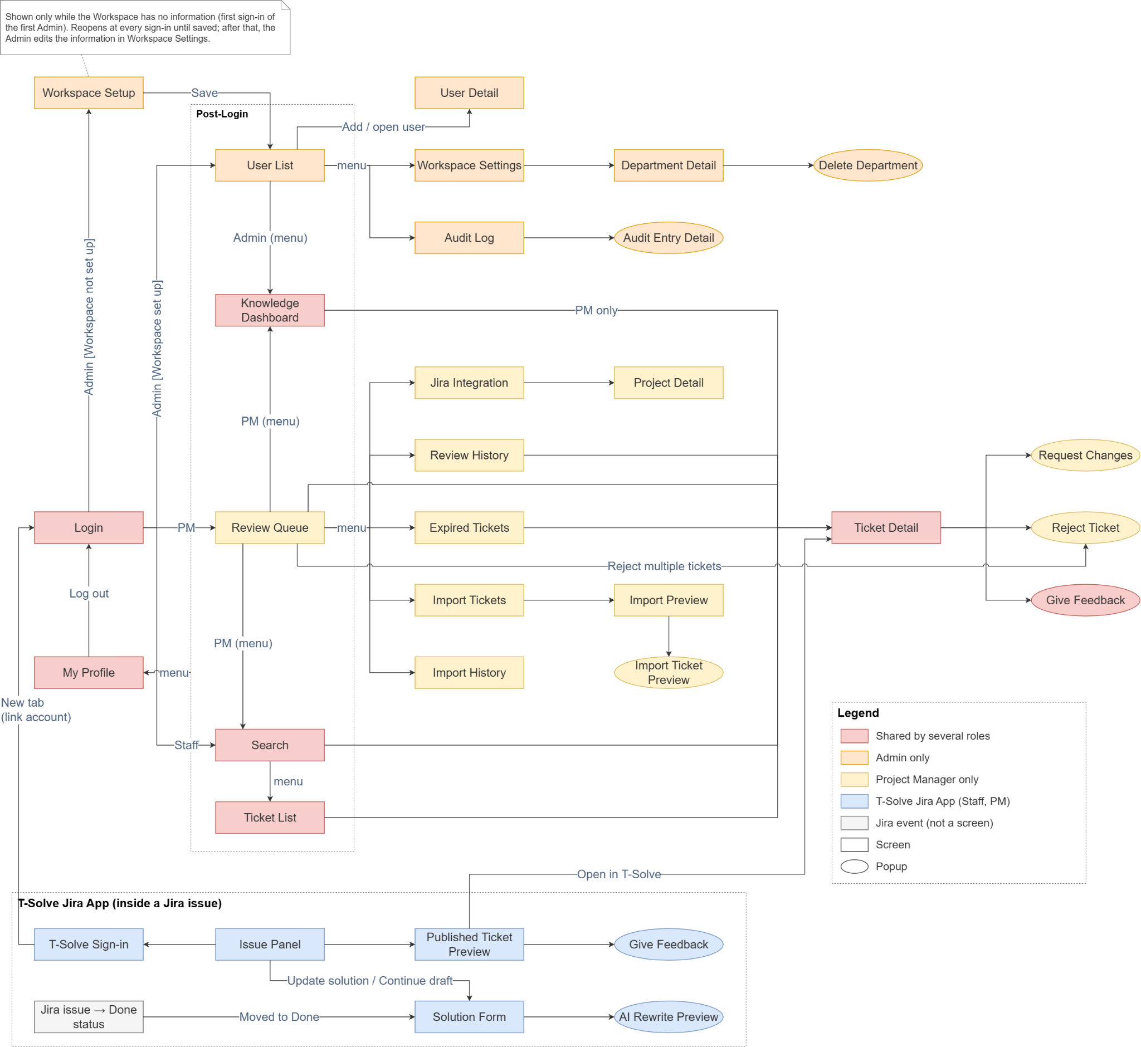

b. Screen List
# | Screen Name | Feature | Description
T-Solve web app
1 | Login | Role-Based Access Control | Allows every user to sign in with a company account through the OIDC Provider (Google in the MVP) and go to the default page of their roles (Admin: User List, Project Manager: Review Queue, Knowledge Manager: Wiki Review List, Ticket Resolver: Search, Employee: Knowledge Chatbot).
2 | My Profile | Role-Based Access Control | Shows the signed-in user's account information, Department, roles, Projects and Spaces, and the Solutions and Wiki documents they contributed with their status and latest review decision.
3 | User List | Role-Based Access Control | Allows the Admin to view and search user accounts, add users by email and open the details of an account.
4 | User Detail | Role-Based Access Control | Allows the Admin to add a user, set their Department and roles (with the Spaces of a Knowledge Manager), change them later, and deactivate or reactivate the account.
5 | Workspace Setup | Workspace & Department Management | Shown to the Admin at sign-in only while the Workspace has no information. Allows entering the company name and the Jira site address and confirming the sign-in provider.
6 | Workspace Settings | Workspace & Department Management | Allows the Admin to edit the Workspace information, create or open Departments, and open a deleted Department to restore it or migrate its data.
7 | Department Detail | Workspace & Department Management | Allows the Admin to view the Project Managers of a Department, rename the Department and delete it.
8 | Delete Department (popup) | Workspace & Department Management | Requires the Admin to confirm deleting a Department: its Projects, tickets and Department Space are hidden and frozen, not deleted.
9 | Migrate Department Data | Workspace & Department Management | Allows the Admin to view the Projects and Wiki documents of a deleted Department, select the data to move, choose the target Department and the new Project Manager of each Project, and migrate the data.
10 | Jira Integration | Jira Integration | Allows the Project Manager to add, test and remove Projects of their Department and open the Project Detail; allows the Admin to set the company Jira site address.
11 | Project Detail | Jira Integration | Allows the Project Manager to manage a Project through two tabs: Members (add Ticket Resolvers, remove members) and Settings (field mapping, Done status, review range, Escalation handler).
12 | Import Tickets | Ticket Import & Repository | Allows the Project Manager to import tickets into one of their Projects through three tabs (Jira, CSV, Manual entry) and to reopen or delete their Drafts.
13 | Import Preview | Ticket Import & Repository | Review screen of a Jira or CSV import: write Solutions (Jira), check valid and invalid rows (CSV), remove issues or rows, save a Draft, then import in Published status.
14 | Import Ticket Preview (popup) | Ticket Import & Repository | Shows an issue or row about to be imported; for Jira import, the Project Manager writes the Solution here for one or several issues.
15 | Import History | Ticket Import & Repository | Lists the previous imports of the Project Manager's Projects with source, time and result.
16 | Ticket Detail | Ticket Import & Repository | Shows the snapshot, Solution, Evidence, Project, status and source link of a ticket; gives the Project Manager of the Project the review and publishing actions.
17 | Search | Intelligent Retrieval | Allows Ticket Resolvers and Project Managers to search the Published tickets of their Departments, ranked by semantic and keyword relevance, with filters.
18 | Ticket List | Intelligent Retrieval | Lists every ticket in every status within the user's Departments, with keyword search and filters.
19 | Review Queue | Review & Approval Workflow | Shows the Project Manager the tickets waiting for review in their Projects, updated in real time; approve or reject several tickets at once or open a ticket to decide.
20 | Request Changes (popup) | Review & Approval Workflow | Allows the Project Manager to return a ticket that came from the Solution Form to its writer with a comment.
21 | Reject Ticket (popup) | Review & Approval Workflow | Requires a mandatory reason before rejecting one or more tickets; rejection is final.
22 | Review History | Review & Approval Workflow | Lists past review decisions in the Project Manager's Projects with their reasons.
23 | Expired Tickets | Review & Approval Workflow | Lists the Expired tickets of the Project Manager's Projects and allows sending them back to the queue.
24 | Give Feedback (popup) | Reuse & Feedback | Allows a Ticket Resolver or Project Manager to mark a Published ticket as helpful or not helpful, with an optional comment.
25 | Knowledge Dashboard | Dashboard & Audit | Shows Solution outcomes (approved, rejected, changes requested), review workload, knowledge coverage, reuse, knowledge gaps and triage results: Project Managers see their Department, the Admin sees the whole Workspace.
26 | Audit Log | Dashboard & Audit | Allows the Admin to view and filter the log of actions performed in the system.
27 | Audit Entry Detail (popup) | Dashboard & Audit | Shows the full details of an audit log entry.
28 | Triage History | AI Ticket Triage | Lists the triage results of the Project Manager's Projects, with filters.
29 | Triage Result Detail (popup) | AI Ticket Triage | Shows one triage result with its sources and routing; allows correcting the class and routing the issue again.
30 | Wiki Home | Wiki Space Management | Shows the Company-wide view and the Department Spaces the user can view; shows the folder tree and the documents of the selected Space, with Wiki search; entry point to create or upload documents and to the Space Settings.
31 | Wiki Document | Wiki Document Management | Shows a Wiki document with its Owner, status and version history; gives the Owner and Knowledge Managers the edit, delete and transfer actions.
32 | Wiki Editor | Wiki Document Management | Allows writing a new document or an update: title, folder, visibility (Department or Company-wide), content and change summary; save as Draft or submit for review.
33 | Upload Documents | Wiki Document Management | Allows uploading up to 10 files to a folder, choosing their visibility, previewing the extracted text and submitting them for review.
34 | Folder (popup) | Wiki Space Management | Allows a Knowledge Manager to create, rename, move or delete a folder.
35 | Transfer Ownership (popup) | Wiki Document Management | Allows the Owner or a Knowledge Manager to choose the new Owner of a document.
36 | Space Settings | Wiki Space Management | Allows a Knowledge Manager to manage a Space through two tabs: Permissions (Departments and users with View or Create access) and Trash (restore or permanently delete documents).
37 | Wiki Review List | Wiki Document Management | Default page of Knowledge Managers: lists the new documents and updates waiting for review in their Spaces, excluding their own.
38 | Review Wiki Document | Wiki Document Management | Shows a new document so that a Knowledge Manager can publish it, request changes or reject it.
39 | Compare Versions | Wiki Document Management | Shows the Published version and a proposed update side by side, with line and word differences, so that a Knowledge Manager can approve it, request changes or reject it.
40 | Wiki Decision (popup) | Wiki Document Management | Requires a comment (request changes) or a reason (reject) for a Wiki document or update.
41 | Knowledge Chatbot | Knowledge Chatbot | Default page of Employees with no other role: ask questions, read answers with citations, continue the conversation and rate answers.
T-Solve Jira App (inside a Jira issue)
42 | Issue Panel | Jira Integration | Shows, inside a Jira issue, the Solution status of the issue for Project members, a search box for Ticket Resolvers and Project Managers, and the “Did this solve your problem?” question for the reporter of a triaged issue.
43 | T-Solve Sign-in | Role-Based Access Control | Allows any user to link their Jira account to T-Solve once by signing in with the company account in a new tab.
44 | Published Ticket Preview | Jira Integration | Shows the Solution of a Published ticket found by search, with a link to open the ticket on the web app.
45 | Solution Form | Solution Authoring & Standardisation | Mandatory form that appears right after a Project member moves a Jira issue of their Project to a Done status: AI-drafted Solution, optional Evidence, Save as draft and Finish.
46 | AI Rewrite Preview (popup) | Solution Authoring & Standardisation | Shows the Solution rewritten by AI so the writer can accept or discard it.

5.2 External API Inventory
# | API Name | Call Direction | Description
1 | Jira App API | T-Solve Jira App to T-Solve | Allows the T-Solve Jira App to link the user's Jira account, submit and resubmit Solutions with Evidence, save and open Drafts, search, show previews, send new issues for triage and record the reporter's answer (API-01 to API-04, API-06).
2 | Sign in with company account (OIDC) | T-Solve to OIDC Provider (Google), OIDC Provider to T-Solve | Redirects the user to the OIDC Provider and receives back the signed-in identity (email) (API-05).
3 | Jira REST API | T-Solve to Jira | Reads the issue summary, description and comments for AI drafting and triage, verifies the Project's token and reads past resolved issues for Jira import. T-Solve never changes the status of an issue.
4 | AI module: language model (Ollama) | T-Solve AI module to the locally hosted LLM | Used by the AI module inside T-Solve to draft and rewrite Solutions, classify new issues, write suggested solutions and write Knowledge Chatbot answers. Only PII-masked content is sent (IV.1.2).
5 | AI module: embeddings (OpenRouter) | T-Solve AI module to OpenRouter | Used by the AI module to compute the vectors of tickets, Wiki documents, issues, search queries and chatbot questions for semantic retrieval. Only PII-masked content is sent (IV.1.2).
6 | Email | T-Solve to Email System (SMTP) | Sends the notification emails of ticket review and Wiki review (GBR-27).

5.3 Background Job Inventory
# | Job | Group | Description
1 | Expire overdue tickets (JOB-02) | Scheduled | Every day at 00:00 (UTC+7): marks as Expired the tickets whose review due date has passed (UC-33).

II. Use Case Specifications
This part specifies every use case of I.4.2. Messages are referenced by code (see V.2) and business rules by GBR code (see V.1). A Solution always follows the Solution template defined in GBR-33. Every user actor inherits the use cases of Employee (I.4.1), so steps that say “Employee” also apply to a user who holds another role. The AI module is part of T-Solve and is not an actor; UC-33 and UC-39 are run by T-Solve itself.

1. Role-Based Access Control

1.1 UC-01 Log in with company account
Primary Actors | Employee | Secondary Actors | OIDC Provider (Google)
Description | As an Employee, I want to sign in with my company account so that I can use T-Solve without a separate password and land on the page for my role.
Preconditions | - The user's company email has been added to T-Solve by the Admin. The first Admin is created at installation (GBR-24).  - The sign-in provider has been configured.
Normal Flow | Log in with company account  - The user opens the T-Solve web app.  - The system shows the Login screen.  - The user clicks "Sign in with Google".  - The system redirects the user to the OIDC Provider.  - The user signs in with the company account and grants consent if asked.  - The OIDC Provider returns the user's verified identity (email) to T-Solve.  - The system looks up an active T-Solve account with that email.  - The system creates a session, updates the user’s full name from the identity returned by the OIDC Provider and records the sign-in in the audit log.  - The system takes the user to the default page of their roles: User List (Admin), Review Queue (Project Manager), Wiki Review List (Knowledge Manager), Search (Ticket Resolver) or Knowledge Chatbot (Employee with no other role). When the user holds several roles, the first page in this order is used.
Alternative Flows | Step 7a_Account not registered  - No T-Solve account matches the returned email.  - The system shows MSG09 on the Login screen and does not create a session.  Step 7b_Account deactivated  - The account exists but has been deactivated by the Admin.  - The system shows MSG10 and does not create a session.  Step 5_User cancels or the provider fails  - The user cancels on the provider's page, or the provider returns an error.  - The system returns to the Login screen and shows MSG06.  Step 9_Workspace not set up yet  - An Admin signs in before the Workspace information has been entered.  - The system opens the Workspace Setup screen (UC-08) instead of the User List.
Postconditions | - The user is signed in.  - The sign-in is recorded in the audit log.

1.2 UC-02 Log out
Primary Actors | Employee | Secondary Actors | None
Description | As an Employee, I want to sign out of T-Solve, so that nobody else can use my session on this computer.
Preconditions | - The user is signed in.
Normal Flow | Log out  - The user opens the user menu or My Profile and clicks “Log out”.  - The system ends the session and clears the chat history of the session (UC-48).  - The system takes the user to the Login screen.
Alternative Flows | Step 1_Session already expired  - The system shows MSG07 and takes the user to the Login screen.
Postconditions | - The session no longer exists; the next request requires signing in again.  - The link between the Jira account and T-Solve (UC-04) is not changed.

1.3 UC-03 View my profile
Primary Actors | Employee | Secondary Actors | None
Description | As an Employee, I want to see my account information, what I can access and what I have contributed, so that I know my Projects, Departments and Spaces and can follow what happened to the Solutions and Wiki documents I submitted.
Preconditions | - The user is signed in.
Normal Flow | View my profile  - The user opens My Profile from the user menu.  - The system shows the full name, company email, Department and roles, read-only.  - The system shows the Projects the user belongs to, with their Department and the user’s role in each Project, and the Spaces the user can view or create documents in, with the access level (for a Knowledge Manager, also the Spaces they administer).  - For a user who has written Solutions, the system shows My Solutions: the number of tickets the user wrote in each status (Pending review, Changes requested, Published, Rejected, Expired, Unpublished) and the list of these tickets with Ticket ID, title, Project, status, the latest review decision with its reason or comment, and its date.  - If needed, the user filters My Solutions by status, Project or date and opens a ticket in the Ticket Detail (UC-24); for a ticket in Changes requested, the user can open its Jira issue to resubmit (UC-19).  - For a user who owns Wiki documents, the system shows My Wiki documents: title, Space, status (Draft, Pending review, Changes requested, Published, Rejected) and the latest review comment or reason; a document opens in the Wiki Document (UC-44).
Alternative Flows | Step 4_No Solution written  - The My Solutions section shows MSG04.  Step 5_Ticket of a Project the user is no longer a member of  - The ticket stays in the list and opens read-only; the user cannot resubmit it (GBR-22).  Step 5_Ticket of a deleted Department  - The ticket is hidden while the Department is deleted (GBR-17).  Step 6_No Wiki document owned  - The My Wiki documents section shows MSG04.  Step 2_Loading error  - The system shows MSG06.
Postconditions | - Nothing changes.

1.4 UC-04 Sign in to T-Solve from Jira
Primary Actors | Employee | Secondary Actors | Ticket Tracker (Jira), OIDC Provider (Google)
Description | As an Employee, I want to link my Jira account to my T-Solve account once by signing in with my company account, so that I can answer triage suggestions on my issues and, as a user or Project Manager, submit Solutions and search from Jira without signing in again.
Preconditions | - The T-Solve Jira App has been installed on the company Jira site by the Jira administrator.  - The user’s company email has an Active T-Solve account (UC-06).
Normal Flow | Sign in from Jira  - The user opens an issue of a Jira project linked to a Project.  - The T-Solve Jira App asks the system whether the user's Jira account is already linked to a T-Solve account.  - The Jira account is not linked: the Issue Panel shows the T-Solve Sign-in screen with MSG62 and a "Sign in with Google" button.  - The user clicks "Sign in with Google".  - The system creates a one-time sign-in link for this Jira account. The T-Solve Jira App opens the link in a new browser tab, and the T-Solve Sign-in screen shows MSG74 while waiting.  - The new tab opens the T-Solve Login screen, which redirects the user to the OIDC Provider.  - The user signs in with the company account.  - The system checks that the account exists and is active, links the Jira account to the T-Solve account and records the link in the audit log.  - The tab shows MSG75 and the Issue Panel refreshes and shows the content the user is allowed to see (UC-19, UC-26, UC-38).
Alternative Flows | Step 2a_Already linked  - The system finds the link and checks that the T-Solve account is still active.  - The Issue Panel skips the sign-in step.  Step 2b_Linked account deactivated  - The Jira account is linked but the T-Solve account has been deactivated (UC-07).  - The Issue Panel shows MSG10.  Step 6_Sign-in link expired or already used  - The user opens the link more than 10 minutes after it was created, or opens it a second time.  - The tab shows MSG73. The user goes back to Jira and continues from step 4.  Step 7_User cancels or closes the tab  - The user cancels on the provider's page or closes the tab.  - The accounts are not linked. The T-Solve Sign-in screen shows MSG62 and the sign-in button again.  Step 8_Account not registered or deactivated  - The tab shows MSG09 or MSG10 and the accounts are not linked.  - The Issue Panel stays signed out.
Postconditions | - The Jira account is linked to the T-Solve account, and the link is recorded in the audit log.  - The user is not asked to sign in again from Jira. Every request from the T-Solve Jira App is checked under GBR-03, so a deactivated account loses access from Jira immediately.

1.5 UC-05 View user list
Primary Actors | Admin | Secondary Actors | None
Description | As the Admin, I want to find user accounts quickly, so that I can check or change who can use T-Solve and with which roles.
Preconditions | - The Admin is signed in.
Normal Flow | View the user list  - The Admin signs in (default page) or opens the User List.  - The system shows the user table: full name, email, Department, roles, status and last sign-in, sorted by name.  - If needed, the Admin types a name or email in the search box (at most 100 characters) and filters by role, Department and status.  - The system updates the table.  - The Admin opens a user to see the User Detail (UC-06, UC-07, UC-50).
Alternative Flows | Step 4_No result  - The table shows MSG04.
Postconditions | - Nothing changes.

1.6 UC-06 Add user account
Primary Actors | Admin | Secondary Actors | None
Description | As the Admin, I want to add users by company email and set their Department and roles at the same time, so that they can sign in with the right permissions, each Project Manager works in the right Department and each Knowledge Manager administers the right Spaces.
Preconditions | - The Admin is signed in.
Normal Flow | Add a user  - The Admin opens the User List and clicks “Add user”.  - The system shows the Add User form with the company email, the Department and the roles Ticket Resolver, Project Manager, Knowledge Manager and Admin. Employee is always selected and cannot be removed.  - The Admin enters the email, selects the Department if any, and selects zero, one or more roles.  - If Project Manager is selected, the Department becomes required: the Project Manager manages Projects only in that Department. If Knowledge Manager is selected, the system shows the Spaces and the Admin selects one or more Spaces the person administers.  - The Admin clicks Save.  - The system checks the required fields (MSG01), the email format (MSG03), that the email is not used by any account (MSG11, MSG111), that a Project Manager has a Department and that a Knowledge Manager has at least one Space (MSG01).  - The system creates the account in Active status with the Employee role, the selected roles, the Department and the Spaces (GBR-28).  - The system records the action in the audit log and shows MSG12.  - The user can now sign in with the company account (UC-01). Until the first sign-in, the user is shown by email; the full name is taken from the company account at sign-in. A Ticket Resolver belongs to no Project until a Project Manager adds them (UC-15).
Alternative Flows | Step 6a_Invalid data  - The system shows the matching message under each invalid field, keeps everything the Admin entered and does not create the account.  Step 6b_Email used by an Active account  - The system shows MSG11 and does not create the account.  Step 6c_Email belongs to a Deactivated account  - The system shows MSG111 with a link to that account and does not create a new one.  - The Admin reactivates the account (UC-07) and, if needed, updates its roles and Department (UC-50).  Step 4_Project Manager selected but no Active Department  - The Department list is empty and the system shows MSG04.  - The Admin creates a Department first (UC-10), then adds the Project Manager.  Step 5_Admin cancels  - The form closes and nothing is saved.
Postconditions | - The new account is Active and its email is unique in the system.  - The account has the Employee role and the selected roles; an account added without any role has the Employee role only.  - A Project Manager has exactly one Department; a Knowledge Manager has at least one Space.  - The action is recorded in the audit log.

1.7 UC-07 Update user account status
Primary Actors | Admin | Secondary Actors | None
Description | As the Admin, I want to deactivate the account of someone who has left the company and reactivate it when needed, so that they can no longer access T-Solve while their history is kept and nothing they were responsible for is left without an owner.
Preconditions | - The Admin is signed in.  - The account exists and is not the Admin’s own account.
Normal Flow | Deactivate an account  - The Admin opens the User List and opens the User Detail of an Active account.  - The Admin clicks Deactivate.  - The system checks the responsibilities of the account (see the alternative flows) and shows MSG57.  - The Admin confirms.  - The system sets the account to Deactivated, ends all of the user’s sessions and rejects every request from the T-Solve Jira App made with the linked Jira account (GBR-03). Space permissions given to the user stop applying (GBR-30).  - If the user is the Escalation handler of Projects, the system makes the Project Manager of each Project its Escalation handler.  - The system keeps the user’s roles, Department, Spaces, tickets, review decisions, Feedback, Project memberships and Wiki documents unchanged; a Knowledge Manager can transfer the documents the user owns (UC-59).  - The system records the action in the audit log and shows MSG05.
Alternative Flows | Step 2a_Own account  - The Deactivate button is not shown on the Admin’s own account (MSG112).  Step 2b_Last active Admin  - The system shows MSG56 and does not allow the deactivation.  Step 3a_User is the Project Manager of Active Projects  - The system runs UC-65 Hand over Projects.  - When every Project has been handed over, the system continues from step 3. If UC-65 is cancelled or not possible (MSG59), the account is not deactivated.  Step 3b_User is the only Knowledge Manager of Spaces  - The system shows MSG79 with those Spaces and the number of items waiting for review.  - The Admin confirms and continues from step 4, or cancels. A Space without Knowledge Manager cannot be administered until the Admin assigns one (UC-50).  Step 5_User has tickets in Changes requested  - The user can no longer resubmit those Solutions. The tickets become Expired when their review due date passes (GBR-10).  Step 1_Reactivate an account  - The Admin opens the User Detail of a Deactivated account and clicks Reactivate.  - The system sets the account back to Active, records the action in the audit log and shows MSG05.  - The user can sign in again with their previous roles, Department and Spaces, and their Space permissions apply again. Projects that were handed over and Escalation handler duties are not given back automatically.  Step 4_Admin cancels  - Nothing changes.
Postconditions | - The account is Deactivated or Active. Users are never deleted.  - No Active Project is left without a Project Manager or an Escalation handler.  - The change is recorded in the audit log.

1.8 UC-50 Update user roles and Department
Primary Actors | Admin | Secondary Actors | None
Description | As the Admin, I want to change the Department and the roles of an existing account and the Spaces of a Knowledge Manager, so that each person keeps exactly the permissions their job needs, without leaving any Project or Space without someone responsible.
Preconditions | - The Admin is signed in.  - The account exists and is Active.
Normal Flow | Update roles and Department  - The Admin opens the User List and opens the User Detail of an account.  - The system shows the account’s Department, roles and, for a Knowledge Manager, Spaces. Employee is always shown and cannot be removed.  - The Admin clicks “Edit roles”.  - The Admin changes the Department, checks or unchecks roles, and selects the Spaces of a Knowledge Manager.  - The Admin clicks Save.  - The system checks that a Project Manager has a Department and a Knowledge Manager at least one Space (MSG01), and the rules of the alternative flows.  - The system saves the changes (GBR-28). The new permissions apply from the user’s next request; screens the user can no longer open are closed and the user is taken to the default page of their roles.  - The system records the old and the new values in the audit log and shows MSG05.
Alternative Flows | Step 4a_Own Admin role  - On the Admin’s own account, the Admin checkbox is disabled (MSG113).  Step 6a_Removing the Admin role of the last active Admin  - The system shows MSG56 and keeps the Admin role.  Step 6b_Removing the Project Manager role, or changing the Department of a Project Manager who manages Active Projects  - The system runs UC-65 Hand over Projects for the Projects of the current Department.  - When every Project has been handed over, the system continues from step 7. If UC-65 is cancelled or not possible (MSG59), nothing is saved.  Step 6c_Removing the Ticket Resolver role  - The system shows MSG78 with the Projects the user is a member of.  - The Admin confirms. The system removes the user from these Projects as in UC-16; where the user was the Escalation handler, the Project Manager becomes the Escalation handler. Tickets the user wrote are kept. The system continues from step 7.  Step 6d_A Space would have no Knowledge Manager  - Removing the Knowledge Manager role or a Space leaves one or more Spaces without Knowledge Manager: the system shows MSG79 with those Spaces and the number of items waiting for review.  - The Admin confirms and continues from step 7, or cancels. Documents the user owns are kept and still need another Knowledge Manager to review them (GBR-34).  Step 6e_Changing the Department of a user who is not a Project Manager  - The user loses the Space permissions of the former Department and gains those of the new one (GBR-30).  - A Ticket Resolver stays a member of their Projects and still sees the tickets of the Departments of those Projects (GBR-02). Wiki documents the user owns are kept.  Step 5_Admin cancels  - Nothing changes.
Postconditions | - The account has the Employee role and the selected roles; each Project Manager has exactly one Department and each Knowledge Manager at least one Space.  - At least one active Admin remains, no Admin removed their own Admin role, and no Active Project is left without a Project Manager.  - The change is recorded in the audit log.

1.9 UC-65 Hand over Projects
Primary Actors | Admin | Secondary Actors | None
Description | As the Admin, I want to give every Active Project of a Project Manager who leaves the company, the role or the Department to another Project Manager of the same Department, so that no Project is left without a reviewer.
Preconditions | - Included by UC-07 (deactivation) or UC-50 (removal of the Project Manager role or change of Department).  - The Project Manager manages at least one Active Project.
Normal Flow | Hand over Projects  - The system shows MSG58 with the Active Projects of the Project Manager: Project ID, Jira project key and the number of tickets waiting for review.  - For each Project, the Admin selects the new Project Manager among the other Active Project Managers of the Project’s Department.  - The Admin confirms.  - The system makes the selected user the Project Manager and a member of each Project; the previous Project Manager is no longer its Project Manager.  - Where the previous Project Manager was the Escalation handler, the new Project Manager becomes the Escalation handler.  - Tickets waiting for review in these Projects appear in the new Project Manager’s Review Queue immediately. Import Drafts of the previous Project Manager for these Projects are deleted.  - The system records each hand-over in the audit log and returns to the use case that included it.
Alternative Flows | Step 2_No other Active Project Manager in the Department  - The system shows MSG59 for that Project and the hand-over cannot be completed.  - The Admin first gives the Project Manager role to someone of that Department (UC-06, UC-50), then starts again.  Step 3_Admin cancels  - No Project is handed over and the including use case does not save its change.
Postconditions | - Each Project concerned has exactly one Active Project Manager of its Department.  - Each hand-over is recorded in the audit log.

2. Workspace & Department Management

2.1 UC-08 Add workspace information
Primary Actors | Admin | Secondary Actors | OIDC Provider (Google)
Description | As the first Admin, I want to enter the Workspace information right after T-Solve is installed, so that users can sign in and Project Managers can connect to Jira.
Preconditions | - T-Solve has been installed and the first Admin has been created.  - The Workspace has no information yet.
Normal Flow | Set up the Workspace  - The Admin signs in for the first time .  - The system detects that the Workspace has no information and opens the Workspace Setup screen.  - The system shows the sign-in provider declared at installation as selected.  - The Admin enters the company name and the company Jira site address.  - The Admin confirms the sign-in provider and clicks Save.  - The system checks the required fields and the format of the Jira site address.  - The system saves the Workspace information, records the action in the audit log and shows a successful message.  - The system takes the Admin to the User List to start creating Departments and adding users.
Alternative Flows | Step 6_Invalid data  - The system shows the matching message under each invalid field and keeps everything the Admin entered.  Step 5_Admin leaves before saving  - Nothing is saved.  - The system opens Workspace Setup again at the Admin's next sign-in. Project Managers cannot add Projects until the Jira site address is saved.  Step 2_Workspace already set up  - The system does not open Workspace Setup. The Admin edits the information in Workspace Settings.
Postconditions | - The Workspace has a company name, a sign-in provider and a Jira site address.  - The action is recorded in the audit log.

2.2 UC-09 Update workspace information
Primary Actors | Admin | Secondary Actors | OIDC Provider (Google)
Description | As the Admin, I want to edit the company information, the sign-in provider and the Jira site address, so that T-Solve stays correct when the company changes.
Preconditions | - The Admin is signed in.  - The Workspace information has been entered (UC-08).
Normal Flow | Edit the Workspace information  - The Admin opens Workspace Settings.  - The system shows the company name, sign-in provider and Jira site address.  - The Admin changes the values and clicks Save.  - The system checks the required fields (MSG01) and the Jira site address (MSG61).  - The system saves the information, records the old and new values in the audit log and shows MSG05.
Alternative Flows | Step 4_Invalid data  - The system shows the matching message under each invalid field and keeps the values entered.  Step 3_Jira site address changed  - Existing Projects keep their tokens; a Project whose connection test then fails shows the error on the Jira Integration screen and its Project Manager re-adds it with a valid token (UC-14).  Step 3_Admin cancels  - Nothing changes.
Postconditions | - The Workspace information is updated.  - The change is recorded in the audit log.

2.3 UC-10 Create Department
Primary Actors | Admin | Secondary Actors | None
Description | As the Admin, I want to create Departments so that the Workspace matches the teams of the company.
Preconditions | - The Admin is signed in.
Normal Flow | Create a Department  - The Admin opens Workspace Settings.  - The Admin clicks "New Department".  - The system shows the Department form.  - The Admin enters the Department name and clicks Save.  - The system checks that the name is entered and does not match any Department, including deleted ones (MSG01, MSG43).  - The system creates the Department in Active status together with its Department Space (GBR-29), records the action in the audit log and shows MSG05.  - The new Department appears in the Department list when the Admin adds a Project Manager (UC-06).
Alternative Flows | Step 5_Name empty or already used  - The system shows MSG01 or MSG43 and keeps the form open.  Step 4_Admin cancels  - The form closes and nothing changes.
Postconditions | - The Department exists with a unique name.  - The action is recorded in the audit log.

2.4 UC-11 Update Department
Primary Actors | Admin | Secondary Actors | None
Description | As the Admin, I want to rename a Department when the team is renamed, so that every screen shows the correct name.
Preconditions | - The Admin is signed in.  - The Department is Active.
Normal Flow | Rename a Department  - The Admin opens Workspace Settings and opens the Department Detail of a Department.  - The Admin clicks Edit, changes the name and clicks Save.  - The system checks the name (MSG01, MSG43).  - The system saves the new name of the Department and of its Department Space, records the action in the audit log and shows MSG05.  - The new name appears on every screen immediately. The Projects and tickets of the Department do not change.
Alternative Flows | Step 3_Name empty or already used  - The system shows MSG01 or MSG43 and keeps the form open.  Step 2_Admin cancels  - Nothing changes.
Postconditions | - The Department has a new, unique name.  - The action is recorded in the audit log.

2.5 UC-12 Delete Department
Primary Actors | Admin | Secondary Actors | None
Description | As the Admin, I want to delete a Department when a team is dissolved, without losing any of its tickets.
Preconditions | - The Admin is signed in.  - The Department is Active.
Normal Flow | Delete a Department  - The Admin opens the Department Detail and clicks Delete.  - The system shows the Delete Department popup with MSG45.  - The Admin confirms.  - The system sets the Department to Deleted and all of its Projects to Removed. Access tokens are deleted, and the Solution Form and Jira import stop (GBR-17).  - The system hides the Department and its Projects, members, tickets and Department Space from Search, all lists, the Wiki, AI Ticket Triage, the Knowledge Chatbot and the T-Solve Jira App for everyone. While the Department is deleted, its tickets are not reviewed and keep their status.  - User accounts are kept and no data is deleted.  - The system records the action in the audit log and shows MSG46.
Alternative Flows | Step 3_Admin cancels  - The popup closes and nothing changes.  Step 4_Project Manager of this Department  - The Project Manager's account stays Active but has no Project to review until the Department is restored (UC-13) or the Admin changes their Department (UC-50).
Postconditions | - The Department is Deleted, hidden and frozen, with no data lost.  - The Admin can later restore the Department (UC-13) or migrate its data to another Department (UC-66).  - The action is recorded in the audit log.

2.6 UC-66 Migrate Department data
Primary Actors | Admin | Secondary Actors | None
Description | As the Admin, when a deleted Department will not come back, I want to move its Projects (with their Solutions) and its Wiki documents to an Active Department, so that this knowledge is available again in Search, AI Ticket Triage and the Knowledge Chatbot.
Preconditions | - The Admin is signed in.  - The Department is Deleted (UC-12).  - At least one other Department is Active.
Normal Flow | Migrate Department data  - The Admin opens Workspace Settings, turns on “Show deleted” and opens a deleted Department.  - The system shows the data of the deleted Department in two groups: Projects (Project ID, Jira project key, previous Project Manager, number of tickets in each status) and Wiki documents (the folder tree and the documents of its Department Space, with their status and Owner).  - The Admin clicks “Migrate data” and selects the target Department among the other Active Departments.  - The Admin selects the data to migrate: one, several or all Projects, and the whole Department Space or selected folders and documents.  - For each selected Project, the Admin selects its new Project Manager among the Active Project Managers of the target Department.  - The system shows MSG114 with a summary: the Projects, tickets (and how many are waiting for review), folders and Wiki documents (and how many are waiting for review) that will move.  - The Admin confirms.  - Projects: the system moves each selected Project to the target Department with its tickets, Solutions, Evidence, review history, members and Project settings, and makes the selected user its Project Manager and Escalation handler. Project IDs, Ticket IDs, statuses and review due dates do not change. The Project stays Removed until the new Project Manager re-adds the Jira project with a new access token (UC-14); its tickets waiting for review appear in the new Project Manager’s Review Queue.  - Wiki documents: the system creates, at the top level of the target Department Space, a folder named after the deleted Department and moves into it the selected folders and documents with their Owner, visibility, status, versions and review history; Company-wide documents stay Company-wide. Items waiting for review move to the Wiki Review List of the target Space. Space permissions are not copied (GBR-30).  - The system indexes the moved Published tickets and documents again: they are now visible according to the target Department and Space (GBR-02, GBR-31).  - The system records the migration, with the items moved, in the audit log and shows MSG115. Migrated data no longer appears in the deleted Department.
Alternative Flows | Step 4a_Only one group selected  - Only the selected group is migrated; the other data stays in the deleted Department and can be migrated later.  Step 4b_Nothing selected  - The Confirm button stays disabled.  Step 5_No Active Project Manager in the target Department  - The system shows MSG59. The Projects cannot be migrated until the Admin gives the Project Manager role to someone of the target Department (UC-50); the Wiki documents can still be migrated.  Step 3_No other Active Department  - The Migrate data button is disabled and shows MSG116.  Step 9a_Folder tree too deep  - Folders that would be deeper than three levels are merged into their level-3 parent folder, with their documents (GBR-29).  Step 9b_Name already used  - A folder or document whose name or title is already used in its new folder receives the suffix “(moved)”.  Step 9c_Target Space has no Knowledge Manager  - The summary of step 6 also shows MSG79; moved items waiting for review wait until the Admin assigns a Knowledge Manager to the target Space (UC-50).  Step 7_Admin cancels  - Nothing changes.  Step 8_Error during the migration  - The system cancels the whole migration, nothing is moved and the system shows MSG06.
Postconditions | - The selected Projects, with their tickets and Solutions, belong to the target Department; the selected Wiki documents belong to its Department Space. No data is lost.  - Data that was not migrated stays in the deleted Department; restoring it (UC-13) only brings back that data.  - Users whose Department is the deleted Department are not changed; the Admin updates them with UC-50.  - The migration is recorded in the audit log.

2.7 UC-13 Restore Department
Primary Actors | Admin | Secondary Actors | None
Description | As the Admin, I want to restore a deleted Department so that the team can use T-Solve again with all of its previous data.
Preconditions | - The Admin is signed in.  - The Department is Deleted.
Normal Flow | Restore a Department  - The Admin opens Workspace Settings and turns on "Show deleted".  - The Admin clicks Restore on a deleted Department.  - The system shows MSG51.  - The Admin confirms.  - The system sets the Department back to Active. Its Project Managers, members, tickets and Department Space are visible again.  - Its Projects stay Removed.  - The system records the action in the audit log and shows MSG52.  - A Project Manager re-adds the Jira project with a new access token for each Project to reconnect it (UC-14).
Alternative Flows | Step 4_Admin cancels  - Nothing changes.  Step 5_Project Manager of a Project has been deactivated  - The Project list shows MSG54 for that Project.  - An Active Project Manager of the Department re-adds the Jira project (UC-14) and becomes the Project Manager of the Project.  Step 2_Some data was migrated to another Department  - The Department is restored with the data that was not migrated; migrated Projects and Wiki documents stay in their new Department (UC-66).
Postconditions | - The Department is Active. Its Projects stay Removed until they are reconnected.  - The action is recorded in the audit log.

3. Jira Integration

3.1 UC-14 Add & configure Jira project
Primary Actors | Project Manager | Secondary Actors | Ticket Tracker (Jira)
Description | As a Project Manager, I want to add a Project to my Department, link it to a Jira project with its own token and configure how T-Solve reads its issues, so that the Solution Form appears at the right time, new issues are triaged and routed to the right handler, and tickets are reviewed on time.
Preconditions | - The Project Manager is signed in and their Department is Active (UC-06).  - The Admin has saved the company Jira site address (UC-08).
Normal Flow | Add a Project  - The Project Manager opens Jira Integration and clicks "Add project".  - The system shows the Project form; the Project will belong to the Project Manager’s Department, shown read-only.  - The Project Manager enters the Jira project key and the project’s access token.  - The Project Manager clicks "Test connection".  - The system checks the fields (MSG01) and checks that the Jira project is not linked to any Project (MSG49).  - The system calls Jira with the token and shows MSG47.  - The system opens the Project settings section with default values: standard Jira field mapping, Done statuses in the Done status category a review range of 3 days and the Project Manager as Escalation handler (UC-39).  - If needed, the Project Manager changes the Done statuses, enters the review range and selects another member of the Project as Escalation handler.  - The Project Manager clicks Save.  - The system checks that the review range is a whole number of 1 or more.  - The system creates the Project with a system-generated Project ID, keeps the token secret, and makes the Project Manager the Project Manager and a member of the Project.  - The system records the action in the audit log and shows MSG05.  - From now on, members of the Project see the Solution Form for issues of that Jira project (UC-19), and every new issue of the Jira project is triaged by T-Solve (UC-38). The Project Manager adds Ticket Resolvers (UC-15) and can import past issues (UC-20).
Alternative Flows | Step 6_Connection fails  - Jira rejects the token or cannot find the project.  - The system shows MSG48 and does not save the Project.  Step 5a_Jira project already linked  - The system shows MSG49 and does not save the Project.  Step 5b_Re-adding the Jira project of a removed Project  - The Jira project key matches a Removed Project of the same Department.  - After a successful connection test, the system reconnects that same Project (keeping its Project ID, tickets, members and Project settings), saves the new token and sets the Project back to Active.  - If the previous Project Manager is still Active and still in the Department, only that person can re-add the Project. Otherwise, the Project Manager re-adding it becomes the Project Manager of the Project.
Postconditions | - The Project belongs to the Project Manager’s Department, is linked to exactly one Jira project, has exactly one Project Manager, its token is stored securely and its Project settings are valid. Or the Project is Removed and its tickets are kept.  - The action is recorded in the audit log.

3.2 UC-15 Add Ticket Resolver to Project
Primary Actors | Project Manager | Secondary Actors | None
Description | As a Project Manager, I want to add Ticket Resolvers to my Project so that only the people who actually handle its issues write Solutions for it and can be chosen as its Escalation handler.
Preconditions | - The Project Manager is signed in and is the Project Manager of an Active Project.  - The person to add has an Active Ticket Resolver account created by the Admin (UC-06).
Normal Flow | Add Ticket Resolvers  - The Project Manager opens Jira Integration and opens the Project Detail of a Project they manage.  - The system shows the Members tab with the current members (full name, email, role, date added).  - The Project Manager clicks "Add member".  - The system shows a user search by name or email that only includes Active Ticket Resolver accounts that are not yet members of the Project.  - The Project Manager selects one or more people and clicks Add.  - The system adds them as members of the Project. They now belong to the Project's Department and can see that Department's tickets (GBR-02).  - The system records the action in the audit log and shows MSG05.  - The new members see the Solution Form when they move an issue of the Jira project to a Done status (UC-19) and can be selected as the Escalation handler of the Project (UC-14).
Alternative Flows | Step 4_No user found  - The system shows MSG04. A person without an account must first be added by the Admin (UC-06).  Step 5_Project Manager cancels  - Nothing changes.
Postconditions | - The selected people are members of the Project. Only members can submit Solutions for the Project (GBR-20).  - The action is recorded in the audit log.

3.3 UC-16 Remove member from Project
Primary Actors | Project Manager | Secondary Actors | None
Description | As a Project Manager, I want to remove people who no longer handle the Project's issues, so that they no longer write Solutions for it.
Preconditions | - The Project Manager is signed in and is the Project Manager of the Project.  - The person to remove is a member of the Project.
Normal Flow | Remove a member  - The Project Manager opens the Project Detail and selects the Members tab.  - The Project Manager clicks Remove on a member.  - The system shows MSG55.  - The Project Manager confirms.  - The system removes the member from the Project. The Solution Form no longer appears for that person in this Jira project.  - Tickets the person wrote are kept.  - The system records the action in the audit log and shows MSG05.
Alternative Flows | Step 5a_Member has tickets in Changes requested  - The person can no longer resubmit those Solutions. The tickets become Expired when their review due date passes (GBR-10).  Step 5b_Member is the Escalation handler  - The system makes the Project Manager the Escalation handler of the Project and shows this in the Project settings.
Postconditions | - The member list of the Project is updated.  - The action is recorded in the audit log.

4. Solution Authoring & Standardisation

4.1 UC-19 Submit solution from Jira
Primary Actors | Ticket Resolver | Secondary Actors | Ticket Tracker (Jira)
Description | As a Ticket Resolver, I want to write the Solution in a fixed structure (Symptoms, Root cause, Resolution steps, Workaround, Scope of applicability) right after moving a Jira issue to a Done status, starting from an AI draft that I can ask AI to rewrite, so that knowledge is captured while it is fresh and others can judge quickly whether it applies to their case. I also want to update and resubmit the Solution when the Project Manager requests changes.
Preconditions | - The issue's Jira project is linked to an Active Project (UC-14) and the Ticket Resolver is a member of that Project (UC-15).  - The Ticket Resolver's Jira account is linked to T-Solve (UC-04).  - The issue has no Ticket in T-Solve (first submission), or the Ticket Resolver's Ticket for the issue is in Changes requested (resubmission).
Normal Flow | Submit a Solution  - The Ticket Resolver moves the Jira issue to a Done status of the Project (for example from In Progress to Resolved) and Jira completes the transition.  - The T-Solve Jira App opens the mandatory Solution Form.  - The AI module of T-Solve drafts each Solution section from the issue summary, description and comments (PII masked under IV.1.2).  - The form shows the issue summary, the Solution template with the drafted sections (Symptoms, Root cause, Resolution steps, Workaround, Scope of applicability, see GBR-33) and the Evidence upload area. Required sections are marked.  - The Ticket Resolver reads and edits each section.  - If needed, the Ticket Resolver clicks "Rewrite with AI" (see Step 6_Rewrite with AI).  - If needed, the Ticket Resolver attaches Evidence: at most 5 files, each at most 10 MB, in PNG, JPG, PDF, DOCX, XLSX, TXT or LOG format (GBR-06).  - The system checks each file as it is added.  - The Ticket Resolver clicks Finish.  - The system checks that every required section (Symptoms, Root cause, Resolution steps, Scope of applicability) is filled in and within its length limit (MSG01, MSG02), and that the files are within limits.  - The system saves the Ticket (source Solution Form, Project of the issue, status Pending review, writer = Ticket Resolver, review due date under GBR-10) with its Evidence. From now on the Evidence is locked. The Ticket appears in the Project's Review Queue immediately.  - The system shows MSG66, the form closes and the Issue Panel shows MSG65.
Alternative Flows | Step 6_Rewrite with AI  - The system sends the filled sections, PII masked under IV.1.2, to the AI module of T-Solve.  - The system shows the AI Rewrite Preview with the original and the rewritten version of each section, keeping the same template.  - The Ticket Resolver clicks Accept to replace the sections with the rewritten version and keep editing, or clicks Discard to keep the Solution unchanged.  - If the rewrite fails, the system shows MSG68 and the Solution is unchanged. The Ticket Resolver continues from step 7.  Step 1a_Resubmit after changes requested  - The Ticket Resolver opens the Jira issue. The Issue Panel shows MSG64 with the Project Manager's comment.  - The Ticket Resolver clicks "Update solution".  - The Solution Form opens with the current Solution, the comment, and the existing Evidence in read-only mode with MSG71.  - The Ticket Resolver edits the sections, can use Rewrite with AI and can add new Evidence files, with at most 5 files in total (MSG34, MSG72).  - The Ticket Resolver clicks Finish.  - The system checks the required sections (MSG01, MSG02), deletes the old Solution and adds the new one (GBR-05), sets the Ticket back to Pending review and keeps its review due date (GBR-10). The Ticket returns to the Project's Review Queue immediately.  - The system shows MSG66 and the Issue Panel shows MSG65.  Step 1b_Ticket expired or Ticket Resolver no longer a member  - The Issue Panel does not show "Update solution". The Project Manager can send an Expired ticket back to the queue (UC-30).  Step 3_AI cannot draft the Solution  - The AI module fails or does not answer in time.  - The form fills the Symptoms section with the issue description and the Resolution steps section with the last comment of the issue, leaves the other sections empty, and shows MSG67. The Ticket Resolver continues from step 5.  Step 8_File rejected  - A file has a type or size that is not allowed: the system shows MSG34 and does not add the file.  - A sixth file is added: the system shows MSG72 and does not add the file.  Step 10_Required section missing or too long  - The system shows MSG01 or MSG02 under each invalid section and keeps the form open with everything the Ticket Resolver entered.  Step 5a_Ticket Resolver saves a Draft  - The Ticket Resolver clicks "Save as draft".  - The system saves the Solution and the attached Evidence as the Ticket Resolver's Draft for this issue, shows MSG41 and closes the form. No Ticket is created (GBR-26). During a resubmission, the Ticket stays in Changes requested and its review due date does not change.  - The Issue Panel shows MSG77 with a "Continue draft" button. The Ticket Resolver clicks it to reopen the form with the Draft content and continues from step 5.  Step 5b_Ticket Resolver closes the form  - The Ticket Resolver clicks Close and the system shows MSG70.  - If the Ticket Resolver confirms, the form submits an empty Solution (every section empty): the system saves the Ticket in Pending review with an empty Solution and any attached Evidence, and the Ticket enters the Project's Review Queue. The Project Manager can only request changes or reject this ticket (MSG20).  - If the Ticket Resolver cancels, the form stays open.  - During a resubmission, closing the form changes nothing and the Ticket stays in Changes requested.  Step 2_Not signed in  - The form shows the T-Solve Sign-in screen with MSG62 (UC-04), then continues from step 3.  Step 11_Cannot reach T-Solve  - The system cannot be reached when the Ticket Resolver clicks Finish (or when the form submits an empty Solution).  - The T-Solve Jira App retries automatically up to 3 times.  - If it still fails, the Jira App shows MSG69. The Solution is not saved and the issue stays in its Done status. During a resubmission, the Ticket stays in Changes requested.  Step 1a_Issue already has a Ticket  - The issue is reopened and moved to a Done status again: the Solution Form does not appear (GBR-04).  Step 1b_Issue out of scope  - The issue moves to a status that is not a Done status of the Project, the Jira project is not linked to any Project, or the Ticket Resolver is not a member of the Project: the Solution Form does not appear and this use case is not triggered (GBR-04).
Postconditions | - A Ticket linked to the Jira issue is in Pending review (with an empty Solution if the Ticket Resolver closed the form), has 0 to 5 Evidence files that can no longer be removed, and is in the Project's Review Queue. Or a resubmitted Ticket has a new Solution (the old one is deleted) and is back in the Review Queue. Or the Ticket Resolver has a Draft for the issue. Or nothing is saved after a failed submission.  - The Jira issue stays in its Done status. T-Solve never changes statuses in Jira (GBR-01).  - The submission is recorded in the audit log.

5. Ticket Import & Repository

5.1 UC-20 Import resolved ticket from ticket management
Primary Actors | Project Manager | Secondary Actors | Ticket Tracker (Jira)
Description | As a Project Manager, I want to bring the past resolved Jira issues of my Project into T-Solve and write Solutions for them, because past issues never went through the Solution Form and have no recorded Solution.
Preconditions | - The user is the Project Manager of the Project. The Project is Active and connected to Jira (UC-14).
Normal Flow | Import from Jira  - The Project Manager opens Import Tickets and selects the Jira tab.  - The Project Manager selects the Project, enters a resolved date range (from date to date) and clicks "Pull from Jira".  - The system uses the Project's token to read issues resolved in that range that have no Ticket in T-Solve, up to 100 issues, oldest first (GBR-15).  - The system shows the Import Preview with the list of issues (Jira key, summary, assignee, resolved date) and an empty Solution column. If more issues match the date range, the system shows MSG35.  - The Project Manager opens an issue in the Import Ticket Preview popup to read its summary, description and comments, fills in the Solution sections (GBR-33) and clicks Apply.  - If needed, the Project Manager selects several issues and clicks "Fill solution" to fill in one set of Solution sections for all selected issues. Each ticket keeps its own copy of the Solution.  - If an issue should not be kept, the Project Manager removes it from the import.  - When every remaining issue in the list has all required Solution sections, the Project Manager clicks Finish.  - The system saves each issue as a Ticket of the Project (source Jira import, writer = the issue's assignee in Jira) in Published status and records an approved decision by the Project Manager for each ticket (GBR-23).  - The system makes the tickets available to Search, AI Ticket Triage and the Knowledge Chatbot, shows MSG32 and records the import in the Import History.
Alternative Flows | Step 2_Invalid date range  - A date is missing (MSG01), or the start date is after the end date or a date is in the future (MSG39). The system does not pull issues.  Step 3a_Jira error  - The Project's token is rejected or Jira does not respond.  - The system shows MSG50, shows no list and records a Failed import in the Import History.  Step 3b_No issues  - The system shows MSG04.  Step 6_Some selected issues already have a Solution  - The system shows MSG36 with the number of issues that will be overwritten. The Project Manager confirms or cancels.  Step 7_Issue removed  - A removed issue is neither saved nor remembered. It can appear again in a later pull.  Step 8_Issues without the required Solution sections remain  - The Finish button stays disabled until every issue in the list has all required Solution sections or is removed.  Step 8a_Project Manager leaves before Finish  - The system shows MSG37.  - If the Project Manager confirms leaving, or the session expires, every change not saved as a Draft is lost and no ticket is imported.  Step 8b_Save a Draft  - The Project Manager clicks "Save as draft". The system saves the issue list, the Solutions written and the removed issues as a Draft (MSG41, GBR-26).  - The Project Manager reopens the Draft from the Draft list on Import Tickets and continues from step 5. The issue list is not pulled from Jira again. Issues that received a Ticket in the meantime are handled as in step 9.  Step 9_Issue already has a Ticket  - During the import, the resolver submitted the Solution of an issue from the Solution Form (UC-19). The system skips that issue, imports the others and shows MSG38.  Step 9_Project no longer Active  - The Project was removed or its Department was deleted before Finish. The system shows MSG40 and no ticket is imported.  Step 9_Import fails  - The system shows MSG33. No ticket is imported and the error is recorded in the Import History.
Postconditions | - Each imported issue is a Published Ticket of the Project with its own Solution and an approve decision in the Review History. The tickets do not go through the Review Queue.  - The import appears in the Import History (UC-23).

5.2 UC-21 Import resolved tickets from CSV
Primary Actors | Project Manager | Secondary Actors | None
Description | As a Project Manager, I want to import a file of past resolved tickets of my Project that already have Solutions, so that they can be reused.
Preconditions | - The Project Manager is signed in and manages at least one Active Project.
Normal Flow | Import CSV  - The Project Manager opens Import Tickets and selects the CSV tab.  - The Project Manager downloads the CSV template (optional) and fills in the data, including the Solution sections of each ticket in the columns symptoms, root_cause, resolution_steps, workaround and scope (GBR-33).  - The Project Manager selects the target Project (one of the Projects they manage) and uploads the file. Every row of the file belongs to that Project.  - The system checks the file type (MSG27), the maximum size of 10 MB (MSG28) and the required columns, including the columns of the required Solution sections (MSG29).  - The system checks each row and shows the Import Preview: valid rows with their Solution (read-only), and invalid rows with MSG30. A row is invalid when a required value is missing (including a required Solution section), a text is too long, or the ticket ID already exists (MSG31).  - The Project Manager reviews the rows, can open a row in the Import Ticket Preview popup and can remove rows that should not be imported.  - The Project Manager clicks Confirm.  - The system saves the remaining valid rows as Tickets of the Project (source CSV, writer taken from the author column if present) in Published status, records an approve decision by the Project Manager for each ticket (GBR-23) and skips the invalid rows.  - The system shows MSG32 and records the import in the Import History.
Alternative Flows | Step 4_File rejected  - The system shows MSG27, MSG28 or MSG29 and stays on the Import Tickets screen.  Step 5_All rows invalid  - The Confirm button is disabled. The Project Manager fixes the file and uploads it again.  Step 6_Editing the Solution of a row  - Solutions are read-only on screen. The Project Manager fixes the file and uploads it again.  Step 7a_Project Manager cancels or leaves  - The system shows MSG37. If confirmed, every change not saved as a Draft is lost and nothing is imported.  Step 7b_Save a Draft  - The Project Manager clicks "Save as draft". The system saves the valid rows (with their read-only Solutions), the invalid rows and the removed rows as a Draft (MSG41, GBR-26).  - The Project Manager reopens the Draft from Import Tickets and continues from step 6 without uploading the file again.  Step 8a_Project no longer Active  - The Project was removed or its Department was deleted before Confirm. The system shows MSG40 and no ticket is imported.  Step 8b_Import fails  - The system shows MSG33. No ticket is imported and the error is recorded in the Import History.
Postconditions | - Valid tickets are Published in the selected Project, each with an approved decision in the Review History. The tickets do not go through the Review Queue.  - The import appears in the Import History (UC-23).

5.3 UC-22 Create a ticket with solution manually
Primary Actors | Project Manager | Secondary Actors | None
Description | As a Project Manager, I want to enter a resolved ticket with its Solution into my Project by hand, so that knowledge that is not in Jira can also be reused.
Preconditions | - The Project Manager is signed in and manages at least one Active Project.
Normal Flow | Create a ticket manually  - The Project Manager opens Import Tickets and selects the Manual entry tab.  - The Project Manager selects the target Project and enters the ticket ID, title, description and the Solution sections (GBR-33).  - If needed, the Project Manager attaches Evidence (at most 5 files, each at most 10 MB, in an allowed format).  - The Project Manager clicks Save.  - The system checks the required fields, including the required Solution sections (MSG01, MSG02), the files (MSG34, MSG72) and that the ticket ID does not exist yet (MSG31).  - The system saves the Ticket of the Project (source Manual, writer = Project Manager) in Published status, records an approved decision by the Project Manager (GBR-23) and locks the Evidence.  - The system shows MSG32 and records the entry in the Import History.
Alternative Flows | Step 5_Validation fails  - The system shows the matching message next to each invalid field and keeps everything the Project Manager entered.  Step 4_Save a Draft  - The Project Manager clicks "Save as draft". The system saves the entered fields and the Evidence files as a Draft (MSG41) without validating them (GBR-26).  - The Project Manager reopens the Draft from Import Tickets to finish it. Evidence files of a Draft can still be removed before clicking Save.
Postconditions | - The Ticket is Published and can be found in Search and is used by AI Ticket Triage and the Knowledge Chatbot. It does not go through the Review Queue.  - The entry appears in the Import History (UC-23).

5.4 UC-23 View import history
Primary Actors | Project Manager | Secondary Actors | None
Description | As a Project Manager, I want to see the previous imports of my Projects, so that I can check what was imported, when, and what failed.
Preconditions | - The Project Manager is signed in.
Normal Flow | View the import history  - The Project Manager opens Import History.  - The system lists the imports of the Projects the Project Manager manages, newest first: date, Project Manager, Project, source (Jira import / CSV / Manual), date range or file name, number of tickets Published, number of removed issues or error rows, status (Completed / Failed).  - If needed, the Project Manager filters by Project, source and date range.  - The Project Manager opens an import to see its error details.
Alternative Flows | Step 2_No import  - The system shows MSG04.
Postconditions | - Nothing changes.

5.5 UC-24 View resolved ticket detail
Primary Actors | Employee, Ticket Resolver, Project Manager | Secondary Actors | None
Description | As a Ticket Resolver or Project Manager, I want to see the full information of a ticket of my Departments so that I can judge and apply its Solution; as an Employee, I want to open the Published tickets the Knowledge Chatbot cites. As the Project Manager of the ticket’s Project, I also want to make review decisions on this screen.
Preconditions | - The user is signed in.  - The ticket belongs to a Project in one of the user’s Departments (GBR-02). From Search and from a Knowledge Chatbot citation, only Published tickets can be opened; an Employee with no other role can only open tickets from a citation. From the Ticket List, tickets in every status can be opened.
Normal Flow | View ticket detail  - The user opens a ticket from Search, the Ticket List, the Review Queue, the Review History, Expired Tickets, the Knowledge Dashboard or a Knowledge Chatbot citation (UC-47).  - The system shows the snapshot (Ticket ID, title, description, source, Project, Department), the Solution section by section (Symptoms, Root cause, Resolution steps, Workaround, Scope of applicability), the Evidence files, the status, the review due date and the source link.  - For a Published ticket, the system shows the Feedback summary and a "Give feedback" button (UC-28; Ticket Resolvers and Project Managers only).  - For the Project Manager of the ticket's Project, the system shows the actions allowed by the status: Approve, Reject and Request changes when the ticket is Pending review (UC-30), with Approve disabled and MSG20 shown when the Solution is empty. Unpublish or Re-publish (UC-25). Send back to queue when the ticket is Expired (UC-30).  - The user opens an Evidence file or the source link.
Alternative Flows | Step 1_Ticket of another Department or of a deleted Department  - The system shows MSG08 and does not show the ticket.  Step 2_Loading error  - The system shows MSG06.
Postconditions | - Each opening of a Published ticket is counted for the dashboard. Nothing else changes.

5.6 UC-25 Unpublish / re-publish a resolved ticket
Primary Actors | Project Manager | Secondary Actors | None
Description | As a Project Manager, I want to take a Published ticket out of use temporarily and bring it back later, so that outdated or wrong Solutions are not reused.
Preconditions | - The user is the Project Manager of the ticket's Project.  - The ticket is Published (to unpublish) or Unpublished (to re-publish).
Normal Flow | Unpublish a ticket  - The Project Manager opens the Ticket Detail of a Published ticket.  - The Project Manager clicks Unpublish.  - The system shows MSG21.  - The Project Manager confirms.  - The system sets the ticket to Unpublished, removes it from Search, AI Ticket Triage and the Knowledge Chatbot and records the decision.  - The system shows MSG22.
Alternative Flows | Step 1_Re-publish a ticket  - The Project Manager opens an Unpublished ticket and clicks Re-publish.  - The system shows MSG23 and the Project Manager confirms.  - The system sets the ticket to Published without a new review, makes it searchable again, records the decision and shows MSG24.  Step 4_Project Manager cancels  - Nothing changes.
Postconditions | - The ticket is Unpublished or Published. An Unpublished ticket is never reviewed again (GBR-11).  - The decision appears in the Review History and the audit log.

6. Intelligent Retrieval

6.1 UC-26 Search Published tickets
Primary Actors | Ticket Resolver, Project Manager | Secondary Actors | None
Description | As a Ticket Resolver or Project Manager, I want to search the Published tickets of my Departments to find existing Solutions quickly, on the web app or directly in Jira.
Preconditions | - The user is signed in to the web app, or signed in through the T-Solve Jira App (Issue Panel).
Normal Flow | Search  - The user opens Search (web app) or the search box of the Issue Panel.  - The user types a query and presses Enter.  - The system combines semantic and keyword relevance to rank the Published tickets in the user's Departments (GBR-02).  - The system shows the results with title, Project, Department, a short excerpt of the Symptoms and Resolution steps, and the helpful rate.  - If needed, the user filters by Department, source or date and the system updates the results.  - The user opens a result: the Ticket Detail on the web app (UC-24) or the Published Ticket Preview in Jira.
Alternative Flows | Step 4_No results  - The system shows MSG04 and records the query as a search with no results for the dashboard.  Step 3_Semantic ranking unavailable  - The system ranks by keyword relevance only.
Postconditions | - The query is recorded in the Search Log. Nothing else changes.

6.2 UC-27 View ticket list
Primary Actors | Ticket Resolver, Project Manager | Secondary Actors | None
Description | As a Ticket Resolver or Project Manager, I want to see every ticket of my Departments in every status, so that I can follow what has been submitted, reviewed or rejected.
Preconditions | - The user is signed in and belongs to at least one Department through a Project or as Project Manager (GBR-02).
Normal Flow | View the ticket list  - The user opens the Ticket List.  - The system lists the tickets of the user’s Departments in every status: Ticket ID, title, Project, Department, source, status, review due date and last update.  - If needed, the user types a keyword (ticket ID, title or Solution) and filters by Department, source and status.  - The system updates the list.  - The user opens a ticket in the Ticket Detail (UC-24).
Alternative Flows | Step 2_No ticket  - The system shows MSG04.
Postconditions | - Nothing changes.

7. Reuse & Feedback

7.1 UC-28 Give feedback
Primary Actors | Ticket Resolver, Project Manager | Secondary Actors | None
Description | As a Ticket Resolver or Project Manager, I want to say whether a Published ticket helped me, so that good Solutions are recognised and weak ones are improved.
Preconditions | - The ticket is Published and belongs to one of the user’s Departments (GBR-02).
Normal Flow | Give feedback  - The user clicks “Give feedback” on the Ticket Detail.  - The system shows the Give Feedback popup.  - The user selects Helpful or Not helpful and optionally writes a comment (at most 500 characters).  - The user clicks Send.  - The system saves the Feedback, replacing the user’s previous Feedback on this ticket if any, and shows MSG26.  - The Feedback is counted on the Knowledge Dashboard (UC-34).
Alternative Flows | Step 3_No rating selected  - The system shows MSG01.  Step 3_Comment too long  - The system shows MSG02.  Step 4_User cancels  - Nothing changes.
Postconditions | - The user has one Feedback on the ticket.

8. Review & Approval Workflow

8.1 UC-29 View review queue
Primary Actors | Project Manager | Secondary Actors | None
Description | As a Project Manager, I want to see the tickets waiting for review in the Projects I manage so that I can decide on each one.
Preconditions | - The Project Manager is signed in and is the Project Manager of at least one Project.
Normal Flow | View review queue  - The Project Manager signs in (default page) or opens the Review Queue.  - The system shows a table of Pending review tickets of the Project Manager's Projects, with Solutions submitted from Jira. Each row shows the ticket ID, title, Project, source, writer, date entered in the queue and review due date, sorted by the earliest review due date by default.  - A newly submitted ticket appears in the table immediately. Tickets imported by the Project Manager do not appear here (GBR-23).  - If needed, the Project Manager sorts the table by a column (for example Project) or filters by Project.  - The Project Manager opens a ticket to read it and decide in the Ticket Detail (UC-24), or selects several tickets or all tickets in the queue and clicks Approve or Reject (UC-30).
Alternative Flows | Step 2_Empty queue  - The system shows MSG13.
Postconditions | - The Project Manager can see the review queue.

8.2 UC-30 Review tickets
Primary Actors | Project Manager | Secondary Actors | Email System, Ticket Tracker (Jira)
Description | As a Project Manager, I want to approve, reject or request changes on the Solutions of my Projects and give Expired tickets another chance, so that only correct knowledge is Published and every decision is recorded.
Preconditions | - The user is the Project Manager of the ticket's Project.  - The ticket is Pending review (approve, reject, request changes) or Expired (send back to queue). The Review Queue (UC-29), the Ticket Detail (UC-24) or Expired Tickets (UC-31) is open.
Normal Flow | Approve tickets  - The Project Manager clicks Approve on the Ticket Detail of a ticket, or selects several tickets or all tickets on the Review Queue and clicks Approve.  - When two or more tickets are selected, the system shows MSG19 and the Project Manager confirms.  - The system sets the tickets to Published and records the decision for each ticket.  - The system makes the tickets available to Search, AI Ticket Triage and the Knowledge Chatbot.  - The system shows MSG14 and removes the tickets from the Review Queue.
Alternative Flows | Step 1a_Reject tickets  - The Project Manager clicks Reject on the Ticket Detail of a ticket, or selects several tickets or all tickets on the Review Queue and clicks Reject.  - The system shows the Reject Ticket popup with MSG15 and a mandatory reason field.  - The Project Manager enters the reason and confirms. When several tickets are selected, one reason applies to all of them.  - The system sets the tickets to Rejected, saves the reason and records the decision for each ticket.  - The system shows MSG16, removes the tickets from the Review Queue and emails the reason to the writer of each ticket (GBR-27).  - Rejected is final. The tickets never return to the Review Queue or Search (GBR-11).  Step 1b_Request changes  - The Project Manager clicks "Request changes" on the Ticket Detail of a ticket that came from the Solution Form.  - The system shows the Request Changes popup.  - The Project Manager enters a comment and clicks Send.  - The system sets the ticket to Changes requested, saves the comment, records the decision and removes the ticket from the Review Queue. The review due date does not change (GBR-10).  - The system shows MSG17.  - The T-Solve Jira App shows MSG64 with the comment in the issue's Issue Panel.  - The system emails the comment to the writer (GBR-27).  - The writer resubmits the Solution (UC-19), or the ticket becomes Expired when its review due date passes (GBR-10).  Step 1c_Empty reason for reject or request change a ticket solution  - When rejecting or requesting changes, the system shows MSG01 and keeps the popup open.  Step 1d_Email fails  - The decision is still saved. For a change request, the writer still sees MSG64 in the Issue Panel. The system logs the error and retries the email (GBR-27).  Step 1e_Project Manager cancels  - Nothing changes.  Step 3_Saving error  - The system shows MSG06 and no ticket changes status.
Postconditions | - Each ticket is Published, Rejected, in Changes requested, or back in the Review Queue with a new review due date.  - Each decision appears in the Review History (UC-32) and the audit log.  - The Jira issue stays in its Done status (GBR-01).

8.3 UC-31 View expired tickets
Primary Actors | Project Manager | Secondary Actors | None
Description | As a Project Manager, I want to see the tickets of my Projects that expired without a decision, so that I can give the good ones another chance.
Preconditions | - The Project Manager is signed in and manages at least one Project.
Normal Flow | View expired tickets  - The Project Manager opens Expired Tickets.  - The system lists the Expired tickets of the Project Manager’s Projects: Ticket ID, title, Project, source, expiry date and previous status.  - If needed, the Project Manager filters by Project.  - The Project Manager opens a ticket (UC-24), or selects one, several or all tickets and clicks “Send back to queue” (UC-30).
Alternative Flows | Step 2_No Expired ticket  - The system shows MSG04.
Postconditions | - Nothing changes unless tickets are sent back (UC-30).

8.4 UC-32 View review history
Primary Actors | Project Manager | Secondary Actors | None
Description | As a Project Manager, I want to see the past decisions on the tickets of my Projects with their reasons, so that decisions stay transparent and can be explained.
Preconditions | - The Project Manager is signed in and manages at least one Project.
Normal Flow | View the review history  - The Project Manager opens Review History.  - The system lists the decisions on the tickets of the Project Manager’s Projects, newest first: date, Ticket ID, title, Project, decision (approve, reject, request changes, unpublish, re-publish, send back), decided by, writer, reason or comment.  - If needed, the Project Manager filters by Project, decision and date range.  - The Project Manager opens the Ticket Detail of a decision (UC-24).
Alternative Flows | Step 2_No decision  - The system shows MSG04.
Postconditions | - Nothing changes. Decisions cannot be edited or deleted.

8.5 UC-33 Expire overdue tickets
Primary Actors | System (scheduled job JOB-02) | Secondary Actors | None
Description | As a Project Manager, I want tickets that waited past their review due date to leave the queue automatically, so that no ticket waits for a decision forever.
Preconditions | - The job is scheduled every day at 00:00 (UTC+7).
Normal Flow | Expire overdue tickets  - At 00:00, the system starts JOB-02.  - The system finds the tickets in Pending review or Changes requested whose review due date has passed (GBR-10), skipping the tickets of deleted Departments.  - The system sets each ticket to Expired and removes it from the Review Queue.  - The system logs the number of Expired tickets per Project.  - The tickets appear in Expired Tickets (UC-31).
Alternative Flows | Step 2_No overdue ticket  - The job ends without doing anything.  Step 3_Database error  - The system rolls back, logs the error and retries after 15 minutes; the tickets keep their status.
Postconditions | - Every overdue ticket is Expired.  - A writer can no longer resubmit an Expired ticket; only its Project Manager can send it back to the queue (UC-30).

9. Dashboard & Audit

9.1 UC-34 View knowledge dashboard
Primary Actors | Project Manager, Admin | Secondary Actors | None
Description | As a Project Manager or the Admin, I want to see how many Solutions are approved, rejected or returned for changes, and how knowledge is captured and reused, so that I can spot review backlogs, weak Solutions and knowledge gaps.
Preconditions | - The user is signed in as a Project Manager or as the Admin.
Normal Flow | View the dashboard  - The user opens the Knowledge Dashboard.  - The system sets the scope: the Project Manager’s Department, or the whole Workspace for the Admin.  - The system computes the metrics for the last 30 days (GBR-18).  - The system shows Solution outcomes: for the period, the number of Solutions approved (Published, including tickets approved at import, GBR-23), Rejected and returned with Changes requested, per Project and per day, with the approval rate; and the current number of tickets Pending review and Expired. A Project Manager can click a number to open the Ticket List filtered on those tickets (UC-27).  - The system shows Knowledge coverage: the number of Published tickets and the share of resolved tickets that are Published, per Department.  - The system shows Reuse & feedback: the number of ticket views, the helpful versus not helpful rate, and the highest and lowest rated tickets.  - The system shows Knowledge gaps: the most frequent searches with no results and the Knowledge Chatbot questions answered without a source (MSG109), and Triage: the number of issues per class, the share answered by a suggestion that solved the problem, and the issues routed to a handler.  - If needed, the user changes the period, the Project filter (Project Manager) or the Department filter (Admin), and the system recalculates.
Alternative Flows | Step 4_Section without data  - The section shows MSG04.  Step 3_Loading error  - The system shows MSG06.  Step 6_Opening a ticket  - A Project Manager clicks a ticket in a list and the system opens the Ticket Detail (UC-24). For the Admin, ticket lists are shown without links, because the Admin does not see the tickets of the Departments.
Postconditions | - A Project Manager or an admin can view knowledge dashboard.

9.2 UC-35 View audit log
Primary Actors | Admin | Secondary Actors | None
Description | As the Admin, I want to see who did what and when in T-Solve, so that I can investigate problems and prove that the rules were followed.
Preconditions | - The Admin is signed in.
Normal Flow | View the audit log  - The Admin opens the Audit Log.  - The system lists the audit entries, newest first: date and time, actor, action, target and summary.  - If needed, the Admin filters by actor, action type, date range and keyword.  - The Admin opens an entry; the Audit Entry Detail popup shows the values before and after the change.
Alternative Flows | Step 3_No entry  - The system shows MSG04.
Postconditions | - Nothing changes. Audit entries cannot be edited or deleted.

10. AI Ticket Triage

10.1 UC-38 Auto suggest solution after ticket is created
Primary Actors | Employee | Secondary Actors | Ticket Tracker (Jira)
Description | As an Employee, when I create an issue in Jira, I want T-Solve to classify it and, when the issue is not sensitive and existing knowledge answers it, reply right away with a suggested solution, so that common problems are solved without waiting for a handler.
Preconditions | - The issue is created in a Jira project linked to an Active Project (UC-14).
Normal Flow | Triage a new issue  - The Employee creates an issue in a Jira project linked to an Active Project.  - The Ticket Tracker notifies the T-Solve Jira App, which sends the issue key, summary and description to T-Solve (API-06).  - The system masks PII (IV.1.2) and looks for related knowledge in the Published tickets of the Project’s Department and in the Published Wiki documents of that Department’s Space and the Company-wide Published Wiki documents of every Space (GBR-36).  - The AI module classifies the issue as Simple, Complex or Sensitive and gives a short reason.  - The issue is Simple: the AI module writes a suggested solution using only the knowledge found.  - The T-Solve Jira App posts MSG80 as a comment on the issue, with the suggested solution and links to its sources, and the Issue Panel shows MSG81 to the reporter with Yes and No buttons.  - The Employee clicks Yes; the Issue Panel shows MSG82 (API-04).  - The system records the triage result (issue, class, reason, sources, answer) for the Triage History (UC-41).
Alternative Flows | Step 4a_Complex issue  - No suggestion is posted. The system records the triage result and routes the issue (UC-39).  Step 4b_Sensitive issue  - No answer is generated or posted and the issue is routed (UC-39).  - Only the issue key, class and reason are stored (GBR-36).  Step 5_No relevant knowledge found  - The issue is handled as Complex (Step 4a).  Step 7a_Employee clicks No  - The Issue Panel shows MSG83. The system records the answer “not helpful” and routes the issue (UC-39).  Step 7b_Employee does not answer  - The answer stays empty and nothing else changes.  Step 3_AI module unavailable  - No comment is posted and the issue is not changed. The system records the issue as “Not triaged” so that the Project Manager can route it from the Triage History (UC-41).  Step 1_Jira project not linked to an Active Project  - T-Solve ignores the issue; this use case is not triggered.
Postconditions | - The issue has a suggested solution posted as a comment, or it is routed (UC-39), or it is unchanged.  - T-Solve never changes the status of the issue (GBR-01).  - The triage result is recorded.

10.2 UC-39 Route issue to handler
Primary Actors | None (run by T-Solve) | Secondary Actors | Ticket Tracker (Jira)
Description | As the Project Manager of a Project, I want Complex and Sensitive issues, and issues whose suggestion did not help, to be flagged and given to the Project’s Escalation handler, so that no issue waits without an owner.
Preconditions | - UC-38 classified the issue as Complex or Sensitive, the reporter answered No, or the Project Manager asked to route the issue (UC-41).
Normal Flow | Route the issue  - The system asks the T-Solve Jira App to add the label tsolve-needs-handler to the issue.  - The system checks whether the issue already has an assignee.  - The issue has no assignee: the T-Solve Jira App assigns it to the Escalation handler of the Project (a Ticket Resolver member or the Project Manager).  - Jira notifies the Escalation handler as for any assigned issue.  - The system records the routing (label, handler, time) in the triage result.
Alternative Flows | Step 2_Issue already has an assignee  - Only the label is added; the assignee is not changed.  Step 3a_Escalation handler deactivated or no longer a member  - The issue is assigned to the Project Manager of the Project.  Step 3b_Jira rejects the change  - The T-Solve Jira App retries up to 3 times; if it still fails, the system records “Routing failed” so that the Project Manager can route the issue again (UC-41).
Postconditions | - The issue has the label tsolve-needs-handler and an assignee.  - T-Solve never changes the status of the issue (GBR-01).  - The routing is recorded.

10.3 UC-41 View triage history
Primary Actors | Project Manager | Secondary Actors | None
Description | As a Project Manager, I want to see how T-Solve classified and answered the new issues of my Projects and correct wrong classes, so that I can trust the triage and improve it.
Preconditions | - The Project Manager is signed in and is the Project Manager of at least one Project.
Normal Flow | View and correct the triage history  - The Project Manager opens the Triage History.  - The system lists the triage results of the Projects the Project Manager manages, newest first: issue key and summary, Project, class, reason, routing and the reporter’s answer. For a Sensitive issue only the key, class and reason are shown.  - If needed, the Project Manager filters by Project, class, answer, routing status or period.  - The Project Manager opens a result in the Triage Result Detail: the suggested solution and its sources; each source opens the ticket (UC-24) or the Wiki document (UC-44).  - If the class is wrong, the Project Manager clicks “Correct class”, selects the right class, optionally enters a note and clicks Save.  - The system stores the corrected class next to the original one; corrections are used as examples to improve future triage.  - The system records the correction in the audit log and shows MSG05.
Alternative Flows | Step 2_No result  - The system shows MSG04.  Step 6a_Corrected to Complex or Sensitive and the issue was not routed  - The system routes the issue (UC-39). A suggestion already posted in Jira is not deleted.  Step 4_Routing failed or Not triaged  - The Project Manager clicks “Route to handler” and the system runs UC-39.  Step 5_Project Manager cancels  - Nothing changes.
Postconditions | - The corrected class is stored with the triage result and the correction is recorded in the audit log.

11. Wiki Space Management

11.1 UC-57 View Space permissions
Primary Actors | Knowledge Manager | Secondary Actors | None
Description | As a Knowledge Manager, I want to see who can access my Space and how, so that I can check that only the right people can read or write its documents. Company-wide documents of the Space are readable by everyone whatever these permissions (GBR-31).
Preconditions | - The user is a Knowledge Manager of the Space (UC-06, UC-50).
Normal Flow | View permissions  - The Knowledge Manager opens the Space Settings from the Wiki Home.  - The system shows the Space name, type and Knowledge Managers.  - The system shows the Permissions tab: the Departments with their access level (View or Create), granted by and date, and the individual users with their Department, access level, granted by and date.  - The Create permission of the Space’s own Department is marked as locked (MSG107); deactivated users are greyed out.  - From here the Knowledge Manager can grant, change or revoke access (UC-60 to UC-62).
Alternative Flows | Step 3_No individual permission  - The users list shows MSG04.
Postconditions | - Nothing changes.

11.2 UC-60 Grant Space access
Primary Actors | Knowledge Manager | Secondary Actors | None
Description | As a Knowledge Manager, I want to give View or Create access to my Space to a Department or to an individual user, so that the right people can read or write its documents without opening the Space to everyone.
Preconditions | - The user is a Knowledge Manager of the Space (UC-06, UC-50).
Normal Flow | Grant access  - The Knowledge Manager opens the Space Settings and selects the Permissions tab.  - The system shows two lists: Departments and individual users with their access level (UC-57).  - The Knowledge Manager clicks “Grant access”.  - The system shows a selector of Departments and Active users that have no permission on the Space yet, and the access level View or Create.  - The Knowledge Manager selects one or more Departments or users and the access level, and clicks Save.  - The system saves the permissions (GBR-30). From the next request, the members of the Departments and the selected users see the Space; with Create they can also create documents and propose updates. Published documents of the Space become available to them in Wiki search and the Knowledge Chatbot.  - The system records the action in the audit log and shows MSG05.
Alternative Flows | Step 4_No Department or user left to select  - The system shows MSG04.  Step 5_Knowledge Manager cancels  - Nothing changes.
Postconditions | - The selected Departments and users have the chosen access to the Space.  - The action is recorded in the audit log.

11.3 UC-61 Change Space access level
Primary Actors | Knowledge Manager | Secondary Actors | None
Description | As a Knowledge Manager, I want to change the access of a Department or a user between View and Create, so that only the people who should write in my Space can create documents.
Preconditions | - The user is a Knowledge Manager of the Space (UC-06, UC-50).  - The Department or user has a permission on the Space.
Normal Flow | Change the access level  - The Knowledge Manager opens the Permissions tab of the Space Settings.  - The Knowledge Manager changes the access level of a Department or a user from View to Create, or from Create to View.  - The system saves the new level (GBR-30) and applies it from the next request.  - The system records the action in the audit log and shows MSG05.
Alternative Flows | Step 2a_Permission of the Space’s own Department  - The level cannot be changed; the system shows MSG107.  Step 2b_Lowering Create to View  - Documents owned by the people concerned are kept. They can no longer create documents or propose updates in the Space; their Drafts stay visible to them but cannot be submitted, and versions already waiting for review stay in the review list.  Step 2c_User still has Create through another permission  - The user keeps Create, because a user’s access is the highest one they receive (GBR-30).
Postconditions | - The Department or user has the new access level.  - The action is recorded in the audit log.

11.4 UC-62 Revoke Space access
Primary Actors | Knowledge Manager | Secondary Actors | None
Description | As a Knowledge Manager, I want to remove the access of a Department or a user to my Space, so that people who no longer need its documents cannot read them or receive them from the Knowledge Chatbot.
Preconditions | - The user is a Knowledge Manager of the Space (UC-06, UC-50).  - The Department or user has a permission on the Space.
Normal Flow | Revoke access  - The Knowledge Manager opens the Permissions tab of the Space Settings.  - The Knowledge Manager clicks Remove on a Department or a user.  - The system shows MSG106.  - The Knowledge Manager confirms.  - The system removes the permission (GBR-30). From the next request, the people concerned no longer see the Space, its Department-only documents are no longer used in their Wiki search and Knowledge Chatbot answers (Company-wide documents stay readable), and earlier citations to these documents show MSG110.  - Documents owned by the people concerned stay in the Space with their status.  - The system records the action in the audit log and shows MSG05.
Alternative Flows | Step 2_Protected permission  - The Remove button is not shown for the Space’s own Department (MSG107).  Step 5_User still has access through their Department  - The user keeps the access of their Department.  Step 4_Knowledge Manager cancels  - Nothing changes.
Postconditions | - The permission no longer exists; documents are kept.  - The action is recorded in the audit log.

11.5 UC-51 Create folder in Space
Primary Actors | Knowledge Manager | Secondary Actors | None
Description | As a Knowledge Manager, I want to create folders in my Space, so that documents are grouped into clear categories.
Preconditions | - The user is a Knowledge Manager of the Space (UC-06, UC-50).
Normal Flow | Create a folder  - The Knowledge Manager opens the Space in the Wiki Home.  - The Knowledge Manager clicks “New folder” at the top level or on an existing folder.  - The system shows the Folder popup with the parent folder selected.  - The Knowledge Manager enters the name and clicks Save.  - The system checks that the name is entered (MSG01), is not used by another folder of the same parent (MSG85) and that the folder is not deeper than three levels (MSG86).  - The system creates the folder, records the action in the audit log and shows MSG05.
Alternative Flows | Step 5_Invalid name or too deep  - The system shows MSG01, MSG85 or MSG86 and keeps the popup open.  Step 4_Knowledge Manager cancels  - Nothing changes.
Postconditions | - The folder exists with a name unique within its parent.  - The action is recorded in the audit log.

11.6 UC-52 Update folder in Space
Primary Actors | Knowledge Manager | Secondary Actors | None
Description | As a Knowledge Manager, I want to rename a folder or move it, so that the folder tree of my Space stays clear when the content grows.
Preconditions | - The user is a Knowledge Manager of the Space (UC-06, UC-50).  - The folder exists.
Normal Flow | Rename or move a folder  - The Knowledge Manager selects a folder in the Wiki Home and clicks Rename or Move.  - The system shows the Folder popup with the current name and parent folder.  - The Knowledge Manager changes the name or selects another parent folder in the same Space and clicks Save.  - The system checks the name (MSG01, MSG85), that the folder is not moved inside itself and that no folder becomes deeper than three levels (MSG86).  - The system saves the folder; its sub-folders and documents move with it. The system records the action in the audit log and shows MSG05.
Alternative Flows | Step 4_Invalid name or position  - The system shows MSG01, MSG85 or MSG86 and keeps the popup open.  Step 3_Knowledge Manager cancels  - Nothing changes.
Postconditions | - The folder has its new name or position; documents are unchanged.  - The action is recorded in the audit log.

11.7 UC-53 Delete folder in Space
Primary Actors | Knowledge Manager | Secondary Actors | None
Description | As a Knowledge Manager, I want to delete folders that are no longer used, so that my Space stays easy to browse.
Preconditions | - The user is a Knowledge Manager of the Space (UC-06, UC-50).  - The folder exists.
Normal Flow | Delete a folder  - The Knowledge Manager selects a folder in the Wiki Home and clicks Delete.  - The system checks that the folder contains no folder and no document, including documents in the trash of that folder.  - The system asks for confirmation; the Knowledge Manager confirms.  - The system deletes the folder, records the action in the audit log and shows MSG05.
Alternative Flows | Step 2_Folder not empty  - The system shows MSG87 and does not delete the folder. The Knowledge Manager first moves (UC-52) or deletes (UC-46) its content.  Step 3_Knowledge Manager cancels  - Nothing changes.
Postconditions | - The folder no longer exists; no document is deleted by this use case.  - The action is recorded in the audit log.

11.8 UC-54 View folders in Space
Primary Actors | Employee | Secondary Actors | None
Description | As an Employee, I want to browse the folders of the Spaces I can view and the Company-wide documents of every Department, so that I find documents by topic.
Preconditions | - The user is signed in.
Normal Flow | Browse folders  - The user opens the Wiki Home.  - The system shows the Company-wide view first (the Company-wide Published documents of every Space, grouped by Department), then the Department Spaces the user can view.  - The user selects a Space.  - The system shows the folder tree of the Space (up to three levels) and the documents of the selected folder that the user is allowed to see (GBR-31).  - The user opens or closes folders and selects a folder.
Alternative Flows | Step 3_User cannot view any Department Space  - Only the Company-wide view is shown.  Step 4_Space without folder  - The system shows the documents at the top level of the Space, or MSG04.  Step 4_Space the user cannot view  - The folder tree of a Space the user cannot view is not shown; its Company-wide documents only appear in the Company-wide view.
Postconditions | - Nothing changes.

11.9 UC-58 View Space trash
Primary Actors | Knowledge Manager | Secondary Actors | None
Description | As a Knowledge Manager, I want to see the documents deleted from my Space, so that I can restore the ones deleted by mistake or remove the others for good.
Preconditions | - The user is a Knowledge Manager of the Space (UC-06, UC-50).
Normal Flow | View the trash  - The Knowledge Manager opens the Space Settings and selects the Trash tab.  - The system lists the deleted documents of the Space, newest first: title, folder, Owner, status before deletion, deleted by and deleted on.  - The Knowledge Manager opens a document read-only, restores it (UC-63) or deletes it permanently (UC-64).
Alternative Flows | Step 2_Trash empty  - The system shows MSG04.
Postconditions | - Nothing changes.

11.10 UC-63 Restore deleted Wiki document
Primary Actors | Knowledge Manager | Secondary Actors | None
Description | As a Knowledge Manager, I want to restore a document deleted by mistake, so that its knowledge is available again without rewriting it.
Preconditions | - The user is a Knowledge Manager of the Space (UC-06, UC-50).  - The document is in the Space trash.
Normal Flow | Restore a document  - The Knowledge Manager opens the Trash tab of the Space Settings (UC-58).  - The Knowledge Manager clicks Restore on a document.  - The system puts the document back in its folder with the status it had before deletion, or at the top level of the Space if the folder no longer exists.  - If the document is Published, the system indexes it again for Wiki search and the Knowledge Chatbot.  - The system records the action in the audit log and shows MSG102.
Alternative Flows | Step 3_Title already used in the folder  - The system adds “(restored)” to the title and shows MSG84 as information.  Step 3_Owner deactivated  - The document is restored; a Knowledge Manager can transfer its ownership (UC-59).
Postconditions | - The document is back in the Space with its previous status.  - The action is recorded in the audit log.

11.11 UC-64 Permanently delete Wiki document
Primary Actors | Knowledge Manager | Secondary Actors | None
Description | As a Knowledge Manager, I want to permanently delete documents from the trash, so that content that must not be kept is removed for good.
Preconditions | - The user is a Knowledge Manager of the Space (UC-06, UC-50).  - The document is in the Space trash.
Normal Flow | Delete permanently  - The Knowledge Manager opens the Trash tab of the Space Settings.  - The Knowledge Manager clicks “Delete permanently” on a document.  - The system shows MSG103 and the Knowledge Manager confirms.  - The system deletes the document, its versions, its original file and its review decisions (GBR-35); only the audit log entry is kept.  - The system shows MSG05.
Alternative Flows | Step 3_Knowledge Manager cancels  - Nothing changes.
Postconditions | - The document can no longer be restored.  - The action is recorded in the audit log.

12. Wiki Document Management

12.1 UC-44 View Wiki documents
Primary Actors | Employee | Secondary Actors | None
Description | As an Employee, I want to find and read the Published documents I am allowed to see, so that I can follow the company’s guides and policies.
Preconditions | - The user is signed in.
Normal Flow | View documents  - The user opens the Wiki Home.  - The system shows the Company-wide view (the Company-wide Published documents of every Space, grouped by Department) and the Department Spaces the user can view.  - The user selects a Space and a folder, or types in the Wiki search box (at most 200 characters).  - The system shows the Published documents that match and that the user is allowed to see (GBR-31): the Company-wide documents of every Space and the documents of the Spaces the user can view, with title, Department, folder, visibility, Owner and last update.  - The user opens a document.  - The system shows the Wiki Document: title, Department Space, folder, visibility (Department or Company-wide), Owner, content of the Published version and its version history; for an uploaded document, the original file can be downloaded.
Alternative Flows | Step 4_No document  - The system shows MSG04.  Step 5_Document not available  - The document was deleted, or the user lost access to its Space: the system shows MSG110.  Step 6_User is the Owner or a Knowledge Manager  - The screen also shows the document’s own status (Draft, Pending review, Changes requested, Rejected) and the actions allowed (UC-45, UC-46, UC-59).
Postconditions | - Nothing changes.

12.2 UC-42 Upload multiple documents from user device to T-Solve
Primary Actors | Employee | Secondary Actors | None
Description | As an Employee, I want to upload several existing documents from my device at once, so that company guides become part of the Wiki and can be used by the Knowledge Chatbot without retyping them.
Preconditions | - The user is signed in.  - The user has the Create permission in the Space (GBR-30).
Normal Flow | Upload documents  - The user opens a Space in the Wiki Home and clicks “Upload documents”.  - The system shows the Upload Documents screen with the target folder, the visibility (Department or Company-wide, applied to every file and editable on each row) and the file area.  - The user selects the folder and adds the files: at most 10 files, each at most 10 MB, in PDF, DOCX, Markdown or TXT format.  - The system checks the type and size of each file as it is added (MSG88, MSG89).  - The system extracts the text of each file and shows one row per file with its title (from the file name, editable), the beginning of the extracted text and the number of words.  - The user corrects the titles and the visibility of each row, removes the files that should not be imported and clicks “Submit for review”.  - The system checks that each title is entered (MSG01) and not used by another document of the folder (MSG84).  - The system creates one Wiki document per file in Pending review, with the user as Owner and the original file attached, and adds the documents to the Wiki Review List of the Space (UC-55).  - The system records the upload in the audit log and shows MSG91.
Alternative Flows | Step 4_File rejected  - The system shows MSG88 or MSG89 and does not add the file.  Step 5_Text cannot be extracted  - The row shows MSG90 and cannot be imported; the user removes it.  Step 7_Invalid title  - The system shows MSG01 or MSG84 on the row and keeps the screen open.  Step 8_No other Knowledge Manager can review  - The user is the only Knowledge Manager of the Space: the system also shows MSG92 and the documents wait until another Knowledge Manager is assigned (GBR-34).  Step 6_User cancels  - Nothing is saved.
Postconditions | - One Wiki document exists in Pending review for each imported file, owned by the user.  - The upload is recorded in the audit log.

12.3 UC-43 Create Wiki document
Primary Actors | Employee | Secondary Actors | None
Description | As an Employee, I want to write a new Wiki document in my Department’s Space and choose whether only the Department or the whole company can read it, so that knowledge that is not linked to any ticket can be found by the right people.
Preconditions | - The user is signed in.  - The user has the Create permission in the Space (GBR-30).
Normal Flow | Create a document  - The user opens a Space in the Wiki Home, selects a folder and clicks “New document”.  - The system opens the Wiki Editor with the title, the folder, the visibility and the content.  - The user enters the title, chooses the visibility, Department (default: readable by the users who can view the Space) or Company-wide (readable by every user), and writes the content with headings, lists, tables, links and images.  - The user clicks “Submit for review”.  - The system checks that the title is entered and unique in the folder and that the content is not empty and within the length limit (MSG01, MSG02, MSG84).  - The system saves the document as version 1 in Pending review with the user as Owner and adds it to the Wiki Review List of the Space (UC-55).  - The system records the action in the audit log and shows MSG91.
Alternative Flows | Step 5_Invalid data  - The system shows the matching message next to each invalid field and keeps everything the user entered.  Step 4a_Save a Draft  - The user clicks “Save as draft”. The system saves the document in Draft status without checking it and shows MSG41; only its Owner can see it.  Step 4b_User leaves the editor  - The system shows MSG108; if confirmed, unsaved changes are lost.  Step 6_No other Knowledge Manager can review  - As in UC-42 Step 8 (MSG92).
Postconditions | - The document exists in Draft or Pending review, owned by the user.  - The action is recorded in the audit log.

12.4 UC-45 Update Wiki document
Primary Actors | Employee | Secondary Actors | None
Description | As an Employee, I want to update a Wiki document when the knowledge changes, so that users always read the current way of working, while a Knowledge Manager checks every change before it is used.
Preconditions | - The user is signed in.  - The user is the Owner of the document in Draft or Changes requested, or has the Create permission in the Space of a Published document (GBR-32).
Normal Flow | Propose an update of a Published document  - The user opens a Published document and clicks Edit.  - The system opens the Wiki Editor with the current title, folder and content.  - The user changes the title, folder, visibility or content and enters a short summary of the change.  - The user clicks “Submit for review”.  - The system checks the fields as in UC-43 and that something has changed (MSG94).  - The system saves the change as a new version in Pending review and adds it to the Wiki Review List (UC-56). The Published version stays in use by the Wiki and the Knowledge Chatbot until the update is approved (GBR-34).  - The system records the action in the audit log and shows MSG91.
Alternative Flows | Step 1a_Own document in Draft or Changes requested  - The Owner edits the same version; for Changes requested, the editor also shows the Knowledge Manager’s comment. Submitting puts the document back in Pending review.  Step 1b_An update is already waiting for review  - If the user wrote it, the system opens that update; otherwise the system shows MSG93 and Edit is disabled.  Step 4_Save a Draft  - The system saves the change as a Draft of the update (MSG41); only its author can see it.  Step 5_No change or invalid data  - The system shows the matching message and keeps the editor open.  Step 3_Visibility changed  - Changing a document from Department to Company-wide, or back, is an update like any other: the Published visibility does not change until a Knowledge Manager approves it (UC-56).
Postconditions | - A new version waits for review or is saved as a Draft; earlier versions are kept.  - The action is recorded in the audit log.

12.5 UC-46 Delete Wiki document
Primary Actors | Employee, Knowledge Manager | Secondary Actors | None
Description | As the Owner of a document, or as a Knowledge Manager of its Space, I want to delete a document that is wrong or no longer valid, so that nobody, including the Knowledge Chatbot, uses it any more.
Preconditions | - The user is the Owner of the document or a Knowledge Manager of its Space (GBR-32).
Normal Flow | Delete a document  - The user opens the document and clicks Delete.  - The system shows MSG100.  - The user confirms.  - The system moves the document to the Space trash (status Deleted), removes it from the Wiki lists, Wiki search and the Knowledge Chatbot immediately, and discards any update waiting for review (GBR-35).  - Earlier chat answers keep their text, but the citation of this document shows MSG110.  - The system records the action in the audit log and shows MSG101.
Alternative Flows | Step 1_Not allowed  - The Delete button is not shown to users who are neither the Owner nor a Knowledge Manager of the Space.  Step 3_User cancels  - Nothing changes.
Postconditions | - The document is in the Space trash and can be restored by a Knowledge Manager (UC-63).  - The action is recorded in the audit log.

12.6 UC-59 Transfer document ownership
Primary Actors | Employee, Knowledge Manager | Secondary Actors | None
Description | As the Owner of a document, or as a Knowledge Manager of its Space, I want to give the ownership of a document to a colleague, for example when I move to another project or when the Owner has left, so that every document keeps someone responsible for it.
Preconditions | - The user is the Owner of the document or a Knowledge Manager of its Space.
Normal Flow | Transfer the ownership  - The user opens the document and clicks “Change owner”.  - The system shows the Transfer Ownership popup with a search among the Active users who have the Create permission in the Space.  - The user selects the new Owner and clicks Transfer.  - The system shows MSG104 and the user confirms.  - The system makes the selected user the Owner (GBR-32), records the action in the audit log and shows MSG05.
Alternative Flows | Step 3_Selected user cannot create in the Space  - The system shows MSG105 and does not transfer the ownership.  Step 4_User cancels  - Nothing changes.  Step 5_Document has a Draft or a version waiting for review  - The new Owner continues it; the author of an update waiting for review stays its author.
Postconditions | - The document has exactly one Owner, who has the Create permission in the Space.  - The action is recorded in the audit log.

12.7 UC-55 Review Wiki document
Primary Actors | Knowledge Manager | Secondary Actors | Email System
Description | As a Knowledge Manager, I want to review new Wiki documents of my Space before they are published, so that only correct and well-structured knowledge is used by the Wiki and the Knowledge Chatbot.
Preconditions | - The user is a Knowledge Manager of the Space (UC-06, UC-50).  - The document is in Pending review and the user is not its Owner (GBR-34).
Normal Flow | Publish a document  - The Knowledge Manager opens the Wiki Review List.  - The system lists the new documents and updates waiting for review in the Knowledge Manager’s Spaces, oldest first, except those they own or wrote: title, type (new or update), Space, folder, Owner and date submitted.  - The Knowledge Manager opens a new document.  - The system shows the Review Wiki Document screen: title, Space, folder, visibility, Owner, content and attached original file.  - The Knowledge Manager checks that the visibility fits the content (a Company-wide document must be suitable for every user) and clicks Publish.  - The system sets the document to Published, makes version 1 the current version and indexes it for Wiki search and the Knowledge Chatbot.  - The system emails the Owner (GBR-27), records the decision and shows MSG95.
Alternative Flows | Step 5a_Request changes  - The Knowledge Manager clicks “Request changes” and enters a mandatory comment in the Wiki Decision popup.  - The system sets the document to Changes requested, saves the comment, emails it to the Owner and shows MSG96. The Owner edits and submits it again (UC-45).  Step 5b_Reject  - The Knowledge Manager clicks Reject, enters a mandatory reason and confirms MSG97.  - The system sets the document to Rejected, saves the reason, emails it to the Owner and shows MSG98. Rejected is final for this document.  Step 5c_Comment or reason empty  - The system shows MSG01 and keeps the popup open.  Step 7_Email fails  - The decision is kept; the system logs the error and retries the email (GBR-27).  Step 3_Document deleted meanwhile  - The system shows MSG08 and refreshes the list.
Postconditions | - The document is Published, in Changes requested, or Rejected.  - The decision and its comment or reason are recorded in the audit log.

12.8 UC-56 Review Wiki update
Primary Actors | Knowledge Manager | Secondary Actors | Email System
Description | As a Knowledge Manager, I want to see exactly what an update changes in a Published document of my Space, so that I can approve it quickly and safely.
Preconditions | - The user is a Knowledge Manager of the Space (UC-06, UC-50).  - An update of a Published document is in Pending review and the user did not write it (GBR-34).
Normal Flow | Approve an update  - The Knowledge Manager opens an update from the Wiki Review List.  - The system compares the current Published version with the proposed version and computes the differences line by line and word by word (java-diff-utils).  - The system shows the Compare Versions screen: changes of title, folder and visibility at the top, then the content side by side, with the current version on the left (removed text struck through in red) and the proposed version on the right (added text highlighted in green). Unchanged parts can be folded.  - If needed, the Knowledge Manager switches to the view of changed lines only.  - The Knowledge Manager reads the author’s change summary and clicks Approve.  - The system makes the proposed version the current Published version, keeps the previous one in the version history and indexes the document again, so the Knowledge Chatbot uses the new content immediately.  - The system emails the author of the update (GBR-27), records the decision and shows MSG95.
Alternative Flows | Step 5a_Request changes  - As in UC-55 Step 5a; the Published version is not changed.  Step 5b_Reject  - As in UC-55 Step 5b; the update is discarded and the Published version is not changed.  Step 2_Published version changed meanwhile  - The system compares with the new current version and shows MSG99; the Knowledge Manager can only request changes or reject.  Step 1_Document deleted meanwhile  - The system shows MSG08 and removes the update from the list.
Postconditions | - The proposed version is Published and the previous one is in the history; or the update is in Changes requested or Rejected and the Published version is unchanged.  - The decision is recorded in the audit log.

13. Knowledge Chatbot

13.1 UC-47 Ask the Knowledge Chatbot
Primary Actors | Employee | Secondary Actors | None
Description | As an Employee, I want to ask a question in natural language and get an answer built only from the knowledge I am allowed to see, with links to its sources, so that I can solve problems myself before creating an issue.
Preconditions | - The user is signed in.
Normal Flow | Ask a question  - The user opens the Knowledge Chatbot.  - The user types a question and sends it.  - The system masks PII (IV.1.2) and finds the most relevant passages only in the Published tickets of the user’s Departments the Published Wiki documents of the Spaces the user can view, and the Company-wide Published Wiki documents of every Space (GBR-37).  - The AI module writes the answer only from these passages, in the language of the question.  - The system shows the answer with numbered citations; each citation opens the ticket (UC-24) or the Wiki document (UC-44).  - The system keeps the question and the answer in the chat history of the session (UC-48).  - If needed, the user asks a follow-up question; the system uses the earlier messages of the session as context and continues from step 3.  - If needed, the user rates the answer (UC-49).
Alternative Flows | Step 3a_No relevant source  - The system answers with MSG109, records the question as a knowledge gap and never writes an answer without a source.  Step 3b_Question about content the user cannot see  - Content outside the user’s scope is never used or revealed; the question is handled as Step 3a.  Step 2_Question empty or too long  - The system shows MSG01 or MSG02 (at most 1,000 characters) and does not send the question.  Step 4_AI module unavailable  - The system shows MSG06 and keeps the question so that the user can send it again.
Postconditions | - The question and the answer, with their citations, are in the session’s chat history.  - No ticket or Wiki document is changed.

13.2 UC-48 View chat history in session
Primary Actors | Employee | Secondary Actors | None
Description | As an Employee, I want to see and continue my earlier conversations with the Knowledge Chatbot during my session, so that I do not have to ask the same question again.
Preconditions | - The user is signed in.
Normal Flow | View chat history  - The user opens the Knowledge Chatbot.  - The system lists the conversations of the current session, newest first.  - The user opens a conversation.  - The system shows its questions and answers with their citations.  - If needed, the user asks a follow-up question in that conversation (UC-47) or starts a new conversation.
Alternative Flows | Step 2_No conversation yet  - The system shows an empty conversation ready for a first question.  Step 5_A cited source is no longer available  - The citation shows MSG110.
Postconditions | - Nothing changes. The conversations are deleted when the session ends (GBR-37).

13.3 UC-49 Give feedback on a Chatbot answer
Primary Actors | Employee | Secondary Actors | None
Description | As an Employee, I want to say whether an answer of the Knowledge Chatbot helped me, so that weak answers and missing knowledge can be found.
Preconditions | - The user has received an answer in the current session (UC-47).
Normal Flow | Rate an answer  - The user clicks Helpful or Not helpful under an answer.  - The system saves the rating with the question and the answer (PII masked) and highlights the selected button.  - The rating is counted on the Knowledge Dashboard (UC-34).
Alternative Flows | Step 1_Rating again  - The new rating replaces the previous rating of this answer.
Postconditions | - The answer has one rating from the user, kept permanently (GBR-37).

III. Functional Requirements

1. Role-Based Access Control

1.1 Authentication

1.1.1 Login
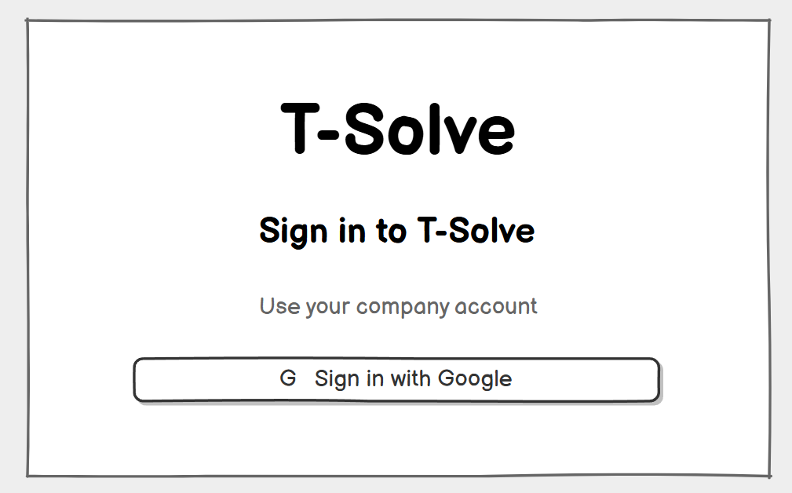
Entry point of the web app. There is no email / password form and no self-registration: users only sign in with their company account; people outside the company cannot sign in. Related use case: UC-01.
On this screen, the user can:
- Sign in with the company account ("Sign in with Google").
Field descriptions
Field Name | Description
Sign in with Google (button) | Starts OIDC sign-in with the provider selected in Workspace Settings. The MVP only supports Google.
Message area | Shows MSG09, MSG10 or MSG06 when sign-in fails; shows MSG07 when the user is sent back here because the session has expired.

1.1.2 T-Solve Sign-in
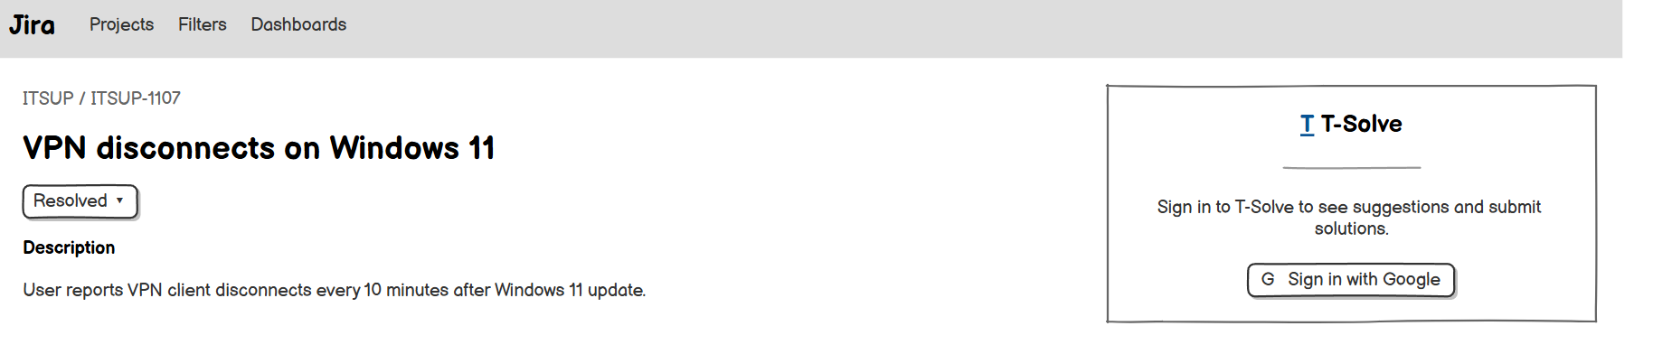
Opened from the Issue Panel in Jira when the user’s Jira account is not linked to T-Solve yet. Related use case: UC-04.
On this screen, the user can:
- Link the Jira account to T-Solve once by signing in with the company account in a new tab.
Field descriptions
Field Name | Description
Sign in with Google (button) | Opens the one-time T-Solve sign-in link in a new browser tab (GBR-19). After signing in, the Jira account is linked to the T-Solve account.
Message area | MSG62 before signing in; MSG74 while waiting for the user to sign in in the new tab; MSG10 when the linked account has been deactivated. (MSG09 and MSG73 are shown in the new tab.) The mock-up needs 2 states: signed out and waiting.

1.2 Account

1.2.1 My Profile
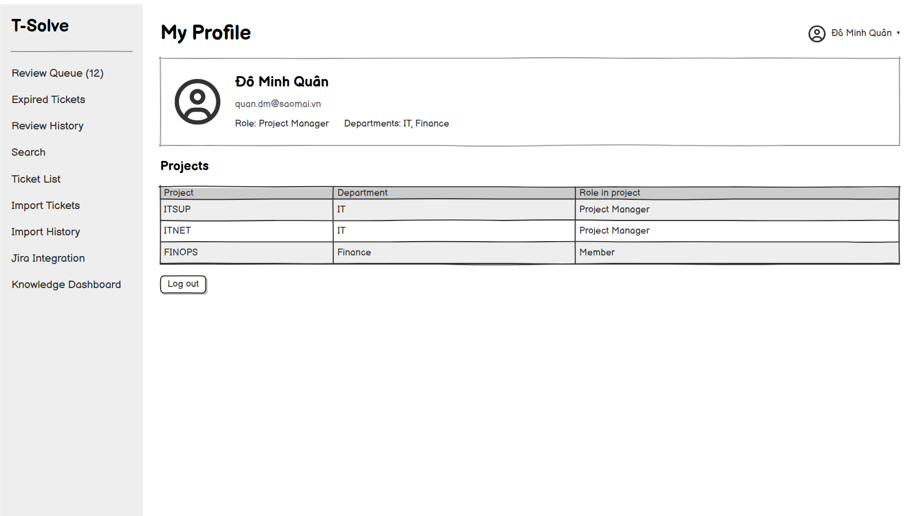
Shows the account of the signed-in user and what they contributed. Account fields are read-only because they come from the company account and the Admin. Related use cases: UC-02, UC-03.
On this screen, the user can:
- View the account information, Department, roles, Projects and Spaces.
- Log out (also available in the user menu on every screen).
Field descriptions
Field Name | Description
Full name | Text, taken from the company account.
Email | Company email; read-only.
Roles | Employee, plus the other roles of the user: Ticket Resolver, Project Manager, Knowledge Manager, Admin.
Projects | The Projects the user belongs to, with their Department and the user’s role in the Project (Project Manager / member). Empty when the user is not a Project member.
Departments | The user’s Department and the Departments of the Projects they are a member of.
Spaces | The Spaces the user can view or create documents in, with the access level; for a Knowledge Manager, the Spaces they administer.
My Solutions | For users who wrote Solutions: the number of their tickets in each status (Pending review, Changes requested, Published, Rejected, Expired, Unpublished) and the list of these tickets with Ticket ID, title, Project, status, latest decision with its reason or comment, and date; filters by status, Project and date; a row opens the Ticket Detail (read-only for a Project the user has left). MSG04 when empty.
My Wiki documents | The Wiki documents the user owns: title, Space, visibility, status and the latest review comment or reason; a row opens the Wiki Document. MSG04 when empty.
Log out (button) | Ends the session and returns to Login.

1.3 User Management

1.3.1 User List
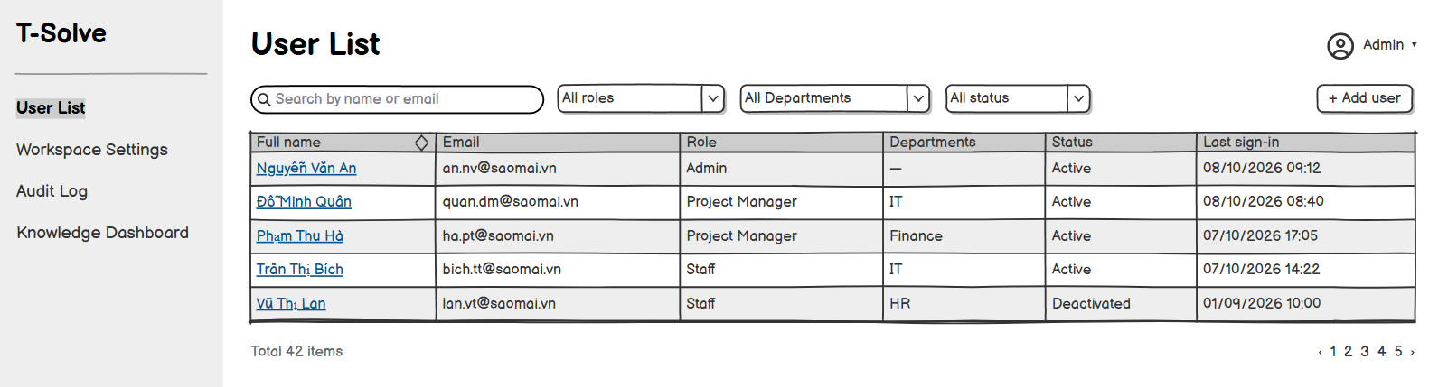
Default page of the Admin. Related use cases: UC-05, UC-06, UC-07, UC-50.
On this screen, the user can:
- Search users by name or email.
- Filter by role, Department and status (Active / Deactivated).
- Add a user (opens the User Detail in add mode).
- Open a user to view the account or to deactivate / reactivate it.
Field descriptions
Field Name | Description
Search box | Free text, at most 100 characters; matches the name or email.
Role filter | All roles (default), Employee only, Ticket Resolver, Project Manager, Knowledge Manager, Admin.
Department filter | All Departments (default) or one Department.
Status filter | All (default), Active, Deactivated.
User table | Columns: Full name, Email, Department, Roles, Status, Last sign-in. Shows MSG04 when empty.
Add user (button) | Opens the User Detail to add a new user.

1.3.2 User Detail
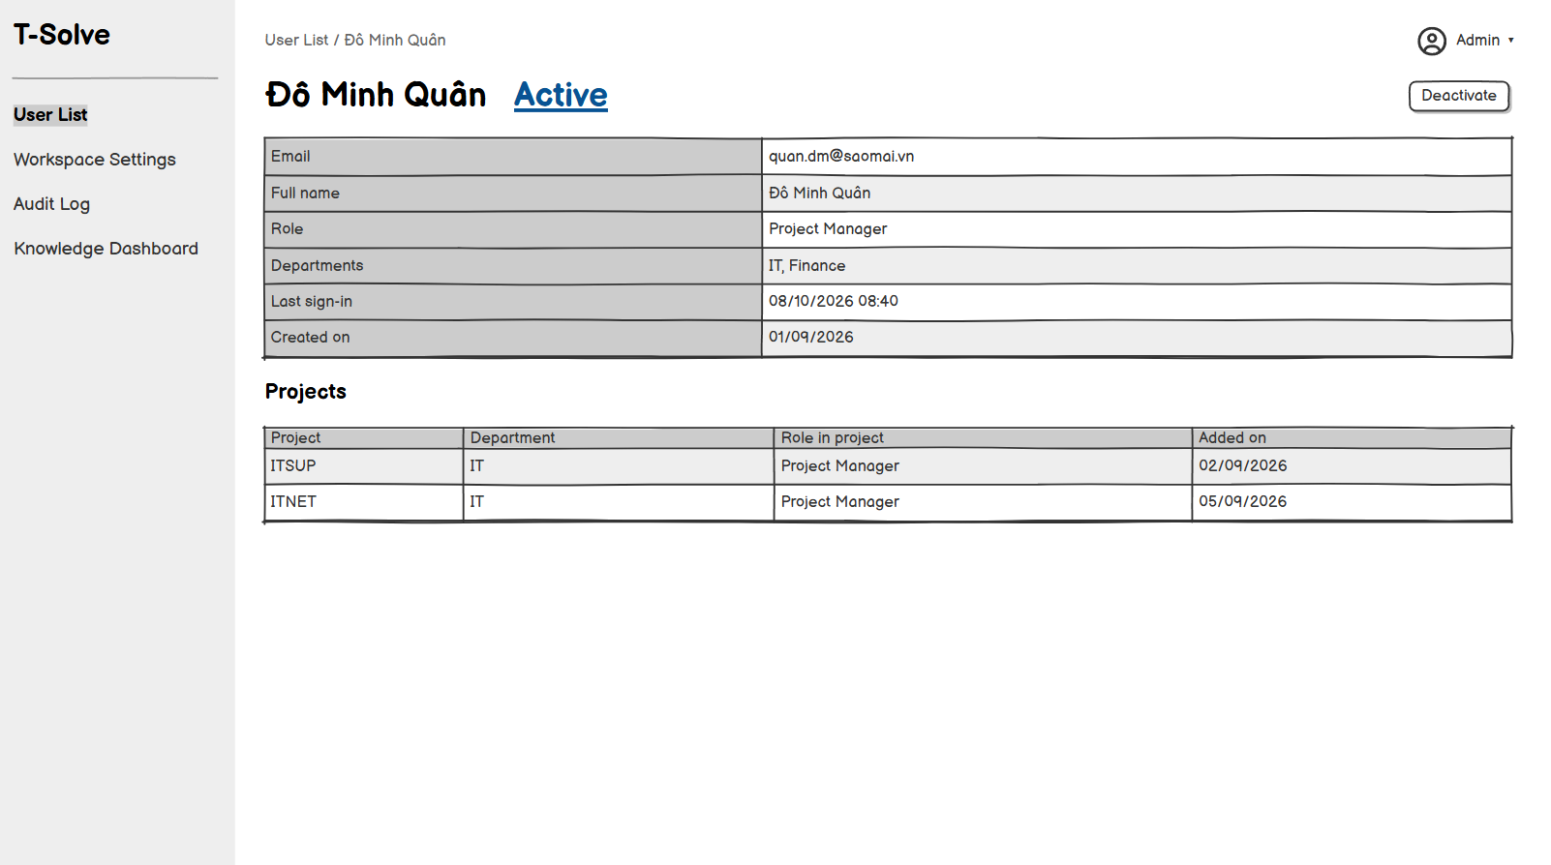
Adds a user by email or shows an existing user. After the account is added, the Admin can change its Department and roles (UC-50) and deactivate or reactivate it. Related use cases: UC-06, UC-07, UC-50.
On this screen, the user can:
- Add a user by company email.
- Choose the Department and the roles; for a Knowledge Manager, the Spaces they administer.
- Deactivate or reactivate the account.
Field descriptions
Field Name | Description
Email * | Company email, valid format (MSG03), at most 100 characters, not already used (MSG11; MSG111 when it belongs to a Deactivated account). Editable only when adding a user. The full name is taken from the company account at sign-in.
Department | Drop-down list of the Active Departments; required for a Project Manager, optional otherwise. A Project Manager manages Projects only in this Department; every user receives the Space permissions of their Department (GBR-30).
Roles | Checkboxes Ticket Resolver, Project Manager, Knowledge Manager, Admin; Employee is always selected. Project Manager requires a Department and Knowledge Manager one or more Spaces (MSG01; MSG04 when there is no Active Department). Admin accounts can only lose the Admin role while another active Admin exists (MSG56). On the Admin’s own account the Admin checkbox is disabled (MSG113).
Projects and Departments | Read-only. The Projects the user belongs to and their Departments; the Spaces of a Knowledge Manager.
Status | Active / Deactivated, shown for existing users; changed with the Deactivate / Reactivate button (MSG57, MSG05). The Deactivate button is hidden on the Admin’s own account (MSG112) and the last active Admin cannot be deactivated (MSG56). Deactivating, removing the role or changing the Department of a Project Manager with Active Projects opens the hand-over of Projects (UC-65: MSG58, MSG59); MSG79 warns when a Space would have no Knowledge Manager.
Edit roles (button) | For an existing user: makes the Department, roles and Spaces editable (UC-50). Removing a role may ask MSG58, MSG59, MSG78 or MSG79.
Save (button) | Saves and shows MSG12 (new user) or MSG05.

2. Workspace & Department Management

2.1 Workspace Setup
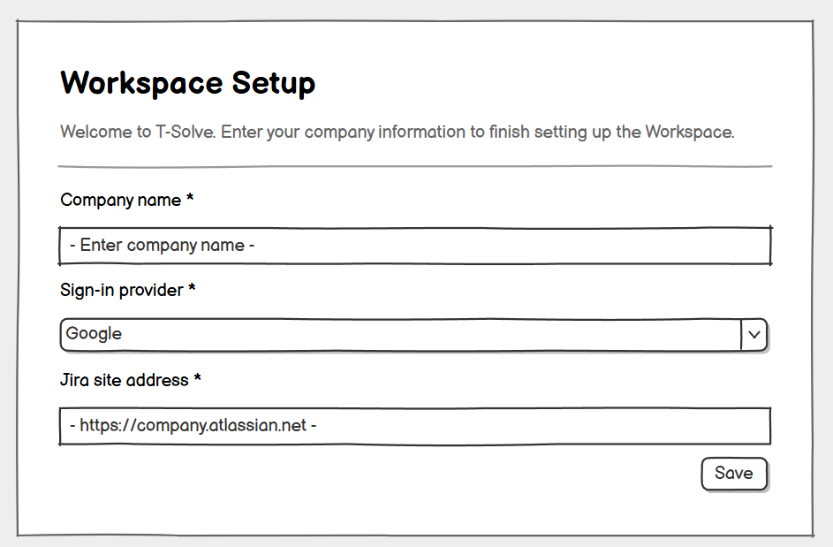

Shown to the Admin at sign-in only while the Workspace has no information (first sign-in of the first Admin after installation). It has no menu and opens again at every sign-in until the information is saved; afterwards the Admin edits the information in Workspace Settings. Related use case: UC-08.

On this screen, the user can:

• Enter the company name and the company Jira site address.

• Confirm the sign-in provider declared at installation.

• Save the Workspace information and go to the User List.

Field descriptions
Field Name | Description
Company name * | Text, at most 100 characters.
Sign-in provider * | Drop-down list, preselected with the provider declared at installation; the MVP only has "Google".
Jira site address * | URL of the company Jira site, at most 200 characters, e.g. https://company.atlassian.net (MSG61). Project Managers cannot add Projects until it is saved.
Save (button) | Checks the required fields (MSG01) and the Jira site address (MSG61), saves the Workspace information, records the action in the audit log, shows MSG05 and opens the User List.
Message area | MSG60 when the screen opens.

2.2 Workspace Settings
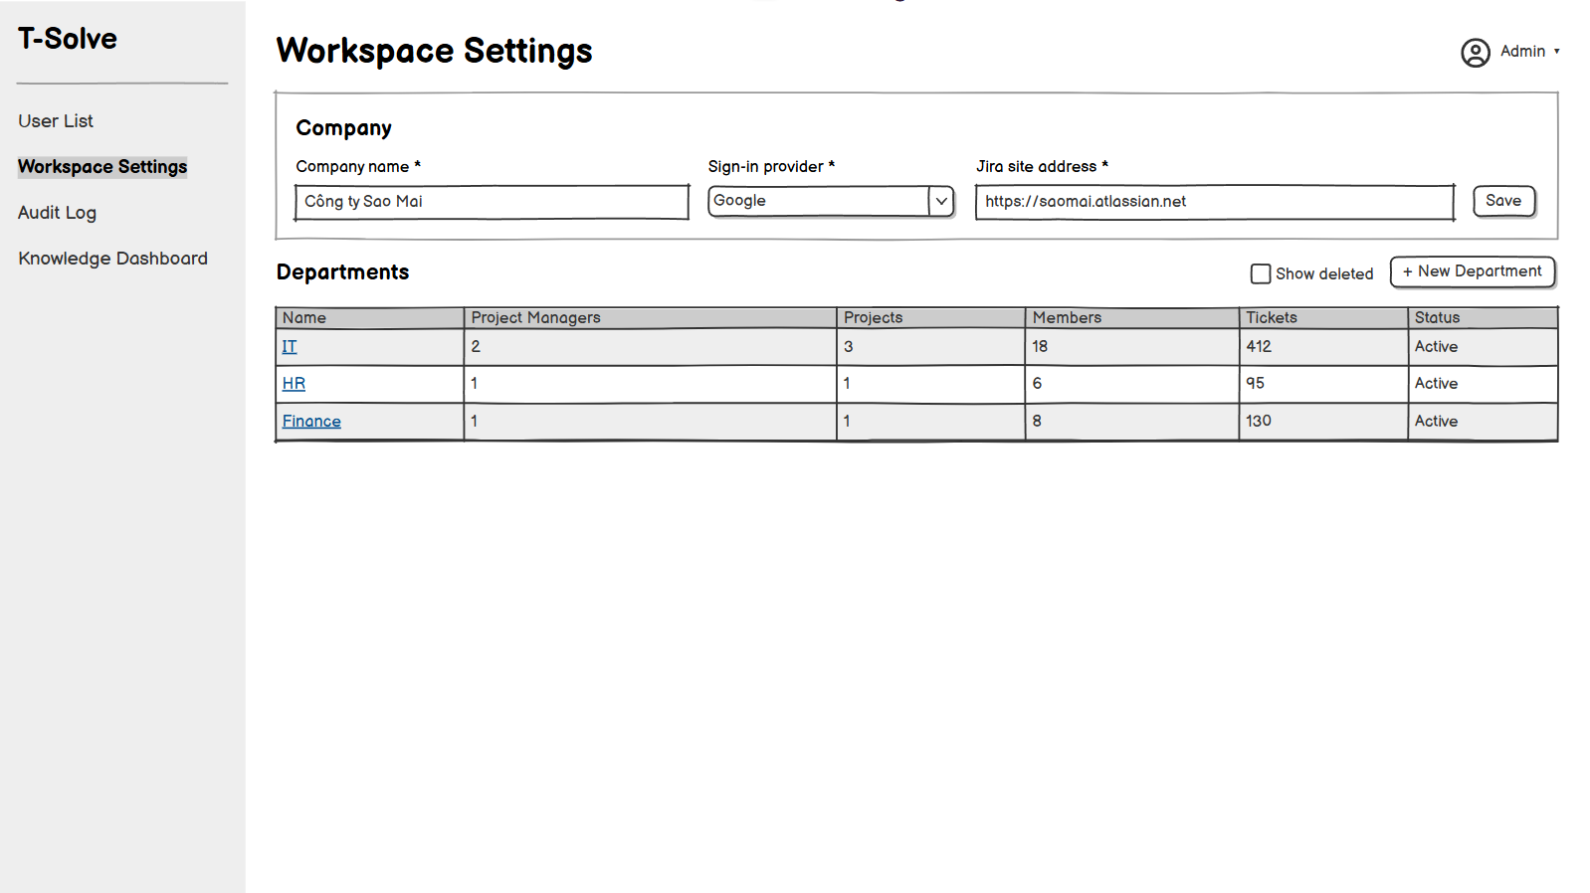
Holds the Workspace configuration and the list of Departments. Related use cases: UC-09, UC-10, UC-13.
On this screen, the user can:
- Edit the company information.
- Choose the sign-in provider.
- Create a Department and open a Department.
- View deleted Departments and restore a Department.
Field descriptions
Field Name | Description
Company name * | Text, at most 100 characters.
Sign-in provider * | Drop-down list; the MVP only has "Google" (Microsoft Entra ID is planned later).
Jira site address * | URL of the company Jira site, at most 200 characters, e.g. https://company.atlassian.net (MSG61). Project Managers cannot add Projects while it is empty.
Departments table | Columns: Name, Project Managers, Projects, Members, Tickets. Deleted Departments are hidden by default; turn on “Show deleted” to list them with a Restore button (MSG51, MSG52) and a Migrate data button that opens the Migrate Department Data screen (UC-66).
New Department (button) | Asks for the Department name *: text, at most 50 characters, unique, including against deleted Departments (MSG43).

2.3 Department Detail
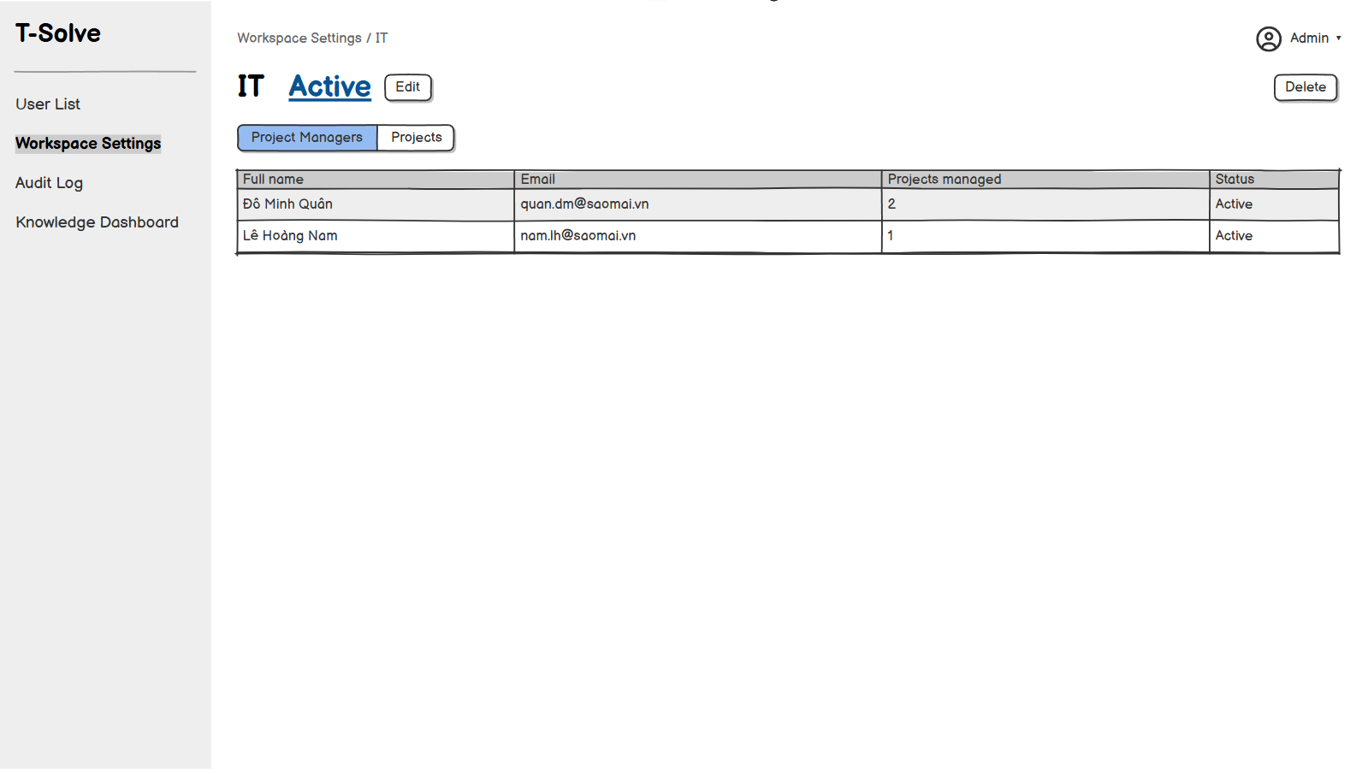
Manages one Department. Related use cases: UC-11, UC-12.
On this screen, the user can:
- Rename or delete the Department.
- View the Project Managers of the Department (Managers tab).
Field descriptions
Field Name | Description
Name * | Text, at most 50 characters, unique (MSG43).
Managers tab | Read-only list of the Project Managers whose Department is this Department, with the Projects each one manages. The Admin sets the Department of a user in the User Detail (UC-06, UC-50).
Delete (button) | Opens the Delete Department popup.

2.4 Delete Department (popup)
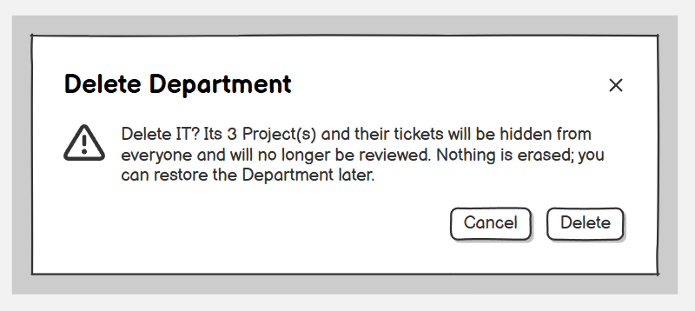
Confirms the deletion of a Department. The Department is not permanently deleted: its Projects and tickets are hidden, frozen and can be restored. Related use case: UC-12.
Field descriptions
Field Name | Description
Message | MSG45 with the Department name and its number of Projects.
Delete (button) | Sets the Department to Deleted, sets its Projects to Removed, deletes their tokens and hides the Department Space, then shows MSG46.
Cancel (button) | Closes the popup without changing anything.

2.5 Migrate Department Data
[Mock-up placeholder: Migrate Department Data]
Opened from Workspace Settings on a deleted Department. Moves the data of the deleted Department, in two groups, to an Active Department. Related use case: UC-66.
On this screen, the user can:
- View the Projects and Wiki documents of the deleted Department.
- Select the Projects and the folders or documents to migrate.
- Choose the target Department and the new Project Manager of each Project.
- Migrate the selected data.
Field descriptions
Field Name | Description
Department header | Read-only: name of the deleted Department, deletion date, number of Projects, tickets and Wiki documents not yet migrated.
Projects tab | Columns: checkbox, Project ID, Jira project key, previous Project Manager, tickets per status. Select one, several or all Projects.
Wiki documents tab | Folder tree and documents of the Department Space with status, visibility and Owner; checkboxes on folders and documents.
Target Department * | Drop-down list of the other Active Departments (MSG116 when there is none).
New Project Manager * | For each selected Project: drop-down list of the Active Project Managers of the target Department (MSG59 when there is none).
Migrate (button) | Disabled while nothing is selected; asks MSG114, then migrates and shows MSG115 (MSG06 if it fails, nothing is moved).
Cancel (button) | Closes without changing anything.

3. Jira Integration

3.1 Jira Integration
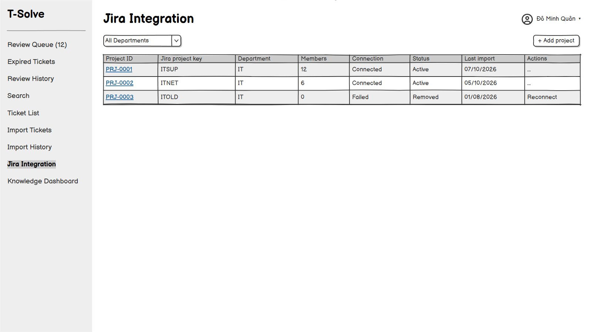
Shows different content depending on the role. The Admin sets the company Jira site. The Project Manager adds, tests and removes the Projects of their Department and opens the Project Detail of the Projects they manage. Related use cases: UC-09, UC-14.
On this screen, the user can:
- Admin: set the company Jira site address.
- Project Manager: add a Project (Jira project key, access token, connection test) to their Department, and remove a Project they manage.
- Project Manager: view the Projects they manage and open the Project Detail.
Field descriptions
Field Name | Description
Jira site address * (Admin) | URL of the company Jira site, for example https://company.atlassian.net; a valid URL of at most 200 characters.
Department (Project Manager) | Read-only: the Project Manager’s Department; every Project they add belongs to it.
Projects table | Columns: Project ID, Jira project key, Project Manager, Members, Connection status, Status (Active / Removed), Last import. For the Projects they manage, the Project Manager can Test connection (MSG47 / MSG46), Remove (MSG53) and open the Project Detail. A Removed Project without an Active Project Manager is marked with MSG54.
Project key * | Text, at most 20 characters; the Jira project must not be linked to another Project yet (MSG49). Entering the key of a Removed Project again reconnects that same Project.
Access token * | Secret text; masked after saving and never shown again. Must be the API token of a Jira account with read permission (Browse projects) on the Jira project; T-Solve does not need write permission (GBR-14).
Project Manager | Read-only: the Project Manager who adds the Project becomes its Project Manager and a member of the Project (GBR-20).

3.2 Project Detail
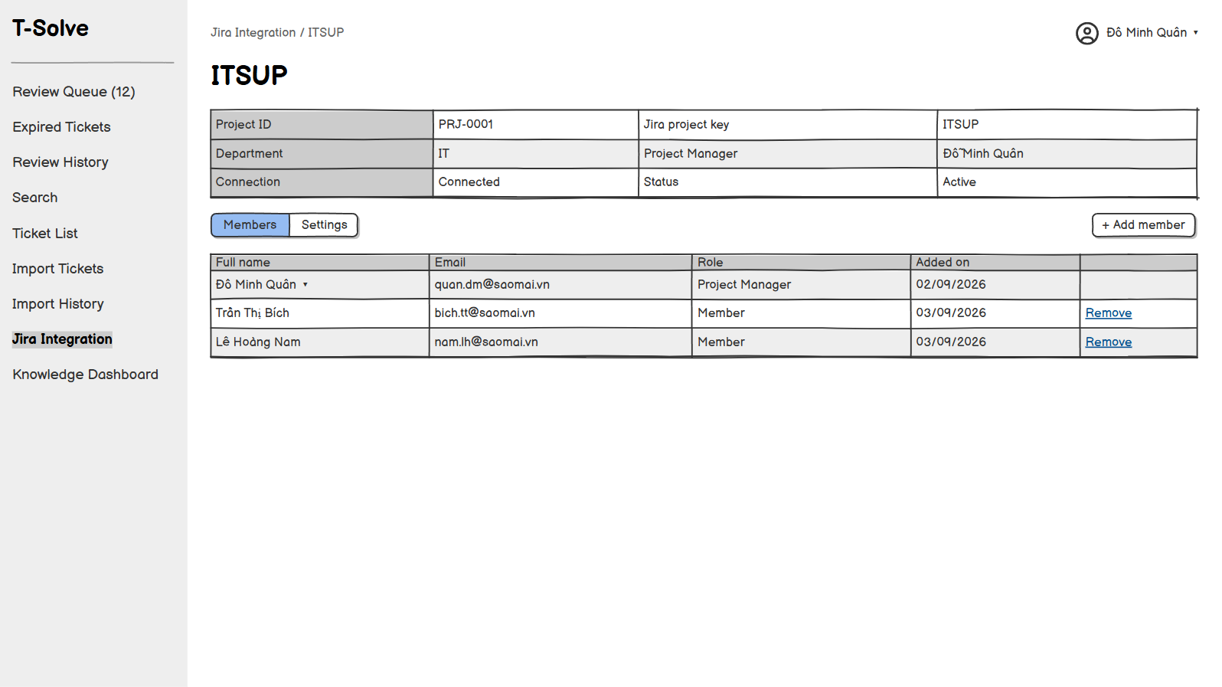
Manages one Project, opened from the Projects table of the Jira Integration screen; only the Project Manager of the Project can use it. It has two tabs: Members and Settings. Related use cases: UC-14, UC-15, UC-16.
On this screen, the user can:
- Add and remove members of the Project.
- Configure the field mapping, Done status, review range and Escalation handler (Settings tab).
Field descriptions
Field Name | Description
Project header | Read-only: Project ID, Jira project key, Department, Project Manager (or MSG54), status (Active / Removed). When the Project is Removed, the Settings tab is read-only.
Members table | Members tab. Columns: Full name, Email, Role, Added on. The Project Manager of the Project is always a member and has no Remove button (UC-16).
Add member (button) | Searches by name or email among the Active Ticket Resolver accounts that are not yet members of the Project; one or more people can be selected (MSG05; MSG04 when nobody is found).
Remove (button) | Asks MSG55; on confirmation, removes the member from the Project.
Field mapping | Settings tab. For each T-Solve field (title, description, resolution comments, resolved date, reporter), choose the Jira field to read the data from. The default is the standard Jira fields.
Done statuses * | Settings tab. Choose one or more statuses of the Jira project (MSG01 when no status is chosen); when an issue moves to a chosen status, the Solution Form appears (GBR-04). Default: the statuses in the Done status category.
Review range * | Settings tab. A whole number of calendar days, 1 or more, with no upper limit (MSG44). Default: 3. Changing the review range does not change the review due date of tickets already in the queue (GBR-10).
Escalation handler * | Settings tab. Drop-down list of the Project members; default: the Project Manager. Receives the issues routed by T-Solve (UC-39).
Save (button) | Settings tab. Saves the Project settings, records them in the audit log and shows MSG05.

3.3 Issue Panel
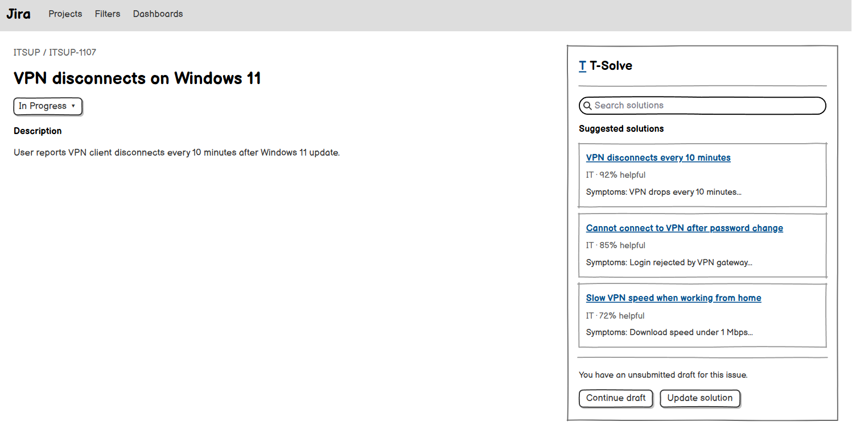
The T-Solve panel inside an issue of a Jira project linked to a Project. Related use cases: UC-04, UC-19, UC-26, UC-38.
On this screen, the user can:
- Reporter of a triaged issue: answer whether the suggested solution solved the problem.
- Ticket Resolver or Project Manager: search Published tickets.
- View the Solution status of the issue and act on it ("Update solution", "Continue draft").
Field descriptions
Field Name | Description
Status notice | For Project members: MSG62 (not signed in), MSG76 (not in the issue’s Department), MSG65 (waiting for review), MSG64 banner with an “Update solution” button (changes requested), MSG77 banner with a “Continue draft” button (unsubmitted Draft).
Triage question | Shown to the reporter after T-Solve posted a suggested solution (UC-38): MSG81 with Yes and No buttons; then MSG82 or MSG83.
Search box | Ticket Resolvers and Project Managers only. Free text, at most 200 characters; results open the Published Ticket Preview; MSG04 when empty.

3.4 Published Ticket Preview
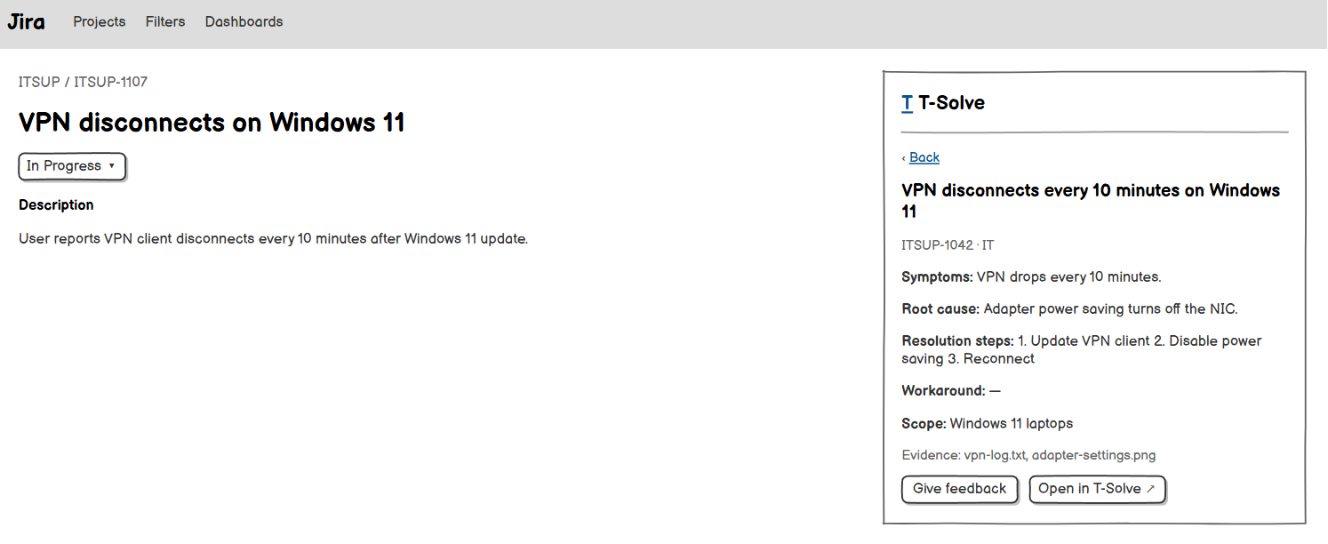
Shows a Published ticket found by search directly in Jira. Related use case: UC-26.
On this screen, the user can:
- Read the Solution and view the list of Evidence.
- Open the ticket on the T-Solve web app.
Field descriptions
Field Name | Description
Title, Ticket ID, Department | Read-only.
Solution | Full Solution, section by section (Symptoms, Root cause, Resolution steps, Workaround, Scope of applicability); read-only.
Evidence | List of file names; opening a file requires access to the ticket's Department.
Open in T-Solve (link) | Opens the Ticket Detail on the web app.

4. Solution Authoring & Standardisation

4.1 Solution Form
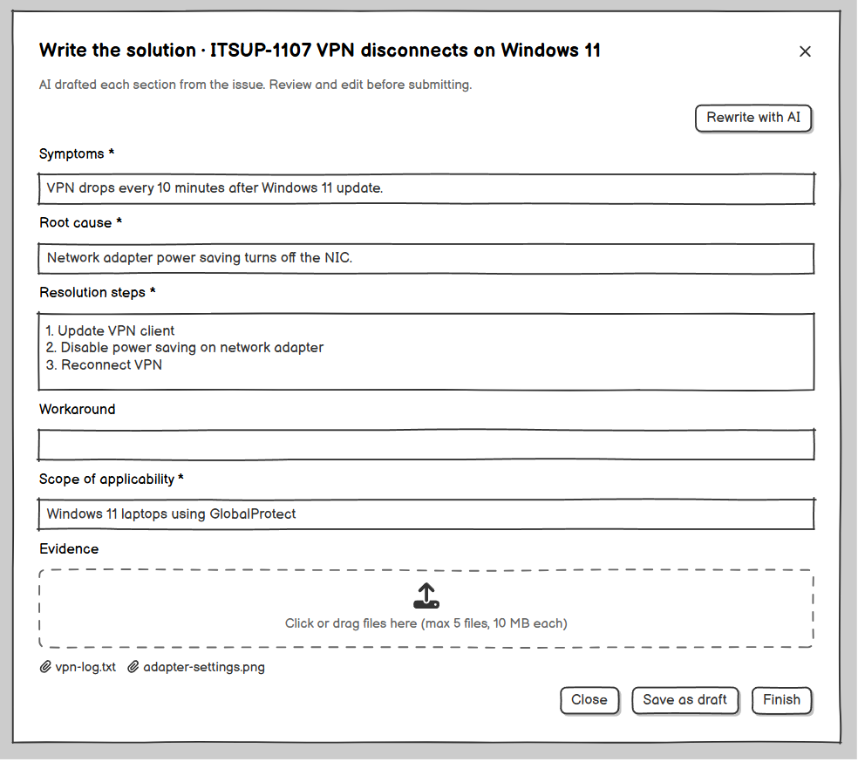
Mandatory form in Jira that appears right after a Project member (Ticket Resolver or Project Manager) moves an issue of their Project to a Done status (only when the issue has no Ticket yet), or is opened from the Issue Panel to resubmit or to continue a Draft. If the user closes the form, it submits an empty Solution (GBR-04). Related use case: UC-19.
On this screen, the user can:
- Edit the Solution drafted by AI.
- Ask AI to rewrite the Solution.
- Attach Evidence.
- Click Finish, save a Draft or close the form.
Field descriptions
Field Name | Description
Issue summary | Read-only: issue key and summary.
Change-request comment | Shown only on resubmission: the Project Manager's comment.
Solution * | The Solution template (GBR-33): Symptoms, Root cause, Resolution steps, Workaround and Scope of applicability, each a multi-line text; every section except Workaround is required (MSG01), at most 10,000 characters in total (MSG02). Pre-filled with the AI draft; when the AI draft is unavailable, Symptoms is filled with the issue description, Resolution steps with the last comment, and MSG67 is shown.
Rewrite with AI (button) | Opens the AI Rewrite Preview (MSG68 when it fails).
Evidence | Upload area: at most 5 files per ticket, each at most 10 MB, in PNG, JPG, PDF, DOCX, XLSX, TXT or LOG format (MSG34, MSG72). On resubmission, existing files are read-only (MSG71). When opened from a Draft, the files of the Draft can be removed.
Finish (button) | Validates and submits the Solution (MSG66). If T-Solve cannot be reached: retries automatically up to 3 times, then shows MSG69 if it still fails.
Save as draft (button) | Saves the current Solution and Evidence as the user's Draft for the issue (MSG41) and closes the form; no Ticket is created (GBR-26).
Close (button) | Asks MSG70; on confirmation, submits an empty Solution (UC-19). When the form was opened to resubmit, closing it changes nothing.

4.2 AI Rewrite Preview (popup)
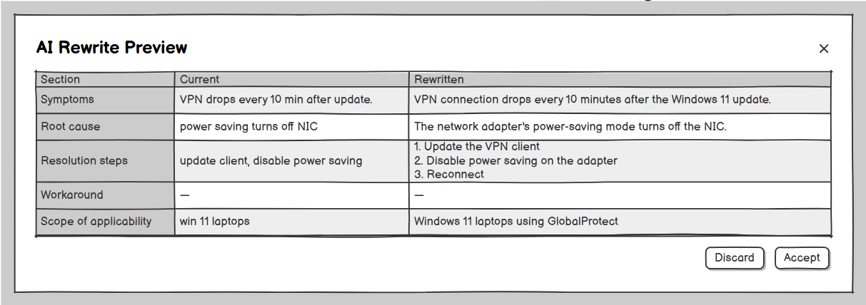
Shows the Solution rewritten by AI next to the current Solution, section by section in the same template. Related use case: UC-19.
Field descriptions
Field Name | Description
Current Solution | Read-only.
Rewritten Solution | Read-only text returned by the AI module.
Accept (button) | Replaces the Solution in the form.
Discard (button) | Closes the popup; the Solution is unchanged.

5. Ticket Import & Repository

5.1 Import Tickets
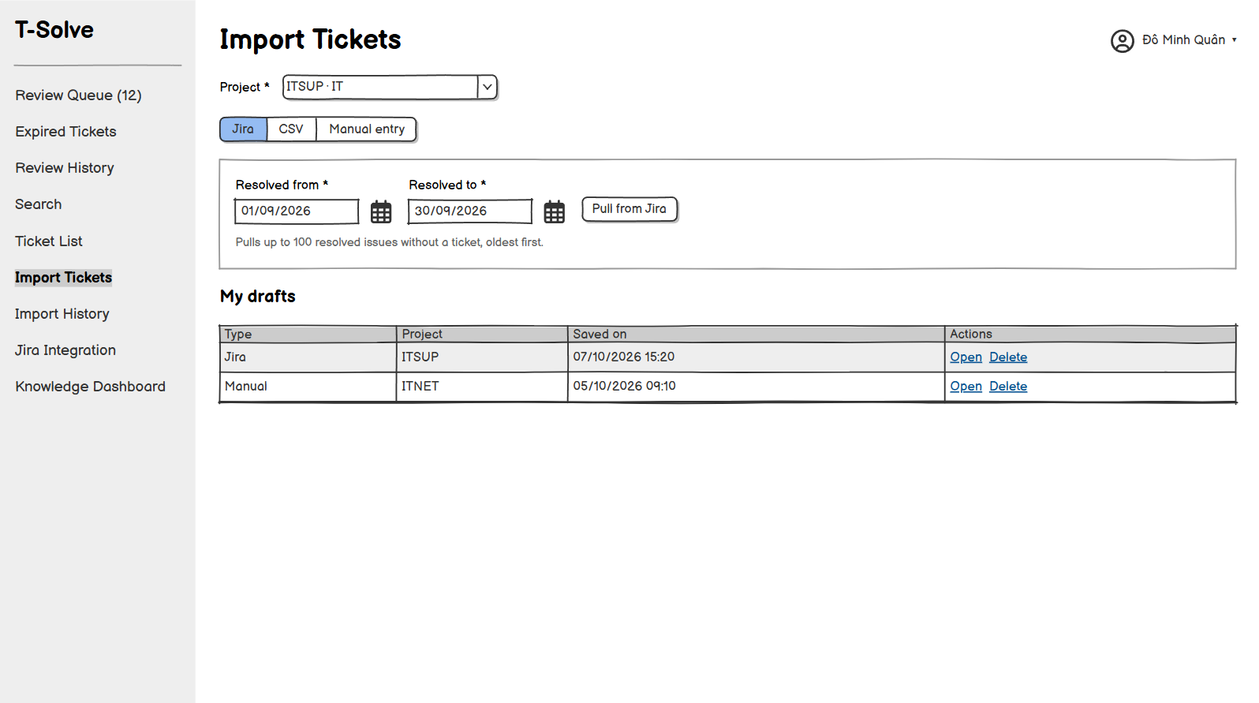[Mock-up placeholder: Import Tickets screen]
Imports tickets into a Project managed by the Project Manager, through three tabs: Jira, CSV and Manual entry. Imported tickets are reviewed by the Project Manager themselves, so they are Published immediately (GBR-23). Related use cases: UC-20, UC-21, UC-22.
On this screen, the user can:
- Jira tab: choose a resolved date range and pull the resolved issues from Jira.
- CSV tab: download the template and upload a CSV file that already contains the Solution of each ticket.
- Manual entry tab: enter one ticket with its Solution and optional Evidence.
- Reopen or delete their own Drafts.
Field descriptions
Field Name | Description
Project * | Drop-down list of the Active Projects managed by the Project Manager (shows the Jira project key and the Department). Each pull from Jira, each CSV file and each manually entered ticket belongs to exactly one Project.
Resolved from * / Resolved to * | Jira tab. Two dates, not in the future; the start date is not after the end date (MSG01, MSG39).
Pull from Jira (button) | Jira tab. Pulls at most 100 issues resolved in the date range that have no ticket yet, oldest first, then opens the Import Preview (MSG50 when Jira fails; MSG04 when there are no issues).
Download template (link) | CSV tab. Template with the required columns ticket_id, title, description, symptoms, root_cause, resolution_steps, scope and resolved_date; optional columns workaround, author and source_url (GBR-33). The template has no Project column.
CSV file * | One .csv file, UTF-8, at most 10 MB (MSG27, MSG28, MSG29).
Ticket ID * | Manual entry. Text, at most 50 characters, must not exist yet (MSG31).
Title * | Manual entry. Text, at most 200 characters.
Description * | Manual entry. Multi-line text, at most 10,000 characters.
Solution * | Manual entry. The Solution template (GBR-33); every section except Workaround is required, at most 10,000 characters in total.
Resolved date | Manual entry. A date, not in the future.
Evidence | Manual entry. Same limits as the Solution Form (MSG34, MSG72).
Upload / Save (button) | CSV: opens the Import Preview. Manual entry: saves the ticket in Published status (MSG32).
Save as draft (button) | Manual entry tab. Saves the entered fields and Evidence as a Draft (MSG41) without validating them (GBR-26).
Drafts | List of the Project Manager's Drafts: type (Jira / CSV / Manual), Project, date saved; Open button (reopens the Import Preview or the Manual entry tab) and Delete button (MSG42).

5.2 Import Preview
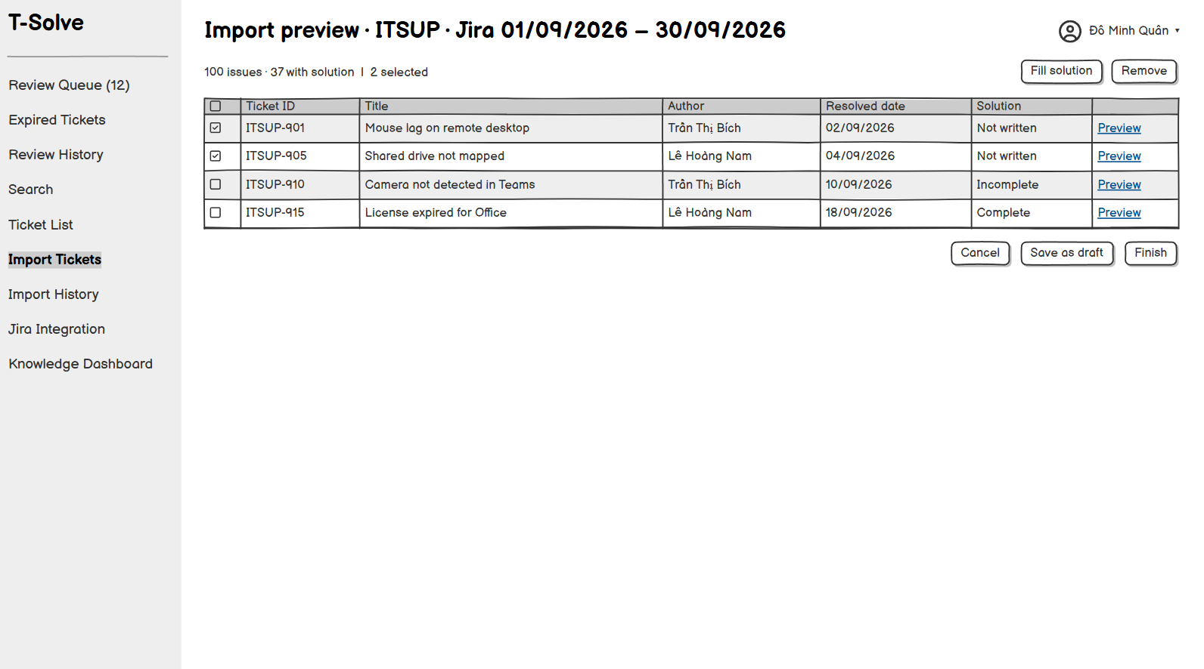
The review screen of an import, shared by Jira import and CSV import. No ticket is imported before the Project Manager clicks Finish / Confirm; the Project Manager can save the import as a Draft to finish it later (GBR-26). Related use cases: UC-20, UC-21.
On this screen, the user can:
- Jira: write the Solution of each issue in the popup, or select several issues to fill in the same Solution.
- CSV: view the valid rows with their Solutions and the invalid rows.
- Open an issue or a row in the Import Ticket Preview popup.
- Remove issues or rows from the import.
- Click Finish / Confirm to import, Save as draft to save a Draft, or cancel.
Field descriptions
Field Name | Description
Summary | Jira: the number of issues in the list and the number of issues that already have a Solution; MSG35 when more issues match the date range. CSV: the number of valid rows and the number of invalid rows (MSG30).
Rows table | Columns: checkbox, Ticket ID (Jira key or ticket_id), Title, Author (Jira assignee or author column), Resolved date, Solution (Jira: empty until it is written; CSV: read-only); for CSV, also Result (Valid / Error) and Error details (for example MSG31, a missing value, a text that is too long).
Preview (button) | Opens the Import Ticket Preview popup of the issue or row.
Fill solution (button) | Jira only. Opens the Import Ticket Preview popup for the selected issues; the Solution is copied separately into each issue. Asks MSG36 when some selected issues already have a Solution.
Remove (button) | Removes the selected issues or rows from the import; they are neither saved nor remembered.
Finish / Confirm (button) | Imports the remaining issues or rows in Published status (MSG32; MSG38 when some issues are skipped; MSG40 when the Project is no longer Active; MSG33 when it fails). Disabled while an issue still has no Solution (Jira) or when no valid row is left (CSV).
Save as draft (button) | Saves the list of issues or rows, the Solutions written and the removed issues or rows as a Draft (MSG41, GBR-26). For CSV, the Draft keeps the validated rows, so the file does not need to be uploaded again.
Cancel (button) | Asks MSG37; on confirmation, returns to Import Tickets without importing; a previously saved Draft (if any) is kept.

5.3 Import Ticket Preview (popup)
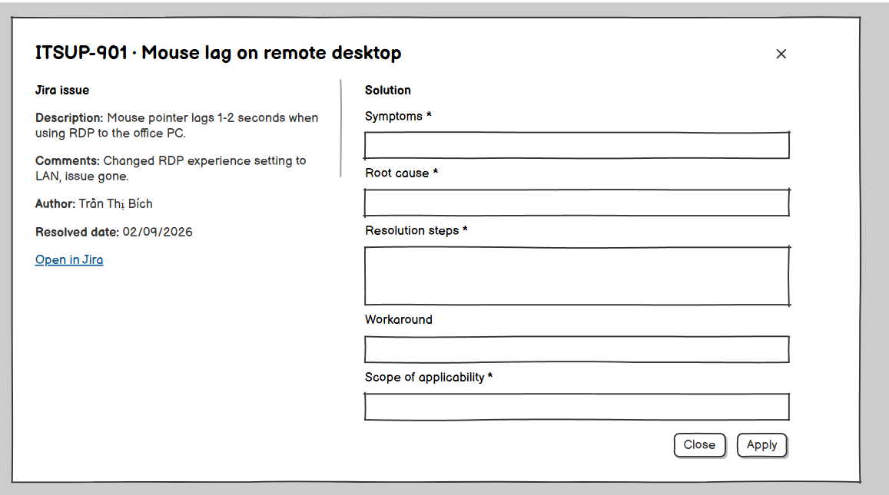
Shows an issue or row about to be imported; for Jira import, this is where the Project Manager writes the Solution. The content is the snapshot taken when the issues were pulled from Jira and is not read from Jira again. Related use cases: UC-20, UC-21.
Field descriptions
Field Name | Description
Ticket ID, title, description | Read-only. When opened for several issues: the list of Jira keys of the selected issues.
Comments | Jira only: the comments of the issue (the mapped resolution comments field), read-only.
Author, resolved date, source link | Read-only; the link opens the issue in Jira.
Solution * | Jira: the Solution template (GBR-33), empty at first; every section except Workaround is required, at most 10,000 characters in total (MSG01, MSG02). CSV: read-only.
Apply (button) | Jira only: writes the Solution to the issue (or copies it to each selected issue) in the Import Preview list; nothing is imported yet.
Close (button) | Closes the popup.

5.4 Import History
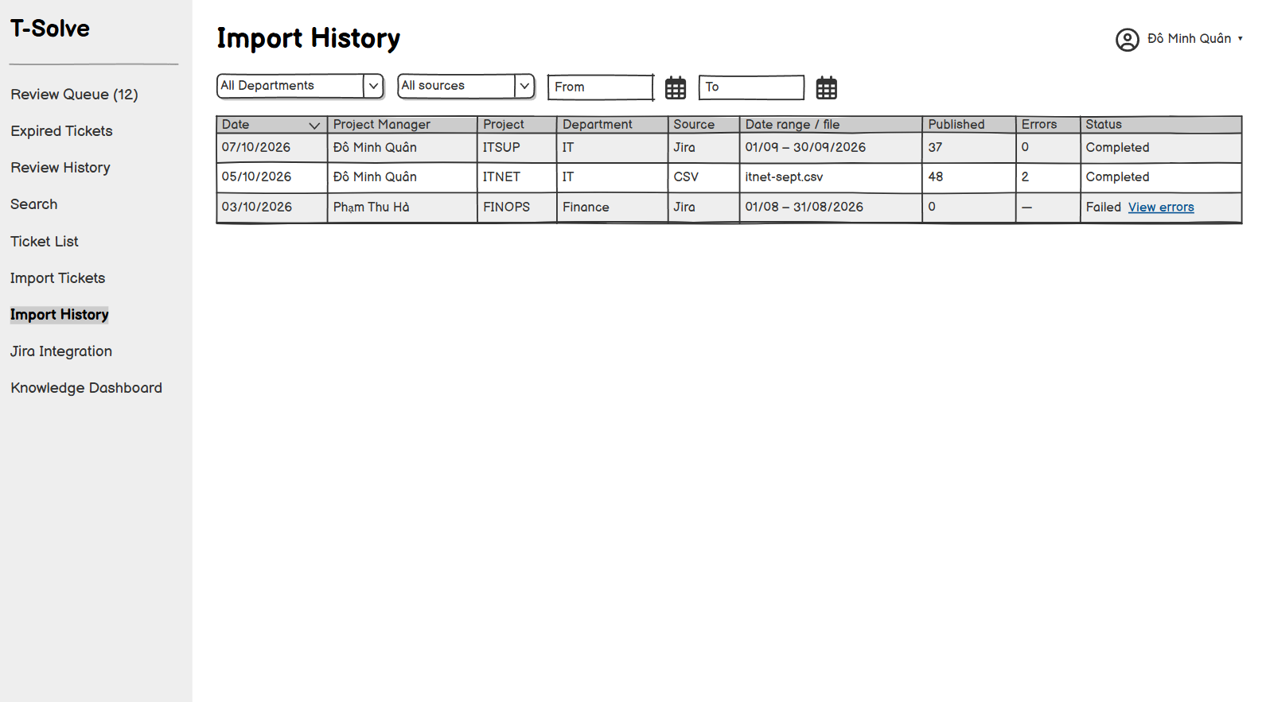
Lists the previous imports (Jira import, CSV, manual entry) of the Projects managed by the Project Manager. Related use case: UC-23.
On this screen, the user can:
- Filter by Department, source and date.
- Open the error details of an import.
Field descriptions
Field Name | Description
Filters | Project, source (Jira import / CSV / Manual), date range.
History table | Columns: Date, Project Manager, Project, Department, Source, Date range / file name, Published, Removed / error rows, Status (Completed / Failed). An import that was not finished (including one still saved as a Draft) is not recorded; a failed pull from Jira is recorded as Failed.

5.5 Ticket Detail
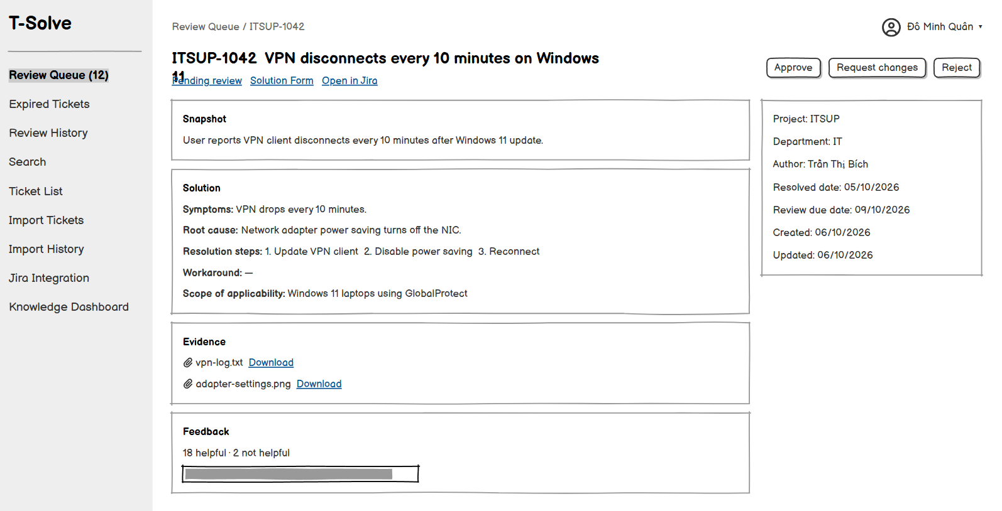
Shows one ticket. The available actions depend on the role and the ticket status; an Employee with no other role only opens Published tickets cited by the Knowledge Chatbot, read-only. Related use cases: UC-24, UC-25, UC-28, UC-30.
On this screen, the user can:
- Read the snapshot, the Solution and the Evidence.
- Ticket Resolver or Project Manager: give Feedback on a Published ticket.
- Project Manager of the ticket's Project: Approve, Reject, Request changes (when Pending review); Unpublish (when Published), Re-publish (when Unpublished), Send back to queue (when Expired).
Field descriptions
Field Name | Description
Source ticket ID, title, description | Read-only snapshot.
Source | Solution Form, Jira import, CSV or Manual, with a link to the Jira issue when there is one.
Project, Department, author, resolved date | Read-only. The author is a T-Solve user (Solution Form, manual entry) or the name taken from the Jira assignee or the CSV author column; it can be empty.
Status | Pending review, Changes requested, Published, Rejected, Unpublished or Expired.
Review due date | Shown while the ticket is waiting for review.
Solution | Read-only, section by section (Symptoms, Root cause, Resolution steps, Workaround, Scope of applicability).
Evidence | List of files that can be opened or downloaded.
Decision details | The rejection reason or change-request comment, if any.
Feedback summary | The number of helpful and not helpful ratings and the latest comments (for Published and Unpublished tickets).
Action buttons | Give feedback (Ticket Resolvers and Project Managers); Approve (MSG14; disabled with MSG20 when the Solution is empty); Reject (Reject Ticket popup: MSG15, MSG16); Request changes (Request Changes popup; disabled with MSG18 for tickets that did not come from the Solution Form); Unpublish (MSG21, MSG22); Re-publish (MSG23, MSG24); Send back to queue (MSG25). The decision buttons are only shown to the Project Manager of the ticket’s Project.

6. Intelligent Retrieval

6.1 Search
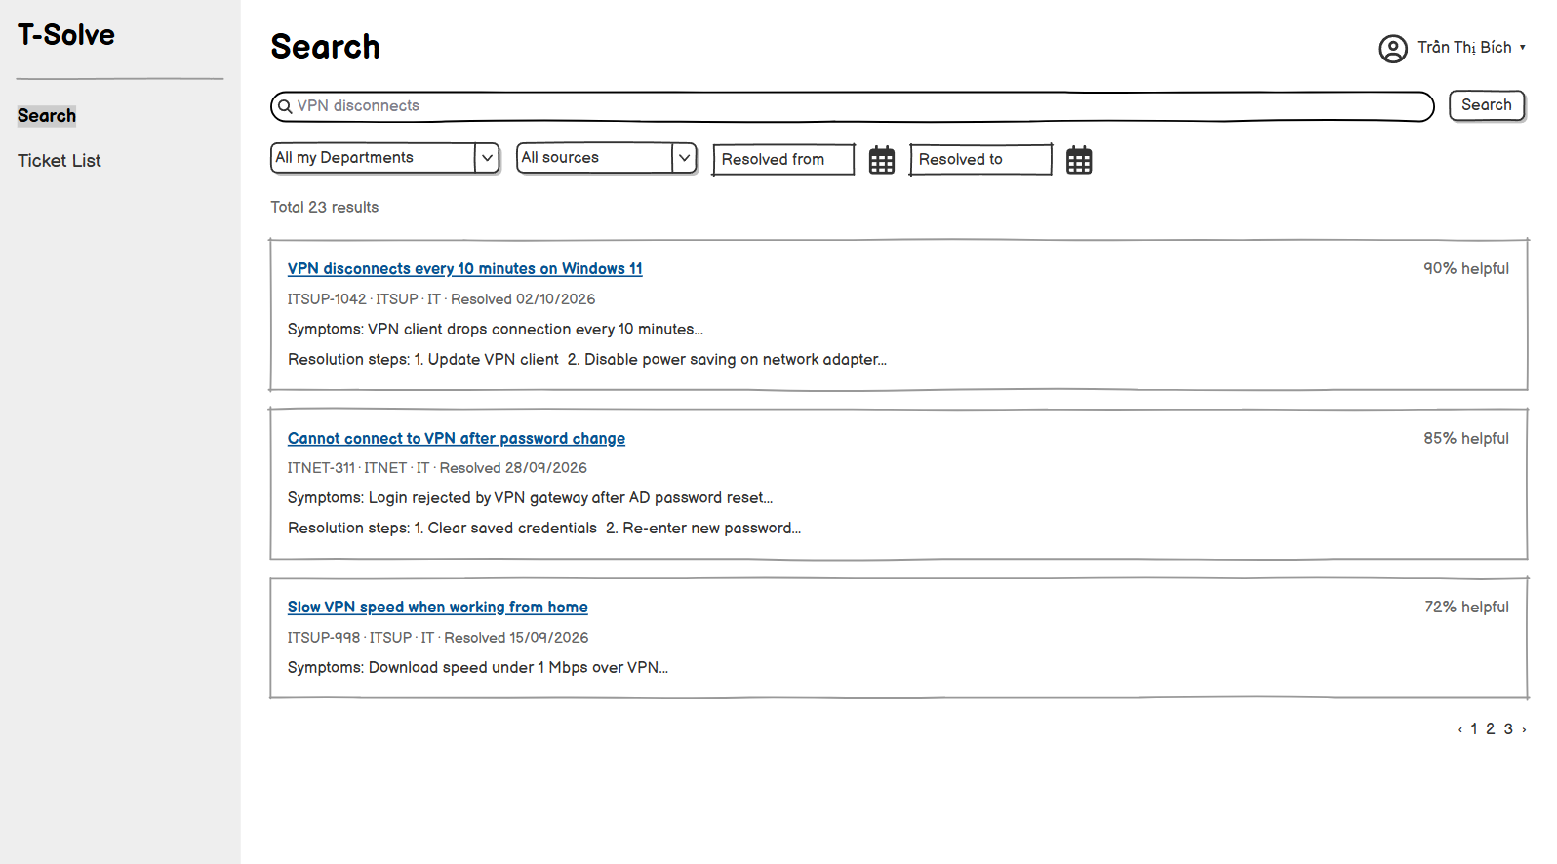
Default page of Ticket Resolvers. Only searches Published tickets in the user’s Departments. Related use case: UC-26.
On this screen, the user can:
- Search with free text.
- Filter the results.
- Open a result.
Field descriptions
Field Name | Description
Search box | Free text, at most 200 characters.
Department filter | All of the user's Departments (default) or one Department.
Source filter | All (default), Solution Form, Jira import, CSV, Manual.
Resolved date filter | Date range, optional.
Results | Ranked by combined semantic and keyword relevance: title, Project, Department, a short excerpt of the Symptoms and Resolution steps, helpful rate, resolved date. Shows MSG04 when empty.

6.2 Ticket List
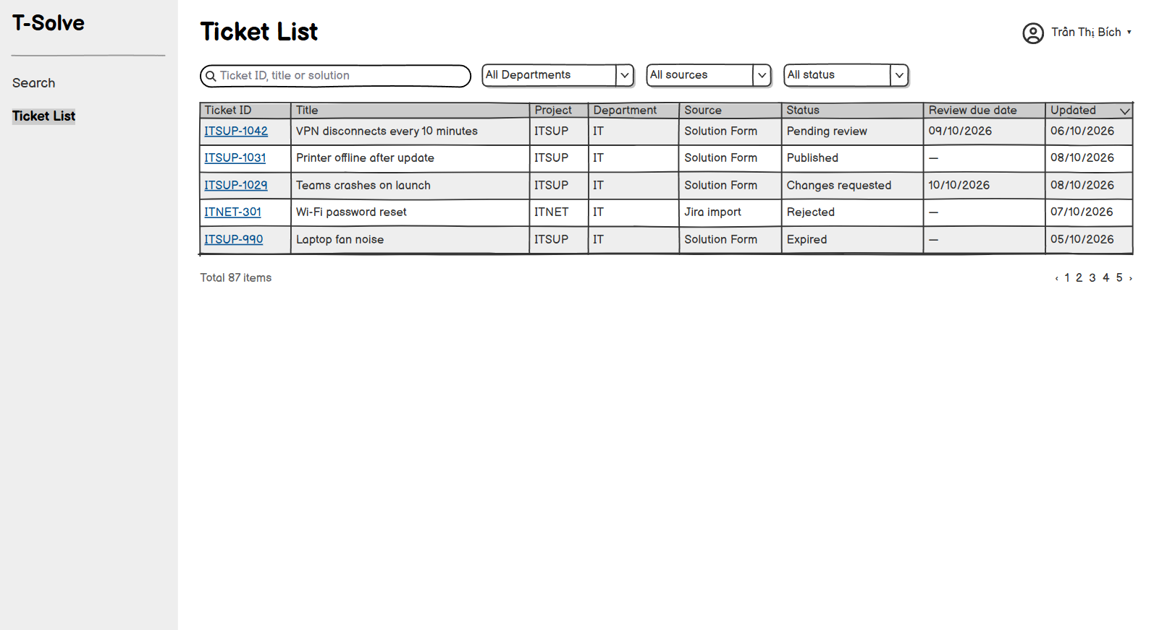
Lists every ticket in every status in the user's Departments. Related use case: UC-27.
On this screen, the user can:
- Search by keyword.
- Filter by Department, source and status.
- Open the Ticket Detail.
Field descriptions
Field Name | Description
Keyword | Free text, at most 100 characters; matches the ticket ID, title or Solution.
Filters | Department, source, status (all six statuses). There is no filter by Project.
Ticket table | Columns: Ticket ID, Title, Project, Department, Source, Status, Review due date, Updated.

7. Review & Approval Workflow

7.1 Review Queue
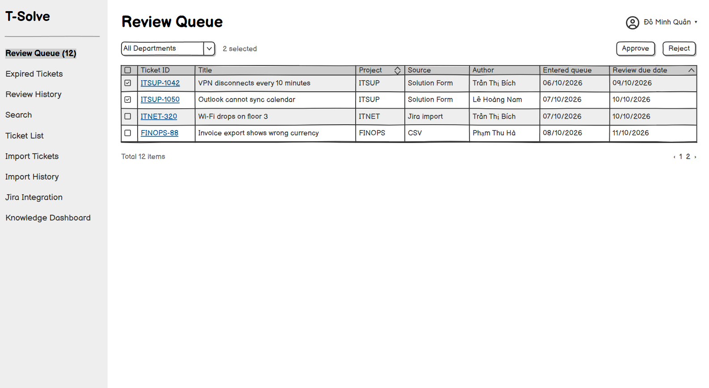
Default page of the Project Manager. Lists in real time the Pending review tickets (Solutions submitted by Ticket Resolvers from Jira) of the Projects the Project Manager manages. Tickets imported by the Project Manager do not go through the queue. Related use cases: UC-29, UC-30.
On this screen, the user can:
- View the tickets waiting for review, filter by Project and sort by column.
- Select one, several or all tickets to approve or reject them at once.
- Open the Ticket Detail to read the Solution and Evidence and decide on each ticket (including Request changes).
Field descriptions
Field Name | Description
Project filter | All the Project Manager’s Projects (default) or one Project.
Ticket table | Columns: checkbox, Ticket ID, Title, Project, Source, Author, Entered queue, Review due date. Sorted by the earliest review due date by default. Shows MSG13 when empty.
Select all (checkbox) | Selects every ticket in the queue, not only the current page; the number of selected tickets is shown.
Approve (button) | Approves the selected tickets; asks MSG19 when two or more tickets are selected; shows MSG14. Tickets with an empty Solution are not approved (MSG20).
Reject (button) | Opens the Reject Ticket popup for the selected tickets (one reason for all of them); shows MSG16.

7.2 Request Changes (popup)
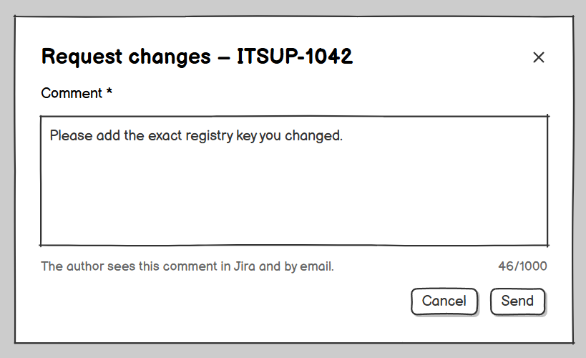
Returns a ticket that came from the Solution Form to its writer; opened from the Ticket Detail. Related use case: UC-30.
Field descriptions
Field Name | Description
Comment * | Multi-line text, at most 1,000 characters (MSG01, MSG02). Shown to the writer in Jira (MSG64) and sent by email (GBR-27).
Send (button) | Shows MSG17.
Cancel (button) | Closes without changing anything.

7.3 Reject Ticket (popup)
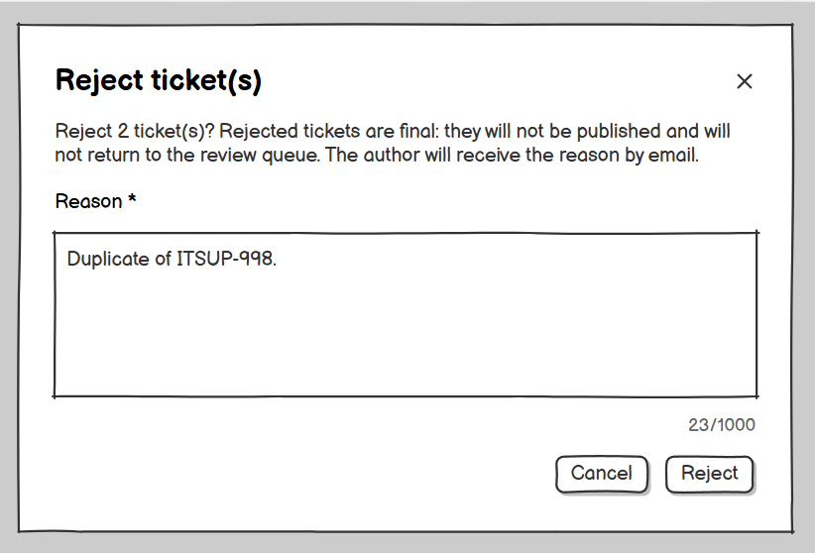
Confirms the rejection of one or more tickets, which is a final decision. Related use case: UC-30.
Field descriptions
Field Name | Description
Message | MSG15 with the number of tickets.
Reason * | Multi-line text, at most 1,000 characters (MSG01, MSG02). Saved in the Review History and sent to the writer by email (GBR-27). When several tickets are selected, the reason applies to all of them.
Reject (button) | Shows MSG16.
Cancel (button) | Closes without changing anything.

7.4 Review History
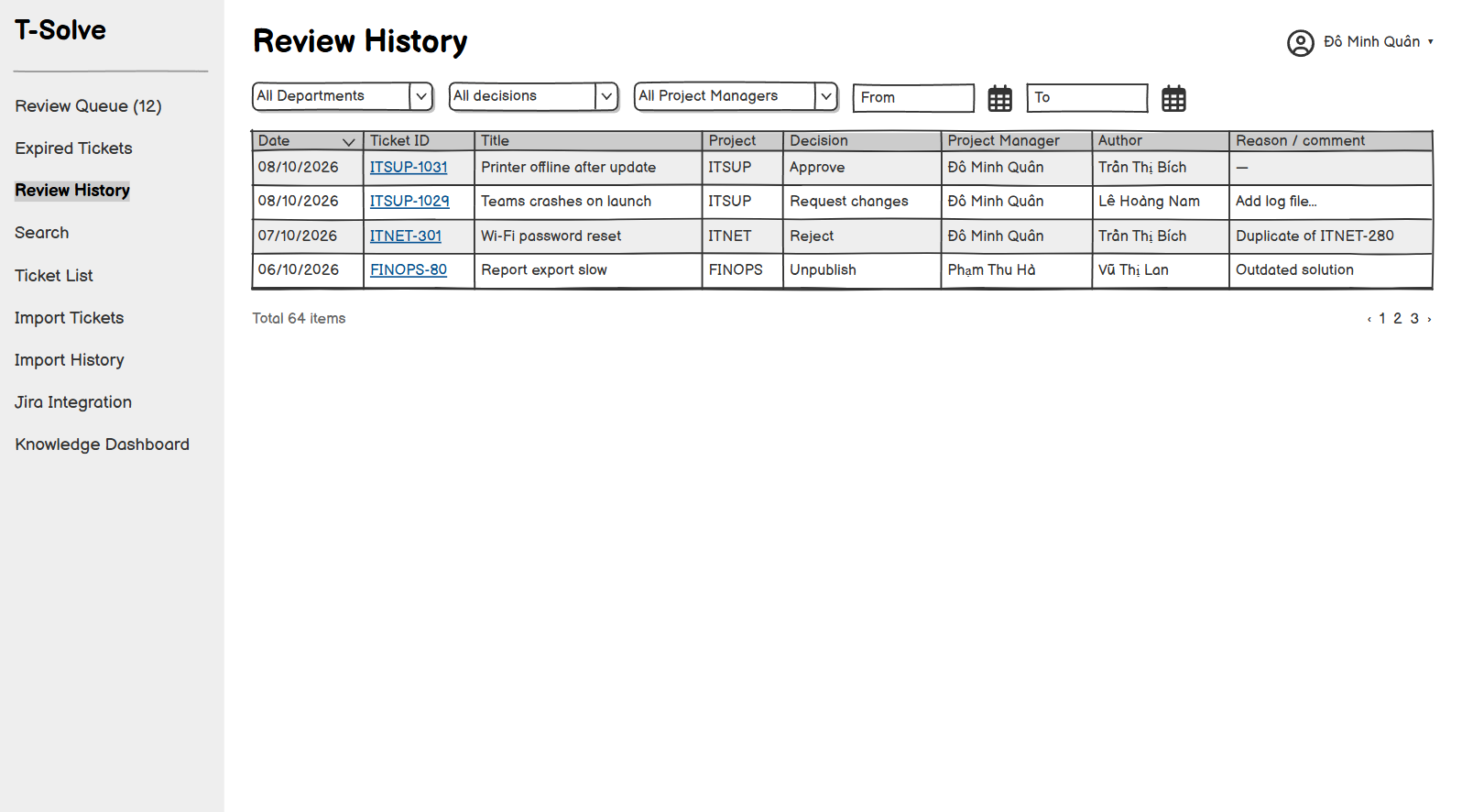
Lists the past decisions in the Project Manager's Projects. Related use case: UC-32.
On this screen, the user can:
- Filter the decisions.
- Open the Ticket Detail.
Field descriptions
Field Name | Description
Filters | Project, decision (approve, reject, request changes, unpublish, re-publish, send back), date range.
History table | Columns: Date, Ticket ID, Title, Project, Decision, Project Manager, Author, Reason / comment.

7.5 Expired Tickets
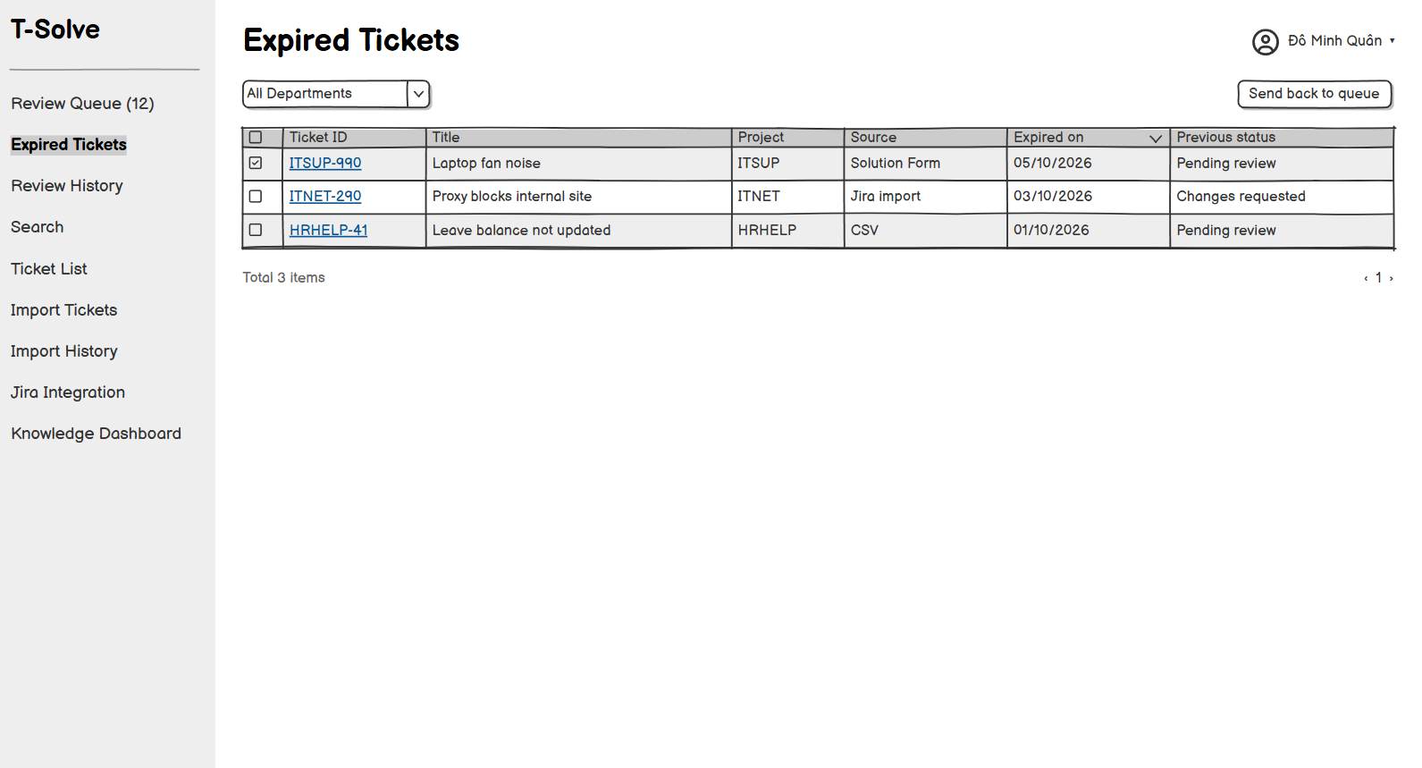
Lists the Expired tickets in the Project Manager's Projects. Related use cases: UC-31, UC-30.
On this screen, the user can:
- Filter by Department.
- Send one, several or all tickets back to the queue.
- Open the Ticket Detail.
Field descriptions
Field Name | Description
Project filter | All the Project Manager’s Projects (default) or one Project.
Ticket table | Columns: checkbox, Ticket ID, Title, Project, Source, Expired on, previous status.
Send back to queue (button) | Applies to the selected tickets (one, several or all); shows MSG25.

8. Reuse & Feedback

8.1 Give Feedback (popup)
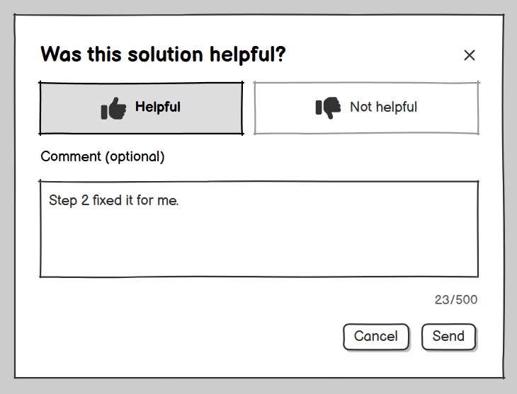
Opened from the Ticket Detail on the web app. Related use case: UC-28.
Field descriptions
Field Name | Description
Helpful? * | Helpful / Not helpful. Each user has one Feedback per ticket; rating again replaces the previous Feedback.
Comment | Multi-line text, optional, at most 500 characters.
Send (button) | Shows MSG26.

9. Dashboard & Audit

9.1 Knowledge Dashboard
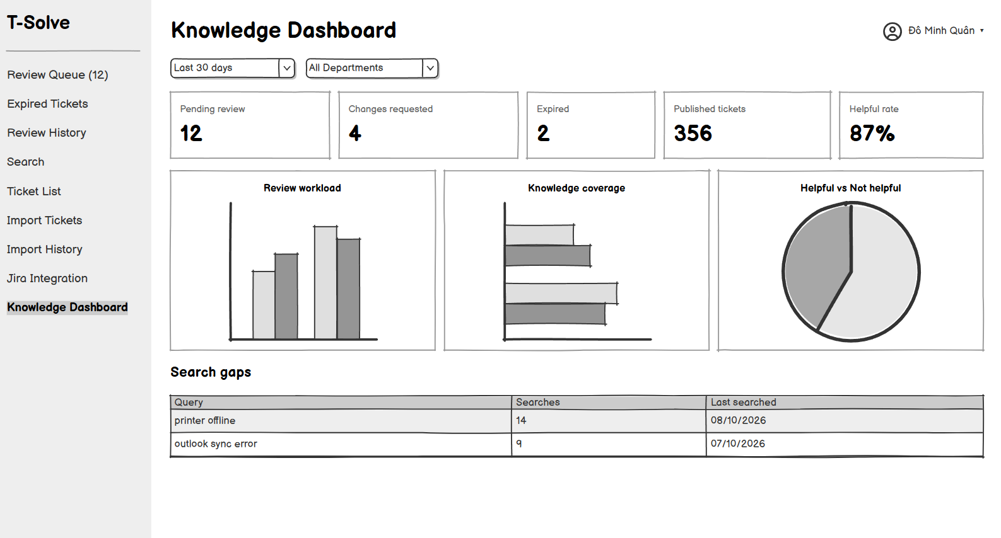
Read-only metrics; the scope depends on the role. Opened from the menu by Project Managers and the Admin. Related use case: UC-34.
On this screen, the user can:
- Change the period and the Department filter.
- Open a ticket from a list (Project Manager only).
Field descriptions
Field Name | Description
Period | Last 7 days, Last 30 days (default), Last 90 days, or a custom range.
Department filter | Project Manager: their Department, with a Project filter. Admin: every Department, or one Department.
Solution outcomes | For the period: Solutions approved (Published, including tickets approved at import), Rejected and returned with Changes requested, per Project and per day, with the approval rate; the current number of tickets Pending review and Expired. A Project Manager clicks a number to open the filtered Ticket List.
Knowledge coverage | The number of Published tickets; the share of resolved tickets that are Published, per Department.
Reuse & feedback | The number of ticket views; the helpful versus not helpful rate; the 5 highest rated and the 5 lowest rated tickets.
Knowledge gaps | The most frequent searches with no results and the Knowledge Chatbot questions answered with MSG109.
Triage | The number of triaged issues per class, the share of Simple issues whose suggestion solved the problem, and the number of issues routed to a handler.

9.2 Audit Log
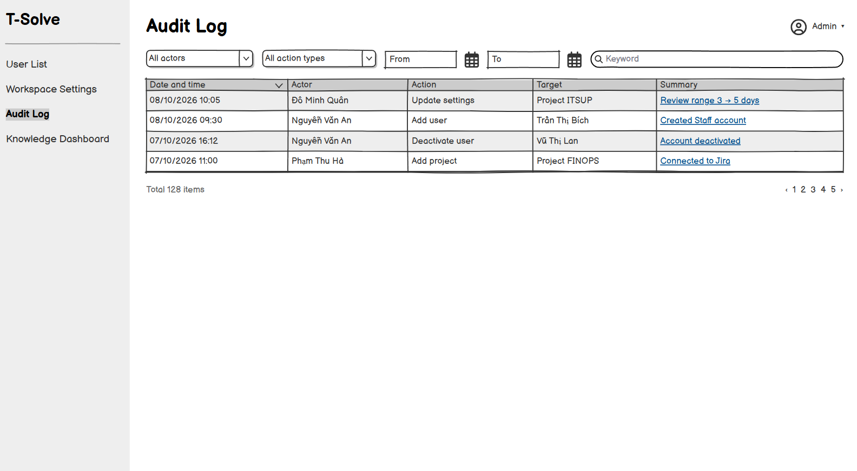
Lists the actions recorded in the system. Related use case: UC-35.
On this screen, the user can:
- Filter the log.
- Open a log entry.
Field descriptions
Field Name | Description
Filters | Actor, action type, date range, keyword.
Log table | Columns: Date and time, Actor, Action, Target, Summary.

9.3 Audit Entry Detail (popup)
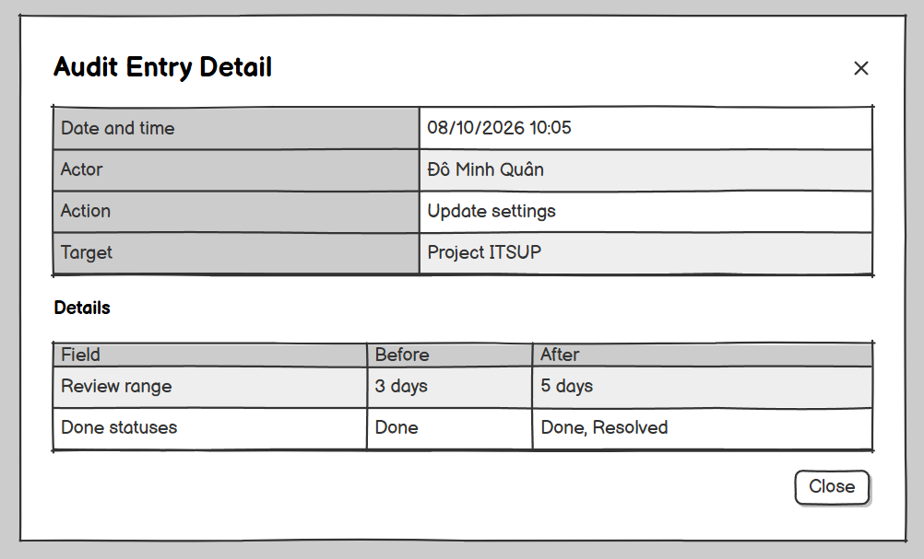
Shows the full details of one audit entry. Related use case: UC-35.
Field descriptions
Field Name | Description
Date and time, actor, action, target | Read-only.
Details | The values before and after the change, if any.

10. AI Ticket Triage

10.1 Triage History
[Mock-up placeholder: Triage History]
Lists the triage results of the Projects managed by the Project Manager. Related use cases: UC-41, UC-39.
On this screen, the user can:
- Filter the triage results.
- Open a result in the Triage Result Detail.
- Route an issue that was not triaged or whose routing failed.
Field descriptions
Field Name | Description
Filters | Project (the Projects the Project Manager manages), class (Simple, Complex, Sensitive, Not triaged), answer (Solved, Not solved, No answer), routing (Routed, Routing failed, Not routed), date range.
Results table | Columns: Date, Issue key (link to Jira), Summary, Project, Class (with the corrected class, if any), Reason, Routing, Answer. For a Sensitive issue, Summary is hidden. Sorted newest first. Shows MSG04 when empty.
Route to handler (button) | Shown for results that are Not triaged or Routing failed; runs UC-39 and shows MSG05.

10.2 Triage Result Detail (popup)
[Mock-up placeholder: Triage Result Detail (popup)]
Shows one triage result. Related use case: UC-41.
On this screen, the user can:
- Read the suggested solution and open its sources.
- Correct the class.
Field descriptions
Field Name | Description
Issue | Read-only: issue key, summary (hidden for Sensitive issues), Project, reporter, date.
Class and reason | Read-only: the class given by the AI module and its reason.
Suggested solution | Read-only: the comment posted in Jira (MSG80), if any.
Sources | Links to the tickets (UC-24) and Wiki documents (UC-44) used; a source that is no longer available shows MSG110.
Routing | Read-only: label added, assignee, time, or “Routing failed”.
Correct class | Drop-down list Simple, Complex, Sensitive and an optional note of at most 500 characters (MSG02). Saving a class Complex or Sensitive for an issue that was not routed routes it (UC-39).
Save (button) | Saves the correction, records it in the audit log and shows MSG05.

11. Wiki Management

11.1 Wiki Home
[Mock-up placeholder: Wiki Home]
Entry point of the Wiki. Shows the Company-wide view and the Department Spaces the user can view, with the content of the selected Space. Related use cases: UC-54, UC-44, UC-42, UC-43, UC-51 to UC-53.
On this screen, the user can:
- Read the Company-wide documents of every Department.
- Select a Space and browse its folder tree.
- Search the Published documents the user can see.
- Open a document.
- Create or upload documents in a Space where the user has the Create permission.
- Knowledge Manager: create, rename, move and delete folders, and open the Space Settings.
Field descriptions
Field Name | Description
Company-wide view | The Company-wide Published documents of every Space, grouped by Department; always shown first.
Spaces list | The Department Spaces the user can view, with the user’s access level (View, Create, Knowledge Manager).
Folder tree | The folders of the selected Space, up to three levels. Knowledge Managers see New folder, Rename, Move and Delete on each folder (Folder popup).
Search box | Free text, at most 200 characters; searches the Company-wide documents of every Space and the Published documents of the Spaces the user can view, ranked by semantic and keyword relevance.
Documents table | Columns: Title, Folder, Visibility, Owner, Status, Updated. Users see Published documents; the Owner also sees their own Drafts, Pending review, Changes requested and Rejected documents; Knowledge Managers see every document of their Spaces except Drafts of others. Shows MSG04 when empty.
New document / Upload documents (buttons) | Shown only in Spaces where the user has the Create permission; open the Wiki Editor or the Upload Documents screen.
Space Settings (button) | Shown only to the Knowledge Managers of the Space.

11.2 Wiki Document
[Mock-up placeholder: Wiki Document]
Shows one Wiki document. Related use cases: UC-44, UC-45, UC-46, UC-59.
On this screen, the user can:
- Read the document and its version history.
- Edit or propose an update.
- Owner or Knowledge Manager: delete the document or transfer its ownership.
Field descriptions
Field Name | Description
Header | Read-only: title, Space, folder, visibility (Department / Company-wide), Owner, status, last published date and version number.
Content | Read-only content of the current Published version (or of the Owner’s own version when it is not Published yet); the original file can be downloaded for uploaded documents.
Status banner | For the Owner: the Knowledge Manager’s comment when changes are requested, or the reason when rejected; MSG93 when an update by another author is waiting for review.
Version history | List of Published versions with number, author, change summary and date; a version opens read-only.
Edit (button) | Shown to the Owner of a Draft or Changes requested document, and to users with the Create permission on a Published document; opens the Wiki Editor (UC-45).
Delete (button) | Shown to the Owner and to the Knowledge Managers of the Space; asks MSG100 and shows MSG101 (UC-46).
Change owner (button) | Shown to the Owner and to the Knowledge Managers of the Space; opens the Transfer Ownership popup (UC-59).

11.3 Wiki Editor
[Mock-up placeholder: Wiki Editor]
Writes a new document or an update of a document. Related use cases: UC-43, UC-45.
On this screen, the user can:
- Enter the title, choose the folder and write the content.
- Save a Draft or submit for review.
Field descriptions
Field Name | Description
Title * | Text, at most 200 characters, unique in the folder (MSG01, MSG84).
Folder * | Tree selector of the folders of the Space; default: the folder selected in the Wiki Home.
Visibility * | Department (default: readable by the users who can view the Space) or Company-wide (readable by every user). Changing it on a Published document is an update reviewed by a Knowledge Manager.
Content * | Rich text editor (headings, lists, tables, links, images of at most 5 MB each), at most 100,000 characters (MSG01, MSG02).
Change summary | Shown for an update; text, at most 300 characters.
Reviewer comment | Read-only; shown when changes were requested.
Save as draft (button) | Saves without checking and shows MSG41.
Submit for review (button) | Checks the fields (and MSG94 for an update without change), saves the version in Pending review and shows MSG91; also shows MSG92 when no other Knowledge Manager can review it.
Cancel (button) | Asks MSG108 when there are unsaved changes.

11.4 Upload Documents
[Mock-up placeholder: Upload Documents]
Uploads several files into a folder of a Space where the user has the Create permission. Related use case: UC-42.
On this screen, the user can:
- Choose the folder and add files.
- Check the extracted text and correct the titles.
- Submit the documents for review.
Field descriptions
Field Name | Description
Folder * | Tree selector of the folders of the Space.
Visibility * | Department (default) or Company-wide; applied to every file and editable on each row.
File area * | At most 10 files per upload (MSG88), each at most 10 MB, in PDF, DOCX, MD or TXT format (MSG89).
Files table | Columns: File name, Visibility, Title * (editable, from the file name, at most 200 characters, MSG01, MSG84), Extracted text (first 300 characters), Words, Result (Ready / MSG90). Remove button on each row.
Submit for review (button) | Disabled while a row has an error or no row is left; creates the documents in Pending review and shows MSG91.
Cancel (button) | Closes the screen; nothing is saved.

11.5 Folder (popup)
[Mock-up placeholder: Folder (popup)]
Creates, renames, moves or deletes a folder of a Space. Related use cases: UC-51, UC-52, UC-53.
Field descriptions
Field Name | Description
Name * | Text, at most 100 characters, unique within the parent folder (MSG01, MSG85).
Parent folder | Tree selector; the new position cannot be deeper than three levels (MSG86) or inside the folder itself.
Save (button) | Saves and shows MSG05.
Delete (button) | Deletes an empty folder after confirmation; shows MSG87 when the folder is not empty.

11.6 Transfer Ownership (popup)
[Mock-up placeholder: Transfer Ownership (popup)]
Chooses the new Owner of a document. Related use case: UC-59.
Field descriptions
Field Name | Description
New owner * | Search by name or email among the Active users who have the Create permission in the Space (MSG105 otherwise).
Transfer (button) | Asks MSG104, then saves and shows MSG05.
Cancel (button) | Closes without changing anything.

11.7 Space Settings
[Mock-up placeholder: Space Settings]
Administers one Space; only its Knowledge Managers can open it. Two tabs: Permissions and Trash. Related use cases: UC-57, UC-60, UC-61, UC-62, UC-58, UC-63, UC-64.
On this screen, the user can:
- View, grant, change and revoke the access of Departments and individual users.
- View the deleted documents of the Space, restore them or delete them permanently.
Field descriptions
Field Name | Description
Space header | Read-only: Space name, Department, Knowledge Managers (assigned by the Admin).
Departments table | Permissions tab. Columns: Department, Access (View / Create, editable), Granted by, Date, Remove. The Space’s own Department always has Create; this row is locked (MSG107). Company-wide documents are readable by everyone whatever these permissions.
Users table | Permissions tab. Columns: Full name, Email, Home Department, Access (View / Create, editable), Granted by, Date, Remove. Deactivated users are shown greyed out and their access does not apply.
Grant access (button) | Permissions tab. Selector of Departments and Active users without a permission on the Space, and the level View or Create; shows MSG05.
Remove (button) | Permissions tab. Asks MSG106, then removes the permission and shows MSG05.
Trash table | Trash tab. Columns: Title, Folder, Owner, Status before deletion, Deleted by, Deleted on. Shows MSG04 when empty.
Restore (button) | Trash tab. Restores the document and shows MSG102.
Delete permanently (button) | Trash tab. Asks MSG103, then deletes the document for good and shows MSG05.

11.8 Wiki Review List
[Mock-up placeholder: Wiki Review List]
Default page of Knowledge Managers. Lists the new documents and updates waiting for review in their Spaces, except those they own or wrote. Related use cases: UC-55, UC-56.
On this screen, the user can:
- Filter the list.
- Open a new document or an update to review it.
Field descriptions
Field Name | Description
Filters | Space (the Knowledge Manager’s Spaces), type (New document / Update), date submitted.
Review table | Columns: Title, Type, Space, Folder, Owner or author of the update, Submitted on. Sorted oldest first. Shows MSG04 when empty.

11.9 Review Wiki Document
[Mock-up placeholder: Review Wiki Document]
Reviews a new document. Related use case: UC-55.
Field descriptions
Field Name | Description
Document | Read-only: title, Space, folder, visibility, Owner, content and original file.
Publish (button) | Publishes the document, emails the Owner and shows MSG95.
Request changes (button) | Opens the Wiki Decision popup with a comment; shows MSG96.
Reject (button) | Opens the Wiki Decision popup with a reason and MSG97; shows MSG98.

11.10 Compare Versions
[Mock-up placeholder: Compare Versions]
Reviews an update of a Published document by comparing it with the Published version; the differences are computed with java-diff-utils. Related use case: UC-56.
On this screen, the user can:
- Compare the two versions side by side or view only the changed lines.
- Approve the update, request changes or reject it.
Field descriptions
Field Name | Description
Metadata changes | Changes of title, folder and visibility, old value next to new value.
Change summary | Read-only text written by the author of the update.
Comparison | Side by side: current Published version on the left with removed text struck through in red, proposed version on the right with added text highlighted in green, word-level highlighting inside changed lines; unchanged blocks can be folded. A toggle switches to the changed-lines-only view. MSG99 when the Published version changed meanwhile.
Approve (button) | Publishes the proposed version and shows MSG95. Disabled with MSG99.
Request changes / Reject (buttons) | As on the Review Wiki Document screen.

11.11 Wiki Decision (popup)
[Mock-up placeholder: Wiki Decision (popup)]
Records a comment or a reason for a Wiki review decision. Related use cases: UC-55, UC-56.
Field descriptions
Field Name | Description
Comment / Reason * | Multi-line text, at most 1,000 characters (MSG01, MSG02); emailed to the Owner or to the author of the update (GBR-27).
Send / Reject (button) | Saves the decision; Reject asks MSG97.
Cancel (button) | Closes without changing anything.

12. Knowledge Chatbot

12.1 Knowledge Chatbot
[Mock-up placeholder: Knowledge Chatbot]
Default page of Employees with no other role. Answers questions only from the Published tickets and Published Wiki documents the user is allowed to see. Related use cases: UC-47, UC-48, UC-49.
On this screen, the user can:
- Ask a question and follow-up questions.
- Open the sources of an answer.
- Rate an answer.
- Start a new conversation or reopen a conversation of the session.
Field descriptions
Field Name | Description
Conversation list | The conversations of the current session, newest first; cleared at sign-out or when the session ends.
Question box | Free text, at most 1,000 characters (MSG01, MSG02); Enter sends the question.
Answer | Text written by the AI module with numbered citations; MSG109 when no source is found; MSG06 when the AI module is unavailable.
Citations | Each citation shows the title and type (ticket or Wiki document) and opens the Ticket Detail or the Wiki Document; MSG110 when the source is no longer available to the user.
Helpful / Not helpful (buttons) | Rate an answer once; rating again replaces the previous rating.
New conversation (button) | Starts an empty conversation.

13. Background Job Inventory

13.1 Expire Overdue Tickets (JOB-02, UC-33)
Trigger: Scheduled, every day at 00:00 (UTC+7).
Purpose: No ticket waits for a decision forever.
Processing steps:
- Find the tickets in Pending review or Changes requested status whose review due date stored on the ticket has passed (GBR-10), skipping the tickets of deleted Departments.
- Set each ticket to Expired and remove it from the Review Queue.
- Log the number of Expired tickets per Project.
Failure behavior:
Scenario | System behavior
Database error | Roll back, log the error and retry after 15 minutes; the tickets keep their status.
No overdue tickets | End without doing anything.

14. External API Inventory
The URL patterns below are proposals for the design phase (Report 4).

14.1 POST: /api/v1/jira-app/solutions (API-01)
URL | POST: /api/v1/jira-app/solutions
Purpose | Receives a Solution with Evidence from the Solution Form (a submission, an empty Solution submitted when the user closes the form, or a resubmission) and saves the ticket in Pending review status; saves, opens and deletes Solution Form Drafts.
Caller | T-Solve Jira App (retries automatically up to 3 times on failure)
Auth | Yes: a token signed by Jira (Forge Invocation Token) identifies the Jira user; the system looks up the link between the Jira account and the T-Solve account (UC-04) and checks GBR-03. The caller must be a member of the issue’s Project (GBR-20).

14.2 GET: /api/v1/jira-app/issues/{issueKey}/panel (API-02)
URL | GET: /api/v1/jira-app/issues/{issueKey}/panel
Purpose | Returns the Issue Panel content for the current user: the Solution status of the issue (including the user’s Draft) for Project members, whether the search box is available, and the triage question for the reporter of a triaged issue.
Caller | T-Solve Jira App
Auth | Yes: a token signed by Jira (Forge Invocation Token) identifies the Jira user; the system looks up the link between the Jira account and the T-Solve account (UC-04) and checks GBR-03.

14.3 GET: /api/v1/jira-app/search (API-03)
URL | GET: /api/v1/jira-app/search?q={query}
Purpose | Searches Published tickets in the user’s Departments from the Issue Panel; GET /api/v1/jira-app/tickets/{id} returns the Published Ticket Preview.
Caller | T-Solve Jira App
Auth | Yes: a token signed by Jira (Forge Invocation Token) identifies the Jira user; the system looks up the link between the Jira account and the T-Solve account (UC-04) and checks GBR-03. Only Ticket Resolvers and Project Managers.

14.4 POST: /api/v1/jira-app/issues/{issueKey}/triage-answer (API-04)
URL | POST: /api/v1/jira-app/issues/{issueKey}/triage-answer
Purpose | Records the reporter’s answer (solved / not solved) to a suggested solution; a “not solved” answer routes the issue (UC-38, UC-39).
Caller | T-Solve Jira App
Auth | Yes: a token signed by Jira (Forge Invocation Token) identifies the Jira user; the system looks up the link between the Jira account and the T-Solve account (UC-04) and checks GBR-03. Only the reporter of the issue.

14.5 GET: /api/v1/auth/oidc/callback (API-05)
URL | GET: /api/v1/auth/oidc/callback
Purpose | Receives the sign-in result from the OIDC Provider and creates a T-Solve session. If the sign-in started from a Jira App link (with a link code), links the Jira account to the T-Solve account (UC-04, GBR-19).
Caller | OIDC Provider (Google), through the user’s browser
Auth | OIDC authorization code, with state and nonce checks.

14.6 POST: /api/v1/jira-app/events/issue-created (API-06)
URL | POST: /api/v1/jira-app/events/issue-created
Purpose | Receives a new issue of a linked Jira project (key, summary, description, reporter, assignee) and returns the triage decision: the class, the comment to post (MSG80) and, when the issue must be routed, the label and assignee to set (UC-38, UC-39). The T-Solve Jira App applies the decision in Jira and reports the result.
Caller | T-Solve Jira App, triggered by the Jira issue-created event
Auth | Yes: a token signed by Jira (Forge Invocation Token) identifies the installation; the issue must belong to a Jira project linked to an Active Project.

IV. Non-Functional Requirements

1. External Interfaces

1.1 User Interfaces
Requirement | Description
Web browser access | The T-Solve web app is used through a web browser on a computer: the two latest versions of Google Chrome, Microsoft Edge and Mozilla Firefox. Nothing needs to be installed on the user's computer.
Screen size | Every screen is fully usable at a resolution of 1366 by 768 pixels or higher. The MVP does not support phones or tablets.
Screens in Jira | Employees, Ticket Resolvers and Project Managers use T-Solve directly in Jira through the T-Solve Jira App: the Issue Panel on a Jira issue (triage question, search, Solution status), the comment posted by AI Ticket Triage, and the Solution Form that appears right after an issue is moved to a Done status. The Jira App follows the look of Jira itself.
Language and formats | The user interface and every system message are in English. Dates are shown as dd/MM/yyyy, times in 24-hour format, in the Vietnam time zone (UTC+7); the job that moves tickets to Expires at 00:00 every day uses the same time zone.
Consistent layout | Every web screen uses the same main layout (left menu by role, content area, page title); lists, forms and dialogs look and behave the same way in every feature.

1.2 Software Interfaces
External system | Connection | Description
Ticket Tracker (Jira) | T-Solve Jira App inside Jira; T-Solve calls the Jira REST API | The T-Solve Jira App (installed by the Jira administrator) shows the Issue Panel and the Solution Form, receives the issue-created event and applies triage decisions. T-Solve reads the summary, description, comments and status of issues and the issues resolved in the past, using the access token of each Project. Through the Jira App, T-Solve only adds a comment, the label tsolve-needs-handler and, for an unassigned issue, an assignee; it never changes the status of an issue (GBR-01).
OIDC Provider (Google in the MVP) | The user’s browser and the OIDC Provider | Authenticates users with their company account. Data sent: the OIDC authentication request (client ID, redirect URI, state, nonce); data received: email and full name. Only emails added by the Admin can sign in (MSG09, MSG10). T-Solve does not store passwords.
AI module: language model (Ollama, locally hosted) | The AI module of T-Solve calls Ollama through the Ollama API | Drafts and rewrites Solutions (UC-19), classifies new issues and writes suggested solutions (UC-38), and writes Knowledge Chatbot answers (UC-47). Data sent: PII-masked issue content, Solution content, the retrieved passages of Published tickets and Wiki documents, and chatbot questions. Evidence, original Wiki files, Ticket IDs and account information are not sent. When it is unavailable, T-Solve keeps working without AI (MSG06, MSG67, MSG68).
AI module: embeddings (OpenRouter) | The AI module of T-Solve calls OpenRouter through the OpenRouter API | Data sent: PII-masked title, description and Solution of Published tickets, text of Published Wiki documents, issue summaries and descriptions, search queries and chatbot questions. Data received: vectors for semantic retrieval. When it is unavailable, retrieval falls back to keyword ranking.
Email System (SMTP) | T-Solve calls the company SMTP server | Send notification emails (GBR-27). Data sent: recipient email, the ticket or document title, Project or Space, decision, reason or comment, and a link. Evidence and Wiki files are not attached.

PII masking rules applied to all content the AI module sends to the language model (Ollama) and the embedding provider (OpenRouter), including issue content, Wiki document text and Knowledge Chatbot questions:
Data type | Masking rule | Note
Email address | Replaced with [EMAIL] | Including emails in comments and signatures.
Phone number | Replaced with [PHONE] | Vietnamese and international numbers.
Full names of T-Solve users; names of Jira assignees, reporters and commenters | Replaced with [NAME] | Detected from the list of T-Solve users and the names taken from the issue.
Tokens, passwords and API keys that appear in the text | Replaced with [SECRET] | Detected from common secret string patterns.
IP address | Replaced with [IP]
File Evidence | Never sent | Stored only in T-Solve.
Original Wiki files | Never sent | Only the extracted text, masked, is sent.

1.3 Communication Interfaces
Requirement | Description
Secure connection | All traffic between the browser, the T-Solve Jira App and T-Solve, and between T-Solve and external services, uses HTTPS (TLS 1.2 or higher).
Data exchange format | The web app and the Jira App communicate with the T-Solve server through a REST API that exchanges JSON data. CSV import files use UTF-8 encoding.
Internet access | Users need a normal Internet connection; T-Solve is hosted on a VPS in the Vietnam region and is reachable through a public web address.

2. Quality Attributes

2.1 Usability
Requirement | Target | Condition
Learning time for Ticket Resolvers | Ticket Resolvers can submit a Solution from Jira and find Published tickets without training, relying only on the labels and messages on screen. | First-time users
Learning time for Project Managers | Project Managers can add and configure a Project, manage its members, and review one day of the Review Queue (approve, reject, request changes, select several tickets) after a guided session of no more than 30 minutes. | First-time users
Learning time for the Admin | The Admin can set up the Workspace, Departments, user accounts (including the Departments of each Project Manager) and the Jira site after a guided session of no more than 1 hour, using the user guide (Report 6). | First-time users
Submitting a Solution | Completing the Solution Form (reading the AI draft, editing, optional Evidence, Finish) takes no more than 3 minutes of form interaction, not counting writing time. | Normal network, AI service available
Reviewing one ticket | The Project Manager makes a decision on one ticket in at most 3 clicks from the Review Queue. | The Review Queue has at least one ticket
Finding an existing Solution | Users find a relevant Published ticket for a known problem within 3 searches. | The problem already has a Published ticket in the user's Department
Few steps to the main functions | Each role reaches its main functions in at most 3 clicks from its default page. | After signing in
Clear feedback | Every action gives visible feedback: a toast message on success, an error next to the field, or a confirmation dialog before actions that are hard to undo (reject, approve several tickets, unpublish, delete a Department, remove a Project, remove a member, deactivate a user, close the Solution Form, leave an import screen, delete a Draft). The content follows V.2. | Every screen
Error prevention | Required fields are marked *, data is validated when leaving a field, and entered data is never lost when validation fails. | Every form
Familiar interface | The web app follows the Ant Design guidelines and the Jira App follows the Atlassian Design System. | Every screen
Learning time for Employees | Employees can read the Wiki, ask the Knowledge Chatbot, answer a triage suggestion and write a Wiki document without training. | First-time users
Learning time for Knowledge Managers | Knowledge Managers can set the permissions of a Space, organise folders and review documents and updates after a guided session of no more than 30 minutes. | First-time users

2.2 Performance
Requirement | Target | Condition
Page load time | Every web page loads within 2 seconds. | Up to 100 concurrent active users
Search response time | Search on the web app and in the Issue Panel returns results within 2 seconds. | Up to 50,000 tickets; embedding service available
Form submission | The system confirms a save or a decision within 2 seconds. | Up to 100 active users
Opening the Solution Form | The Solution Form opens within 2 seconds; the AI draft appears within 15 seconds, otherwise the form continues without a draft (MSG67). | Normal network
Import CSV | A 10 MB CSV file (about 5,000 tickets) is validated and its preview shown within 60 seconds. | Each user imports only one file at a time
Jira import | The issue list (at most 100) is shown on the Import Preview within 30 seconds; Finish is confirmed within 5 seconds. | Jira responds normally
Expire job | JOB-02 completes within 30 minutes. | Runs at 00:00 every day
Ticket entering the Review Queue | A newly submitted ticket appears in the Project's Review Queue within 5 seconds. | Normal network
Deciding on several tickets | Approving or rejecting the selected tickets is confirmed within 2 seconds. | Up to 100 tickets selected in the Review Queue
Concurrent users | The system works fully with up to 100 active users. | Deployed on one server
AI Ticket Triage | The suggested solution is posted, or the issue is routed, within 60 seconds after the issue is created. | AI module available
Knowledge Chatbot answer | An answer with its citations is shown within 10 seconds. | Up to 50,000 tickets and 10,000 Wiki documents; AI module available
Wiki publication | A Published document or approved update is used by Wiki search and the Knowledge Chatbot within 1 minute. | Document of at most 100,000 characters
Compare Versions | The comparison of two versions is shown within 3 seconds. | Document of at most 100,000 characters
Upload Documents | The text of 10 files of 10 MB is extracted and previewed within 60 seconds. | Text-based PDF or DOCX
Permission changes | A role or Space permission change applies from the user’s next request. | Every request

2.3 Security
Requirement | Description
Authentication required | Every page and API, except the Login screen and the sign-in callback, requires the user to be signed in with a company account.
No stored passwords | T-Solve never stores user passwords; sign-in is delegated to the OIDC Provider.
Deactivated accounts | A deactivated account cannot sign in or use an existing session.
Access by role, Department, Project and Space | Every request is checked against the user’s roles, Departments, Projects and Space permissions. Users never see tickets or Evidence of other Departments (GBR-02); only members of a Project submit its Solutions and only its Project Manager decides on its tickets (GBR-09, GBR-20); Wiki documents are only shown when they are Company-wide or belong to a Space the user can view (GBR-31); a Knowledge Manager never reviews their own document (GBR-34).
Jira token protection | A Project's access token only needs read permission, is stored encrypted, is never shown again after saving, and is deleted when the Project is removed or its Department is deleted.
Evidence access | Evidence files can only be accessed by users who are allowed to view the ticket; there are no public or guessable links.
Personal data sent to AI | Before content is sent by the AI module to Ollama and OpenRouter, it is cleaned and PII is masked according to the rule table in IV.1.2; Evidence and original Wiki files are never sent outside. Sensitive issues are never answered and their content is not stored (GBR-36).
Session expiry | A session ends after 8 hours, or after 60 minutes of inactivity (MSG07).
Audit trail | Sign-ins, changes to users, roles and Departments, changes to Projects, Project settings and members, review decisions, imports, triage corrections, Space permissions, folder changes, Wiki review decisions, deletions, restorations and ownership transfers are recorded in the audit log and cannot be edited.
Knowledge Chatbot scope | The Knowledge Chatbot only retrieves from the Published tickets and Published Wiki documents the user is allowed to see, checked on every question; it never reveals content outside that scope, even when asked about it (GBR-37). Conversations are kept only for the session.

2.4 Availability and Reliability
Requirement | Description
Availability | The web app and the Jira App API are available 99% of the time during working hours (8:00 to 18:00, Monday to Friday, UTC+7).
Never blocks Jira | The Solution Form only opens after Jira has moved the issue to a Done status, so a T-Solve failure never blocks Jira. If a Solution cannot be submitted, the T-Solve Jira App retries automatically up to 3 times and then shows MSG69.
Email failures do not block review | A failed email does not change or undo a review decision; the system retries sending up to 3 times within 1 hour and logs the error.
AI failures do not break the system | If the AI module or the embedding provider fails, users can still write Solutions, review, search (by keyword only) and read the Wiki; new issues stay untriaged and can be routed from the Triage History; the Knowledge Chatbot shows MSG06.
Backup | The database, Evidence files and Wiki files are backed up daily and kept for 14 days.

V. Requirement Appendix

1. Business Rules
GBR-ID | Rule Statement | Applies To | Rationale | Enforced By
GBR-01 | T-Solve never changes any status in Jira. The Solution Form opens after Jira has moved the issue to a Done status. After a rejection or a change request, the Jira issue keeps its current status. During AI Ticket Triage, T-Solve only adds a comment, the label tsolve-needs-handler and, for an issue without assignee, an assignee (GBR-36). | Every interaction with Jira | Jira manages the ticket lifecycle; T-Solve is only a knowledge layer. | Automated by the system
GBR-02 | Ticket Resolvers and Project Managers see the tickets of their own Departments, in every status; Search only returns the Published tickets of those Departments. The Departments of a Ticket Resolver are their own Department and those of the Projects they belong to; a Project Manager sees the tickets of their own Department. Any user can open a Published ticket of their Departments (their own Department and those of their Projects) that the Knowledge Chatbot cites. Tickets of a deleted Department are not shown to anyone. The writer of a ticket can always open it read-only from My Profile (UC-03). | Every ticket view screen, Search, Issue Panel | Keeps the knowledge of each team private. | Automated by the system
GBR-03 | Users only sign in with their company account through the provider chosen by the Admin (Google in the MVP). An email that has not been added by the Admin, or a deactivated account, cannot sign in. | Sign-in (web and Jira) | No self-registration; employees who leave lose access immediately. | Automated by the system
GBR-04 | The Solution Form only appears when an issue moves to a Done status of the Project (UC-14), in a Jira project linked to an Active Project, only for Ticket Resolver or Project Manager members of that Project, and only when the issue has no Ticket yet. An issue that is reopened and moved to a Done status again does not get the form. If the user closes the form, it submits an empty Solution, and that ticket can only receive a change request or be rejected (GBR-09). If the submission fails, the T-Solve Jira App retries automatically up to 3 times; if it still fails, the Solution is not saved. | Solution Form | One Ticket per issue; every resolved issue leaves a Ticket to review. | Automated by the system
GBR-05 | Each Ticket has exactly one Solution, with no versions. The Solution only changes through Request changes and the writer's resubmission: on resubmission, the old Solution is deleted and the new Solution is added; nothing is overwritten. The Solution of a Published ticket cannot be edited: to correct it, the Project Manager unpublishes the old ticket (UC-25) and creates a new ticket by manual entry (UC-22). An issue pulled from Jira only becomes a Ticket once it has a Solution; a Solution filled in for several issues is copied separately into each Ticket. | Tickets | Keeps reviewed knowledge stable. | Automated by the system
GBR-06 | Evidence is optional: at most 5 files per Ticket, each at most 10 MB, in PNG, JPG, PDF, DOCX, XLSX, TXT or LOG format. Saved Evidence is never deleted or replaced; new files can only be added after changes are requested. | Solution Form, manual entry | Evidence must always be trustworthy. | Automated by the system
GBR-07 | The status of a Ticket is one of Pending review, Changes requested, Published, Rejected, Unpublished, Expired, and it only changes as described in Other Requirements (V.3). | Tickets | A clear, predictable lifecycle. | Automated by the system
GBR-08 | A Ticket submitted by a Ticket Resolver enters the Project’s Review Queue as soon as it is saved in Pending review status (submitted from the Solution Form, resubmitted, or sent back to the queue). Tickets imported by the Project Manager do not go through the Review Queue (GBR-23). | Review Queue | Knowledge is reviewed early. Even when several tickets are approved or rejected at once, each ticket gets its own decision and Review History record; the system asks for confirmation (MSG15, MSG19) and does not approve tickets with an empty Solution (MSG20). | Automated by the system
GBR-09 | Review decisions: approve (the ticket becomes Published); reject (the ticket becomes Rejected, a reason is required); request changes with a comment (only for tickets that came from the Solution Form). Approve and reject can be applied to one ticket, to several selected tickets or to all tickets in the queue; request changes apply to one ticket at a time. A ticket with an empty Solution cannot be approved. Only the Project Manager of the ticket's Project can decide and publish; a Project Manager can approve a ticket they wrote themselves, and the Review History shows both the writer and the approver. | Review Queue, Ticket Detail | The decision maker must know how the project handles issues internally. | Automated by the system
GBR-10 | The review range of each Project is a whole number of calendar days, 1 or more, set by its Project Manager (UC-14; default 3). The review due date is the date the ticket first entered the Review Queue plus the review range of the Project at that time, counted in calendar days (not working days). The review due date is stored on the ticket and does not change when the ticket is resubmitted, when changes are requested or when the review range is changed. Exception: when the Project Manager sends an Expired ticket back to the queue (UC-30), the new review due date is the send-back date plus the current review range. A ticket in Pending review or Changes requested that has no decision when its review due date has passed becomes Expired at 00:00. | Review, Project Detail, JOB-02 | No ticket waits forever. | Automated by the system
GBR-11 | Rejected is final: the ticket never returns to the Review Queue or Search. An Expired ticket can be sent back to the queue by the Project Manager. A Published ticket can be unpublished and re-published directly as Published; an Unpublished ticket is never reviewed again. | Ticket Detail, Expired Tickets | A final decision always stays final. | Automated by the system
GBR-12 | AI is optional and AI failures do not break the system. The AI module inside T-Solve drafts and rewrites Solutions, classifies new issues, writes suggested solutions and Knowledge Chatbot answers with a locally hosted LLM (Ollama), and computes embeddings with OpenRouter. The data sent and the PII masking rules are described in IV.1.2. The writer must read the AI rewrite and click Finish themselves. | Solution Form, Search, AI Ticket Triage, Knowledge Chatbot | The system keeps working without AI. | Automated by the system
GBR-13 | CSV import accepts one UTF-8 file of at most 10 MB that follows the template; each file belongs to exactly one Project chosen by the Project Manager on the form, and each row must contain the required Solution sections (GBR-33). A CSV row or a manually entered ticket whose ticket ID already exists is an error and is not imported; Jira import does not list issues that already have a Ticket. Only Project Managers import tickets, and only into the Projects they manage. | Import | Ticket IDs are unique. | Automated by the system
GBR-14 | The company has one Jira site, whose address is set by the Admin. The Jira administrator installs the T-Solve Jira App on the Jira site. Each Project Manager adds Projects to their own Department; each Project is linked to one Jira project and has its own access token. The token must be the API token of a Jira account with read permission (Browse projects) on that Jira project; T-Solve only uses the token to read. A Jira project is linked to only one Project. | Jira Integration | The Admin may not have access to every project. | Automated by the system
GBR-15 | Jira import only reads Jira issues that were resolved within the date range chosen by the Project Manager and that have no Ticket yet: at most 100 issues per pull, oldest first. Jira import only runs when the Project Manager clicks the pull button. | Jira import | Each import is small enough to review in one sitting. | Automated by the system
GBR-16 | Only the Admin adds users (by email) and changes their roles; the permissions of each role are fixed (GBR-28). Each user has at most one Department, selected by the Admin (required for a Project Manager); a Knowledge Manager’s Spaces are selected by the Admin; a Ticket Resolver also belongs to the Departments of the Projects they belong to (GBR-20). | User management | Simple, safe access control. | Automated by the system
GBR-17 | Deleting a Department does not delete data: the Department becomes Deleted, its Projects become Removed (tokens are deleted), and its Projects, members, tickets and Department Space are hidden from everyone; during that time, tickets are not reviewed and their status does not change. The Department name stays reserved. The Admin can restore the Department; then a Project Manager assigned to it reconnects its Projects (UC-14). Instead of restoring it, the Admin can migrate its Projects and Wiki documents to another Department (UC-66, GBR-38). | Deleting or restoring a Department | No ticket is lost. | Automated by the system
GBR-18 | The Knowledge Dashboard shows the last 30 days by default. | Dashboard | Recent, comparable figures. | Automated by the system
GBR-19 | A user links their Jira account to their T-Solve account once, by signing in with the company account through a one-time sign-in link opened from the T-Solve Jira App. The link can only be used once and expires after 10 minutes. After that, the system identifies the user through the Jira account in each request (signed by Jira) and checks on every request that the T-Solve account is still active (GBR-03). | T-Solve Sign-in, Issue Panel, Solution Form | Users sign in from Jira only once; employees who leave lose access from Jira immediately. | Automated by the system
GBR-20 | Each Project belongs to exactly one Department, is linked to exactly one Jira project, and an Active Project always has exactly one Project Manager. A Project Manager belongs to exactly one Department at a time, adds Projects only to that Department and becomes the Project Manager of every Project they add; a Department can have several Project Managers. The Project Manager adds members from the Active Ticket Resolver accounts and is also a member of the Project. Only members of a Project can write Solutions for it (GBR-04) and be its Escalation handler. | Jira Integration, Project Detail, Solution Form | The person closest to the project manages its details; the Admin only manages accounts and Departments. | Automated by the system
GBR-21 | A removed Project becomes Removed and is not deleted: its token is deleted, the Solution Form and Jira import stop, its tickets are kept, and its Project Manager can still decide on, unpublish, re-publish and send back those tickets. Re-adding the same Jira project reconnects that same Project. A Project Manager cannot be removed from their Project; the Project Manager only changes when the Admin hands the Project over to another Active Project Manager of the same Department while deactivating the account (UC-07). A Removed Project whose Project Manager has been deactivated has no Project Manager (MSG54) until an Active Project Manager of the Department re-adds it and becomes its Project Manager (UC-14). | Jira Integration, Review Queue | A ticket always has a Project and a person responsible for it. | Automated by the system
GBR-22 | Roles can be changed by the Admin (UC-50). A deactivated account keeps its Project memberships but cannot act. Before a Project Manager loses Active Projects (deactivation, removal of the role or change of Department), the Admin hands each Project over to another Active Project Manager of the Project’s Department; if there is none, the change is not allowed (MSG58, MSG59). Removing the Ticket Resolver role removes the user from their Projects (MSG78). A member removed from a Project cannot resubmit Solutions of that Project. Project hand-over follows UC-65. | User Detail, Project Detail, Solution Form | Permissions always match the current role and Projects. | Automated by the system
GBR-23 | Import is review: tickets that come from Jira import, CSV or manual entry are brought in by the Project Manager themselves, so they are saved directly in Published status with an approved decision by that Project Manager; they do not go through the Review Queue and do not become Expired. For Jira import, every issue in the list must have a Solution or be removed from the import before Finish; removed issues are not remembered and can be pulled again. The Project Manager can save the import as a Draft (GBR-26); leaving the screen without saving a Draft imports nothing. The writer of an imported ticket is the assignee of the issue in Jira or the author column of the CSV (text, can be empty). | Import Tickets, Import Preview | The Project Manager is the reviewer of the Project, so the tickets they bring in do not need a second review. | Automated by the system
GBR-24 | The first Admin is created at installation: the operations team declares the email of the first Admin and the Google OIDC information (client ID, client secret) in the deployment configuration; at first start-up, the system creates the Workspace with Google as the sign-in provider and an active Admin account with that email. Once the Workspace has an Admin, this configuration does not create another Admin. | Installation, first sign-in | The system has no self-registration, so an Admin must exist from the start. | Automated by the system
GBR-25 | The Workspace always has at least one active Admin: the system does not allow deactivating the last active Admin or removing their Admin role (MSG56), and an Admin can neither deactivate their own account nor remove their own Admin role (MSG112, MSG113). Every Active Project always has a Project Manager: a Project Manager who is deactivated, loses the role or changes Department first hands over their Active Projects to another Active Project Manager of the Project’s Department (UC-65, MSG58, MSG59). | User Detail | The system always has an administrator, and no Active Project is left without a reviewer. | Automated by the system
GBR-26 | A Draft is only created when the user clicks "Save as draft" on the Solution Form (UC-19), the Import Preview (UC-20, UC-21) or the Manual entry tab (UC-22). Only its creator can see a Draft; it is not a Ticket, does not enter the Review Queue, does not appear in Search and does not change the status or review due date of a ticket. Each user has at most one Solution Form Draft per issue. A CSV import Draft keeps the validated rows (the Solutions stay read-only). Validation (required Solution sections, ticket ID, Project still Active) only runs on submission or Finish. A Draft is deleted when it is submitted or imported successfully, or when its creator deletes it (MSG42). | Solution Form, Import Preview, Import Tickets | Users do not lose their work when they cannot finish right away. | Automated by the system
GBR-27 | The system sends a notification email: to the writer of a ticket when it is rejected (with the reason) or changes are requested (with the comment); to the Owner of a Wiki document, or the author of an update, when it is published, returned for changes (with the comment) or rejected (with the reason). In the MVP, only these events send email. A failed email does not change the decision; the system retries up to 3 times within 1 hour and logs the error. | Reject Ticket, Request Changes | Writers learn the review result without opening Jira. | Automated by the system
GBR-28 | Every Active account has the Employee role. The Admin can add the Ticket Resolver, Project Manager, Knowledge Manager and Admin roles, and a user can hold several roles; their permissions add up and every role inherits the permissions of Employee. Each user has at most one Department, set by the Admin; a Project Manager has exactly one and manages Projects only in it. A Knowledge Manager has at least one Space. | User management, every request | Each person gets exactly the permissions of their jobs. | Automated by the system
GBR-29 | The Wiki is organised in Department Spaces: exactly one Space per Department, created, renamed, hidden and restored together with its Department; there is no separate company-wide Space. Every Wiki document belongs to the Space of the Department responsible for its content and has a visibility, Department or Company-wide. A Space contains folders (at most three levels, unique names within a parent). A Space is never deleted. | Wiki | Knowledge is grouped the way the company is organised. | Automated by the system
GBR-30 | Access to a Space is View (read the Department documents of the Space) or Create (View, plus create documents at either visibility and propose updates), given by a Knowledge Manager of the Space to Departments or to individual Active users. A user’s access is the highest one they receive through their Departments (their own Department and the Departments of their Projects) and their own permission; permissions only add access. The Space’s own Department always has Create on it; this cannot be removed. The Knowledge Managers of a Space have full access to it. Permissions of a deactivated user do not apply. | Space Settings, every Wiki request, Knowledge Chatbot | Departments share knowledge, and exceptions for individuals do not open a Space to a whole Department. | Automated by the system
GBR-31 | A user can view a Wiki document only when it is Published and it is either Company-wide or in a Space the user can view. Draft documents are visible only to their Owner; documents and updates in Pending review, Changes requested or Rejected are visible only to their Owner or author and to the Knowledge Managers of the Space. Deleted documents are only visible in the Space trash to its Knowledge Managers. While an update waits for review, everyone sees the Published version and its Published visibility. Wiki search, AI Ticket Triage and the Knowledge Chatbot apply the same rule. | Wiki, Knowledge Chatbot, AI Ticket Triage | Only reviewed knowledge is shared, and only with the right people. | Automated by the system
GBR-32 | Any user with the Create permission in a Department Space can create or upload documents there, at either visibility, and becomes their Owner. The Owner edits their document while it is a Draft or in Changes requested, deletes it and transfers its ownership to an Active user who has the Create permission in the Space. Any user with the Create permission can propose an update of a Published document, including a change of visibility; a document has at most one update waiting for review. A Knowledge Manager of the Space can delete any document and transfer its ownership. | Wiki documents | Writers manage their own documents without asking an administrator. | Automated by the system
GBR-33 | Every Solution follows the Solution template: Symptoms, Root cause, Resolution steps, Workaround and Scope of applicability. Every section except Workaround is required; the whole Solution has at most 10,000 characters. | Solution Form, import, manual entry | Solutions are easy to compare and apply. | Automated by the system
GBR-34 | Every new Wiki document and every update of a Published document is reviewed by a Knowledge Manager of the Space before it is Published: publish (or approve), request changes with a comment, or reject with a reason. A Knowledge Manager never reviews a document they own or an update they wrote; when no other Knowledge Manager exists in the Space, the item waits (MSG92). Approving an update makes it the Published version and keeps the previous version in the history. Rejected is final for that document or update. The reviewer also checks that the visibility fits the content. Each Space should have at least two Knowledge Managers so that their own documents can be reviewed. | Wiki review | The Knowledge Chatbot and Wiki search only use reviewed knowledge; nobody approves their own work. | Automated by the system
GBR-35 | Deleting a Wiki document moves it to the Space trash: it disappears from the Wiki, Wiki search and the Knowledge Chatbot immediately and an update waiting for review is discarded. A Knowledge Manager of the Space can restore it with its previous status or delete it permanently, with its versions and files; there is no automatic purge in the MVP. Only empty folders can be deleted. | Wiki deletion | Mistakes can be undone; content that must go can be removed for good. | Automated by the system
GBR-36 | AI Ticket Triage only runs on issues created in a Jira project linked to an Active Project. The AI module classifies each issue as Simple, Complex or Sensitive. Only a Simple issue receives a suggested solution, written only from the Published tickets of the Project’s Department and the Published Wiki documents of that Department’s Space and the Company-wide Published documents of every Space, with links to its sources. Sensitive issues are never answered and only their key, class and reason are stored. Complex and Sensitive issues, and issues whose reporter answers No, receive the label tsolve-needs-handler and, when unassigned, are assigned to the Project’s Escalation handler (or its Project Manager when the handler can no longer act). A Project Manager can correct a class. | AI Ticket Triage, Triage History | Common problems are solved at once, while personal or confidential matters always reach a person. | Automated by the system
GBR-37 | The Knowledge Chatbot answers only from the Published tickets of the user’s Departments and the Published Wiki documents of the Spaces the user can view and the Company-wide Published documents of every Space, checked on every question. Every answer cites its sources; when no source is found, it says so (MSG109) and records a knowledge gap instead of answering. Questions are PII-masked before being sent to the AI module’s models. The conversation is kept only for the session; ratings are kept permanently. | Knowledge Chatbot | Users get trustworthy answers without seeing knowledge they are not allowed to see. | Automated by the system
GBR-38 | The data of a deleted Department can be migrated to an Active Department (UC-66), in two groups that can be migrated separately: Projects with their tickets, Solutions, Evidence, review history and members, each given a new Project Manager of the target Department; and the folders and Wiki documents of its Department Space, moved into a folder named after the deleted Department in the target Space. Identities, statuses, review due dates, Owners, visibility and history are kept; migrated Projects stay Removed until their new Project Manager re-adds the Jira project (UC-14). A migration cannot be undone; restoring the Department (UC-13) only brings back the data that was not migrated. | Migrate Department Data, Restore Department | Knowledge of a dissolved team stays available without breaking any identifier. | Automated by the system

2. System Messages

# | Message code | Message type | Context | Content
General
1 | MSG01 | Red text below the field | A required field is left empty | The {field_name} field is required.
2 | MSG02 | Red text below the field | The input is longer than the allowed limit | {field_name} must not exceed {max_length} characters.
3 | MSG03 | Red text below the field | Invalid email format | Please enter a valid email address.
4 | MSG04 | Inline | A list or search result has no items | No results found.
5 | MSG05 | Toast | Changes are saved successfully | Changes saved successfully.
6 | MSG06 | Toast | Unexpected server error | Something went wrong. Please try again later.
7 | MSG07 | Confirmation dialog | The session has expired | Your session has expired. Please log in again.
8 | MSG08 | Inline | The user opens a page or ticket they are not allowed to access | You do not have permission to access this page.
Authentication & account
9 | MSG09 | Inline | The company account has no T-Solve account | This account is not registered in T-Solve. Please contact your Admin.
10 | MSG10 | Inline | A deactivated user tries to sign in | Your T-Solve account has been deactivated. Please contact your Admin.
11 | MSG11 | Red text below the field | The email is already used when adding a user | This email is already used by another account.
12 | MSG12 | Toast | A user account is created successfully | User account created successfully.
Review
13 | MSG13 | Inline | The Review Queue has no waiting tickets | No tickets are waiting for review.
14 | MSG14 | Toast | Tickets have been approved | {count} ticket(s) approved and published.
15 | MSG15 | Confirmation dialog | The Project Manager clicks Reject on one or more tickets (a reason is required) | Reject {count} ticket(s)? Rejected tickets are final: they will not be published and will not return to the review queue. The author will receive the reason by email.
16 | MSG16 | Toast | Tickets have been rejected | {count} ticket(s) rejected.
17 | MSG17 | Toast | Changes have been requested successfully | Changes requested. The author will see your comment in Jira and receive it by email.
18 | MSG18 | Tooltip | Hovering over Request changes on a ticket that was not submitted from Jira | Request changes is only available for tickets submitted from the Solution Form in Jira.
19 | MSG19 | Confirmation dialog | The Project Manager clicks Approve with two or more tickets selected | Approve and publish {count} ticket(s)?
20 | MSG20 | Tooltip / inline | Approve on a ticket with an empty Solution (the writer closed the Solution Form) | This ticket has an empty solution and cannot be approved. Request changes or reject it.
Ticket management
21 | MSG21 | Confirmation dialog | The Project Manager clicks Unpublish | Unpublish this ticket? It will no longer appear in search or in Jira.
22 | MSG22 | Toast | The ticket has been unpublished | Ticket unpublished.
23 | MSG23 | Confirmation dialog | The Project Manager clicks Re-publish | Re-publish this ticket? It will appear in search and in Jira again.
24 | MSG24 | Toast | The ticket has been re-published | Ticket re-published.
25 | MSG25 | Toast | Expired tickets have been sent back to the queue | {count} ticket(s) sent back to the review queue.
26 | MSG26 | Toast | Feedback has been sent (web or Jira) | Thank you for your feedback.
Import
27 | MSG27 | Red text below the field | The uploaded file is not a CSV file | Only CSV files are supported.
28 | MSG28 | Red text below the field | The CSV file is larger than the allowed limit | File size must not exceed 10 MB.
29 | MSG29 | Inline | The CSV file is missing required columns | The file is missing required column(s): {column_names}.
30 | MSG30 | Inline | Some rows fail validation in the preview | {count} row(s) have errors and will not be imported. See the details below.
31 | MSG31 | Inline (error row in the preview) | The imported Ticket ID already exists | Ticket ID {ticket_id} already exists. Use a new ID.
32 | MSG32 | Toast | The import is completed | Import completed: {created} ticket(s) published, {skipped} skipped.
33 | MSG33 | Toast | The whole import has failed | Import failed. No tickets were imported. Please try again.
34 | MSG34 | Red text below the field | The Evidence file type or size is not allowed | {file_name} cannot be attached. Allowed types: PNG, JPG, PDF, DOCX, XLSX, TXT, LOG; maximum size: 10 MB.
35 | MSG35 | Inline | After pulling 100 issues, more issues still match the date range | Showing the first 100 issues. {count} more match this date range; finish this import, then pull again.
36 | MSG36 | Confirmation dialog | Filling one Solution for several issues when some issues already have a Solution | Replace the solution of {count} issue(s) that already have one?
37 | MSG37 | Confirmation dialog | The Project Manager leaves the Import Preview before Finish / Confirm | Leave this import? Nothing has been imported. Unsaved changes will be lost unless you save a draft.
38 | MSG38 | Inline | On Finish, some issues are skipped because they already have a ticket | {count} issue(s) were skipped because they already have a ticket: {issue_keys}.
39 | MSG39 | Red text below the field | The Jira import date range is invalid | Select a valid date range: the start date must not be after the end date, and neither date may be in the future.
40 | MSG40 | Inline | Finish / Confirm when the Project has been removed or the Department has been deleted | This Project is no longer active. Nothing was imported.
41 | MSG41 | Toast | A Draft is saved successfully (Solution Form, Import Preview, Manual entry) | Draft saved. Only you can see it.
42 | MSG42 | Confirmation dialog | The user deletes a Draft | Delete this draft? This cannot be undone.
Administration
43 | MSG43 | Red text below the field | The Department name already exists (including deleted Departments) | A Department with this name already exists.
44 | MSG44 | Red text below the field | The review range is not a whole number of 1 or more | Review range must be a whole number of days, 1 or more.
45 | MSG45 | Confirmation dialog | The Admin deletes a Department | Delete {department_name}? Its {count} Project(s) and their tickets will be hidden from everyone and will no longer be reviewed. Nothing is erased; you can restore the Department later.
46 | MSG46 | Toast | The Department has been deleted | Department deleted.
47 | MSG47 | Toast | The Jira project connection test succeeds | Connected to Jira successfully.
48 | MSG48 | Inline | The Jira project connection test fails | Could not connect to Jira. Check the project and token and try again.
49 | MSG49 | Red text below the field | The Jira project is already linked to a Project | This Jira project already belongs to {department_name}.
50 | MSG50 | Inline | Pulling issues from Jira fails | Jira import failed: {error_message}.
51 | MSG51 | Confirmation dialog | The Admin clicks Restore on a deleted Department | Restore {department_name}? Its Projects, members and tickets will be visible again. Each Project must be reconnected to Jira by a Project Manager.
52 | MSG52 | Toast | The Department has been restored | Department restored.
53 | MSG53 | Confirmation dialog | The Project Manager removes a Project | Remove project {project_key}? The Solution Form and Jira import will stop for this Project. Its tickets are kept.
54 | MSG54 | Inline | A Removed Project whose Project Manager has been deactivated | No Project Manager. Tickets of this Project are not being reviewed.
55 | MSG55 | Confirmation dialog | The Project Manager removes a member from the Project | Remove {user_name} from project {project_key}? They will no longer be able to submit or resubmit solutions for this Project or be its Escalation handler.
56 | MSG56 | Inline | The Admin tries to deactivate the last active Admin | You cannot deactivate the last active Admin.
57 | MSG57 | Confirmation dialog | The Admin clicks Deactivate on an account that manages no Active Project | Deactivate {user_name}? They will be signed out and can no longer use T-Solve on the web or from Jira. Their tickets and history are kept.
58 | MSG58 | Confirmation dialog | The Admin deactivates the Project Manager of Active Projects | {user_name} is the Project Manager of {count} active Project(s). Select a new Project Manager for each Project before deactivating.
59 | MSG59 | Inline | A Project to hand over has no other Active Project Manager in its Department | No other active Project Manager in {department_name}. Add a Project Manager for this Department first.
60 | MSG60 | Inline | The Admin signs in while the Workspace has no information (Workspace Setup) | Welcome to T-Solve. Enter your company information to finish setting up the Workspace.
61 | MSG61 | Red text below the field | The Jira site address is not a valid URL | Please enter a valid Jira site address, e.g. https://company.atlassian.net.
T-Solve Jira App
62 | MSG62 | Inline | A user opens the panel without having linked their Jira account | Sign in to T-Solve to use the T-Solve panel.
63 | MSG63 | Inline | Retired: similar-ticket suggestions in the Issue Panel were removed with UC-17 | No similar published tickets found for this issue.
64 | MSG64 | Banner (Jira panel) | The Project Manager has requested changes | Changes requested by {manager_name}: "{comment}". Update the solution and resubmit.
65 | MSG65 | Inline | The Solution has been submitted and is waiting for review | Solution submitted – awaiting review.
66 | MSG66 | Toast | The writer clicks Finish successfully | Solution submitted. It is now waiting for review.
67 | MSG67 | Inline | The AI draft cannot be created | AI draft is unavailable right now. Please write or edit the solution yourself.
68 | MSG68 | Inline | The AI rewrite fails | AI rewrite is unavailable right now. Your solution has not been changed.
69 | MSG69 | Toast | T-Solve still cannot be reached after the Jira App retries automatically | Could not reach T-Solve after several attempts. The issue stays resolved in Jira, but the solution was not submitted.
70 | MSG70 | Confirmation dialog | The writer closes the Solution Form (opened after resolving the issue) before clicking Finish | Close the form? An empty solution will be submitted for review. To keep your work for later, use Save as draft instead.
71 | MSG71 | Inline | The Solution Form is opened after changes have been requested | Existing evidence cannot be removed. You can add new files.
72 | MSG72 | Red text below the upload area | Adding a 6th Evidence file | A ticket can have at most 5 Evidence files.
73 | MSG73 | Inline | The sign-in link from Jira has expired or has already been used | This sign-in link has expired or has already been used. Go back to Jira and click Sign in with Google again.
74 | MSG74 | Inline (Jira panel) | Waiting for the user to finish signing in in the new tab | Finish signing in in the new tab. This panel will update when you are done.
75 | MSG75 | Inline | The Jira account has been linked to T-Solve | Your Jira account is now linked to T-Solve. You can close this tab and return to Jira.
76 | MSG76 | Inline (Jira panel) | A user who is not a member of any Project in the issue’s Department opens the search box | Search is not available: you are not a member of any Project in this Department.
77 | MSG77 | Banner (Jira panel) | The user has an unsubmitted Solution Form Draft for the issue | You have an unsubmitted draft for this issue. Continue the draft to submit your solution.
Roles
78 | MSG78 | Confirmation dialog | The Admin removes the Ticket Resolver role from a Project member | Remove the Ticket Resolver role from {user_name}? They will be removed from {count} Project(s). Their tickets are kept.
79 | MSG79 | Confirmation dialog | A change would leave one or more Spaces without Knowledge Manager (deactivation, removal of the role or of a Space, migration to a Space without Knowledge Manager) | After this change, {space_names} will have no Knowledge Manager. {count} item(s) are waiting for review there. Continue?
AI Ticket Triage
80 | MSG80 | Jira comment | T-Solve posts a suggested solution on a Simple issue | T-Solve suggestion: {suggested_solution} Sources: {source_links}. Did this solve your problem? Answer in the T-Solve panel of this issue.
81 | MSG81 | Inline (Jira panel) | The reporter opens an issue that received a suggestion | Did this suggestion solve your problem?
82 | MSG82 | Toast (Jira panel) | The reporter answers Yes | Great! Your answer has been recorded.
83 | MSG83 | Toast (Jira panel) | The reporter answers No | Thanks. A handler will take care of this issue.
Wiki
84 | MSG84 | Red text below the field | The document title is already used in the folder | A document with this title already exists in this folder.
85 | MSG85 | Red text below the field | The folder name is already used in the parent folder | A folder with this name already exists here.
86 | MSG86 | Inline | A folder would be deeper than three levels | Folders can have at most three levels.
87 | MSG87 | Inline | Deleting a folder that is not empty | This folder contains {folder_count} folder(s) and {document_count} document(s). Move or delete them first.
88 | MSG88 | Red text below the upload area | More than 10 files are added | You can upload at most 10 files at a time.
89 | MSG89 | Red text below the upload area | A file type or size is not allowed | {file_name} cannot be uploaded. Allowed types: PDF, DOCX, MD, TXT; maximum size: 10 MB.
90 | MSG90 | Inline (row) | The text of an uploaded file cannot be extracted | The text of {file_name} cannot be read. Remove it from the upload.
91 | MSG91 | Toast | A document or update is submitted for review | Submitted for review. A Knowledge Manager of {space_name} will review it.
92 | MSG92 | Inline | No other Knowledge Manager of the Space can review the item | No other Knowledge Manager can review this in {space_name}. It will wait until a reviewer is assigned.
93 | MSG93 | Inline | An update by another author is already waiting for review | An update of this document is waiting for review. You can edit it again after the review.
94 | MSG94 | Inline | An update is submitted without any change | Nothing has changed in this document.
95 | MSG95 | Toast | A document or update is published | Document published.
96 | MSG96 | Toast | Changes are requested on a document or update | Changes requested. The author will receive your comment by email.
97 | MSG97 | Confirmation dialog | A Knowledge Manager rejects a document or update | Reject this document? It will not be published. The author will receive the reason by email.
98 | MSG98 | Toast | A document or update is rejected | Document rejected.
99 | MSG99 | Inline | The Published version changed after the update was written | The published version has changed since this update was written. You can only request changes or reject it.
100 | MSG100 | Confirmation dialog | A user deletes a document | Move {title} to the trash? It will no longer appear in the Wiki or be used by the Knowledge Chatbot.
101 | MSG101 | Toast | A document is moved to the trash | Document moved to the trash.
102 | MSG102 | Toast | A document is restored from the trash | Document restored.
103 | MSG103 | Confirmation dialog | A Knowledge Manager deletes a document permanently | Delete {title} permanently? This cannot be undone.
104 | MSG104 | Confirmation dialog | A user transfers the ownership of a document | Make {user_name} the owner of {title}?
105 | MSG105 | Red text below the field | The new Owner has no Create permission in the Space | {user_name} cannot create documents in this Space.
106 | MSG106 | Confirmation dialog | A Knowledge Manager removes a Space permission | Remove the access of {grantee} to {space_name}? Documents they own stay in the Space.
107 | MSG107 | Tooltip | The Create permission of the Space’s own Department is selected | This permission belongs to the Department that owns this Space and cannot be changed.
108 | MSG108 | Confirmation dialog | The user leaves the Wiki Editor with unsaved changes | Leave the editor? Unsaved changes will be lost.
Knowledge Chatbot
109 | MSG109 | Inline (chat answer) | No source is found for a question | I could not find an answer in the knowledge you can access. You can create an issue in Jira to ask for help.
110 | MSG110 | Inline | A cited ticket or document is no longer available to the user | This source is no longer available.
Administration (continued)
111 | MSG111 | Red text below the field | The email belongs to a Deactivated account when adding a user | This email belongs to a deactivated account. Reactivate it instead of adding a new one.
112 | MSG112 | Tooltip | The Admin opens their own account | You cannot deactivate your own account.
113 | MSG113 | Tooltip | The Admin edits the roles of their own account | You cannot remove your own Admin role.
114 | MSG114 | Confirmation dialog | The Admin migrates the data of a deleted Department | Migrate {project_count} Project(s) with {ticket_count} ticket(s) and {document_count} Wiki document(s) from {department_name} to {target_name}? This cannot be undone.
115 | MSG115 | Toast | The migration is completed | The data of {department_name} has been migrated to {target_name}.
116 | MSG116 | Tooltip | There is no other Active Department to migrate to | There is no other active Department to migrate the data to.

3. Other Requirements

3.1 Scope Boundaries
- T-Solve does not create Jira issues or change their status, SLA or existing assignee. During AI Ticket Triage it only adds a comment, the label tsolve-needs-handler and, for an issue without assignee, an assignee.
- The MVP serves one Workspace; other identity providers (for example Microsoft Entra ID) and API imports from other trackers (for example Sentry) are outside the MVP.
- In the MVP, each Project is linked to exactly one Jira project. Projects not linked to any tracker, or linked to a tracker other than Jira, are outside the MVP; therefore a Department that does not use Jira cannot store tickets yet.
- Tickets are organised only by Department and Project, with no categories or tags. Folders only exist in the Wiki.
- Only employees with a company account can sign in. Guest accounts for customers or partners, and customer project Spaces, are out of scope for the MVP.
- Wiki permissions are given per Space, to Departments or individual users; restrictions on single documents inside a Space are outside the MVP.
- There is no separate company-wide Space: a document for the whole company belongs to the Department responsible for it and is marked Company-wide. Assigning reviewers per folder inside a Space is outside the MVP.
- T-Solve does not group similar tickets for joint review and does not pull issues from Jira on a schedule.
- The Solution of a Published ticket cannot be edited directly. Workaround: the Project Manager unpublishes the old ticket (UC-25) and creates a new ticket with the correct Solution by manual entry (UC-22).
- Notifications are only sent by email, for ticket review (reject, request changes) and Wiki review (publish, request changes, reject); T-Solve has no in-app notifications.
- The Knowledge Chatbot keeps a conversation only during the session and does not act in Jira.
- The MVP does not support phones or tablets.

