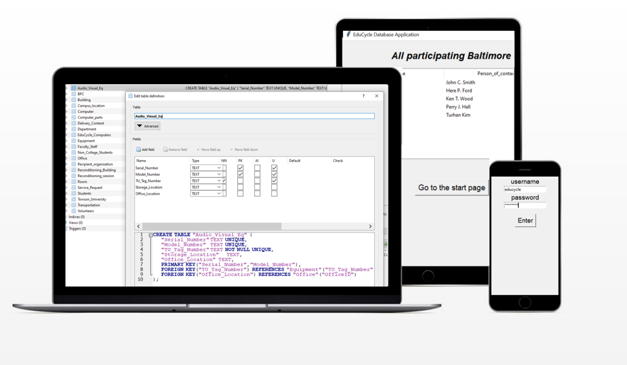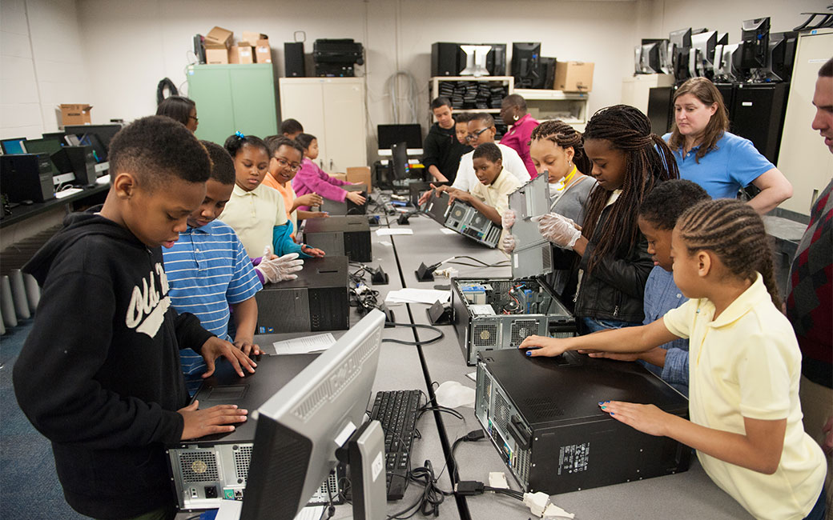

With information on computer parts storage, the E.D.’s contents make it useful for other members of Towson University as well.

The E.D. includes a responsive Graphical User Interface with concise inputs and effortless navigation.

The E.D. is built on a simple backbone using SQLite and Python. Facilitating the training of new personnel in its design and implementation.

The Educycle Database is used by the TU Educycle program to store and manage information from all points in the process, from Pre-reconditioning to Delivery.

**Extensible**

**Reuseability**

**Intuitive**

**Functionality**

**EduCycle Database**