Spring 2020



Alexander Dao, Andy Stoerkel, Turhan Kimbrough

cosc457

EduCycle Database

Project Report

**Table of Contents**

1. Introduction of the EduCycle Database 2

2. EduCycle Program 2

3. User Requirements 4

3.1 Process Modeling Requirements 4

3.2 Data Modeling Requirements 4

3.3 Expected Database Queries 5

4. Entity Relationship Diagram 6

4. Task List 7

**Introduction of the EduCycle Database**

The development of the database project for the EduCycle program started on February of 2020. This is to help assist the coordinator, Julie Leary, in organizing EduCycle’s database of computers and reconditioning sessions and keep the records of all of the equipment, staff, students, and volunteers that have participated in this program. Currently, there has no such database that houses this information. When writing annual reports, this will help the coordinator with effectively finding and tracking all of the necessary information needed and will not only save time, but also keep an organized database for future use.

A team of three students are currently working on this project. The database will be made through SQLite and the user interface will be created using Python. The project is being created for the COSC 457 Database Management System course and will be the first time each member will work a database.

**EduCycle Program**

From 2014, EduCycle has taken out of lifecycle computers from Towson University and reconditioned them for reuse. This has lessened the technology trash on campus as well as saved thousands of dollars of students’ money. Reconditioning sessions have gone far to not only involve TU students, but also Baltimore Public Schools in the general area.

Base on this, the development of a website geared to non-TU schools will be created. This will create an easy way for schools, K-12, to learn more about the EduCycle Program, be involved in our reconditioning sessions, receive recondition computers (at no charge), and a faster way to reach one of the managers in charge for further assistance. This website will consist of informative pages that will give the user more knowledge about the entire program as a whole, as well as learning more to take part.

**User Requirements**

Process Modeling Requirements

1. Towson University has many Department, Staff, and students
2. Department as information such as Name and code number
   1. Each department can have their own Service Request
   2. Each department can have multiple equipment in their rooms
   3. Department can have delivery contents delivered to them
3. Staff and students have information, such has Name, TU ID, SSN
   1. (Staff only) Will have which Department they belong to
   2. (Students only) Will have their Major and school information
   3. Both student and staff can participate in Reconditioning session
4. Reconditioning sessions will have information like Building_ID, Room_ID, and staff
   1. A reconditioning session can Store many EduCycle Computers
   2. A reconditioning session can have Non-college students (Baltimore Public School students) participating
5. Baltimore Public schools host the non-college students
   1. They can also place Service Request
   2. Can receive deliver request for computers
6. Equipment can consist of; TU Tag number, Type, storage location, and manufacture code
   1. A/V Equipment is a subcategory of Equipment
   2. Computer Parts is a subcategory of Equipment
   3. Computer is a subcategory of Equipment
7. Equipment (and its sub-category) can be stored in departments, buildings, offices, and rooms

(*) There are more Requirements for the Process Model, however, the ones above are the main concepts

Data Modeling Requirements

**Allow Manager and Student employees to input information on Service Request Tickets, Equipment, and volunteers:**

1. Allow user to manually update all of the information above
   1. (Only Manager side) Service Request Ticket
2. Allow users to view list of equipment, staff, student information, and Baltimore Public Schools
3. Allow users to locate a computer and where it is being stored
4. Can view whether or not a computer has been through the EduCycle Reconditioning program
5. Allow user to generate a list of students and staff that was enrolled in the reconditioning sessions

Expected Database Queries

**Create an application that can:**

1. View Baltimore Public schools that are participating in the program
2. List of Service Request tickets with each school
3. View Towson University Students Participants for Volunteering
4. Find which students have been participating in which groups during different Reconditioning sessions
5. Find the list of contact information for each teachers who were staff

**Entity Relationship Diagram**

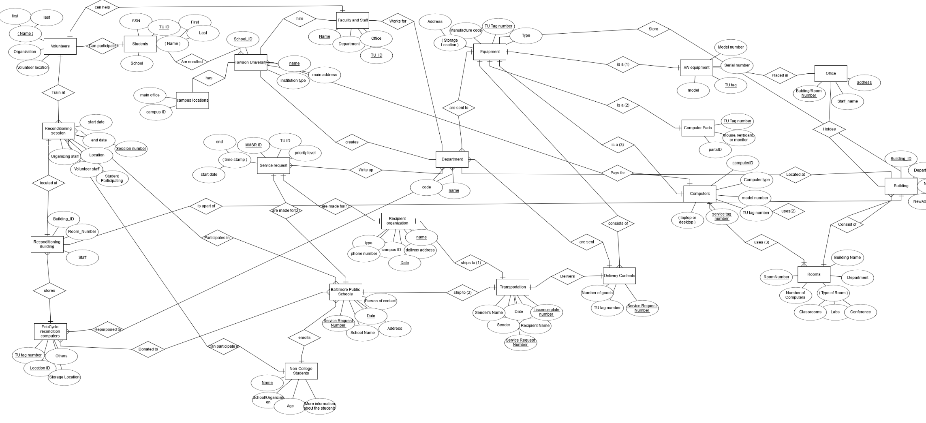

**Task List**

|  |  |  |  |  |
| --- | --- | --- | --- | --- |
| Task Name | Duration (Day(s)) | Start | Finish | Member Names |
| Brainstorm Ideas for Database | 1 | 2/6/2020 | 2/6/2020 | All |
| Research more about EduCycle | 2 | 2/8/2020 | 2/10/2020 | All |
| Interview EduCycle Coordinator | 1 | 2/13/2020 | 2/13/2020 | All |
| Create Use Cases | 1 | 2/20/2020 | 2/20/2020 | All |
| Create Requirements | 1 | 2/20/2020 | 2/20/2020 | All |
| Create the ERD | 5 | 2/22/2020 | 2/27/2020 | All |
| Create Schema Diagram | 8 | 3/1/2020 | 3/9/2020 | All |
| Group meeting with members | 1 | 3/10/2020 | 3/10/2020 | All |
| Database Created (DB Browser) | 5 | 3/10/2020 | 3/15/2020 | Alex |
| Insert Sample Dataset | 1 | 3/15/2020 | 3/15/2020 | Andy |
| Create Application for Database | 1 | 3/20/2020 | 3/20/2020 | Turhan |
| Queries Made | 11 | 3/20/2020 | 3/31/2020 | Turhan, Andy |
| Interface modified | 19 | 4/1/2020 | 4/19/2020 | Turhan |
| Testing database and interface | 1 | 4/19/2020 | 4/19/2020 | Andy |
| Discuss requirements with group | 1 | 4/20/2020 | 4/20/2020 | All |
| Finalize the project | 5 | 4/20/2020 | 4/25/2020 | All |
| Prepare the Powerpoint | 2 | 4/26/2020 | 4/28/2020 | Alex |
| Practice for the presentation | 2 | 4/28/2020 | 4/30/2020 | All |
| Presentation in class | 1 | 4/30/2020 | 4/30/2020 | Turhan, Andy |
| Submit final project | 1 | 5/7/2020 | 5/7/2020 | All |