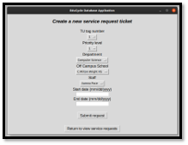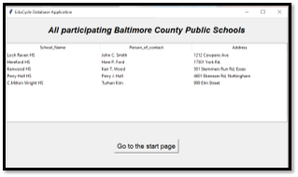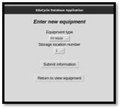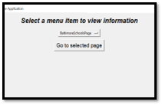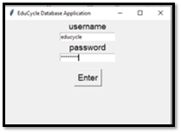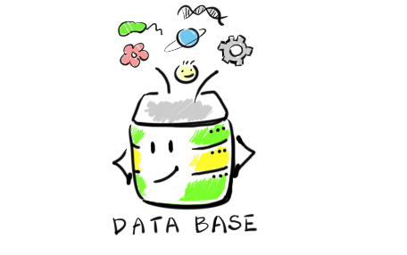

Educycle Database:

* Allows you to add/remove

equipment

* Request for refurbished equipment from Towson to a participating school
* View enrolled members
* Create/view equipment reconditioning sessions
* Offers an interface for administrators (management) & students

Technological Components:

* SQLite for database
* Tkinter GUI for interface
* Python 3 for back-end
* Safeguarding against SQL injections so no information

is leaked

**Creating**

**Service request**

**Adding data**

How does it work?

Email: EduCycle@towson.edu

Site: www.EduCycleProgram.com

**Log-in**

**View Tables**

It’s as easy as

Filling out forms!