AholdDelhaize

ThomasVos

2022-10-12

library(readxl)  
library(ggplot2)  
pacman::p_load(tidyverse, haven, lmtest, stargazer,   
 ARDL, modelsummary, car,tseries,mFilter)  
df = read_excel('../Assignment_Module2_Part3.xlsx')  
  
# In order to simplify the return function get a lag  
df$AHOLD.L1 = lag(df$AHOLD, n = 1)  
df$AEX.L1 = lag(df$AEX, n = 1)  
  
df$returnAhold = ((df$AHOLD-df$AHOLD.L1)/df$AHOLD.L1)  
df$returnAEX = ((df$AEX-df$AEX.L1)/df$AEX.L1)  
  
reg.1 = lm(df$returnAhold ~ df$returnAEX, data=df)  
summary(reg.1)

##   
## Call:  
## lm(formula = df$returnAhold ~ df$returnAEX, data = df)  
##   
## Residuals:  
## Min 1Q Median 3Q Max   
## -0.097416 -0.005478 0.000421 0.005883 0.110439   
##   
## Coefficients:  
## Estimate Std. Error t value Pr(>|t|)   
## (Intercept) 0.0002019 0.0002361 0.855 0.393   
## df$returnAEX 0.5060040 0.0188400 26.858 <2e-16 ***  
## ---  
## Signif. codes: 0 '***' 0.001 '**' 0.01 '*' 0.05 '.' 0.1 ' ' 1  
##   
## Residual standard error: 0.01186 on 2524 degrees of freedom  
## (1 observation deleted due to missingness)  
## Multiple R-squared: 0.2223, Adjusted R-squared: 0.222   
## F-statistic: 721.4 on 1 and 2524 DF, p-value: < 2.2e-16

plot.1 <- ggplot() +   
 geom_line(data = df, aes(x = day, y = AEX.L1, color = "PCE")) +  
 geom_line(data = df, aes(x = day, y = AHOLD.L1, color = "DPI")) +  
 theme(legend.position="bottom") +  
 xlab('Date') +  
 ylab('Change in PCE and DPI')  
  
plot.1

## Warning: Removed 1 row(s) containing missing values (geom_path).  
## Removed 1 row(s) containing missing values (geom_path).

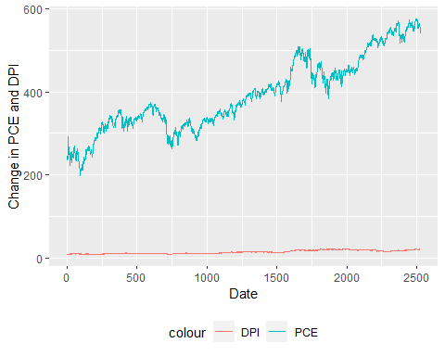

df$Residuals = c(NA,resid(reg.1))  
plot.Residual = plot(df$day, df$Residuals, ylab="Residuals",   
 xlab="Time",   
 main="Residuals plot")

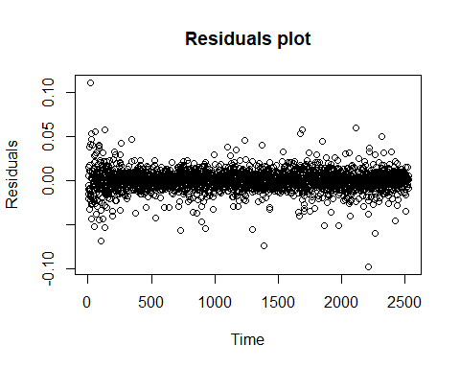

plot.Residual

## NULL

durbinWatsonTest(reg.1)

## lag Autocorrelation D-W Statistic p-value  
## 1 -0.0444479 2.088545 0.026  
## Alternative hypothesis: rho != 0

library(tseries)  
df.1rowLess = df[-c(1:1), ]  
adf.test(c(df.1rowLess$returnAEX,df.1rowLess$returnAhold))

## Warning in adf.test(c(df.1rowLess$returnAEX, df.1rowLess$returnAhold)): p-value  
## smaller than printed p-value

##   
## Augmented Dickey-Fuller Test  
##   
## data: c(df.1rowLess$returnAEX, df.1rowLess$returnAhold)  
## Dickey-Fuller = -17.615, Lag order = 17, p-value = 0.01  
## alternative hypothesis: stationary