ConsumptionAndIncome

ThomasVos

2022-10-12

library(readxl)  
library(ggplot2)  
pacman::p_load(tidyverse, haven, lmtest, stargazer,   
 ARDL, modelsummary, car,tseries,mFilter)  
df = read_excel('../Assignment_Module2_Part2.xlsx')  
  
reg.1 = lm(df$PCE ~ df$DPI, data=df)  
  
summary(reg.1)

##   
## Call:  
## lm(formula = df$PCE ~ df$DPI, data = df)  
##   
## Residuals:  
## Min 1Q Median 3Q Max   
## -466.65 -50.09 -1.91 45.03 264.15   
##   
## Coefficients:  
## Estimate Std. Error t value Pr(>|t|)   
## (Intercept) -68.25230 8.40130 -8.124 2.68e-14 ***  
## df$DPI 0.91772 0.00128 716.705 < 2e-16 ***  
## ---  
## Signif. codes: 0 '***' 0.001 '**' 0.01 '*' 0.05 '.' 0.1 ' ' 1  
##   
## Residual standard error: 84.03 on 232 degrees of freedom  
## Multiple R-squared: 0.9995, Adjusted R-squared: 0.9995   
## F-statistic: 5.137e+05 on 1 and 232 DF, p-value: < 2.2e-16

cor(df$PCE, df$DPI)

## [1] 0.9997742

reg.1.res = resid(reg.1)   
df$Residuals = resid(reg.1)  
  
#dwtest(reg.1.res)  
  
dwtest(PCE ~ DPI, data = df)

##   
## Durbin-Watson test  
##   
## data: PCE ~ DPI  
## DW = 0.47989, p-value < 2.2e-16  
## alternative hypothesis: true autocorrelation is greater than 0

durbinWatsonTest(reg.1.res)

## [1] 0.4798936

plot.1 <- ggplot() +   
 geom_line(data = df, aes(x = Quarter, y = PCE, color = "PCE")) +  
 geom_line(data = df, aes(x = Quarter, y = DPI, color = "DPI")) +  
 theme(legend.position="bottom") +  
 xlab('Date') +  
 ylab('Change in PCE and DPI')  
  
plot.1

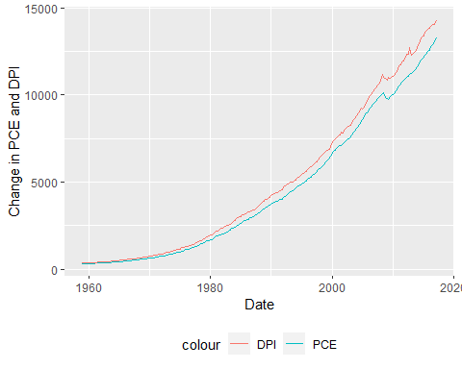

plot.Residual = plot(df$Quarter, df$Residuals, ylab="Residuals",   
 xlab="Time",   
 main="Residuals plot")

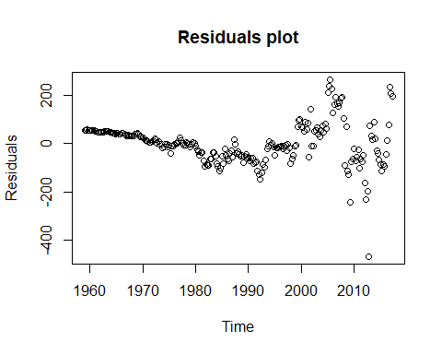

plot.Residual

## NULL

# Importing library  
library(tseries)  
#adf.test(df)  
  
df$logPCE = log10(df$PCE)  
df$logDPI = log10(df$DPI)  
  
plot.log <- ggplot() +   
 geom_line(data = df, aes(x = Quarter, y = logPCE, color = "PCE")) +  
 geom_line(data = df, aes(x = Quarter, y = logDPI, color = "DPI")) +  
 theme(legend.position="bottom") +  
 xlab('Date') +  
 ylab('Change in PCE and DPI')  
  
plot.log

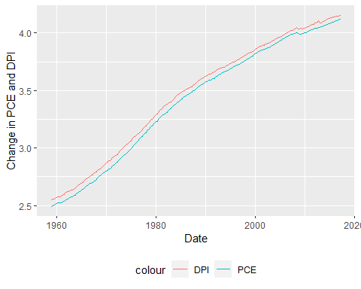

gdp <- ts(df$PCE, start = c(1960,01), end =c(2014,4), frequency = 4)  
  
ts.plot(gdp)

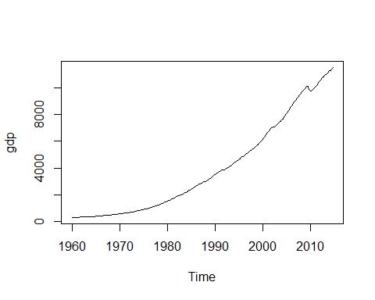

hp.decom <- hpfilter(gdp, freq = 1600, type = "lambda")  
  
par(mfrow = c(1, 2), mar = c(2.2, 2.2, 1, 1), cex = 0.8)  
plot.ts(gdp, ylab = "") # plot time series  
lines(hp.decom$trend, col = "red") # include HP trend  
legend("topleft", legend = c("data", "HPtrend"), lty = 1,   
 col = c("black", "red"), bty = "n")  
plot.ts(hp.decom$cycle, ylab = "") # plot cycle  
legend("topleft", legend = c("HPcycle"), lty = 1, col = c("black"),   
 bty = "n")

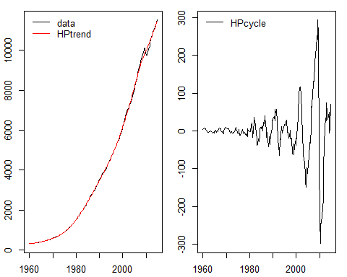

#reg.loged.1 = lm(PCE ~ hp.decom, data=df)  
#summary(reg.loged.1)  
  
  
  
df$difference = df$DPI - df$PCE  
  
plot.2 <- ggplot() +   
 geom_line(data = df, aes(x = Quarter, y = difference, color = "Difference")) +  
 xlab('Date') +  
 ylab('Difference DPI and PCE')  
  
plot.2

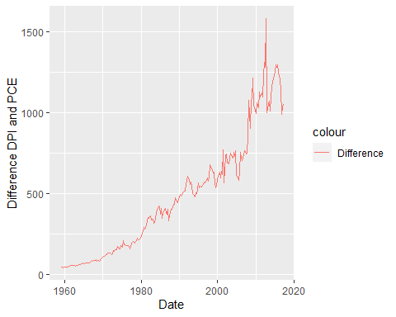

reg.2 = lm(df$PCE ~ df$difference + df$DPI, data=df)  
summary(reg.2)

## Warning in summary.lm(reg.2): essentially perfect fit: summary may be unreliable

##   
## Call:  
## lm(formula = df$PCE ~ df$difference + df$DPI, data = df)  
##   
## Residuals:  
## Min 1Q Median 3Q Max   
## -2.585e-11 -9.690e-14 6.570e-14 2.252e-13 1.321e-11   
##   
## Coefficients:  
## Estimate Std. Error t value Pr(>|t|)   
## (Intercept) 1.367e-12 2.198e-13 6.222e+00 2.28e-09 ***  
## df$difference -1.000e+00 1.515e-15 -6.599e+14 < 2e-16 ***  
## df$DPI 1.000e+00 1.281e-16 7.804e+15 < 2e-16 ***  
## ---  
## Signif. codes: 0 '***' 0.001 '**' 0.01 '*' 0.05 '.' 0.1 ' ' 1  
##   
## Residual standard error: 1.94e-12 on 231 degrees of freedom  
## Multiple R-squared: 1, Adjusted R-squared: 1   
## F-statistic: 4.823e+32 on 2 and 231 DF, p-value: < 2.2e-16