Part 2 report on the traffic analytics pipeline

Objective
Part 2 develops a reproducible Python workflow that transforms the raw Metro Interstate Traffic Volume CSV into cleaned and feature-engineered datasets for traffic analysis and subsequent machine-learning tasks. The workflow also generates visualisations of important traffic patterns and provides a command-line application for querying the processed data. Structured logging is incorporated throughout the workflow to record processing stages, data-quality interventions, generated outputs and invalid user inputs.

Methodology
Stage | Method | Result
Load & validate | Load CSV; validate schema and dates | 48,204 rows, 9 columns
Standardise | Standardise categorical fields | 48,143 non-holiday entries retained as missing
Deduplicate | Remove exact duplicates; retain repeated timestamps | 17 removed; 48,187 rows remain
Validate numeric data | Flag temperature ≤0 K and rainfall >500 mm/h | 10 temperature and 1 rainfall value
Impute | Monthly median for temperature; overall median for rainfall | 11 invalid values imputed
Save | Export cleaned dataset | 48,187 rows, 9 columns
Exact duplicates were removed, while repeated timestamps were retained because they can represent multiple weather conditions within the same hour. Physically invalid temperatures (≤0 K) and implausible rainfall (>500 mm/hour) were treated as missing and imputed using median values. Retaining repeated timestamps until feature engineering was important because removing them during cleaning would have discarded valid information about multiple weather conditions recorded within the same hour.

Feature engineering
feature_engineering.py consolidates the 48,187 cleaned records into 40,575 unique hourly observations and expands the dataset from 9 to 32 variables. Time features include hour, day of week, month, year, weekend/day-type indicators, traffic period and cyclical hour encoding. Eleven binary weather indicators preserve the weather conditions reported at each timestamp, while temperature, cloud coverage and traffic volume are also standardised for subsequent analysis.
A three-level congestion target was derived from traffic-volume quartiles: Low (≤1,248.5 vehicles), Moderate (>1,248.5 to ≤4,952) and High (>4,952). This produced 10,144 Low, 20,289 Moderate and 10,142 High observations.
These engineered features were selected to represent different aspects of traffic behaviour. Hour and day-type variables capture recurring commuting patterns, while cyclical encoding represents the periodic nature of time without treating the end and beginning of the day as unrelated. Weather indicators preserve the potentially overlapping conditions recorded at each timestamp, and standardised numerical variables place continuous features on comparable scales for subsequent machine-learning algorithms. The congestion category also provides a categorical representation of traffic intensity that can be used in later classification tasks.

Findings
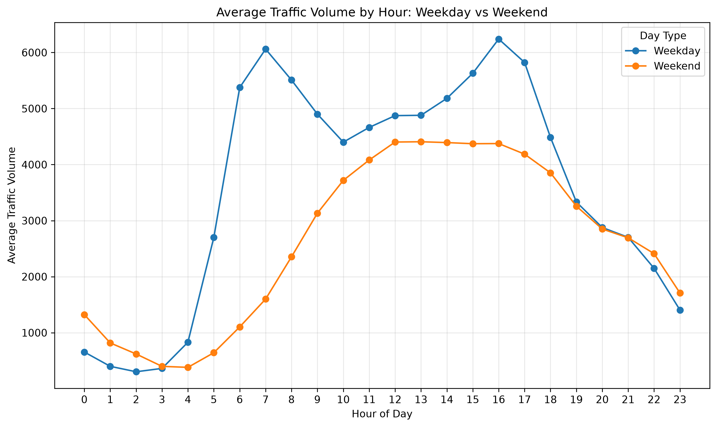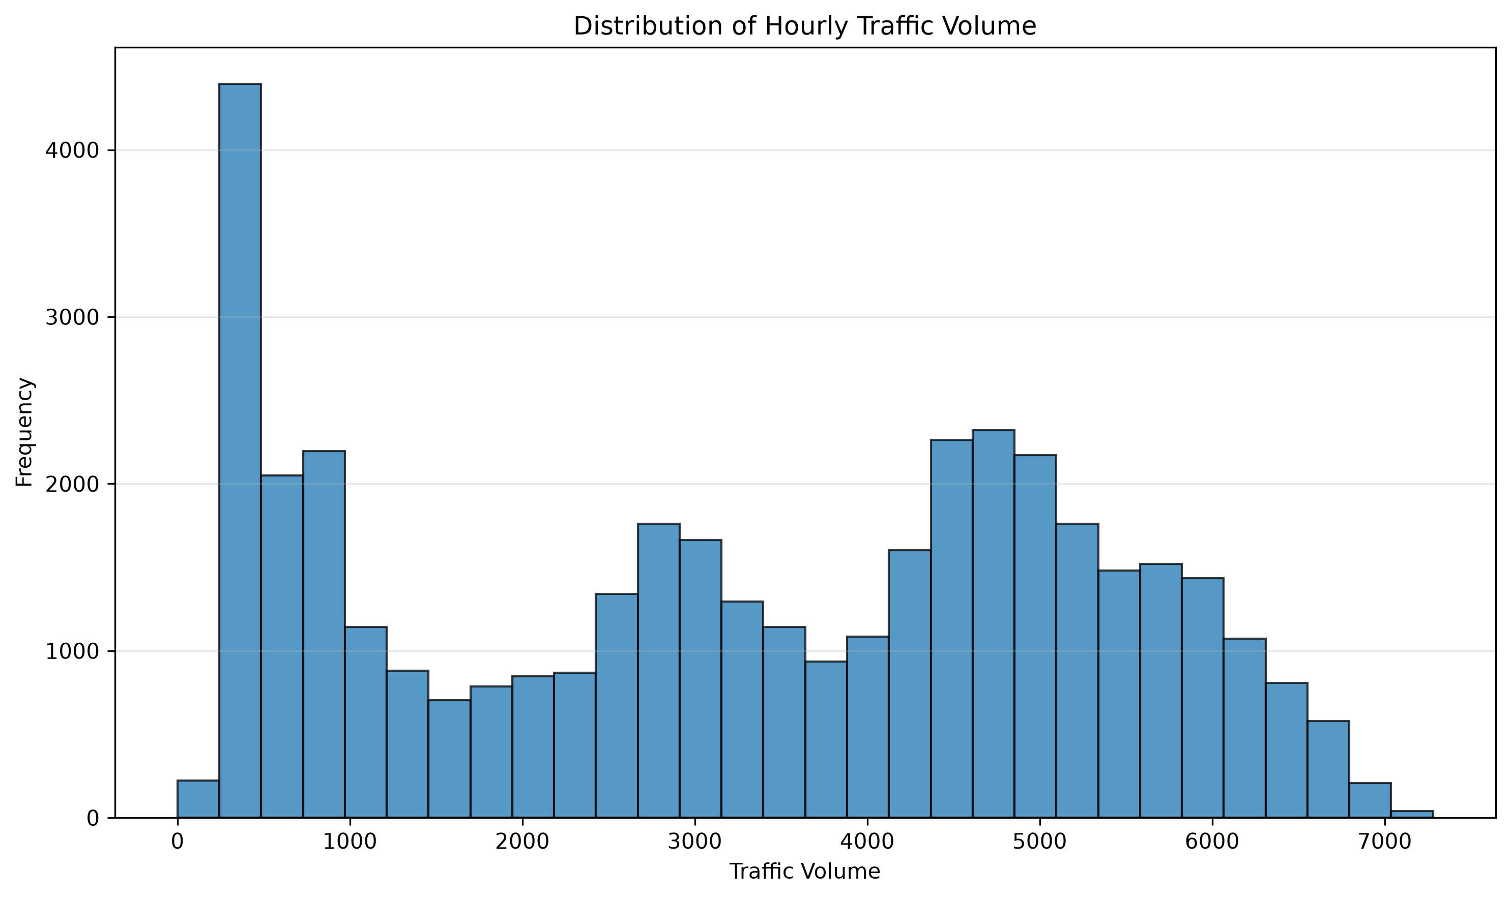
Figure 2. Distribution of hourly traffic volume
Figure 1. Average hourly traffic profile on weekdays and weekends

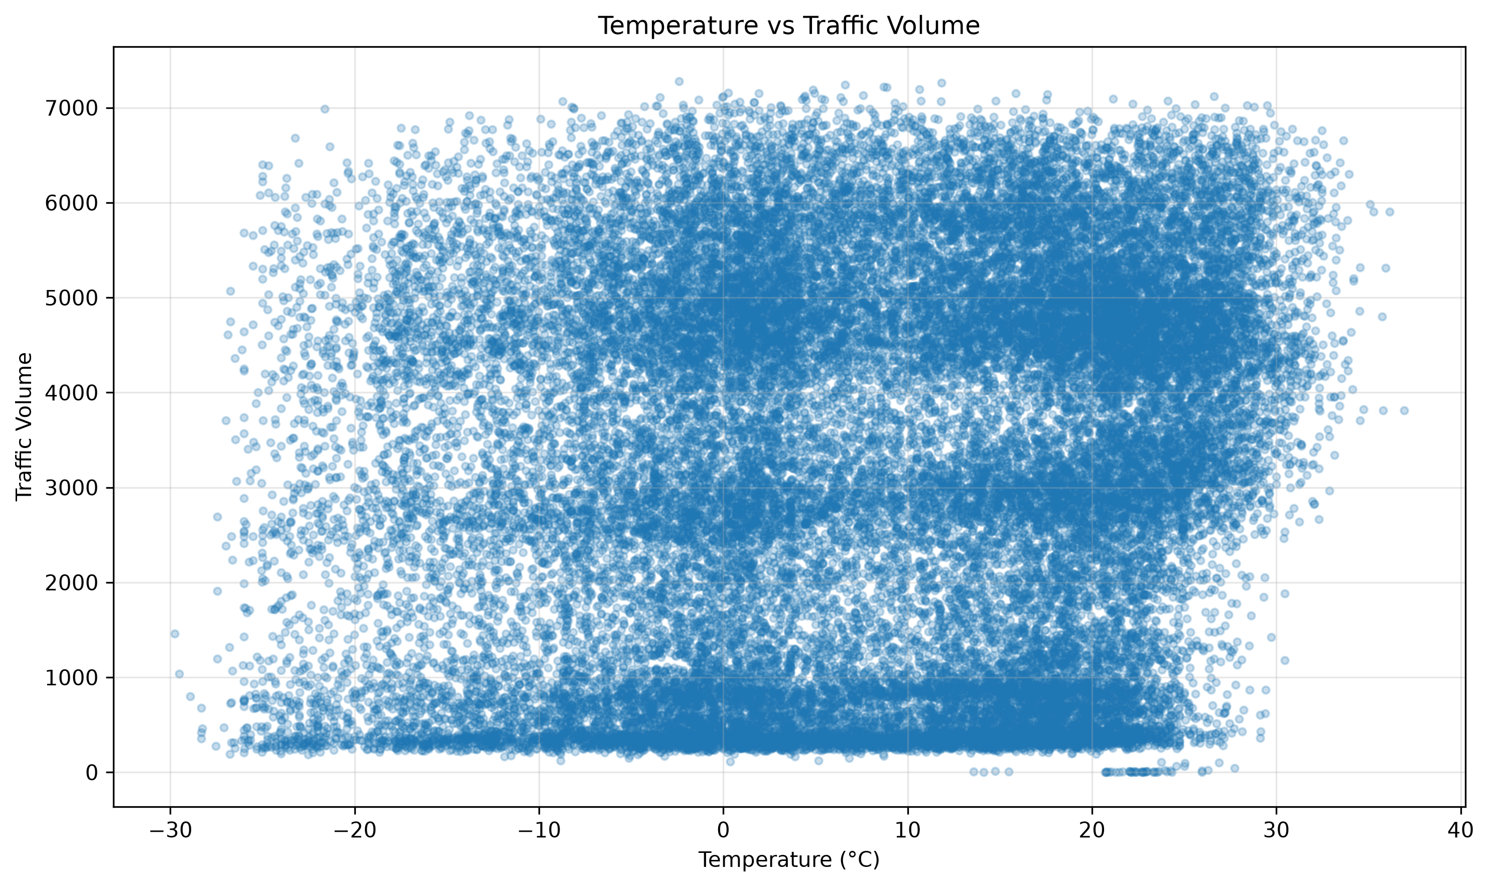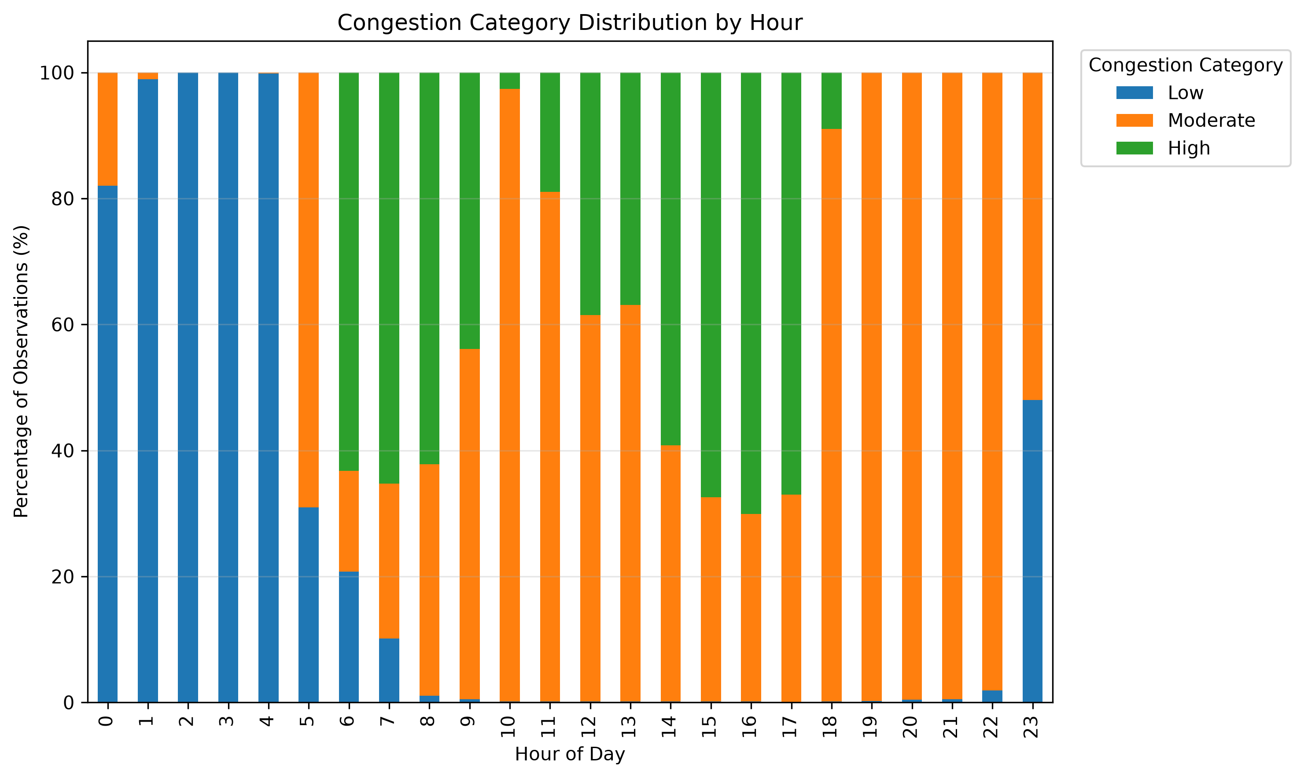
Figure 3. Temperature versus traffic volume
Figure 4. Congestion category by hour of day

Figure 1, hourly traffic profile. Weekday traffic shows pronounced commuting peaks, reaching approximately 6,241 vehicles/hour at 16:00, compared with a lower weekend maximum of approximately 4,408 at 13:00. This demonstrates the importance of hour and day type in predicting traffic demand.
Figure 2, traffic-volume distribution. Traffic volume ranges from 0 to 7,280 vehicles/hour, with a mean of 3,291 and median of 3,427. The multimodal distribution reflects distinct overnight, daytime and commuting traffic regimes.
Figure 3, temperature and traffic volume. Temperature has only a weak positive relationship with traffic volume (r = 0.139), with both high and low traffic occurring across a broad temperature range. Temperature alone therefore has limited explanatory value.
Figure 4, congestion by hour. Congestion varies strongly by time of day: Low congestion accounts for 100% of observations at 03:00, while High congestion reaches approximately 70.1% at 16:00. This supports the importance of hour-based features for modelling traffic conditions.

Command-line application
cli_app/traffic_cli.py provides four commands: date summarises traffic for a selected date; high-traffic ranks hours by historical average traffic; compares weekday and weekend traffic; and recommend identifies lower-traffic hours within a specified time range. For example, weekday traffic averages 3,557 vehicles/hour, compared with 2,624 on weekends. Invalid inputs are handled with clear error messages and logged appropriately.

Logging and reproducibility
Each executable script uses logging.getLogger(__name__) with console and file handlers and records containing timestamp, level, module and message. INFO, WARNING, DEBUG and ERROR are used for normal milestones, recoverable issues, detailed troubleshooting and failures respectively; DEBUG feature-engineering output can be enabled with --debug. Internal status messages use logging rather than print(). Reproducibility is supported by requirements.txt, the documented execution order (pipeline.py → feature_engineering.py → visualizations.py → CLI), and the project README.

Limitations
- Imputed sensor values: Ten invalid temperature readings and one implausible rainfall reading were replaced with median values, so these represent estimates rather than observed measurements.
- Dataset-relative congestion: Low, Moderate and High congestion are based on dataset quartiles rather than official traffic-engineering thresholds.
- Repeated weather observations: Multiple weather records at the same timestamp were consolidated into hourly binary indicators, reducing some detail from the original records.
- Historical recommendations: The CLI recommends lower-traffic periods using historical averages and does not account for real-time traffic conditions or incidents.

