Azure DevOps
Week -4

Emp Name – Ahmed Taufique
Emp id – 1433732

2. Deploy the pet clinic in azure dev ops

A.
Step-1 : Create a project named pet clinic

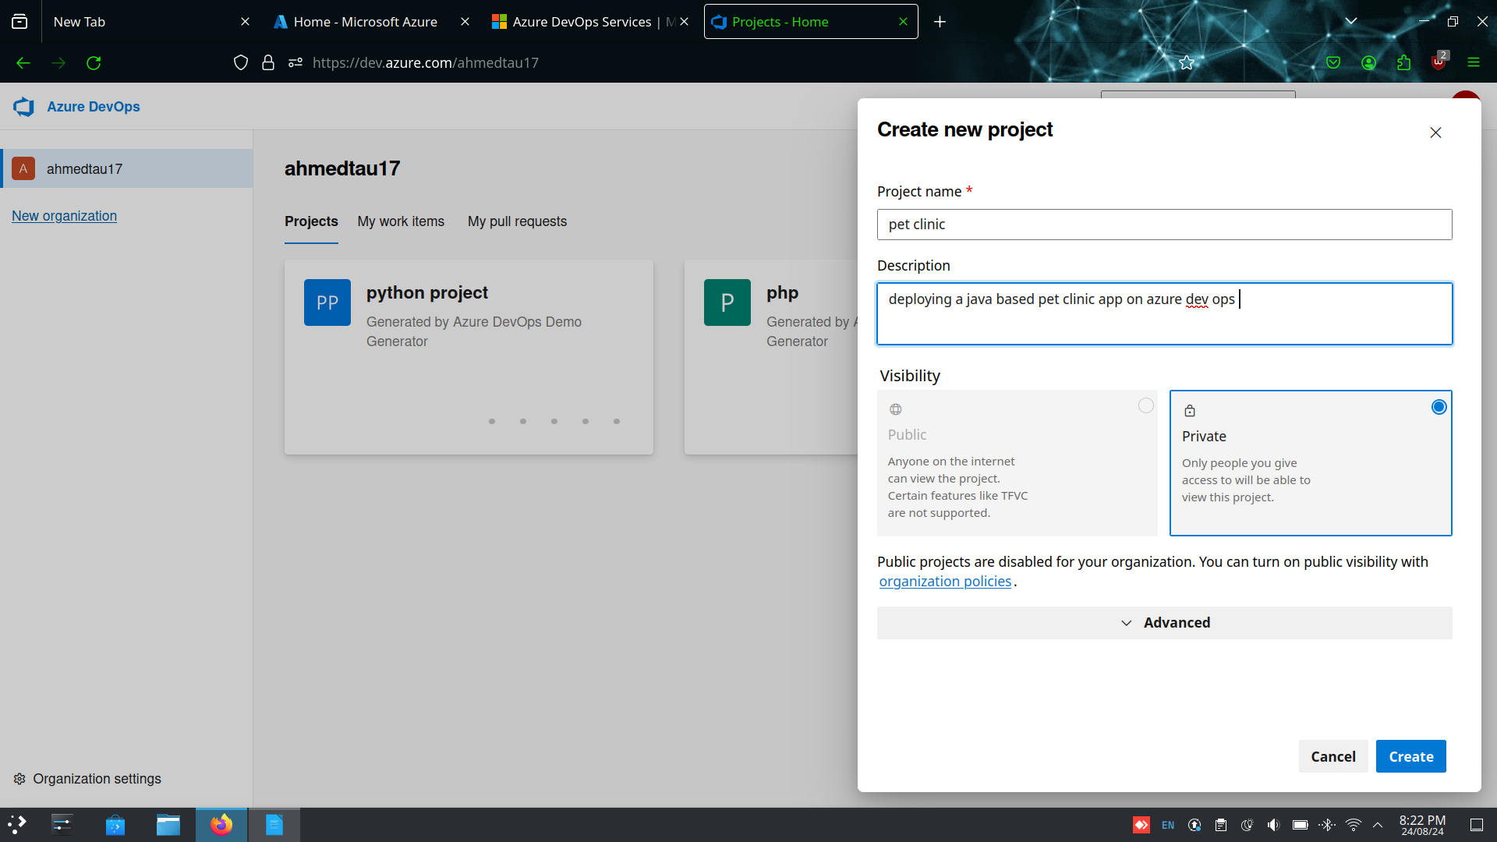
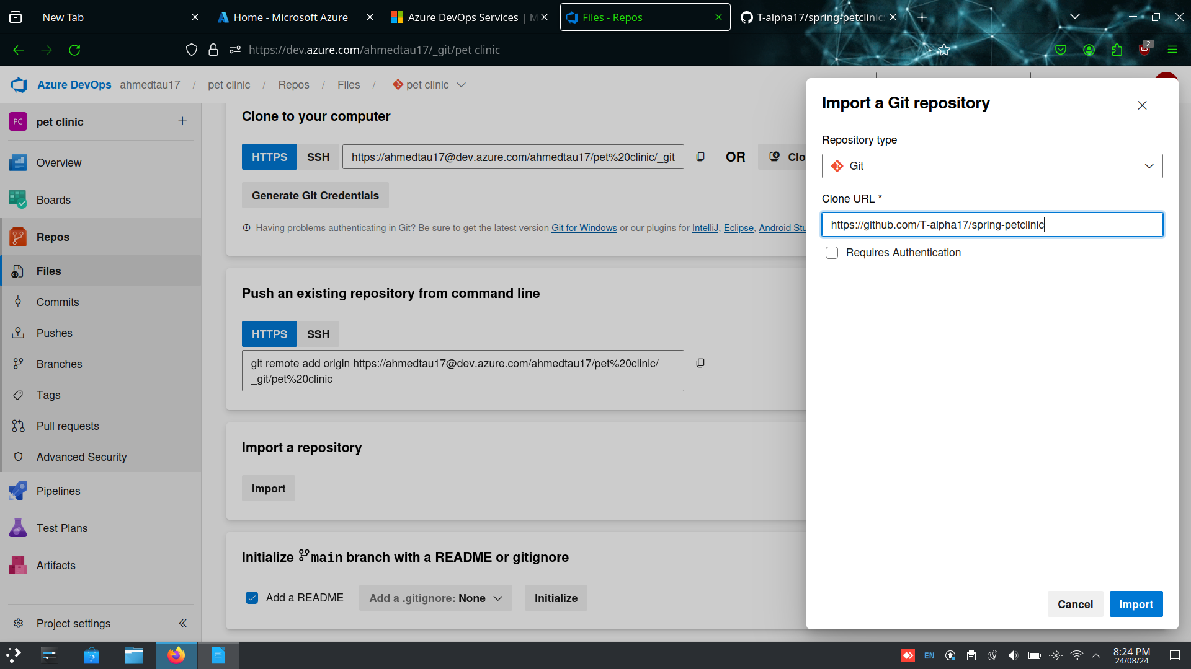
Step-2 : Go to repos and import the spring pet-clinic repository from the github
Step-3 : Go to pipelines and create a new pipeline select a new starter pipeline while configuring

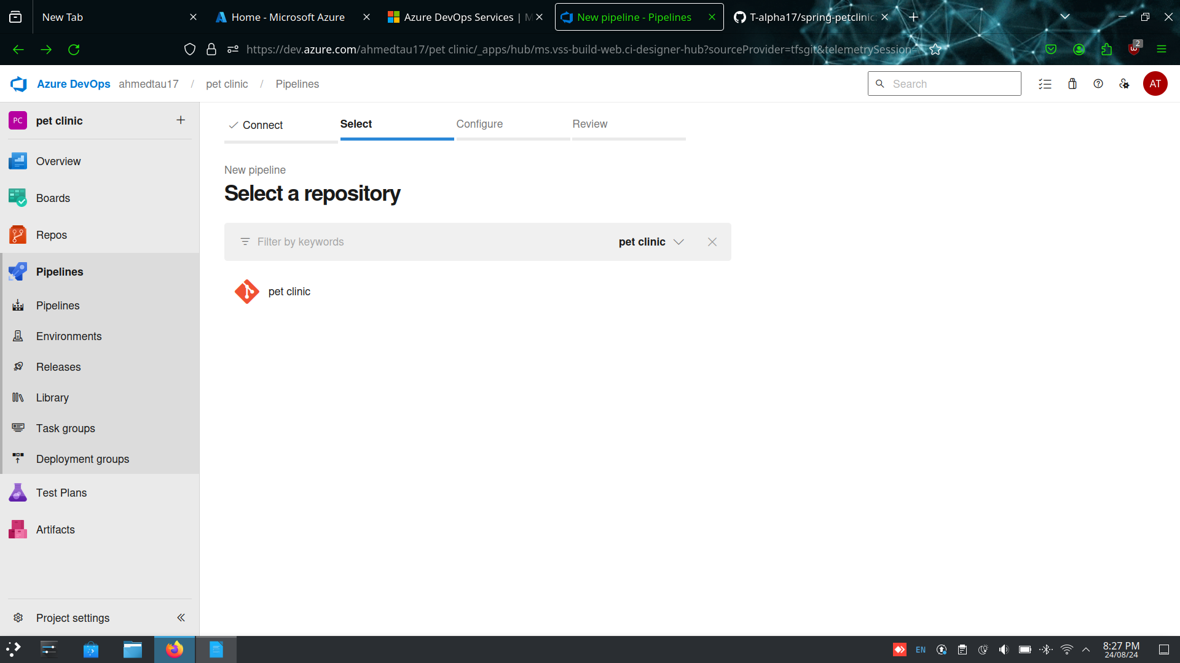

Step-4 : Write the YAML file and validate and save and make sure yo change the jdk version to 17

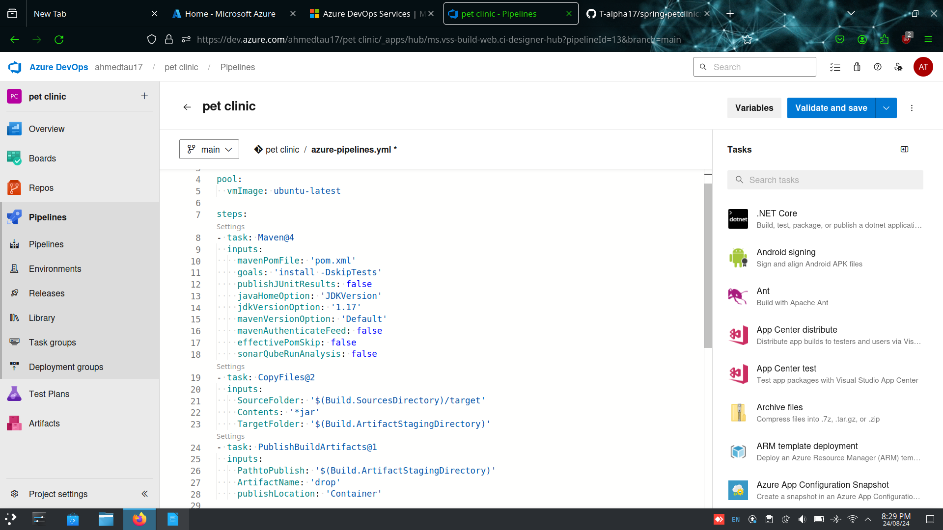

Step-5: Make sure that all jobs run successfully and check if the artifcate is created or not

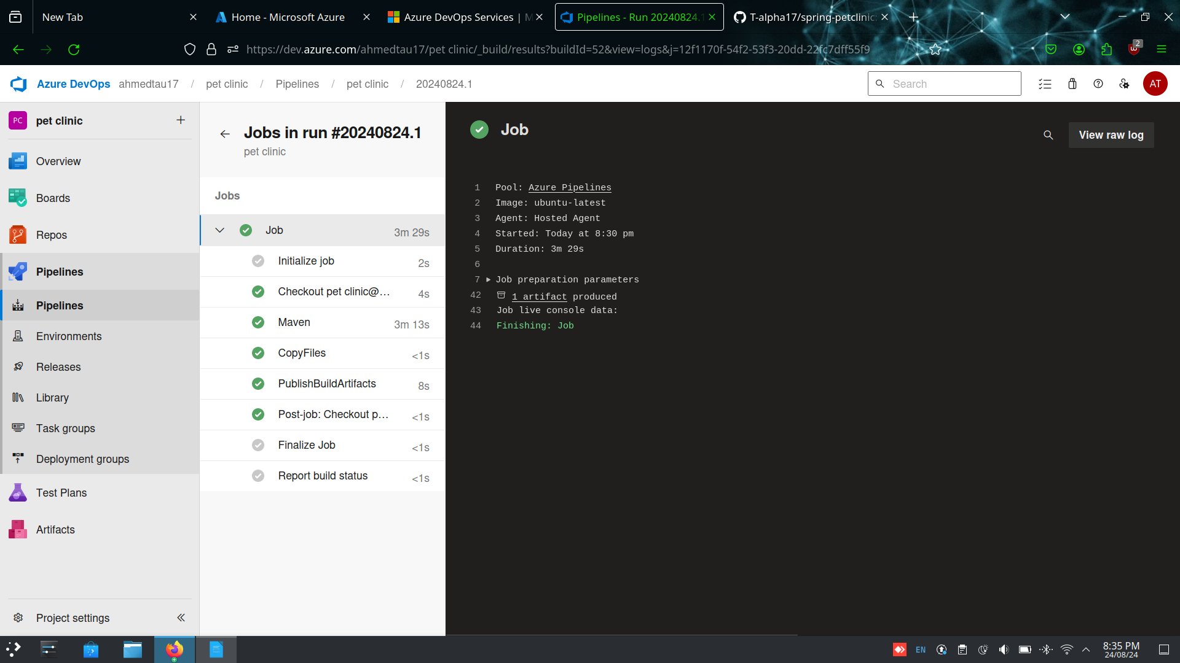
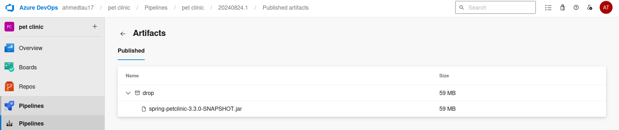
Step-6 : Navigate to released and create a release pipeline , make sure to add the artifact
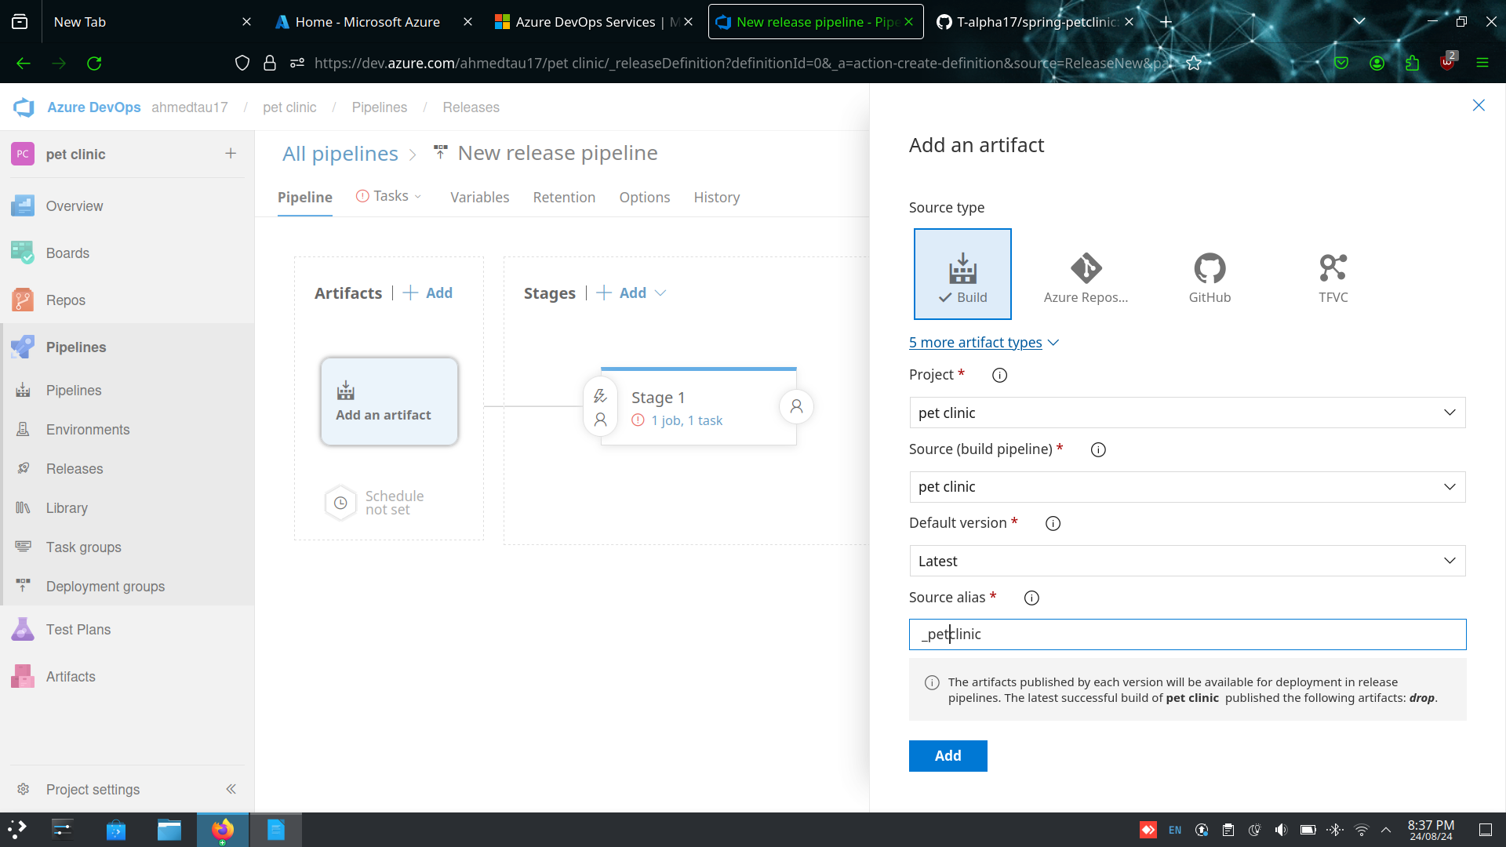
Step-7: Make sure to change the run agent to azure pipelines and select windows 2019

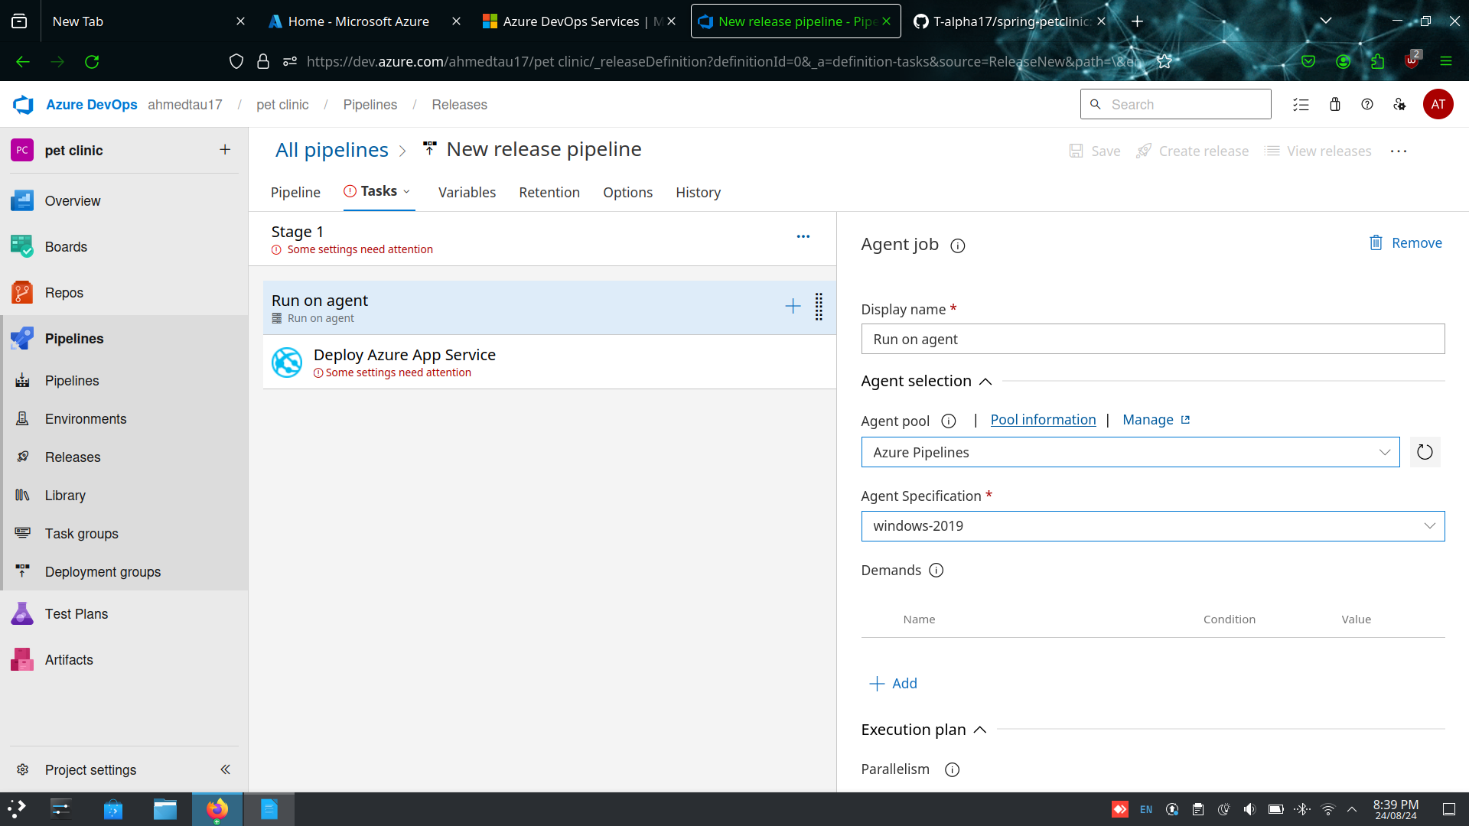
Step-8 : Make sure to add azure cli and azure app service deploy, azure cli version = 1.* and azure app service deploy = 4.*

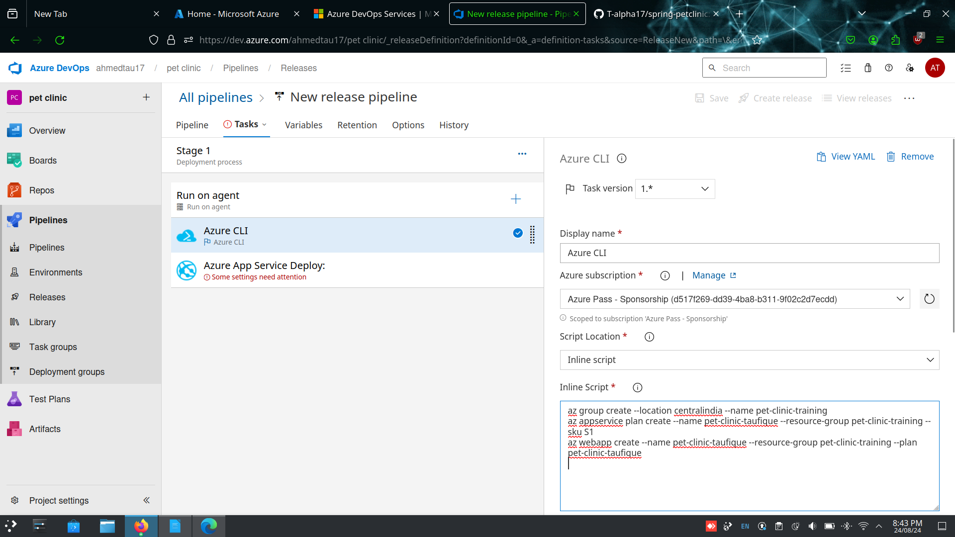

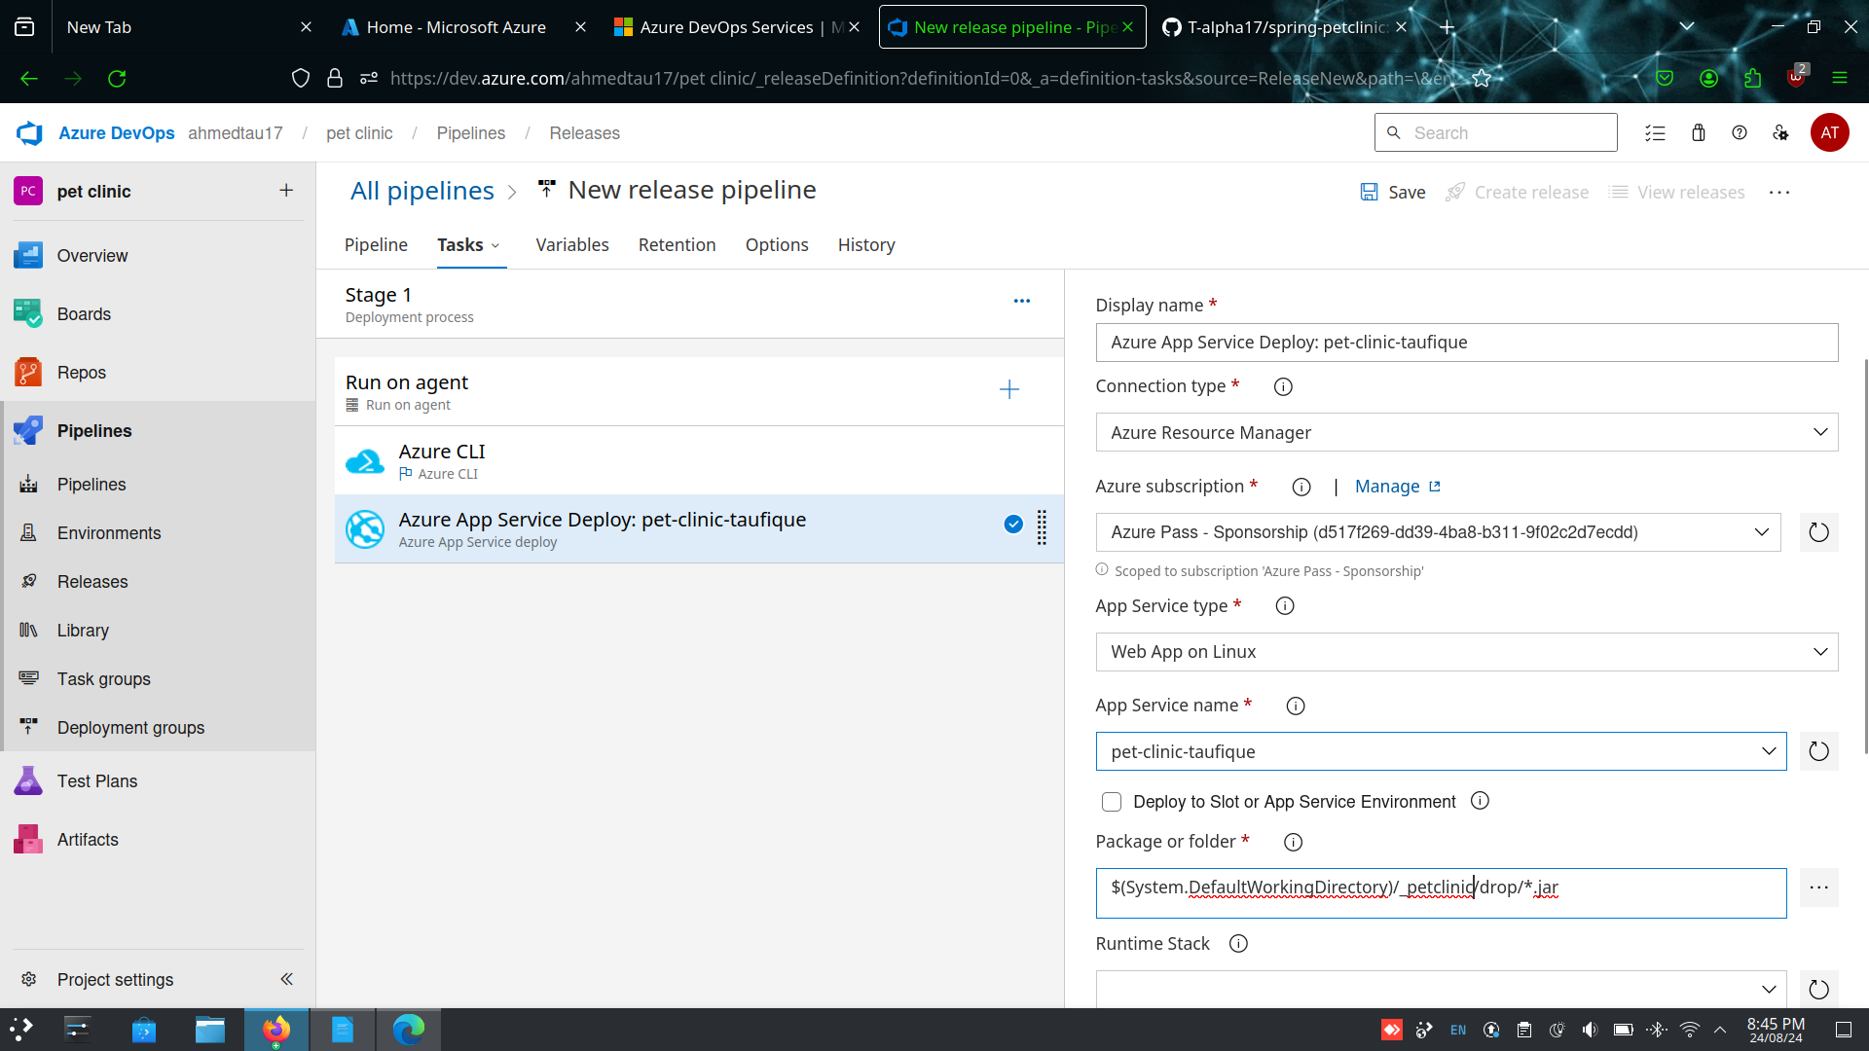
Step-9 : Create a release the pipeline

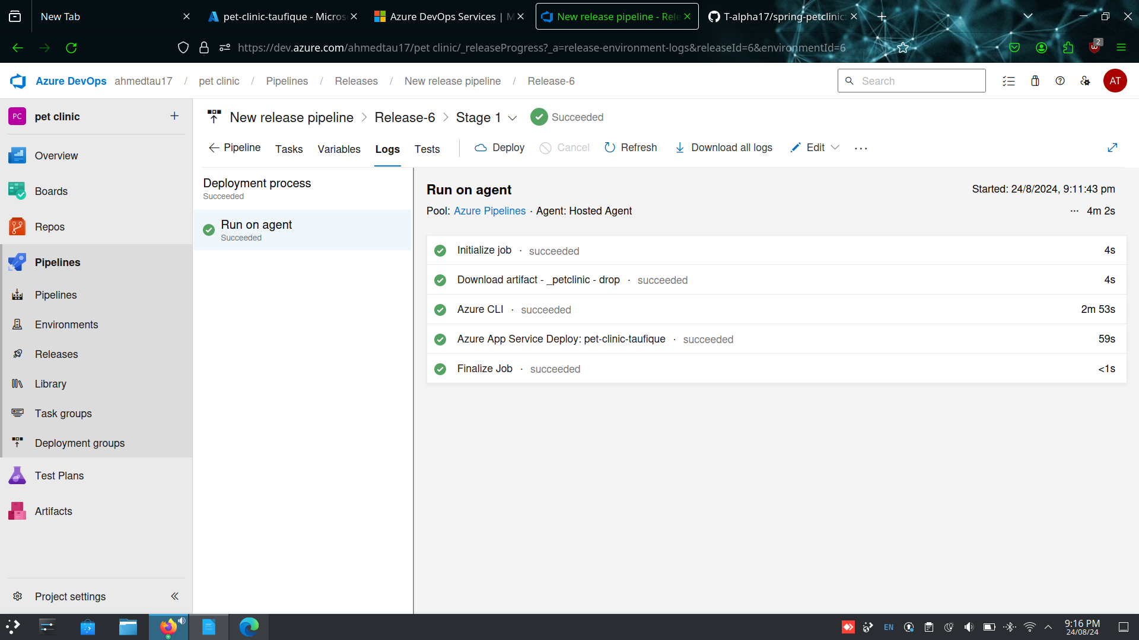

Step-10: Change the configuration and add java 17

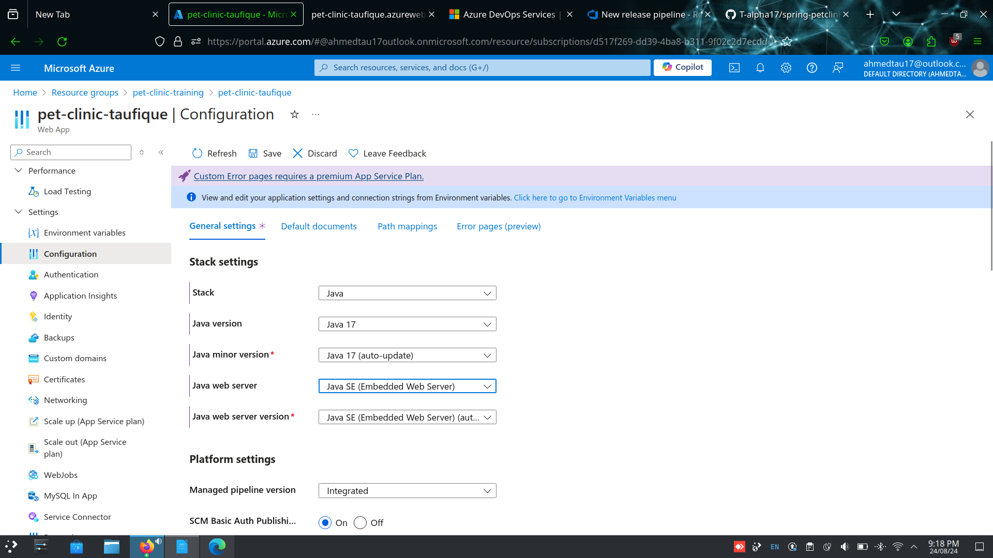

Step- 11 : click on browse and launch the web app



