Docker & Kubernetes
Week – 5

Emp Name – Taufique Ahmed
Emp Id – 1433732

1. Deploy spring pet clinic application on docker

A.

Step-1 : Clone the repository of the pet clinic to the host machine

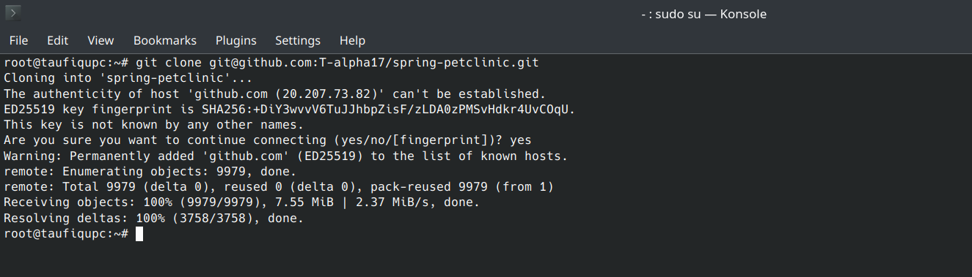
Step-2 : Run the following command to generate the target file to the repository

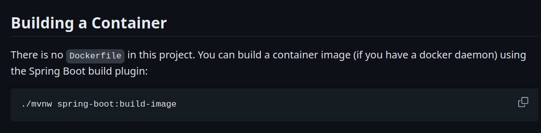
Step-3: Make a note of the target folder path

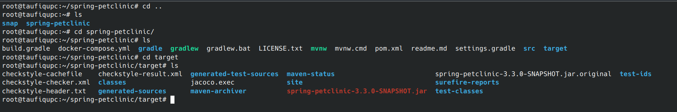

Step-4: Write the docker file
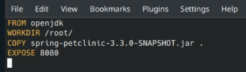

Step-5 : Build the docker image using docker build command
Step -6 : Check of the image and push it to the docker hub. (Before that make sure that you are logged into the docker)
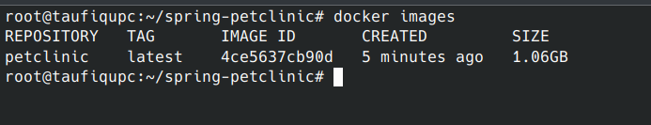
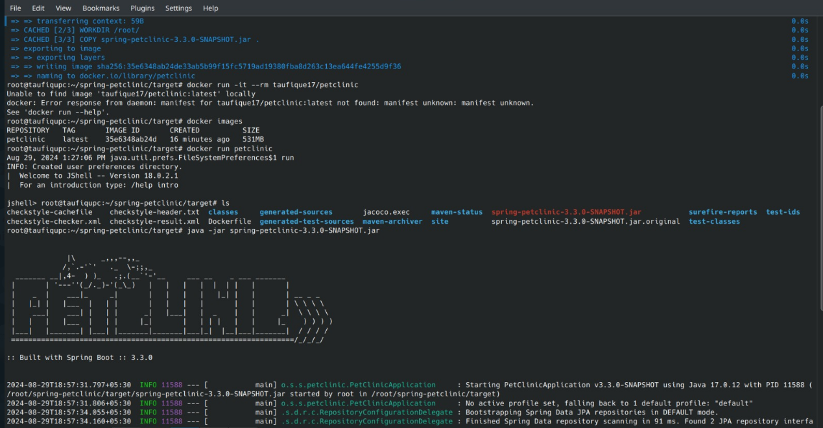
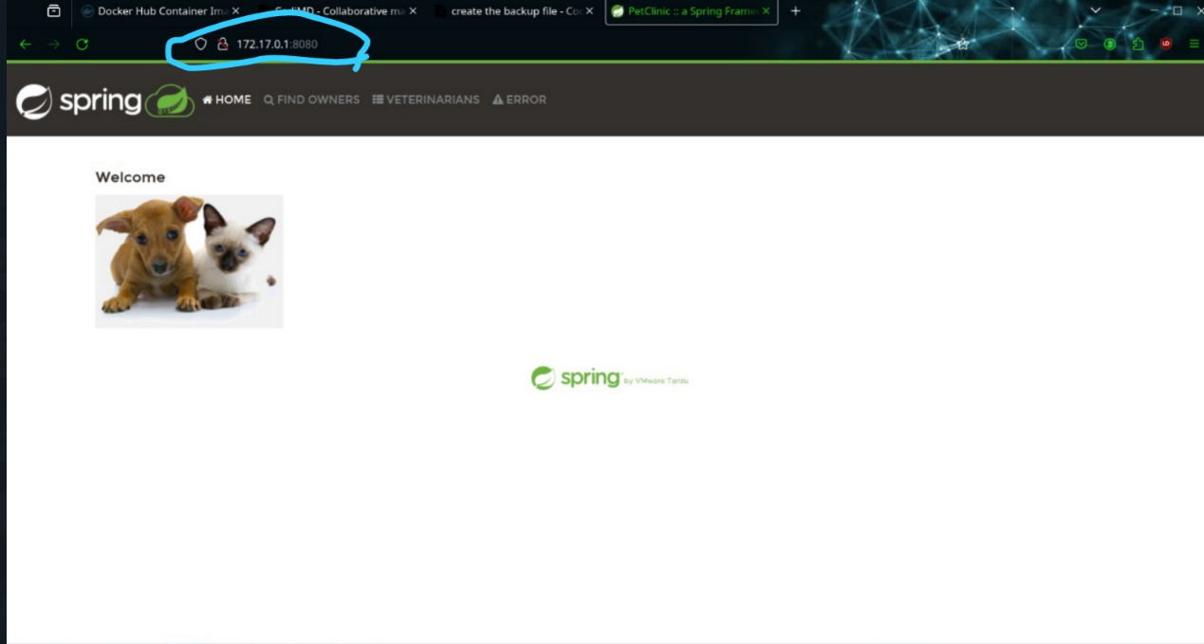
Step-7: Open a the browser and type the docker ip address, followed by :8080

2. Deply Spring pet clinic on kubernetes?

A.

Step-1 : Create the kubernetes cluster
