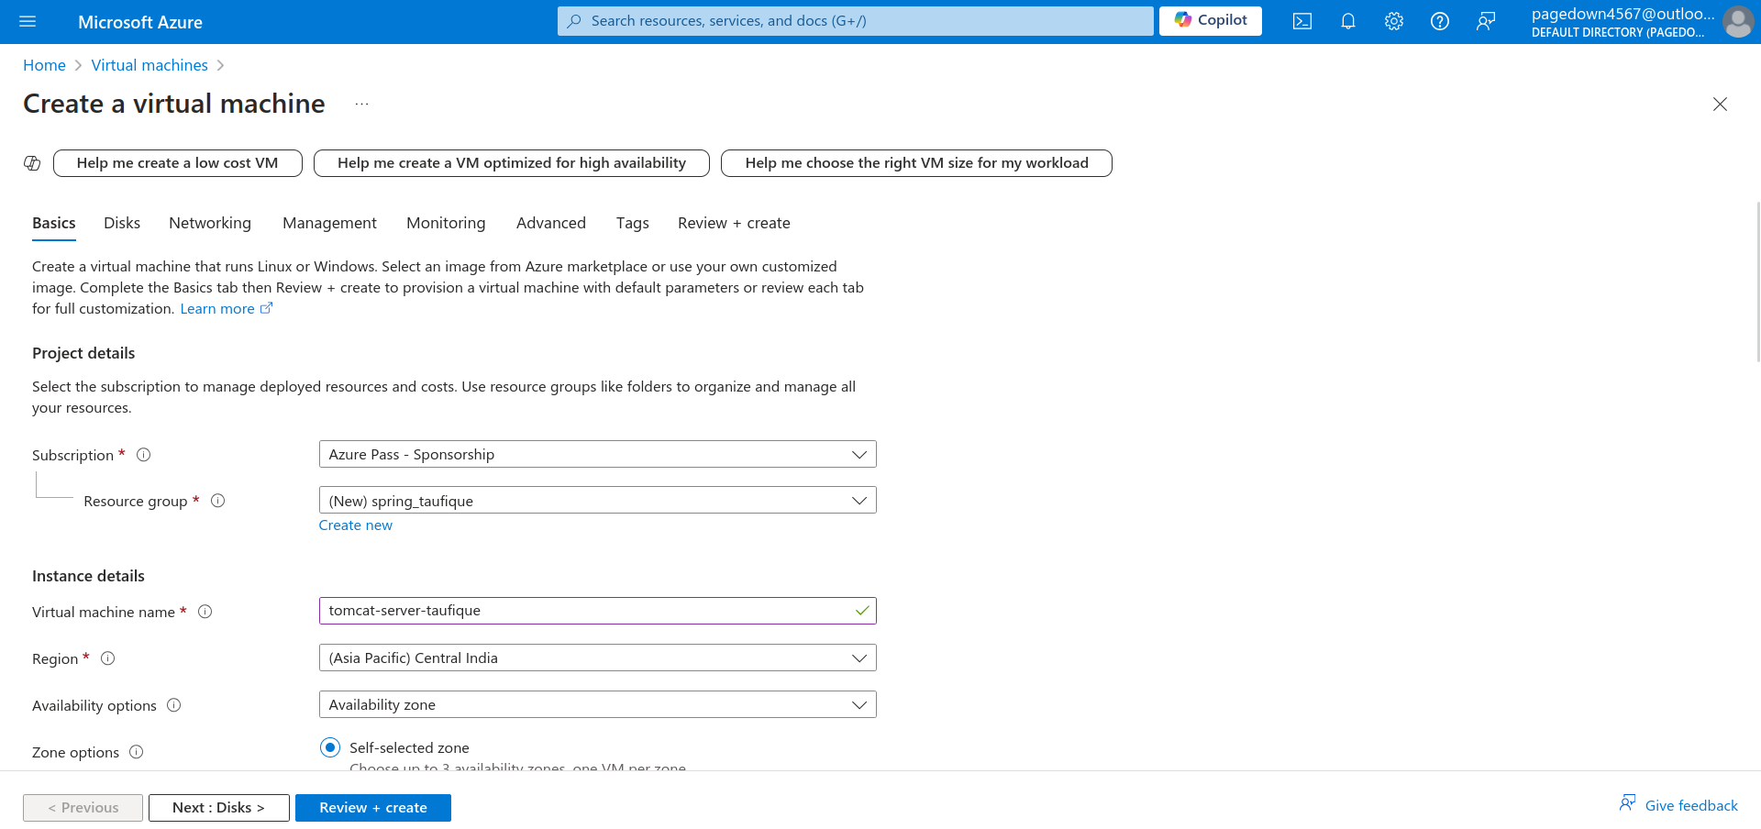
Step-1: Creating a virtual machine to run tomcat server

Step-2: Setting up tomcat server on ubuntu

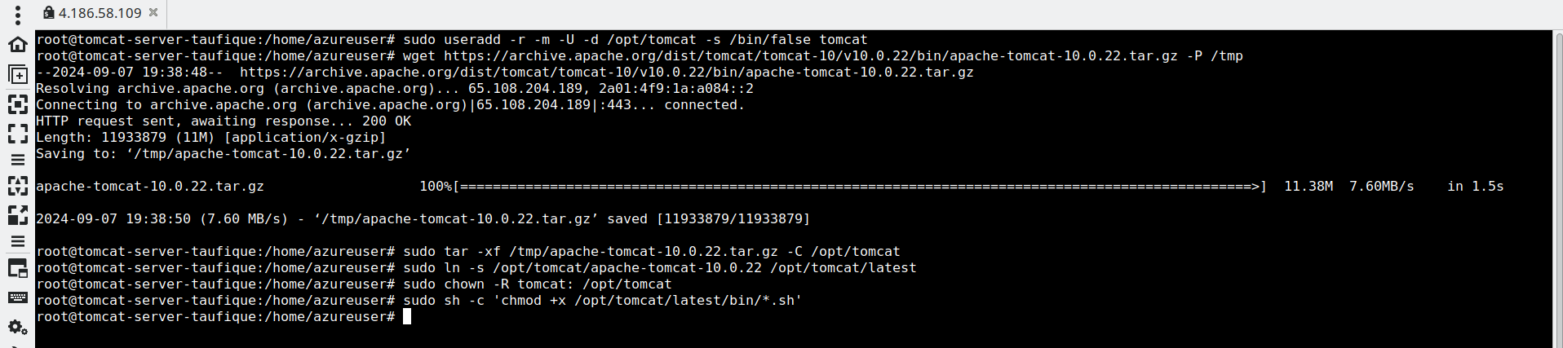
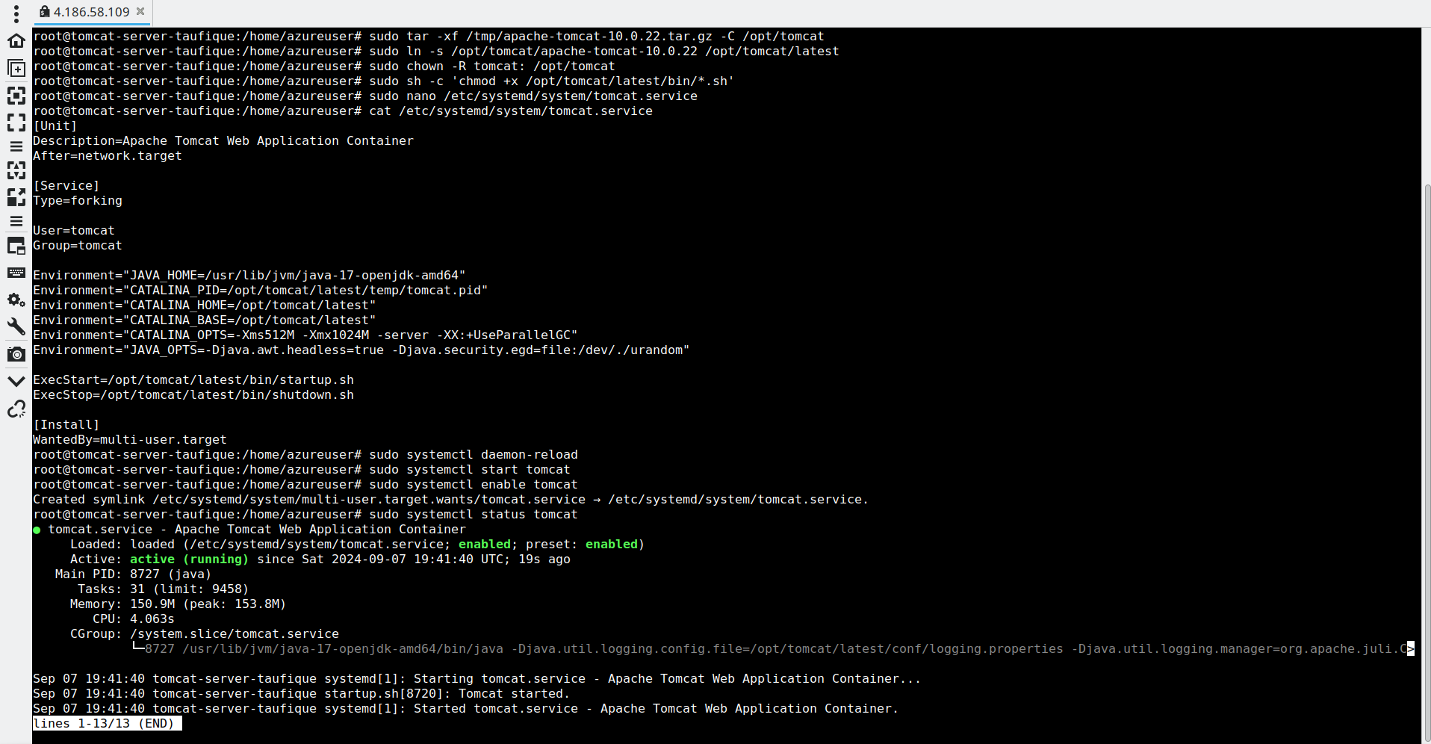

Step-3: Tomcat landing page

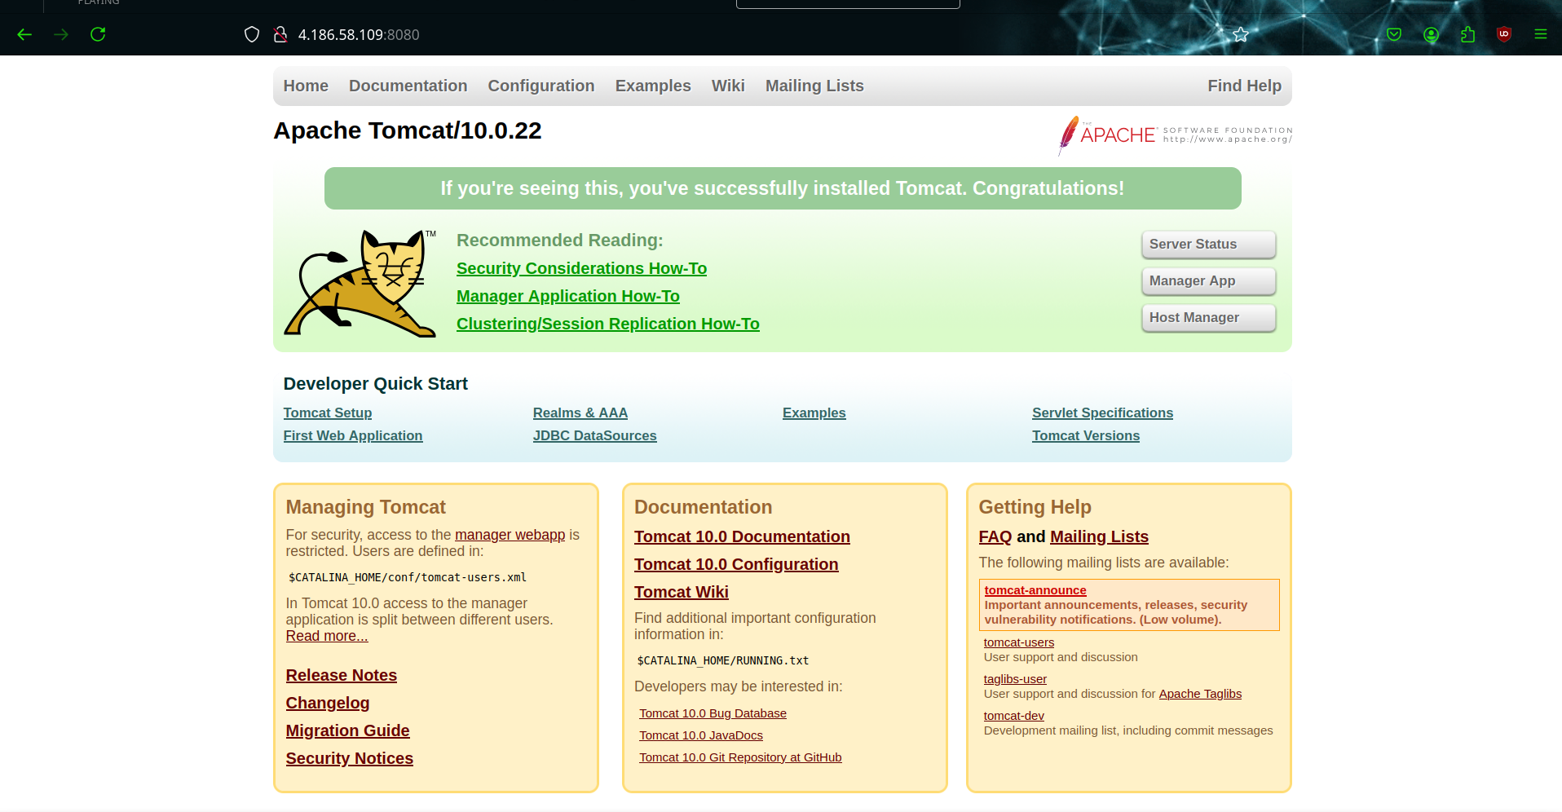
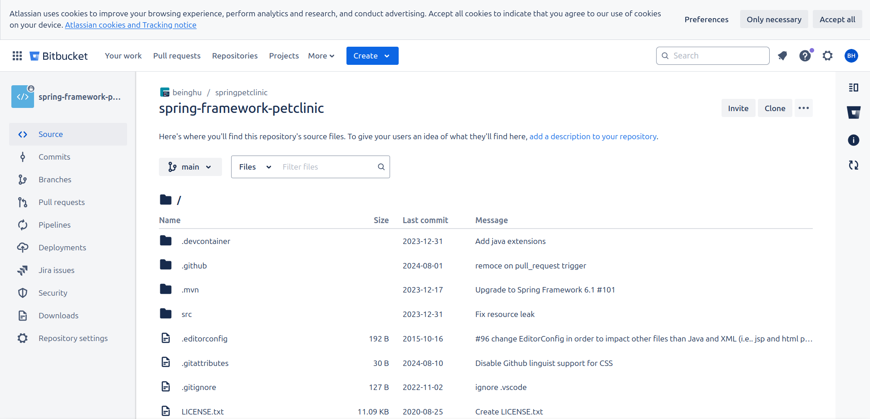
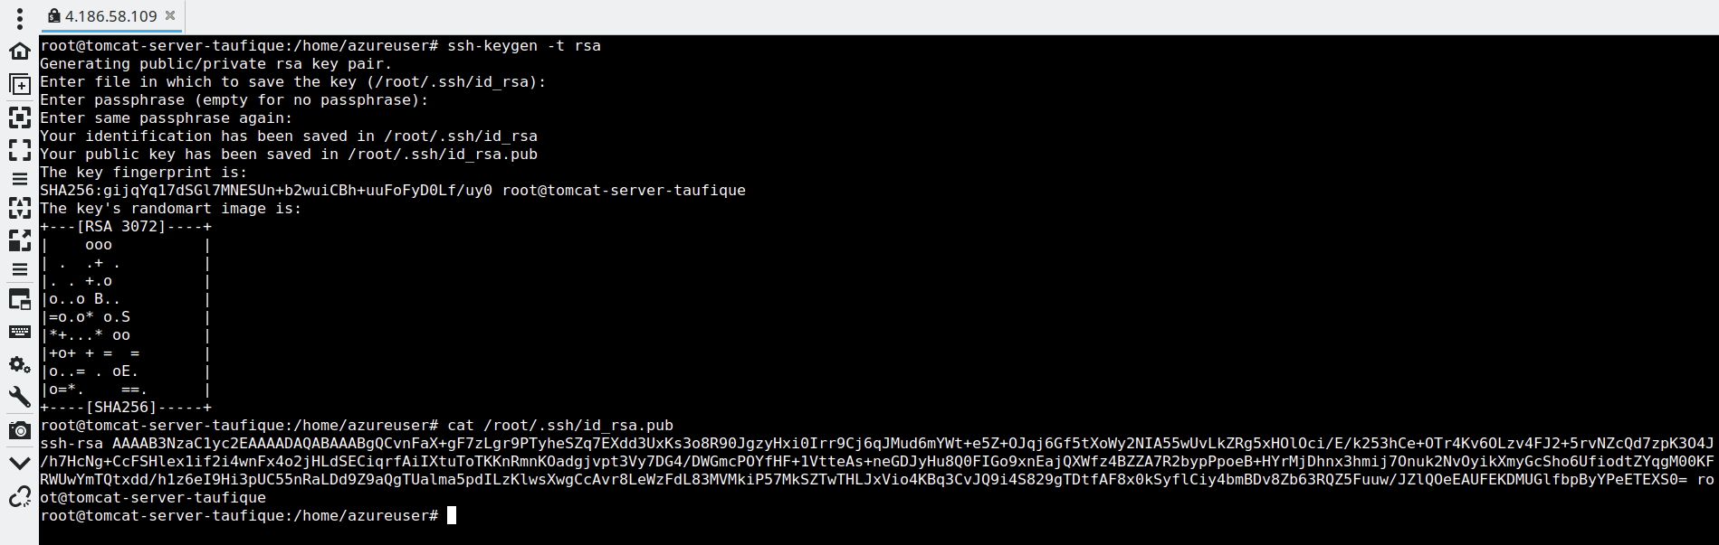

Step-4 : Cloning the open source repository

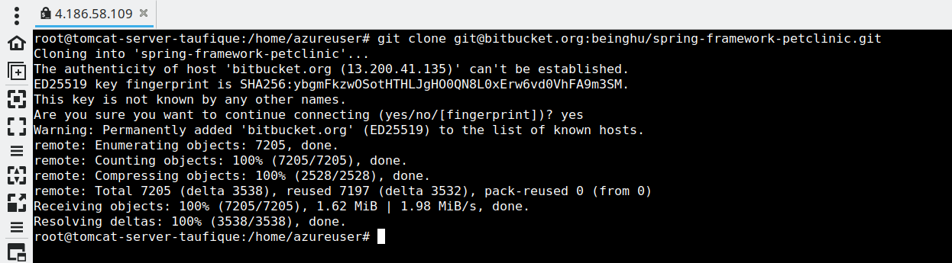
Step-5: Creating a Mysql database server

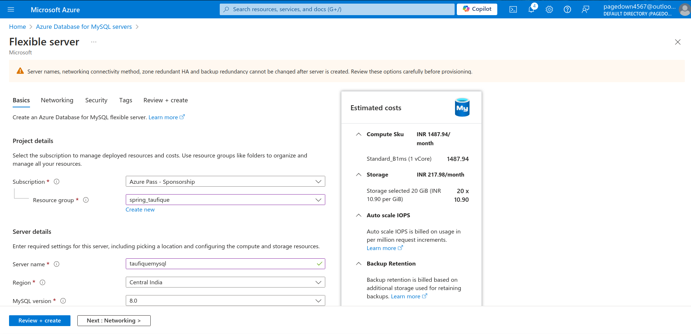
Step-6: Creating a petclinic database
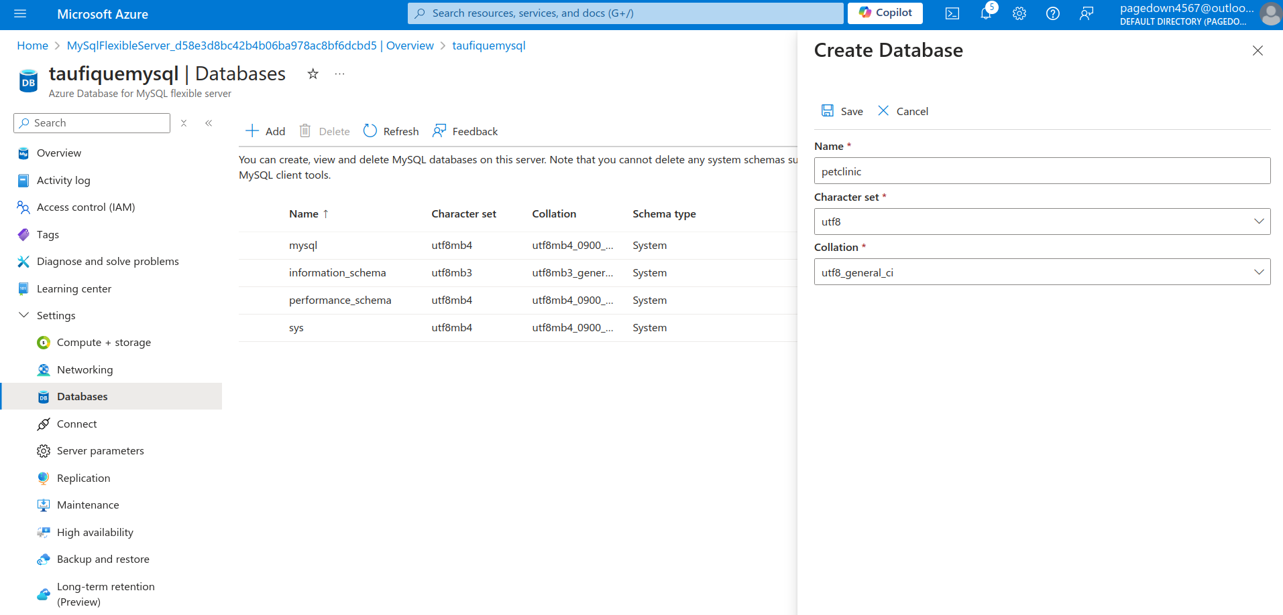
Step-7: Configuring pom.xml to connect to Mysql database with tomcat server
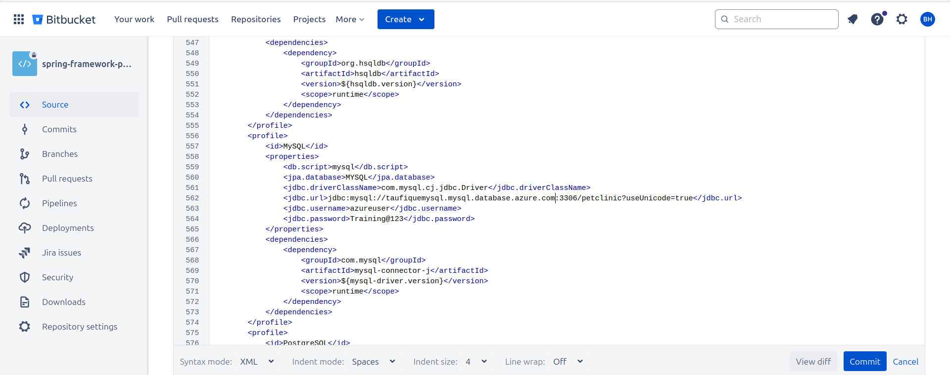
Step-8: Building .war file using maven
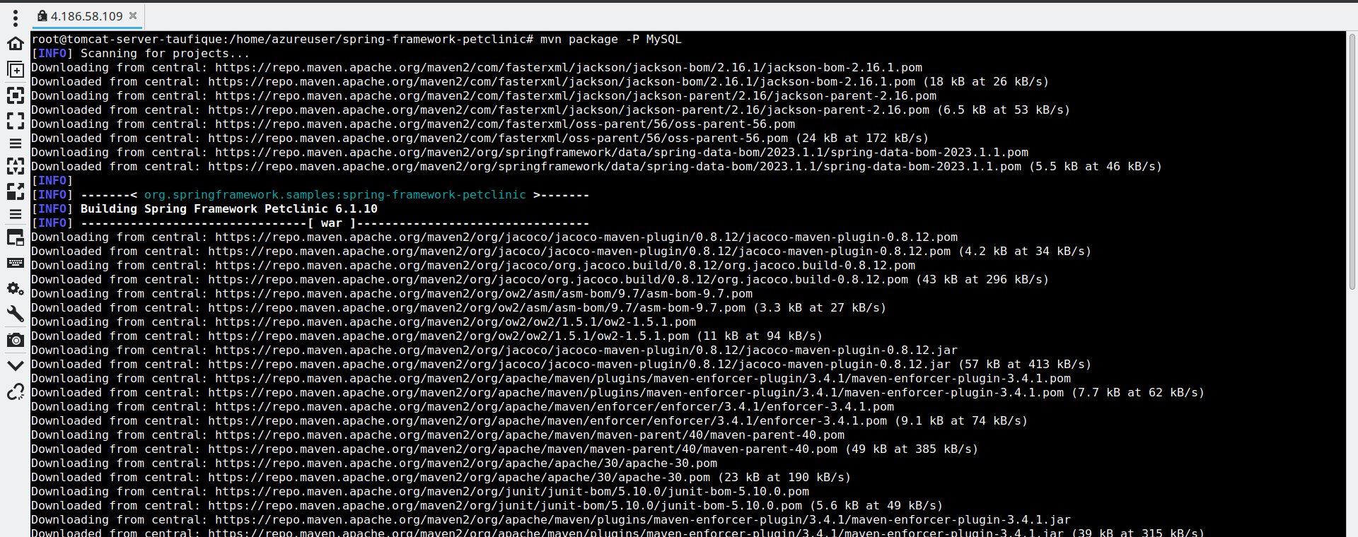
Step-9: Copying the .war file to /opt/tomcat/webapps directory
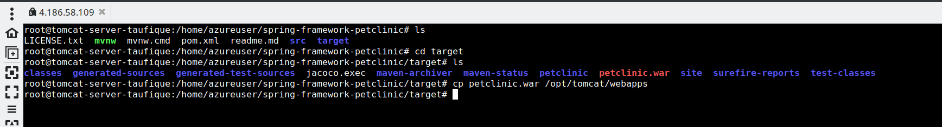

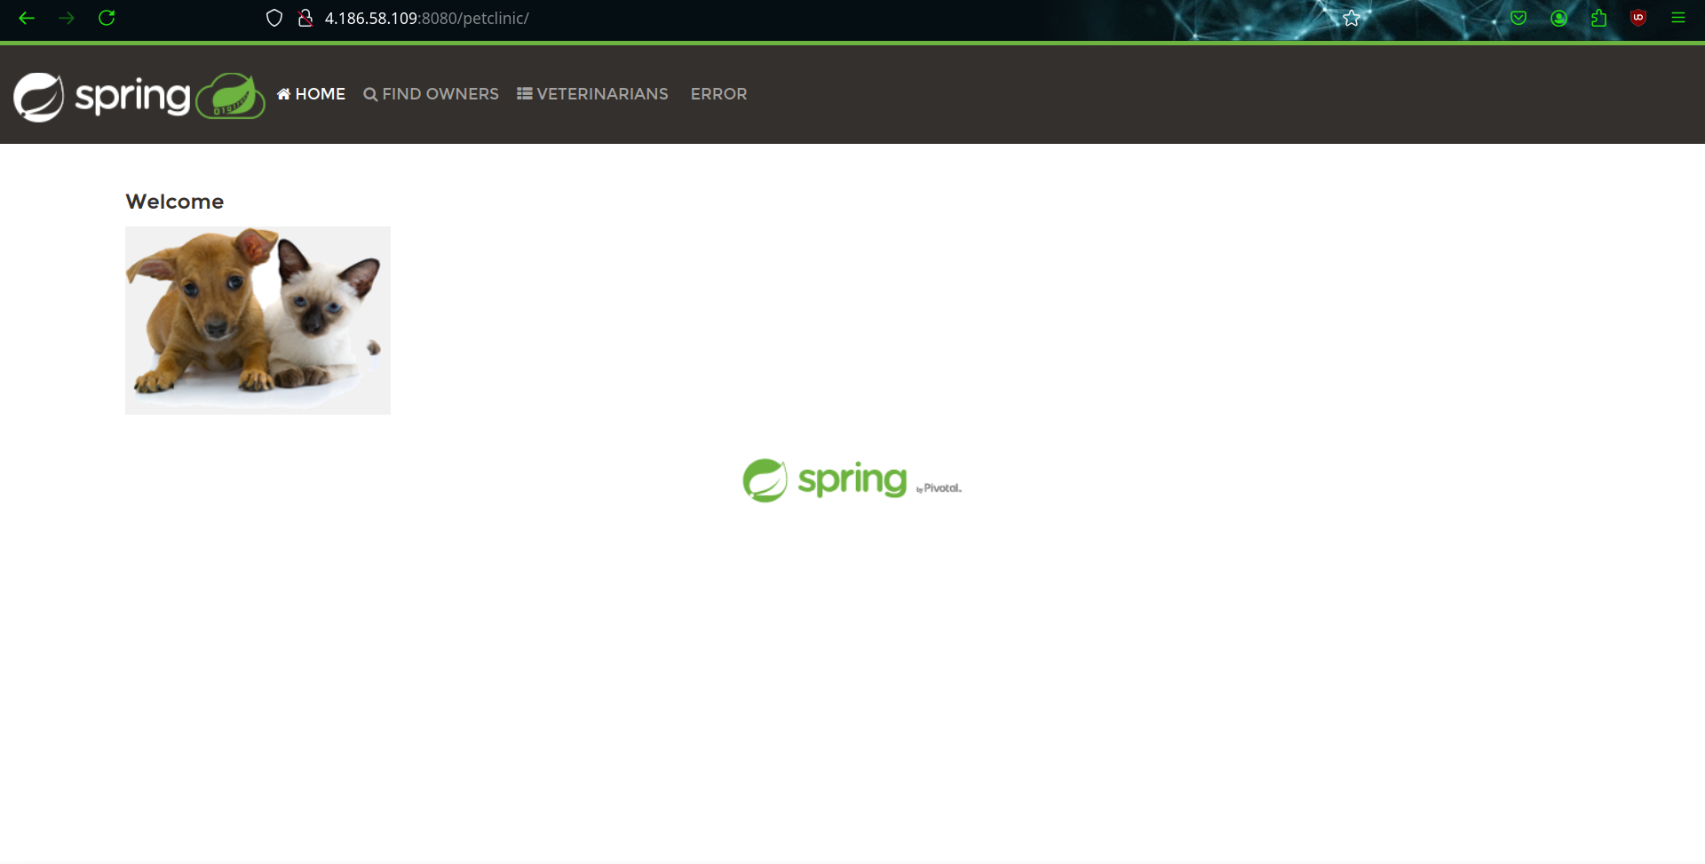
Step -10: Setting up a jenkins server
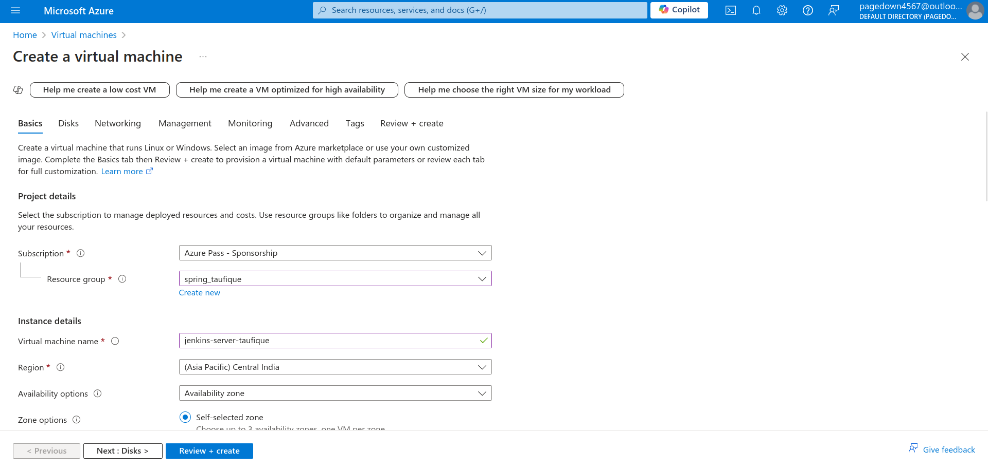

Step-11: Installing jenkins
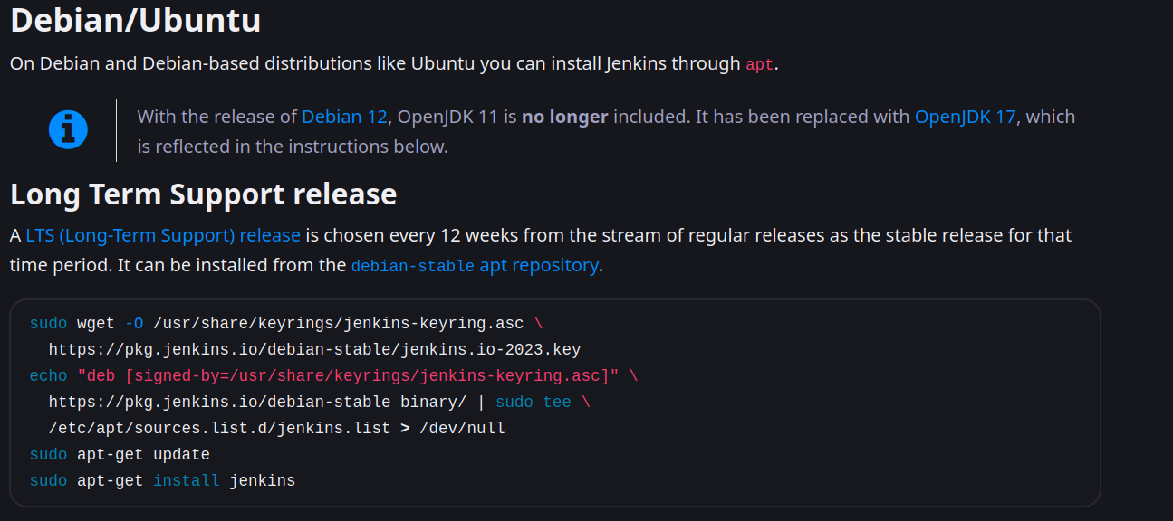

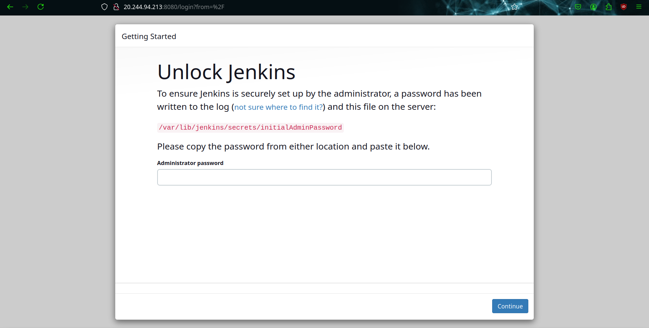
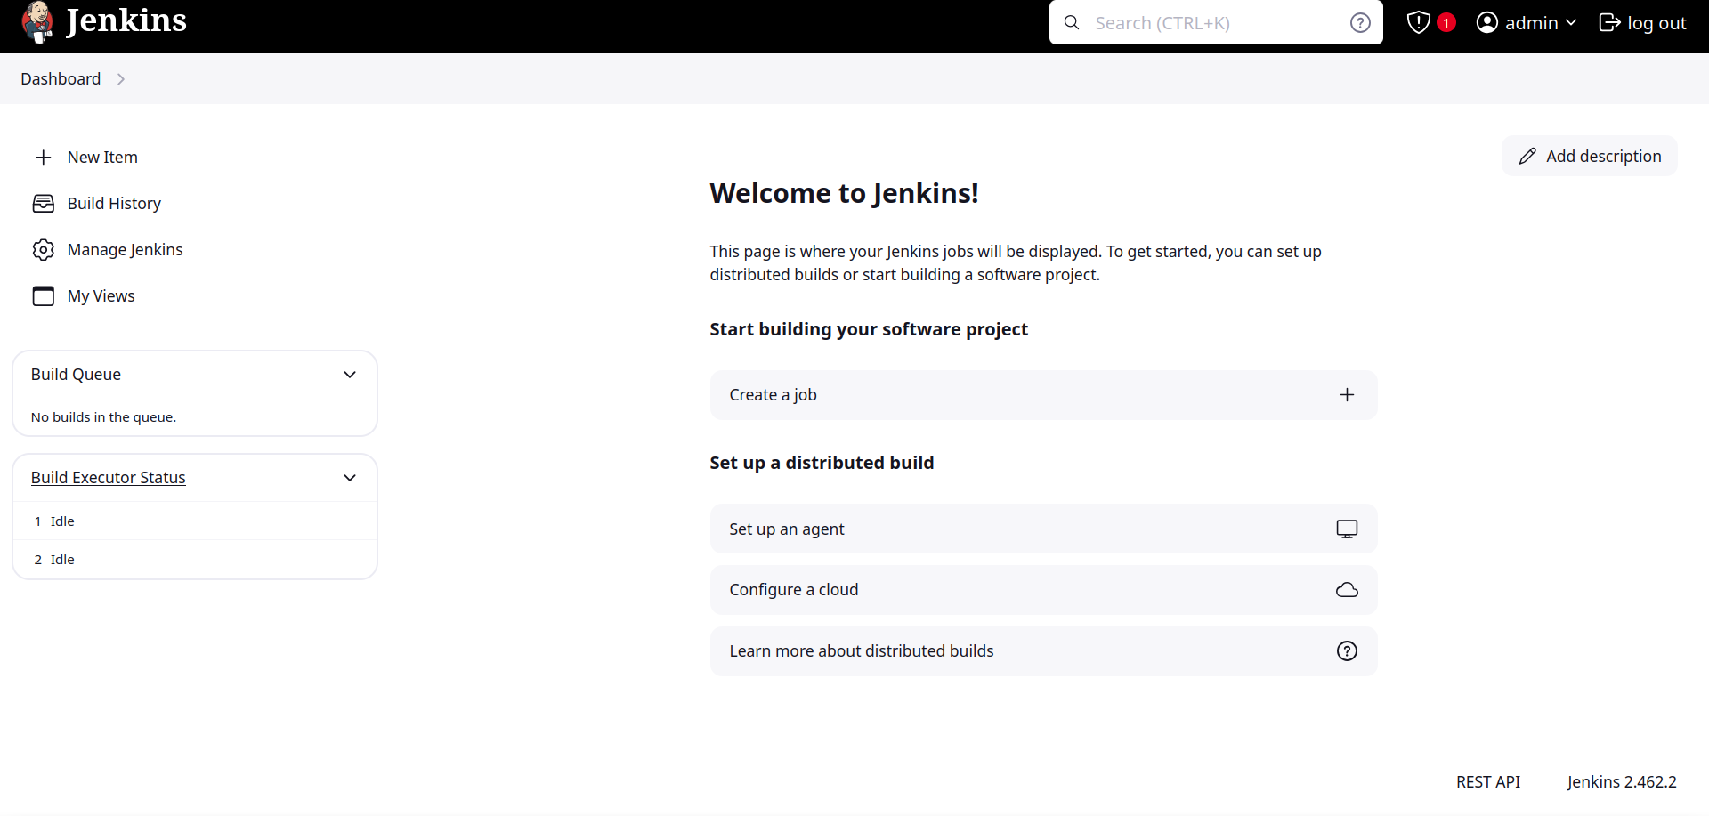
Step-12: Adding the private key of jenkins
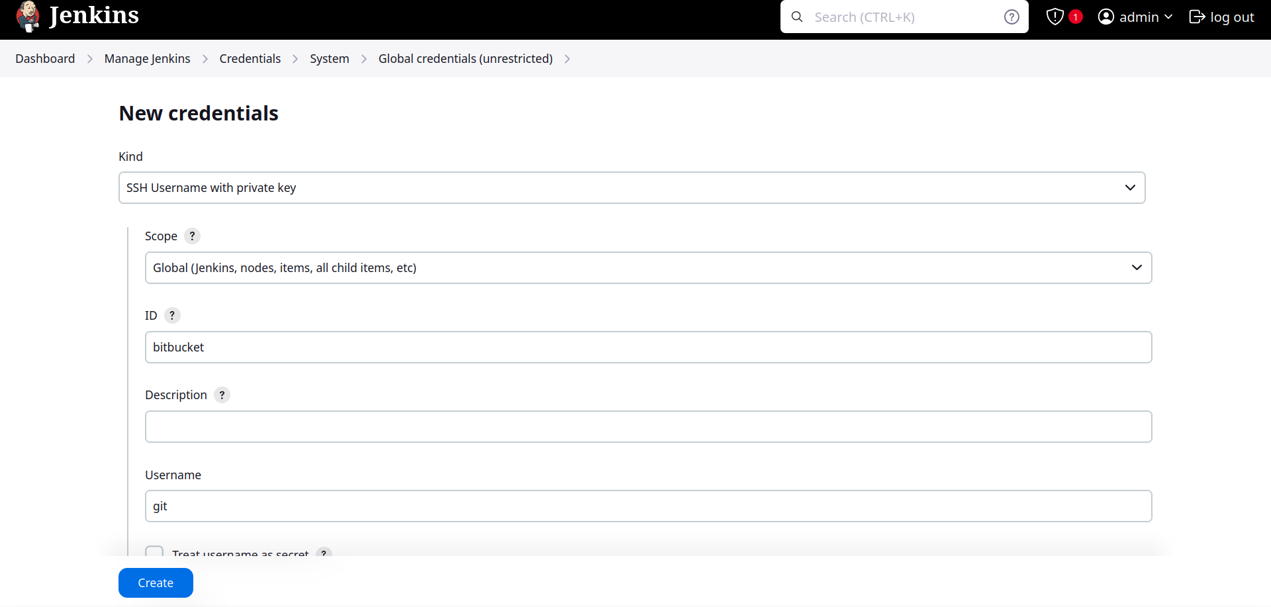

Step-13: Adding jenkins public key to bitbucket and tomcat server

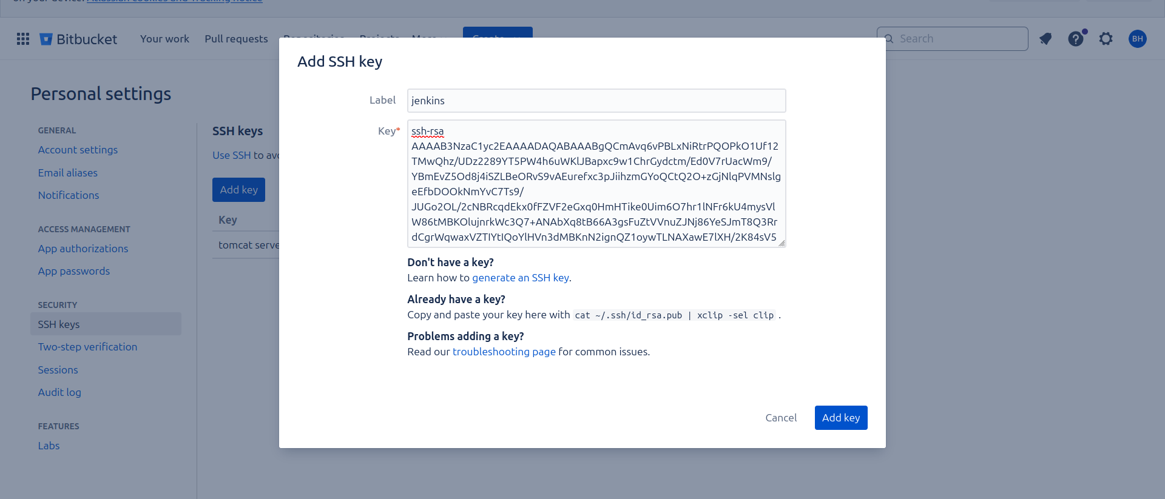
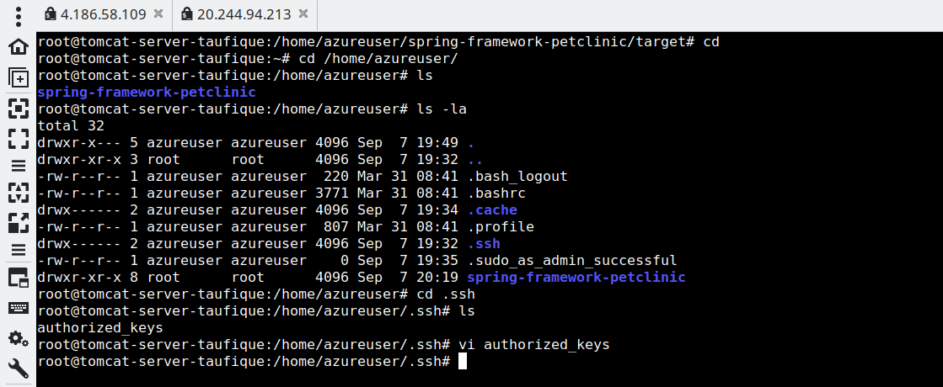
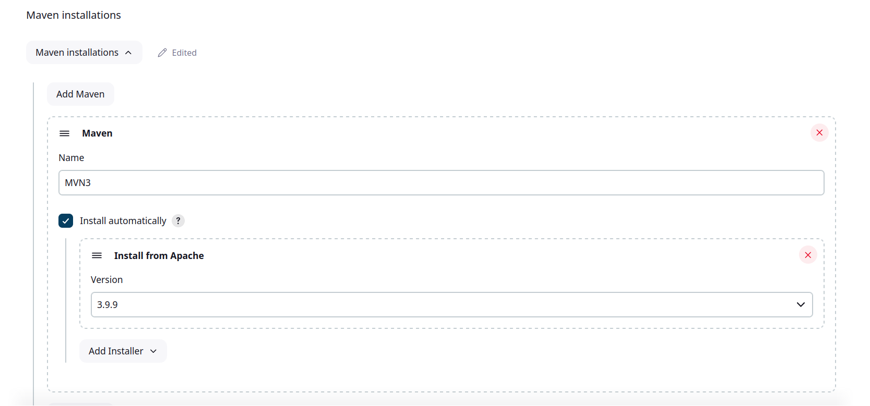
Step-14: Build a ci/cd pipeline
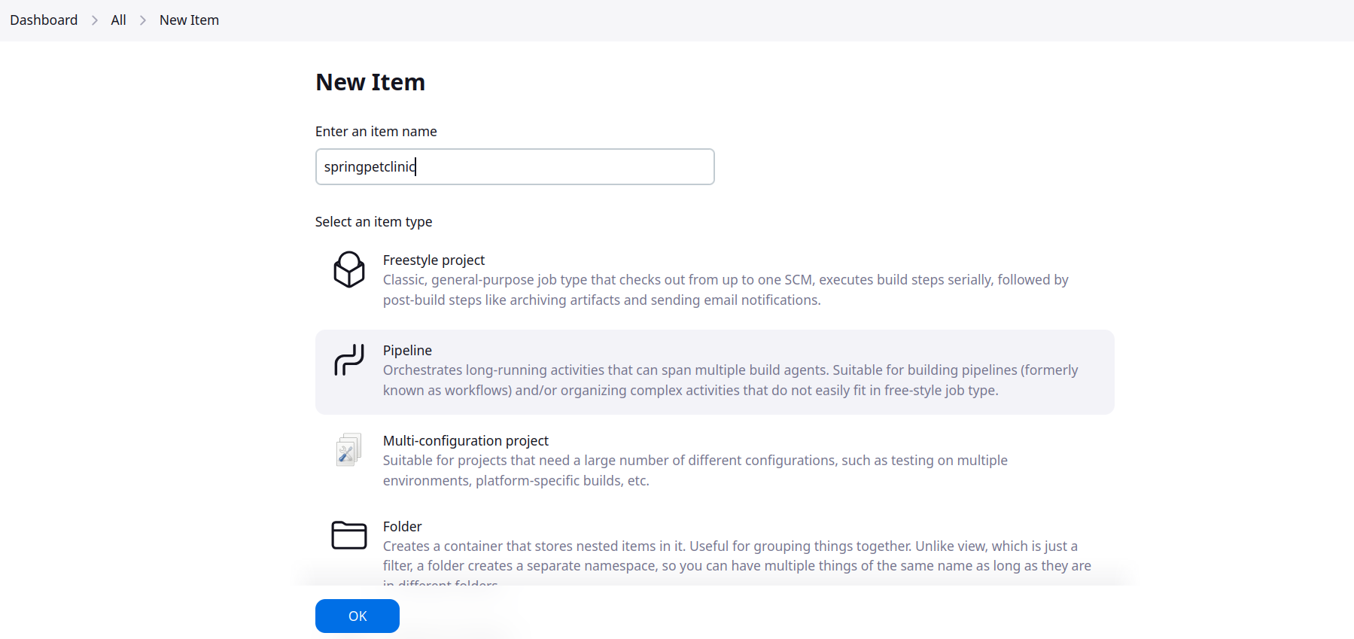

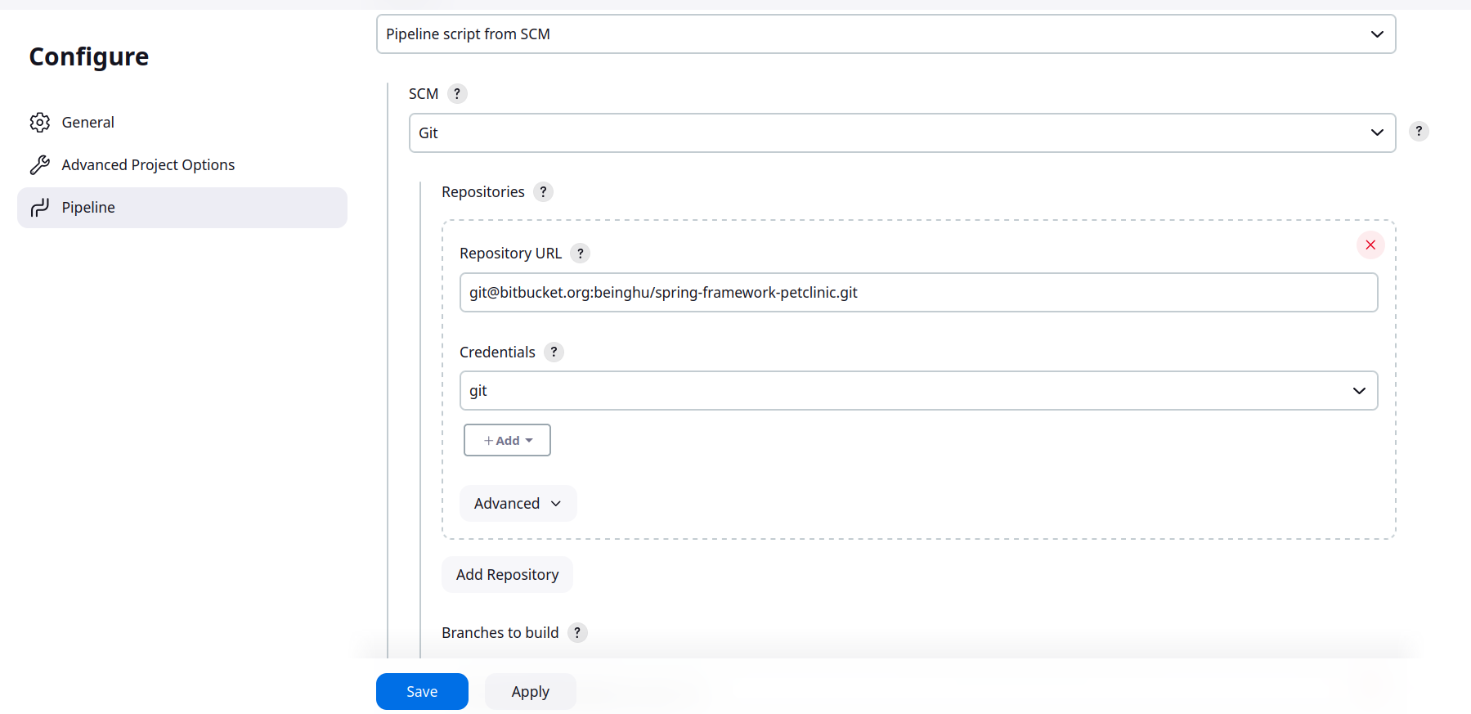
i
i

Step-15 : Writing the jenkinsfile

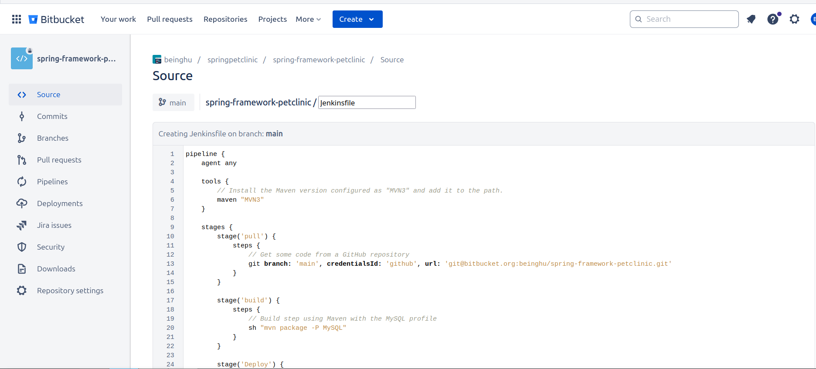
Step-16: Generating the api token for webhook

Step-17: Add the webhook
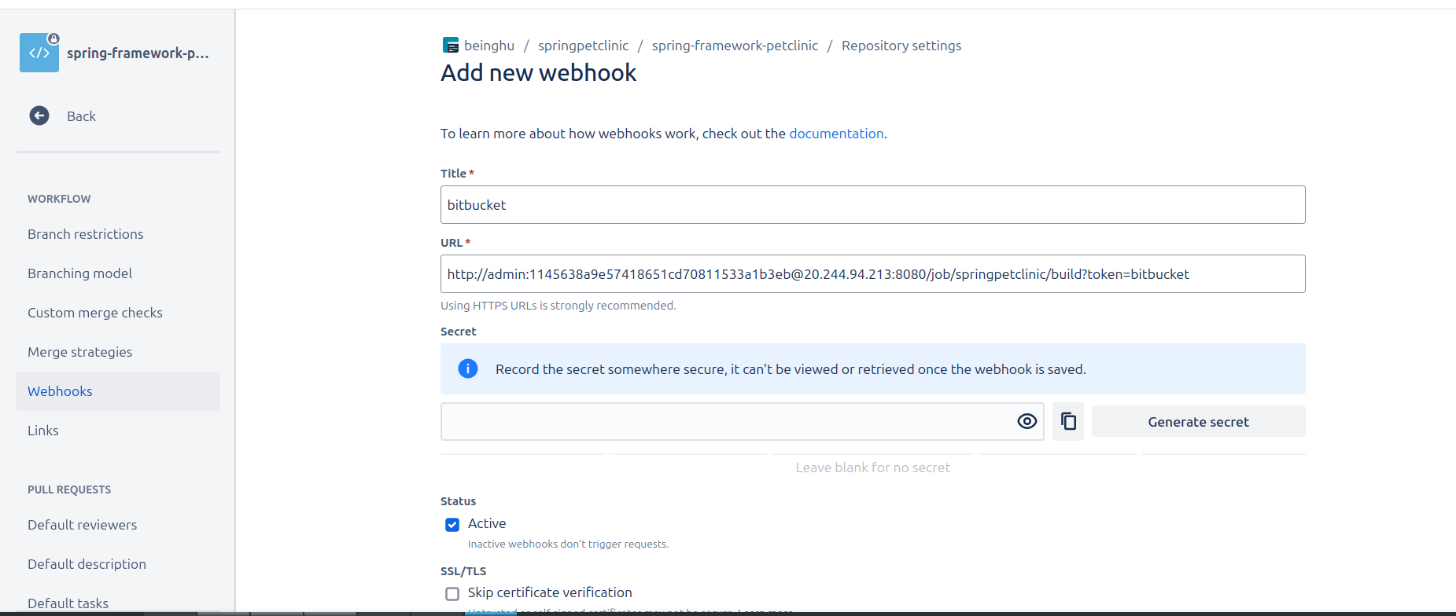

Step-18 : Checking if ci/cd pipeline is triggered



