**East West University**

**Project Report**

**Course Title: CSE360 Computer Architecture**

**Section**: **02**

**Semester: SPRING 2022**

**Report Title:**  **Microprocessor-based automatic door opener.**

**Submitted To: Dr. Md. Sawakt Ali**

**Assistant Professor, Dept. of CSE,**

**East West University.**

**Submitted By:**

**Date:**

**Objective:**

Automatic door opening system is used to open the door automatically. We are going to use 8051 microcontroller (AT89C51), IR sensor an L293D motor driver and 2 motors to design this door. Automatic door opening system uses IR sensor to sense a presence and opens and closes with embedded motor driver equipments for the door opening system. The door opens when any human movement is detected near the door it detects with the help of IR sensor .We have designed two-story door so we used 2 motors to move on opposite directions to open and close the door automatically.

**Theory:**

Our system puts forward an automatic and precise door opening system based on human movement sensing near the door. Opening a door in places like hotels, Shopping complexes, and offices can be a tedious task and sometimes requires hiring a person just for the sake of opening the door whenever a person arrives.

Well this project proposes a system that allows for automatic door opening solutions by sensing human presence near it. Our system achieves this functionality with the help of IR sensors. IR stands for infrared sensors. Every living body emits some infrared energy. This energy is sensed by an IR sensor from a good distance. This signal is then processed and the door is opened and closed based on this data.

When a living being arrives within the sensor range, it detects its presence and sends out a command that opens the door. The door then automatically closes after a specific time delay if there is no further motion near the door.

The automatic door system includes an infrared sensor (IR sensor), an AT89C51 microcontroller (8051), an L293D motor driver, a motor, and a power supply. The microcontroller is used to read data values from input devices and communicate with the outside world. In the microcontroller 8051 Pins, 1 to 8 are the PORT 1 Pins. PORT 1 Pins consists of 8–bit bidirectional Input / Output Port. The IR ( infrared) sensor has a 3-pin connection. Pin 1 is the Data Out pin. Pin 2 is the Ground pin.It must be connected to the ground. Pin 3 is the Vcc pin. It must be connected to a 5V supply.The range of this sensor is 3-15 feet.In the software version, there is another pin named test pin to test the circuit functionality. It is a dual H-bridge motor driver integrated circuit (IC). Motor drivers act as current amplifiers since they take a low current control signal and provide a higher current signal which drives the motors. In the motor driver, the Enable 5,7 pin enables the input pin Input 1(2) , Input 2(7) and Input 3(10) , Input 4(15) respectively.Pin 3 is used for Enable 1(1) and Enable 2(9). Pin 8, Vcc2 (Vs) Connected to Voltage pin for running motors (4.5V to 36V) and pin 16(VSS ) . Output (1,2 and 3,4) pins are used to connect with the two motors.

**Design:**

**Hardware**: In hardware we used a sensor that can detect people when they infront of them. And we need a microcontroller that can take that data and give commands to open or close doors. When we are going to close or open the doors we need a motor to do that. And a motor controller to control the motor.

1. AT89C51 2. IR Obstacle Sensor 3. L293D 4. Motor 5.Logic State

Here we can see how the hardware is working. IR sensor after sensing someone in front of the doors sending data to AT89C51 microcontroller then the microcontroller sending signal according to that data to L293D motor controller then the motor controller executes the motor according to that signal and both of the doors are open.

**Software:**

We have used instruction sets to let the microcontroller sense the sensor and send signals to the motor to close and open the door accordingly. Our software program is going to work accordingly to the flowchart shown below:

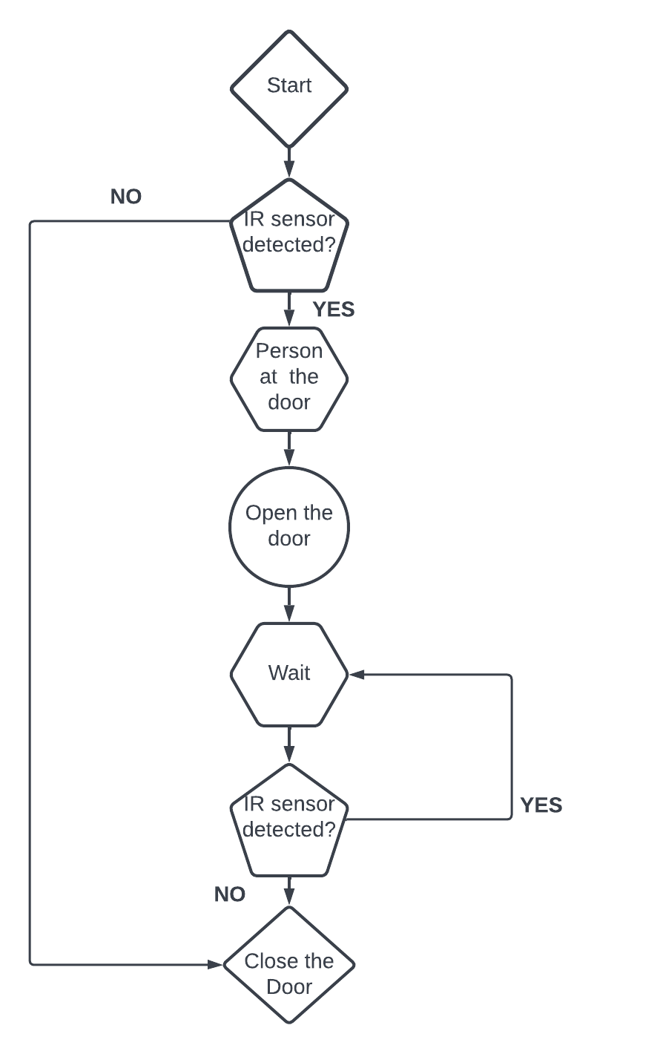

**Implementation:**

**Hardware:**

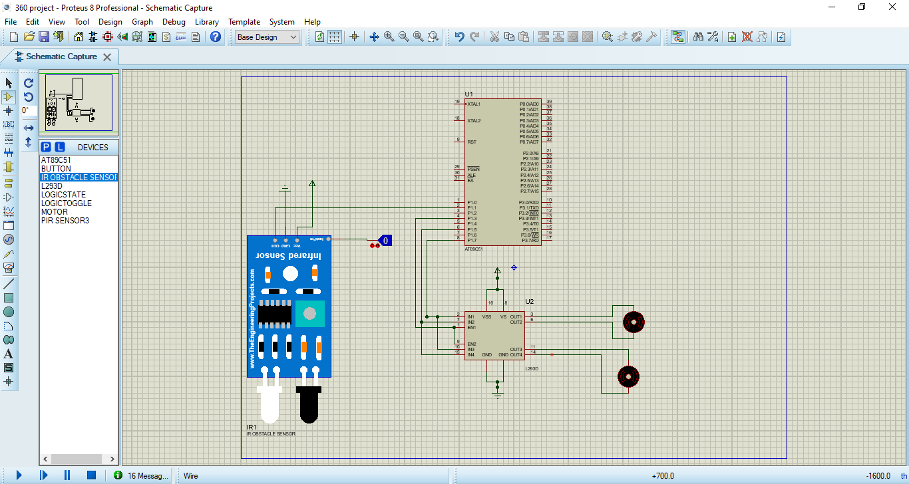

This is the circuit we design for automatic doors to open or close. Below demonstration for this circuit. IR sensor’s OUT pin connects P1. pin of AT89C51(micro-controller). If the IR sensor detects something then it will send a signal to AT89C5. AT89C51 will enable L293D(Motor Controller) through P1.3 to EN1 and EN2. Then the microcontroller's port 1.5 and 1.7 will send a signal to L293D for the rotating motor. And both of the motors will rotate bi-directional.

**Software:**

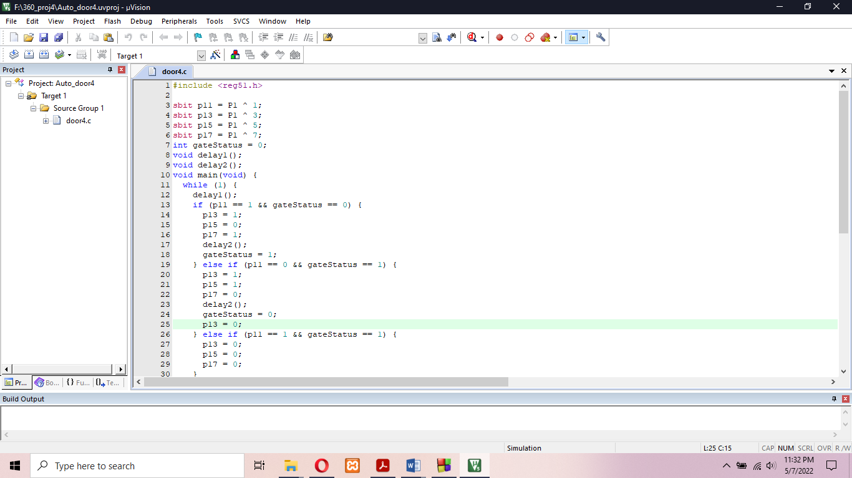

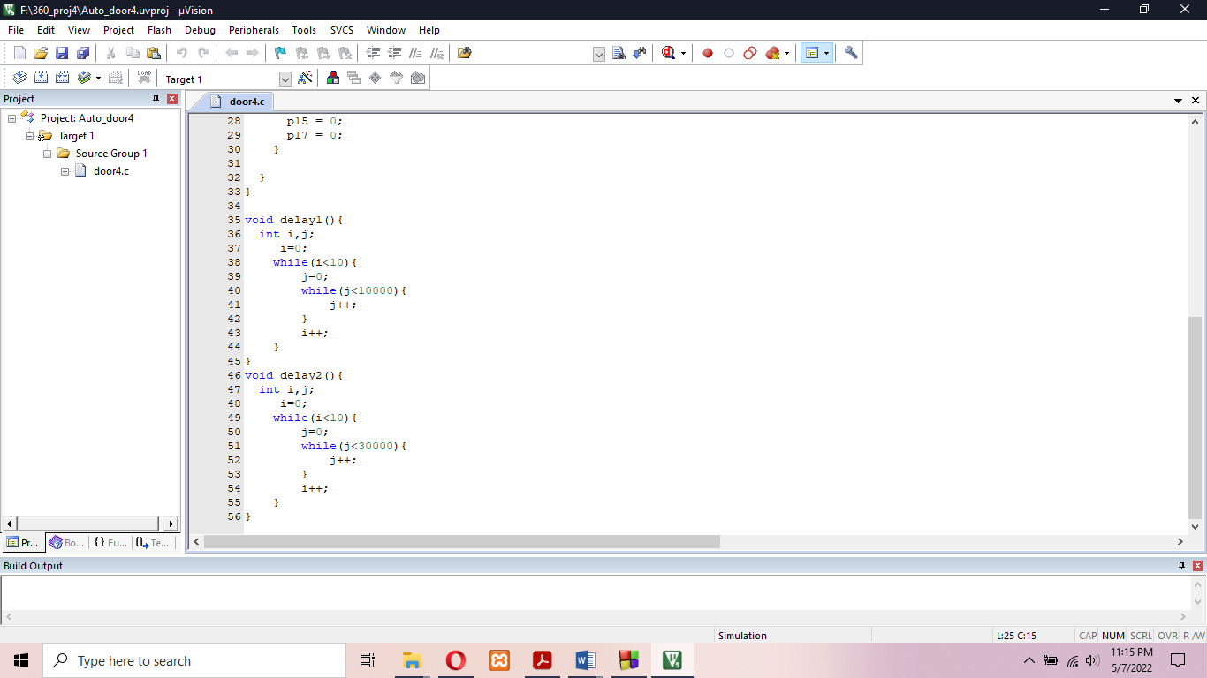

Here is the instruction inside AT89C51 microcontroller .We use reg51.h because this microcontroller is based on 8051. With *sbit* we are assign port to a variable. Here, p11 is connect to the sensor p13 is connected to EN1, EN2, P15 is connected to IN2 and IN4 and p17 is connected to IN1 and IN3 of motor controller. Here the while loop will keep running until we stop this circuit. Inside *while* loop we divided gate status 3 part.

1. Someone is at the door and the door is close as p11=1 and gateStatus=0

In this case ,P15 and P17 will turn to the opposite directions to open the gate and the enable port will be active.

1. Someone not at the door and the door is open as p11=0 and gateStatus=1

In this case ,P15 and P17 will turn to the opposite directions to close the gate and the enable port will be active.

1. Someone is at the door and the door is open as p11=1 and gateStatus=1
2. In this case ,P15 and P17 will turn to the same directions thus the door will be closed and the enable port will be inactive.

Here we used two delay method first one is for sensor. Sensor take some micro second to detect the movements and sending signal. And the second one for opening and closing door.

**Debugging-Test-run:**

This is the very first state of the circuit. if we see the sensor we can see the test pin 0 that’s why voltage across the motor is equal so the motor cannot spin.

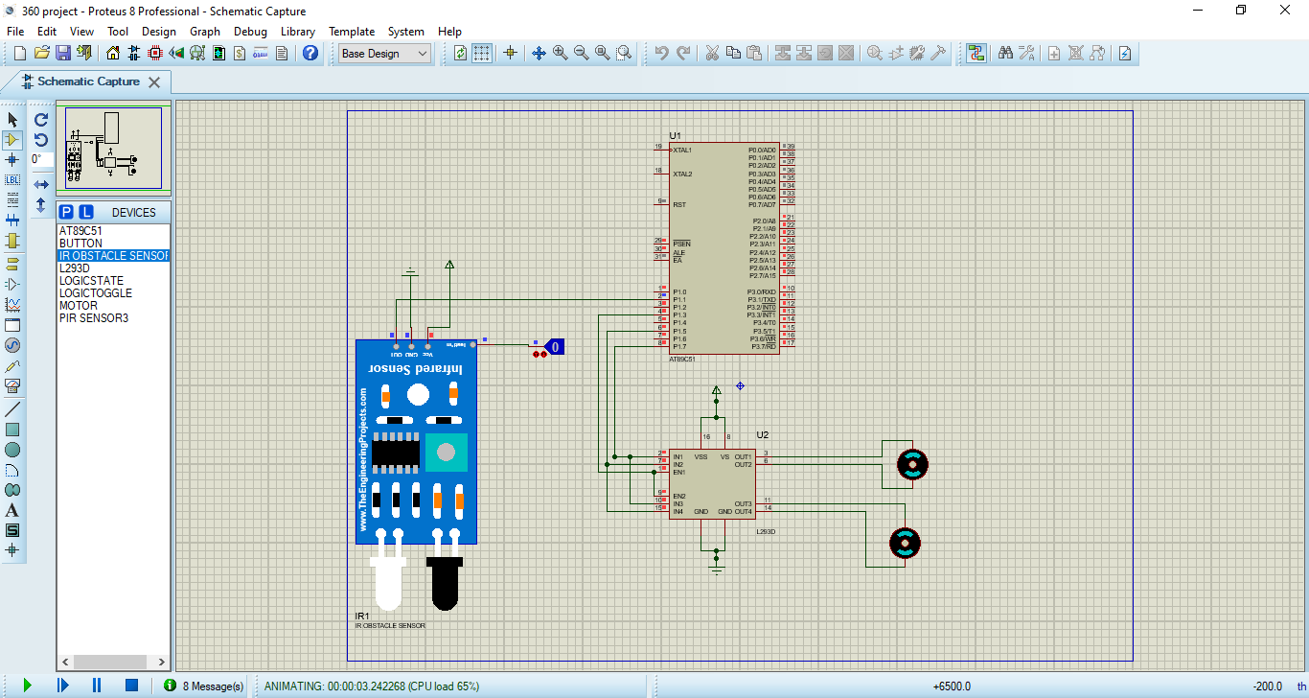

Now when the sensor detects something one of the motors will start to spin clockwise another anti-clockwise and thus both of the doors will. In this case when test pin 1 we can see that the motor's positive side has more voltage than the negative side that means the motors are spinning clockwise or anti-clockwise.

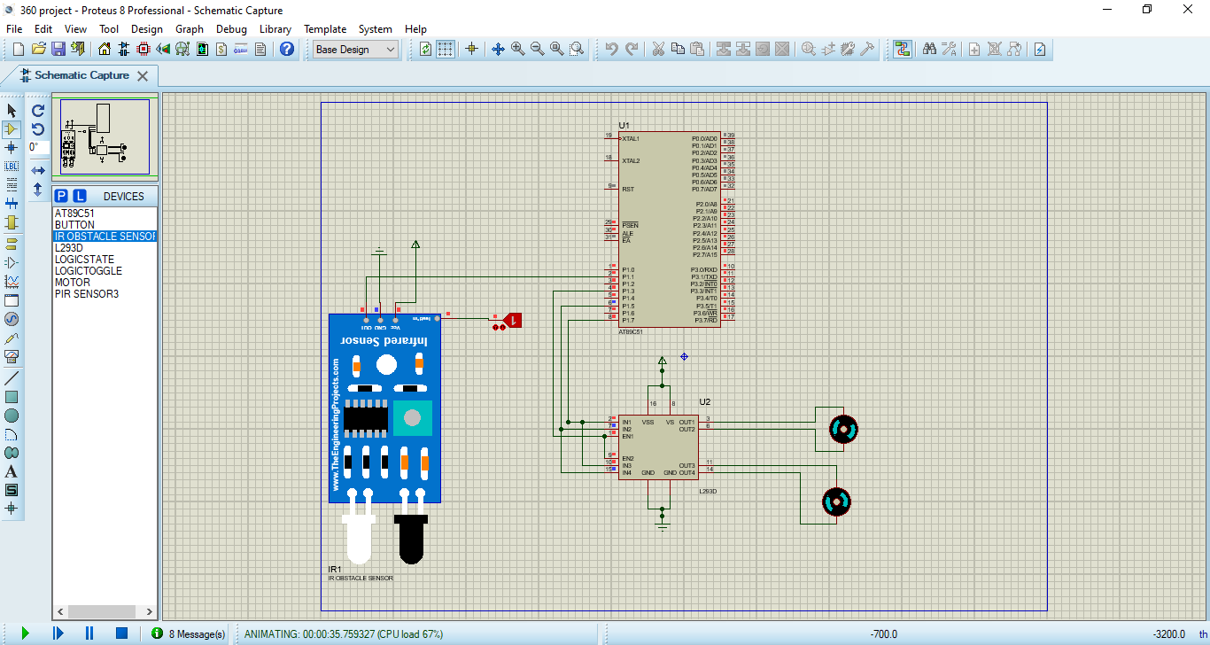

If an object moves from the sensor,then the door will close. As we can see the test pin 0 and the positive voltage is less than the negative voltage that means the motors will spin anti clockwise if the previous were clockwise and clockwise if the previous was clockwise and the door will close.

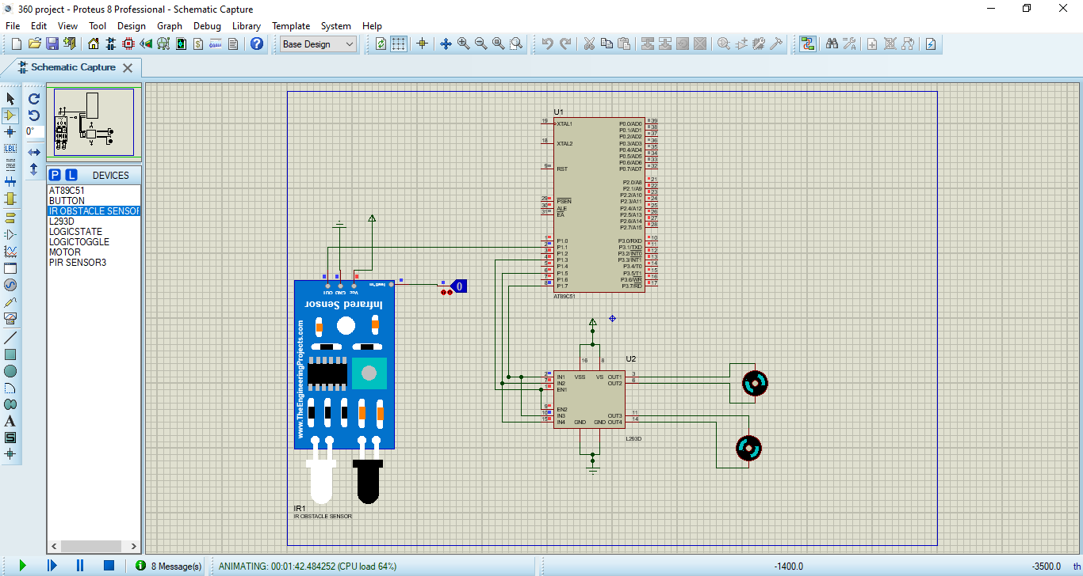

**Conclusion and Future Improvements:**

We can use this system in many places. Since the door is opened only when a person is detected and remains close all other times, it can save a lot of time energy and labor. It is also very useful for the places where air-conditioning is used. Also it is a great way for ensuring security.

Our project has limitations; like it needs electrical energy to operate. If we are out of power supply, we have to open the door manually. The door also need maintenance. The security is also not ensured in our project.

We can add a lock system, camera set up, other new features for ensuring security purposes also we can use more powerful sensor to detect even for efficiently. Also we can reduce the power consumption and even make it run on solar energy.

The automatic gate provides convenient access. Overall, it is a good system to make our daily life a bit easier. But we can update the system in the future. Along with this system, we can use Face-detection through Camera for Automated Attendance System. We can also upgrade the system using higher bit microprocessors for speed optimization.