AI-Resume project

Installing and running our application

By Group 18

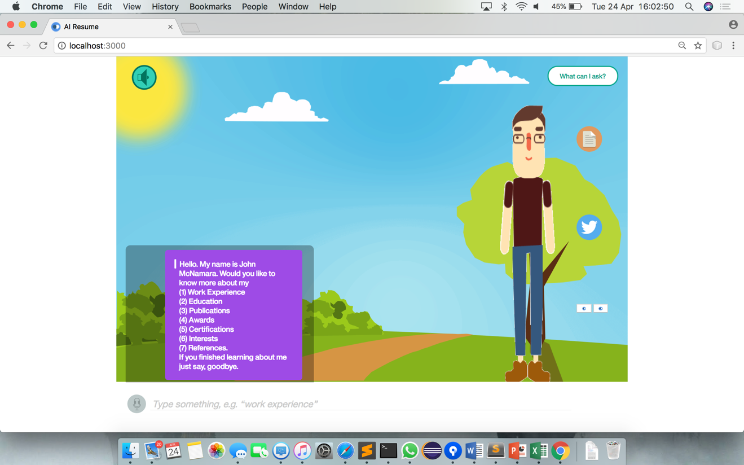

# This guide is designed to help you download and run our application

Our application is a webpage containing a chat box which you are able to use to communicate with the avatar shown to find out information about the CV within the application. The chat system is made using Watson conversation service and provides intelligent answers based on the input you provide. You are able to interact with the avatar in two ways:

* Using keyboard to input responses to the avatar
* Using your microphone to speak to the avatar

Both methods will support audio responses from the avatar, which you are able to toggle on and off using the button on the top left of the screen.

**Getting started**

To begin using our application you must follow these steps to ensure you have all required software.

1. Clone / Download our repository from Github using this link – <https://github.com/T-cherry/AI-Resume>
2. Change the name of the “.env.example” file to “.env” within the Application folder within the repository folder.
   * You may get a warning about changing the file type but accept this.

If using Windows then you must open the file using an application such as “Notepad” and then *SaveAs* the document as a .env file with no name.

* + - If you cannot find this file it may be due to it being a hidden file and therefore you must reveal hidden files
      * On MacOS you can do this in finder by pressing the keys cmd + shift + ‘.’ together
      * On Windows go to this link for details - <https://support.microsoft.com/en-gb/help/14201/windows-show-hidden-files>

1. Ensure you have node.js installed on your machine
   * To install this go to <https://nodejs.org/en/>
2. Open your terminal or command line
3. Navigate to the “Application” folder inside the repository folder
4. Once inside this folder in your terminal/command prompt run the command – “ npm install”
   * This will take a moment as the node modules are created for the application
5. Once command prompt it ready for input use command – “ npm start ”
   * You will the receive a message telling you that your application is running and where it is running.



1. Open an internet browser (for example GoogleChrome)
   * Some features do not currently work in safari
2. Enter “localhost:” followed by the number of the port you were told the application was running on into the URL search bar.
   * For the example above this would be “localhost:3000”
3. You should now be presented with the screen as shown at the beginning of the document and will to use the application.

**Using the application**

This section gives a brief explanation on how to use the application. The actual interactions with the avatar via the chat box should be fairly straight forward and therefore we have provided just a brief explanation of the features.

Our system works on the basis of you having a conversation with the avatar via your input and the output in the dialog box. The conversation is slightly guided as to help users find the types of information they are looking for; this means users are often given a list of options they can ask about. To select a topic, you are able to write a response which indicates the choice made or more simply input the number related to topic.

**Audio output toggle**



This allows users to toggle whether they would like audio output or not, when the icon is green the application will read out the avatar’s responses. To toggle this just click on the icon.

**Speech input**



This allows users to toggle whether they would like to provide input using their microphone. This feature is off as default and requires the user to click the icon to enable it. Once on, the user will be able to use their microphone and their speech will be translated into input for the chat window.

**Topics help**

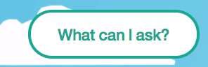

This feature is designed to help users understand the types of things they can ask the avatar about. When you click this button it will display a list of topics which you are able to ask about within your input.

**Toggle backgrounds**

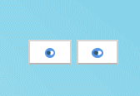

These buttons allow you to change the background that your avatar is on. To switch background, simply click on either button.

**View Resume**



This button allows users to view the PDF version of the resume that the application is based upon. Upon clicking this button, a new tab will open with the resume displayed.

**Twitter insights**



This button will take you to twitter insights page, this will display the output of the resume owner’s twitter account going through IBM’s personality insights service. It provides an opportunity for employers to gain a deeper understanding of what the applicant may be like.

**Closing the application**

Once finished using the application closing it requires 2 steps:

1. Close the internet browser you are viewing the application in
2. Terminate the terminal or command prompt you used to start the application

**Reopening the application**

These steps are for users that that have already followed all required steps to install the application stated at the beginning of this document. This steps will allow you to open the application again once closed.

1. Open terminal or command prompt
2. Navigate to the “Application” folder within the downloaded repository
3. Run command “npm run build”
4. Run command “npm start”
5. Open an internet browser (for example GoogleChrome)
   * Some features do not currently work in safari
6. Enter “localhost:” followed by the number of the port you were told the application was running on into the URL search bar.
   * For the example above this would be “localhost:3000”
7. You should now be presented with the screen as shown at the beginning of the document and will to use the application.