RESPONSIVE RENDER REPORT
Threadline browser &
viewport review
Production homepage visual comparison
Screenshots captured across Chromium, Firefox, and WebKit at desktop, tablet, and mobile viewport sizes.
Browser | Engine | Viewports
In-app Browser | Chromium | 1920 × 1080; 1440 × 900; 1024 × 768; 390 × 844
Firefox 141 | Gecko | 1920 × 1080; 1440 × 900; 390 × 844
WebKit 26 | WebKit | 1920 × 1080; 1440 × 900; 390 × 844
Key observation. At 1920 × 1080 and 1440 × 900, WebKit wraps the hero heading across three lines; Chromium and Firefox use two. The difference remained after all document fonts reported loaded.
Across the tested views, the page rendered without blank states, framework overlays, or visible horizontal overflow.
Production URL: https://threadline-website-hp2-1.vercel.app/

How common are these viewport sizes?
Worldwide usage context · StatCounter Global Stats · June 2026
Screen-resolution share is a useful market signal, but it is not the same as CSS viewport share or device ownership. Browser chrome, zoom, operating-system scaling, and device-pixel ratio can change the usable viewport.
Tested size | Audience | Current market signal | Why it remains useful for QA
1920 × 1080 | Desktop | 20.2% of desktop views; #1 worldwide | Essential high-width desktop check and the strongest exact-resolution match in this test set.
1440 × 900 | Desktop | Outside the current desktop top six | A practical mid-width laptop/desktop check that tests wrapping before the compact navigation breakpoint.
1024 × 768 | Compact desktop / tablet | Outside the current desktop top six | Useful as a compact-width breakpoint proxy; responsive behavior matters more than the exact hardware share.
390 × 844 | Mobile | 6.31% of mobile views; #3 worldwide | A common modern mobile viewport and a strong representative check for the stacked layout and menu.
Takeaway. The matrix combines a leading desktop resolution, a common mobile viewport, and two lower-share sizes that are strategically valuable for finding breakpoint and text-wrapping issues.

Sources and interpretation
StatCounter Global Stats measures worldwide page-view share by reported screen resolution. Rankings above compare each tested size with the June 2026 platform-specific top six.
• Desktop: https://gs.statcounter.com/screen-resolution-stats/desktop/worldwide
• Mobile: https://gs.statcounter.com/screen-resolution-stats/mobile/worldwide

High-resolution desktop — Chromium
In-app Browser · Chromium · 1920 × 1080
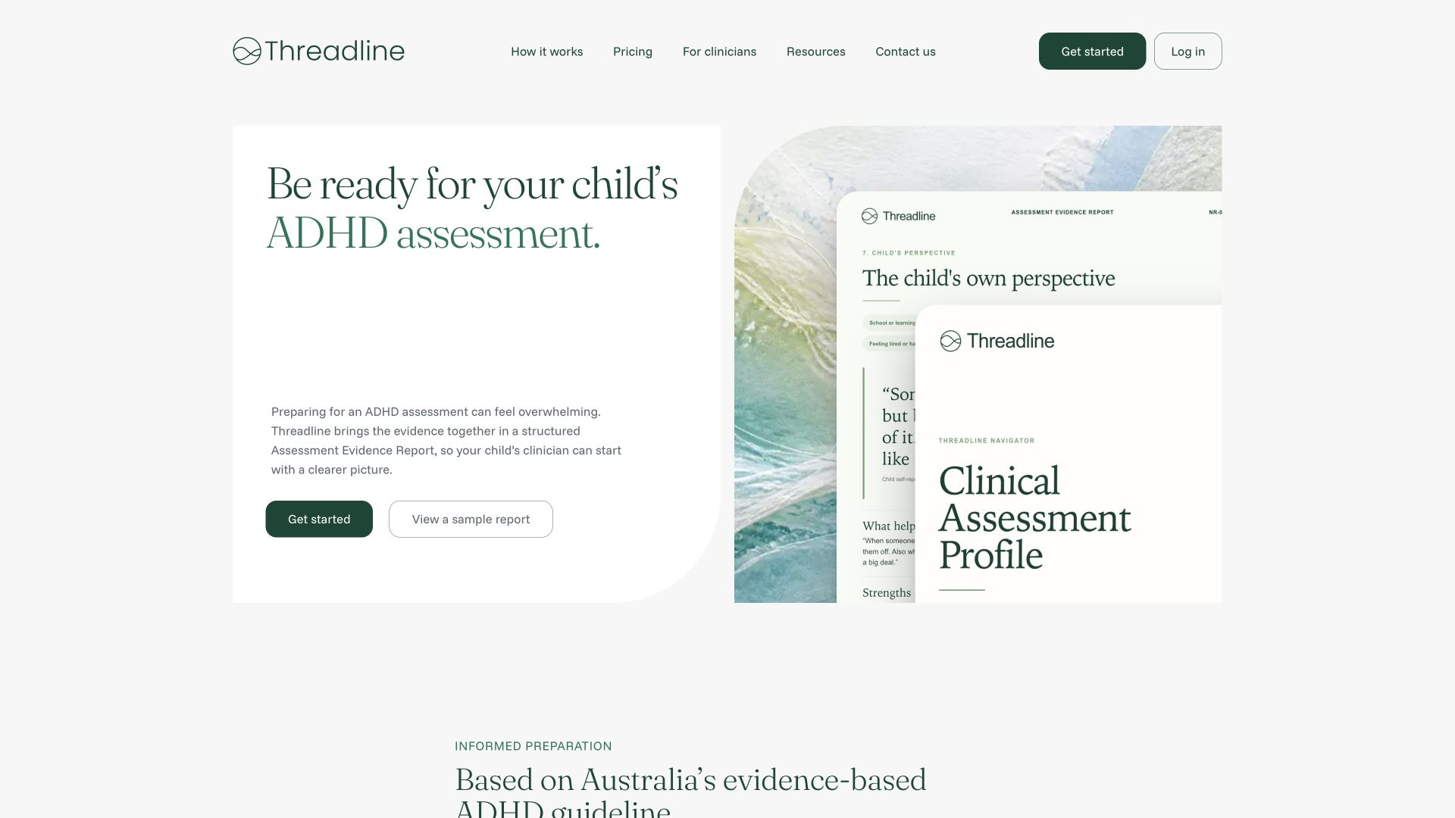
Figure 1. Production homepage in Chromium at 1920 × 1080.
Observation: The hero heading uses two lines, with the full desktop navigation and the beginning of the next section visible.

High-resolution desktop — Firefox
Firefox 141 · Gecko · 1920 × 1080
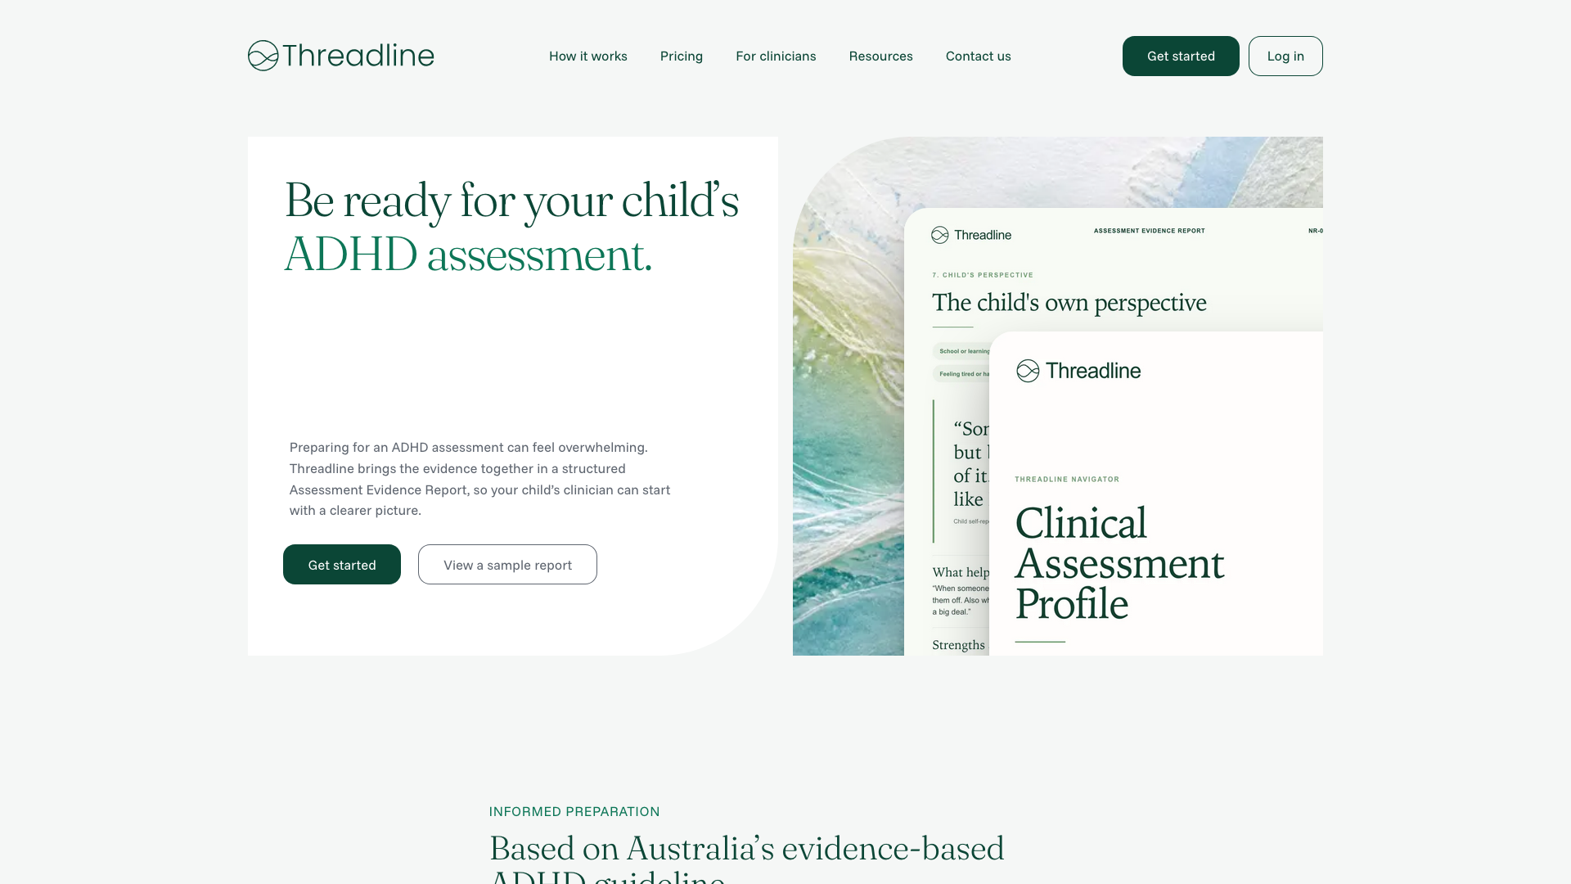
Figure 2. Production homepage in Firefox at 1920 × 1080.
Observation: The hero heading uses two lines and closely matches the Chromium layout.

High-resolution desktop — WebKit
WebKit 26 · 1920 × 1080 · document fonts loaded
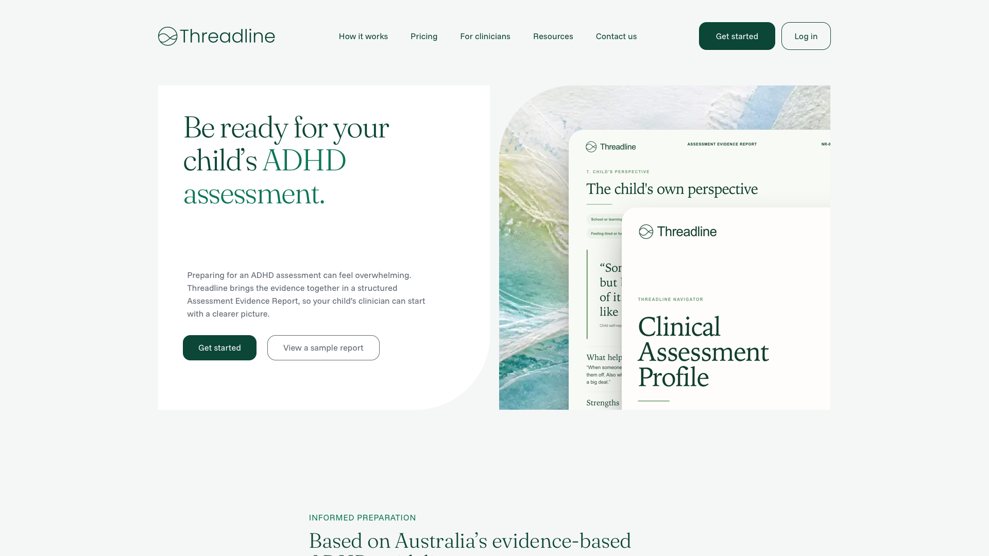
Figure 3. Production homepage in WebKit at 1920 × 1080.
Observation: The hero heading uses three lines, preserving the browser-specific wrap seen at 1440 × 900.

Desktop — Chromium
In-app Browser · Chromium · 1440 × 900
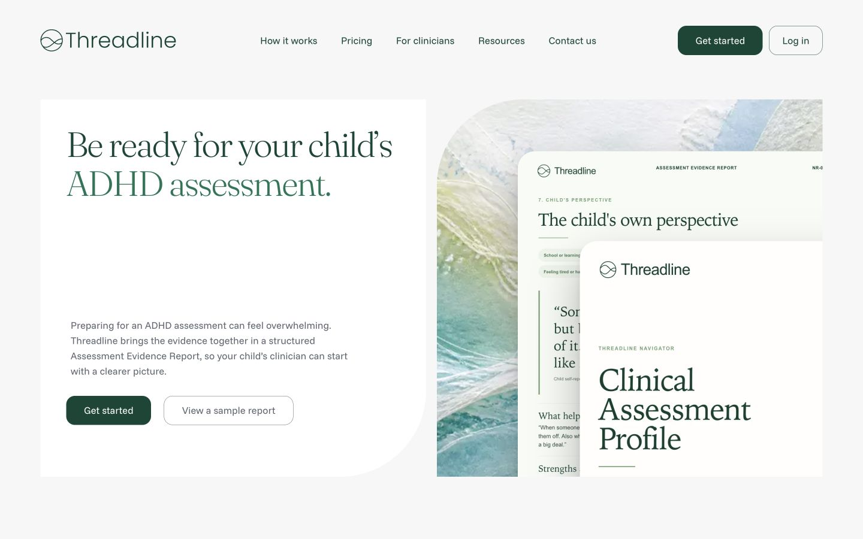
Figure 4. Production homepage in Chromium at 1440 × 900.
Observation: The hero heading uses two lines, and the complete desktop navigation remains visible.

Desktop — Firefox
Firefox 141 · Gecko · 1440 × 900
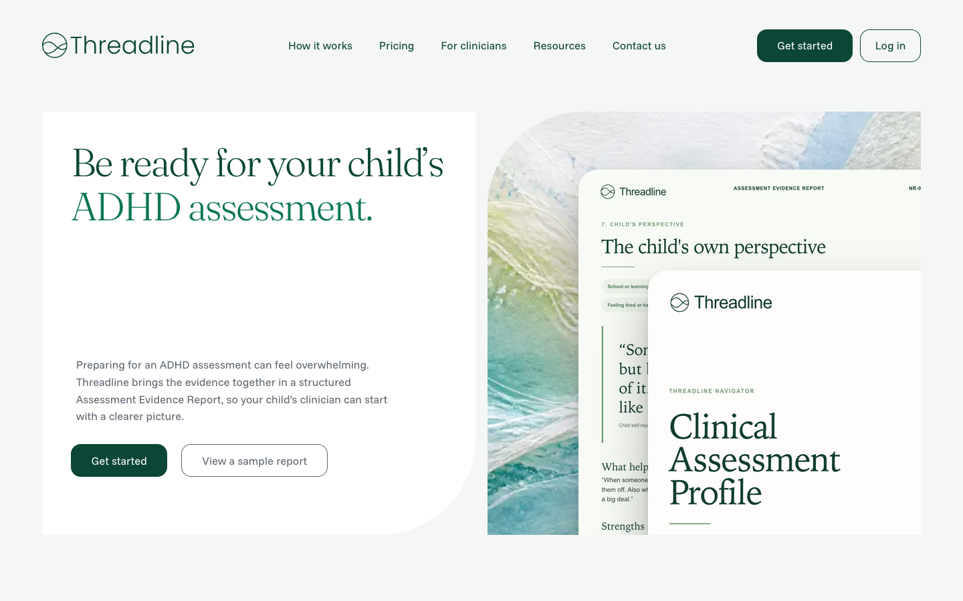
Figure 5. Production homepage in Firefox at 1440 × 900.
Observation: The hero heading also uses two lines. The overall crop and spacing closely match Chromium.

Desktop — WebKit
WebKit 26 · 1440 × 900 · document fonts loaded
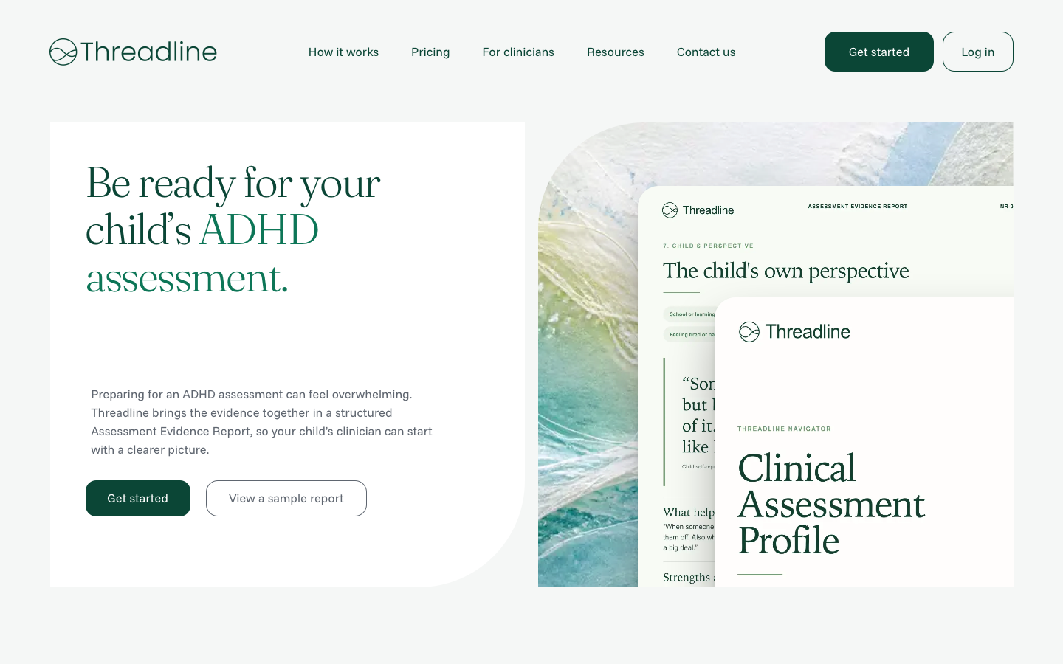
Figure 6. Production homepage in WebKit at 1440 × 900.
Observation: The hero heading uses three lines, producing a taller text block than Chromium and Firefox.

Tablet / compact desktop — Chromium
In-app Browser · Chromium · 1024 × 768
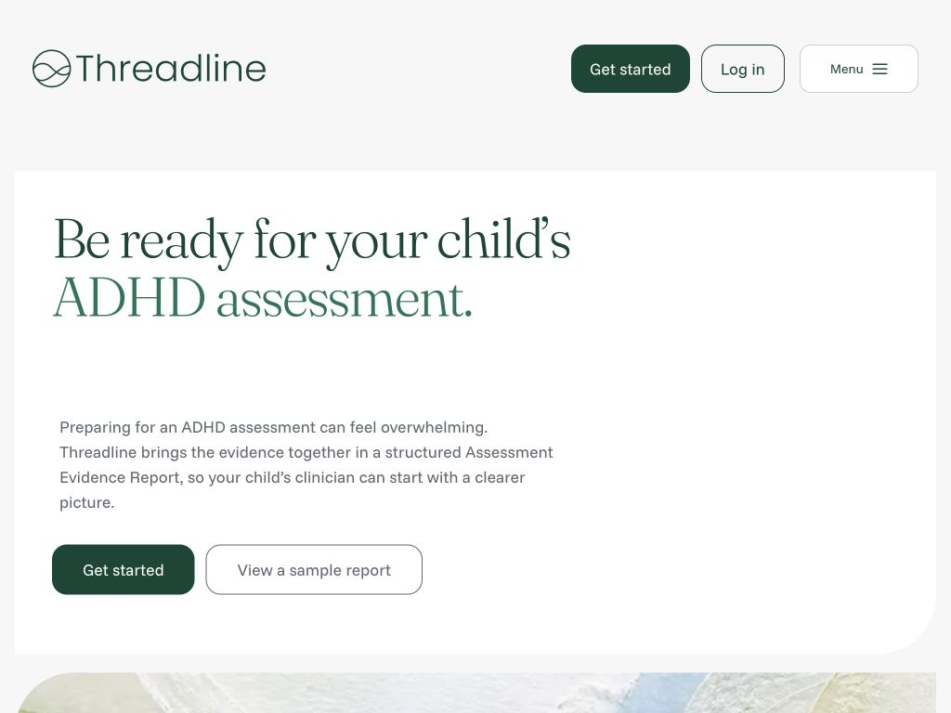
Figure 7. Production homepage in Chromium at 1024 × 768.
Observation: The navigation collapses to the Menu control while Log in and Get started remain visible.

Mobile — three-browser comparison
390 × 844 · Chromium, Firefox 141, and WebKit 26
All three engines preserve the same stacked hero, navigation trigger, calls to action, and artwork placement.
Chromium | Firefox 141 | WebKit 26
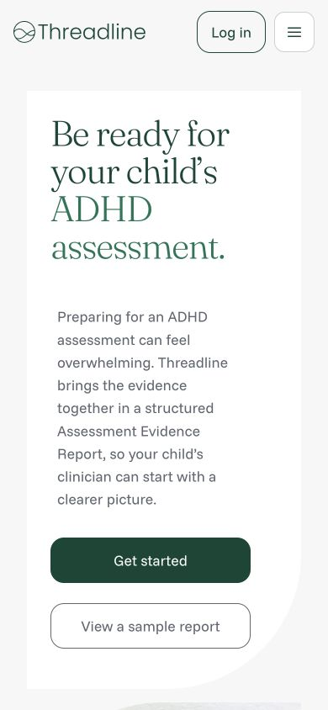 | 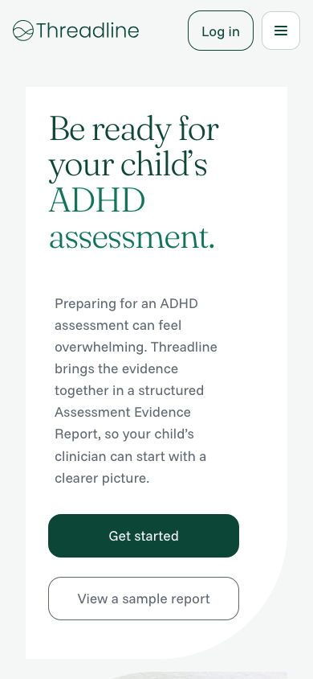 | 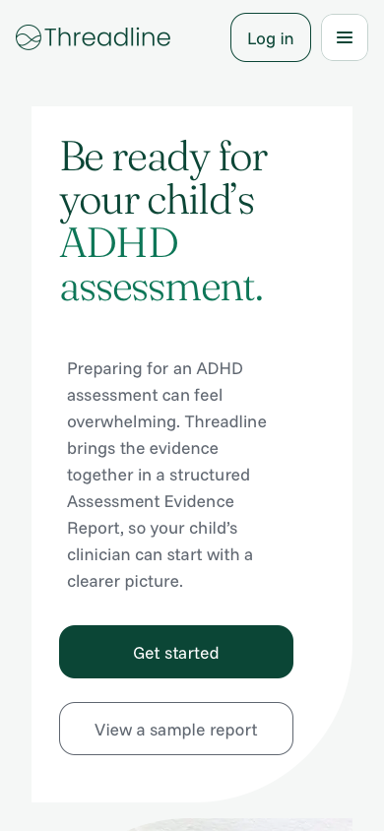
Observation: The hero heading wraps to four lines in all three engines, while controls and content spacing remain consistently placed.

Mobile navigation — Chromium
In-app Browser · Chromium · 390 × 844 · menu open

Figure 8. Mobile navigation expanded in Chromium at 390 × 844.
Interaction result: The menu opens successfully and exposes How it works, Pricing, For clinicians, Resources, Contact us, and Get started.

