MSCQR Customer Verification Guide

Document ID: AQR-SOP-CU-002
Version: 2.1
Last Updated: 2026-03-11

1. What this guide is for
Use this guide when you want to check whether a product is genuine using the public MSCQR page.

You do not need an account for a normal product check.

This guide shows you how to:
- enter or scan a code
- read the result page
- understand the main result messages
- report a suspicious product or contact support

2. What you can do on the customer page
On the public verification page you can:
- type the code printed next to the QR label
- use mobile camera capture if your device supports it
- see whether the product is verified, already checked before, or possibly suspicious
- review the scan summary and support details
- report a suspicious item

3. How to check a product
Have the code or QR label ready before you start. If you scan the QR label on the product, the verification page may open automatically. If it does not, you can still type the code yourself.

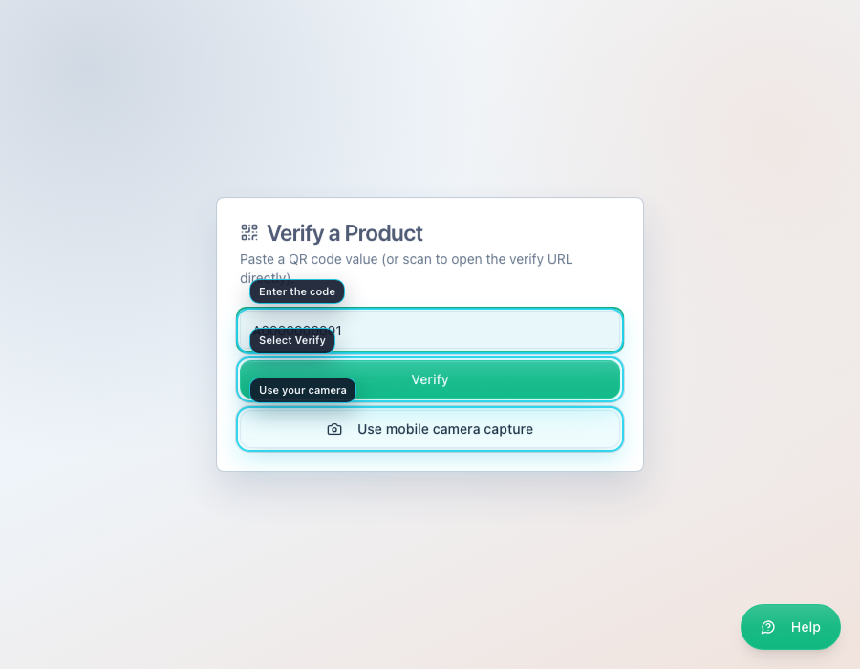
Start Verification

3.1 Enter the code manually
1. Open the public verify page.
2. Type the code exactly as it appears next to the QR label.
3. Select Verify.
4. Wait for the result page to open.

3.2 Use mobile camera capture
1. Open the public verify page on a phone or device with a camera.
2. Select Use mobile camera capture.
3. Take a photo or choose an image that clearly shows the QR code.
4. Wait while the system reads the code.
5. The result page will open automatically.

If camera capture does not work in your browser, type the code manually instead.

3.3 What to read first on the result page
1. Read the large status banner at the top.
2. Read the short explanation underneath.
3. Review the Scan summary to see when the item was first and last verified.
4. If the page shows a warning, read Risk Signals before deciding what to do.

4. Understand the result

4.1 Verified Authentic
This usually means the code is valid and this is the first successful customer verification.

What to do:
1. Review the banner.
2. Review the brand, manufacturer, and scan summary details.
3. Keep the screen if you want proof of the check.

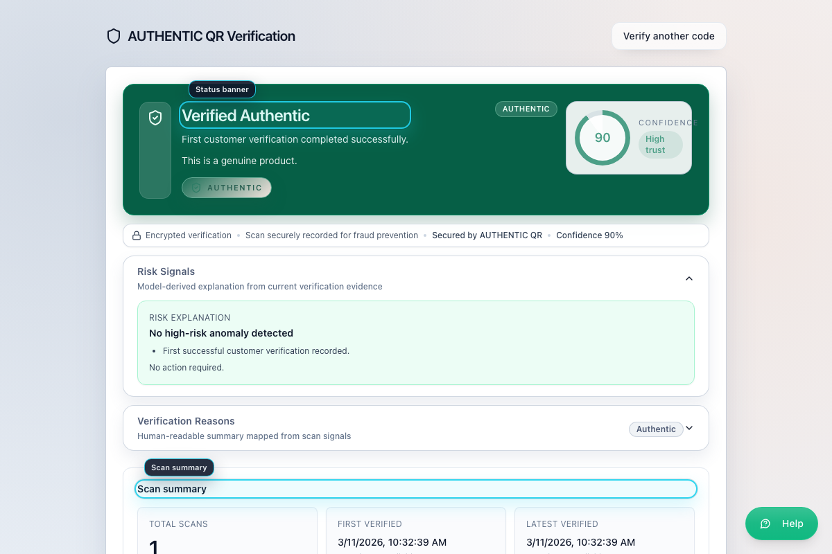
Verified Authentic

4.2 Verified Again
This means the product has already been checked before. That can be normal, especially if you or the seller are checking it again.

What to do:
1. Review the result details.
2. Check the scan summary if you want to see earlier verification activity.
3. Use the support contact if anything still feels unclear.

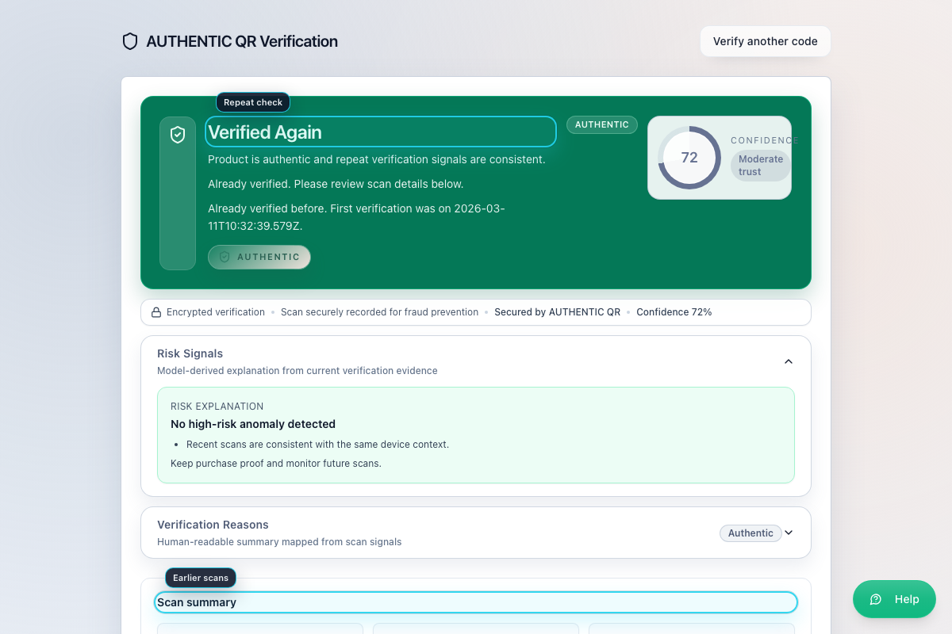
Verified Again

4.3 Possible Duplicate
This means the system has seen unusual scan activity. It does not automatically prove the product is fake, but it does mean you should be careful.

What to do:
1. Review the warning message.
2. Review Risk Signals, Verification Reasons, and Scan summary.
3. If anything looks wrong, do not rely on the product.
4. Open the incident drawer and report the case.

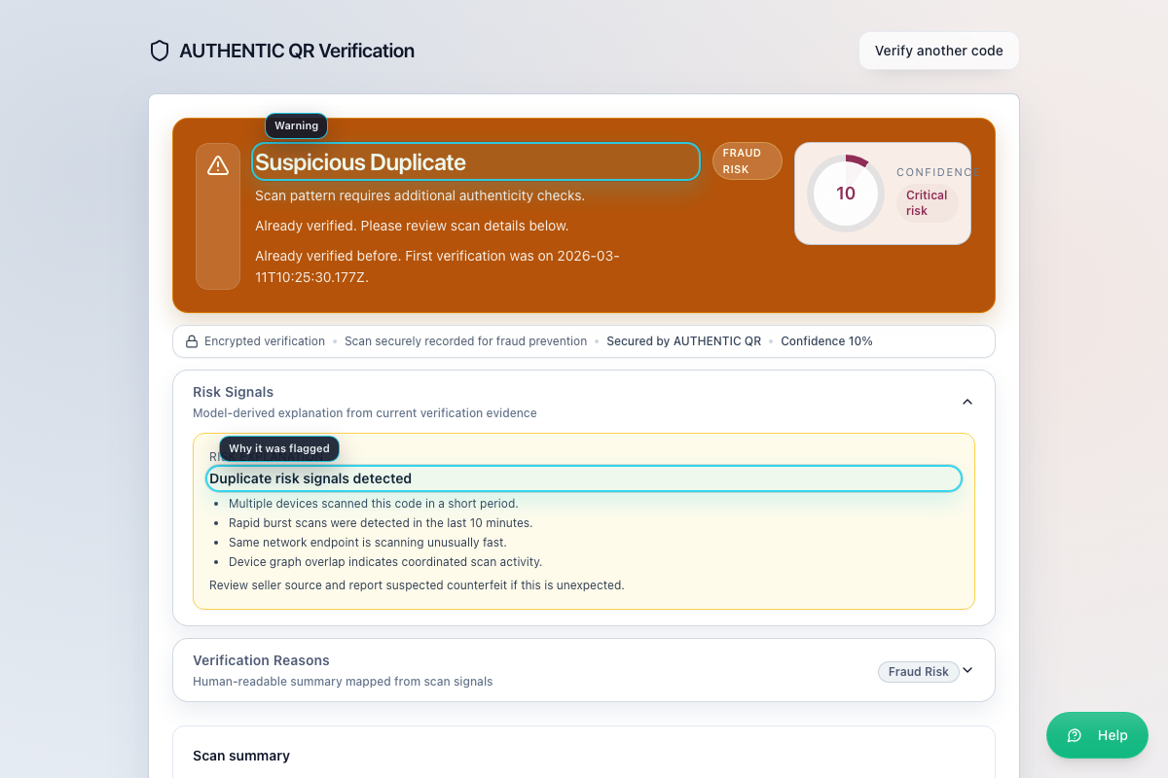
Possible Duplicate

4.4 Other possible outcomes
You may also see messages such as:
- under investigation
- blocked
- unassigned
- invalid
- verification service unavailable

When that happens:
1. Read the banner and warning text first.
2. Review the support contact shown on the page.
3. Report the case if the product looks suspicious.

5. Review the Verification Details
After a successful verification, review the page in this order:
1. Read the main status banner.
2. Review the Verification Reasons.
3. Review the Scan summary for first and latest verification details.
4. Review supply-chain information such as brand owner and support contact.
5. If the page shows a warning, read the risk explanation before deciding what to do next.

6. Optional Ownership Features
Some brands let customers claim ownership after a successful check. If the page says the feature is unavailable, stop there and use the product support contact instead.

6.1 Claim ownership on the current device
1. Open a successfully verified product page.
2. Select the claim action when it is available.
3. Read the claim confirmation message.
4. Select Confirm claim.

Use this only if you want the current device to remember that you own the item.

6.2 Sign in with email OTP for portable ownership
1. On the verification page, find Sign in for better protection.
2. Enter your email address.
3. Select Send OTP.
4. Open the email and get the one-time code.
5. Enter the code in One-time code.
6. Select Verify OTP.

After that, you can link the claim to your signed-in customer account if the page offers that option.

6.3 Start a resale or ownership transfer
1. On a claimed product page, open the resale or transfer section.
2. Select Start resale transfer.
3. Enter the recipient email if you want the system to email the next owner.
4. Leave the email blank if you only want to copy the secure transfer link yourself.
5. Select Create transfer.
6. Share the link securely.

6.4 Accept a transfer
1. Open the transfer link.
2. Sign in if the page requires it.
3. Select Accept ownership transfer.

7. Report a suspicious product

7.1 Send a report
1. On the verification page, open the report area.
2. Select Open incident drawer.
3. Choose the Issue type.
4. Enter a description of what looked suspicious.
5. Add your email if you want follow-up updates.
6. Attach photos or evidence if available.
7. Submit the report.
8. Save the returned case reference and any support ticket reference shown by the system.

The system automatically adds:
- verification classification
- scan summary
- ownership state
- tamper-check information when available

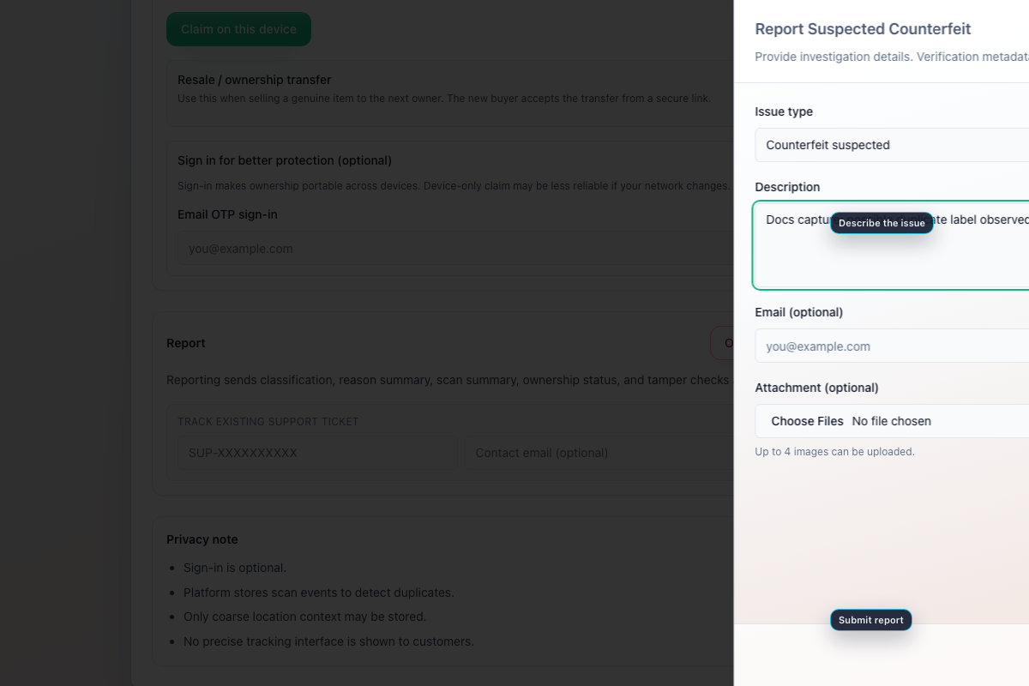
Report Counterfeit

7.2 After submitting
If the system creates a support ticket, the page may show:
- support ticket reference
- current ticket status
- SLA due time

Keep that information if you want to track the case later.

8. Track an Existing Support Ticket
1. On the verification page, find Track existing support ticket.
2. Enter the support ticket reference.
3. Enter the contact email if you have one.
4. Select Track status.
5. Review the returned status, workflow stage, and SLA due time.

9. Use the support contact
If the verification page shows support details, use them in this order:
1. Note the support email, phone number, or website shown in Support Contact.
2. Keep the verification result or ticket reference ready.
3. Contact the brand with the exact code or reference when needed.

10. Quick reminder
Use this order when checking a product:
1. Open the verify page.
2. Enter the code or use mobile camera capture.
3. Read the result banner first.
4. Review the scan summary and support contact.
5. If the result looks suspicious, report the case immediately.
6. If you submitted a report, keep the case or support ticket reference.

11. Troubleshooting
- If camera capture fails, type the code manually.
- If the page says the verification service is unavailable, reconnect and try again. Use Retry now if it is shown.
- If the code is not recognized or looks damaged, do not assume the product is genuine. Report the case.
- If ownership claim is unavailable, that is controlled by the brand policy. Use the support contact instead.
- If you lose the support email, you can still track a ticket from the verification page if you have the reference.

12. Mandatory Compliance Statements

12.1 UK GDPR and Data Protection
MSCQR processes personal data in accordance with UK GDPR and the Data Protection Act 2018. Data protection queries must be directed to administration@mscqr.com.

12.2 Security and Access Control
Access control is role-based for Super Admin, Licensee Admin, and Manufacturer users. Communication is encrypted over HTTPS, passwords are handled using secure controls, and critical actions are recorded in audit logs.

12.3 Incident Response and Fraud Reporting
The controlled process is: report intake -> review -> containment -> documentation -> resolution.

12.4 QR Code Usage and Non-Duplication
All QR codes are unique, traceable, and single-use where applicable. QR codes must not be duplicated, altered, or reused.

12.5 Audit Logging Notice
Administrative actions, QR allocations, fraud reports, and login attempts are logged and retained for 180 days.

12.6 Acceptable Use
Unauthorized access, reverse engineering, misuse of fraud reporting, or interference with system security is prohibited.

12.7 Hosting and Disclaimer
The platform is hosted via AWS Lightsail and Amazon RDS with reasonable security controls and is provided on a best-effort basis.

