Manufacturer Printer Setup Guide

Purpose

Use this guide when a manufacturer workstation needs to print through MSCQR without asking the operator to start any technical service manually.

The standard MSCQR flow is:

1. Install the printer normally in Mac or Windows.
2. Install the MSCQR Connector once on that same computer.
3. Open Printer Setup in MSCQR and confirm the printer shows as ready.
4. Print from Batches.

After the first install, the connector starts automatically whenever that user signs in.

First-time setup for a manufacturer workstation

1. On the computer that is physically connected to the printer, open the MSCQR onboarding email or the Install Connector page in MSCQR.
2. Choose the correct installer:
Mac installer for macOS
Windows package for Windows PCs
3. Run the installer once.
4. Confirm the printer already appears in the operating-system printer list.
5. Sign in to MSCQR and open Printer Setup & Support.
6. Select Refresh status.
7. Continue only when MSCQR shows the printer as ready.

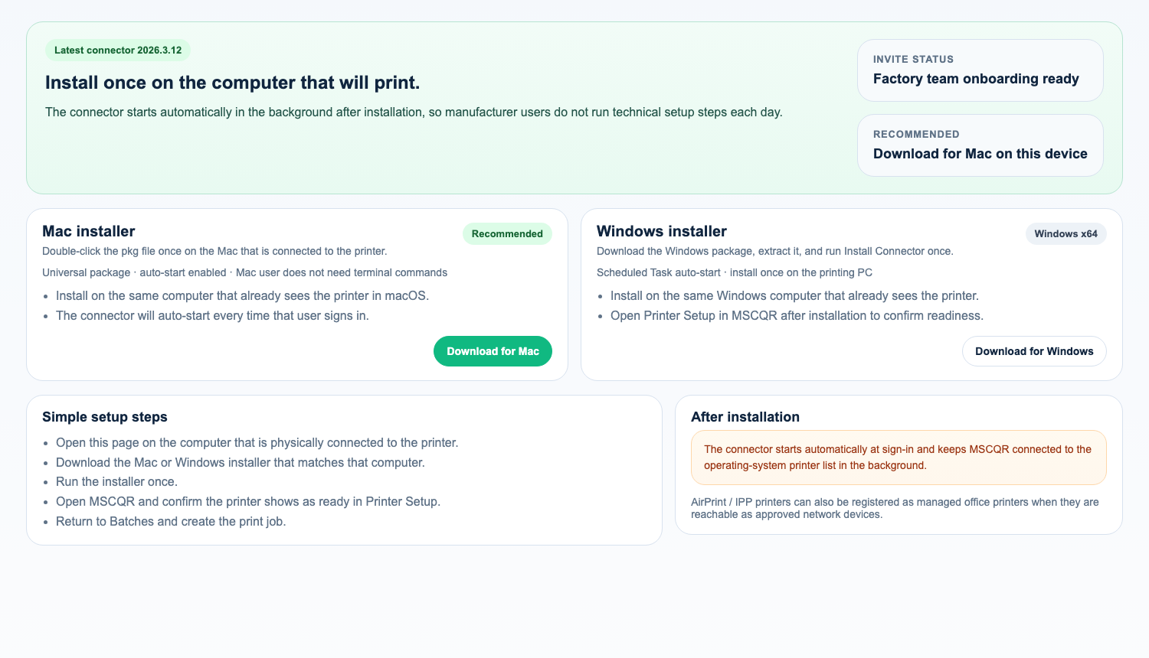
Connector download page

Which printer path should you use?

LOCAL_AGENT

Use this when the printer depends on the workstation that the user is sitting at.

Typical examples:

- USB printers
- desktop printers already added in Mac or Windows
- printers that rely on a local driver or spooler
- vendor-specific printer languages such as SBPL or ESC/POS

What the operator should know:

- install the printer in the operating system first
- install the MSCQR Connector once on that same computer
- the connector then starts automatically in the background

NETWORK_DIRECT

Use this for approved factory label printers that are saved by IP/port and accept raw label commands.

Current supported raw label languages:

- ZPL
- TSPL
- EPL
- CPCL

NETWORK_IPP

Use this for office printers, AirPrint printers, and IPP Everywhere printers that accept PDF jobs over IPP or IPPS.

Choose:

- Backend direct when the MSCQR backend can safely reach the printer
- Site gateway when the printer stays inside a private manufacturer network

What the operator should see in MSCQR

Open Printer Setup & Support and look for a business-safe result:

- Ready: the saved printer or workstation printer is good to use
- Preparing: MSCQR is still checking the route
- Offline: the connector, printer, or gateway is not reachable right now
- Needs attention: setup must be corrected before printing

The operator should never need to read ports, localhost addresses, stack traces, or internal system messages.

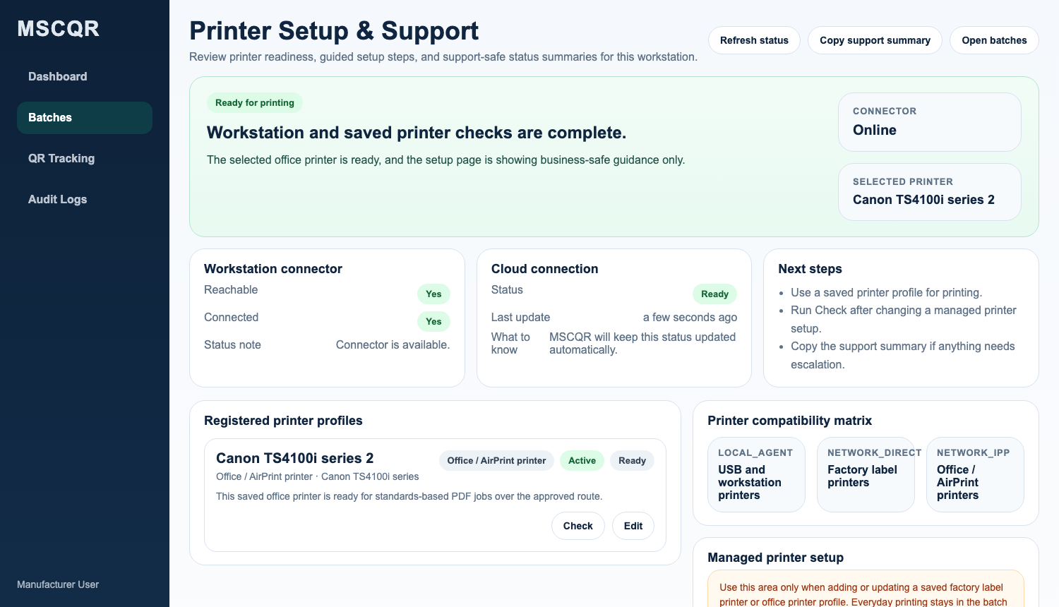
Printer Setup & Support

Workstation printer checklist

Use this checklist for printers installed directly on the Mac or Windows computer:

1. The printer already works in the operating system.
2. The MSCQR Connector is installed on that same computer.
3. Printer Setup shows the connector is reachable.
4. The active workstation printer is the one the operator actually wants to use.
5. Create Print Job shows the workstation printer as ready before the run begins.

Register a factory raw LAN printer

In Printer Setup:

1. Add a managed printer profile.
2. Choose NETWORK_DIRECT.
3. Enter the approved printer IP address or host and port.
4. Choose the supported command language.
5. Save.
6. Select Check.
7. Use the profile only after the status becomes ready.

Register an office / AirPrint / IPP printer

In Printer Setup:

1. Add a managed printer profile.
2. Choose NETWORK_IPP.
3. Enter either:
the full printer URI
or the host, port, and resource path
4. Enable TLS when the printer supports IPPS.
5. Choose Backend direct or Site gateway.
6. Save.
7. Select Check.

Recommended defaults:

- port 631
- resource path /ipp/print
- ipps:// when supported

Private factory network: site gateway setup

Use this only when the printer cannot be reached directly from the MSCQR backend.

1. Register the printer as NETWORK_IPP.
2. Choose delivery mode Site gateway.
3. Save the profile.
4. Copy the one-time gateway bootstrap secret shown by MSCQR.
5. Add the values below to the connector agent.env file on the trusted site workstation.
6. Restart the connector or reinstall it through the packaged installer.
7. Return to Printer Setup and confirm the profile changes to Site gateway online.

DOTENV code
PRINT_GATEWAY_BACKEND_URL=https://your-mscqr-host/api
PRINT_GATEWAY_ID=<gateway-id>
PRINT_GATEWAY_SECRET=<one-time-bootstrap-secret>

Before live printing

Confirm all of the following:

1. The printer profile or workstation printer is Ready.
2. The operator sees the correct saved printer name before they start.
3. A small test run completes successfully.
4. Printed counts update inside MSCQR.
5. If anything looks wrong, stop and correct setup before the production run.

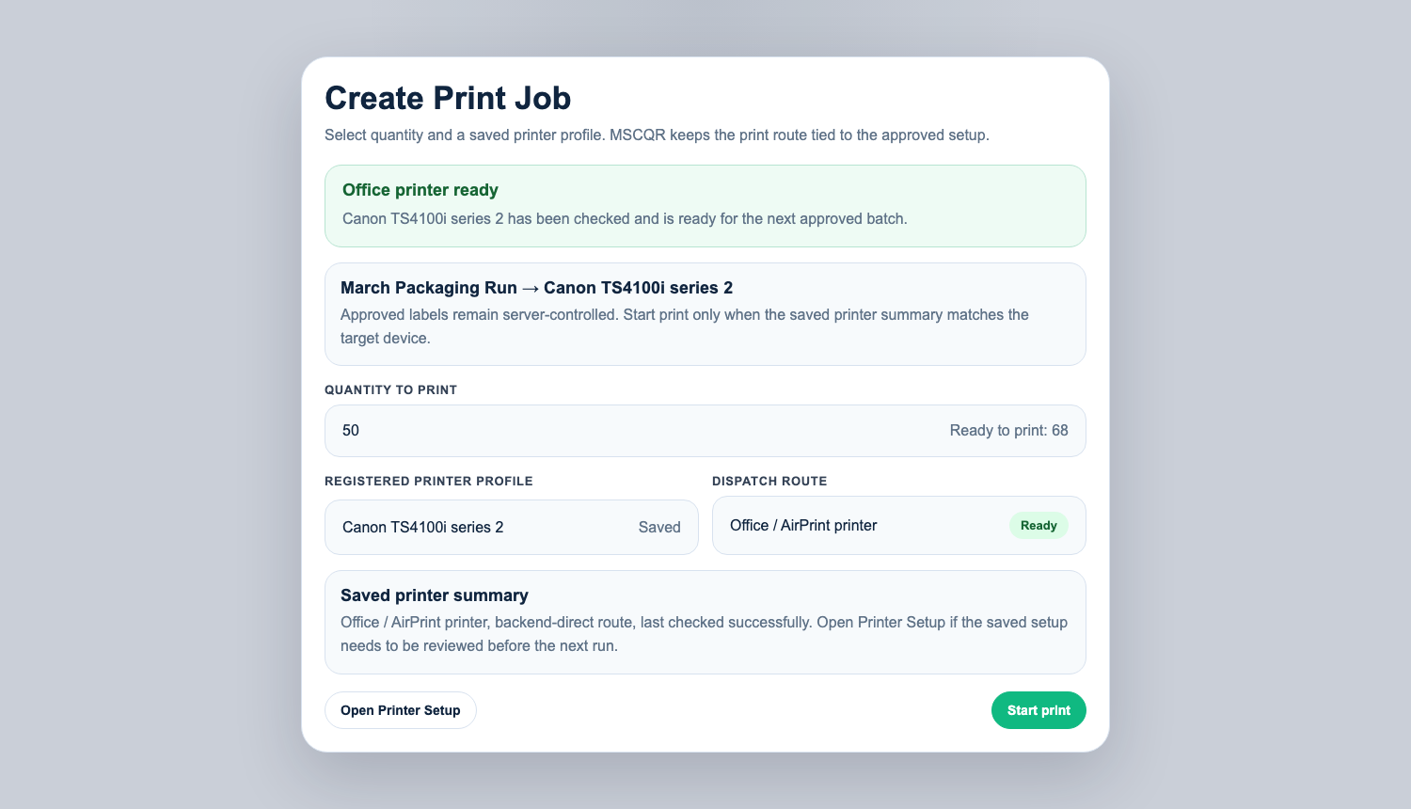
Create Print Job

Troubleshooting

If printing does not start:

1. Open Printer Setup.
2. Read the business-safe status.
3. If the connector is missing, return to Install Connector and install it on that computer.
4. If the printer is missing, confirm it still appears in the operating system.
5. If a saved network printer is not ready, run Check again.
6. Copy the support summary and send it to support if the issue continues.

Lightsail and Docker note

If MSCQR is deployed on AWS Lightsail with Docker Compose:

- use docker compose, not systemctl
- use the Lightsail browser terminal opened with Connect using SSH
- confirm the Git commit on Lightsail matches the Git commit on your local machine before and after the update

