AuthenticQR Customer Verification Guide

Document ID: AQR-SOP-CU-001
Version: 1.0
Last Updated: 2026-02-16

1. Purpose
Define the customer-side verification and reporting procedure for authenticity checks.

2. Scope
Applies to public verify flow users (no account required).

3. Preconditions
- Product QR code is available.
- Internet connection is active.

4. Procedure

4.1 Verify first scan
1. Scan product QR code.
2. Review status and product details.
3. Confirm Verified Authentic outcome.

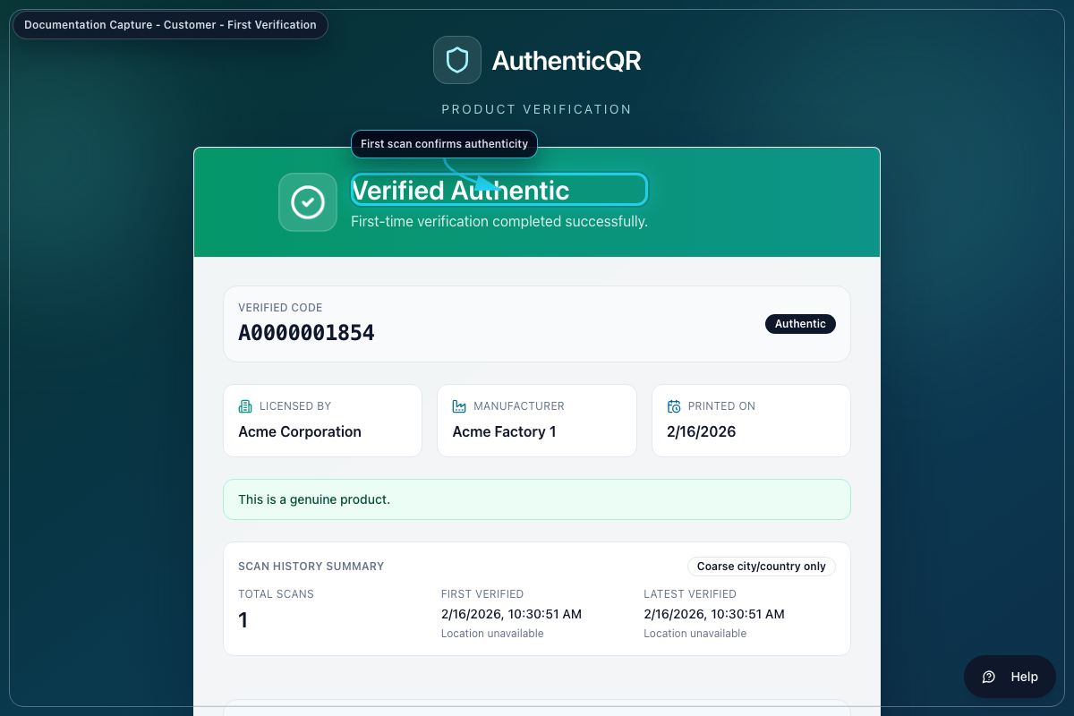
Verified Authentic

4.2 Validate repeat check behavior
1. Scan the same code again.
2. Confirm Verified Again appears.

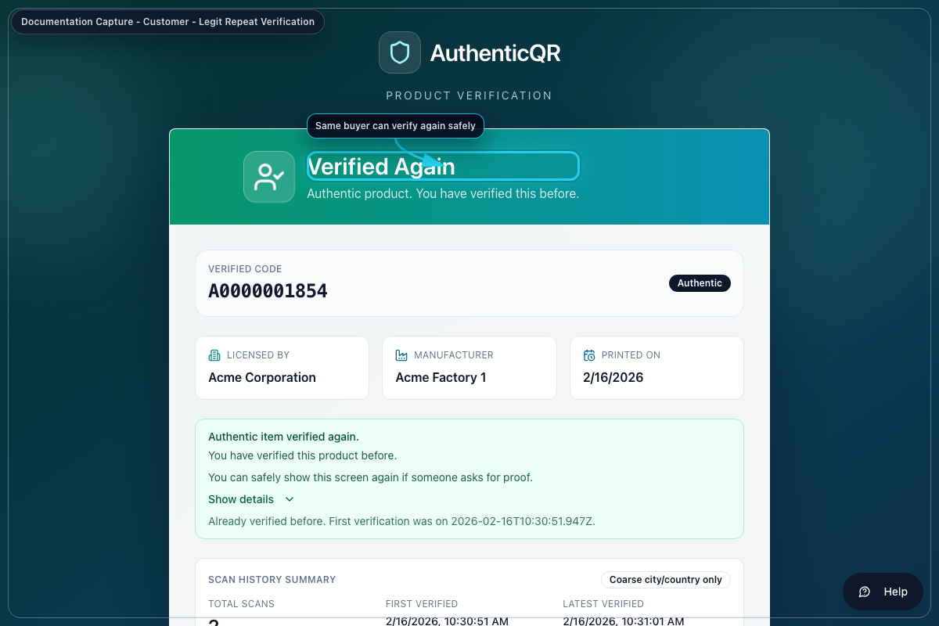
Verified Again

4.3 Handle duplicate warning
1. If Possible Duplicate appears, review flag reasons.
2. Do not trust product until reviewed.

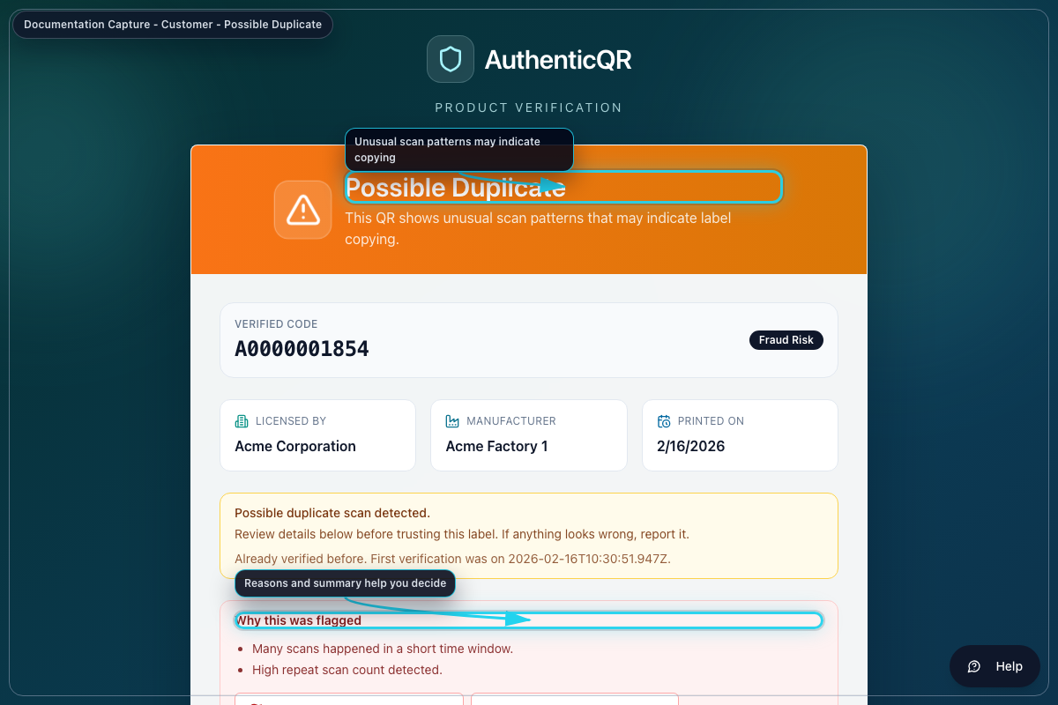
Possible Duplicate

4.4 Submit suspected counterfeit report
1. Select Report suspected counterfeit.
2. Complete incident type and observations.
3. Add optional photos/contact details.
4. Submit report.

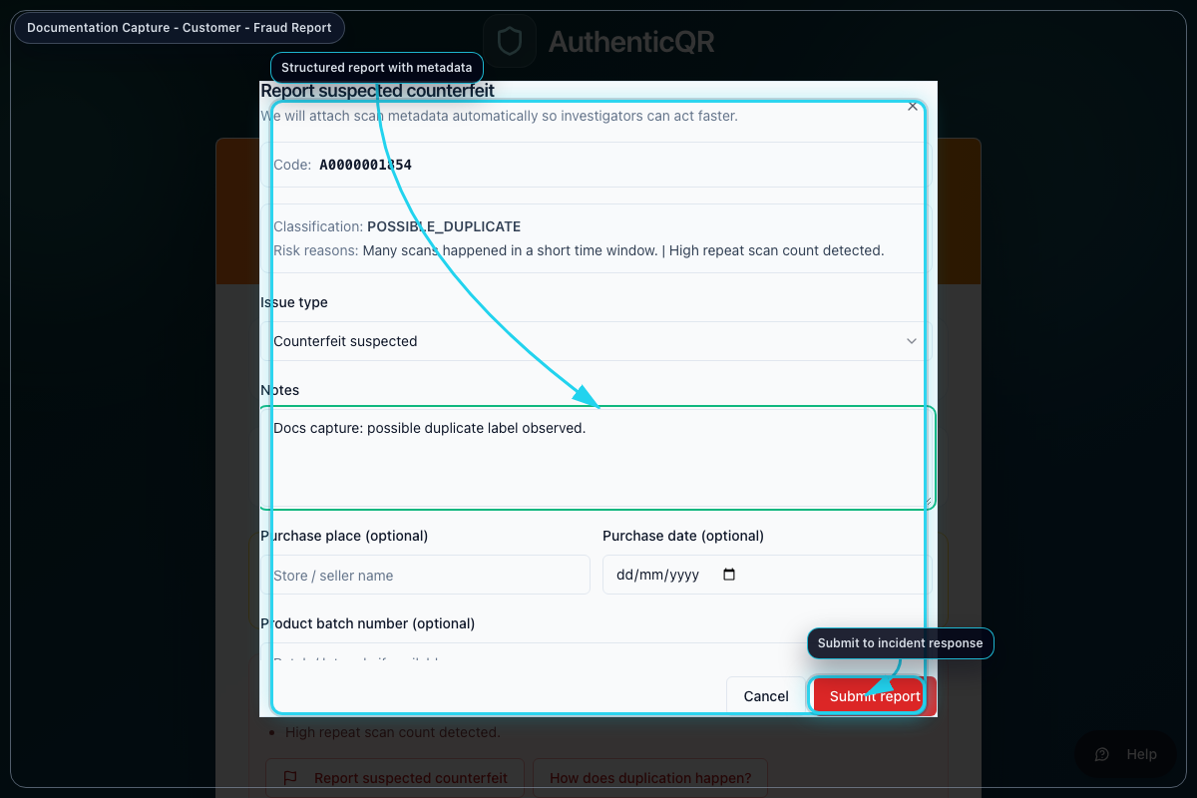
Report Counterfeit

5. Acceptance Criteria
- Verification screen renders a clear status.
- Duplicate warning displays rationale.
- Report submission returns a reference and audit trail.

6. Escalation
- If verification is unavailable, retry and contact brand support.
- If code appears invalid or suspicious, submit report immediately.

7. Mandatory Compliance Statements

7.1 UK GDPR & Data Protection notice
{{APP_NAME}} processes personal data in accordance with UK GDPR and the Data Protection Act 2018. Data protection queries must be directed to {{DPO_EMAIL}} or {{SUPER_ADMIN_EMAIL}}.

7.2 Security & Access Control statement
The platform enforces role-based access control (Super Admin, Licensee, Manufacturer), encrypted HTTPS communication, secure password handling, and audit logging of critical actions.

7.3 Incident Response & Fraud Reporting
Controlled process: report intake -> review -> containment -> documentation -> resolution.

7.4 QR Code Usage & Non-Duplication policy
All QR codes are unique, traceable, and single-use where applicable. QR codes must not be duplicated, altered, or reused.

7.5 Audit Logging notice
Administrative actions, QR allocations, fraud reports, and login attempts are logged and retained for {{RETENTION_DAYS}} days.

7.6 Acceptable Use clause
Unauthorized access, reverse engineering, misuse of fraud reporting, or interference with system security is prohibited.

7.7 Hosting & Disclaimer statement
The platform is hosted via {{HOSTING_PROVIDER}} with reasonable security controls and is provided on a best-effort basis.

