AuthenticQR Licensee/Admin Procedure Guide

Document ID: AQR-SOP-LA-001
Version: 1.0
Last Updated: 2026-02-16

1. Purpose
Define the controlled operating procedure for Licensee/Admin users managing manufacturer accounts and QR inventory allocation.

2. Scope
This procedure applies to organization-scoped Licensee/Admin accounts.

3. Preconditions
- Active Licensee/Admin account.
- Organization assignment configured.
- At least one manufacturer profile available (or ability to create one).

4. Procedure

4.1 Sign in
1. Open the login page.
2. Enter Licensee/Admin credentials and select Sign in.
3. Confirm access to QR Requests, Batches, Manufacturers, and Audit Logs.

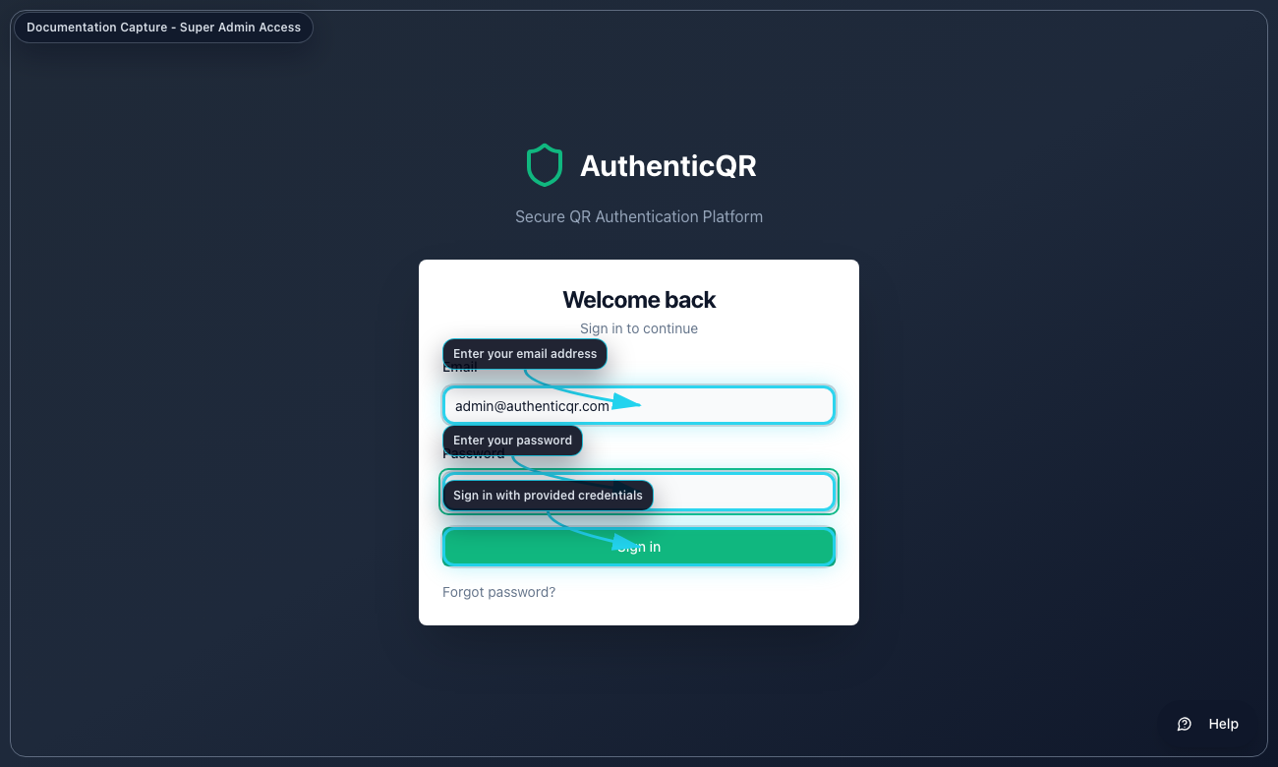
Licensee Login

4.2 Create or invite manufacturer user
1. Open Manufacturers.
2. Select Add Manufacturer.
3. Enter user profile and email.
4. Use invite mode and submit.

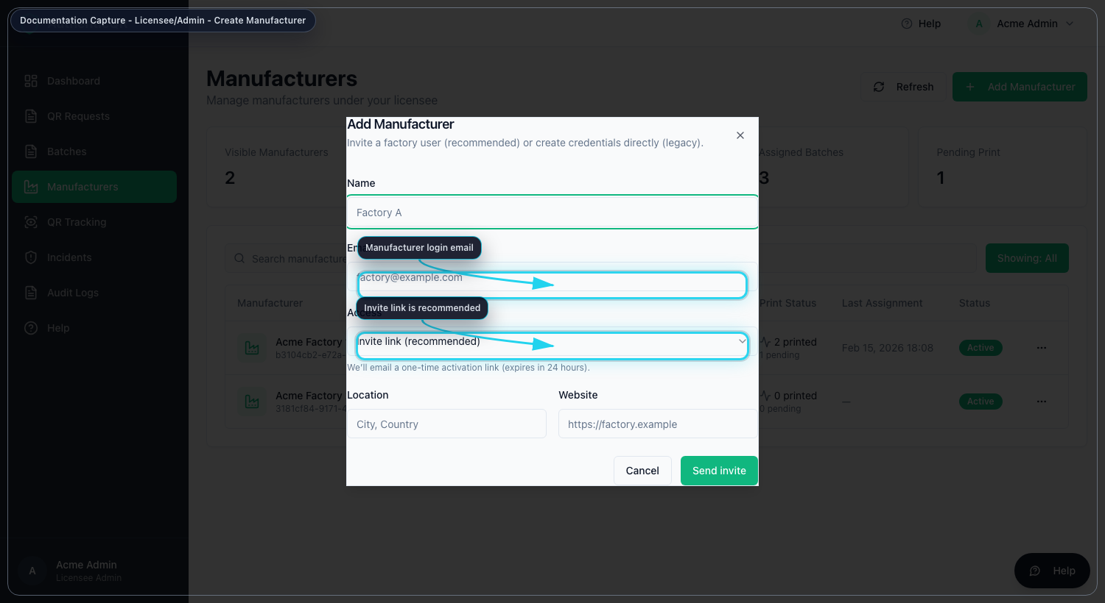
Create Manufacturer

4.3 Request new QR inventory
1. Open QR Requests.
2. Enter quantity and optional note.
3. Select Submit Request.
4. Track approval status.

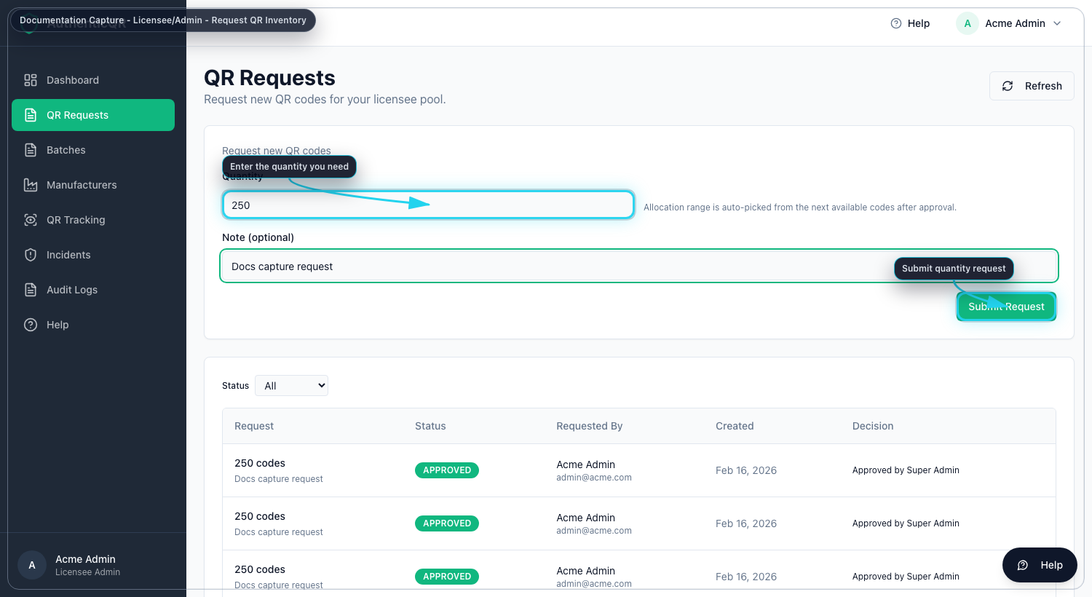
Request QR Inventory

4.4 Assign received batch to manufacturer
1. Open Batches.
2. Select a received batch with available quantity.
3. Open Assign Manufacturer.
4. Select manufacturer and quantity.
5. Submit assignment.

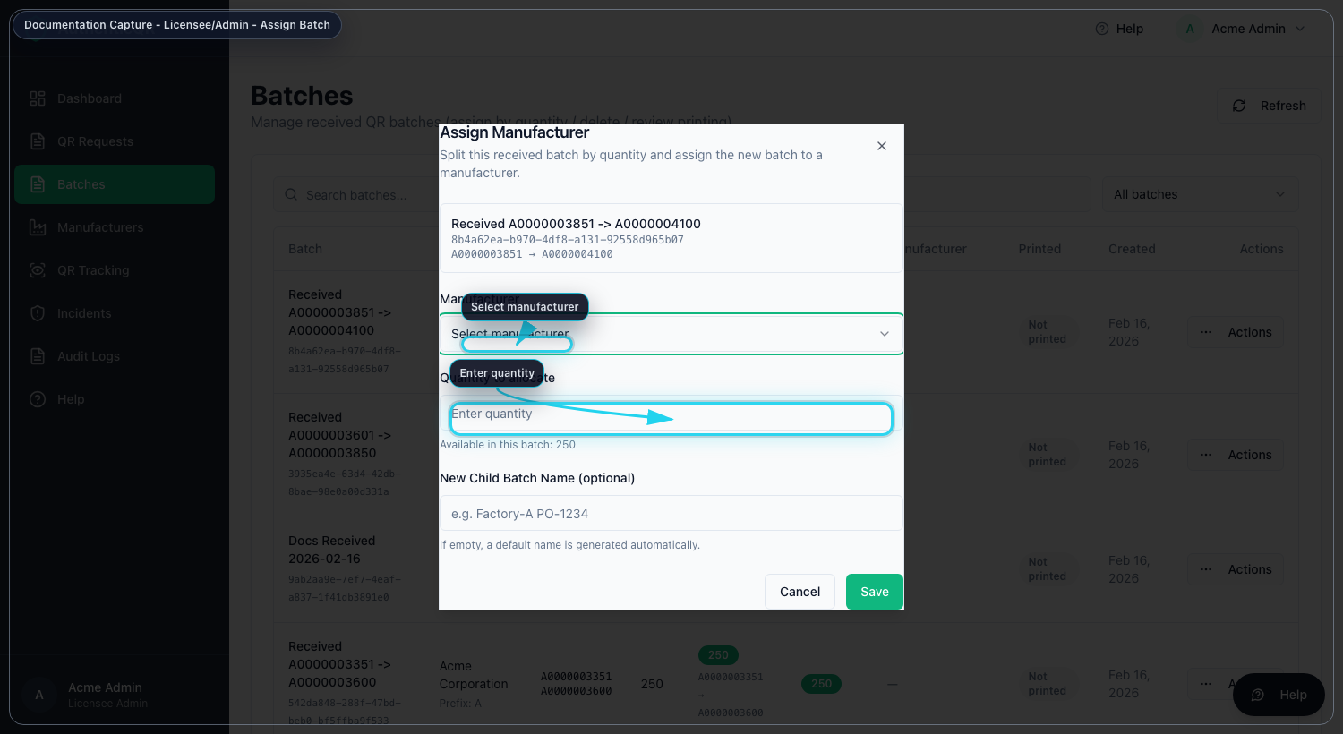
Assign Batch

5. Acceptance Criteria
- Manufacturer can view assigned batch.
- No overlapping allocation ranges.
- Assignment event appears in audit and trace timeline.

6. Nonconformance and Escalation
- If assignment fails with quantity errors, refresh and verify remaining balance.
- If manufacturer cannot view batches, verify assignment target and account activation.
- Escalate unresolved allocation defects with batch ID, quantity, and timestamp.

7. Mandatory Compliance Statements

7.1 UK GDPR & Data Protection notice
{{APP_NAME}} processes personal data in accordance with UK GDPR and the Data Protection Act 2018. Data protection queries must be directed to {{DPO_EMAIL}} or {{SUPER_ADMIN_EMAIL}}.

7.2 Security & Access Control statement
The platform enforces role-based access control (Super Admin, Licensee, Manufacturer), encrypted HTTPS communication, secure password handling, and audit logging of critical actions.

7.3 Incident Response & Fraud Reporting
Controlled process: report intake -> review -> containment -> documentation -> resolution.

7.4 QR Code Usage & Non-Duplication policy
All QR codes are unique, traceable, and single-use where applicable. QR codes must not be duplicated, altered, or reused.

7.5 Audit Logging notice
Administrative actions, QR allocations, fraud reports, and login attempts are logged and retained for {{RETENTION_DAYS}} days.

7.6 Acceptable Use clause
Unauthorized access, reverse engineering, misuse of fraud reporting, or interference with system security is prohibited.

7.7 Hosting & Disclaimer statement
The platform is hosted via {{HOSTING_PROVIDER}} with reasonable security controls and is provided on a best-effort basis.

