AuthenticQR Manufacturer Procedure Guide

Document ID: AQR-SOP-MF-001
Version: 1.0
Last Updated: 2026-02-16

1. Purpose
Define the controlled operating procedure for Manufacturer users performing print workflows.

2. Scope
This procedure applies to manufacturer accounts with assigned batches.

3. Preconditions
- Active manufacturer account.
- Assigned batch with available quantity.
- Secure environment for ZIP print pack handling.

4. Procedure

4.1 Sign in
1. Open the login page.
2. Enter manufacturer credentials.
3. Confirm access to assigned Batches.

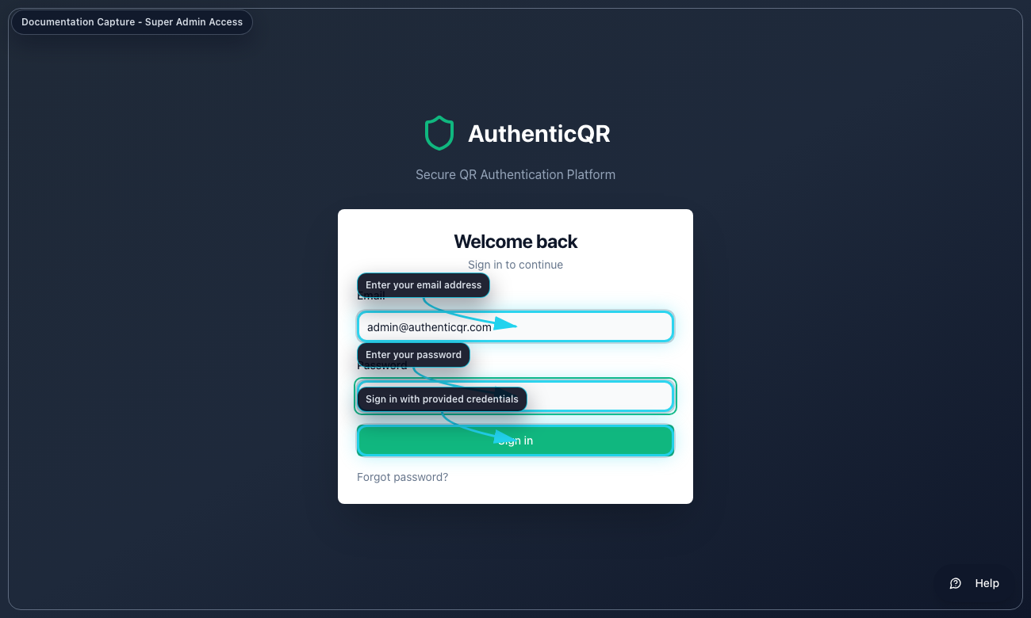
Manufacturer Login

4.2 Create print job
1. Open Batches.
2. Select assigned batch.
3. Select Create Print Job.
4. Enter quantity and confirm.

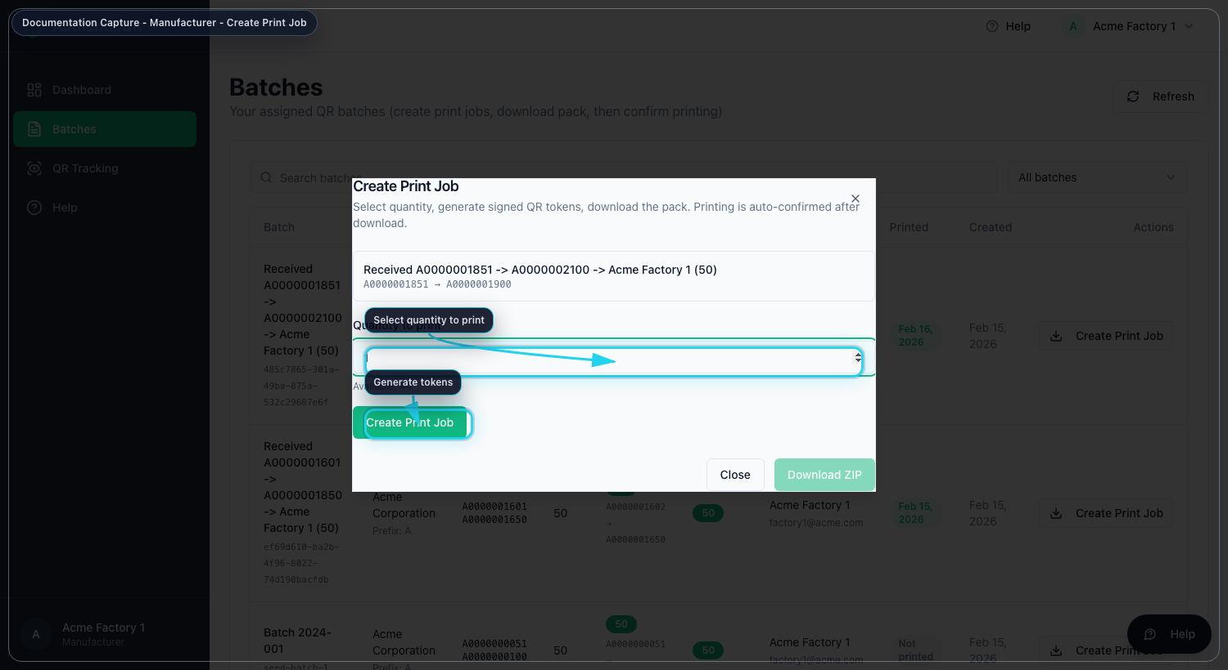
Create Print Job

4.3 Download print pack
1. Select Download ZIP.
2. Save ZIP in controlled storage.
3. Execute print process per plant controls.

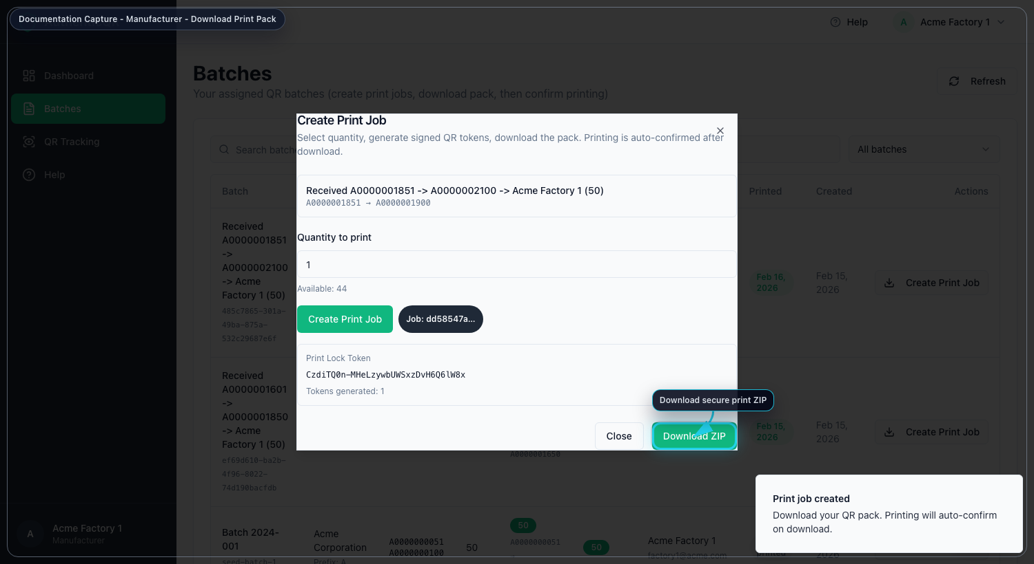
Download Print Pack

4.4 Validate print status
1. Return to Batches.
2. Confirm status reflects printed output.

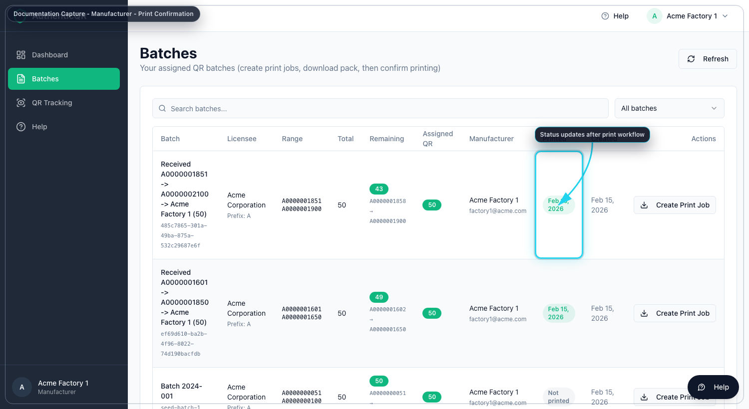
Printed Status

5. Acceptance Criteria
- ZIP download completes successfully.
- Printed status updates in system records.
- Trace events reflect print workflow.

6. Nonconformance and Escalation
- If token expires or download fails, create a new print job for remaining quantity.
- If status does not update, refresh once and verify connectivity.
- Escalate with batch ID, job ID, and timestamp when unresolved.

7. Mandatory Compliance Statements

7.1 UK GDPR & Data Protection notice
{{APP_NAME}} processes personal data in accordance with UK GDPR and the Data Protection Act 2018. Data protection queries must be directed to {{DPO_EMAIL}} or {{SUPER_ADMIN_EMAIL}}.

7.2 Security & Access Control statement
The platform enforces role-based access control (Super Admin, Licensee, Manufacturer), encrypted HTTPS communication, secure password handling, and audit logging of critical actions.

7.3 Incident Response & Fraud Reporting
Controlled process: report intake -> review -> containment -> documentation -> resolution.

7.4 QR Code Usage & Non-Duplication policy
All QR codes are unique, traceable, and single-use where applicable. QR codes must not be duplicated, altered, or reused.

7.5 Audit Logging notice
Administrative actions, QR allocations, fraud reports, and login attempts are logged and retained for {{RETENTION_DAYS}} days.

7.6 Acceptable Use clause
Unauthorized access, reverse engineering, misuse of fraud reporting, or interference with system security is prohibited.

7.7 Hosting & Disclaimer statement
The platform is hosted via {{HOSTING_PROVIDER}} with reasonable security controls and is provided on a best-effort basis.

