AuthenticQR Super Admin Procedure Guide

Document ID: AQR-SOP-SA-001
Version: 1.0
Last Updated: 2026-02-16

1. Purpose
Define the controlled operating procedure for Super Admin users managing tenants, inventory approvals, and incident response.

2. Scope
This procedure applies to platform-level Super Admin accounts.

3. Preconditions
- Active Super Admin account.
- Valid sign-in credentials.
- IR Center access enabled.

4. Procedure

4.1 Sign in and verify scope
1. Open the login page.
2. Enter Super Admin credentials and select Sign in.
3. Confirm navigation includes Licensees, QR Requests, and IR Center.

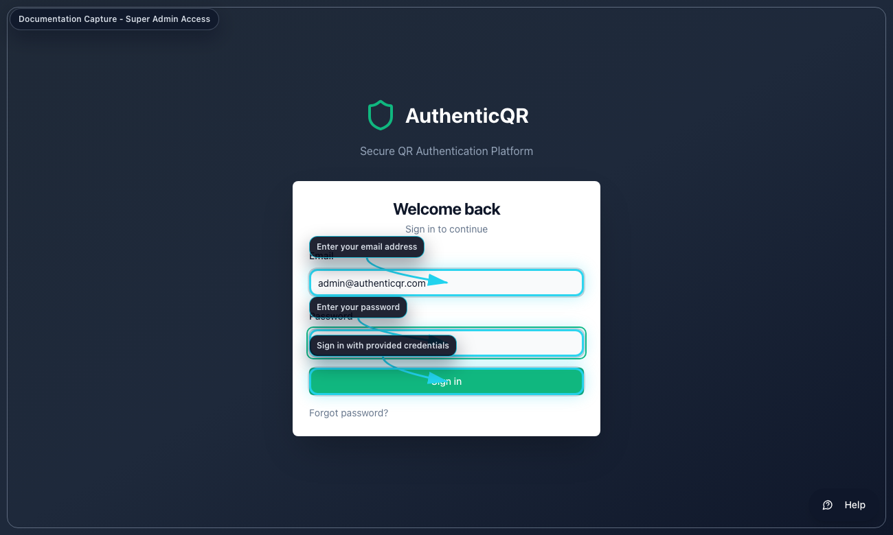
Super Admin Login

4.2 Create a licensee tenant
1. Open Licensees.
2. Select Add Licensee.
3. Enter organization details.
4. Submit and confirm tenant creation.

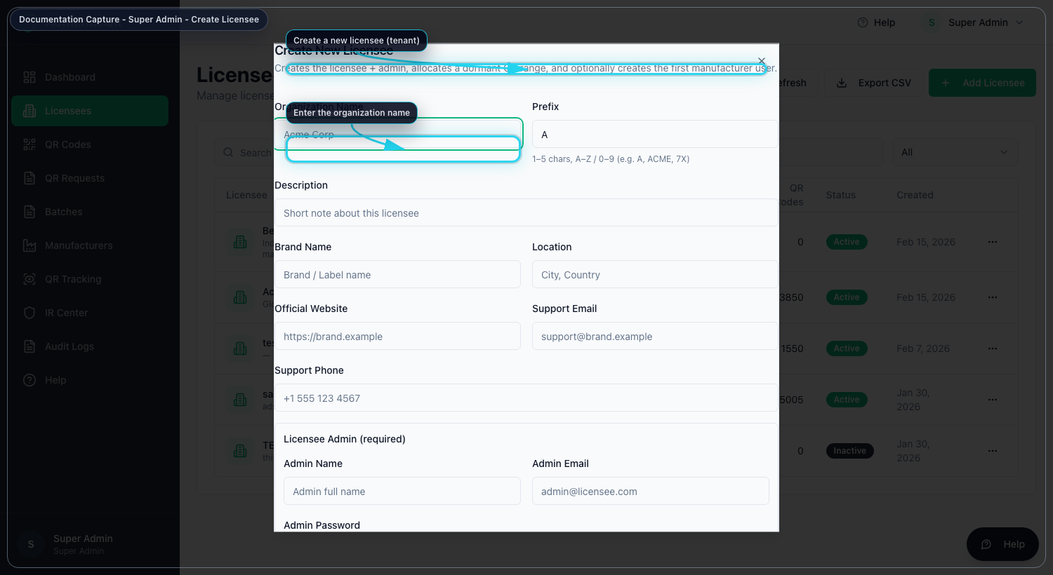
Create Licensee Tenant

4.3 Approve QR inventory requests
1. Open QR Requests.
2. Filter pending requests.
3. Review request details.
4. Approve or reject.

Acceptance criterion: approved requests allocate the next available QR sequence.

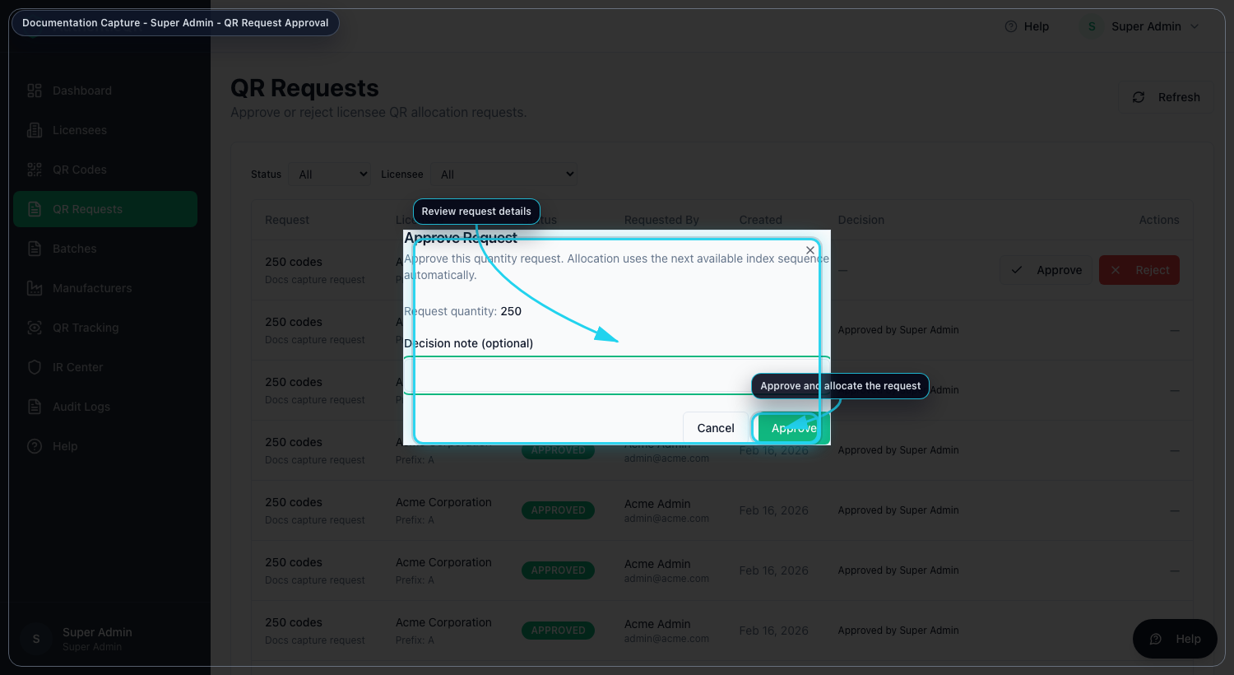
Approve QR Request

4.4 Operate Incident Response
1. Open IR Center.
2. Review incidents, alerts, and policies.
3. Prioritize by severity and assign ownership.
4. Apply containment actions only with documented reason.

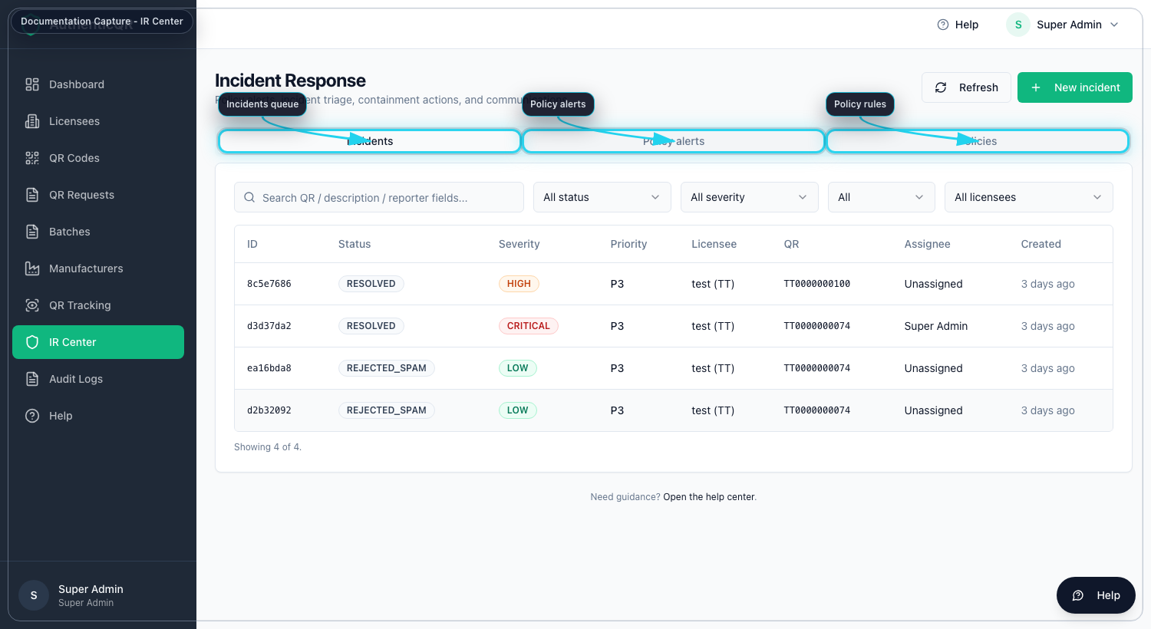
IR Center Dashboard

4.5 Configure policy rules
1. Open IR Center > Policies.
2. Select New policy.
3. Configure thresholds and scope.
4. Enable rule and validate alert behavior.

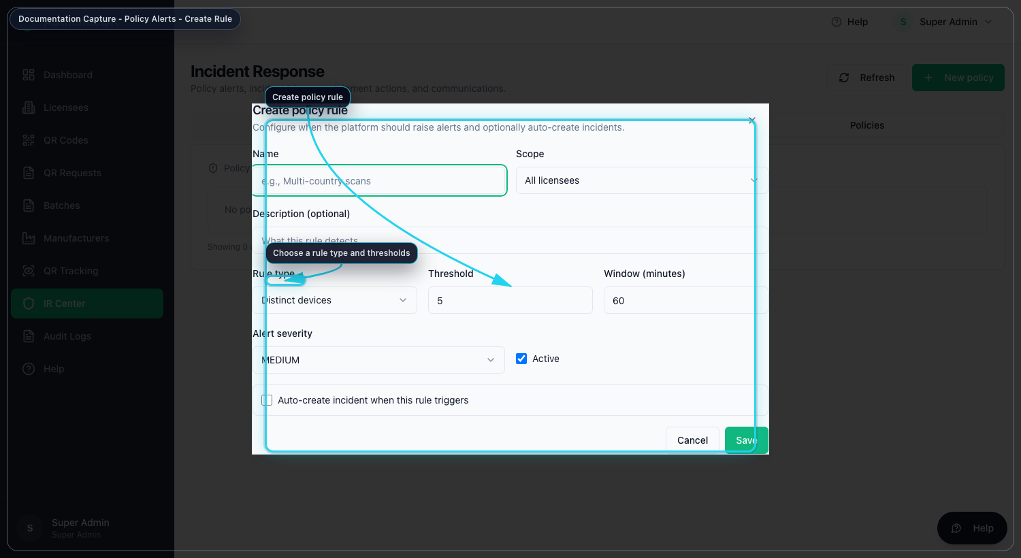
Create Policy Rule

4.6 Execute containment and communications
1. Open incident detail.
2. Apply action with reason.
3. Compose and send stakeholder communication.
4. Confirm timeline logging.

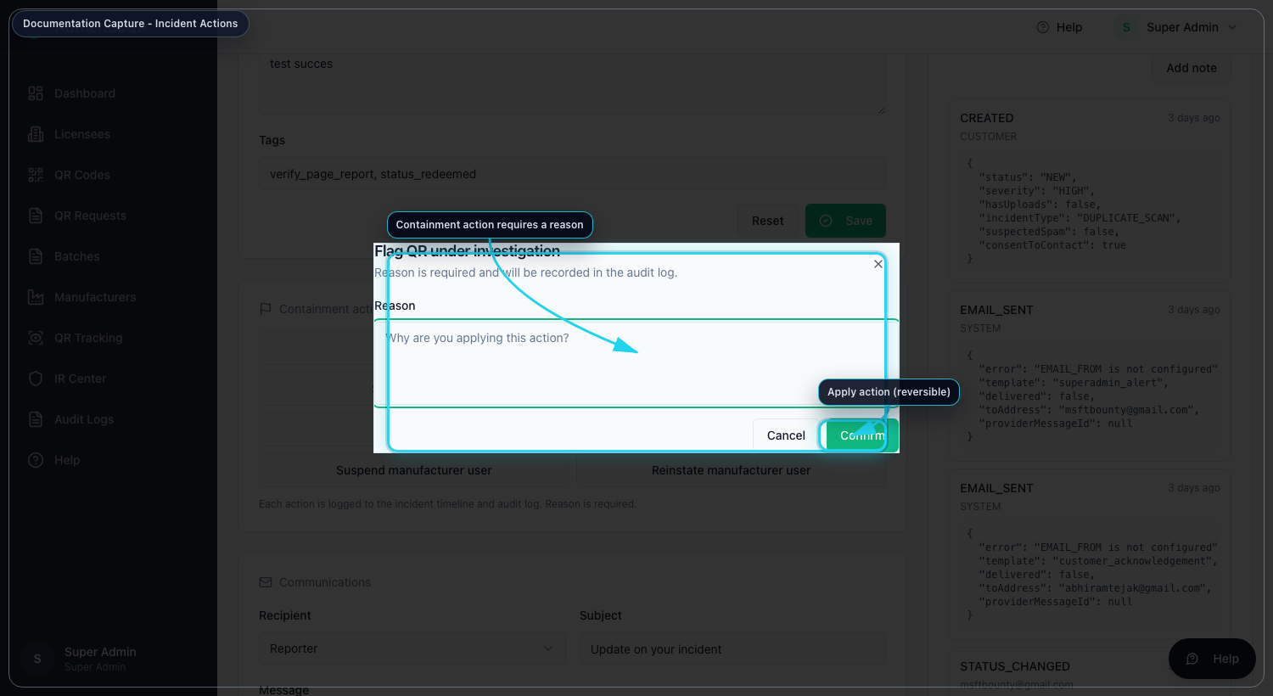
Incident Actions

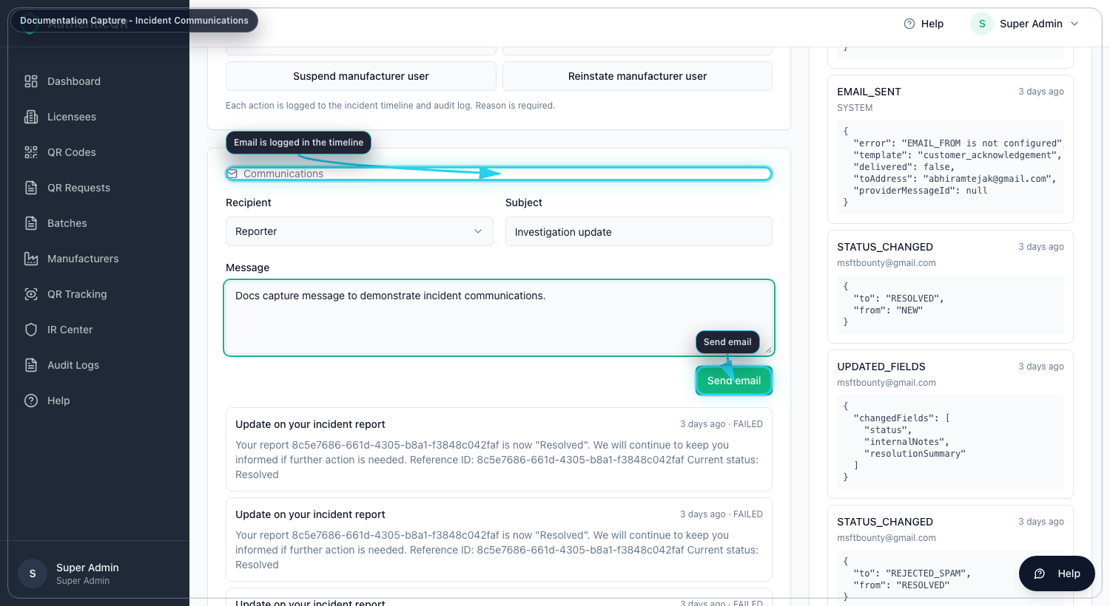
Incident Communications

5. Records and Evidence
- Incident timeline entries.
- Audit logs for approvals/actions.
- Communication status records.

6. Nonconformance and Escalation
- If approvals fail repeatedly, collect request ID, timestamp, and actor email.
- If email delivery fails, validate SMTP configuration and sender domain policy.
- Escalate platform failures to the engineering owner with incident ID and logs.

7. Mandatory Compliance Statements

7.1 UK GDPR & Data Protection notice
{{APP_NAME}} processes personal data in accordance with UK GDPR and the Data Protection Act 2018. Data protection queries must be directed to {{DPO_EMAIL}} or {{SUPER_ADMIN_EMAIL}}.

7.2 Security & Access Control statement
The platform enforces role-based access control (Super Admin, Licensee, Manufacturer), encrypted HTTPS communication, secure password handling, and audit logging of critical actions.

7.3 Incident Response & Fraud Reporting
Controlled process: report intake -> review -> containment -> documentation -> resolution.

7.4 QR Code Usage & Non-Duplication policy
All QR codes are unique, traceable, and single-use where applicable. QR codes must not be duplicated, altered, or reused.

7.5 Audit Logging notice
Administrative actions, QR allocations, fraud reports, and login attempts are logged and retained for {{RETENTION_DAYS}} days.

7.6 Acceptable Use clause
Unauthorized access, reverse engineering, misuse of fraud reporting, or interference with system security is prohibited.

7.7 Hosting & Disclaimer statement
The platform is hosted via {{HOSTING_PROVIDER}} with reasonable security controls and is provided on a best-effort basis.

