AuthenticQR - Customer Verification Manual
Document Type: User Operating Procedure
Audience: Customer (scanner / verification page)
Version: 1.0
Last Updated: 2026-02-16

1. Purpose
This manual explains the public verification process, result interpretation, and counterfeit reporting.

2. Access
- No account is required to verify a product.
- Open /verify and scan or enter the QR code.
- Optional sign-in methods may be available for ownership protection.

3. Result Interpretation
Result A - Verified Authentic
- Meaning: first valid verification for this printed code.
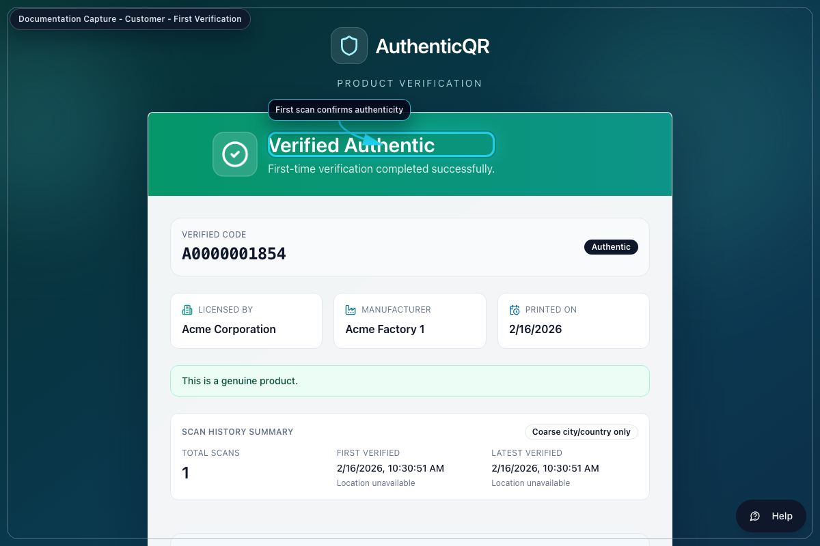
First-time verification (customer-first-verification.png)
Result B - Verified Again
- Meaning: same customer/device repeating a valid check.
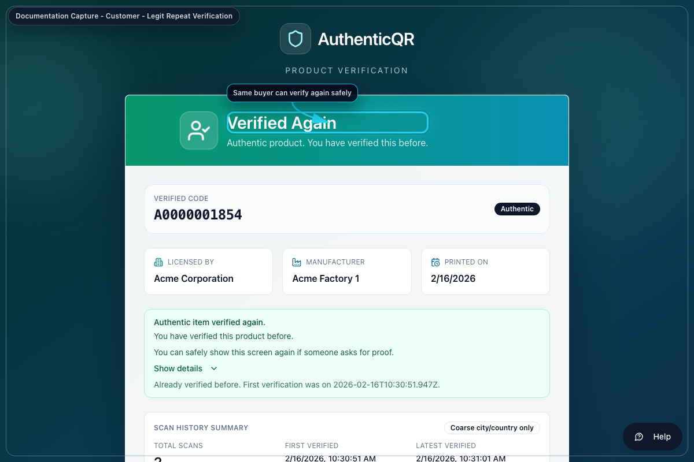
Legitimate repeat verification (customer-verified-again.png)
Result C - Possible Duplicate
- Meaning: unusual pattern detected (for example many scans in short time or cross-device pattern).
- Action: review reasons shown on page and report if suspicious.
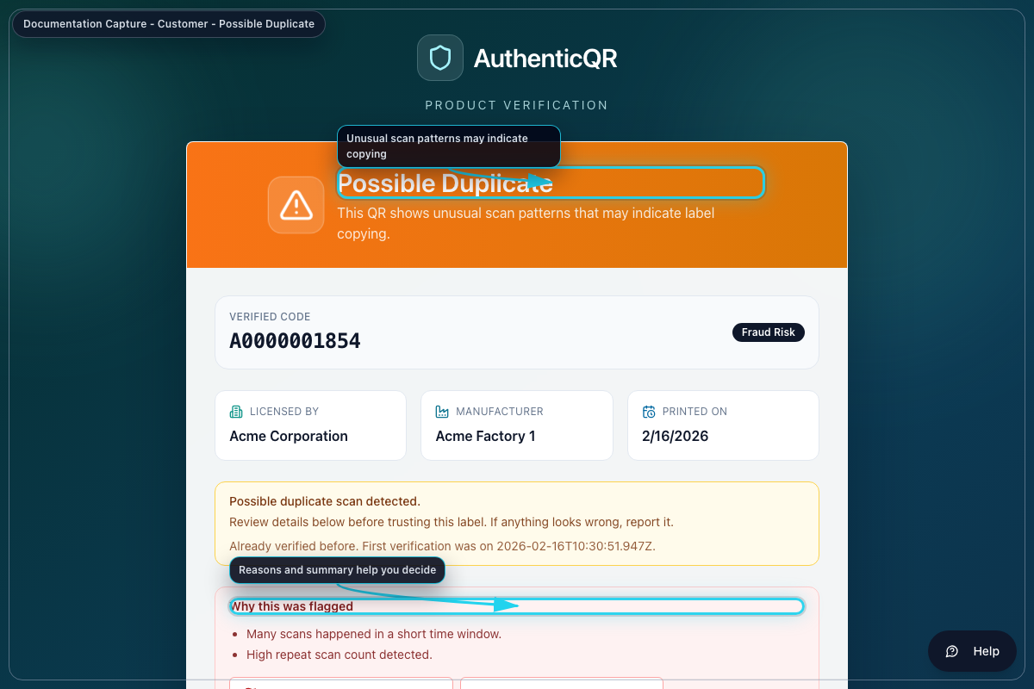
Possible duplicate state (customer-possible-duplicate.png)

4. Report Suspected Counterfeit
1. Select Report suspected counterfeit.
2. Choose issue type and provide notes.
3. Attach optional image evidence.
4. Submit report for investigation.
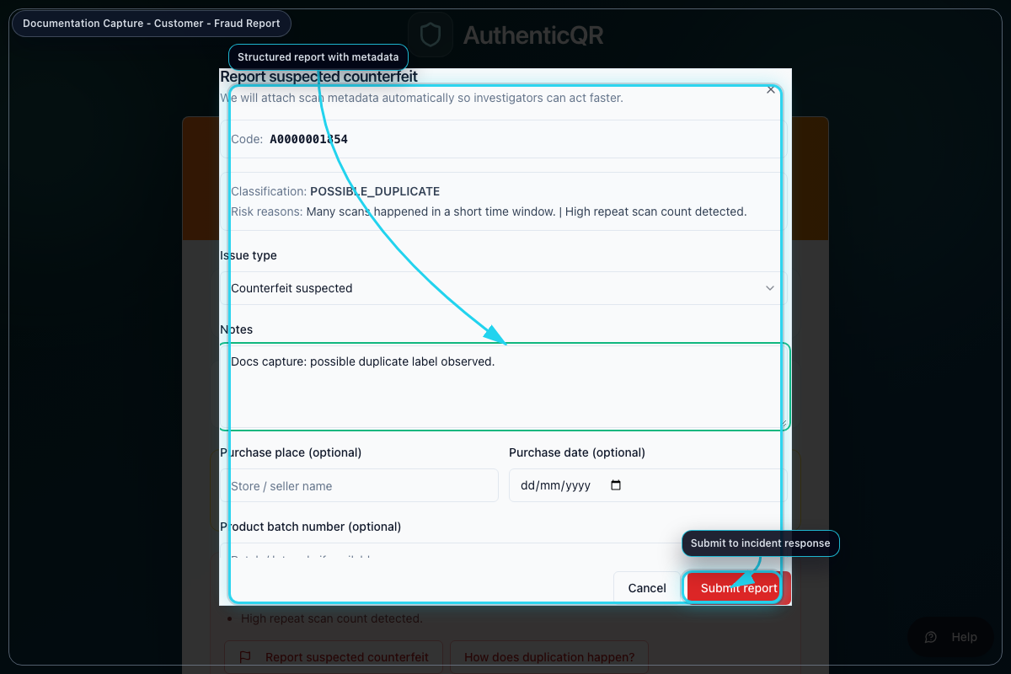
Counterfeit report form (customer-report-dialog.png)

5. Troubleshooting
- If verification is unavailable, retry after a short delay.
- If code is not recognized, verify label integrity and contact support.
- If possible duplicate appears, avoid purchase/use until confirmation.

Control Notes
- Use only organization-approved accounts and devices.
- Do not share credentials or one-time links.
- Record incidents and corrective actions in system logs.
- If an operation fails, capture timestamp, role, and page before escalation.

