AuthenticQR - Licensee/Admin User Manual
Document Type: User Operating Procedure
Audience: Licensee/Admin (brand/company)
Version: 1.0
Last Updated: 2026-02-16

1. Purpose
This manual defines organization-scoped procedures for QR inventory requests, manufacturer onboarding, and batch assignment.

2. Access and Password
- Account provisioning: invited by Super Admin or org admin.
- Invite acceptance: use one-time link, set password, then sign in.
- Reset path: Forgot Password from /login.
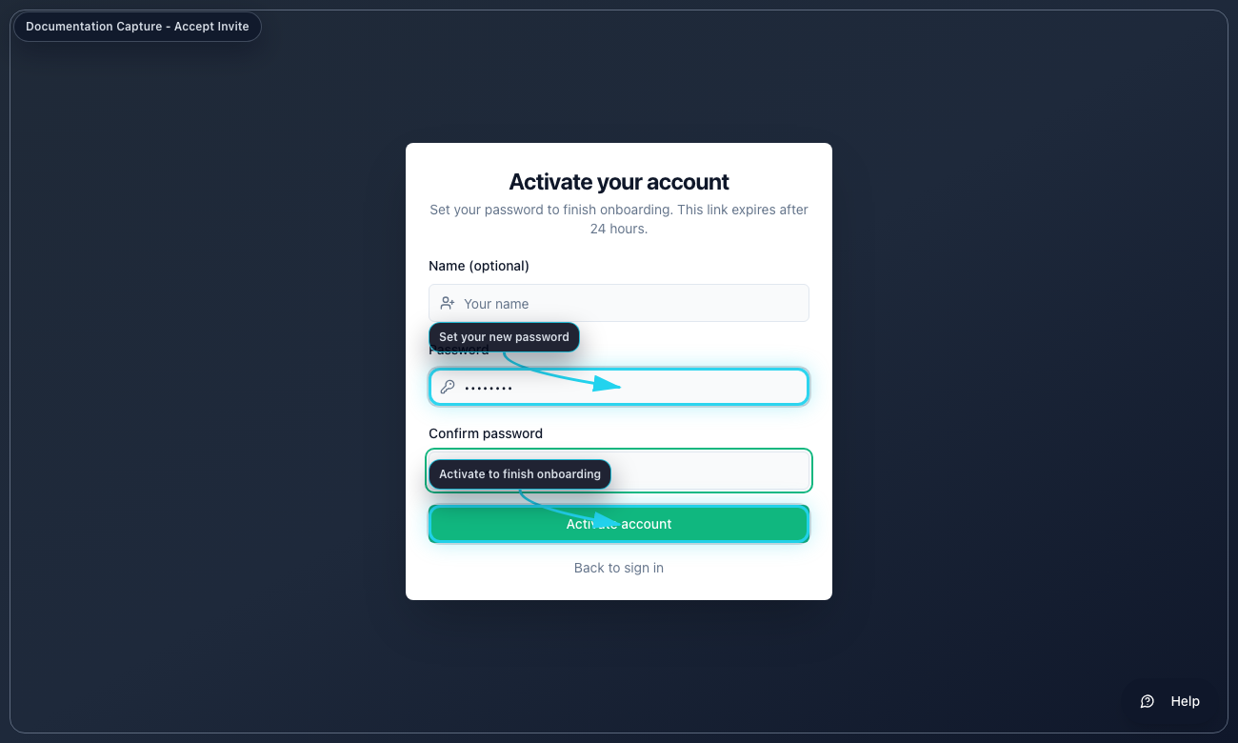
Accept invite and set password (password-accept-invite.png)
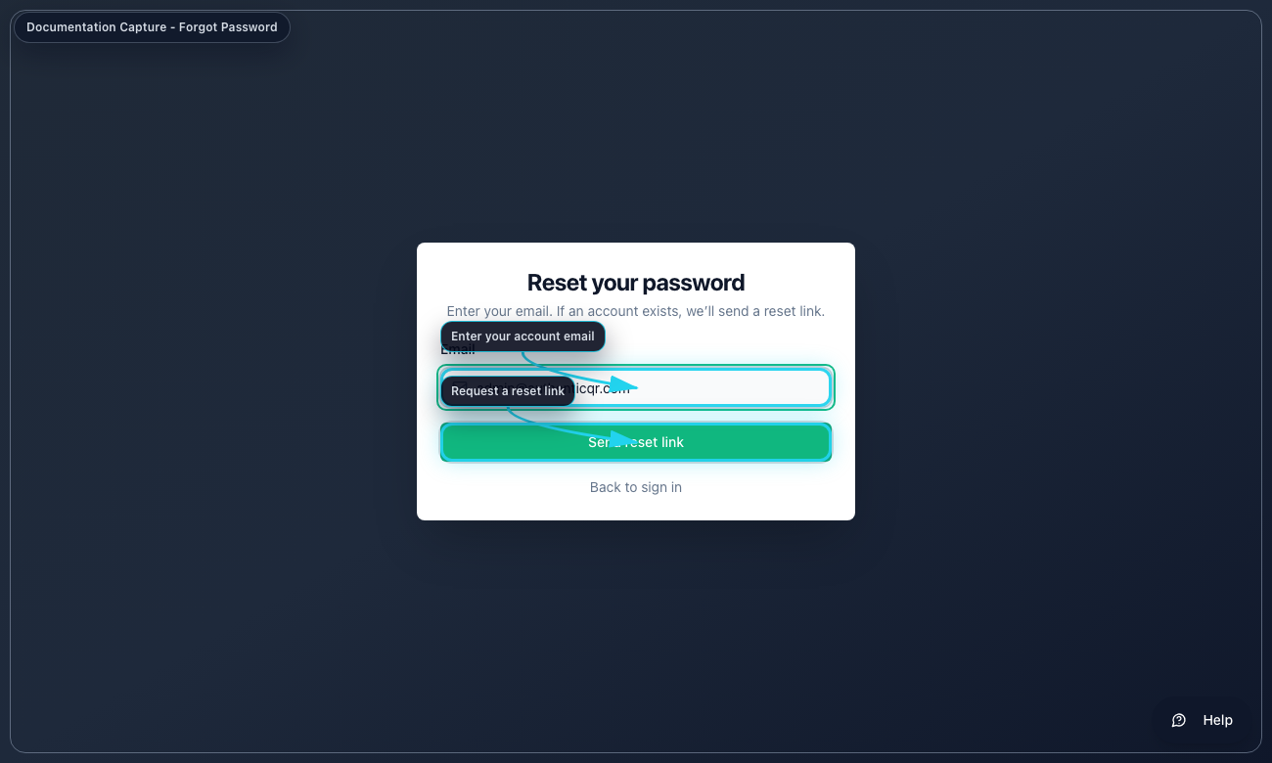
Forgot password request (password-forgot-password.png)
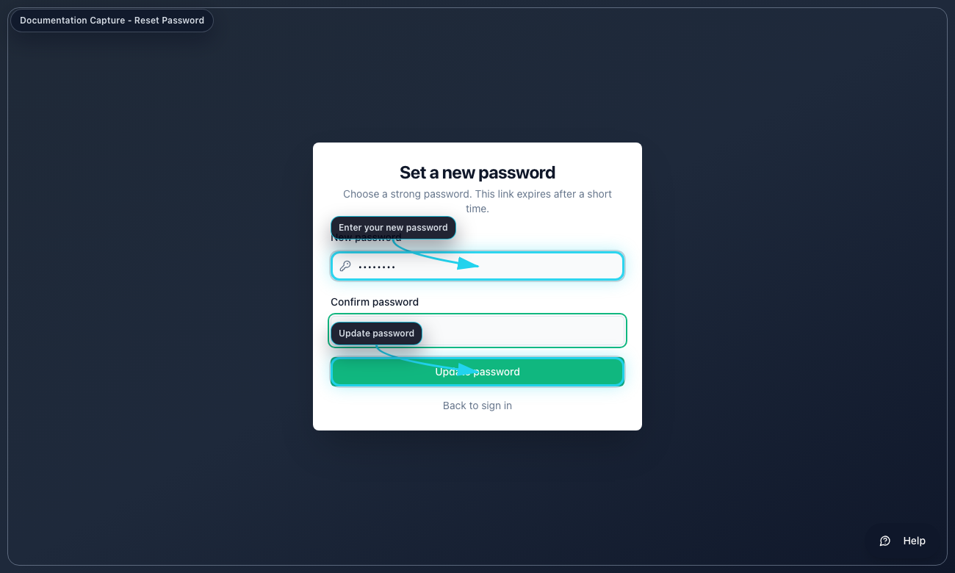
Reset password (password-reset-password.png)

3. Core Procedures
Procedure A - Request QR inventory
1. Open QR Requests.
2. Enter quantity and optional note.
3. Submit request.
4. Track decision from Super Admin.
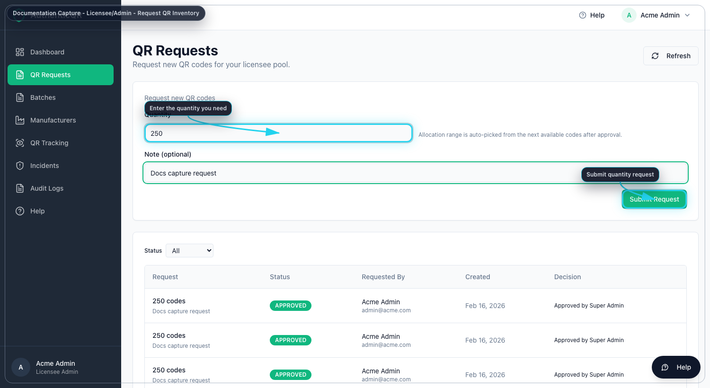
QR inventory request (licensee-request-qr-inventory.png)
Procedure B - Create manufacturer account
1. Open Manufacturers.
2. Select Add Manufacturer.
3. Enter contact and login details.
4. Send invite.
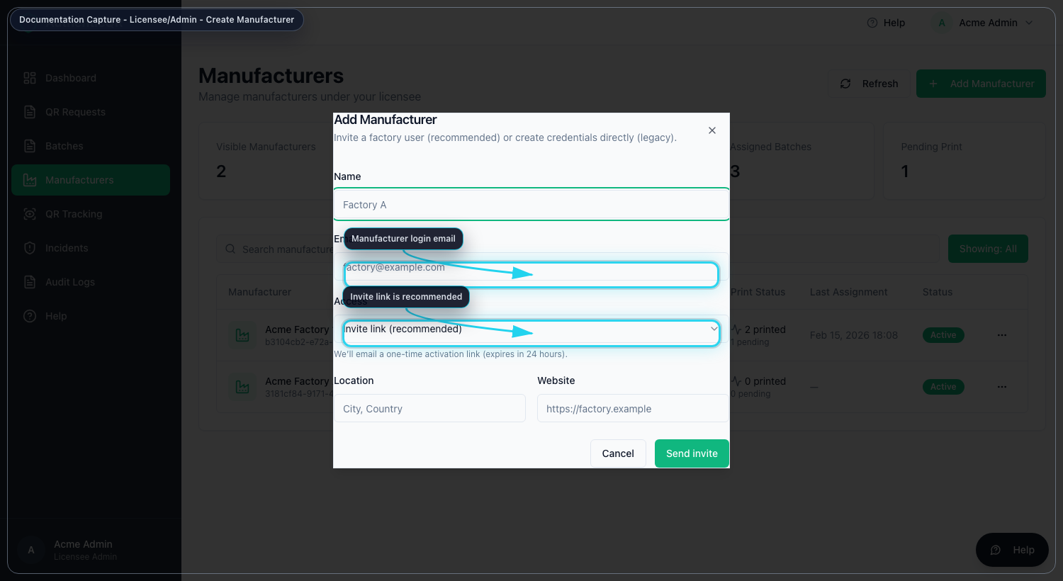
Manufacturer onboarding (licensee-create-manufacturer.png)
Procedure C - Assign received batch
1. Open Batches.
2. Open Actions for a received batch.
3. Choose Assign Manufacturer.
4. Set quantity and confirm.
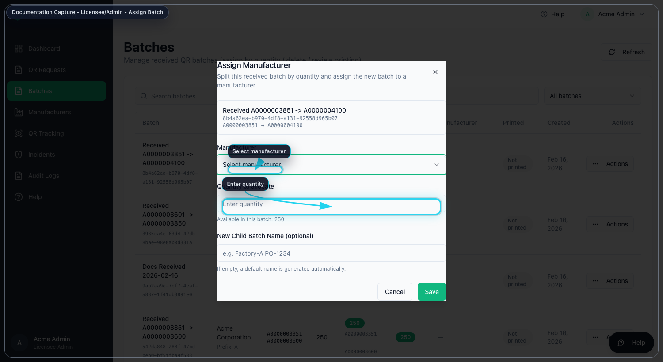
Batch assignment (licensee-assign-batch.png)

4. Troubleshooting
- If quantity fails, reduce assignment to available balance.
- If manufacturer cannot see a batch, confirm assignment and account status.
- If request is not visible, refresh QR Requests and verify filter.

Control Notes
- Use only organization-approved accounts and devices.
- Do not share credentials or one-time links.
- Record incidents and corrective actions in system logs.
- If an operation fails, capture timestamp, role, and page before escalation.

