AuthenticQR - Manufacturer User Manual
Document Type: User Operating Procedure
Audience: Manufacturer (factory user)
Version: 1.0
Last Updated: 2026-02-16

1. Purpose
This manual defines print workflow controls for assigned batches, secure ZIP download, and printed-status confirmation.

2. Access and Password
- Account provisioning: invited by licensee admin or super admin.
- Use invite link for initial password setup.
- Use Forgot Password when needed.
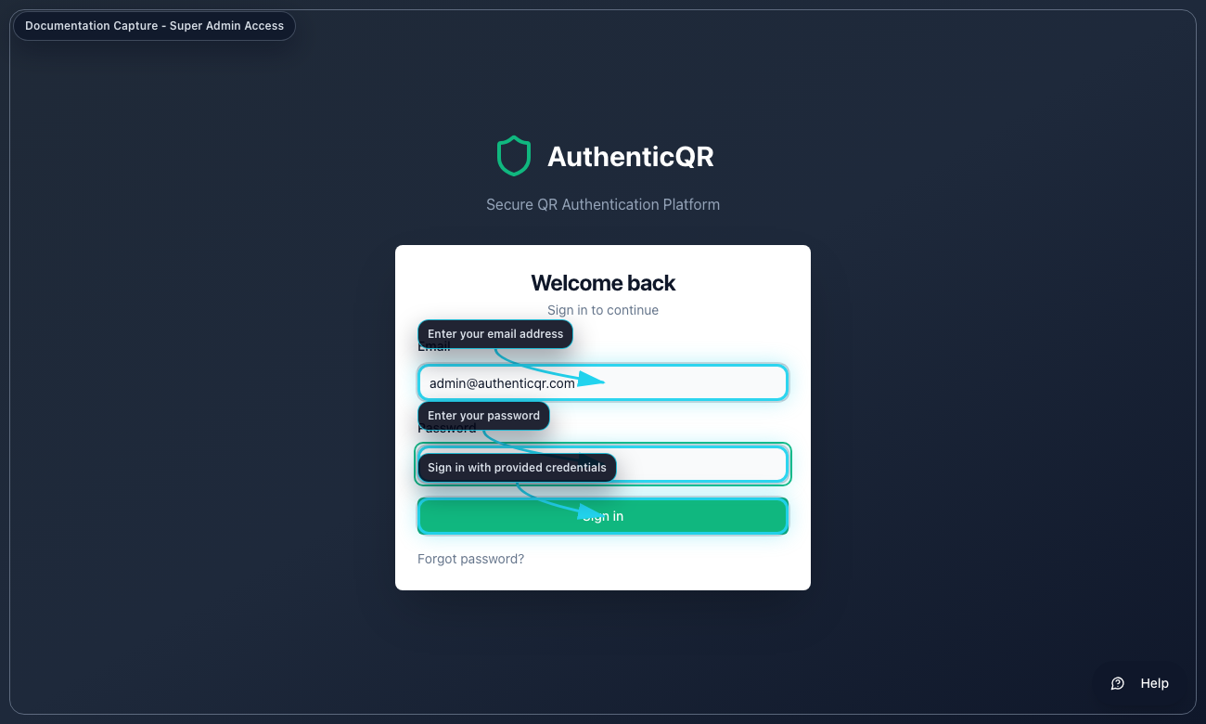
Sign in page (access-super-admin-login.png)

3. Print Workflow
Procedure A - Create print job
1. Open Batches.
2. Select Create Print Job on assigned batch.
3. Enter quantity to print.
4. Generate print job.
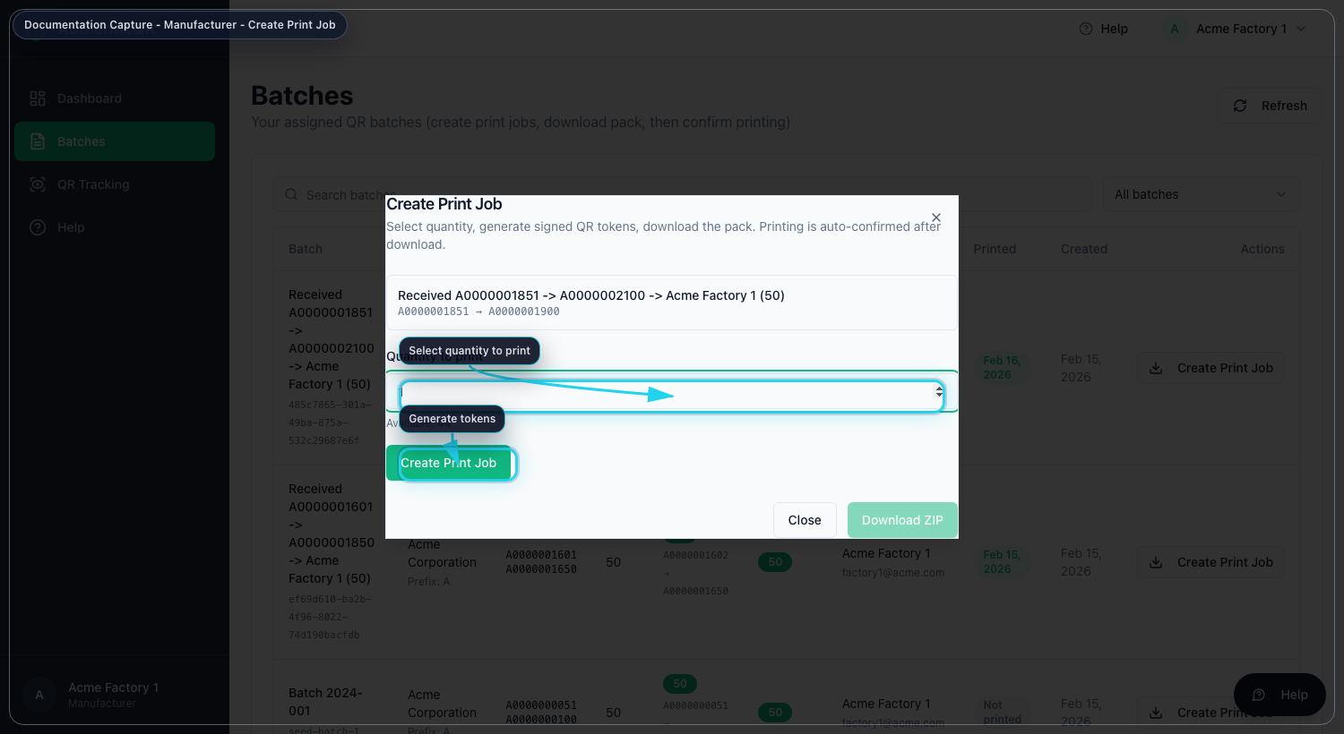
Create print job (manufacturer-create-print-job.png)
Procedure B - Download secure print pack
1. After job creation, select Download ZIP.
2. Store ZIP in controlled print environment.
3. Print labels for approved quantity only.
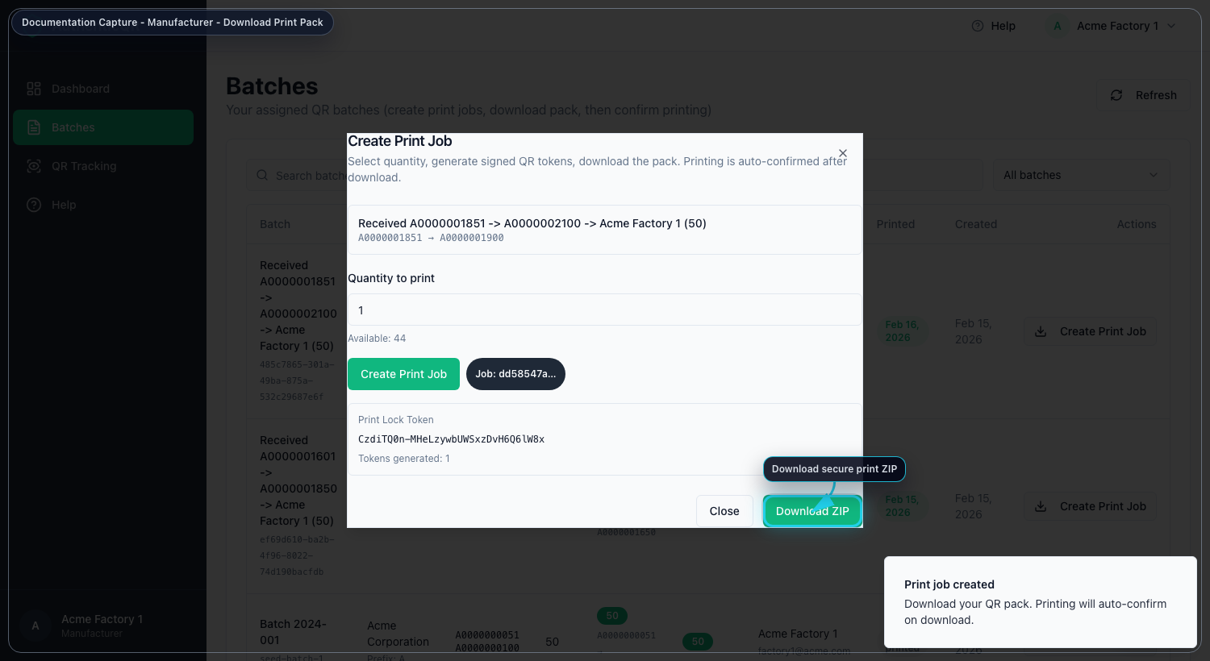
Download secure print pack (manufacturer-download-print-pack.png)
Procedure C - Verify print status
1. Return to Batches list.
2. Confirm printed status is updated.
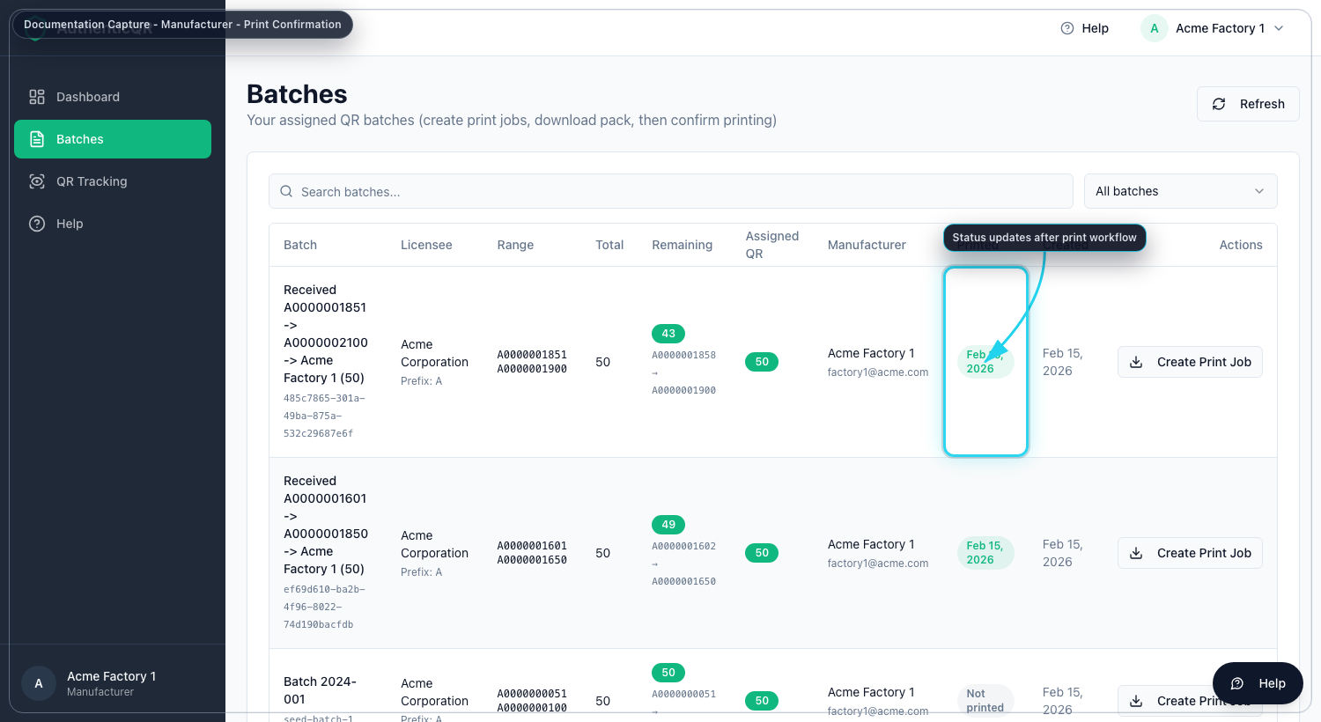
Print status confirmation (manufacturer-print-status.png)

4. Troubleshooting
- If Create Print Job is unavailable, confirm batch is assigned to your account.
- If download is blocked, generate a new print job for remaining quantity.
- If status does not update, refresh and escalate with batch ID and time.

Control Notes
- Use only organization-approved accounts and devices.
- Do not share credentials or one-time links.
- Record incidents and corrective actions in system logs.
- If an operation fails, capture timestamp, role, and page before escalation.

