AuthenticQR - Super Admin User Manual
Document Type: User Operating Procedure
Audience: Platform Super Admin
Version: 1.0
Last Updated: 2026-02-16

1. Purpose
This manual defines the operational procedure for platform-level administration, tenant onboarding, QR request approvals, and incident response.

2. Access and Account Setup
- Account provisioning: created by platform owner or existing platform super admin.
- First sign-in: use assigned credentials at /login.
- Password recovery: use Forgot Password if enabled for your account.
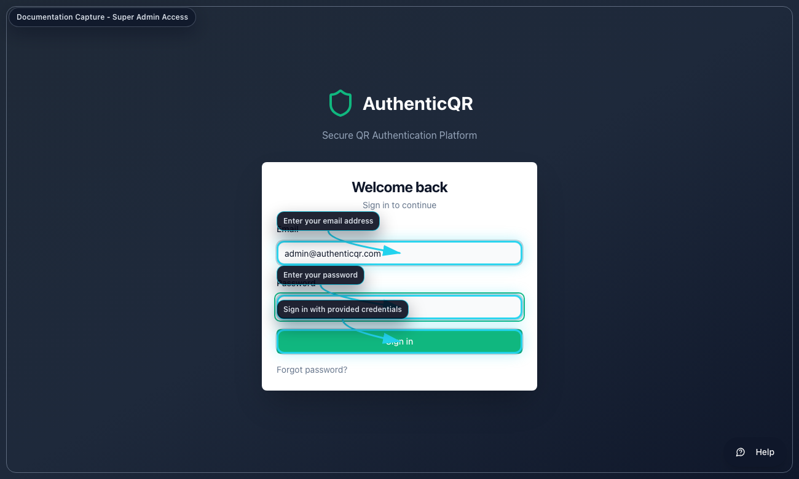
Sign in page (access-super-admin-login.png)

3. Core Procedures
Procedure A - Create a licensee organization
1. Open Licensees.
2. Select Add Licensee.
3. Enter licensee profile and admin details.
4. Submit and verify tenant appears in the list.
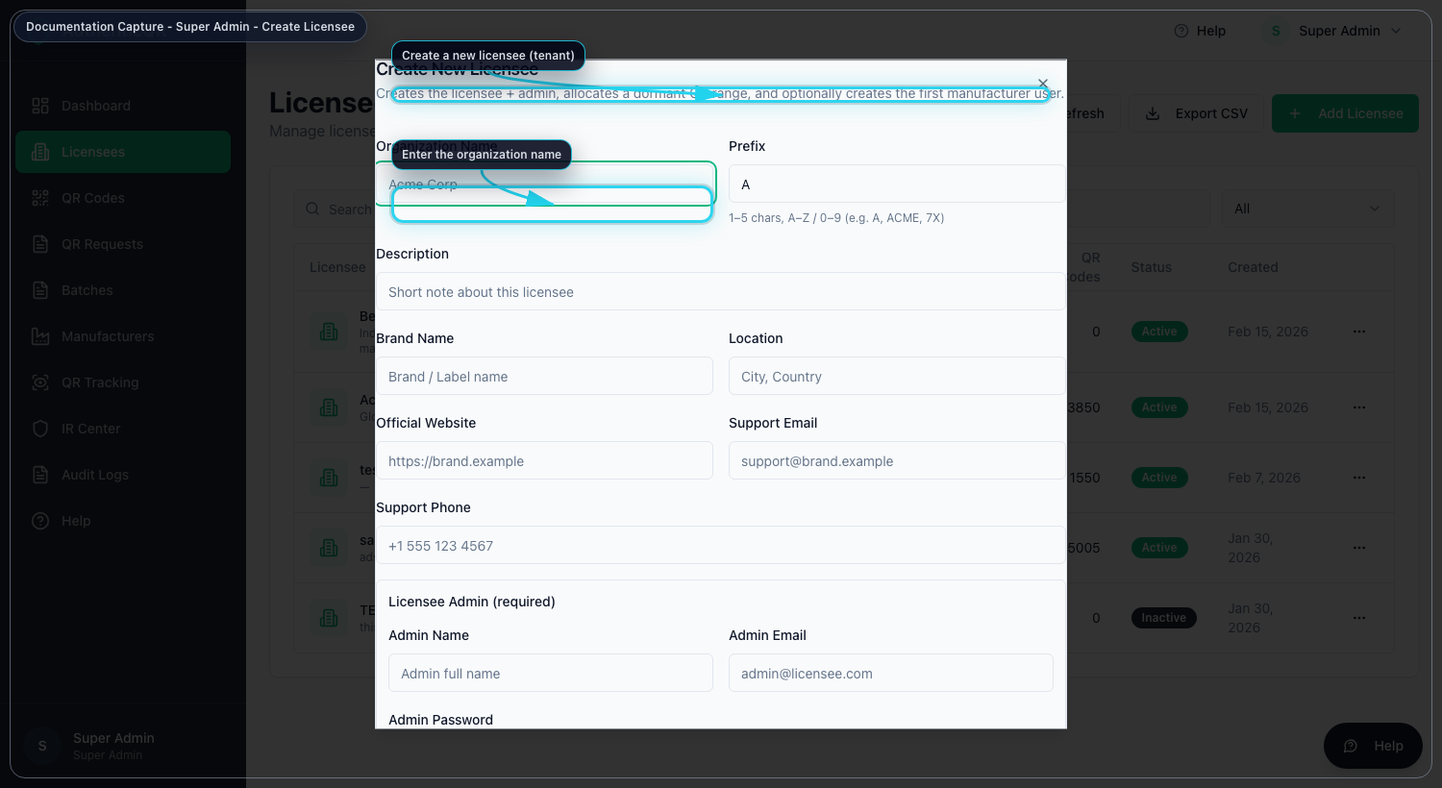
Create licensee flow (superadmin-create-licensee.png)
Procedure B - Approve QR inventory requests
1. Open QR Requests.
2. Filter by Pending.
3. Review quantity and decision note.
4. Approve or Reject.
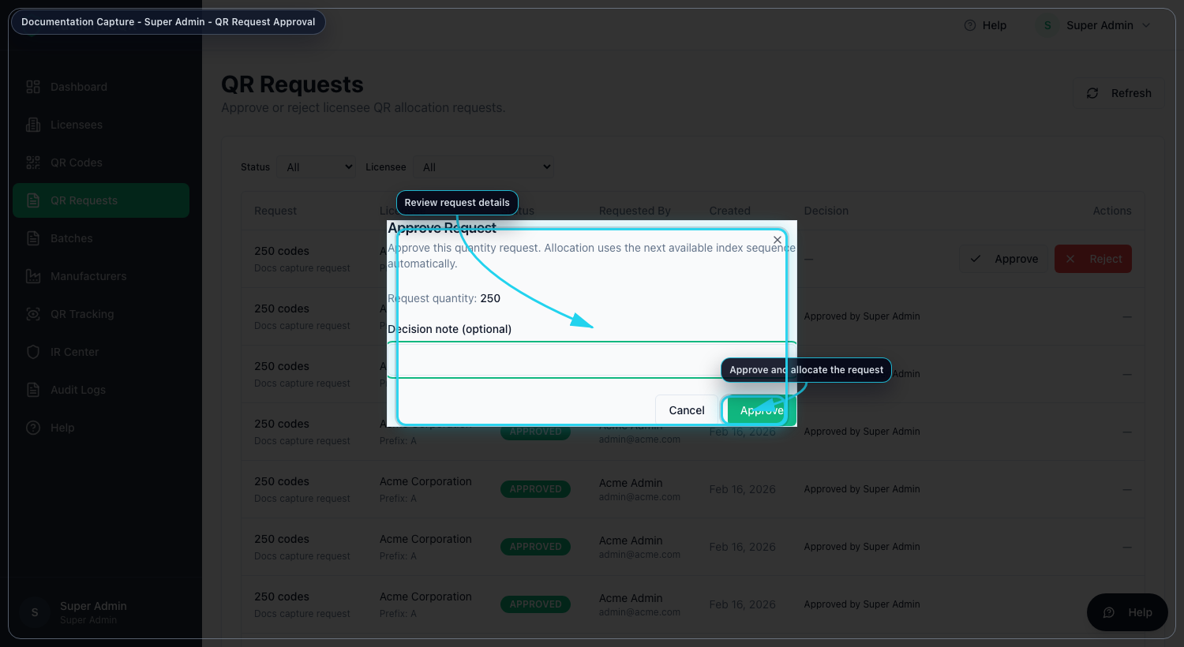
QR request approval (superadmin-approve-qr-request.png)
Procedure C - Incident Response operations
1. Open IR Center.
2. Review Alerts and Incidents.
3. Assign owner, severity, and priority.
4. Apply containment action only with reason.
5. Track communications and closure notes.
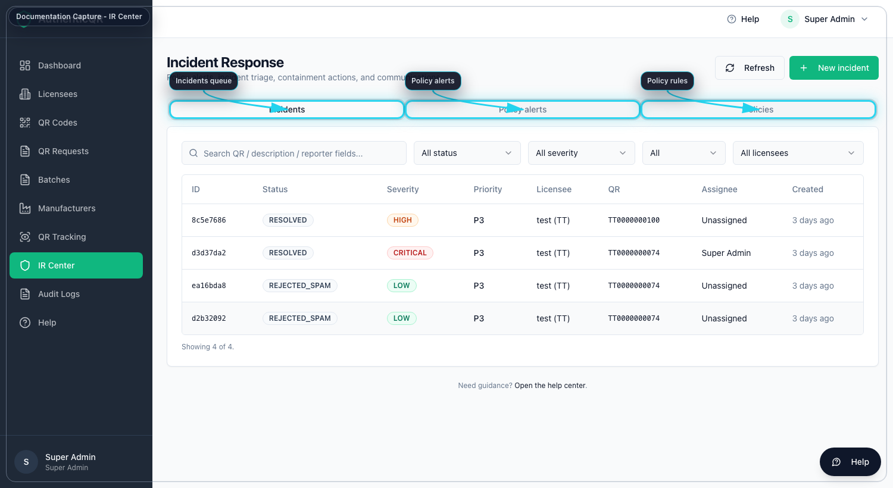
IR dashboard (ir-dashboard.png)
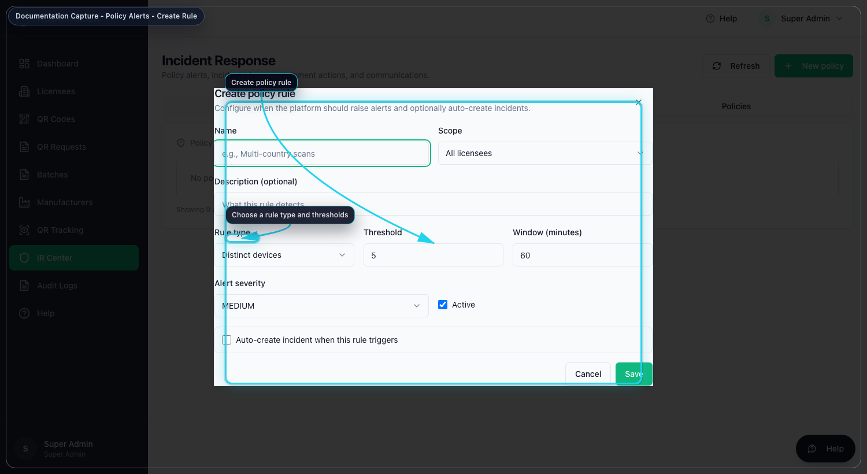
Policy rule creation (ir-policy-create.png)
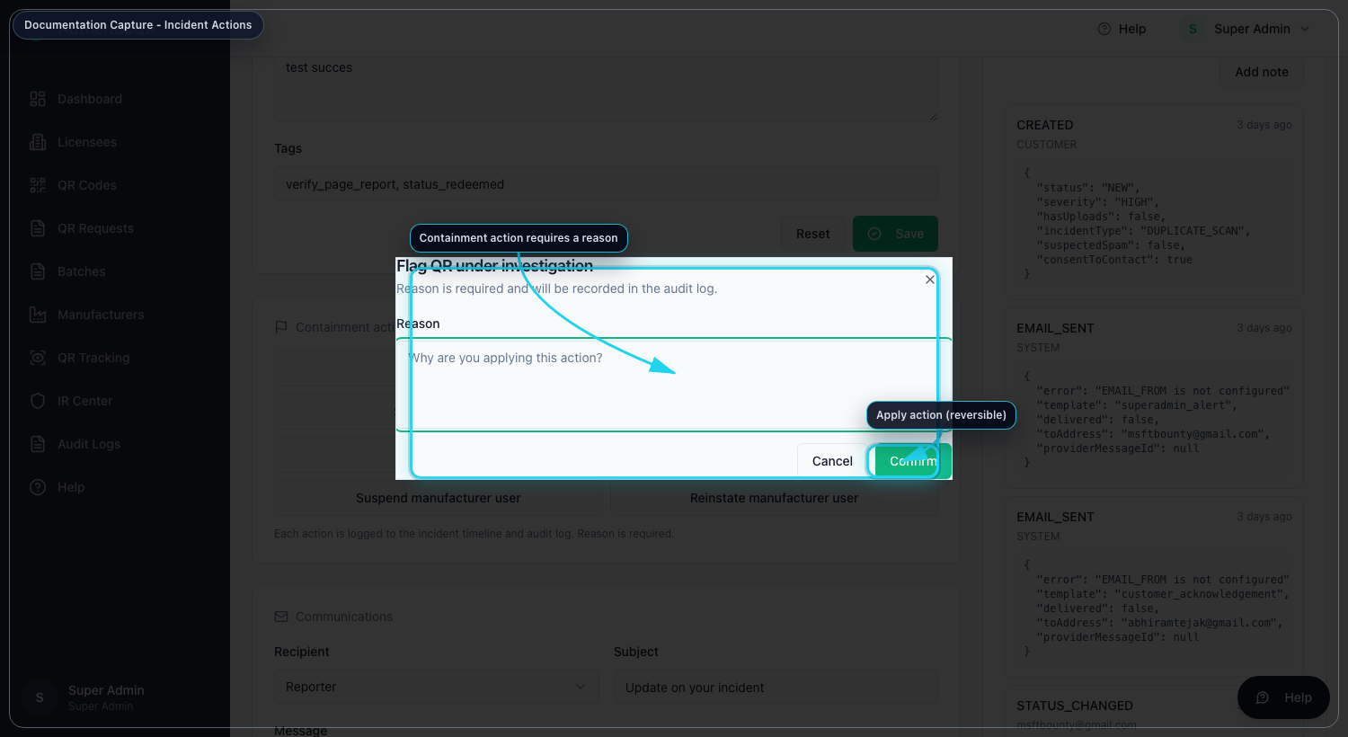
Containment actions (ir-incident-actions.png)
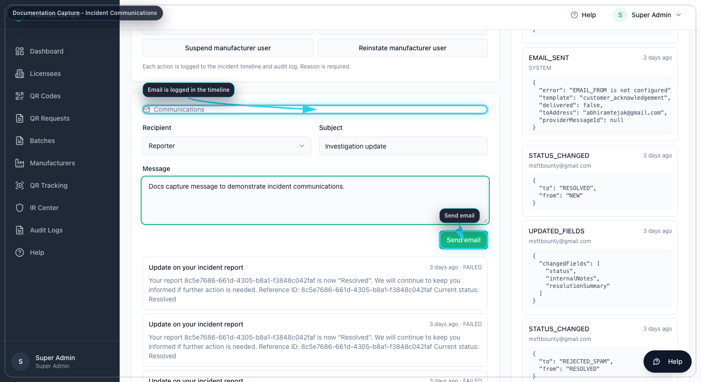
Incident communications (ir-communication-compose.png)

4. Troubleshooting
- If approval controls are missing, verify role is Platform Super Admin.
- If IR actions fail, check incident status and required reason fields.
- If email send fails, verify SMTP and sender configuration.

Control Notes
- Use only organization-approved accounts and devices.
- Do not share credentials or one-time links.
- Record incidents and corrective actions in system logs.
- If an operation fails, capture timestamp, role, and page before escalation.

