AuthenticQR (MSCQR) Licensee Admin User Manual

Document ID: AQR-SOP-LA-002
Version: 2.0
Last Updated: 2026-03-10

1. Purpose
This manual is the current operating guide for the Licensee Admin role. It is written so a Licensee Admin can:
- activate an invited account
- sign in without outside knowledge
- understand every menu item available to the role
- request, assign, trace, and review QR activity in the correct order

2. Current Licensee Admin Navigation
After sign-in, the left menu shows:
- Dashboard
- QR Requests
- Batches
- Manufacturers
- QR Tracking
- Audit Logs

The top-right controls show:
- notification bell
- Support issue reporter
- Help
- user menu with Account and Log out

3. Access, Onboarding, and Sign-In

3.1 First-time access from an invite
1. Open the invite link from email.
2. On Activate your account, enter your name if required.
3. Enter a password with at least 8 characters.
4. Enter the same password again in Confirm password.
5. Select Activate account.
6. Wait for the redirect to the dashboard.

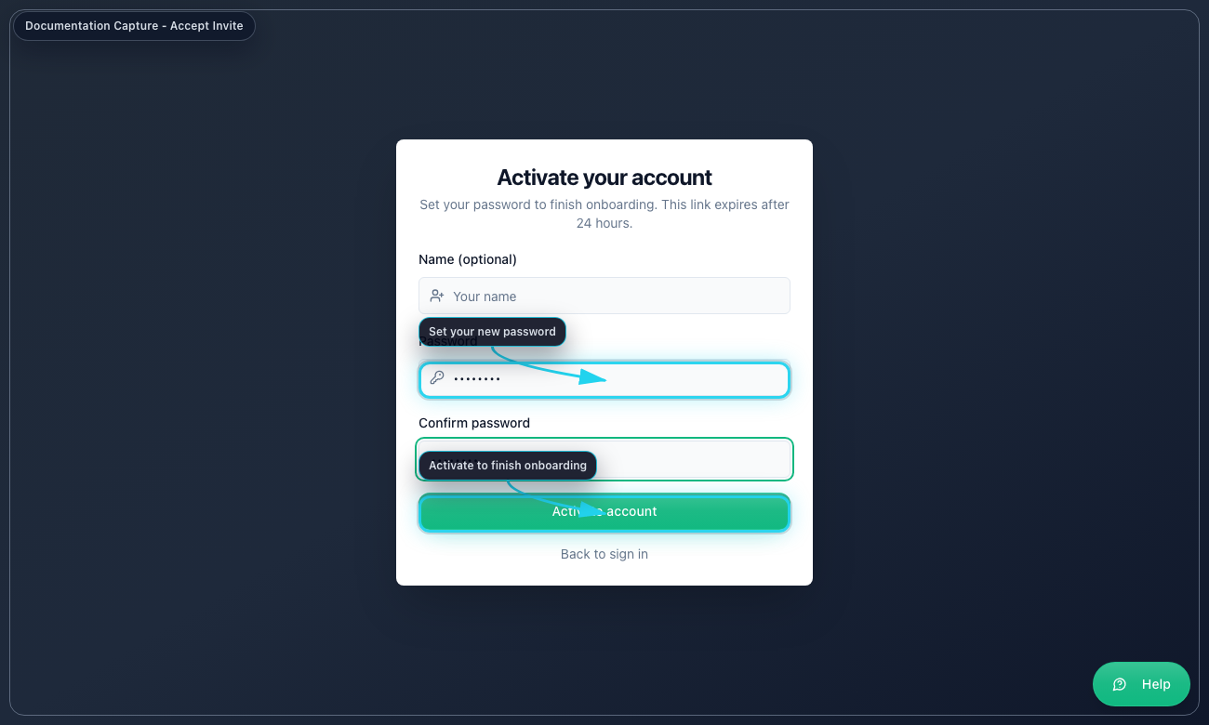
Accept Invite

3.2 Standard sign-in
1. Open the login page.
2. Enter your email address.
3. Enter your password.
4. Select Sign in.
5. If MFA is requested, enter the 6-digit code or backup code.
6. Select Verify MFA.
7. Confirm the left menu matches the items listed in Section 2.

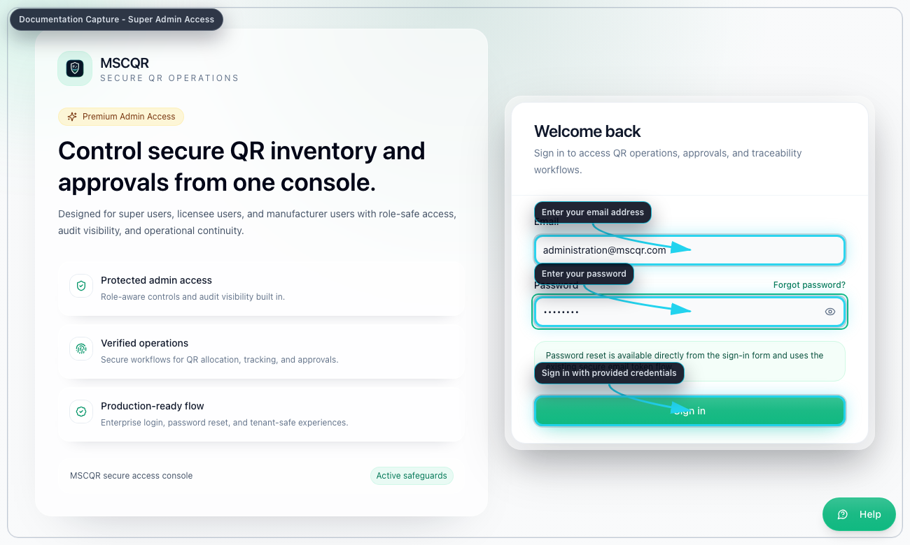
Licensee Login

3.3 Forgot password
1. On the login page, select Forgot password?
2. Enter your email address.
3. Select Send reset link.
4. Open the reset email.
5. Enter the new password twice.
6. Select Update password.
7. Return to login and sign in again.

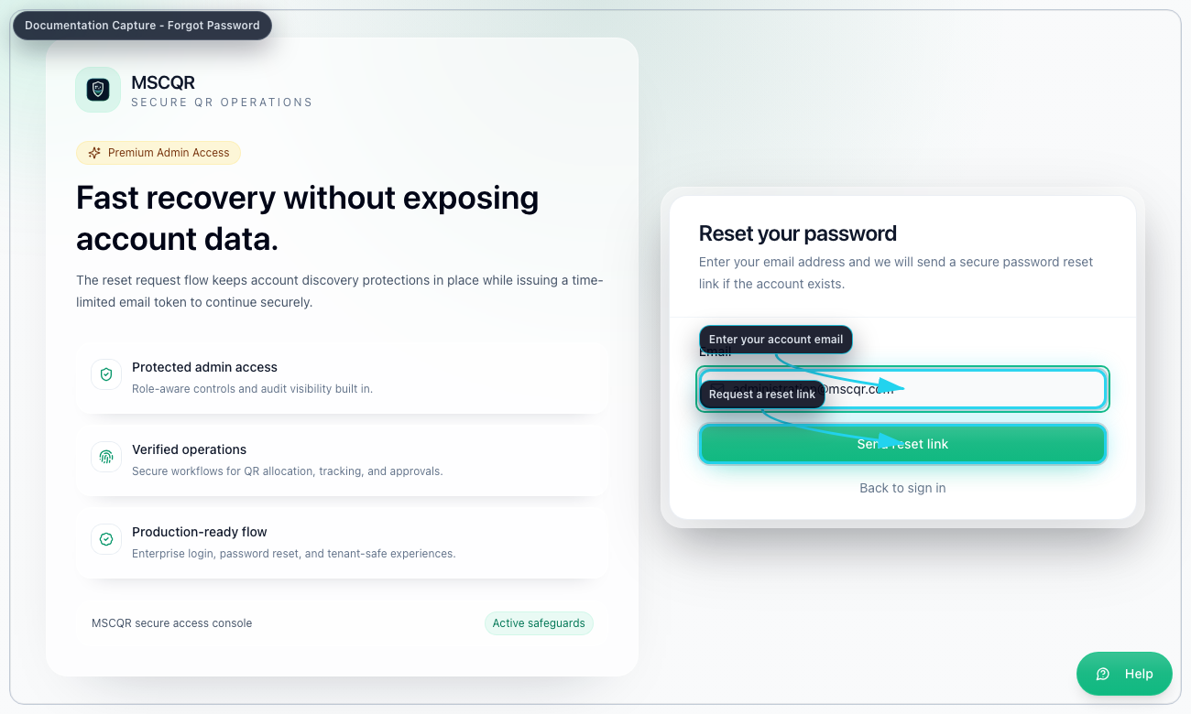
Forgot Password

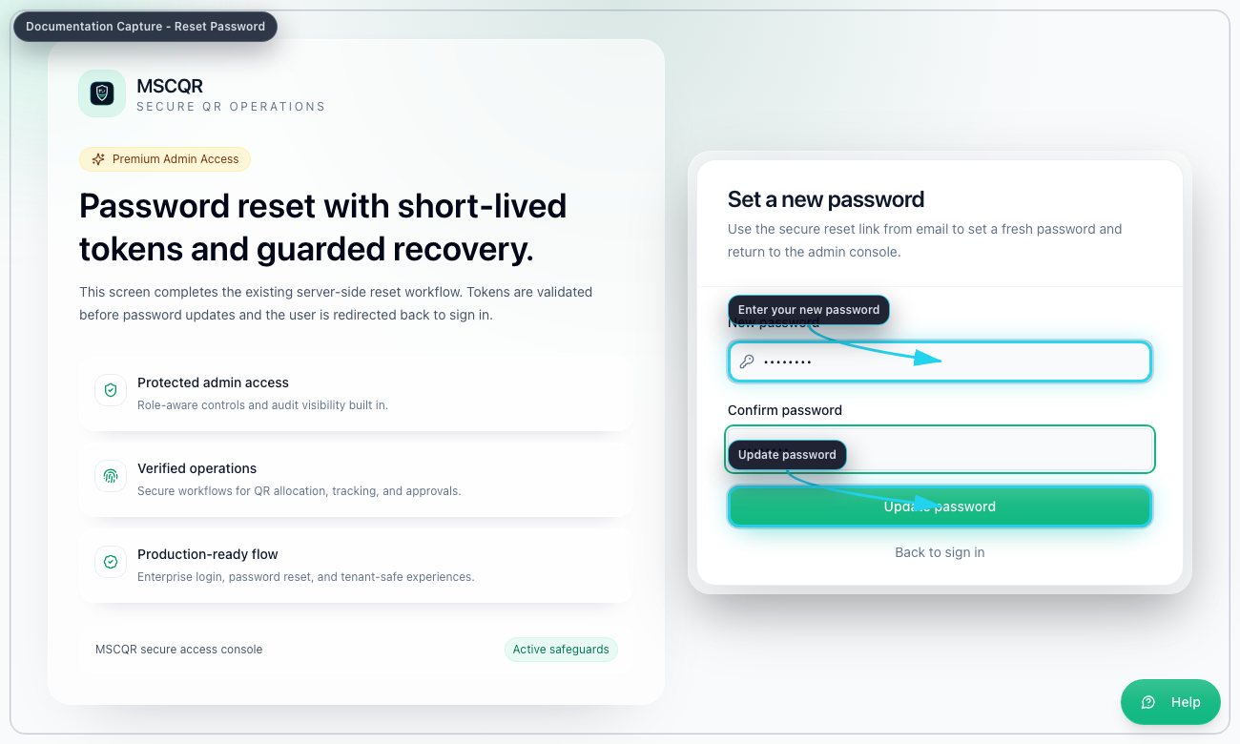
Reset Password

4. Common User Menu and Page Controls

4.1 Notification bell
Use the bell to open live notifications. Select a notification to open the linked record or page.

4.2 Support issue reporter
Select Support in the top bar when you need to report an application issue to Super Admin.

Use it in this order:
1. Open the problem page first so the screenshot shows the right state.
2. Select Support.
3. Enter a short summary.
4. Describe what you were trying to do.
5. Review the auto-captured screenshot and diagnostics.
6. Select Send report.

4.3 Help
Select Help to open the contextual help page for the current screen.

4.4 Account and log out
Open the user menu to:
- select Account and update your profile or password
- select Log out and end the session

5. Dashboard
Purpose: see your organization scope before requesting or assigning stock.

Use Dashboard to:
- review QR totals for your organization
- review unassigned inventory
- inspect recent audit activity
- jump quickly to Batches, Manufacturers, QR Requests, or QR Tracking

Recommended order:
1. Open Dashboard.
2. Check whether unassigned inventory already exists.
3. Review recent activity for unexpected assignments or prints.
4. Move to QR Requests only if more stock is required.

6. QR Requests
Purpose: request new QR inventory for your organization.

6.1 Submit a new request
1. Open QR Requests.
2. Enter the Quantity required.
3. Enter Batch name. This becomes the received batch name after approval.
4. Enter an optional note.
5. Select Submit Request.
6. Wait for Super Admin approval.

Result after approval:
- the next available QR sequence is allocated automatically
- the approved request appears in your batch inventory as a received source batch

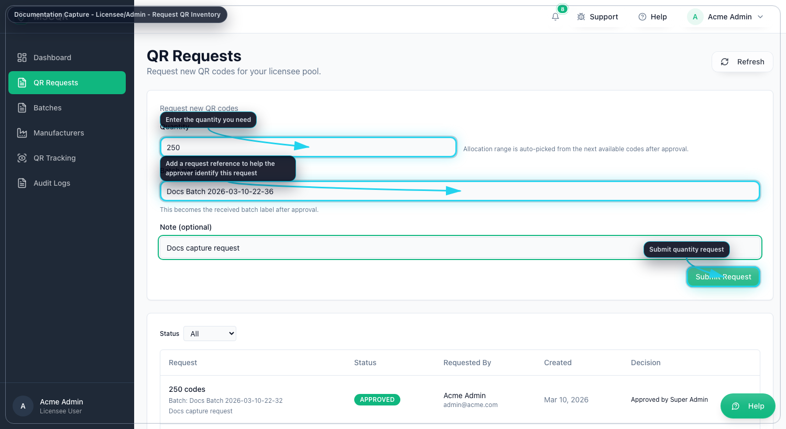
Request QR Inventory

6.2 Track request status
1. Stay on QR Requests.
2. Filter by Status.
3. Review the request row for quantity, batch name, requester, created date, and decision details.

7. Batches
Purpose: manage received source batches and assign controlled quantities to manufacturers.

7.1 Understand the Batches page
For Licensee Admin, the main table shows one stable row for each source batch. You do not manage split allocations from the main list. You open the workspace and work inside the three tabs:
- Overview
- Operations
- Audit

7.2 Open the source batch workspace
1. Open Batches.
2. Search for the source batch or use the assignment filter.
3. Select Open.
4. Work from the workspace instead of trying to manage splits from the main list.

7.3 Review the source batch in Overview
Use Overview to confirm:
- original QR quantity
- remaining unassigned quantity
- assigned quantity by manufacturer
- print progress
- redeemed and blocked counts
- source batch identifiers and dates

7.4 Allocate quantity to a manufacturer in Operations
1. Open the source batch workspace.
2. Open Operations.
3. In Allocate to manufacturer, select the manufacturer.
4. Enter Quantity to allocate.
5. Check the remaining balance shown by the system.
6. Select Allocate quantity.

7.5 Use the other Operations actions
Inside the same workspace you can:
- Rename source batch
- View allocation structure
- Download audit package

7.6 Review trace history in Audit
1. Open the workspace.
2. Select Audit.
3. Review commissioned, assigned, printed, redeemed, and blocked events.
4. Select Refresh history if a recent assignment is missing.

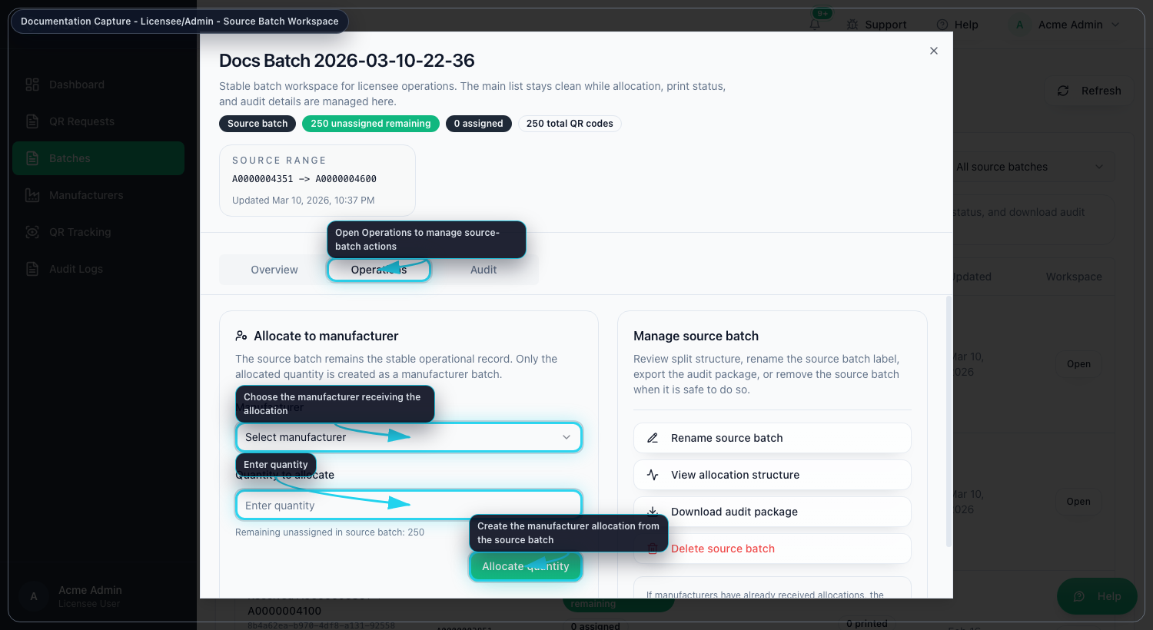
Batch Workspace Operations

8. Manufacturers
Purpose: invite and manage manufacturer users for your organization.

8.1 Add a manufacturer
1. Open Manufacturers.
2. Select Add Manufacturer.
3. Enter the manufacturer name and email.
4. Enter location and website if required.
5. Select Send invite.
6. If the user cannot find the email, ask Super Admin to verify delivery settings or resend the invite later.

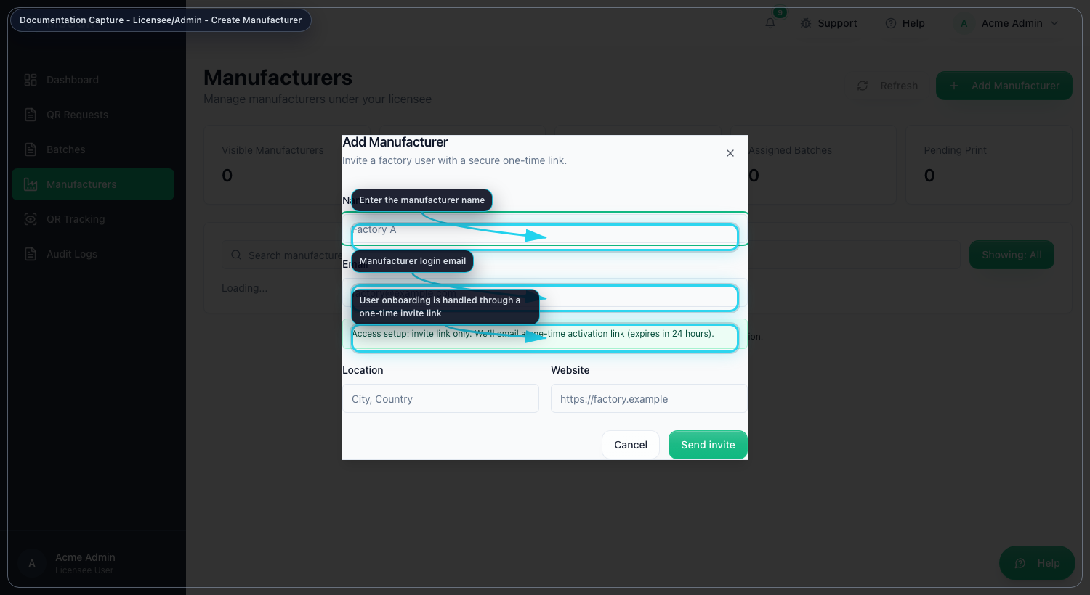
Create Manufacturer

8.2 Review manufacturer workload
Use Manufacturers to review:
- assigned batch totals
- pending print totals
- printed batch totals
- last assignment time
- active or inactive status

8.3 Open a manufacturer’s assigned batches
You can open workload directly in three ways:
1. Select Open manufacturer batches.
2. Select the printed chip to jump to printed work.
3. Select the pending chip to jump to pending print work.

8.4 View manufacturer details
1. Select View details.
2. Review the profile, assigned totals, and recent batches.
3. Use Open manufacturer batches from the dialog if you need the batch list immediately.

8.5 Deactivate or restore a manufacturer
1. Open the action menu for the manufacturer.
2. Select Deactivate or Restore.
3. Confirm the action.

9. QR Tracking
Purpose: inspect scan events and lifecycle state inside your own organization scope.

9.1 Filter results
1. Open QR Tracking.
2. Enter one or more filters:
QR code, batch ID or batch name, status, first-scan filter, and date range.
3. Select Apply filters.
4. Review the scope cards, batch summary, and scan logs.

9.2 Review allocation context before escalating
1. Find the batch in the summary table.
2. Select Open allocation map.
3. Confirm how the source batch was split before assuming stock is missing.

10. Audit Logs
Purpose: review live operational history for your organization.

10.1 Review the log stream
1. Open Audit Logs.
2. Leave the page in LIVE mode when you want realtime updates.
3. Use Pause when you want the list to stop moving.
4. Search by batch, user, or event data.
5. Filter by action type.
6. Expand details when you need entity IDs or full payload fields.

Use this page to confirm:
- request submission
- manufacturer assignment
- print events
- verification outcomes
- incident-related updates that are visible to your scope

11. Correct Working Order for Everyday Use
Use this sequence for normal operations:
1. Check Dashboard for current stock and recent events.
2. If more stock is needed, submit the request in QR Requests.
3. When approved stock arrives, open Batches.
4. Allocate only the required quantity to each manufacturer.
5. Use Manufacturers to review pending or printed workload.
6. Use QR Tracking when you need scan-level investigation.
7. Use Audit Logs to confirm exactly what happened and when.

12. Troubleshooting
- If a manufacturer cannot see a batch, open Manufacturers, review the manufacturer details, and then open their batches directly.
- If Allocate quantity fails, re-open the source batch workspace and check the remaining unassigned amount shown there.
- If request status looks wrong, refresh QR Requests and check the status filter.
- If audit history looks incomplete, use Refresh history inside the batch workspace before escalating.
- If the app misbehaves, use the top-bar Support reporter so diagnostics and a screenshot are captured automatically.

13. Mandatory Compliance Statements

13.1 UK GDPR and Data Protection
MSCQR processes personal data in accordance with UK GDPR and the Data Protection Act 2018. Data protection queries must be directed to administration@mscqr.com.

13.2 Security and Access Control
Access control is role-based for Super Admin, Licensee Admin, and Manufacturer users. Communication is encrypted over HTTPS, passwords are handled using secure controls, and critical actions are recorded in audit logs.

13.3 Incident Response and Fraud Reporting
The controlled process is: report intake -> review -> containment -> documentation -> resolution.

13.4 QR Code Usage and Non-Duplication
All QR codes are unique, traceable, and single-use where applicable. QR codes must not be duplicated, altered, or reused.

13.5 Audit Logging Notice
Administrative actions, QR allocations, fraud reports, and login attempts are logged and retained for 180 days.

13.6 Acceptable Use
Unauthorized access, reverse engineering, misuse of fraud reporting, or interference with system security is prohibited.

13.7 Hosting and Disclaimer
The platform is hosted via AWS Lightsail and Amazon RDS with reasonable security controls and is provided on a best-effort basis.

