MSCQR Customer Verification User Manual

Audience: Customer / Product Verifier
Website manual: https://www.mscqr.com/help/customer
Last updated: May 4, 2026

Purpose
Use this manual to check a garment QR label with the current MSCQR public verification page. It explains how to start a check, read the result, and report a concern.

Access And Prerequisites
- You do not need an operator account to open the public verify page.
- You need the QR label or the printed code from the garment tag.
- Camera scanning depends on browser support. Manual code entry works on every device.
- MSCQR records scan events to help detect unusual repeated use and support investigations.

1. Start Verification
Open https://www.mscqr.com/verify, then scan the QR label or enter the code manually.

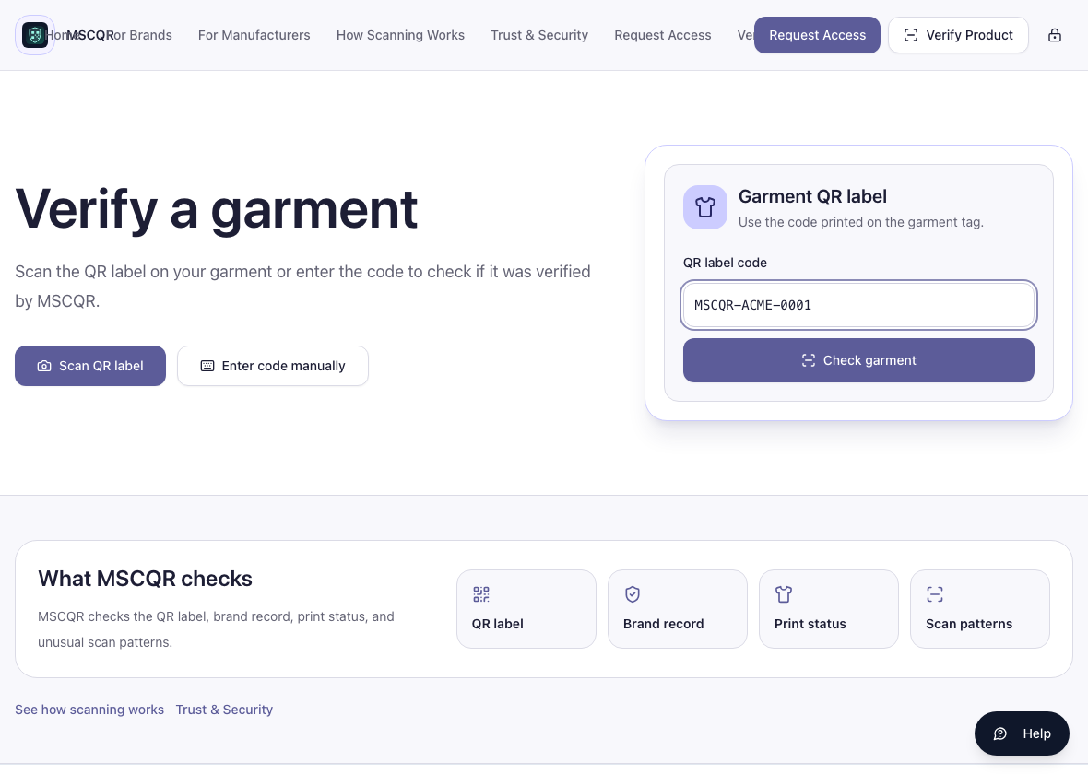
Customer verify start

Steps:
1. Select Scan QR label if your device and browser support camera capture.
2. Or select Enter code manually and type the code printed on the garment tag.
3. Select Check garment.
4. Wait for the result page.

2. Read A Verified Result
A normal successful result appears as This garment is genuine with Verified by MSCQR.

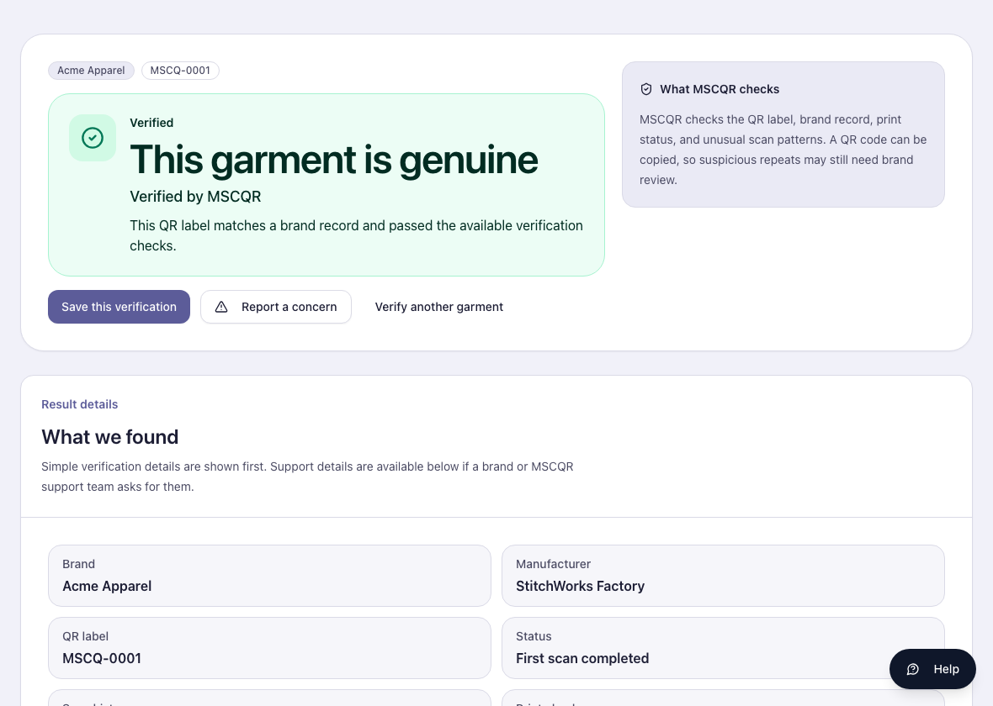
Customer verified result

Read the page in this order:
1. Main result banner.
2. Result details.
3. Brand and manufacturer details.
4. Scan summary.
5. Support contact.

3. Read A Repeat Verification
A repeat check can still show a successful result when the scan pattern looks normal.

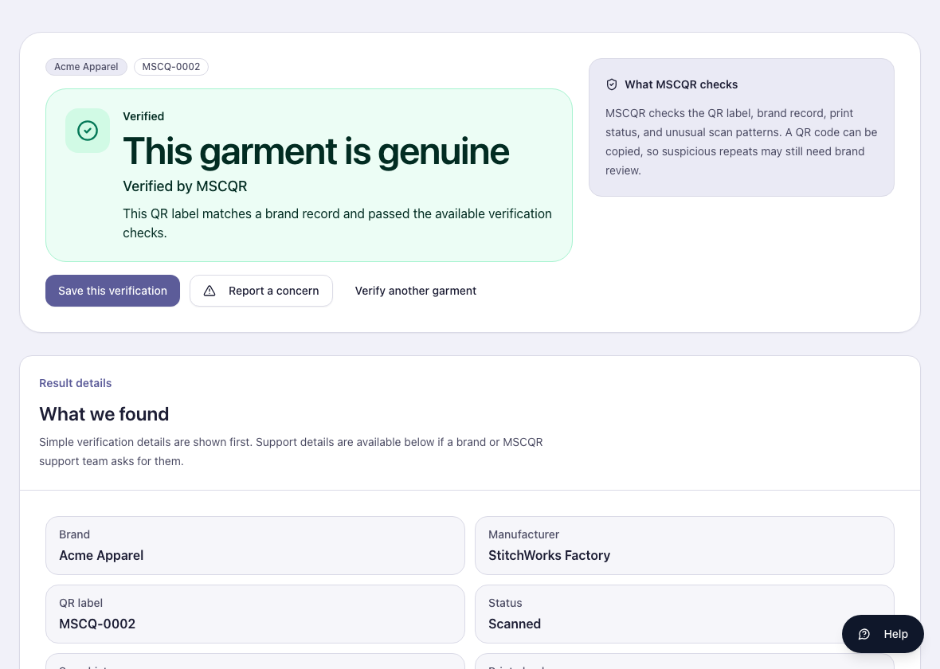
Customer repeat result

A repeat result means the code has been checked before. This can be normal, especially if you scan your own product again. Review the scan summary if you want more context.

4. Read A Review-Required Result
If MSCQR cannot fully verify the item, the page shows a review-needed result.

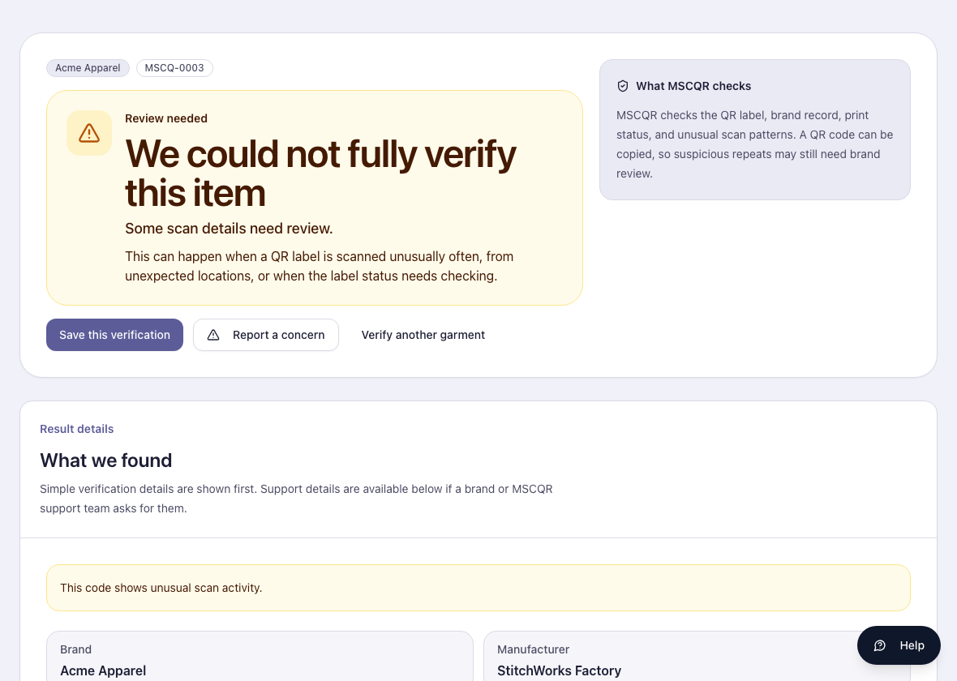
Customer review-required result

This does not automatically prove the product is fake. It means the scan details need review before you rely on the result.

Check:
- whether the label or packaging looks altered
- whether the seller details match the product
- whether the scan summary shows unusual activity
- whether the brand support details are available

5. Report A Concern
Use Report a concern if the product, seller, label, or result looks suspicious.

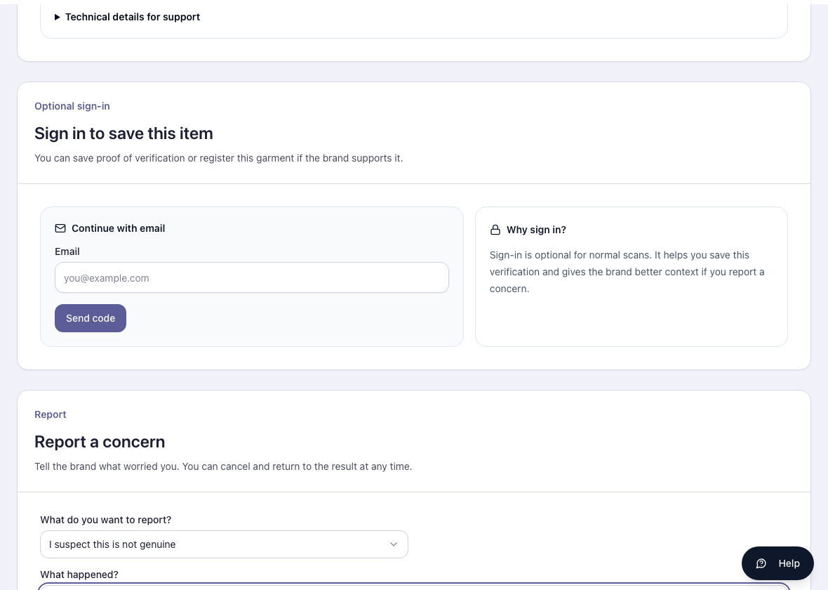
Customer report concern

Steps:
1. Select Report a concern.
2. Choose the reason that best matches the issue.
3. Describe what happened.
4. Submit the concern.
5. Keep any support reference shown by MSCQR.

What To Do If Something Looks Wrong
- Code not found: check the printed code and try again. Report a concern if the tag looks suspicious.
- Camera scan fails: enter the code manually.
- Review-needed result: do not rely on the item until you review the details or contact the brand.
- Service unavailable: retry later or contact the brand support shown on the page.
- You submitted a concern: keep the support reference for follow-up.

Glossary
- QR label: the MSCQR code printed on the garment tag.
- Manual code entry: typing the printed code instead of scanning.
- Scan summary: a record of first and latest verification activity shown to help you understand the result.
- Review-needed result: MSCQR needs the brand or support team to review unusual scan details.
- Support reference: the case reference returned after submitting a concern.

CTO Recommendations
- Next best feature: add a customer-safe downloadable verification receipt.
- Security hardening: add abuse-resistant concern reporting with stronger rate-limit feedback and attachment scanning.
- Scalability: add localized customer manual pages for the main regions where MSCQR garments are sold.

