MSCQR Licensee Admin User Manual

Audience: Licensee Admin / Brand Admin
Website manual: https://www.mscqr.com/help/licensee-admin
Last updated: May 4, 2026

Purpose
Use this manual to operate the current MSCQR Licensee Admin workspace. It covers the workflows implemented in the current UI: signing in, checking the overview, requesting QR labels, inviting manufacturers, allocating batches, reviewing scan activity, and checking history.

Access And Prerequisites
- You need an active Licensee Admin account for your company.
- New users receive an invite link and set their password before signing in.
- Your account is scoped to your own company. You cannot see other licensees.
- Use the top-bar Help control to open the matching website manual page for the screen you are using.

1. Start From Overview
Open Overview after signing in. Confirm the current QR label totals, printed label count, scan count, and recent workspace activity before requesting more labels or assigning stock.

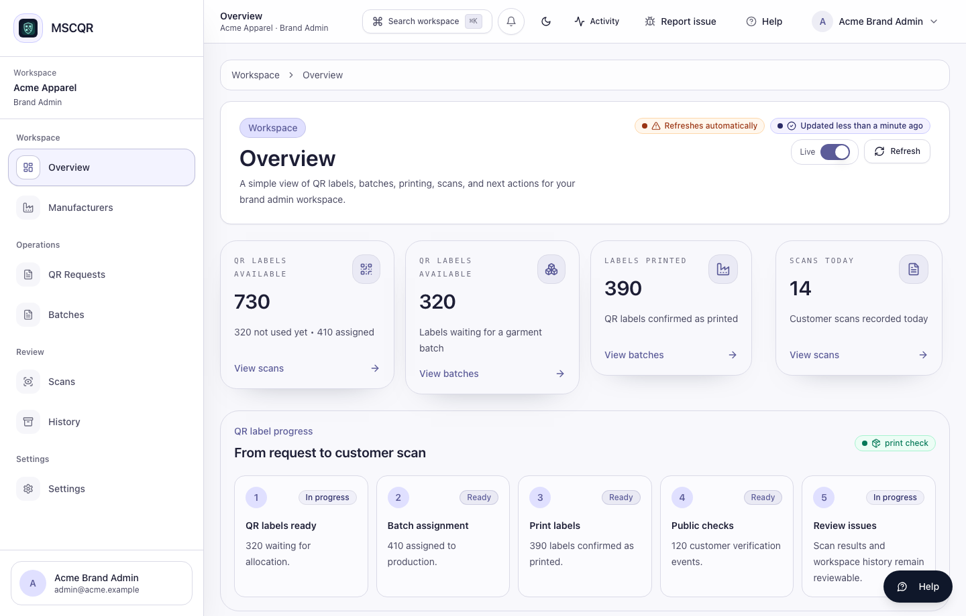
Licensee Admin overview

Recommended order:
1. Check QR labels available.
2. Check labels printed and scans today.
3. Review recent activity for unexpected changes.
4. Move to QR Requests, Batches, or Manufacturers only after confirming the current position.

2. Request QR Labels
Open QR Requests when your company needs more labels for a production run.

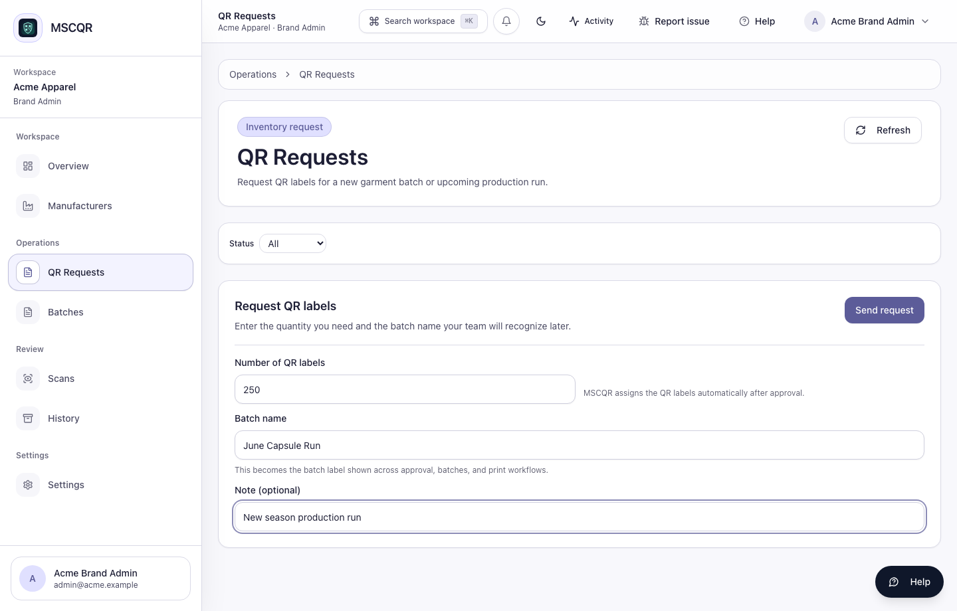
Licensee Admin QR request

Steps:
1. Enter the number of QR labels needed.
2. Enter a clear batch name that your team will recognize later.
3. Add an optional note for the approver.
4. Select Send request.
5. Track the request in the request history table.

After approval, MSCQR allocates the labels and the approved source batch appears in Batches.

3. Invite A Manufacturer
Open Manufacturers to add factory admin users who will receive assigned batches and manage printing.

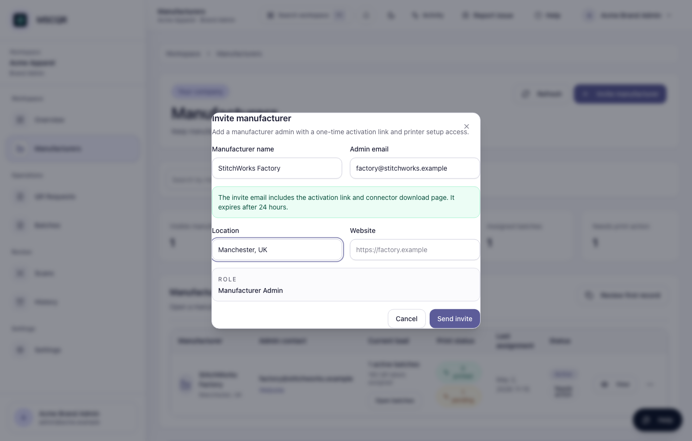
Invite manufacturer

Steps:
1. Select Invite manufacturer.
2. Enter the manufacturer name and admin email.
3. Add location and website if available.
4. Select Send invite.

The invite email includes the activation link and printer helper download page. Do not share one account across factories or users.

4. Allocate A Batch To A Manufacturer
Open Batches, then open the source batch workspace. The current UI keeps one stable row per source batch; manufacturer allocations are managed inside the workspace.

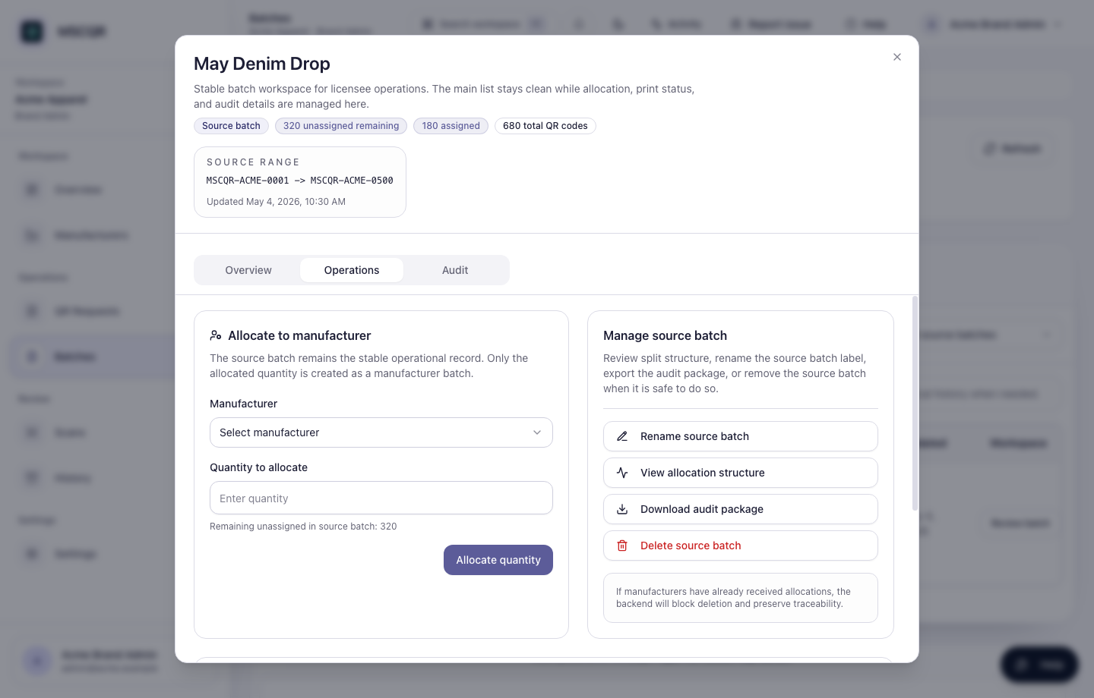
Batch workspace operations

Steps:
1. Find the approved source batch.
2. Select Open.
3. Open the Operations tab.
4. Choose the manufacturer.
5. Enter the quantity to allocate.
6. Select Allocate quantity.
7. Use Overview and Audit in the same workspace to confirm the result.

Only allocate the quantity that should move to that manufacturer now. The remaining unassigned quantity stays on the source batch.

5. Review Scan Activity
Open Scans to review verification activity for your company.

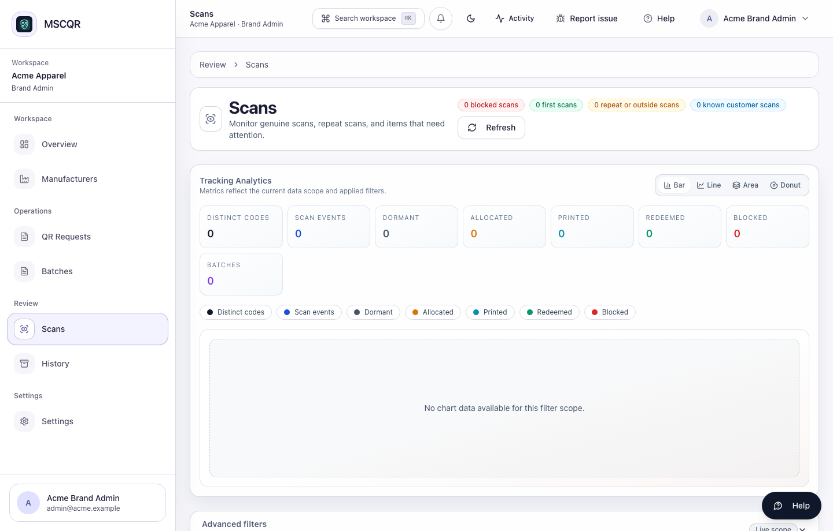
Licensee Admin scan activity

Use this page to:
- search by QR code, batch, status, or date range
- review first scans and repeated scans
- identify items that need review
- keep allocation context before escalating an issue

6. Review History
Open History to inspect workspace events such as approvals, assignments, print confirmations, and verification activity.

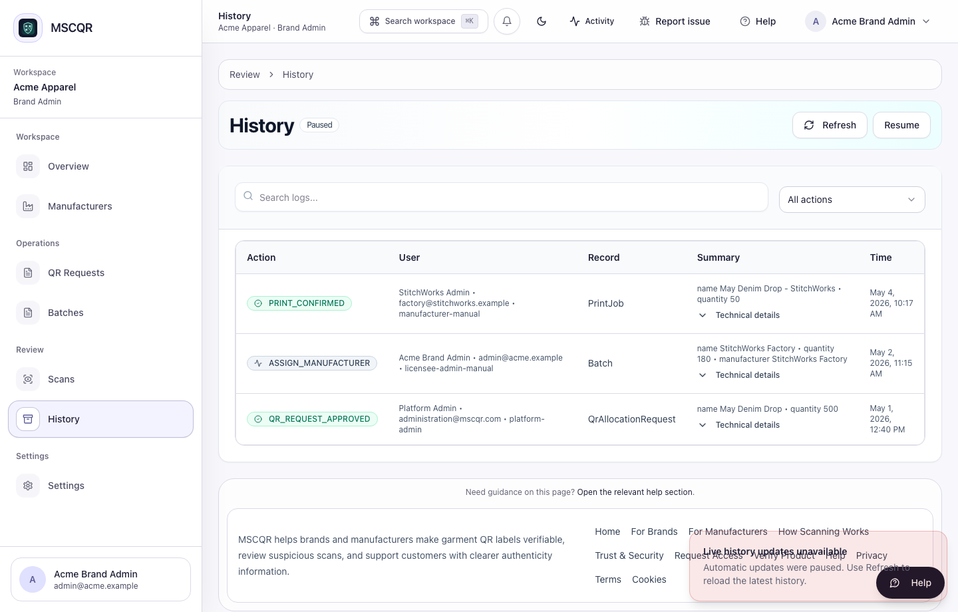
Licensee Admin history

Use History when you need to confirm who did what and when. Expand details only when you need additional record context for investigation.

What To Do If Something Looks Wrong
- Manufacturer cannot see a batch: open Manufacturers, confirm the manufacturer account is active, then open that manufacturer’s batches.
- Allocation quantity fails: reopen the source batch workspace and check the remaining unassigned quantity.
- QR request is missing: clear filters in QR Requests, then refresh.
- Recent audit history is missing: refresh History or the batch workspace Audit tab.
- UI or workflow error: use the top-bar support reporter so MSCQR attaches diagnostics and a screenshot.

Glossary
- Source batch: the approved label inventory received by the licensee.
- Manufacturer allocation: a quantity split from a source batch for a manufacturer to print.
- QR request: a request for more QR labels.
- Scan activity: customer verification events and related review signals.
- History: audit records for operational actions.

CTO Recommendations
- Next best feature: add role-safe export bundles from Scans and History for licensee audits.
- Security hardening: add tenant-level approval thresholds for unusually large QR label requests.
- Scalability: add saved filters for high-volume licensees that review many batches daily.

