# NANDA KUMAR TUTARAPU

8179408179 nandatutarapu8179@gmail.com

LINKED IN

[www.linkedin.com/in/nanda-tutarapu-555b5927b](http://www.linkedin.com/in/nanda-tutarapu-555b5927b)

# OBJECTIVE

I aim to continuously explore and enhance my skills. By working hard and staying true my conscience, I strive to contribute to the development of the organization and achieve personal growth.

# INTERNSHIPS

Java Fulla Stack Internship - (DREAM FACTORY)

Cyber Security Virtual internship - EDUSKILLS

Machine Learning Algorithm and Their Applications - WALYS LIFE SKILLS INTERNATIONAL

# CERTIFICATIONS

**Certificate Of Java**

Infosys

**Cyber Security Foundations**

Cisco

**Data scientist Administrator**

Microsoft

**System Administrator**

Service now

# SKILLS

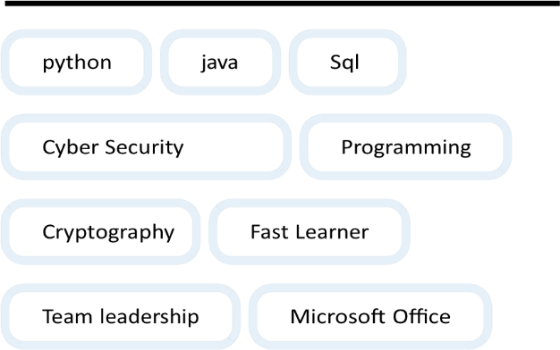

# PROJECT

# SIGN LANGUAGE RECONIGATION USING PYTHON

Developed a system to recognize sign language gestures using Python, OpenCV. The system can be used to aid communication for the deaf and dumb, and can be extended to creating automatic editors, where a person can write by just their hand gestures

# EDUCATION

**B.tech, Bonam venkata chalamaiah engineering college**

2020 – 2024 CGPA- 7.5

## Senior secondary, Aditya junior college

2020 CGPA -6.2

## SSC, Sree KonaSeema E.M. High School

2017 CGPA-9.2

# HOBBIES

**Blogging**

## Traveling , playing cricket