Cinema Junction
A Prototype Incorporating Familiar and Unfamiliar Navigation Elements

AIM
To develop a desktop prototype named 'Cinema Junction' incorporating both familiar and unfamiliar navigation elements and to evaluate usability among different user groups using Proto.io.

TOOLS USED
• Proto.io – For designing and testing the interactive prototype.
• Desktop Layout (1366x768 resolution).

FAMILIAR NAVIGATION ELEMENTS IMPLEMENTED
1. Top Navigation Bar (Home | Actors | Favourites).
2. Clickable Actor Cards on Home Screen.
3. Back to Home Button on Actor Detail Screens.
4. Favourites Page with Movie Cards.
5. Standard Tap/Click Navigation Between Screens.


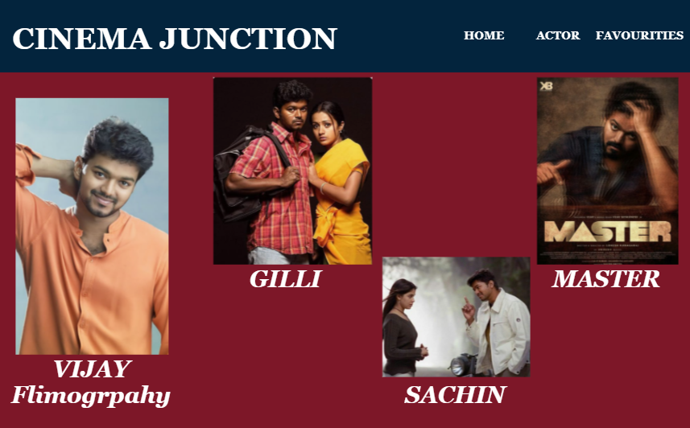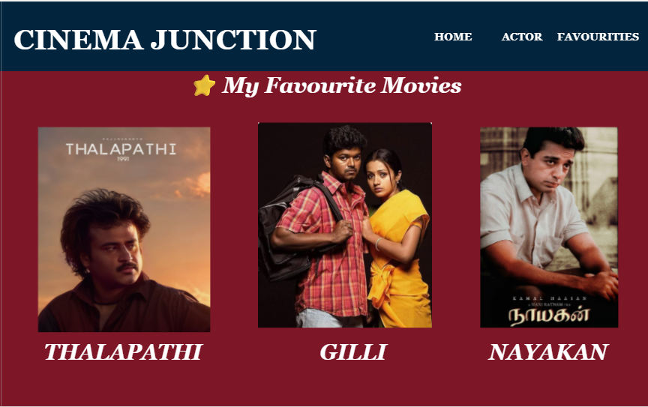
These elements follow common user interface patterns found in modern web and desktop applications, ensuring ease of use and predictability.

UNFAMILIAR (NOVEL) NAVIGATION ELEMENTS IMPLEMENTED
1. Double-Click on Movie Poster to Add to Favourites.
2. Hidden Feedback Message ('Added to Favourites') revealed on Double Click.
3. (Optional) Hover-based Information Reveal on Movie Posters.
4. (Optional) Hidden Sliding Side Panel for Quick Navigation.
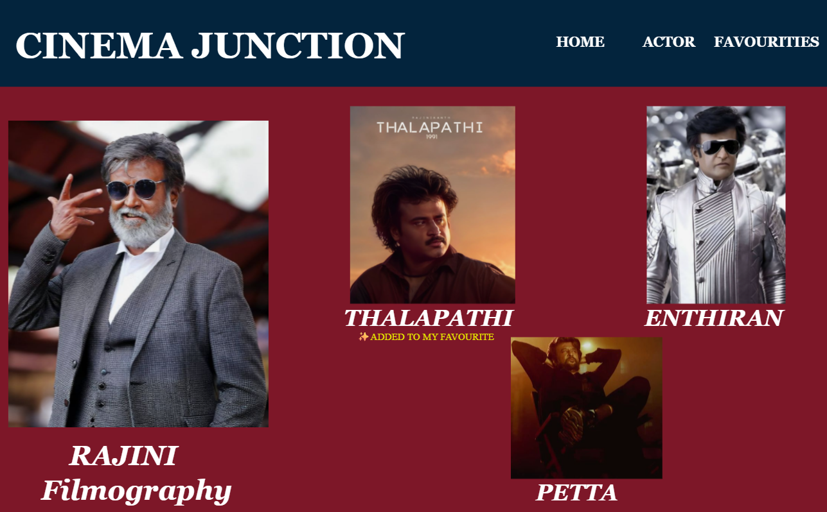

These elements were intentionally introduced to observe user behavior when interacting with less conventional navigation methods.

PROCEDURE SUMMARY
Step 1: Created a new Desktop project in Proto.io.
Step 2: Designed the Home screen with actor cards (Rajini, Kamal, Vijay, Ajith, Simbu).
Step 3: Created individual Actor Detail screens with movie listings.
Step 4: Connected screens using standard click interactions (Familiar Navigation).
Step 5: Created a Favourites screen.
Step 6: Duplicated the project to create an Experimental Version.
Step 7: Added Double-Click interaction and hidden feedback message (Unfamiliar Navigation).

USABILITY TESTING PLAN
User Groups:
• College Students (Tech-Savvy Users)
• Middle-Aged Users (Moderate Technology Experience)
• Non-Technical Users

Evaluation Criteria:
• Ease of Navigation
• Task Completion Time
• Error Rate
• User Satisfaction
• Discoverability of Unfamiliar Features

CONCLUSION
The Cinema Junction prototype successfully demonstrates the difference between familiar and unfamiliar navigation patterns. Familiar elements ensured quick and intuitive usage, while unfamiliar elements required exploration and adaptation. The usability comparison helps understand how different user groups respond to innovative interaction designs.

