# Snake Game Project

For my project I decided to make the snake game. The aim of the game is to guide a snake around the map and make sure the snake does not hit the outer bounds of the map or that the snake does not run into itself. You collect cherries and every time you collect a cherry the size of the snake will increase making the game harder to play.

I have three functions for this game

The game

The settings

The leader board

The first function is to start playing the game. You control the snake using WASD or the arrow keys. Every time you collect a cherry the snake size will increase and your score will increase. Once your score hits a certain point the speed of the snake will increase. The speed at which it increase will be determined by the difficulty of the game. p You will get a game over screen when the snake hits off the border of the map or the snake hits off itself . When you get a game over you enter your name and your score will be recorded if your get a higher score than one of the top 5.

The next function is the settings. Here you can change the difficulty of the game. If you set the game to easy mode then the snake will start off small (3 squares long) and the start speed of the snake will be slow. If you set the game to normal mode then the snake will start off at a normal length (5 squares long) and the start speed of the snake will be at a steady speed. If you set the game to hard mode then the snake will start off long (7 squares long) and the start speed of the snake will be fast.

The last function is the leader board. This will show you the top 5 players score in order of highest score. The scores and the user names will be read from a text file.

There will also be an exit function that will close the game.

Github Link: <https://github.com/T00199391/SnakeGame.git>





JavaDoc

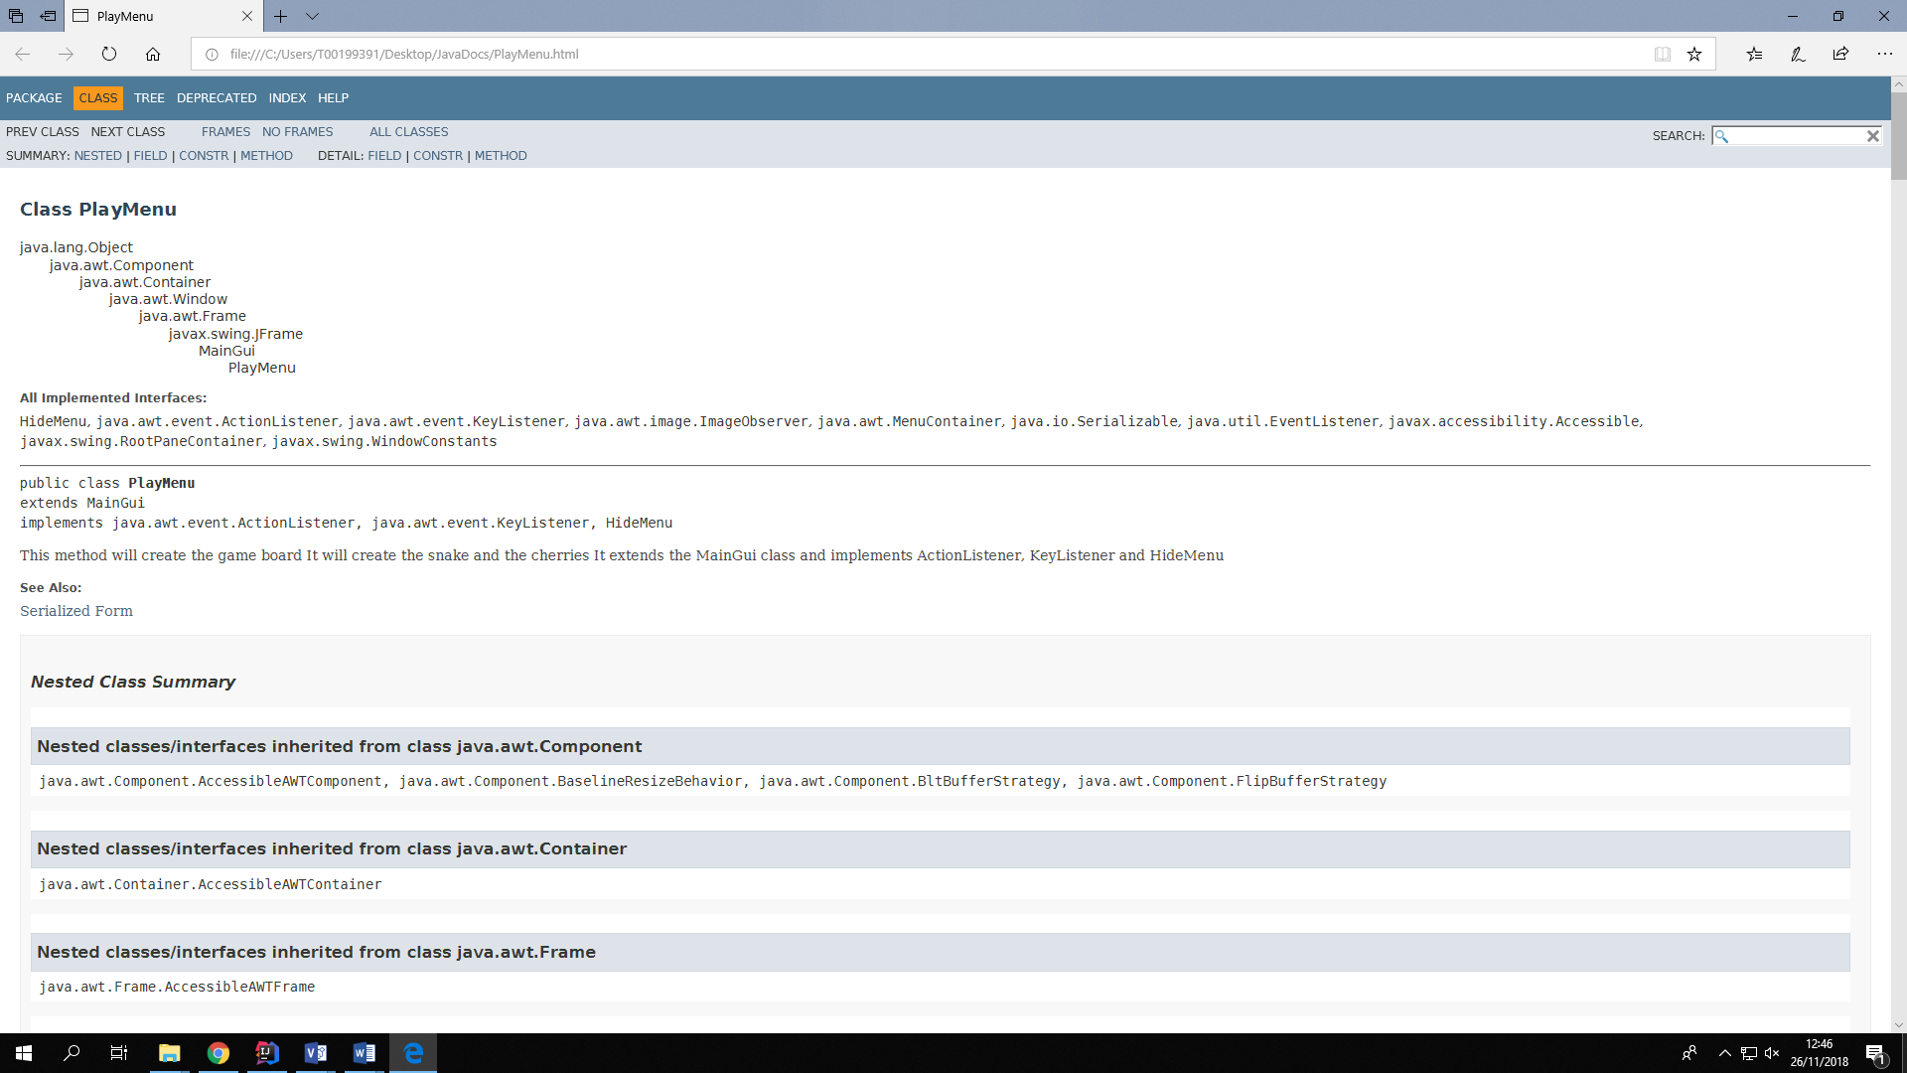

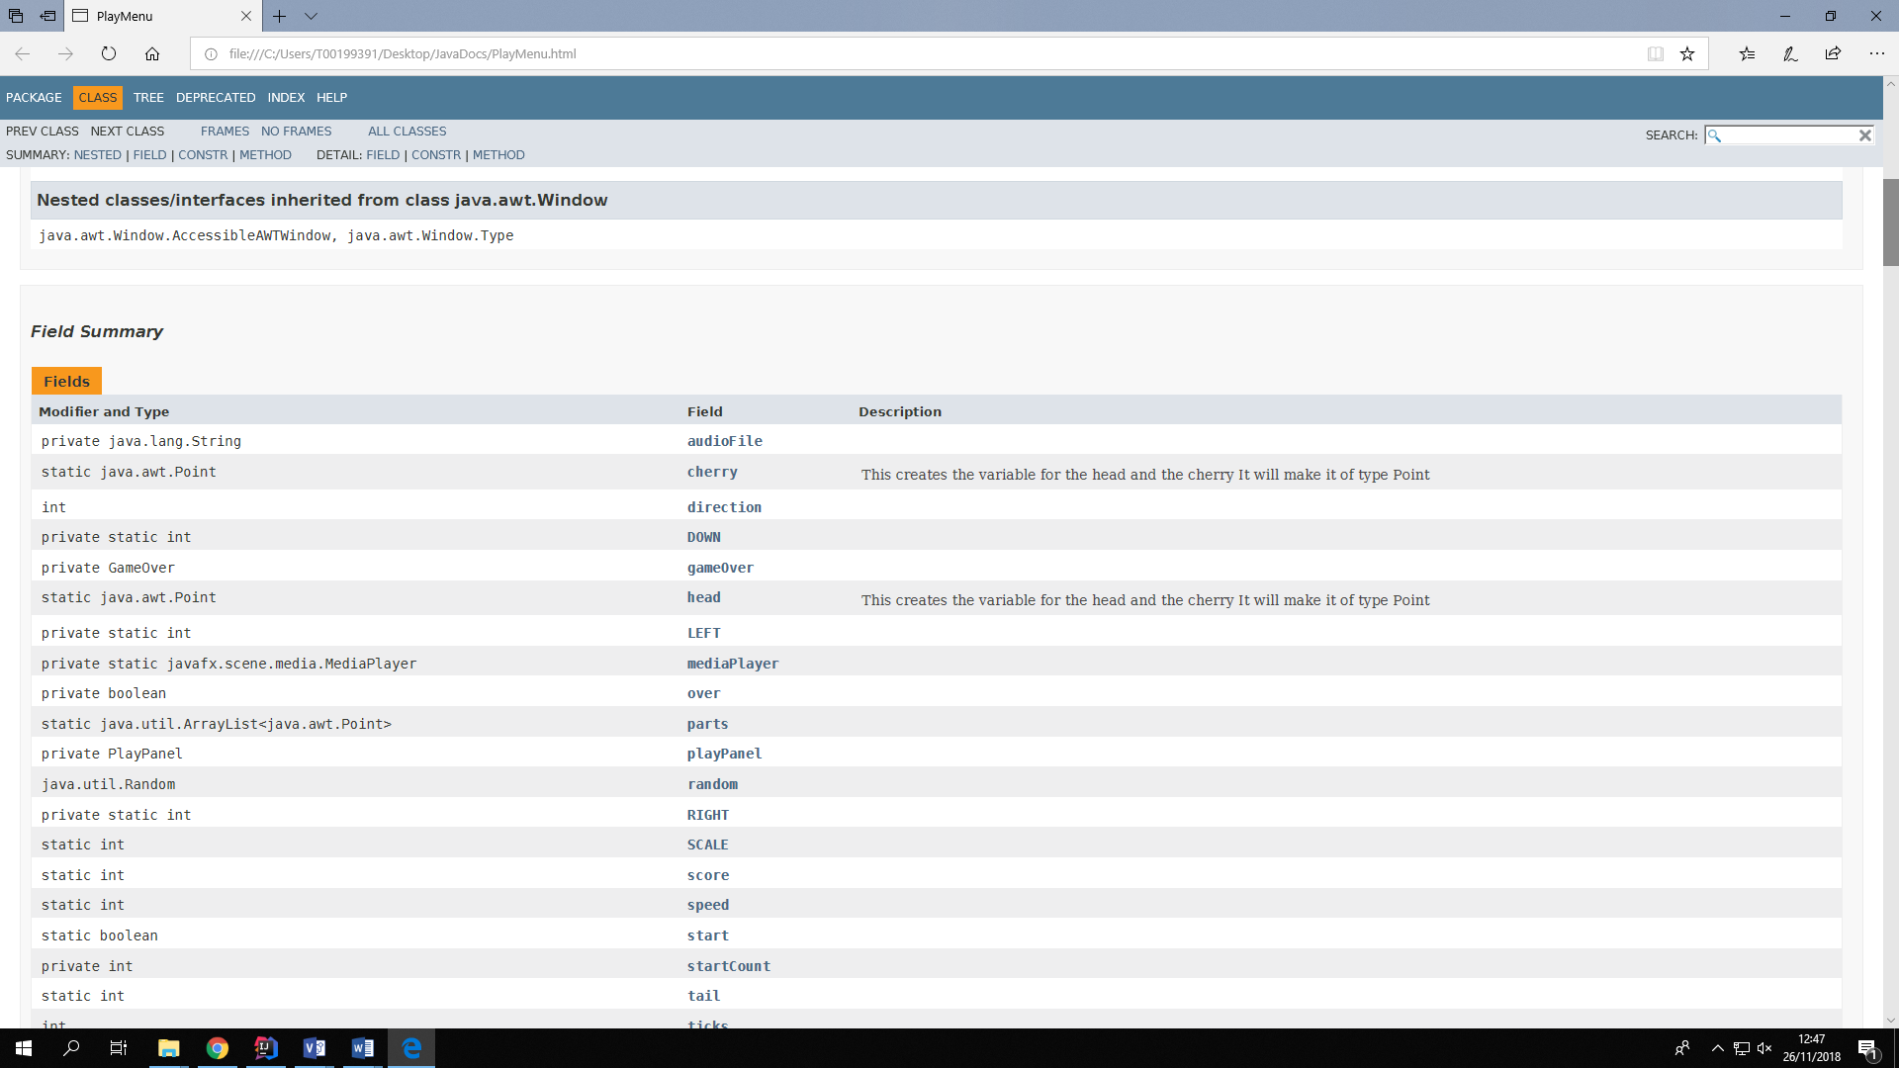

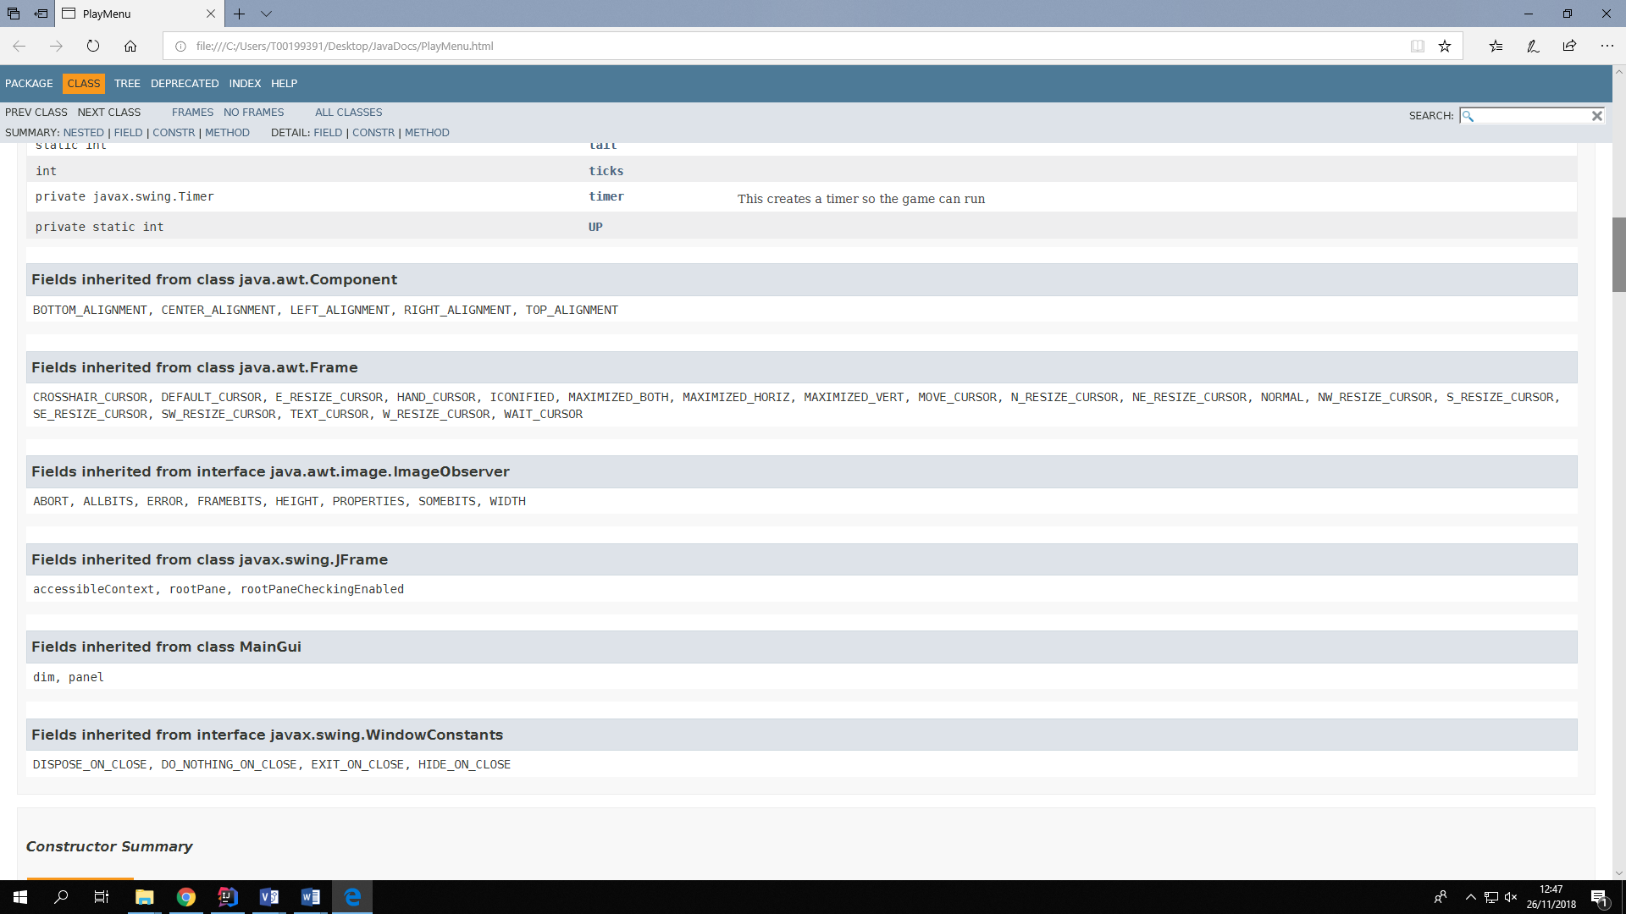

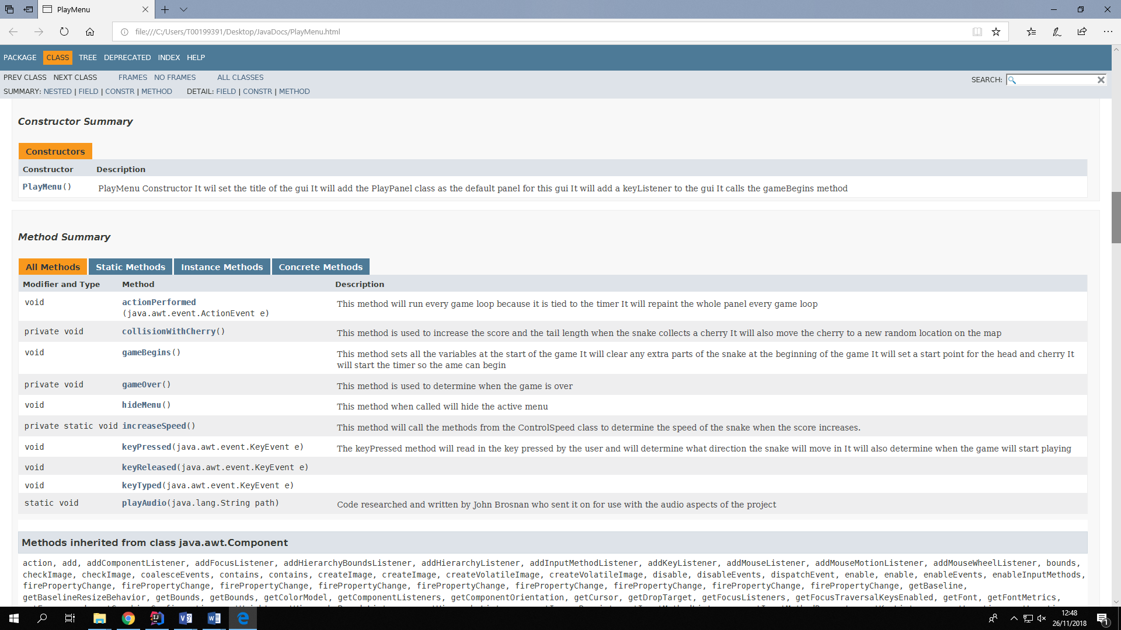

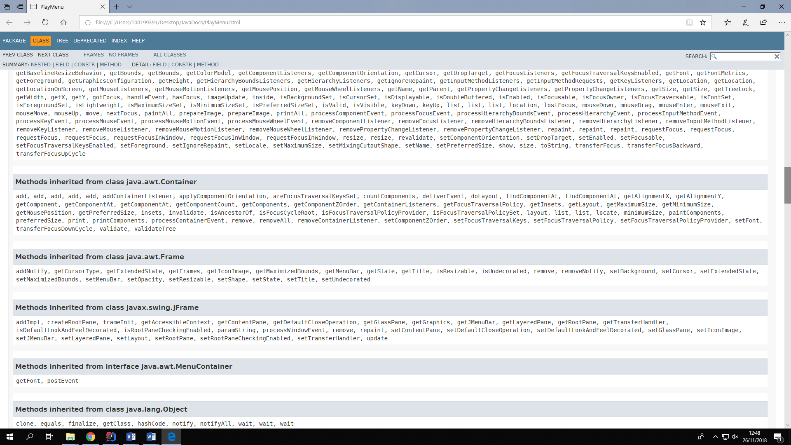

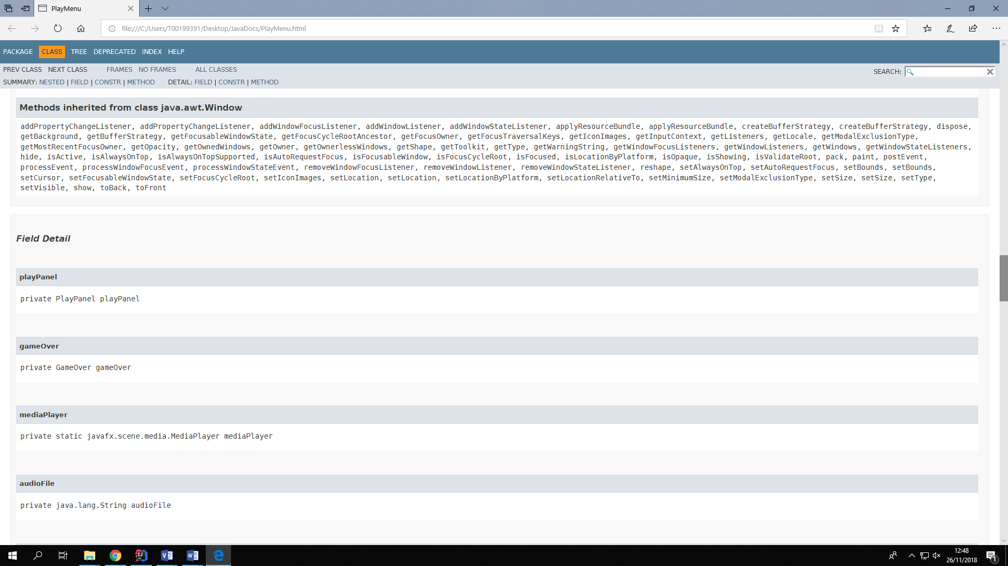

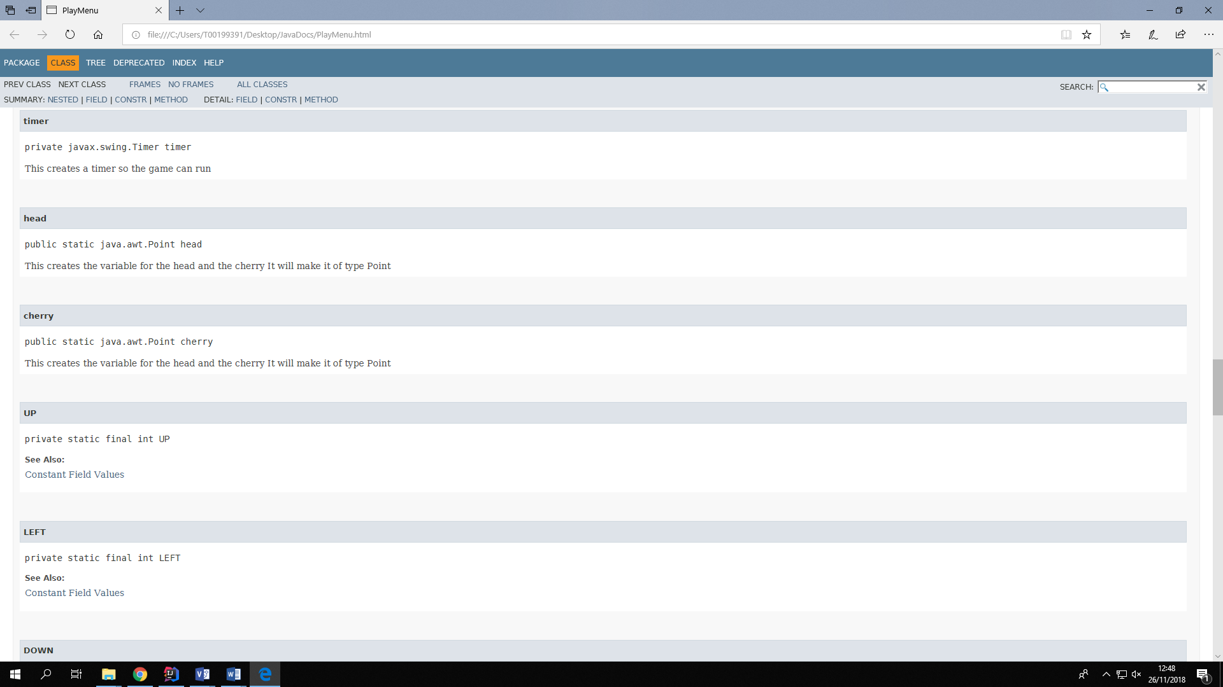

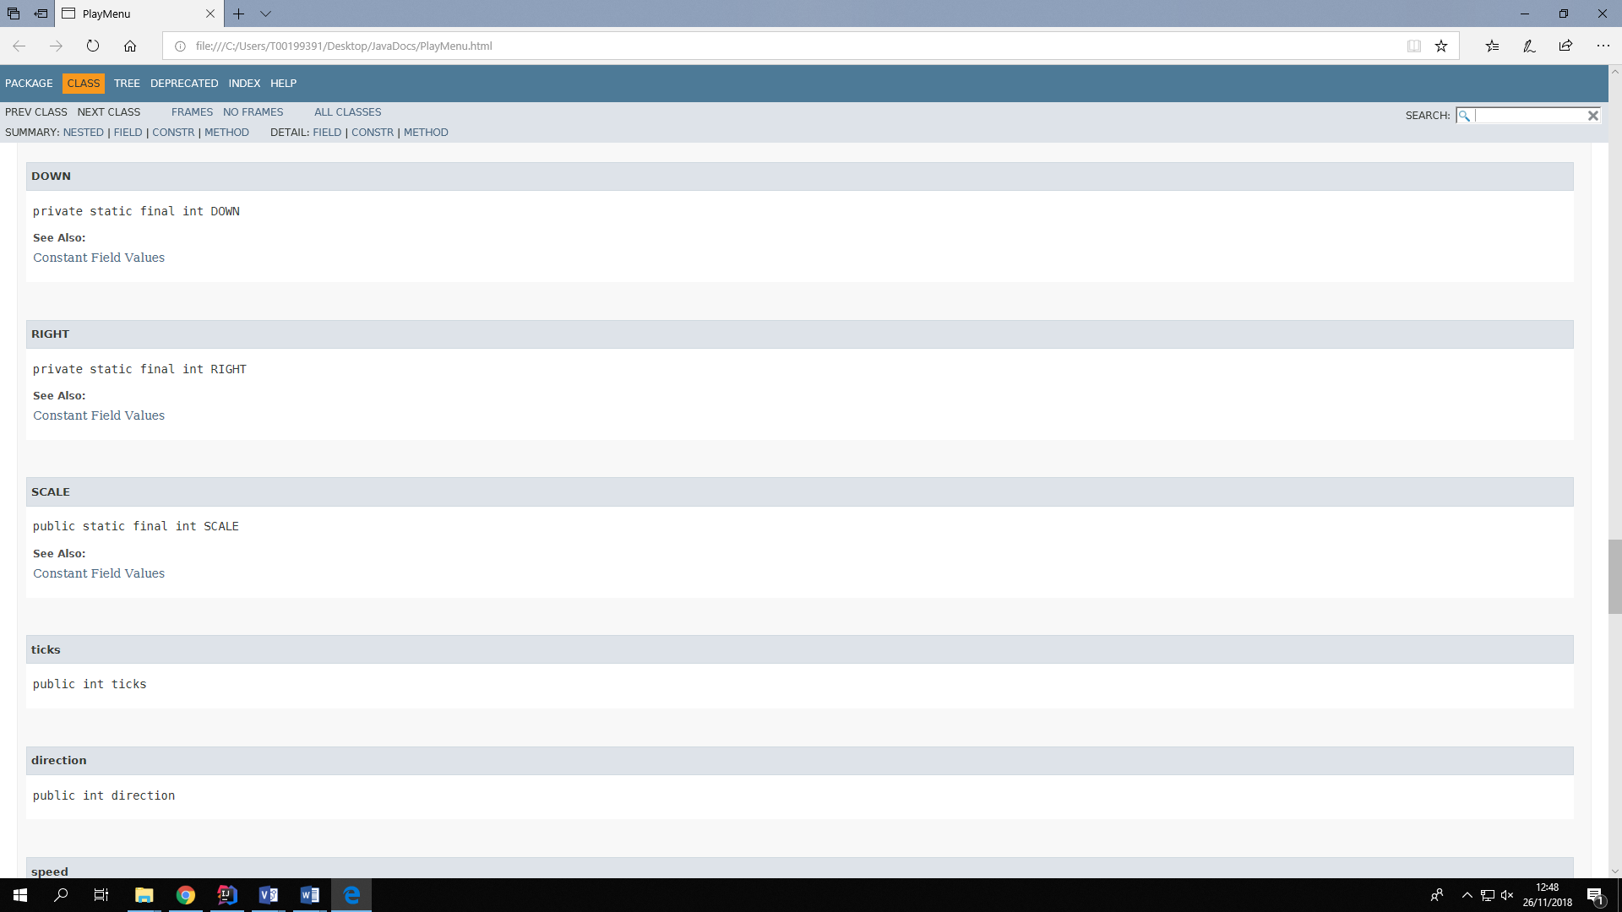

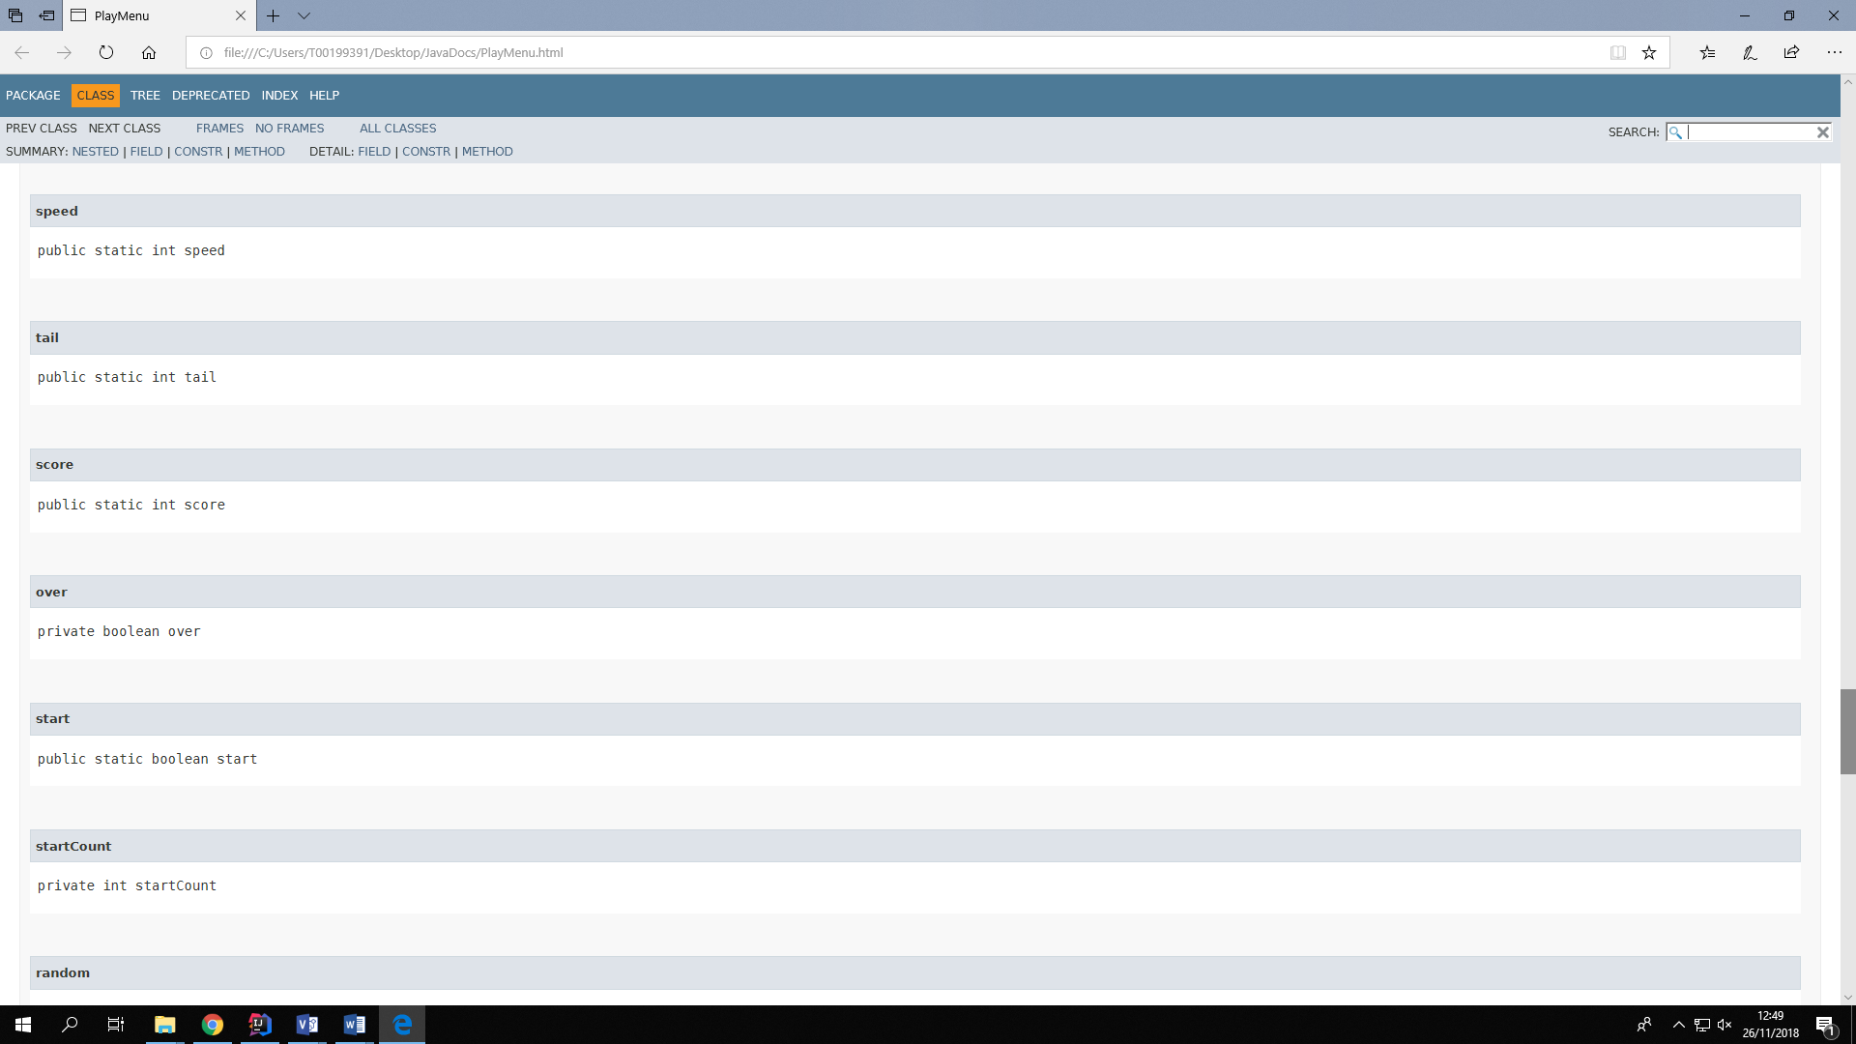

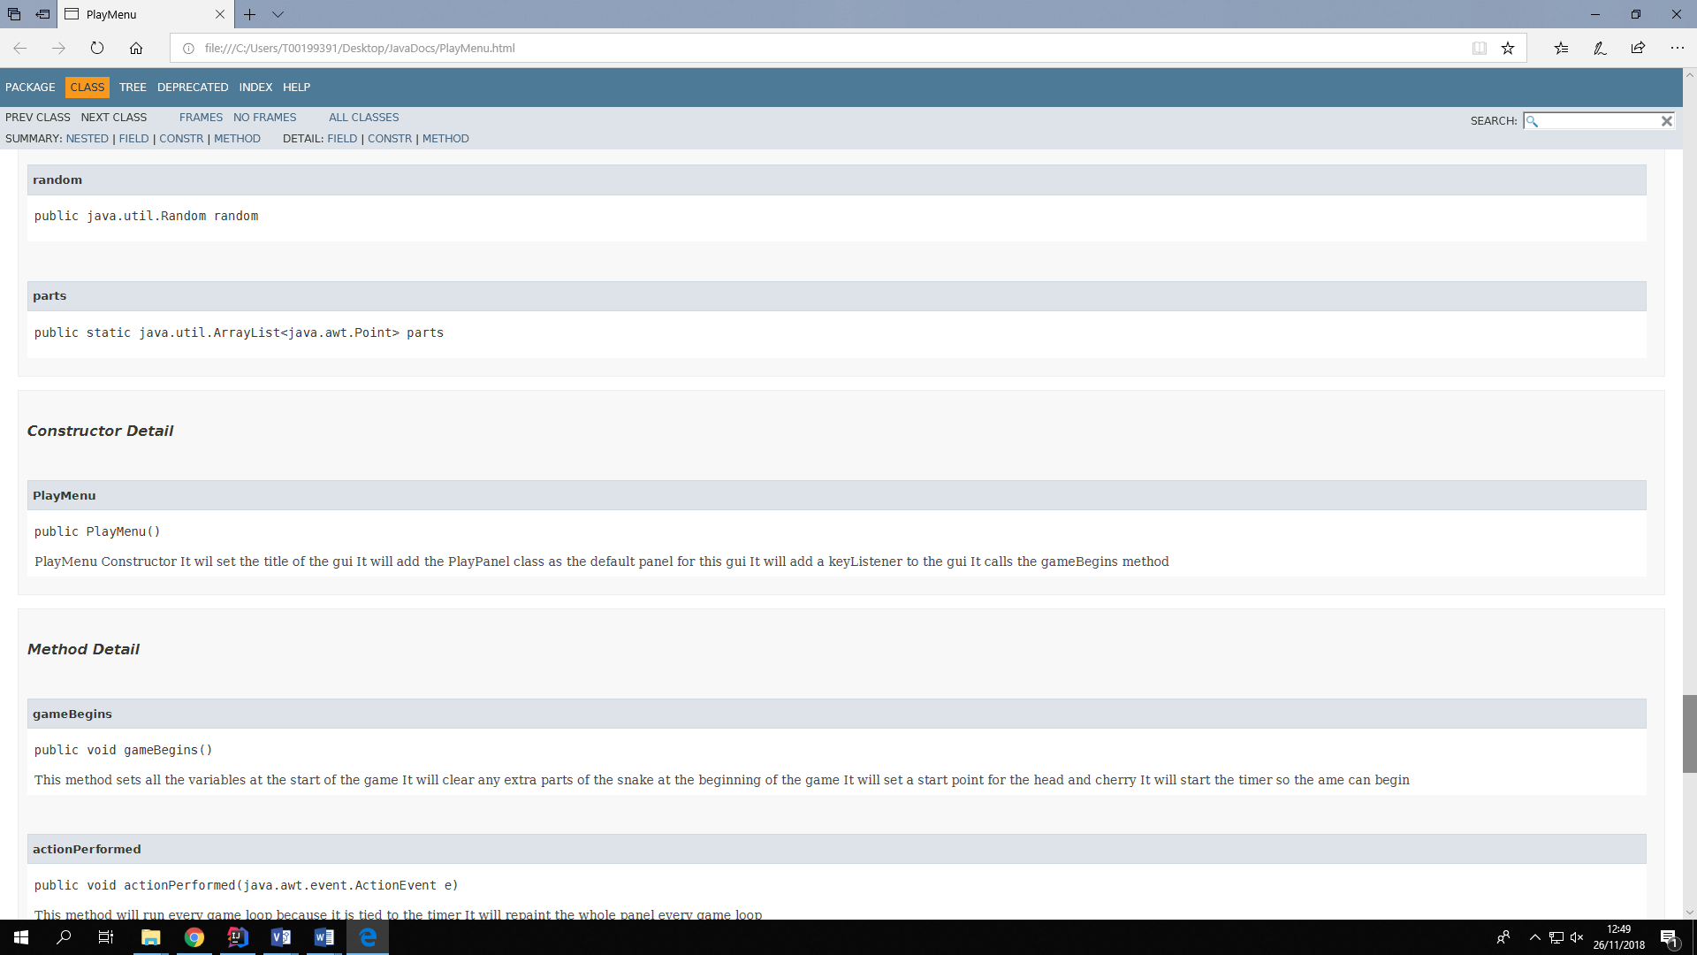

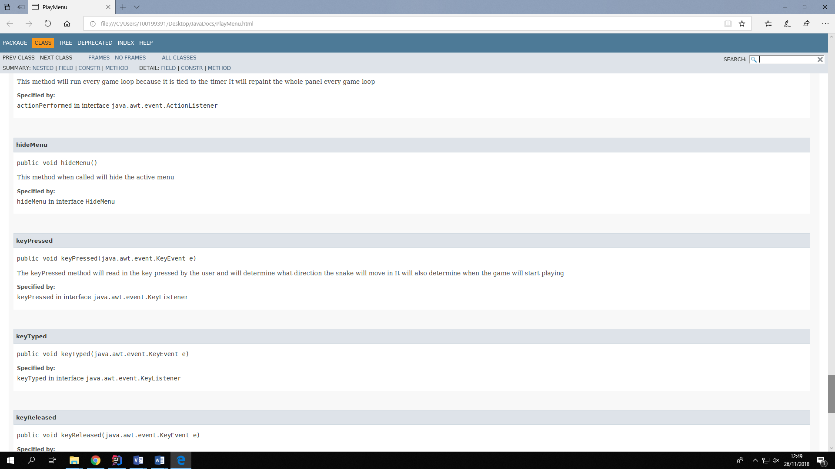

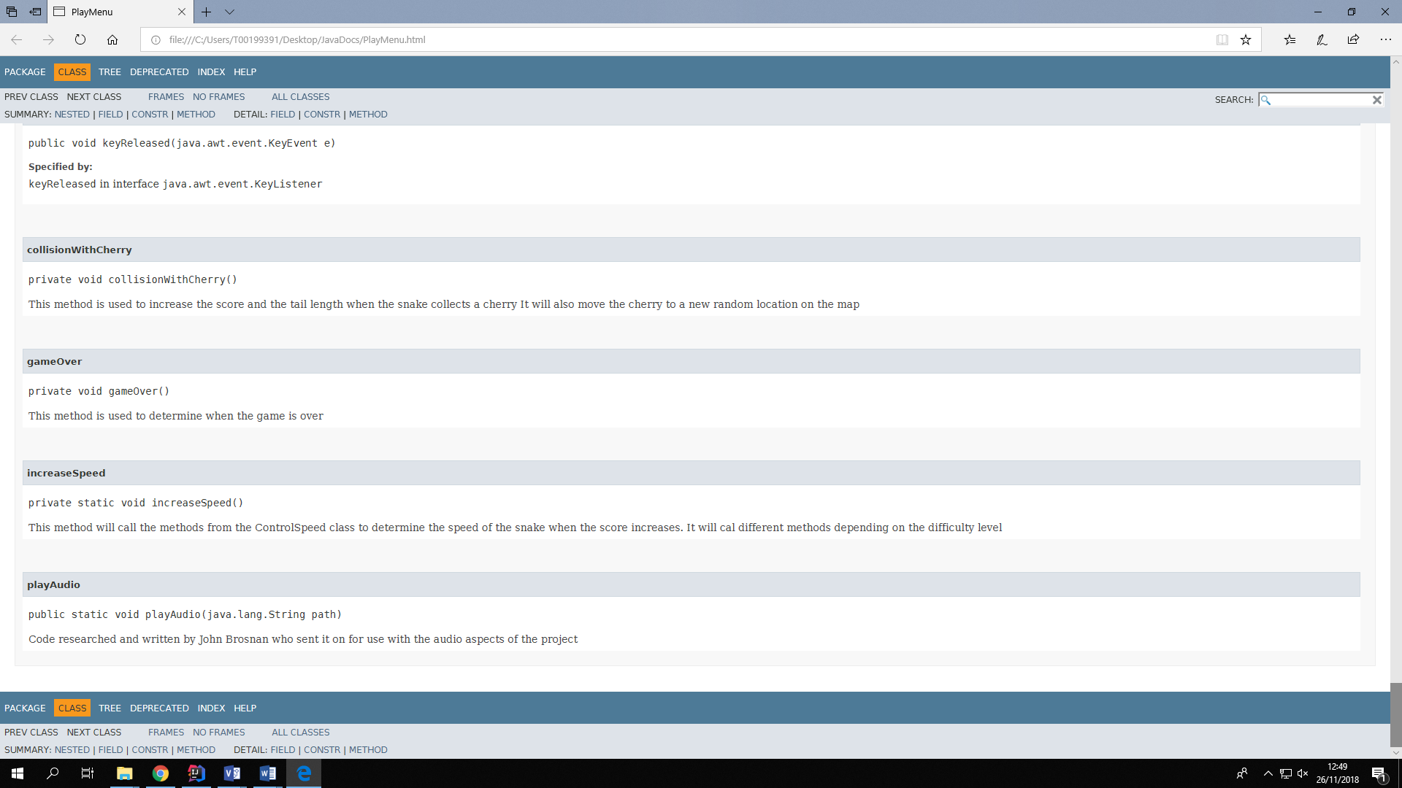

Commit Logs

