9. Prototype / Mockups
This section presents the Room4U user-interface prototypes and mockups. The screens illustrate the layout, information hierarchy, navigation, and main interactions of the system. Room4U provides two role-based interfaces: the Student Interface and the Administrator Interface. Both use the Room4U open-book logo and a consistent blue-and-white visual language, including the account bar, left navigation, room information panels, status indicators, and primary action buttons. The mockups communicate the intended appearance and behavior of the system before implementation.

The following subsections describe the interactive prototypes, screen list, individual mockups, key confirmation and result dialogs, and accessibility considerations.

9.1. Interactive Prototype
Room4U provides separate navigation flows for Student and Administrator roles. The Student prototype covers room discovery, availability checking, booking submission, request tracking, request details, cancellation, history, and logout. The Administrator prototype covers request processing, room management, room creation and editing, room suspension and resumption, room-usage schedules, and maintenance scheduling.

- Student Interactive Prototype: Students can search for meeting rooms, inspect room information and availability, submit booking requests, review request statuses and details, cancel eligible requests, view processed requests, and log out.
  - Prototype Link: Figma Student Prototype
- Administrator Interactive Prototype: Administrators can review and process booking requests, approve or reject pending requests, cancel approved bookings when permitted, manage room information, suspend or resume rooms, inspect room usage, and create or remove maintenance schedules. The interface also provides confirmation, success, and validation dialogs for important actions.
  - Prototype Link: Figma Administrator Prototype

9.2. Screen List and Mockups
This subsection lists the main Room4U screens and their associated use cases. The screens are grouped by user role. Each entry identifies the screen's purpose and summarizes the information, actions, and important interaction states represented by the mockups.

Screen List
Screen ID | Screen Name | Related Use Case(s)
S01 | Sign In | UC-01
S02 | Room Search and Availability | UC-02, UC-03
S03 | Booking Request | UC-04
S04 | My Requests, Details and History | UC-02, UC-05, UC-06
S05 | Admin Request Queue | UC-02, UC-07
S06 | Request Details and Processing | UC-07, UC-08, UC-09, UC-10
S07 | Room Management | UC-11, UC-12
S08 | Room Availability and Maintenance | UC-12, UC-13

9.2.1. Student Interface
The Student Interface supports the complete student-side booking flow. Students can sign in, search for rooms, inspect availability, submit a booking request, monitor its status, open request details, cancel an eligible request, review request history, and log out.

9.2.1.1. S01 - Sign In
- Description: This screen is the entry point for both Student and Administrator users. It provides Email and Password fields and a Sign In button. Users sign in with accounts provided by the system; no public registration flow is shown. The screen includes Room4U branding and a short explanation of the service. If authentication fails, an error message is displayed so the user can check the credentials and try again.
- Mockup View:
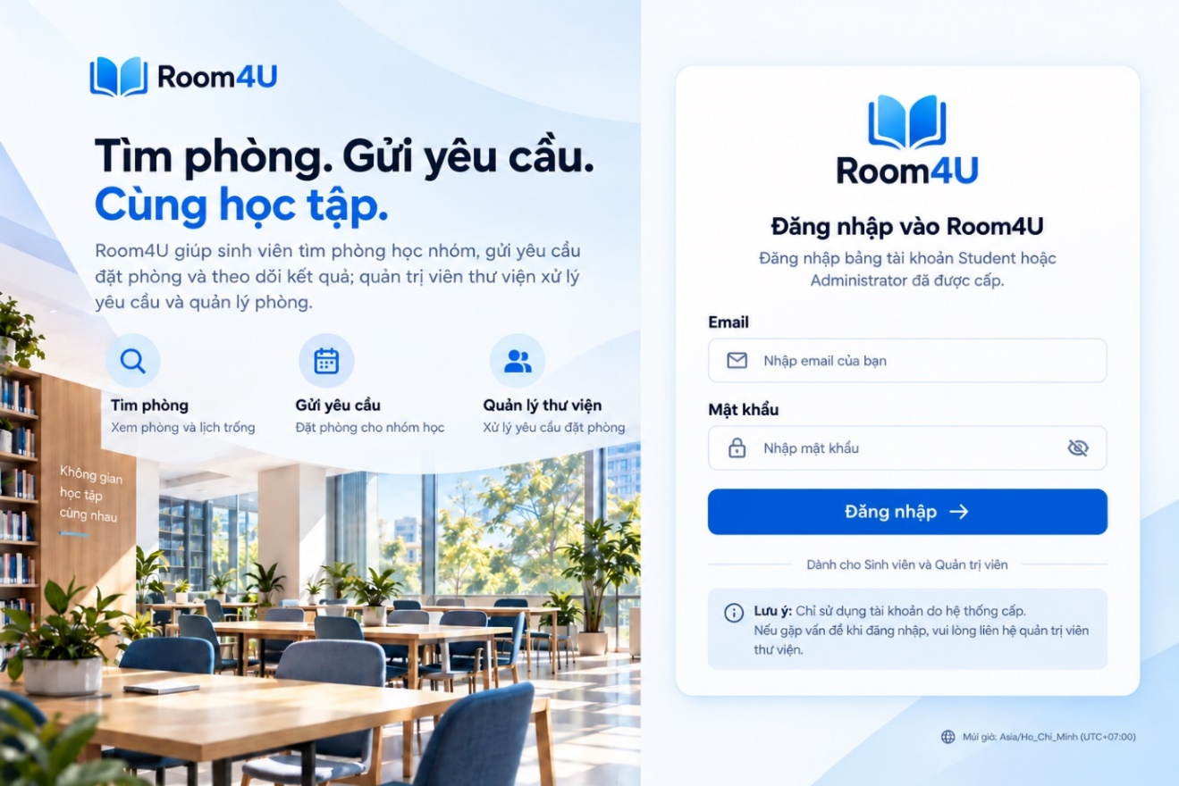

9.2.1.2. S02 - Room Search and Availability
- Description: This flow helps students find a suitable meeting room and check its schedule before submitting a booking request. It consists of room-search results and a room-availability view.
  - Room Search: Students can search using available criteria such as the intended date, number of people, and room requirements. Results are presented as room cards showing a room image, room name, capacity, floor, equipment, current status, and an action to inspect the room or its availability.
  - Room Availability: After selecting a room, students can view its time-slot schedule for a selected date. The schedule distinguishes available periods from approved bookings, maintenance periods, and other unavailable periods so that students can choose a valid time before opening the booking-request form.
- Mockup Views:

S02.1 – Room Search 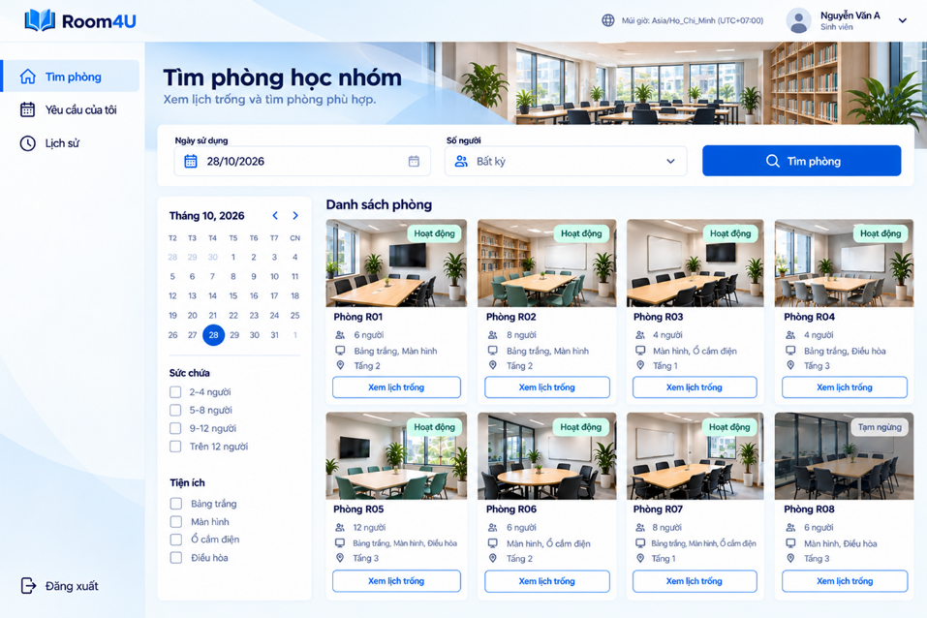

S02.2 – Room Availability
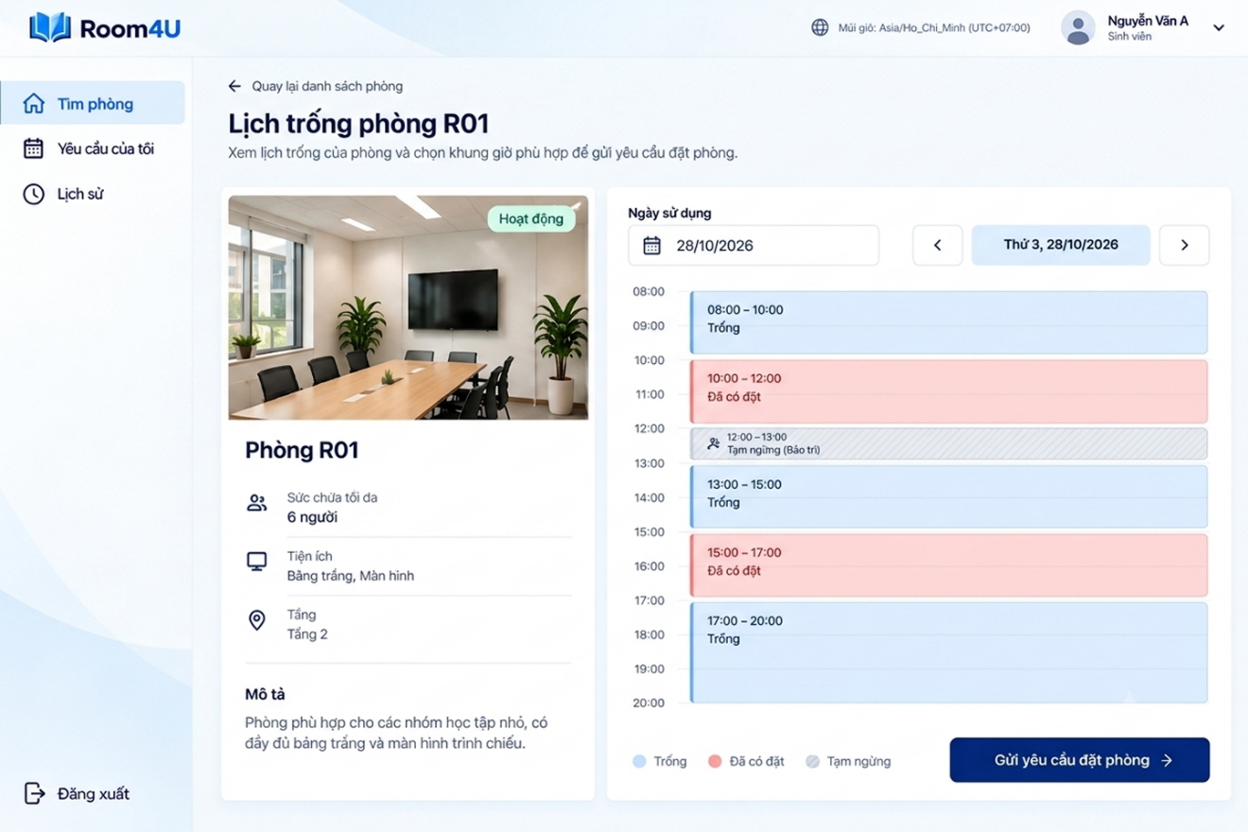

9.2.1.3. S03 - Booking Request
- Description: This screen allows a student to submit a booking request for the selected room. The form displays the room information and collects the usage date, start time, duration, number of participants, purpose of use, and an optional note. The available duration options are 30, 60, 90, and 120 minutes. The system calculates the end time from the selected start time and duration and displays it for the student to review. The start time must be later than the current time and no more than seven days from the current time (BR-04). The system validates the request against room capacity, availability, and the applicable booking rules. A successfully submitted request receives a request ID and appears with Pending status in the student's request list.
- Mockup View:
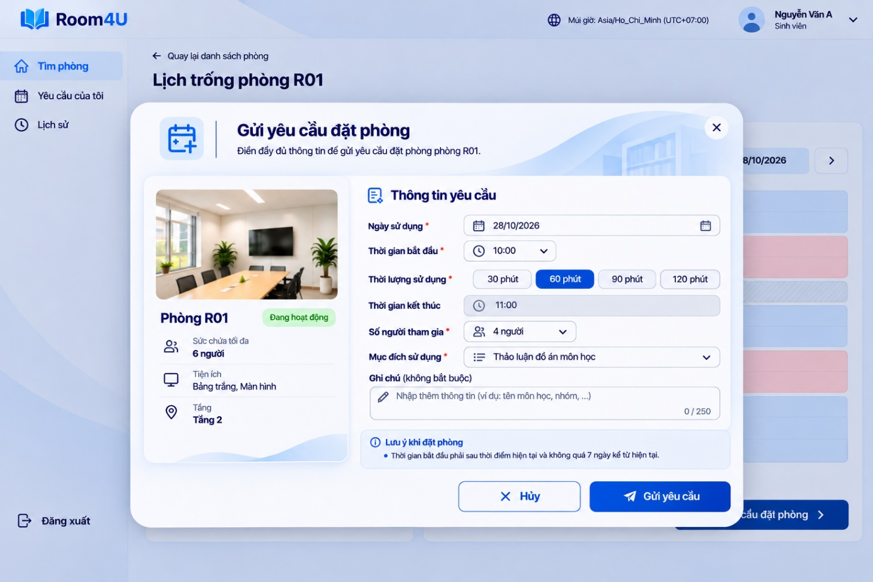

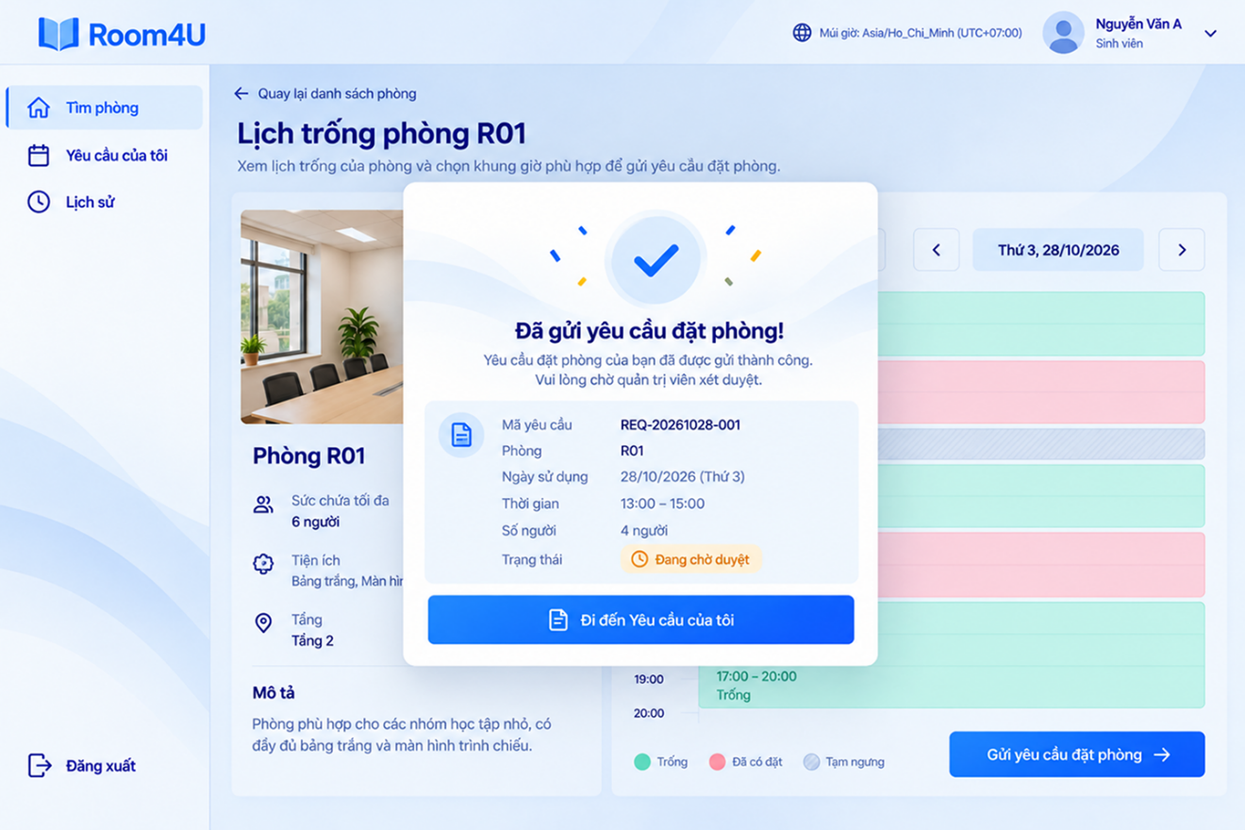

9.2.1.4. S04 - My Requests and History
- Description: This area allows students to monitor submitted booking requests and review requests that have already been processed. The active-request screen provides search and status filters. Each row shows the request ID, room, usage date and time, purpose, current status, and a View Details action. Students can open a request to inspect its full information. A separate History screen lists previously processed requests.

9.2.1.4.1. S04.1 - My Requests List
This screen displays the student's request list. Status tabs help students narrow the results, while the search field supports searching by request ID, room, or purpose. The table presents the request ID, room, usage date and time, purpose, status, and a View Details action. Pagination is provided when the results exceed one page.

- Mockup View :
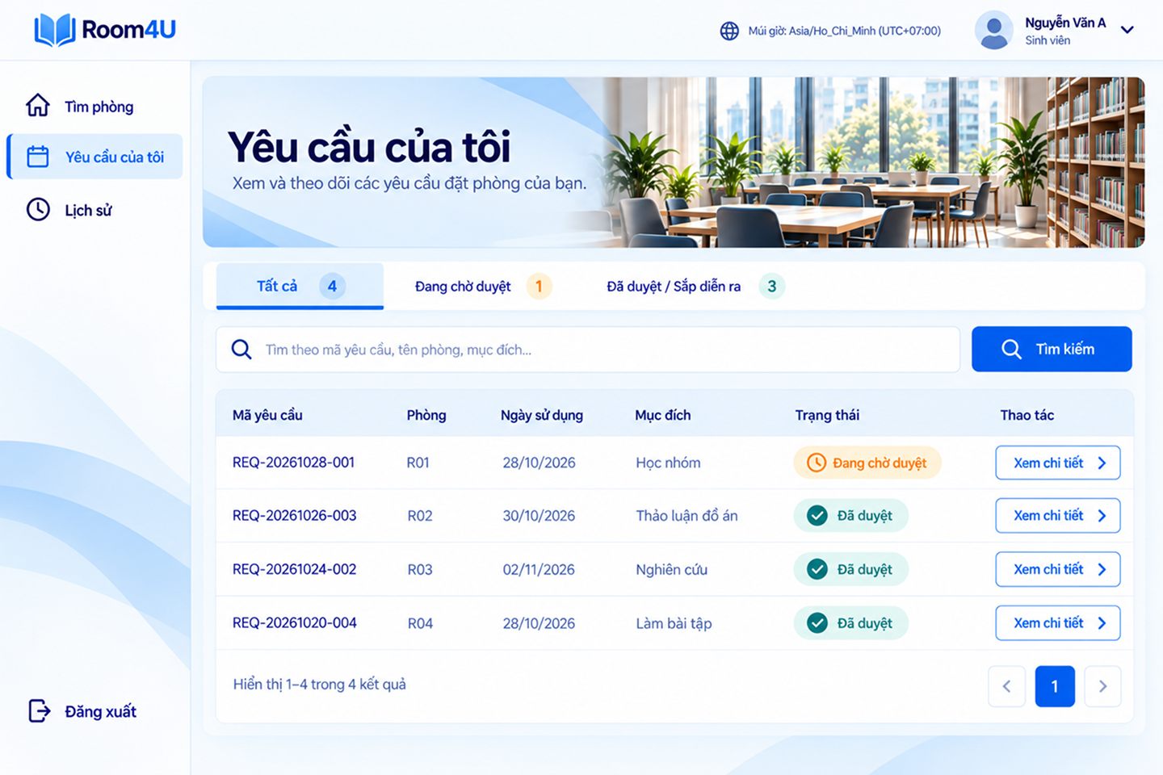

9.2.1.4.2. S04.2 - Booking Request Details
This screen presents the full information for one selected request. It includes the request ID and current status, room information, usage date and time, number of participants, purpose, optional note, and requester information. The student can use Cancel Request when cancellation is permitted. Cancellation is subject to the applicable request-status and booking-time rules; it is not an unconditional action.
- Mockup View:
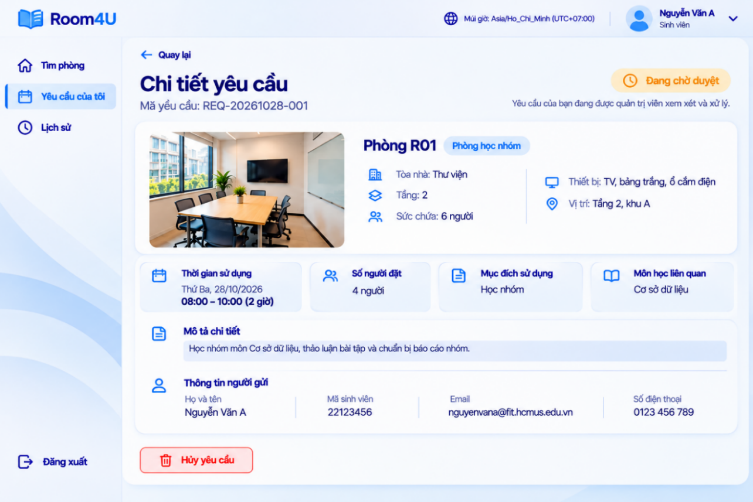
Cancellation Interaction: When a student selects Cancel Request for an eligible request, the system asks for confirmation before changing the request status. If cancellation is not allowed, the interface explains why the action cannot proceed. Closing the dialog or choosing not to continue leaves the request unchanged.

History Function: The History screen allows students to review previously processed booking requests. It includes Rejected and Cancelled requests, as well as Approved requests whose scheduled usage time has passed. An approved request retains its Approved status; the interface may indicate that its scheduled time has passed rather than changing the status to Completed. The history table shows the request ID, room, usage date, purpose, status, and a View Details action. Search and pagination help students locate older records.

Logout Interaction: The Logout option is available in the left navigation. Selecting it opens a confirmation dialog over the current page. The dialog provides Cancel and Log Out actions. Cancel closes the dialog and keeps the student on the current page; Log Out ends the session and returns the user to the Sign In screen.
- Mockup View – History Page with Logout Confirmation:
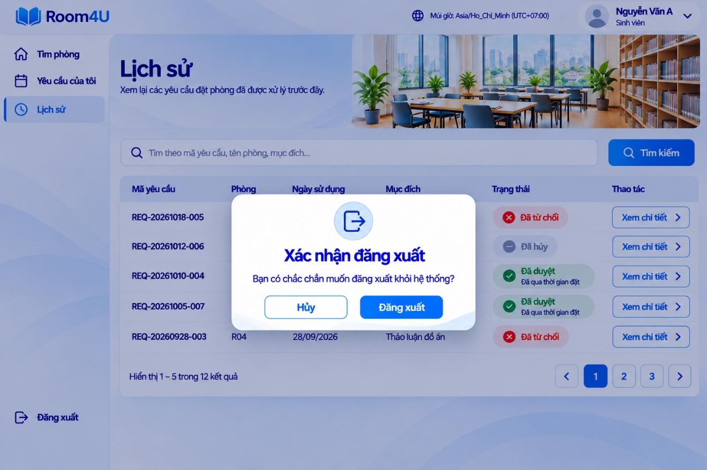

9.2.2. Administrator Interface
The Administrator Interface supports the management and supervision of Room4U operations. Administrators can review and process student booking requests, inspect request details and processing history, approve or reject pending requests, and cancel approved bookings when the applicable conditions are met. The interface also provides room-management functions, including adding rooms, updating room information, and suspending or resuming rooms. In addition, administrators can monitor room usage, view maintenance schedules, create maintenance blocks, and remove the effect of eligible future maintenance blocks while retaining their records. Confirmation, success, and error dialogs provide feedback for important actions and prevent changes when the required conditions are not satisfied.

9.2.2.1. S05 - Admin Dashboard
- Description: This screen is the administrator's request-management queue. It provides status categories for Pending, Approved, Rejected, and Cancelled requests, together with a search field and a submission-date filter. The request table displays key information such as request ID, room, requested usage period, number of participants, submission time, and current status. Administrators select View Details to inspect and process an individual request.
- Mockup View:
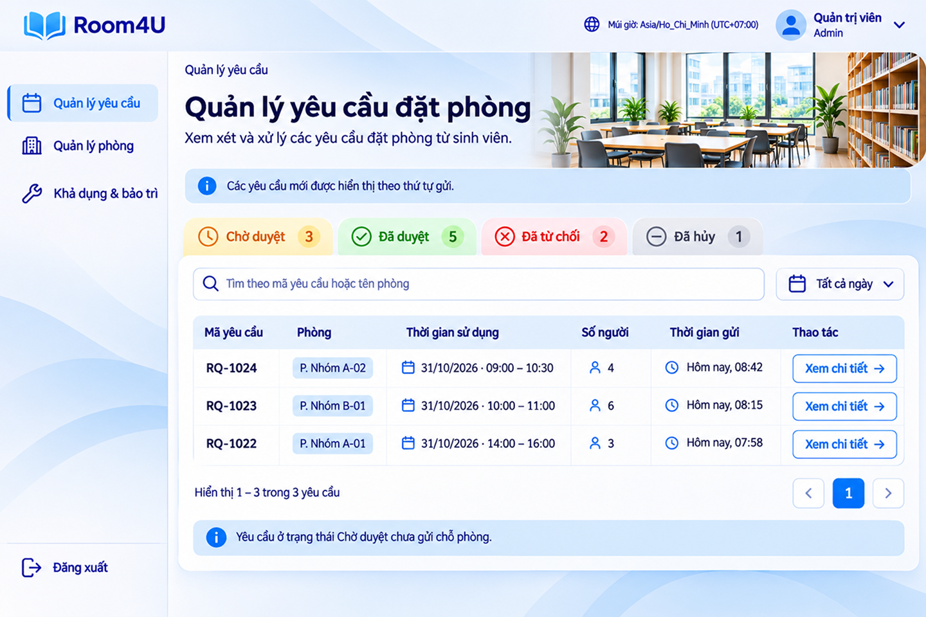

9.2.2.2. S06 - Booking Request Details and Processing
- Description: This screen presents the details and processing controls for a selected booking request. Its layout changes according to the request status. Common information includes booking details, requester information, room information, the room schedule, and request-processing history.
  - Pending Requests: Administrators review the requested date and time, duration, number of participants, purpose, notes, requester details, room capacity, equipment, and room availability. They can approve a request when the slot is valid or reject it by providing a reason. Before approval, the system checks for scheduling conflicts. If the requested period is no longer available, the interface displays a conflict message and does not approve the request.
  - Approved, Rejected, and Cancelled Requests: Administrators can review the booking information, current status, processing reason when applicable, and request history. For an Approved request, the detail screen provides a Cancel Booking action when cancellation is permitted. The administrator must enter a reason and confirm the action. The cancellation-reason field allows 1–250 characters after leading and trailing whitespace are removed (BR-13). Rejected and Cancelled requests are presented for review rather than as pending requests awaiting approval.
- Mockup Views:

S06.1 – Pending Request Details:
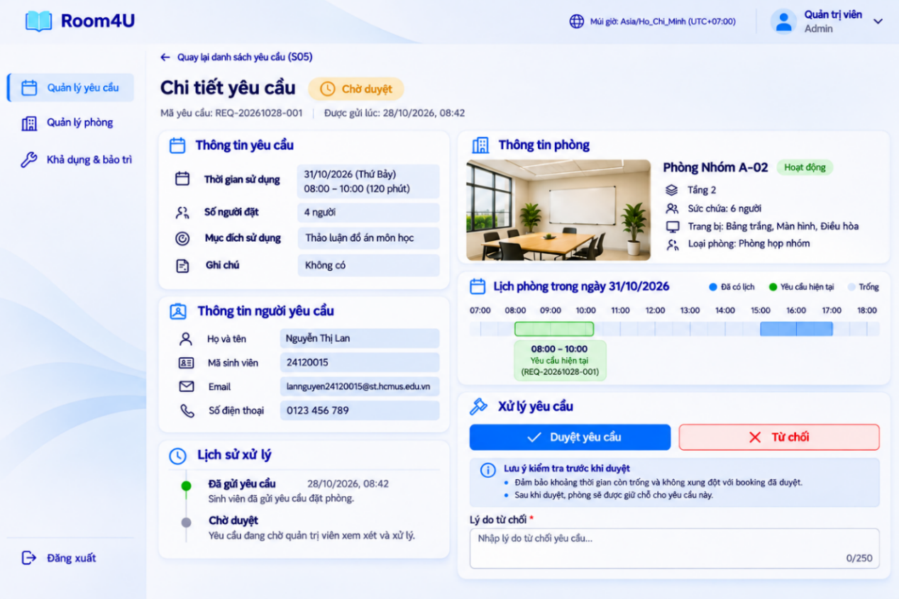

S06.1a – Confirm Approval:
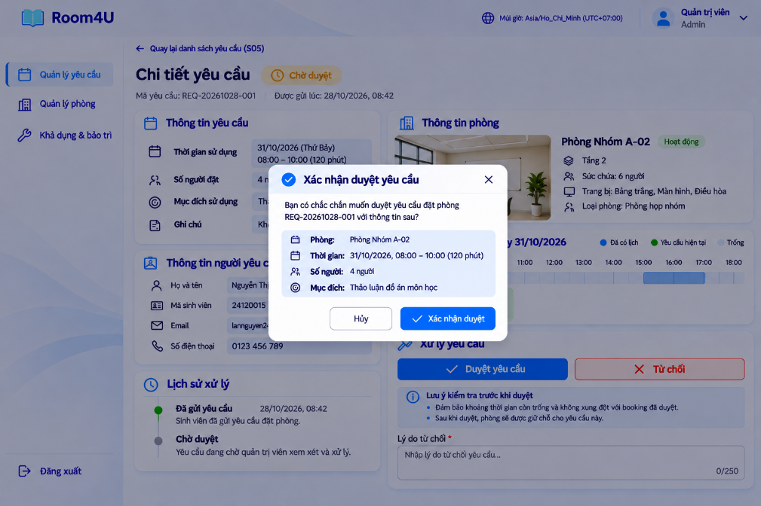

S06.1b – Reject Request:
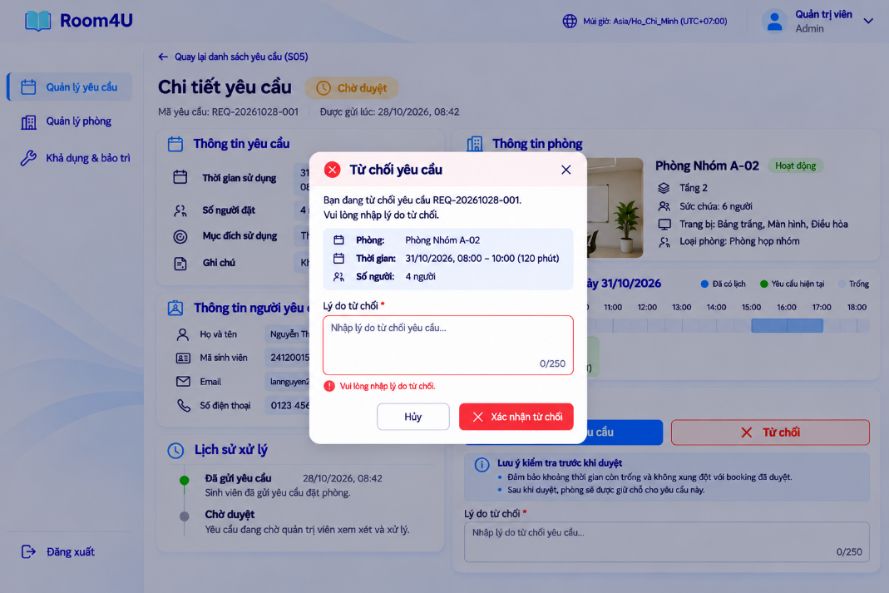

S06.1c – Approval Success:
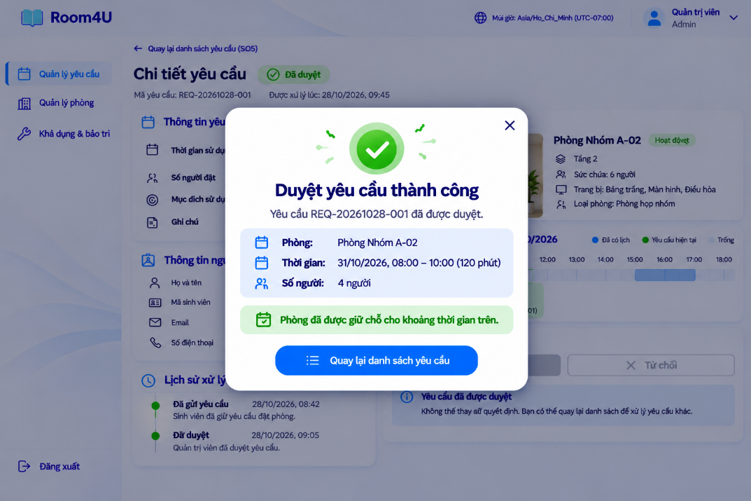

S06.1d – Rejection Success:
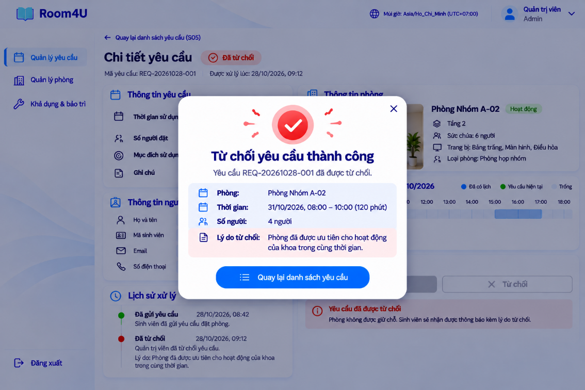

S06.1e – Scheduling Conflict:
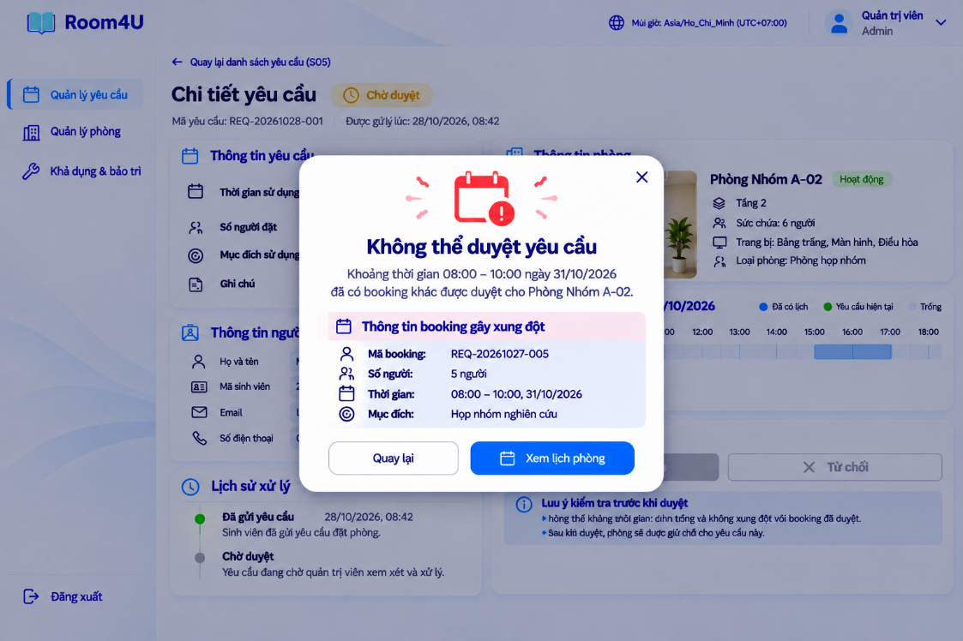

S06.2 – Approved Request Details and Cancellation:
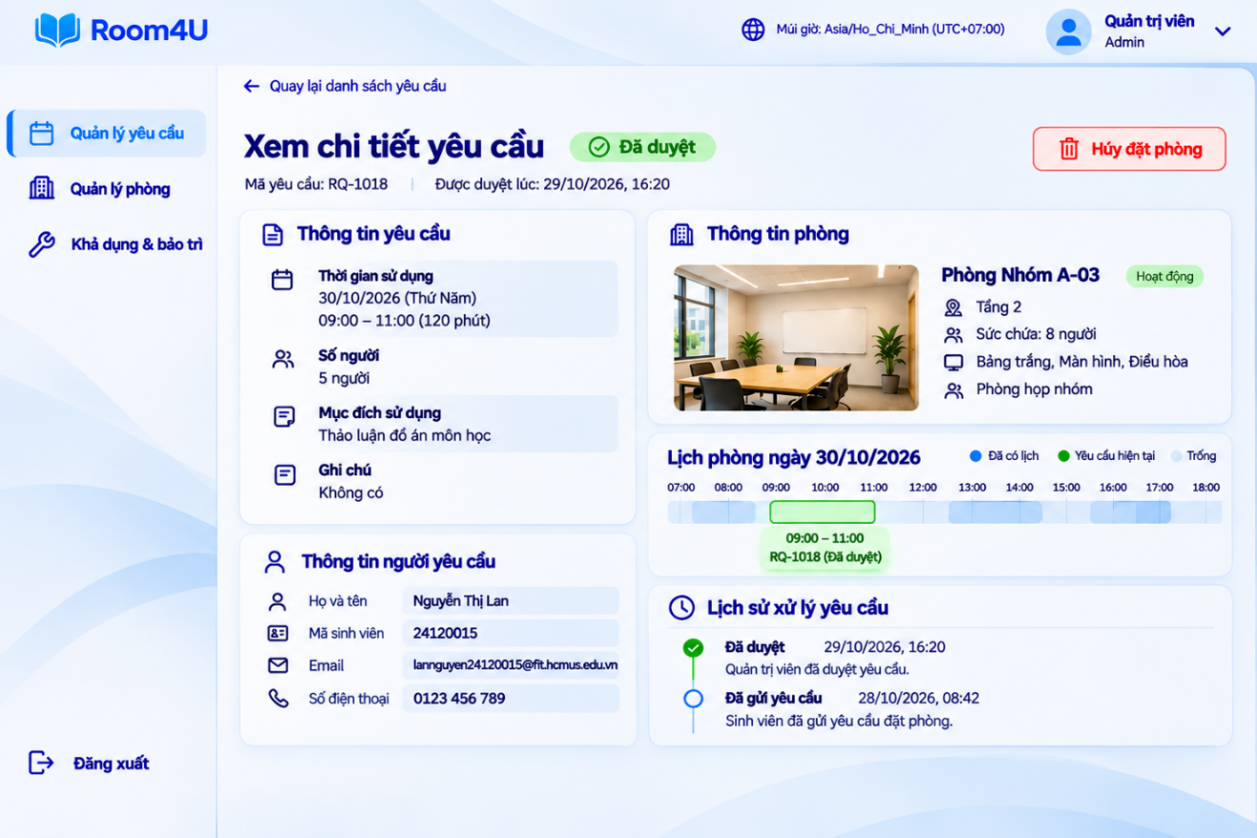
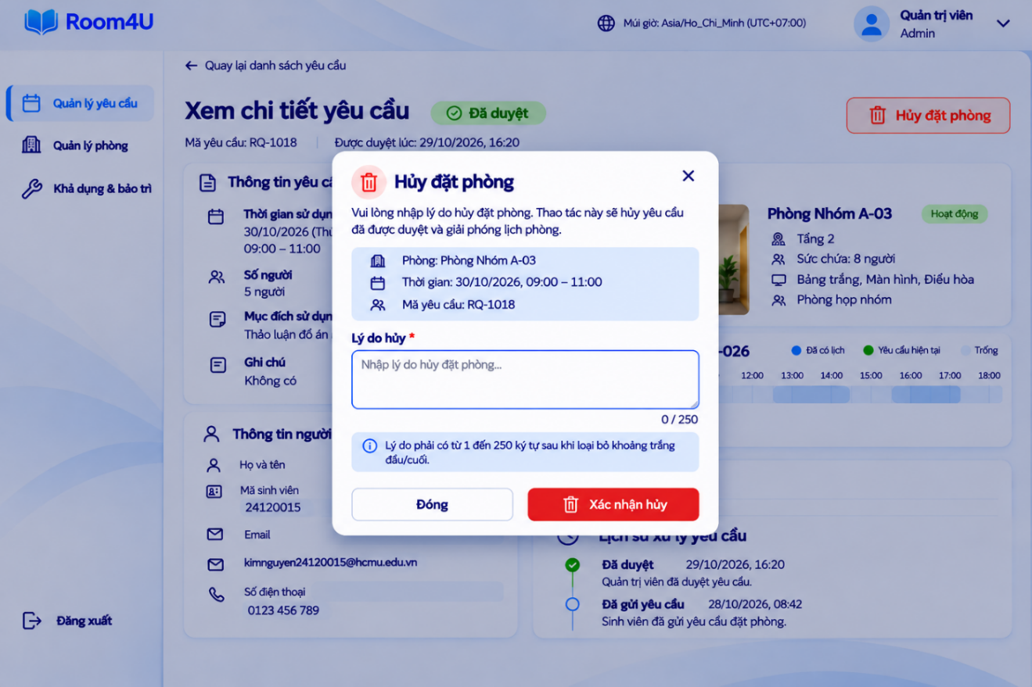

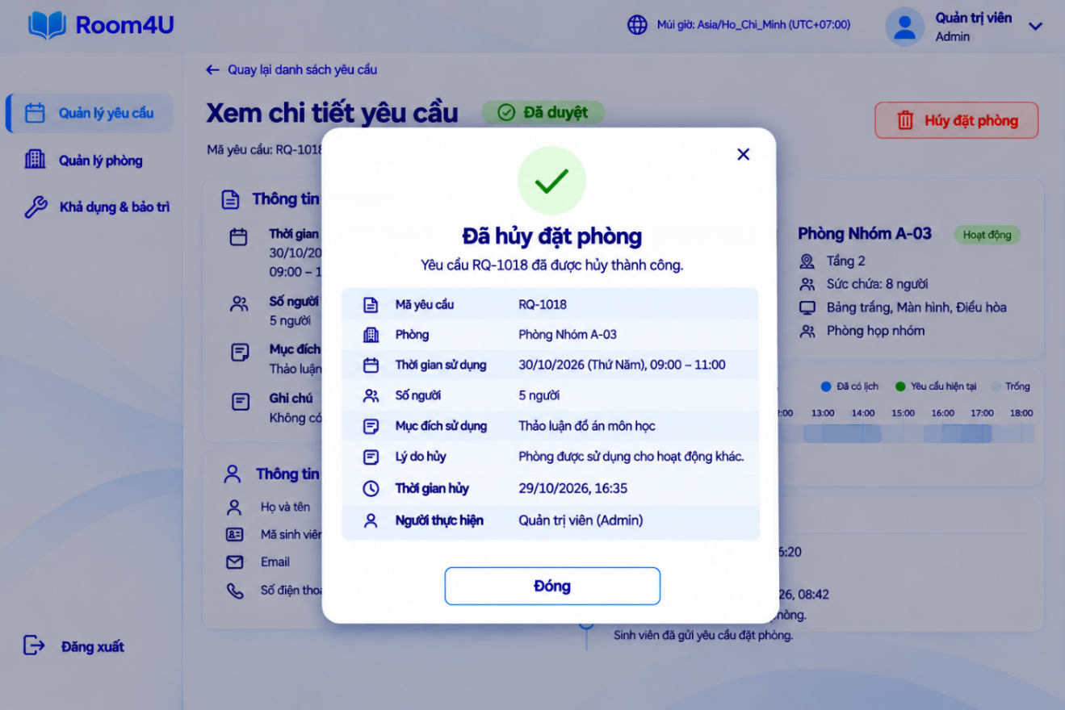
Approved Booking Cancellation: The administrator can initiate cancellation from the Approved Request Details screen when the applicable conditions allow it. A cancellation dialog requests a reason and asks the administrator to confirm. The reason must contain 1–250 characters after trimming leading and trailing whitespace (BR-13). After confirmation, the request is updated to Cancelled and the interface displays the result and relevant booking information.

S06.3 – Rejected Request Details:
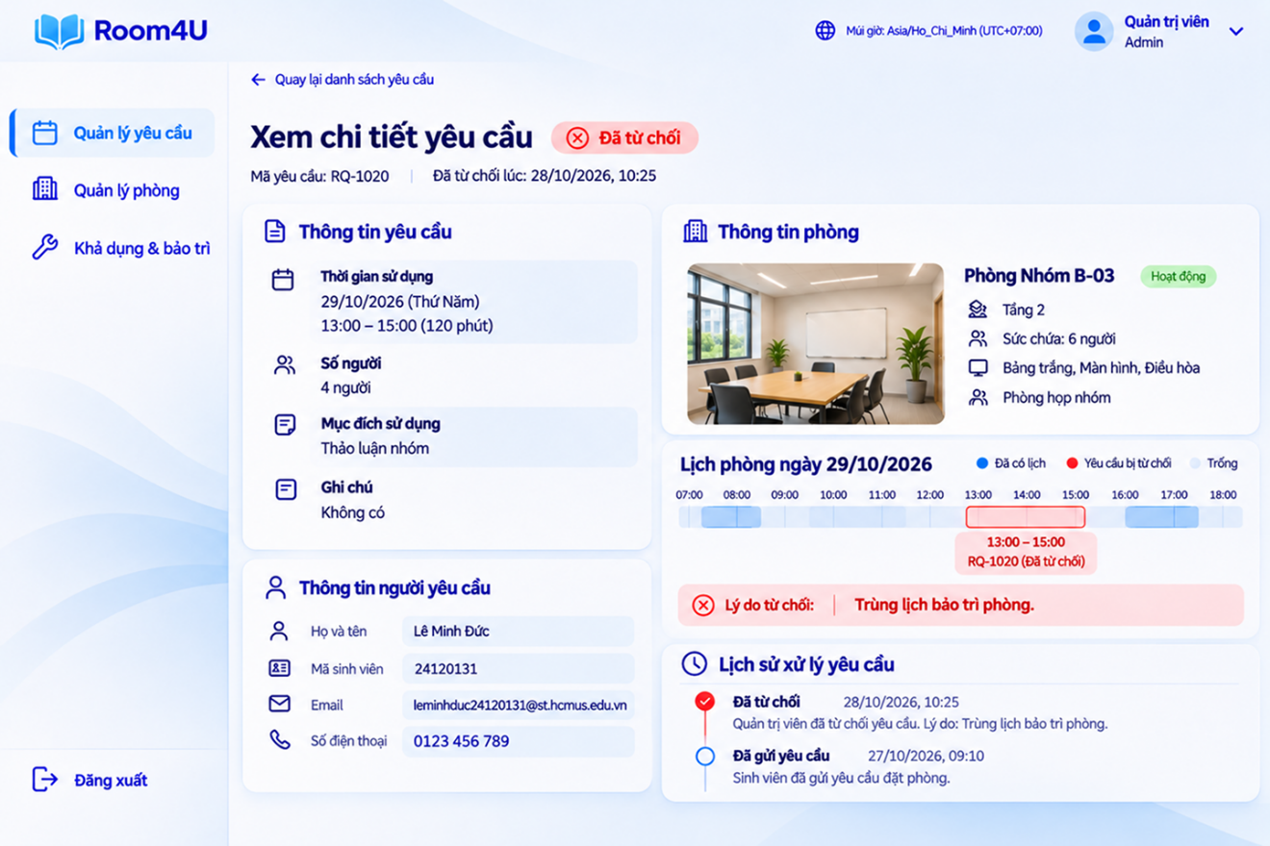

S06.4 – Cancelled Request Details:
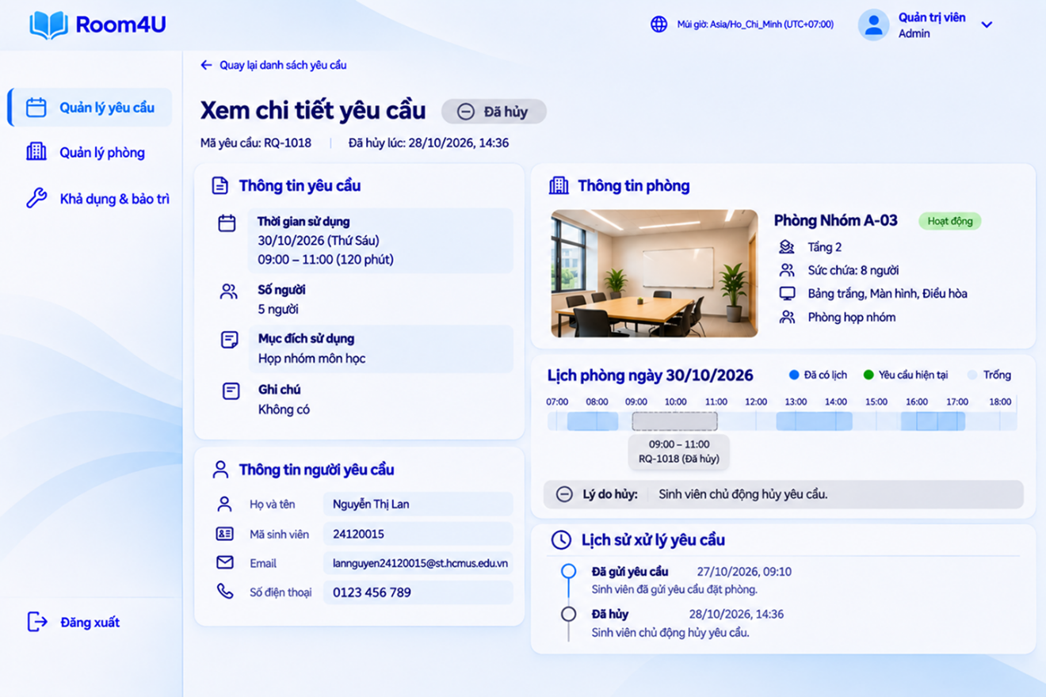

9.2.2.3. S07 - Room Management
- Description: This screen allows administrators to manage room records and monitor each room's current status. Summary cards show the total number of rooms and the counts of Active, Under Maintenance, and Suspended rooms. Administrators can search for a room and filter the list by floor or status. The room table and detail panel show the room code, room name, floor, capacity, equipment, description, and status. Available actions include adding a room, editing room information, and suspending or resuming a room, subject to the system rules.
- Mockup View: 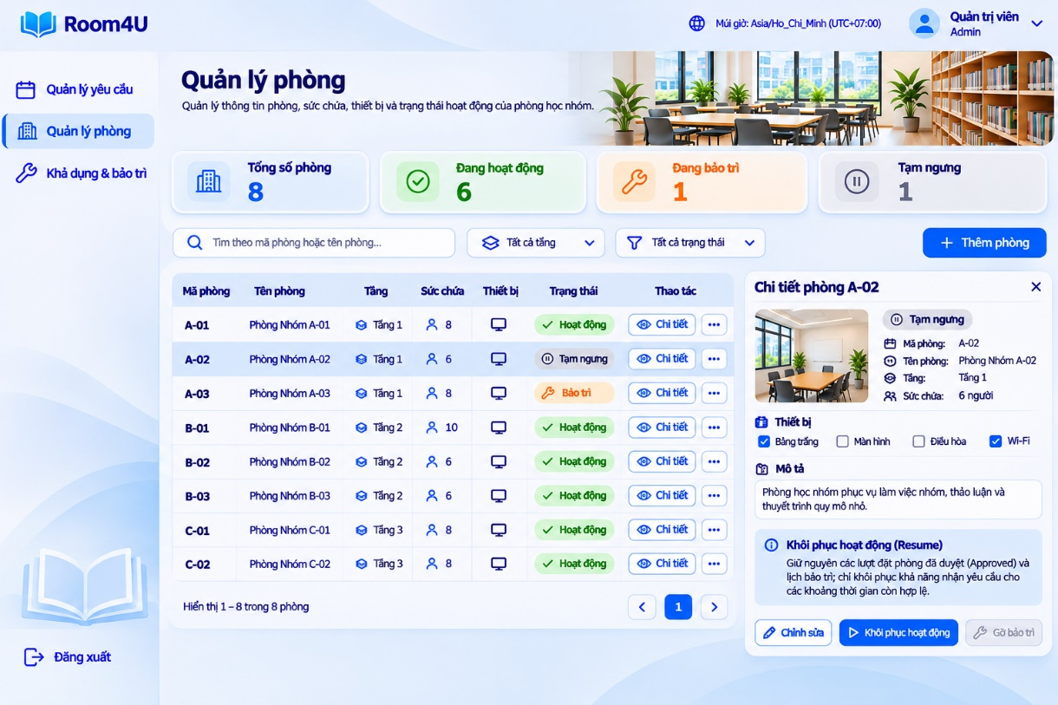
Room Creation: The Add Room dialog collects a unique room code, room name, floor, capacity, equipment selections, and an optional description. The room code must be unique without case sensitivity after leading and trailing whitespace are removed. Capacity must be an integer from 1 to 50. The description is optional and limited to 250 characters. After a valid submission, a success dialog confirms that the new room has been added and shows its key details.
Room Editing: The Edit Room dialog displays the selected room's existing information for update. The room code is shown as an identifier and is not edited in this flow. Administrators can update the room name, floor, capacity, equipment, and optional description. After a valid update, a success dialog confirms that the room information has been updated.
Suspend and Resume: The room detail panel provides the applicable room-status action. When a suspended room is resumed, existing Approved bookings and maintenance schedules are preserved. Resume restores the ability to receive new booking requests only for time periods that remain valid; it does not cancel, modify, or overwrite existing bookings or maintenance records.

9.2.2.4. S08 - Room Availability and Maintenance
- Description: This screen allows administrators to inspect room usage and manage maintenance schedules. The interface separates the room-usage calendar from the maintenance schedule so that Approved bookings and maintenance records can be reviewed without confusing their meanings.
  - Room Usage History: Administrators can inspect room schedules in the available calendar views and identify Approved bookings, maintenance periods, and available time slots. The schedule is organized by room and date to support availability checks.
  - Maintenance Schedule: Administrators can view existing maintenance records, create a maintenance schedule, inspect its details, and remove its effect when eligible. A maintenance record identifies the affected room, start and end time, reason, and status. The maintenance list provides view and remove actions; an edit action is not included in the current UC-13 flow.
  - Maintenance Rules and Removal Flow: To create a maintenance schedule, the administrator specifies the room, start time, end time, and reason. The system rejects creation if the requested period overlaps an Approved booking or an active maintenance period. Creating maintenance does not automatically cancel or modify an Approved booking. To remove a schedule's effect, the administrator selects a block that is Active and has not started, reviews the information, and confirms the action. On success, the system removes the block's effect on availability, updates the room schedule, and retains the maintenance record for reference. If the block has already started or no longer meets the eligibility conditions, the system displays an error and makes no change to the record.
- Mockup Views:
  - S08.1 – Room Usage History:
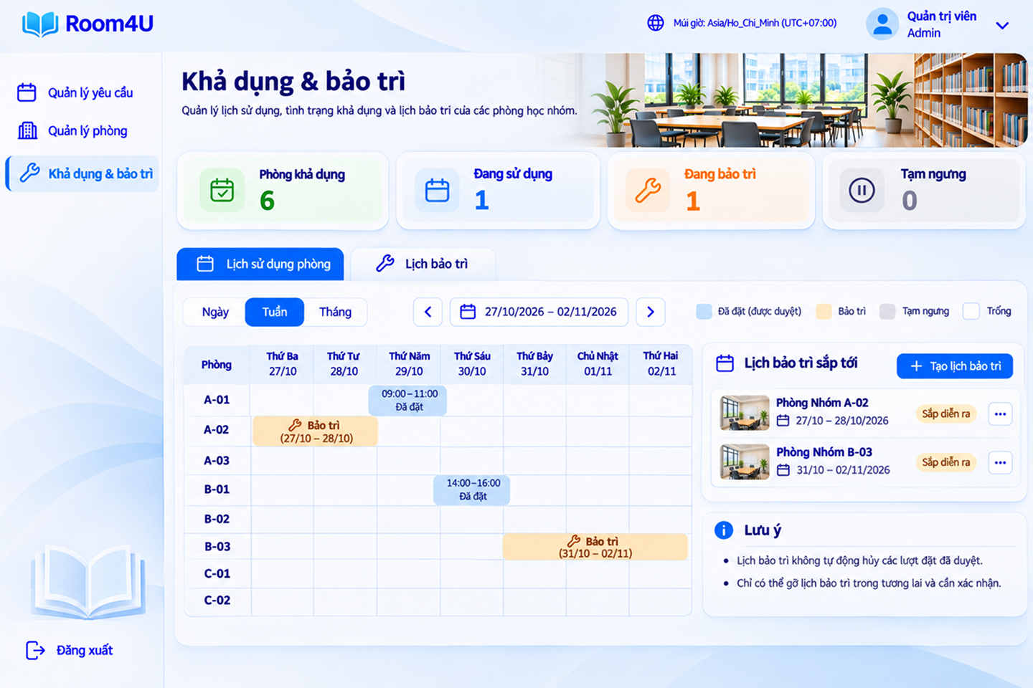

Create Maintenance Schedule: The creation dialog collects the room, maintenance date, start time, end time, and reason. The end time must be later than the start time. The system validates the selected interval against Approved bookings and active maintenance schedules before creating the record.
Maintenance List Actions: Each maintenance record can be viewed or selected for removal when eligible. The current flow does not provide an edit action. A successful removal deactivates the schedule's effect but retains its record; unsuccessful removal leaves the record and schedule unchanged.

  - S08.2 – Maintenance Schedule:
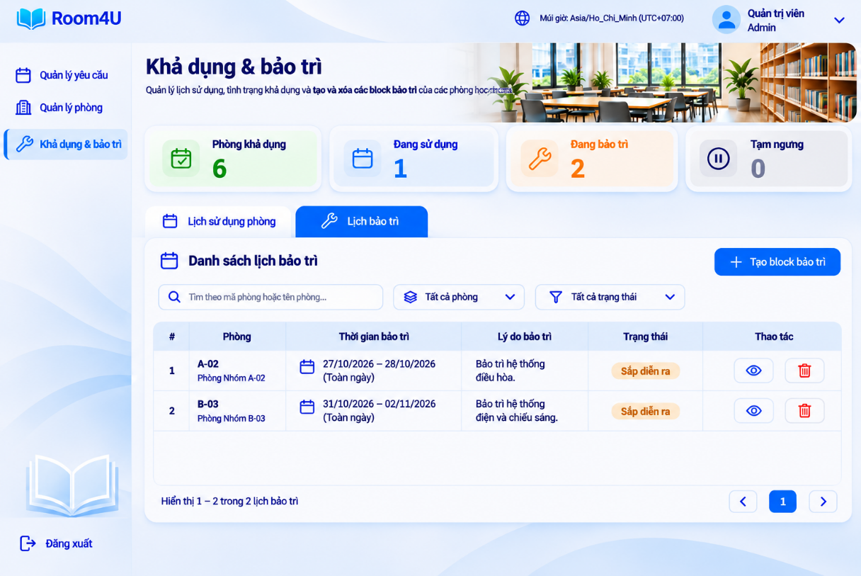

Case 1 – Removal Not Allowed: The maintenance schedule has already started. The system explains that the schedule is no longer eligible for removal, provides the room and schedule details, and offers a Close action. The record and its effect remain unchanged.
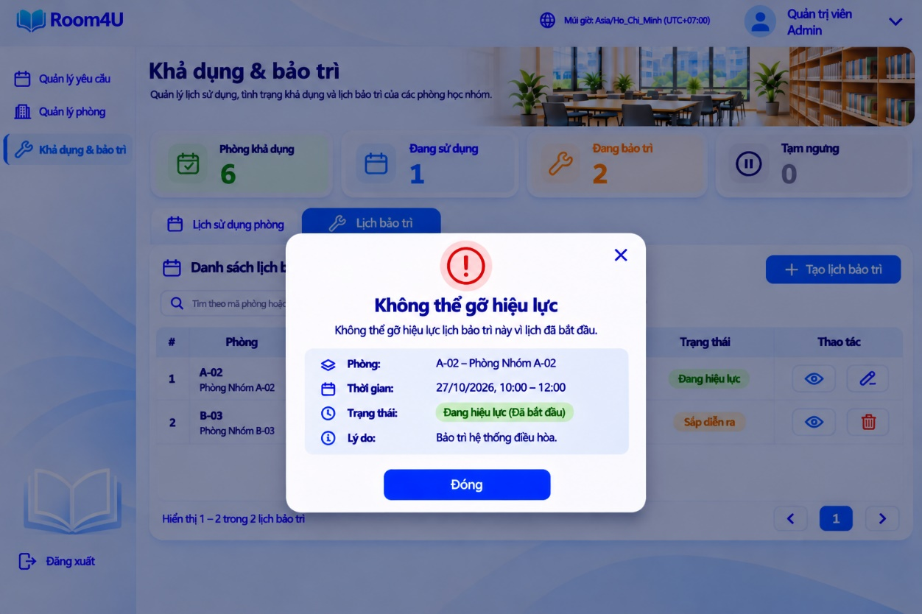

Case 2 – Creation Not Allowed — Conflicting Approved Booking: The system rejects the creation because the requested maintenance period overlaps with an existing Approved booking (FR-25). The dialog displays the affected room and conflicting time periods. No new maintenance record is created, and existing bookings remain unchanged.
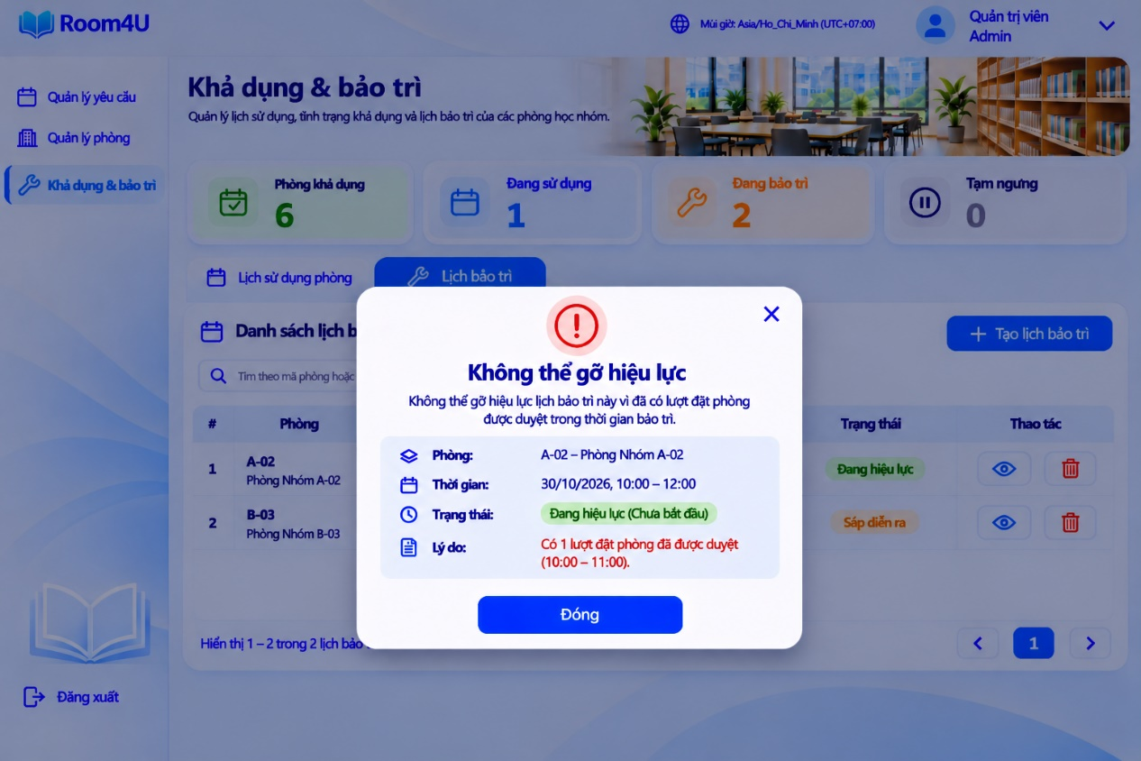

9.3. Accessibility Considerations
Color and Status Indicators: The blue-and-white palette maintains a consistent visual hierarchy. Statuses use distinct text labels and supporting icons as well as color, so meaning is not communicated by color alone.
Input Labels and Feedback: Form fields use visible labels and helpful placeholders. Required fields and validation messages should be clearly identified, especially for booking submission, rejection reasons, room creation and editing, and administrator cancellation reasons.
- Keyboard and Focus: Interactive controls such as buttons, search fields, form inputs, navigation items, and dialogs should have a logical keyboard order and a visible focus state during implementation.
- Keyboard Navigation: Interactive elements, including buttons, input fields, dropdowns, and navigation links, should support keyboard navigation to improve accessibility and usability.
- Dialog Feedback: Confirmation, success, and error dialogs should have clear titles, concise explanations, and action labels that describe the outcome. Error dialogs should explain why an operation is blocked and confirm that the underlying record remains unchanged.

