7 Use Case Model

7.1 Use case diagrams
Figures 1 and 2 are two views of the same Room4U boundary. Student and Administrator both use UC-01–03. The Administrator view continues with UC-07–13. Actors represent external roles, not the development team or the database.
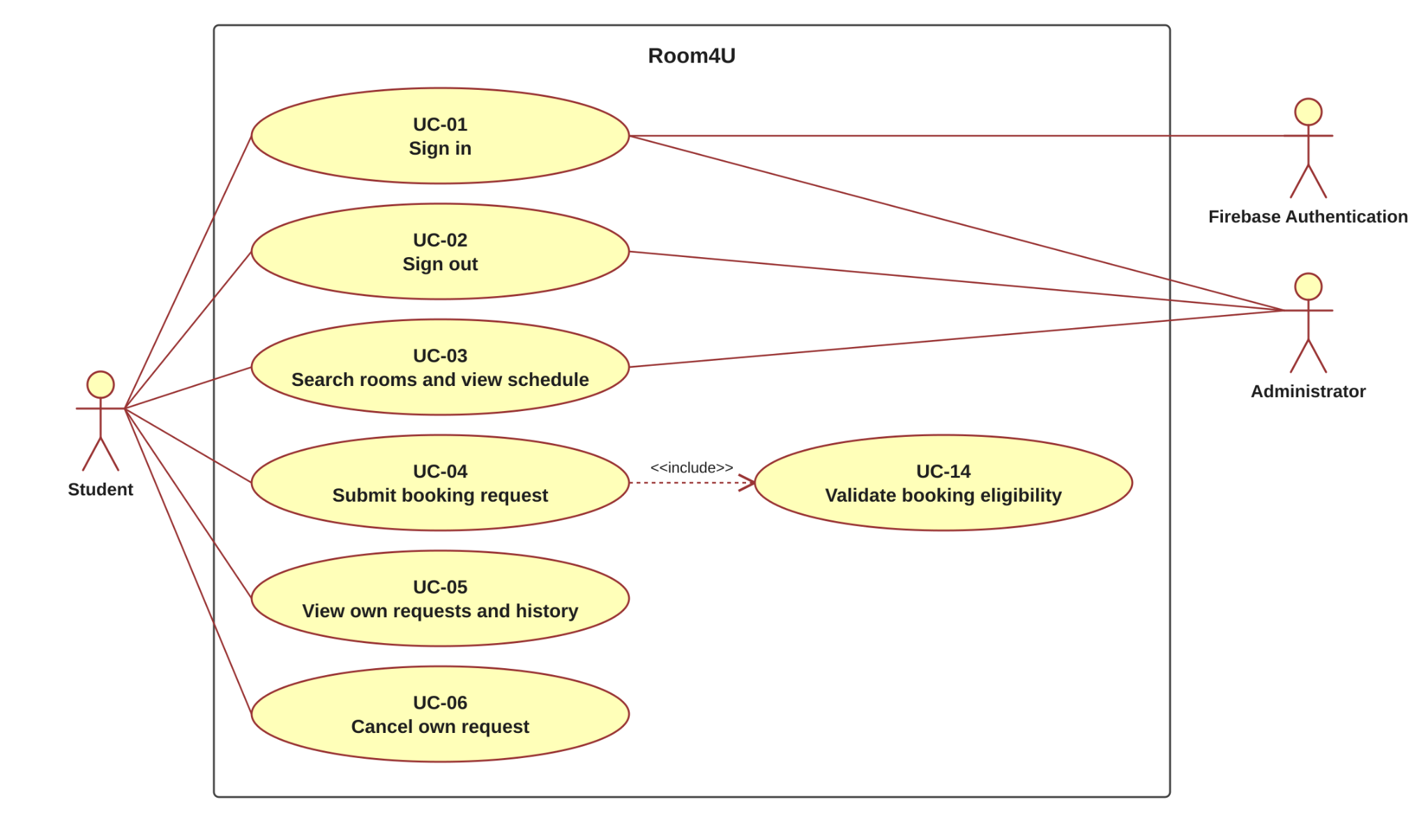
Figure 1 Student workflows and shared session and room access
The dashed include arrow points from UC-04 to UC-14 because every submission validates eligibility. UC-14 is internal included behavior and has no direct user association. Preconditions such as being signed in are not modeled as repeated include relationships.

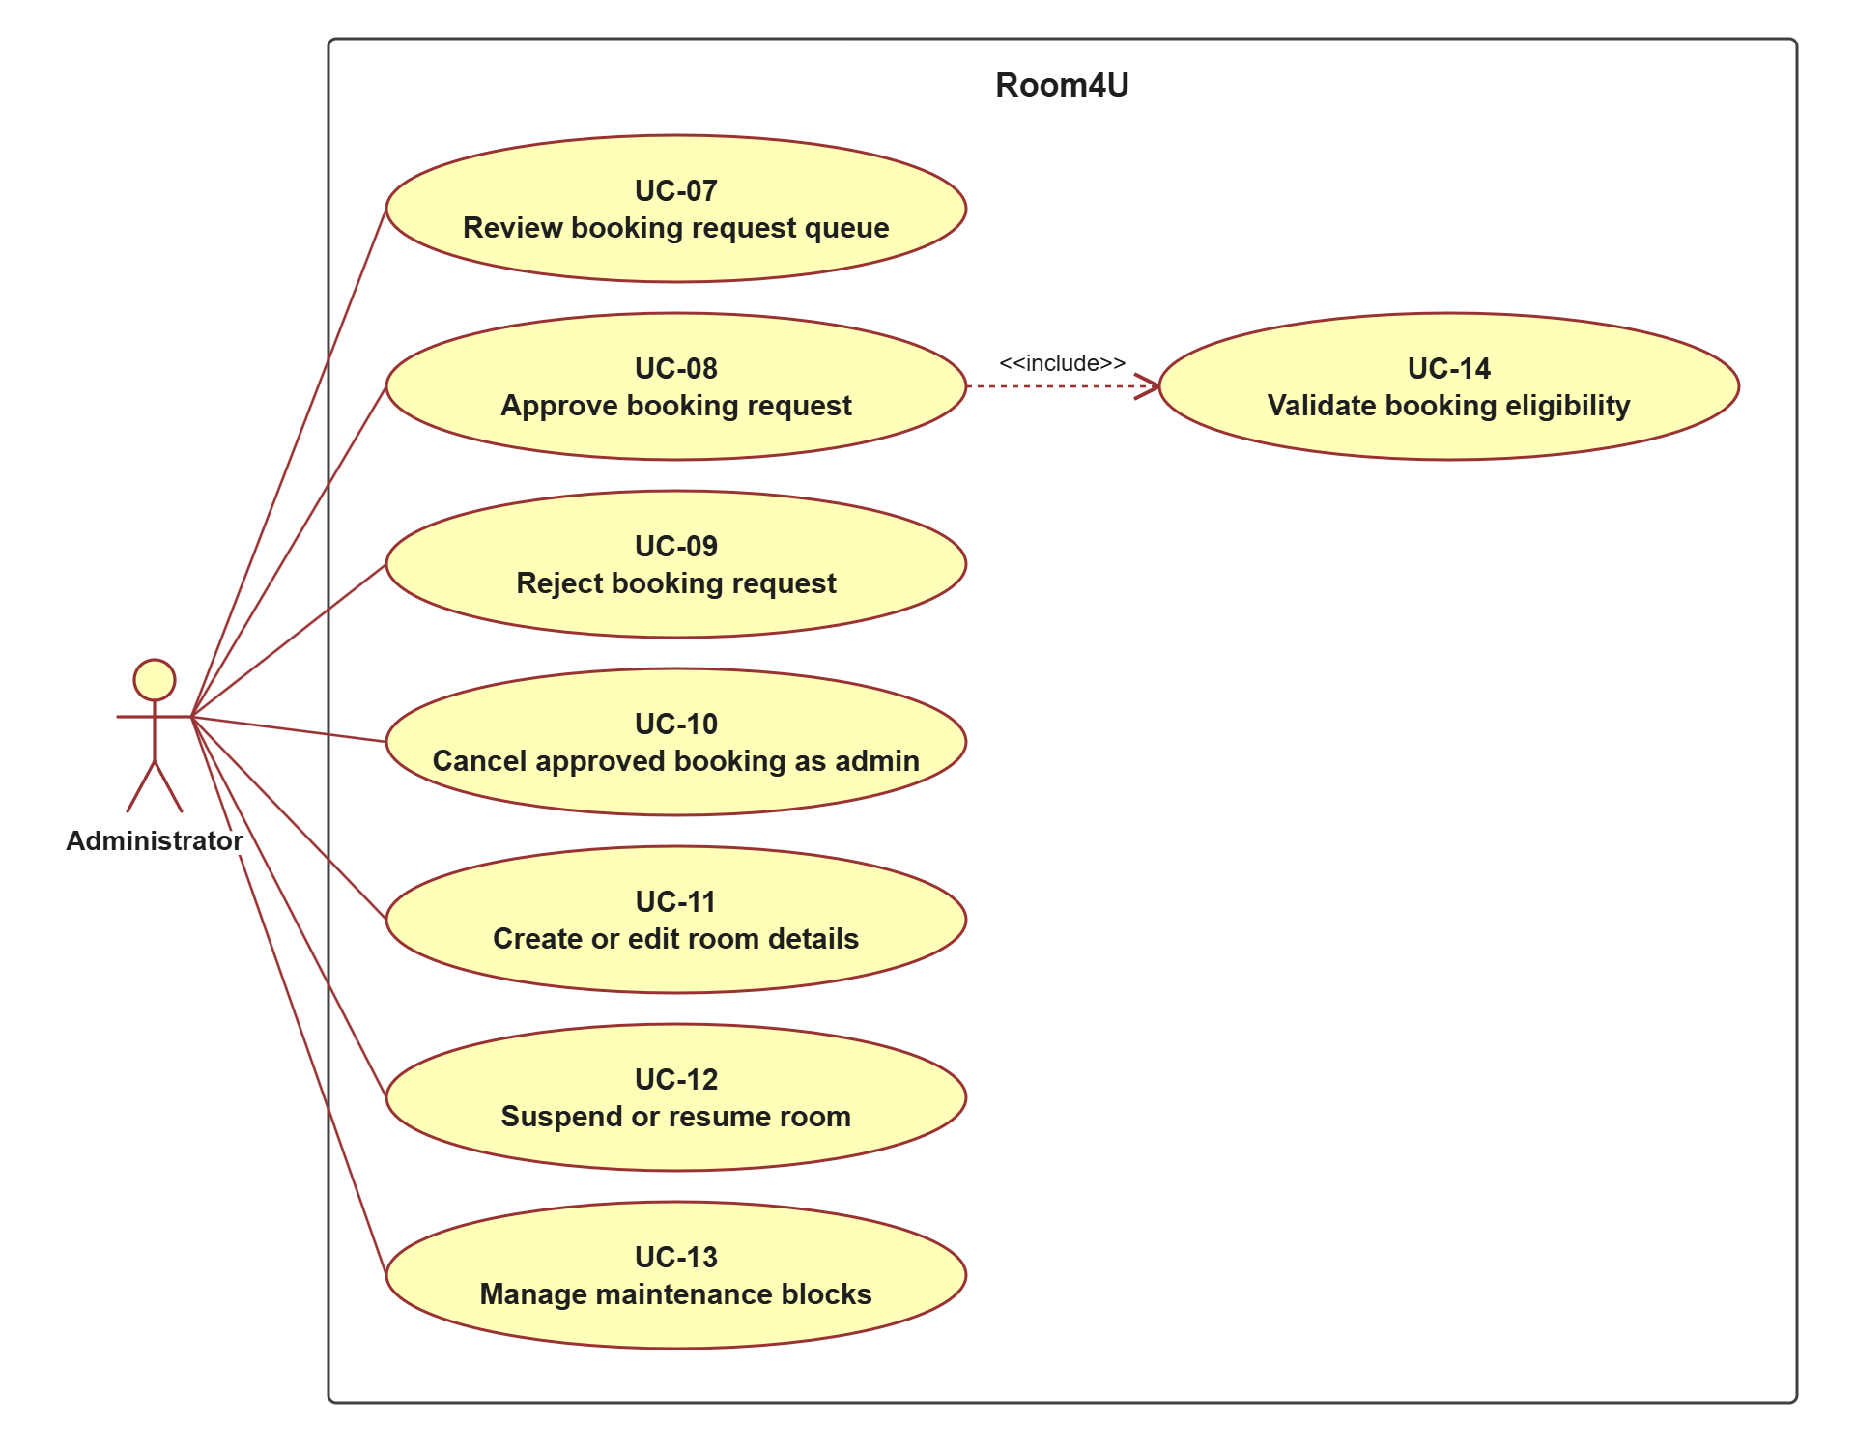
Figure 2 Administrator workflows for requests, rooms and maintenance
UC-08 includes UC-14 for every approval. Rejection, cancellation and maintenance management are separate user goals; they are not unconditional includes of approval. No extend relationship or actor generalization is needed for the specified behavior.

7.2 Actors
Actor | Responsibilities
Student | Uses an account created in advance; searches rooms and views schedules; submits, views and cancels only their own booking requests.
Administrator | Reviews, approves, rejects and cancels booking requests; manages rooms and maintenance blocks; also searches rooms and views schedules. May work in several windows at the same time.
Firebase Authentication | External system that checks a user's sign-in credentials. It takes part in UC-01 only; Room4U itself decides the user's role and what the user may see.

The backend and PostgreSQL are internal parts of Room4U and are not use case actors. The instructor and TA are project stakeholders, not product actors.

7.3 Use case list
ID and use case | Primary actor | Priority and related FR
UC-01 Sign in | Student or Administrator | Must  FR-01–FR-03
UC-02 Sign out | Student or Administrator | Must  FR-05
UC-03 Search rooms and view schedule | Student or Administrator | Must  FR-06–FR-09, FR-27
UC-04 Submit booking request | Student | Must  FR-10–FR-11, FR-19
UC-05 View own requests and history | Student | Must  FR-04, FR-12, FR-19
UC-06 Cancel own request | Student | Must  FR-04, FR-13, FR-19
UC-07 Review booking request queue | Administrator | Must  FR-03, FR-14, FR-19
UC-08 Approve booking request | Administrator | Must  FR-15, FR-16, FR-19
UC-09 Reject booking request | Administrator | Must  FR-17, FR-19
UC-10 Cancel approved booking as administrator | Administrator | Must  FR-18, FR-19
UC-11 Create or edit room details | Administrator | Must  FR-20, FR-21, FR-27
UC-12 Suspend or resume room | Administrator | Must  FR-16, FR-22–FR-23, FR-27
UC-13 Manage maintenance blocks | Administrator | Must  FR-16, FR-24–FR-27
UC-14 Validate booking eligibility | None (included by UC-04 and UC-08) | Included Must behavior  FR-10, FR-15, FR-16, FR-22

