Project Documentation

Deep Research AI Agent System

Date: 2 March 2025

**Overview:**

DeepCrawl-A Deep research ai agent system is a web crawling application designed to performin-depth research on user-provided queries. It leverages Tavily for web crawling, a dual agent system for data collection and answer drafting, and LangGraph/LangChain frameworks for organizing information. The system uses the Hugging Face Inference API for natural language processing and is deployed via Streamlit Community Cloud with a custom interface hosted on GitHub.

**Purpose:**

This project fulfills the given problem statement

"Design a Deep Research AI Agentic System that crawls websites using Tavily for online information gathering. Implement a dual-agent (or more agents) system with one agent focused on research and data collection, while the second agent functions as an answer drafter. The system should utilize the LangGraph & LangChain frameworks to effectively organize the gathered information."

**Features:**

1. Web Crawling: Uses tavily to gather data from web.
2. Dual-agent system: Research agent collects data, Drafting agent generates answer.
3. Framework Integration: LangGraph oversees the workflow, LangChain handles all the tools.
4. Deployment: Hosted on streamlit community cloud via github.

**Requirements:**

* Python: 3.9 or higher
* Streamlit
* HuggingFace and Tavily API keys.

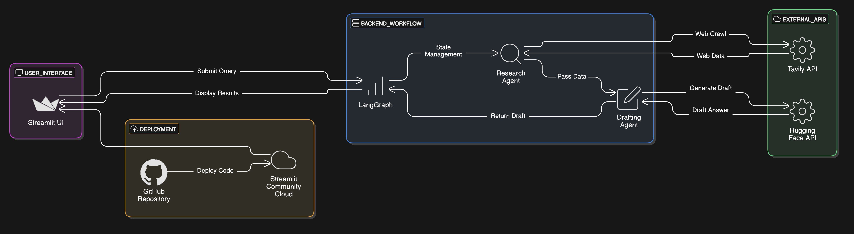**System Architecture:**