**Steps Followed:**

Tech Stacks Used:

* **Snowflake (Database)**
* **DBT (Data Build Tool)**
* **Preset (Dashboard)**
* **Setting up Snowflake Account**

1. Create Snowflake Account.
2. Created DBT user and assigned a role for DBT connection. (Code added)
3. Created PRESET user and assigned REPORTER role for Preset Connection. (Code added)

* **Setting up DBT**

1. Created GIT repository.
2. Created Virtual environment and activated it.
3. Installed below package.
   1. **pip install dbt-snowflake** (As my database is snowflake)
   2. **pip install pandas** (Used for Data Profiling)
4. Test if the installation is proper.  
   A screen shot of a computer

   Description automatically generated
5. Setting up DBT
   1. Setup dbt user profile by following command.
      1. **mkdir %userprofile%\.dbt** (Establishes connection with snowflake)
   2. create a dbt project with below command.
      1. **dbt init <project_name>** (creates a new folder in repository)
      2. Select database you want to use. (In my snowflake was present).
      3. Enter snowflake account <xxx-xxx>
      4. Give user name / password / warehouse / database / schema / threads (I used one) (same as the user created in the snowflake)
      5. Run command **dbt debug** (to check everything is configured correctly).

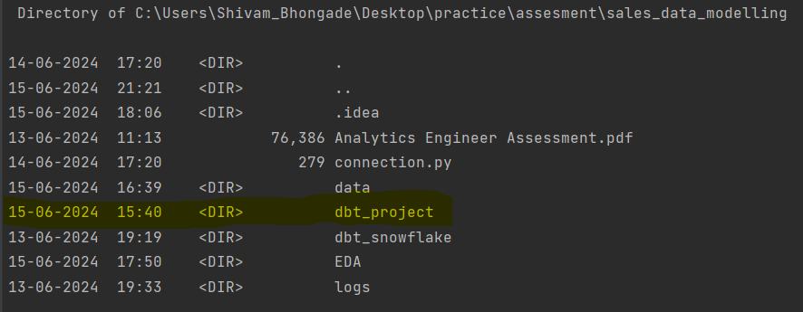

* **Setting up Preset**

1. Created workspace
2. Created connection to database. (By adding same details as given in snowflake end)

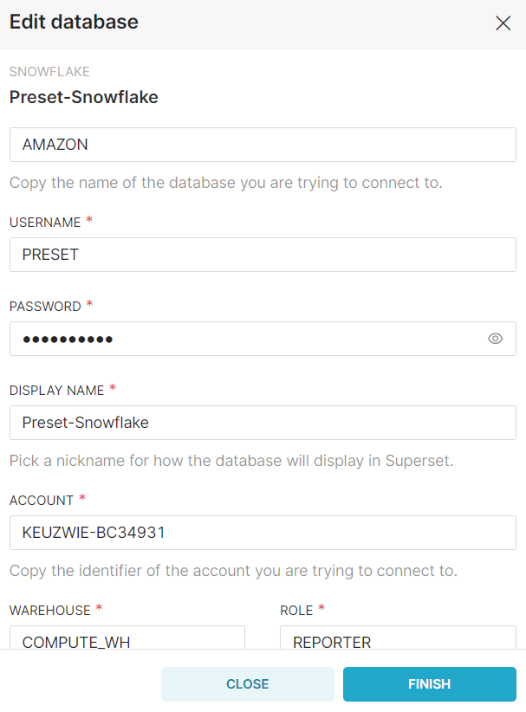

1. Import dataset from database.
2. Create Chart and Dashboard.  
   