**Graphics and Animation Tools LAB**

BACHELOR OF TECHNOLOGY

in

COMPUTER SCIENCE AND ENGINEERING

with specialization in ***Open Source and Open Standards***

Submitted by

**Student Name – Nakul Garg**

**Roll No - R100218032**

**SAP ID - 500069410**

Submitted to

***Mr. Durgansh Sharma***

***Assitant Professor,Department of Cybernetics***



**SCHOOL OF COMPUTER SCIENCE**

UNIVERSITY OF PETROLEUM & ENERGY STUDIES

Bidholi Campus, Energy Acres, Dehradun – 248007.

**Febuarary - 2020**

Table of Contents

Experiment – 1 3

Aim : Installation of GIMP 3

Experiment – 2 4

Aim : Design of UPES logo using GIMP 4

Experiment – 3 5

Aim : Design of Google logo using GIMP 5

Experiment – 4 6

Aim : Create your own animation using GIMP 6

**Cartoon Character** 6

**Creative Words** 7

# Experiment – 1

## Aim : Installation of GIMP

**GIMP**

Step 1: Open browser and visit “gimp.org “

Step 2: On the website, you will get the download button with the latest version number. Example “Download 2.10.14”, just click on it and you’ll be redirected to the download page. On the download page, there are two options “**Download GIMP via BitTorrent**” and “**Download GIMP Directly**”.

Step 3: After the download is completed, open the software and select “**Install of All Users“.**

Step 4: Now select your language and click on “**OK“.**

Step 5: Now if you want to customize the installation then click on **Customize**, accept the GNU GENERAL PUBLIC LICENSE and click “**Next**“. Or else click on “**Install**“.

Step 6: Select your installation location and click “**Next“**

Step 7: Select the components you want to install; clear the components you do not want to install. Click “Next” when you are ready to continue.

Step 8: Select “**Create a Desktop icon**“, review the installation and click on “**Install“**. The installation process will take some time, so wait until the installation completely.

# Experiment – 2

## 

## Aim : Design of UPES logo using GIMP

Step 1-Create a new layer and make different layers for different work so that you can undo your wrong work.

Step 2-Divide your screen in four equal quadrants to get the exact Centre of the screen using guide tool: Horizontal 50% and Vertical 50%.

Step 3-Draw a circle by pressing CTRL Shift and then make that circle a path by selecting the To Path in select menu.

Step 4-Now according to UPES logo write University with a Purpose in circular path by selecting the text in different layer ‘text along path’.

Step 5-Now design the structure of UPES logo by tracing with the picture using path tool.

Step 6-Your logo is ready and save it.

Output :



# Experiment – 3

## Aim : Design of Google logo using GIMP

Step 1-Download the picture of google logo and trace it using different layers and Path tool.

Step 2-Using path tool trace the exact logo on different layer.

Step 3-After tracing the logo as neat as possible fill the respective colors of the logo.

Step 4-Your logo is ready and save it.

Here is the logo :-

Output:

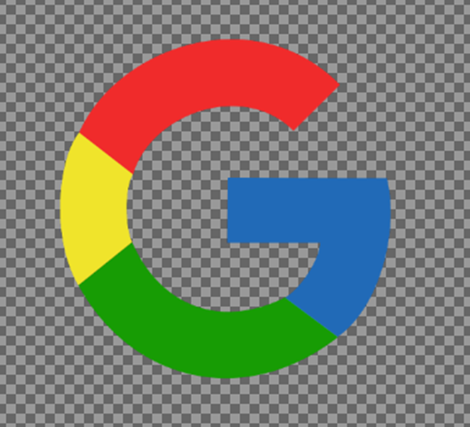

# 

# Experiment – 4

## Aim : Create your own animation using GIMP

### **Cartoon Character**

Step 1-First select your favorite cartoon character as mine is ‘HAGERAMARU’.

Step 2-Now download the picture of your cartoon and trace it using different layers and

Path tool.

Step 3-After tracing the whole cartoon fill the respective colors.

Step 4-Your cartoon is ready and save it.

Output :



### **Creative Words**

Step 1-Create a new layer to start designing the artifacts.

Step 2-Create many layers so that we can work on different layers for every effect.

Step 3-Using text tool write your words.

Step 4-Using brush tool make them a unique look so that they can describe themselves.

Step 5-Using stroke tool stroke your shapes so that they can look attractive.

Step 6-Fill different colors in background and foreground to make your designs look more attractive.

Here Are the Six Words That I have designed: -.

Output :

