Assignment: Statement of Applicability

Statement of Applicability
- It is required for the certificate and it’s to tell that which controls are and aren’t applicable to the organization’ ISMS
- Any control which excluded will be asked why and why for those your chose for your ISMS too. List of controls org selected to mitigate risk and state whether they fully implemented yet

Why is it matters
Just reason why you chose not to implement and implement to fulfil the requirements

It helps with risk assessment to security control
To address and respond to a threat which in identification step with treatment plan which is to implement security control to mitigate the risk

Easier time with auditor
Auditors know your objectives and aim to review and improve the ISMS. Data of SoA must match with the certification and always up to date

Provide Detail
Know why need to be implemented, for what and the how it works which can help mitigate risks you are aiming

Statement of Applicability Document Sample:

How to write ISO27001 SoA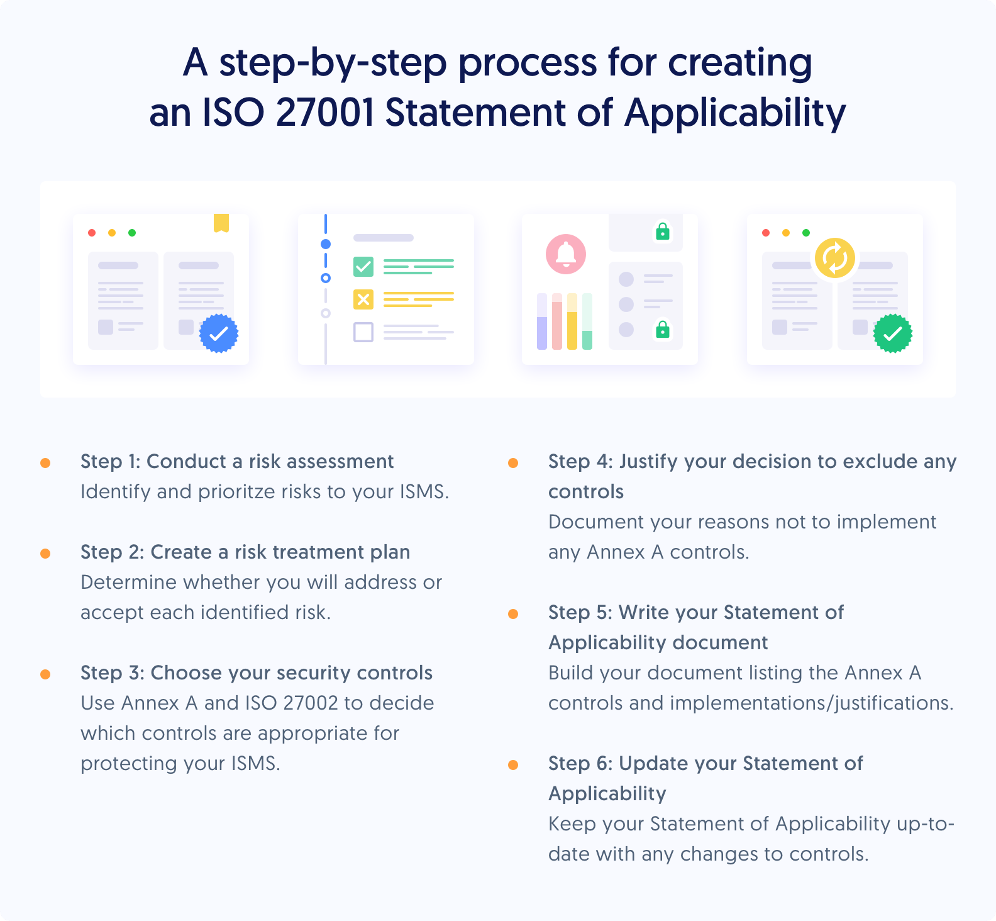

1. Identify and analyse risks to your ISMS
With all risk listed, know which one to prioritize based on likelihood and impact both assigning with a risk treatment to the risk owner and plan to close the VA
2. Define your risk treatment plan
Come up with security measure and document of the process with mitigating the risk and expected timeline to remediate any nonconformities. 4 standard risk treatment options:
- Mitigate with control to reduce likelihood or impact
- Avoid risk where it could happen
- Transfer the risk to insurance or 3rd party
- Accept risk when it’s in risk appetite range
3. Select security controls from Annex A
Use control from Annex A to mitigate (weak password: strong password policy)
4. Justify any excluded controls
List down the control which you exclude on the SoA to show auditor the reason and that you aware of the risk, just not applicable to your organisation
5. Complete your Statement of Applicability document
The Statement of Applicability lists all 93 Annex A controls, states whether each control is applied or not, explains why, shows related requirements (legal, business, compliance, etc.), and includes the implementation date
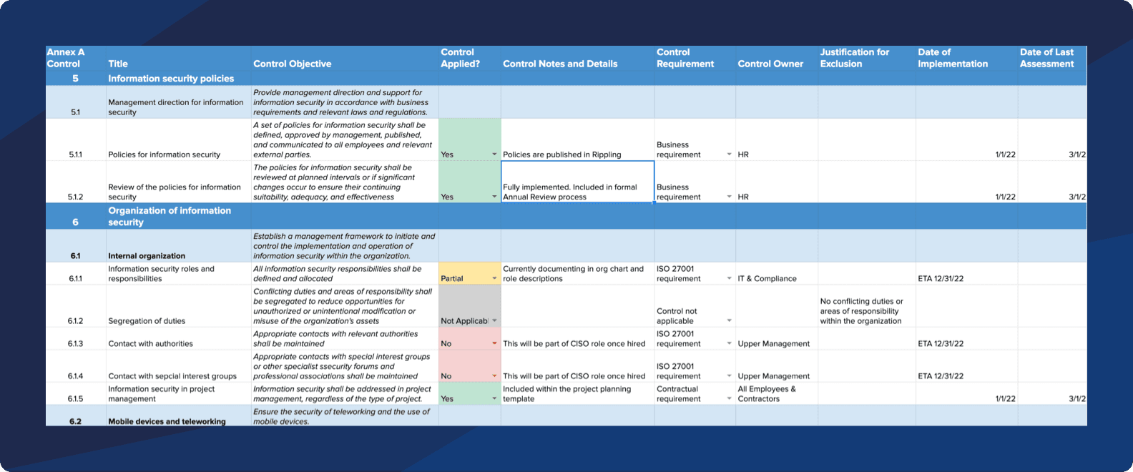
SoA must include:
- Control ID: The Annex A identifier (e.g., A.5.1)
- Control Name: The name or short description of the control
- Implemented?: Yes / No / Not Applicable
- Justification: Why the control was or wasn’t selected
- Implementation Status: Fully implemented, partially implemented, planned
- Control Owner: Person or role responsible
- Implementation Date: When the control was implemented
- Last Reviewed: When the control was last evaluated
- Requirement Type: Whether it supports a legal, contractual, business, or other requirement
- Related Risks: Reference to risk treatment or risk register (optional)

6. Keep your Statement of Applicability up to date
The Statement of Applicability must be kept updated regularly. As the organization improves its ISMS, controls may be reviewed, added, changed, or removed over time. Regular management reviews ensure the SoA reflects the current security controls in use.

