Computer assisted design

Pulse Width Modulation Generator with 555 timer

Student : Ursutiu Toma

Group : 2021/S2

Technical requirements:

|  |  |  |  |  |
| --- | --- | --- | --- | --- |
| Duty cycle[%] | Duty cycle[%] | Output signal amplitude[V] | Output signal amplitude[V] | F[Hz] |
| 60 | 90 | 2 | 8 | 5000 |

Content

1.Theoretical support

1.1Pulse width modulation

1.2Duty cycle

1.3IC 555

1.3.1 IC 555 timer pin diagram and description

2.Block diagram

3.Electrical schematic

4.Simulations

4.1Transient simulation

4.2Parametric simulation

4.3Monte Carlo simulation

5.List of parts

6.Calculus

7.Layout on the Printed Circuit Board

8.References

1.Theoretical support

1.1Pulse width modulation

**Pulse-width modulation** (**PWM**), or **pulse-duration modulation** (**PDM**), is a method of reducing the average power delivered by an electrical signal, by effectively chopping it up into discrete parts. This is useful when we use analog devices, which can take any value between 0 and 1, for example half-way to on, two-thirds the way on etc, and pair them with digital devices, microcontroller(MCU) for example who only take values of absolute 1 or 0. So we can translate analog input into digital input for an MCU by using an ADC(analog-to-digital converter) for example. PWM is a way to control analog devices with a digital output. It’s one of the primary means by which MCUs drive analog devices like variable-speed motors, dimmable lights, actuators and speakers.

1.2Duty cycle The term duty cycle describes the proportion of ‘on’ time to the regular interval, a low duty cycle corresponds to low power, because the power is off most of the time. We express duty cycle in percentages . For example, when a digital signal is on half of the time and off the other half of the time the digital signal has duty cycle of 50%.

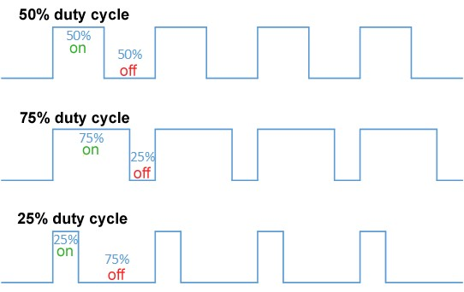

1.3IC 555

The 555 timer IC is an integrated circuit (chip) used in a variety of timer, delay, pulse generation, and oscillator applications. Derivatives provide two (556) or four (558) timing circuits in one package. The design was first marketed in 1972 by Signetics Since then, numerous companies have made the original bipolar timers, as well as similar lowpower CMOS timers. In 2017, it was said that over a billion 555 timers are produced annually by some estimates, and that the design was "probably the most popular integrated circuit ever made".

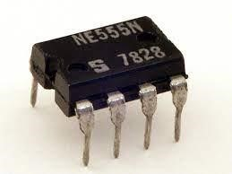

Signetics NE555 in 8-pin DIP package

1.3.1 IC 555 timer pin diagram and description

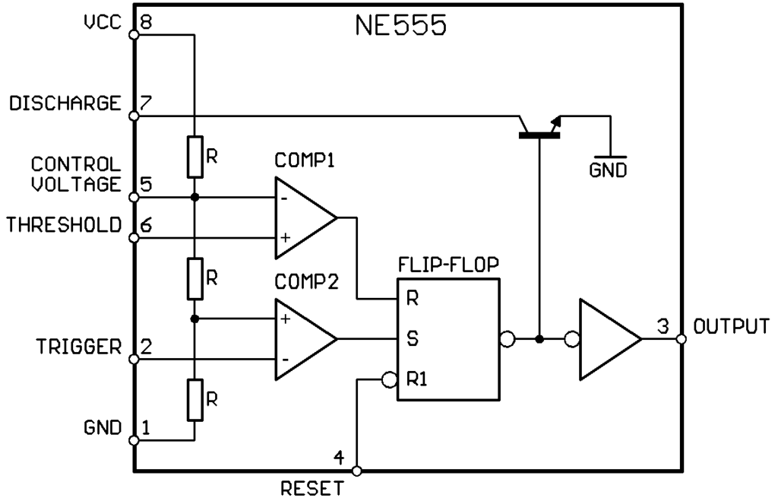

Internal block diagram of IC 555 timer

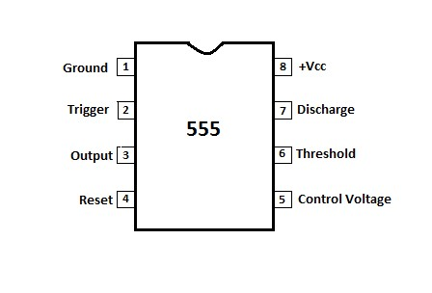

|  |  |  |
| --- | --- | --- |
| Pin Number | Pin Name | Pin Function |
| 1 | Ground | Pin 1 connects the 555 timer chip to ground. |
| 2 | Trigger | Pin 2 is the trigger pin. It works like a starter pistol to start the 555 timer running.  The trigger is an active low trigger, which means that the timer starts when voltage on pin 2 drops to below 1/3 of  the supply voltage. When the  555 is triggered via pin 2, the output on pin 3 goes high. |
| 3 | Output | Pin 3 is the output pin. 555 timer's output is digital in nature. It is either high or low. The output is either low, which is very close to 0V, or high, which is close to the supply voltage that's placed on pin 8.  The output pin is where you would connect the load that you want the 555 timer to power. This may be an LED, in the case of a 555 timer LED flasher circuit. |
| 4 | Reset | Pin 4 is the reset pin. This pin can be used to restart the 555 timer's timing operation. This is an active low input, just like the trigger input. Thus, pin 4 must be connected to the supply voltage of the 555 timer to operate. If it is momentarily grounded, the 555 timer's operation is interrupted and won't start again until it's triggered again via pin 2. |
| 5 | Control Voltage | Pin 5 is the control pin. In most 555 timer circuits, this pin is simply connected to ground, usually through a small capacitor, about 0.01 µF capacitor. This capacitor serves to level out any fluctuations in the power supply voltage that might affect the operation of the timer.  Some circuits (though rare) do use a resistor between the control pin and Vcc to apply a small voltage to pin 5. This voltage alters the threshold voltage, which in turn |
|  |  | changes the timing interval. Most circuits do not use this capability, though. |
| 6 | Threshold | Pin 6 is the threshold pin. The purpose of this pin is to monitor the voltage across the capacitor that's discharged by pin 7. When this voltage reaches 2/3 of the supply voltage (Vcc), the timing cycle ends, and the output on pin 3 goes low. |
| 7 | Discharge | Pin 7 is the discharge pin. This pin is used to discharge an external capacitor that works in conjunction with a resistor to control the timing interval. In most circuits, pin 7 is connected to the supply voltage through a resistor and to ground through a capacitor. |
| 8 | Power Supply (Vcc) | Pin 8 is connected to the positive power supply voltage. 555 timer ICs need DC voltage in order to operate. This is the pin which connects to the DC voltage to power the 555 chip.  The voltage must be at least  4.5V and no greater than 15V. It's common to run 555 timer circuits using 4 AA or AAA batteries for 6V or a single 9V battery. |

2.Block diagram

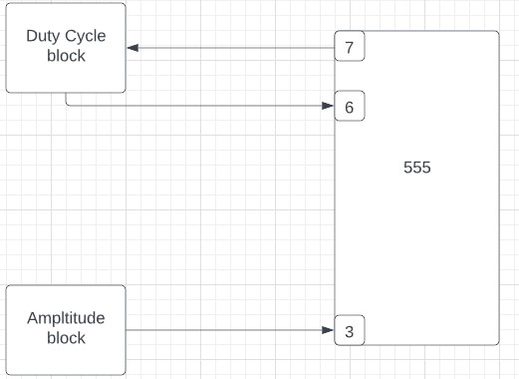

3.Electrical schematic

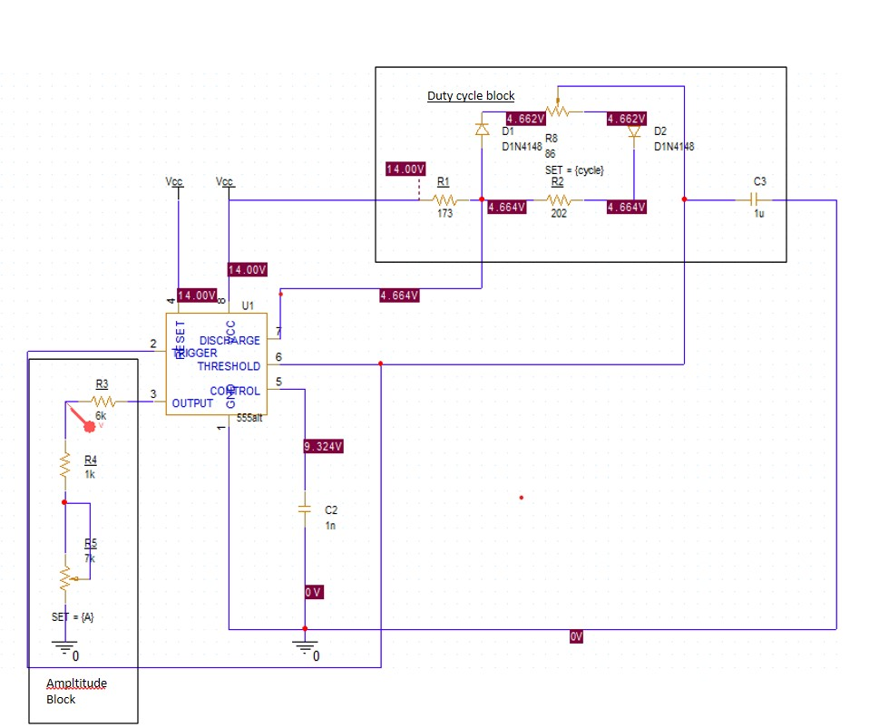

The circuit is supplied by a 14V DC source, from the datasheet we know that supplied voltage must be at least 4.5V and must not be greater than 15V. The supply is connected to pins 8(Power Supply) and 4(Reset).The current flows through R1 and then through R8 and it will start to charge the capacitor. While the capacitor is charging the output of the 555 timer is ‘1’. After the capacitor is fully charged the transistor located at pin 7 will discharge and the output will be ‘0’.

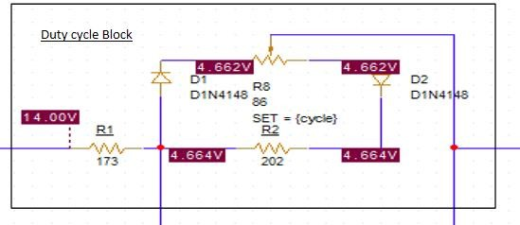

The duty cycles block responsibility is to set the duration of on/off time of the output signal. The values of the resistances and the potentiometer has been calculated from the formulas :

𝑇 = 𝑡𝐻 + 𝑡𝐿 = 0.693 ∗ (𝑅1 + 𝑅2 + 𝑃) ∗ 𝐶1 (1)

𝑡𝐻 = 0.693(𝑅1 + 1 ∗ 𝑃) ∗ 𝐶1 (2)

𝑡𝐿 = 0.693(𝑅1 + 0𝑃) ∗ 𝐶1 (3)

𝐶1 ~1𝑢𝑓

From (3) I found R1 = 173Ω. From (2) I found P = 83Ω.

From (1) I found R2 = 202Ω.

Amplitude block

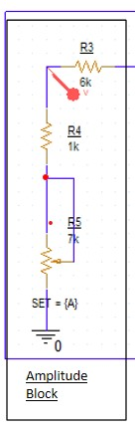

The values of the amplitude are set by using a voltage divider with two resistances and an potentiometer. The formulas from which I deduced the values of the R3 and R5:

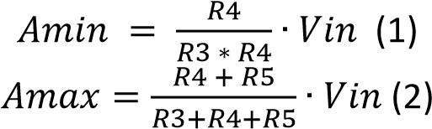

Amin = 2V.

Amax = 8V.

For easy deduction I choose R4 = 1kΩ.

From (1) I obtained R3 = 6∙R4.

From(2) I obtained R5 = 7∙R4.

4.Simulations

4.1 Time domain analysis.

The time domain analysis is necessary to observe the variation of the output signal over its duration. From the calculations I have deduced that my signal has a period of 0.2ms. For the analysis a period of 2ms has been chosen to observe the signal over 5 periods.

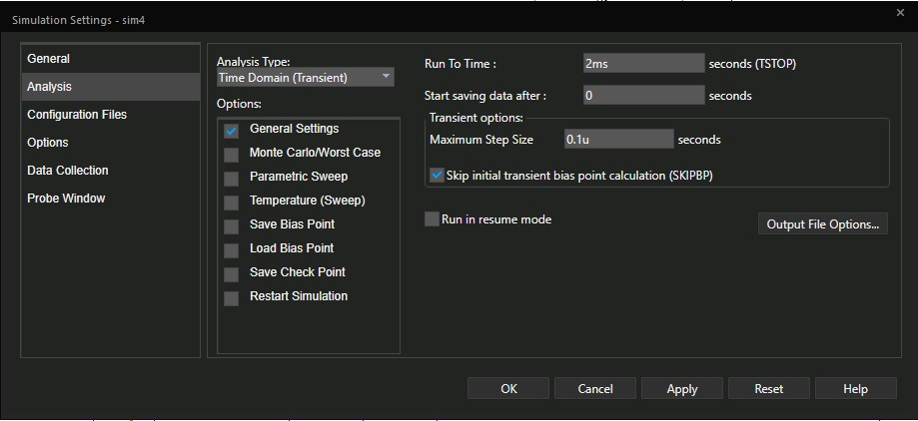

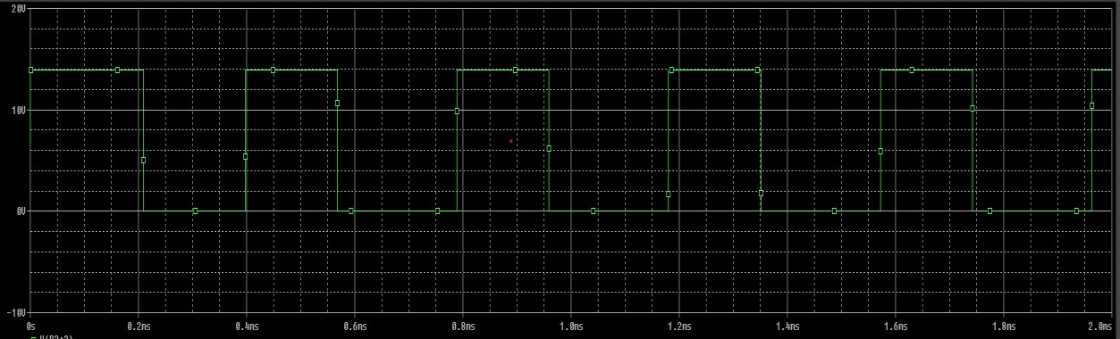

4.2Parametric Simulations

The parametric simulation is necessary because we need to observe how the potentiometers influence the duty cycle and the amplitude of our signal.

The first simulation is for the duty cycle, where the parameter that will change is the value of the potentiometer. From the requirements my duty cycle is between 60-90%. The low value corresponds to the potentiometer being fully closed, and the high value corresponds to the potentiometer being fully open.

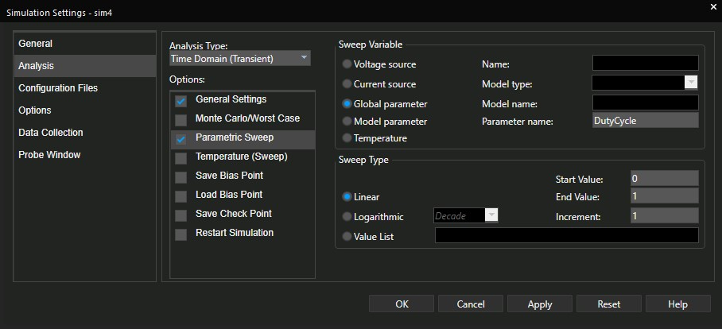

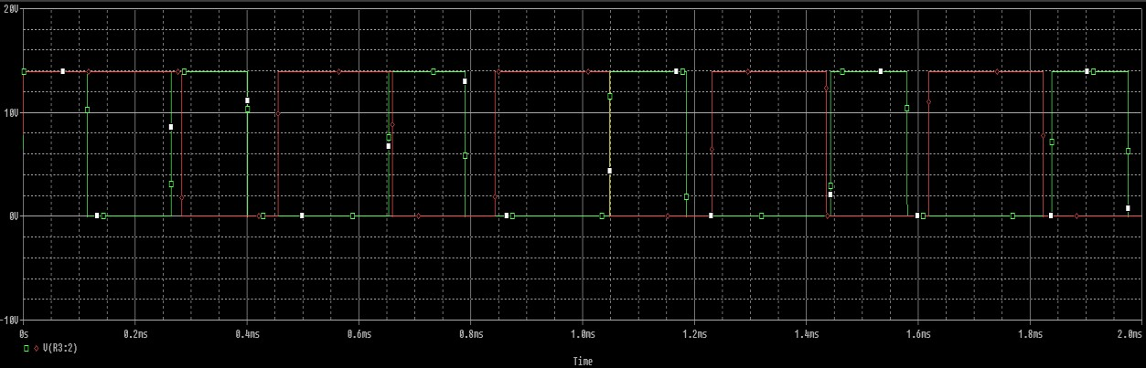

Red – value of the potentiometer is 1.

Green – value of the potentiometer is 0.

Another parametric analysis must be done to observe the variation in amplitude of the output signal due to the potentiometer. The value which will be changed during the simulation is the value of the potentiometer which can vary between 1(full closed) and 0(fully open).

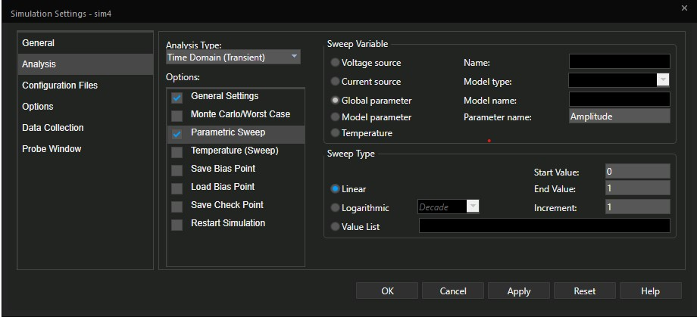

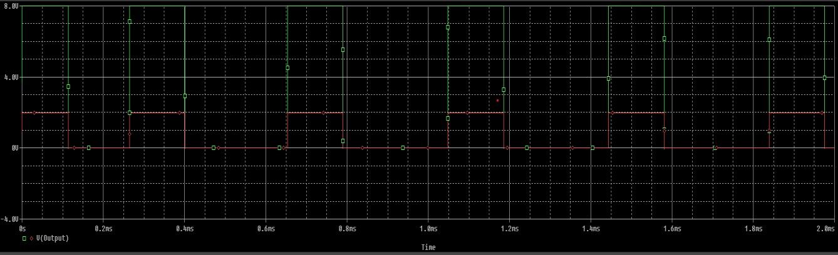

Red-potentiometer is fully closed.

Green – potentiometer is fully open.

4.3Monte Carlo/Worst Case simulation.

The Monte Carlo analysis is a type of statistical analysis , which shows us the circuits behaviour when values of the components are changed in their tolerance domain. Below is the same circuit with the values of the resistances shown.

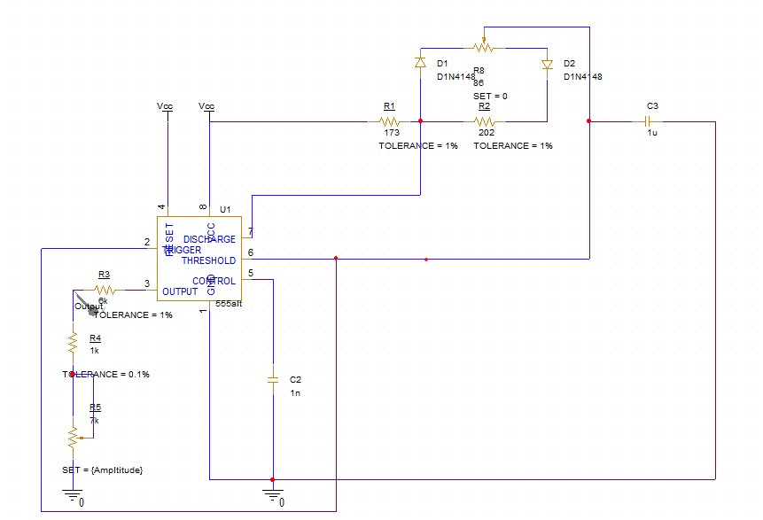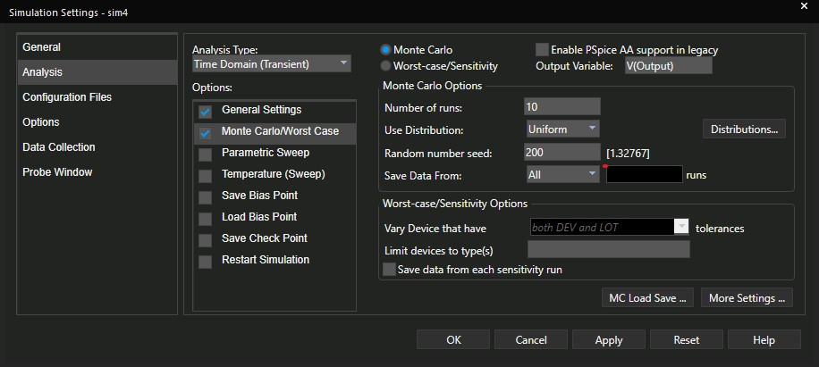

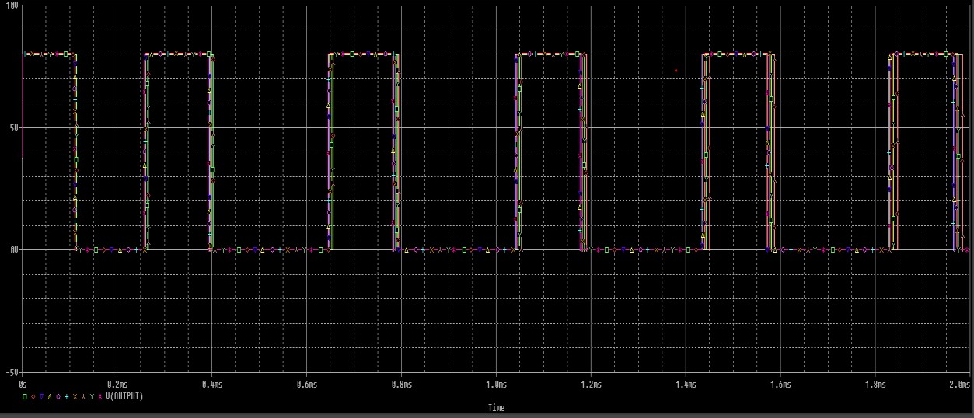

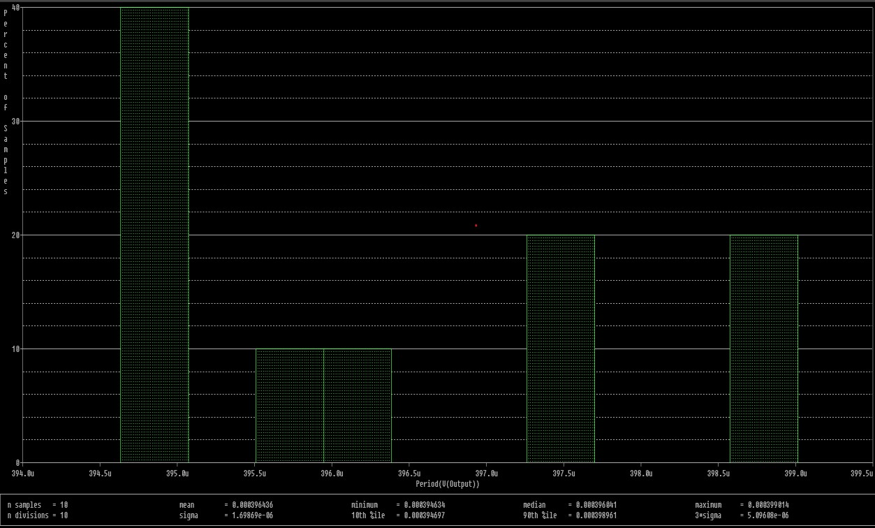

5.List of parts

[https://ro.farnell.com/texas-instruments/lmc555cm-nopb/ic-timer-15vsmd/dp/3121178?st=555%20ic](https://ro.farnell.com/texas-instruments/lmc555cm-nopb/ic-timer-15v-smd/dp/3121178?st=555%20ic)  - IC 555

<https://ro.farnell.com/vishay/mrs25000c1740fct00/res-174r-1-600mw-axial-metal-film/dp/9464913>

-174Ω Resistor

<https://ro.farnell.com/vishay/mrs25000c2000fct00/res-200r-1-600mw-axial-metal-film/dp/9465880>-200Ω Resistor

<https://ro.farnell.com/multicomp-pro/mp006336/res-1k-0-5w-axial-metal-film/dp/3619440>-1kΩ Resistor

<https://ro.farnell.com/vishay/cmf556k0000bheb/res-6k-0-5w-axial-metal-film/dp/3596931>6kΩResistor

<https://ro.farnell.com/vishay/p16np101mab15/potentiometer-100r-20-16mm-panel/dp/2550644>100Ω Potentiometer

<https://ro.farnell.com/bourns/pdb081-p41-103b1/rotary-potentiometer-10kohm-0/dp/3758654>10kΩ Potentiometer

<https://www.farnell.com/datasheets/2918175.pdf> 1uF cap

<https://www.vishay.com/docs/23106/125l.pdf>

6.Calculus

7.Layout on the Printed Circuit Board

A printed circuit board (PCB) is a medium used in electrical and electronic engineering to connect electronic components to one another in a controlled manner. It takes the form of a laminated sandwich structure of conductive and insulating layers: each of the conductive layers is designed with an artwork pattern of traces, planes and other features (like wires on a flat surface) etched from one or more sheet layers of copper laminated onto and/or between sheet layers of a non-conductive substrate. Electrical components may be fixed to conductive pads on the outer layers in the shape designed to accept the component's terminals, generally by means of soldering, to both electrically connect and mechanically fasten them to it. Another manufacturing process adds vias: plated-through holes that allow interconnections between layers.

For the PCB layout design I choose KiCaD. KiCad is a free software suite for electronic design automation (EDA). It facilitates the design and simulation of electronic hardware. It features an integrated environment for schematic capture, PCB layout, manufacturing file viewing, SPICE simulation, and engineering calculation. Tools exist within the package to create bill of materials, artwork, Gerber files, and 3D models of the PCB and its components.

I choose to implement my project in two ways. The only difference is at the output. The first design only uses a transistor at the output, and the second uses an amplifier configured as a buffer.

7.1.First Design

7.2First Design 3d-View

7.2.Second Design

7.2.Second design 3d-view

8.References

<https://www.electronics-tutorials.ws/waveforms/555_oscillator.html><https://en.wikipedia.org/wiki/Pulse-width_modulation><https://learn.sparkfun.com/tutorials/pulse-width-modulation/all><https://www.analogictips.com/pulse-width-modulation-pwm/><http://www.bel.utcluj.ro/dce/didactic/fec/>