**GUI Layout**

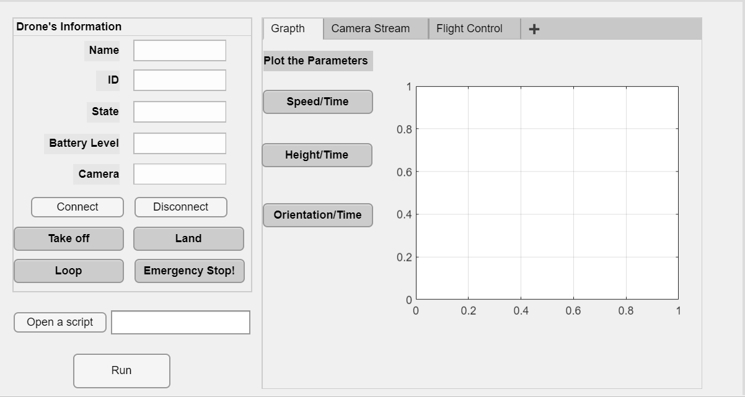

**Drone’s Information**

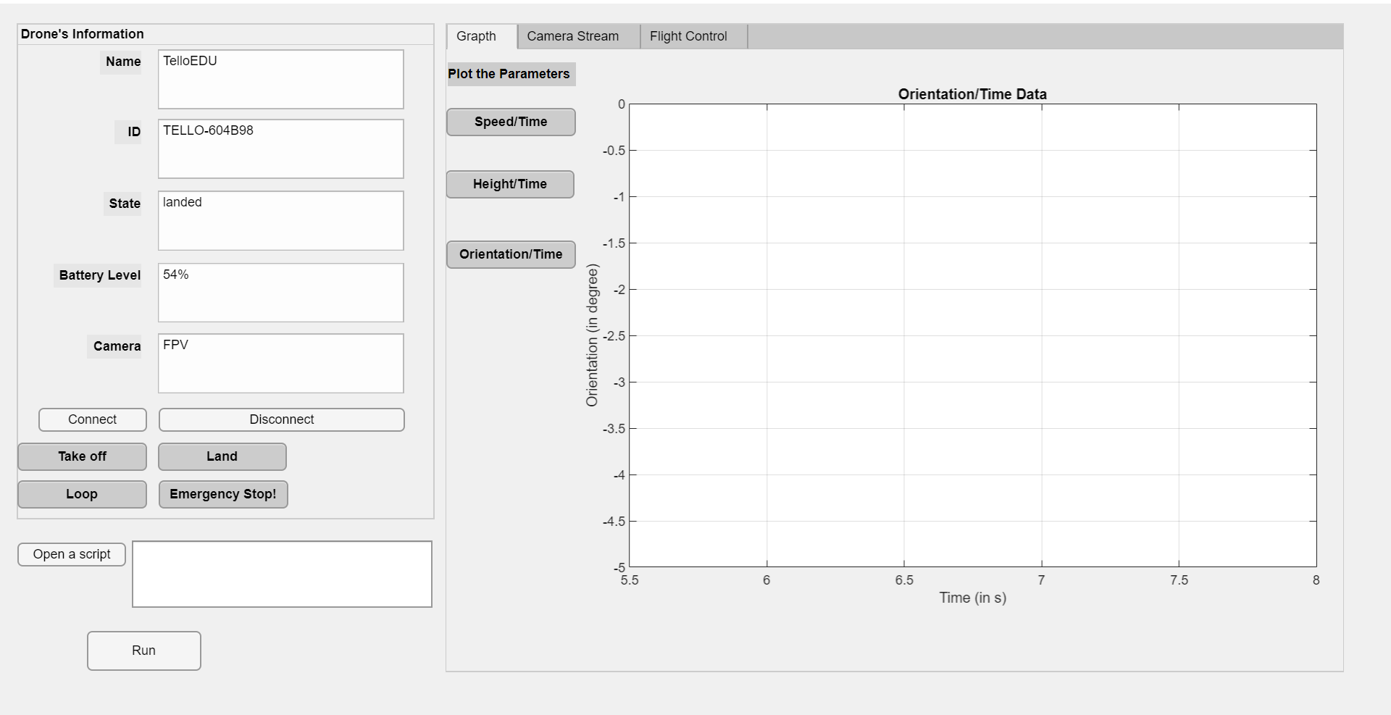

**Open a script and run**

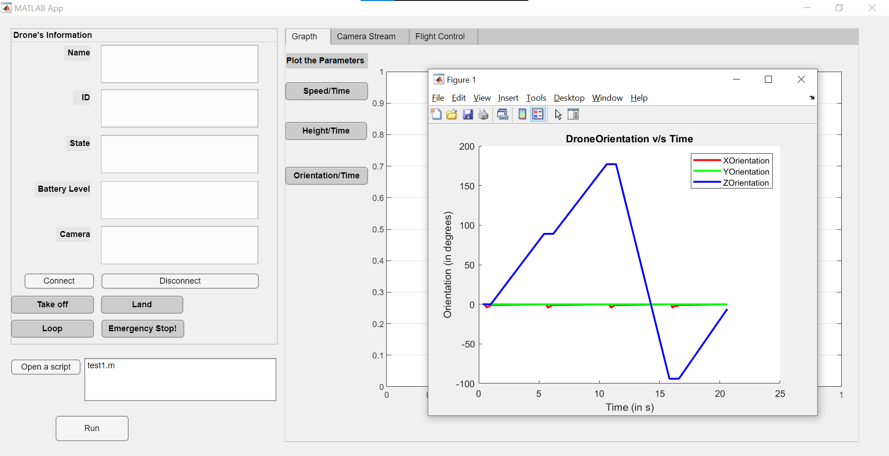

**Camera stream**

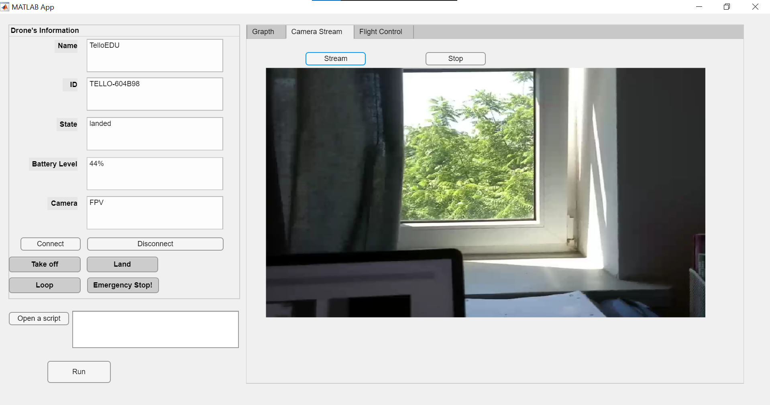

**Basic commands – Take off, Land, Emergency Stop!**

**Movement with keyboards**