License.ps1
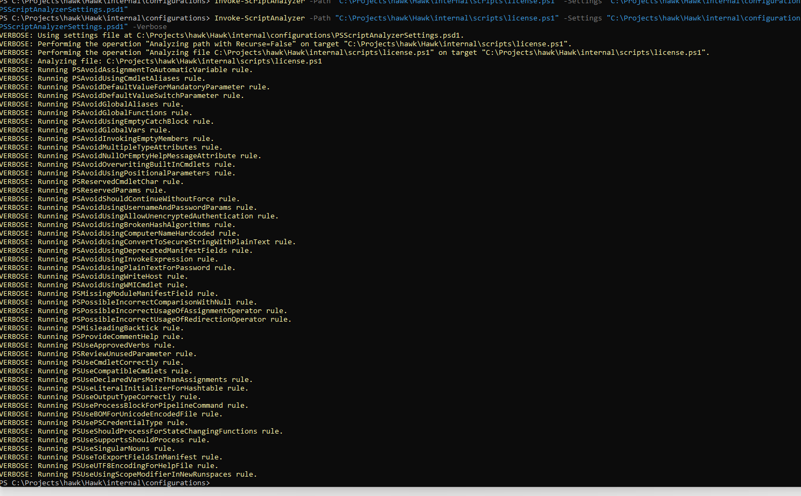
- Get-AllUnifiedAuditLogEntry.ps1

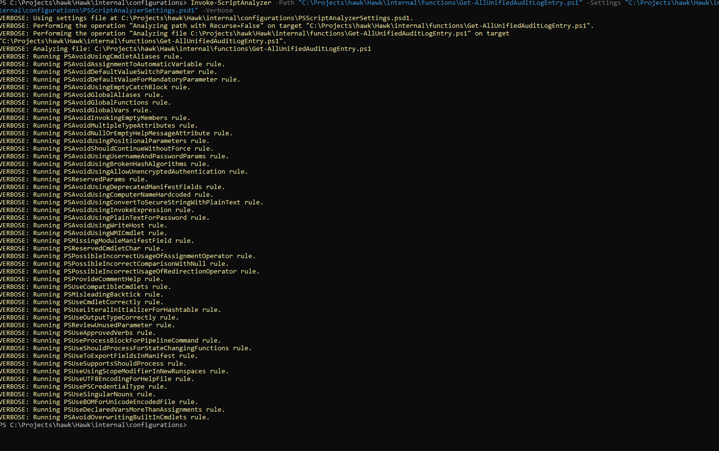

- Get-HawkMessageHeader.ps1

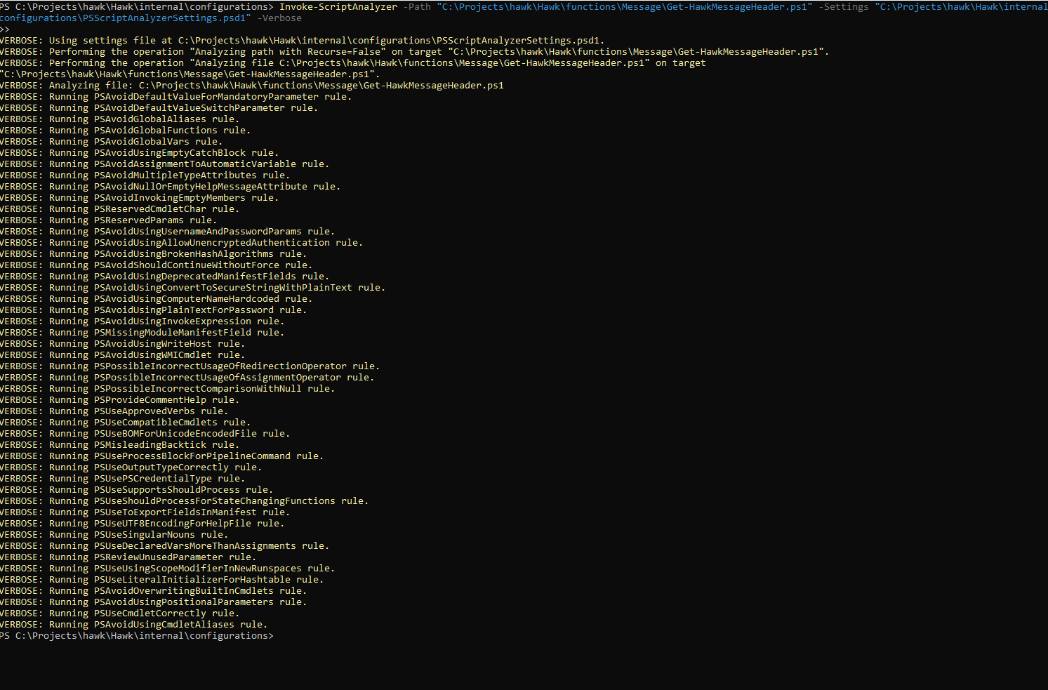
Get-HawkTenantAuthHistory.ps1
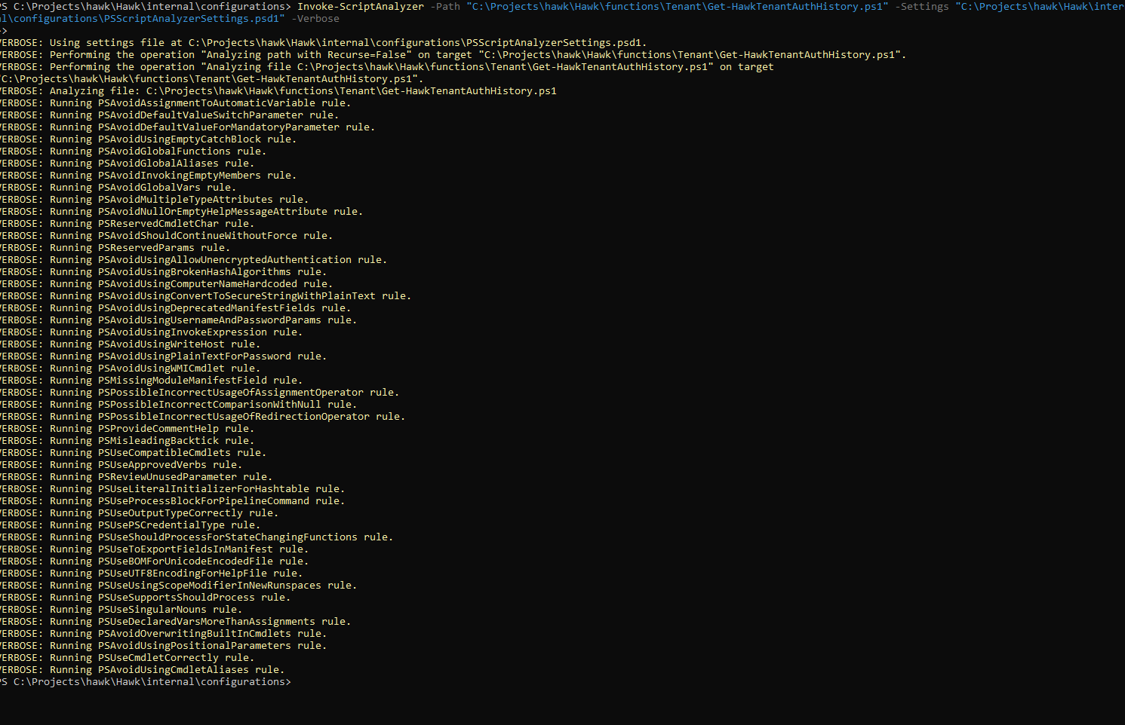

Import-AzureAuthenticationLogs.ps1
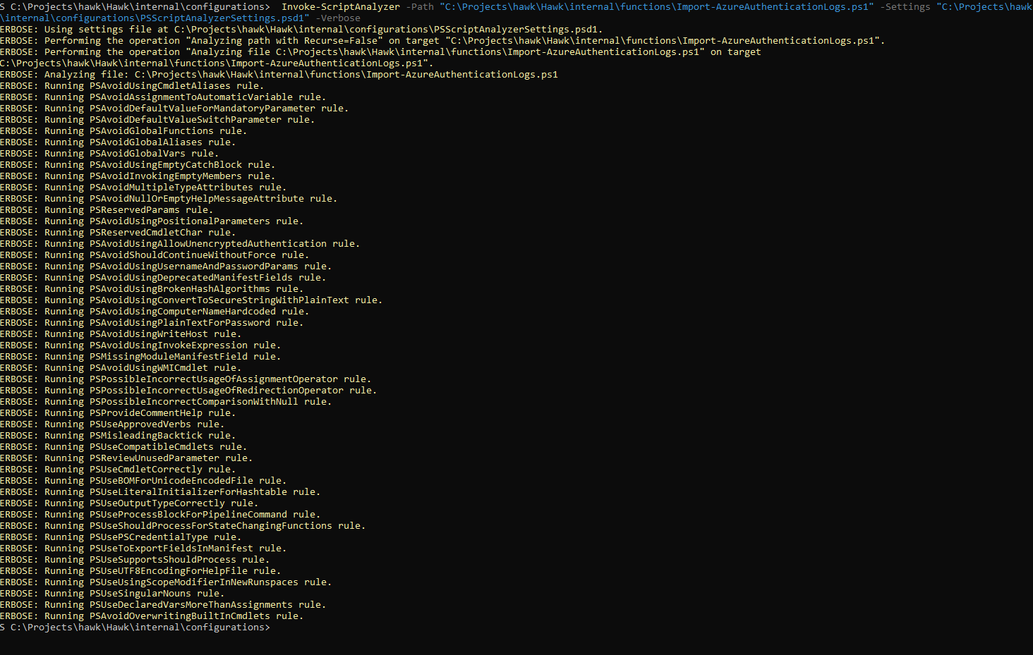
Initialize-HawkGlobalObject.ps1
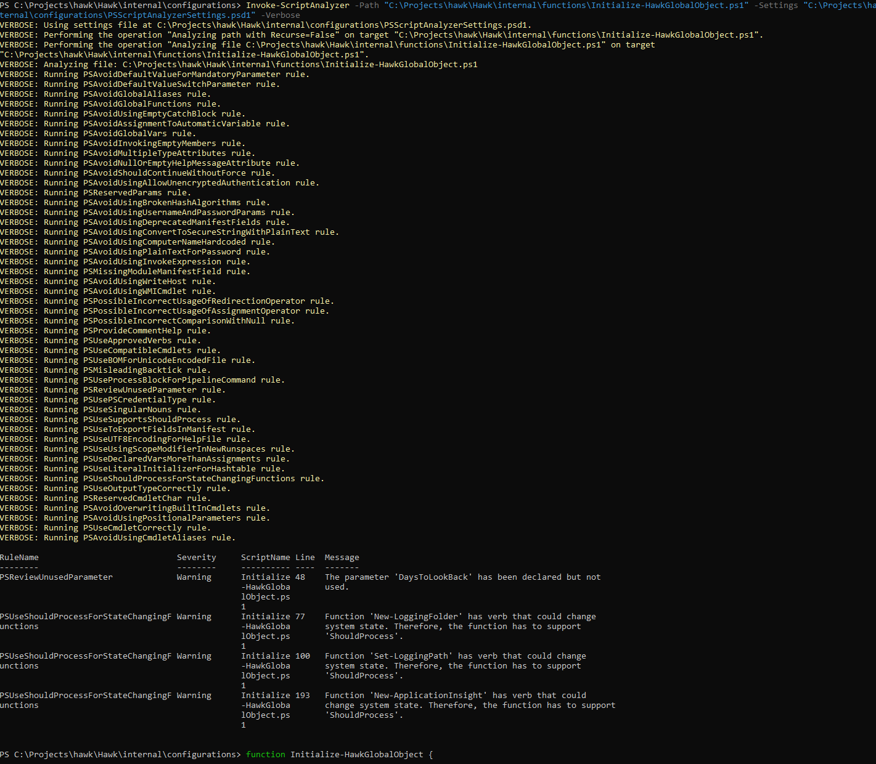

- Out-LogFile.ps1

