License.ps1

* Get-AllUnifiedAuditLogEntry.ps1

* Get-HawkMessageHeader.ps1

Get-HawkTenantAuthHistory.ps1

Import-AzureAuthenticationLogs.ps1

Initialize-HawkGlobalObject.ps1

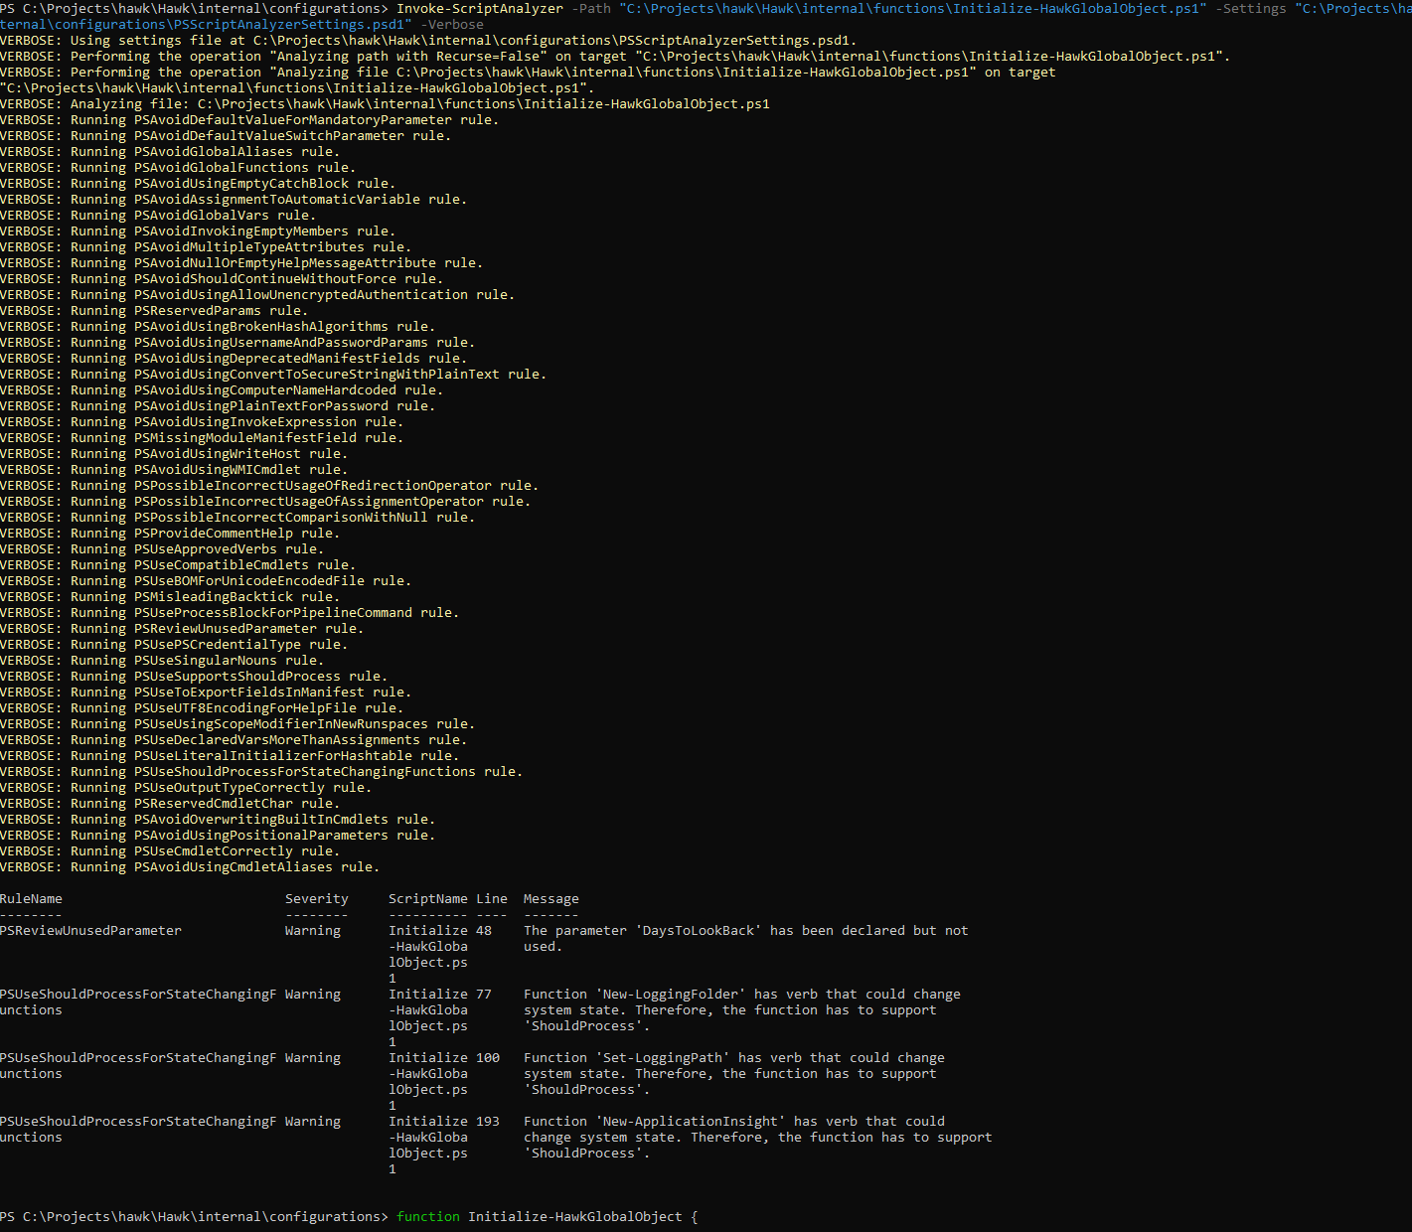

* Out-LogFile.ps1

