EasySave 3.0 : Quick Reference Guide
Overview: EasySave is a GUI application for managing Full (copies all files) and Differential (copies only new/modified files) backups. Launch the application by double-clicking EasySave.exe.

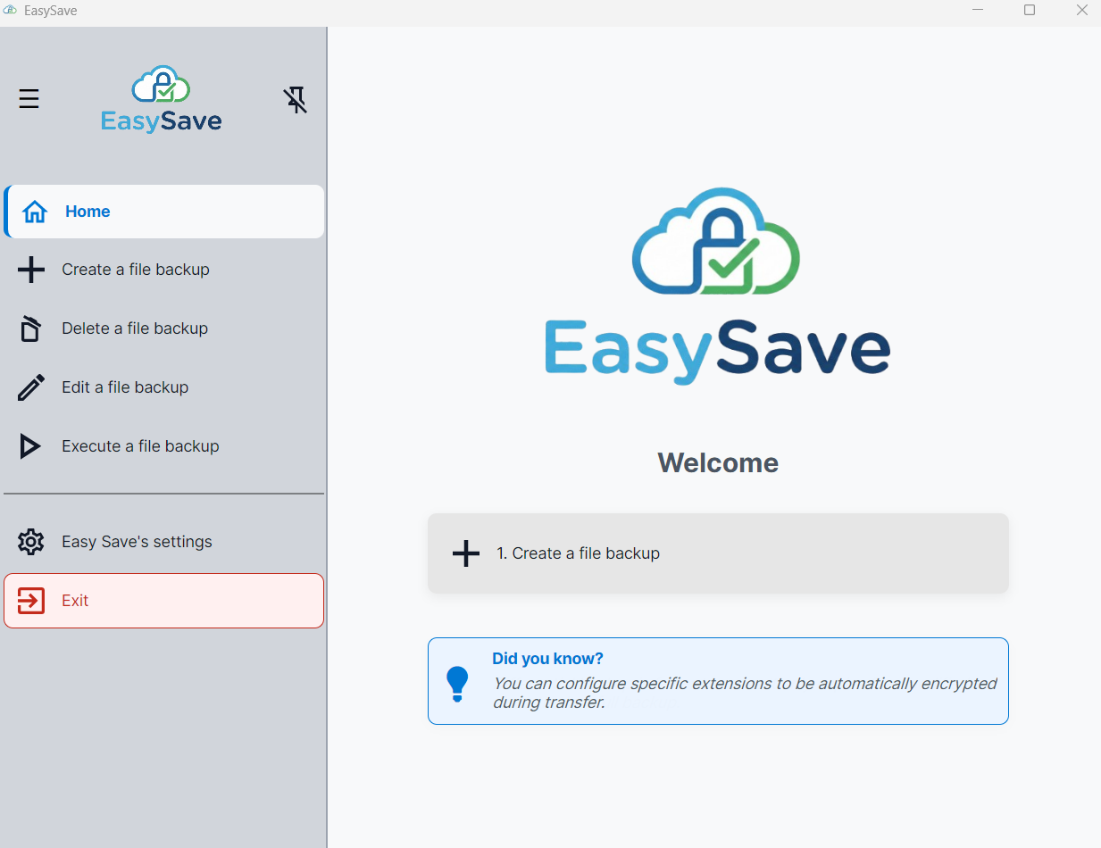

1. Navigation & Job Management
The left sidebar is the main navigation menu:
- Create: Configure a new backup by setting a Name, Source folder, Target folder, and Type (Full/Diff).
- Edit / Delete: Modify existing job parameters or remove them entirely.
- Execute: Access the execution panel to run jobs.
- Settings: Configure application-wide preferences.

2. Executing Backups
To run backups, go to the Execute tab, select a job and play.
- Real-Time Controls: * ▶ Play: Starts or resumes a paused job.
  - ⏸ Pause: Pauses the job (takes effect after the current file transfer finishes).
  - ⏹ Stop: Immediately stops the job and aborts the current file transfer.
- Business Software Interrupt: If your configured business software is running, new backups cannot start, and active backups are automatically paused until the software is closed.

3. Settings
Access the Settings menu to customize EasySave's behavior (langage, log configuration, log destination, file encryption, business software and transfer restrictions).

