Architectures for Software Systems
Software Architecture in Perspective
Reading Questions 1
Nguyễn Sĩ Hiền – K14T01
Readings:
[Lattanze 08] Chapter 1
[Bass 03] Chapter 1, Chapter 2

Questions:

- What is software architecture? What is different between architecture design and detail design?
- Answer: The software architecture of a program or computing of the system is the structure or structures of the system, which comprise the software elements, the externally visible properties of those elements and the relationships among them. Here, Structure is represent of architecture. A representation of a structure is usually called a view of system. It’s Physical, Static and Runtime Perspective. Beside, Software elements are the course grained “parts” of the system. Specific design structure is result of Perspective plus Element. In static perspective, elements are code modules, files, data…In Runtime Perspective, elements are threads, processes, object…And the last Physical perspective, elements are computer, actuators...Architecture focuses on quality of system, and write other hand is non-functional of system.
- We have three different between architecture design and detail design.
  - First, Architecture Design focus on the external properties of elements, the ensemble of elements, and system structure, whereas detailed designers focus on the internals of elements, data structures, and algorithms utilized within an element.
  - Second, Architecture Design is decided by the overall properties of a system such as performance, security…On the Whole, they are quality (non-function). But detailed design concerned with specification function.
  - Last, Architecture Design is declarative; generally .it based largely on intuition and experience. Conversely, detailed designs are meant to be translated directly into code, diagrams…
- Why is software architecture important?
Answer: Software architecture important because software architecture help for:
- Communication among stakeholders. We know that software architecture is declarative and generally. So, Stakeholders are easy to understand and talk, exchange view on their common concerns.
- Early design decisions if Organization have early architecture. First, Architecture defines constrains on implementation. This means that the implementation divided into the prescribed elements. From that architecture define constrains to ensure implement well. The architecture dictates organization structure. The system architecture includes the highest-level decomposition of the system, so architecture afraid change of manager. As Quality attribute impact to architecture, Architecture inhibits or enables quality attribute. The architecture helps in evolutionary prototyping. This aids the development process in two ways. The system is executable early in the product's life cycle. Its fidelity increases as prototype parts are replaced by complete versions of the software. These prototype parts can be a lower-fidelity version of the final functionality, or they can be surrogates that consume and produce data at the appropriate rates. A special case of having the system executable early is that potential performance problems can be identified early in the product's life cycle. Last, Architecture enables more accurate cost and schedule estimate.
- Transferable abstraction of a system, reusable model of architecture. If Organization has more product lines, it can share common architecture. We easy to exchange architecture of them before.

- What are the key factors that effects architecture and in turn it influences environment that spawned it (Architecture Business Cycle – ABC)? Show ABC for original WEB system.
- Answer : The key factors that effects architecture is :
  - System stakeholder, affect how to delivered system is viewed by its eventual recipients, and so they find a voice in one or more of the system‘s stakeholder.
  - The developing Organization. However, if Organization may have immediate business investment or a long- term investment, Object development will different. So, it affect to architecture of system.
  - Background and experience of architecture. If experience architecture design new system instead of new architecture of graduation. What happen? If I give you one change to choose, who will you choose? And of course, Experience Architecture will design better.
  - Technical Environment that is current when architecture is designed will influence that architecture. It might include standard industry practices or software engineering techniques prevalent in the architect's professional community. It is a brave architect who, in today's environment, does not at least consider a Web-based, object-oriented, middleware-supported design for an information system.
- ABC with Original WEB system :
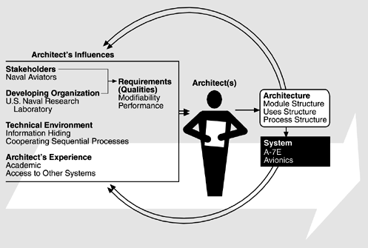
The architects included one of the authors of this book and one of the leaders in the development of software engineering principles, but the architects had little experience in the avionics domain, although they did have access to other avionics systems and to experts in avionics. There was no compiler available for the target platform

