Architectures for Software Systems
Tactics for archiving Quality attributes
Reading Questions 3
Nguyễn Sĩ Hiền – K14T01 – T086828
Reference:
[Bass 03] Chapters 5, 13

Questions:

- Describe tactics to archive Availability and Performance quality attributes.
Answer:
- Goal of Availability Tactics are do anything to archive about fault masked or repair made in system. To do that, some tactic developed, researched and summarized in this picture :
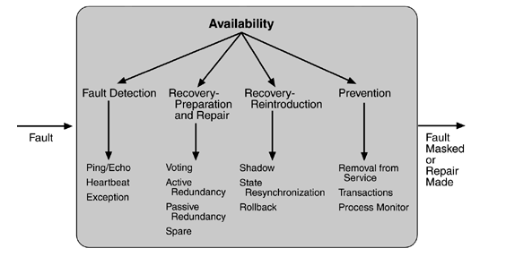
- We know that Availability tactics to control Availability attribute. We usually consider Fault Detection, Fault Recovery-Preparation and Repair, Fault Recovery-Reintroduction, and Fault prevention to archive this goals .
  - In Fault Detection, Architectures usually use three tactics: Ping/Echo, Heartbeat and Exception. First, to ensure system isn’t been discontinued, in a period not use time, Components will checking continuous. This is Ping/Echo Tactic. It can used be used by clients to ensure that a server object and the communication path to the server are operating within the expected performance bounds. Second, Heartbeat (dead man time). In this case, one component emits a heartbeat message periodically and another component listens for it. If the heartbeat fails, the originating component is assumed to have failed and a fault correction component is notified. Last, this is Exception Tactics that one method for recognizing faults is to encounter an exception. It handler typically executes in the same process that introduced the exception.
  - In Fault Recovery-Preparation and Repair, Architectures use four tactics: Voting, Active redundancy (hot restart), Pass redundancy and Spare. Voting (voting Algorithm) can be "majority rules" or "preferred component" or some other algorithm. This method is used to correct faulty operation of algorithms or failure of a processor and is often used in control systems. Beside, Active redundancy tactic usually use. All redundant components respond to events in parallel. The response from only one component is used (usually the first to respond), and the rest are discarded. When a fault occurs, the downtime of systems using this tactic is usually milliseconds since the backup is current and the only time to recover is the switching time. Active redundancy is often used in a client/server configuration, such as database management systems, where quick responses are necessary even when a fault occurs. Passive redundancy (warm restart/dual redundancy/triple redundancy). One component (the primary) responds to events and informs the other components (the standbys) of state updates they must make. When a fault occurs, the system must first ensure that the backup state is sufficiently fresh before resuming services. This approach is also used in control systems, often when the inputs come over communication channels or from sensors and have to be switched from the primary to the backup on failure. And the last tactic is Spar. This is often used as the standby client workstation, where the user can move when a failure occurs. The downtime for this tactic is usually minutes.
  - In Fault Recovery-Reintroduction, we have three tactics: Shadow operation, state resynchronization, and checkpoint/rollback.
  - In Fault prevention, we follow some fault tactics: Removal from service, transactions, process monitor. Tactic removes a component of the system from operation to undergo some activities to prevent anticipated failures. Transaction is the bundling of several sequential steps such that the entire bundle can be undone at once. Transactions are used to prevent any data from being affected if one step in a process fails and also to prevent collisions among several simultaneous threads accessing the same data.
- With Performance attribute is different. Its goal is response generated within time constrains. To control performance, architecture consider resource demand, resource management, resource arbitration, follow the picture :
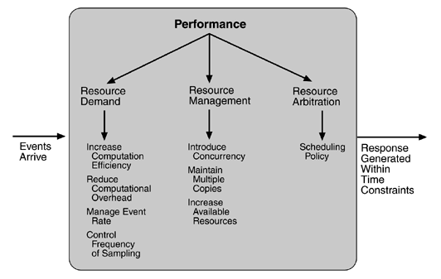
  - In resource demand, one tactic for reducing latency is to reduce the resources required for processing an event stream. It includes: Increase computation efficiency and reduce computation overhead. With this tactic, the importance improve algorithm. Another tactic for reducing latency is to reduce the number of events processed. This can be done in one of two fashions: Manage Event rate and Control frequency of sampling. Other tactics for reducing or managing demand involve controlling the use of resources: Bound execution times and bound queue sizes.
  - Another, in resource management, we have three tactics: introduce concurrency, maintain multiple copies of either data or computations, and increase available resource. Introduce concurrency is increase many threads to processing. Multiple copies are a tactic that data is replicated, either on different speed repositories or on separate repositories, to reduce contention. Since the data being cached is usually a copy of existing data, keeping the copies consistent and synchronized becomes a responsibility that the system must assume. Increase available resource improves about hardware.
  - Other, in resource arbitration, we can increase performance by prioritization of scheduling policy in processing. We have four tactics: First-in/first-out, Fixed-priority scheduling, dynamic priority scheduling, static scheduling. In Fixed-priority, we have three strategies: sematic importance, deadline importance, rate monitor. In dynamic priority scheduling, we have two strategies round robin and earliest deadline first.

- Consider a widely used Web site, such as Amazon or eBay. What tactics would you need to consider when choosing the architectural patterns or architectural strategies for meeting the performance requirements you enumerated in that question?
Answer:
- Then, this is a picture about an e-commerce reference architecture:
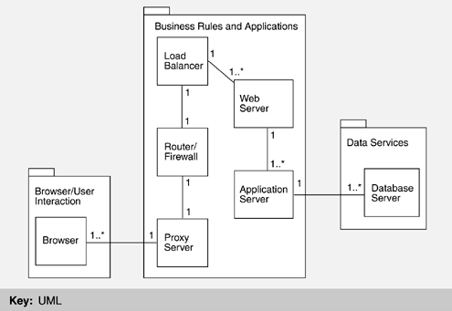
- We can see that this system has three components: Browser/user interaction, Business rules and application, Data Service.
- To control performance attribute, we must do :
  - With proxy server, we can use tactic “multiple copies”. Requests from individual browsers may first arrive at a proxy server, which exists to improve the performance of the Web-based system. They are typically located close to the users, often on the same network, so they save a tremendous amount of both communication and computation resources.
  - With Load Balance, we can use tactics “Introduce physical concurrency”. So, we can avoid clash in bandwidth, one can request to different server.
  - With Webserver, we can use tactic “introduce concurrency”. So, our processing will better. Another, we can use tactics “increase available resource” or “increase computation efficiency” to improve performance.
  - With database server, we can use tactics “Stored procedure” to decrease bandwidth among data server and application server.

3. | Given the set of tactics you chose in question 2, what tradeoffs with other quality attributes might you expect from using them (such as security, availability, and Modifiability)?  Answer:  - With some tactics in question 2 as: multiple copies, introduce physical concurrency, introduce concurrency, increase available resource, increase computation efficiency and stored procedure.  - When we use tactics “increase available resource” then Availability and scalability attribute will increase. With strong hardware systems, the issues about using 24/7 are normally and Faculty extends the system.  - With tactic “multiple copies”, Proxy servers are also used by companies that want to restrict their employees' access to certain Web sites. In this case the proxy server is acting somewhat like a firewall. This is increase security quality attribute.  - With tactics that database server use is perfect. The request for service arrives at the database, where it is converted into an instruction to add, modify, or retrieve information. Modern database architectures share many of the qualities of the entire e-commerce system presented. They frequently use internal replication for performance, scalability, and high availability. They may use caching for faster performance.

