Architectures for Software Systems
Architecture Drivers
Reading Questions 2
Nguyễn Sĩ Hiền – K14T01
Readings:
[Lattanze 08] Chapter 3, chapter 8, chapter 9
[Bass 03] Chapters 4

Questions:

- What are architectural drivers? List and describe each. Of the architectural drivers which tend to have the greatest influence on design and system structure?
Answer:
- Architecture driver are requirements that will shape the software architecture
- Architecture driver include :
  - High Level Functional requirement or coarse-grained
  - Quality attribute
    - Availability
    - Usability
    - Performance
    - …
  - Constrains
    - Business Constrains
    - Technical Constrains
- High-level functionality is an obvious architectural driver and refers to those general requirements for what the system must do. Technical and business constraints are fixed premade decisions that are in place before design begins. Quality attribute requirements are properties that the system must possess, such as availability, security, high performance, and so forth. Constraints and quality attribute requirements will have the most influence over the design.
- Show use case and six parts quality attribute scenario template
Answer:
- Six Parts quality attribute scenario template :
  - Stimulus : A condition that effects the system
  - Source of stimulus : The entity that generated the stimulus
  - Environment – The condition under which the stimulus occurred
  - Artifact stimulated : the artifact that was stimulated by the stimulus
  - Response : the activity that result because of stimulus
  - Response measure: the measure by which the system ‘s response will be evaluated.
- Use Case models describe what is needed in a system in terms of functional responses to given stimuli. A use case is initiated by an entity, and then goes on to describe a sequence of interactions between the entity (and entities) and the system that, when taken together, model systemic functional requirements.
- This is one use case about VSM (Version Management).
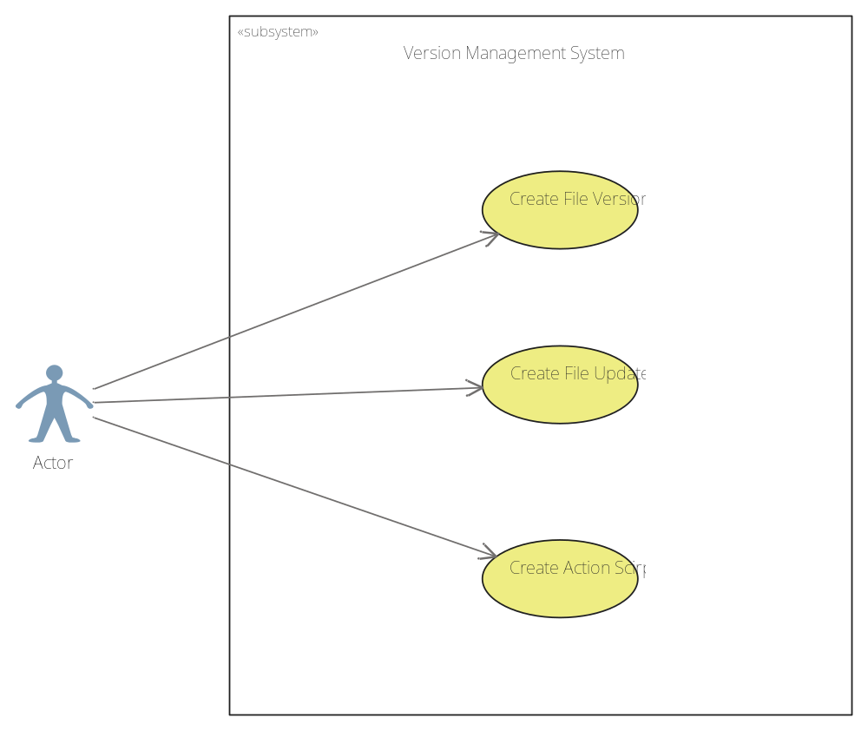

- Show some possible business and technical constrains:
Answer:
- Technical constraints are direct, premade design decisions that become like load-bearing walls in the design space that can have dramatic impact on the permissible design choices that the architect can make when designing a system. It is often the case that architects must incorporate various kinds of hardware, software products, operating systems, legacy elements, and systems in their architectural designs and the resulting implementations. EX: Software will program by Java language, run in SQL express editor 2005.
- Business Constrains are indirect, premade design decisions with dramatic impact to the design and can severely limit the permissible design choices available to the architect. They are indirect in the sense that business constraints generally do not specify particular technical approaches, solutions, or products, but imply the use of specific technical approaches, solutions, or products. EX: The scope of project only allows 15 week to development and 5 members. With this scope, Architecture design will consider which design will suitable and make decision.

Table 1: Performance General Scenario

- What is general scenario generation table? Each team member will be given one different quality attribute among Availability, Modifiability, Performance, Security, Testability, and Usability quality attributes. Show general scenario generation table for that quality attribute.
Answer:
- General Scenario table is a basis quality attribute scenario framework for recording, negotiating, and analyzing quality attribute requirement. In other worlds, it is check-list to ensure that all possibilities have been considered rather than as an explicit generation mechanism.

Stimulus | A number of source both external and internal
Source | Periodic event, sporadic event…
Environment | System
Artifact stimulus | System
Response | Process stimulus, change level of service
Response measure | Time, time lay.
Table 1: Performance General Scenario

- For the current system you are currently working on, what are the most important qualities? What are the system-specific scenarios that capture these qualities and what are the general scenarios they make concrete?
Answer:
- For the my Current system, the most important qualities is Performance ( performance in checkout and recording, update ) and Availability ( can available all day ).
- Then, this general scenarios of them :

Source(s) of the stimulus | Cashier
Stimulus | The cashier checkout for customer
Relevant environmental conditions | POST system in normal mode and overload mode
Architectural elements | POST System
System response | The number of item in inventory is reduced and items list is updated
Response measure(s) | The response time is less than 2 seconds in normal mod, 5 seconds in overload mode
Table 2: Performance General Scenario for Post System

Source(s) of the stimulus | Cashier, administrator
Stimulus | User uses the tool for 14 hours straight
Relevant environmental conditions | During normal environment.
Architectural elements | POST system
System response | The tool should not crash and stable operation
Response measure(s) | The software will operate when it was run and it will not off or hang during time use.
Table 2: Availability General Scenario for Post System

